|  |  |
| --- | --- |
| **Ex.No. :** 09  **Date :** 18-04-24 | **VALIDATION OF EMAIL ACCOUNT USING PHP** |

**AIM :**

To validate the Email Account using php.

**PROGRAM :**

**HTML CODE :**

<html>

<head>

<title>TODO supply a title</title>

<meta charset="UTF-8">

<meta name="viewport" content="width=device-width, initial-scale=1.0">

</head>

<style>

.f1{

border:2px solid blue;

width:100%;

height:70px;

background-color:lightblue;

}

.f2{

border:2px solid black;

width:100%;

height:70px;

background-color:red;

font-size:30;

}

.button1{

padding:5px 5px;

background-color:blue ;

}

</style>

<body>

<div class="f1">

<center><h1>Online Email Validation</h1></center>

</div>

<form method="POST" >

<center><div class="f2">

<label for="mail">Type Your Mail</label>

<input placeholder="email" type="text" name="mail" size="50">

</div></center>

<center> <button class="button1" onclick="match()">&nbsp;&nbsp;&nbsp;&nbsp;&nbsp;&nbsp;Test&nbsp;&nbsp;&nbsp;&nbsp;&nbsp;&nbsp;</button> </center>

</form> </div> <?php

if(isset($_POST))

{ $emaill=$_POST["mail"];

$pattern="/^[a-z0-9.]+@[a-z0-9.]+\.[a-zA-Z]{2,4}$/";

if($emaill=="")

{

echo "<h1 style='background-color:rgb(78, 109, 246);width: 350px;border-radius: 25px;'>Please enter the email-id</h1>";}

else

{

if(preg_match($pattern,$emaill))

{

echo "<h1 style='background-color:rgb(57, 243, 57);width: 300px;border: 3px solid black;border-radius: 20px;text-align: center;'>Valid Email-ID: $emaill</h1>"; }

else {

echo "<h1 style=' background-color:rgb(241, 22, 22);width: 300px;border: 3px solid black;border-radius: 25px;'>Invalid Email-ID: $emaill</h1>";}

}} ?>

</h1> </center>

</body></html>

**OUTPUT :**

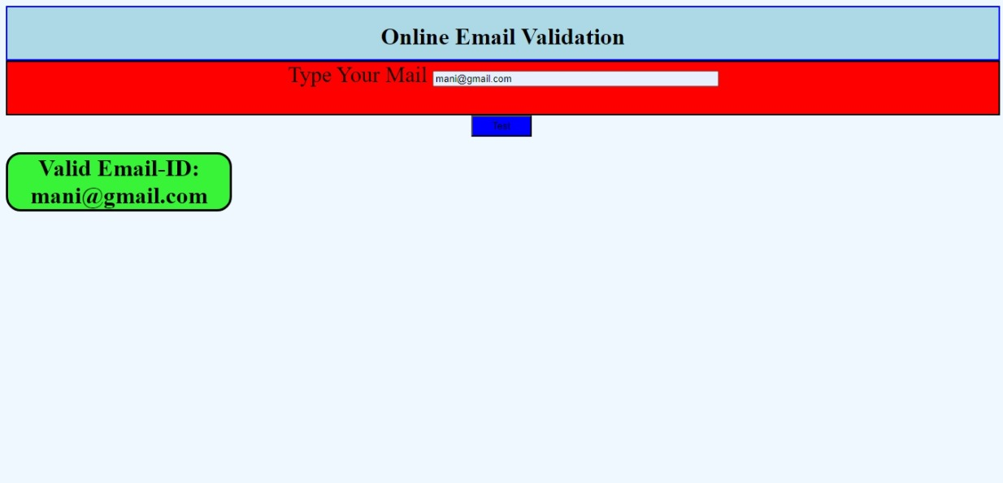

**RESULT :**

Thus the above program for validate the Email Account using php was Executed and Verified Successfully.