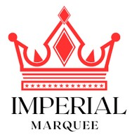 **IMPERIAL MARQUEE**

# INVOICE

Name:Date:

Event Type: Invoice No:

SUBTOTAL

DESCRIPTION

COST PER HEAD

NO OF GUEST

**GRAND TOTAL**

Proprietor: Nighat Parveen

Managing Director: Umair Khalid

Contact No: 0331-6537631

Address: Service Mor, Gujrat SIGNATURE