**Task5B**

**Design a web application with JavaFX event handling.**

**Aim:** Design a JavaFX application for a basic login page that allows users to enter their username and password. Upon clicking the login button, the application should authenticate the user credentials. If the credentials are valid, the application should display a success message and provide an option to close the login window.

Algorithm:

Step1: Create a JavaFX application extending the Application class.

Step2: Implement the start method to set up the graphical user interface (GUI)

with labels for username and password, text fields for user input, buttons

for login and closing, and a status label to display login feedback.

Step3: Set up event handlers for the login and close buttons.

Step4: In the login button event handler:

Step4.1: Retrieve the entered username and password.

Step4.2: Call an authentication method to validate the credentials.

Step4.3: If the credentials are valid, hide the login components and display

a success message along with the close button.

Step4.4: If the credentials are invalid, display an error message.

Step5: In the close button event handler, close the login window.

**Program:**

import javafx.application.Application;

import javafx.geometry.Insets;

import javafx.scene.Scene;

import javafx.scene.control.Button;

import javafx.scene.control.Label;

import javafx.scene.control.PasswordField;

import javafx.scene.control.TextField;

import javafx.scene.layout.VBox;

import javafx.stage.Stage;

public class LoginApplication extends Application {

private TextField usernameField;

private PasswordField passwordField;

private Label statusLabel;

@Override

public void start(Stage primaryStage) {

// Create GUI components

Label titleLabel = new Label("Login Page");

Label usernameLabel = new Label("Username:");

Label passwordLabel = new Label("Password:");

usernameField = new TextField();

passwordField = new PasswordField();

Button loginButton = new Button("Login");

Button closeButton = new Button("Close");

statusLabel = new Label();

// Event handler for the login button

loginButton.setOnAction(event -> {

String username = usernameField.getText();

String password = passwordField.getText();

boolean loginSuccessful = authenticate(username, password);

if (loginSuccessful) {

titleLabel.setVisible(false);

usernameLabel.setVisible(false);

passwordLabel.setVisible(false);

usernameField.setVisible(false);

passwordField.setVisible(false);

loginButton.setVisible(false);

closeButton.setVisible(true);

statusLabel.setText("Login successful!");

} else {

statusLabel.setText("Invalid username or password!");

}

});

closeButton.setOnAction(event -> {

Stage stage = (Stage) closeButton.getScene().getWindow();

stage.close();

});

// Layout setup

VBox root = new VBox(10);

root.setPadding(new Insets(20));

root.getChildren().addAll(

titleLabel,

usernameLabel,

usernameField,

passwordLabel,

passwordField,

loginButton,

closeButton,

statusLabel

);

// Create the scene and show the stage

Scene scene = new Scene(root, 400, 300);

primaryStage.setScene(scene);

primaryStage.setTitle("Login Page");

primaryStage.show();

}

// Simulated authentication method (replace with actual server logic)

private boolean authenticate(String username, String password) {

// Perform authentication logic here

// For simplicity, let's consider a hardcoded username and password

return username.equals("admin") && password.equals("password");

}

public static void main(String[] args) {

launch(args);

}

}

Output:

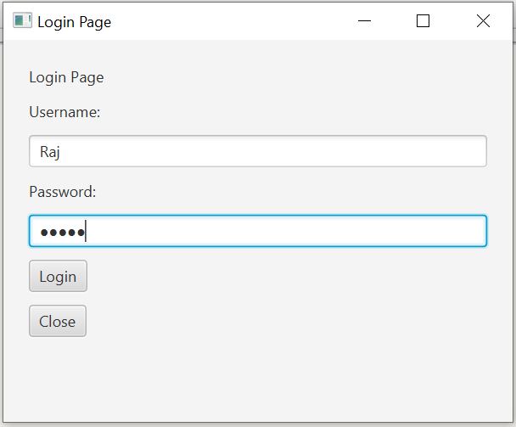

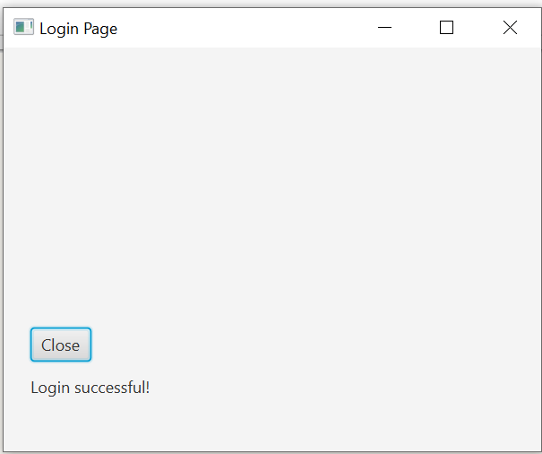

**Result:** Thus the simple calculator application using JavaFX experiment was successfully completed and output verified.