

**Data Science**

**Lab - 5**

**Name: Manikandan P**

**RegNo: 2019202030**

**.WORKING WITH SUV-DATASET**

**Importing Libraries**

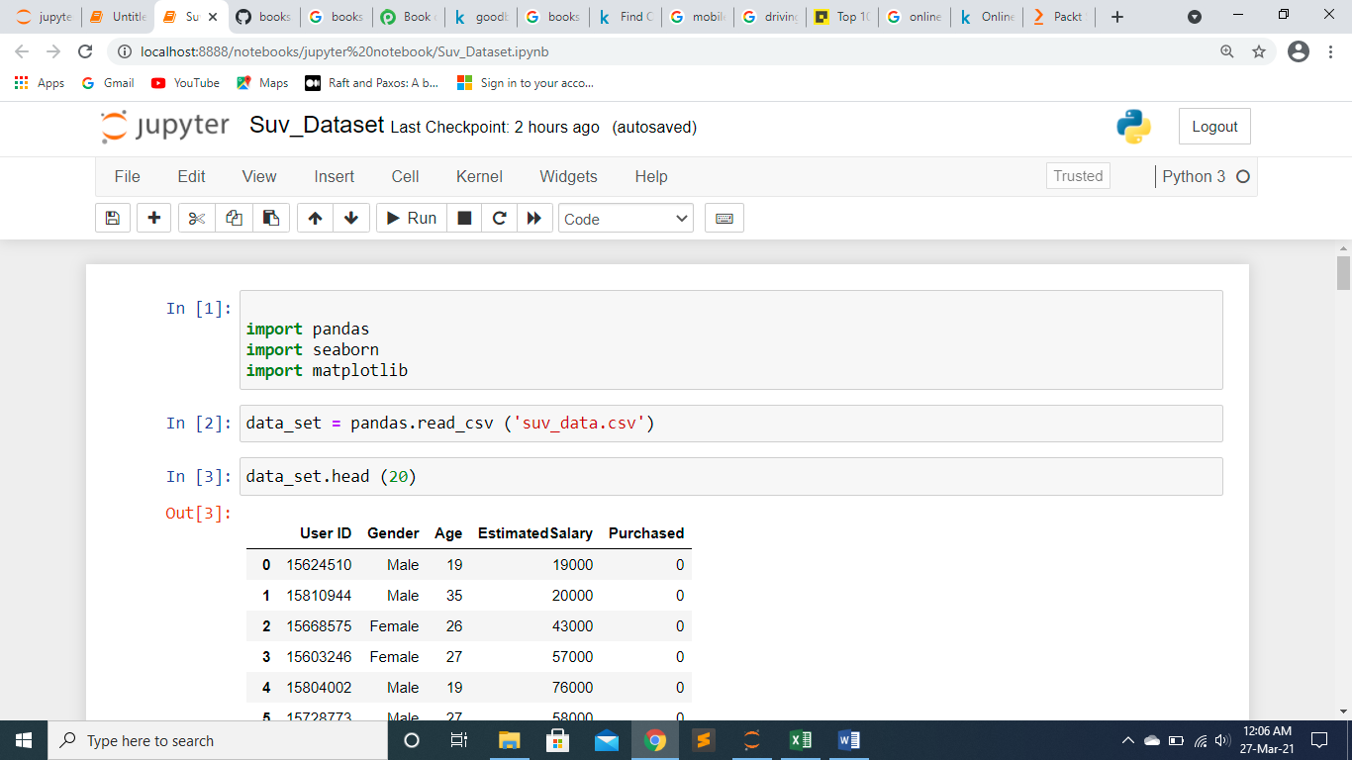

**Loading suv_data.csv dataset**

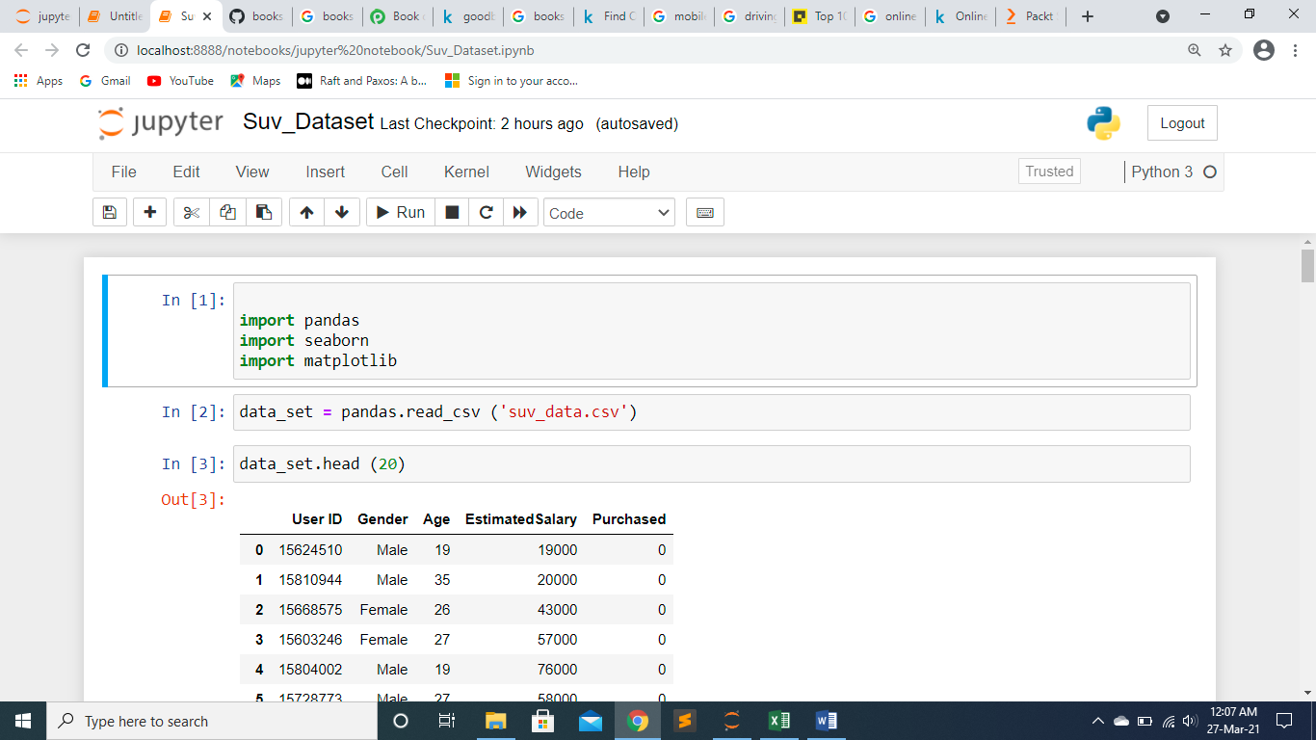

**Displaying first 20 records of data**

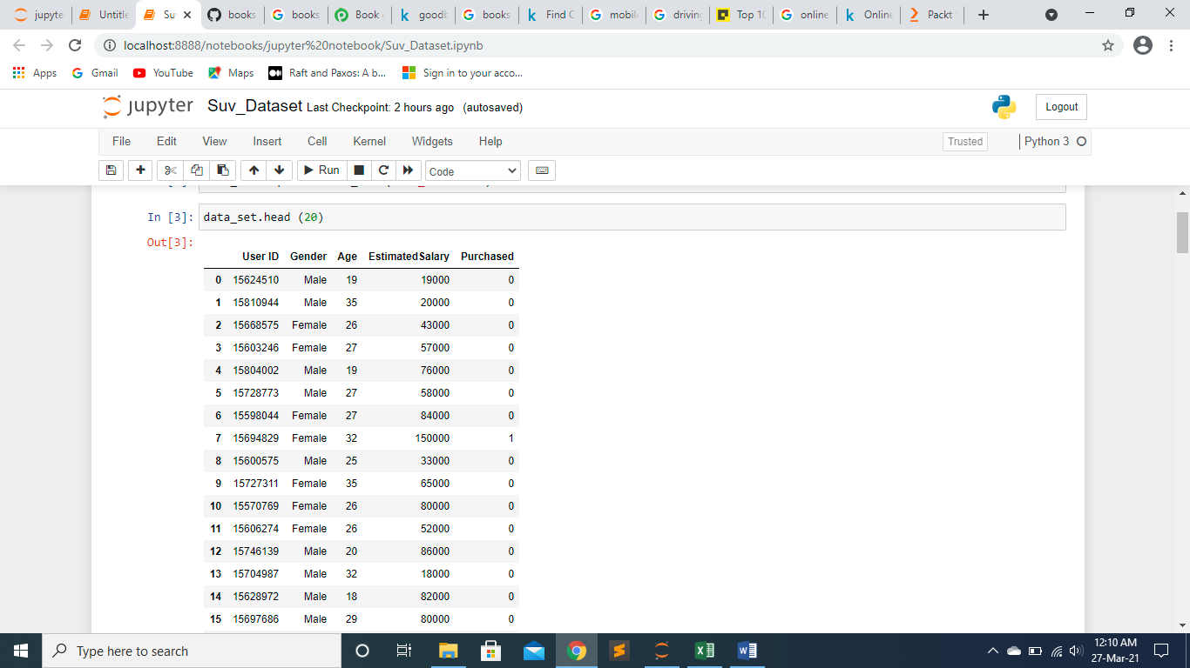

**Displaying datatypes of columns**

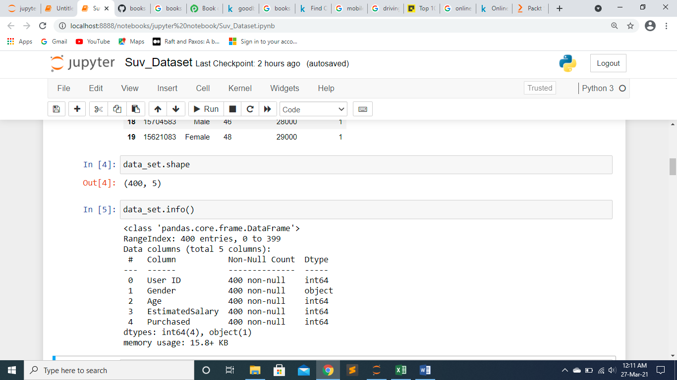

**Grouping dataset by “purchased”**

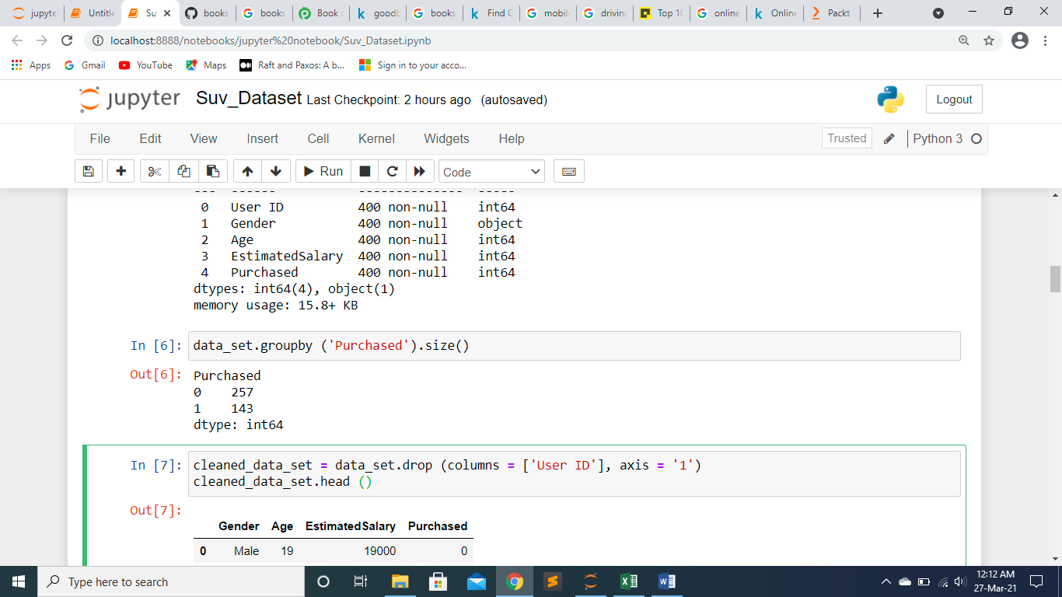

**Droping column “UserID” and displaying**

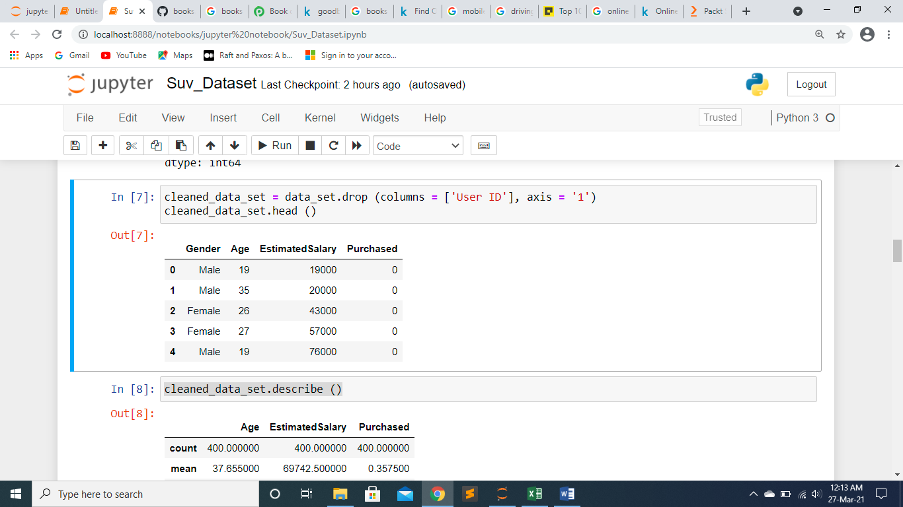

**Describing Dataset**

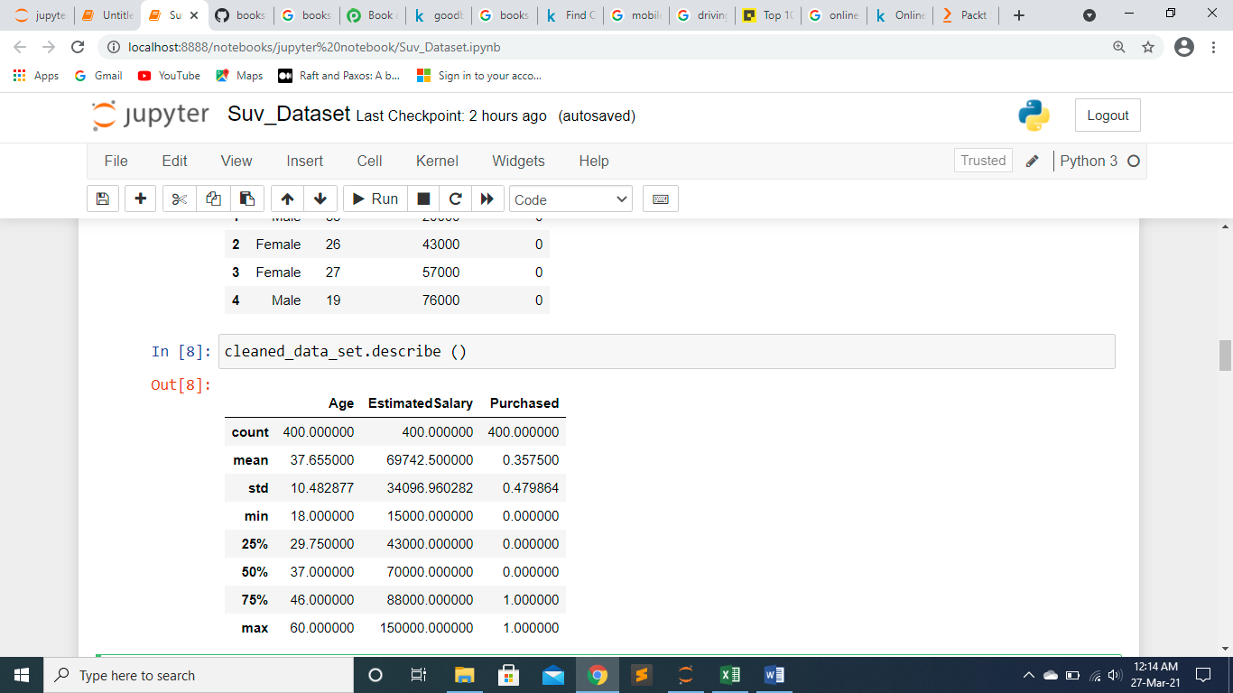

**Displaying purchased and not purchased count in Bar Diagram**

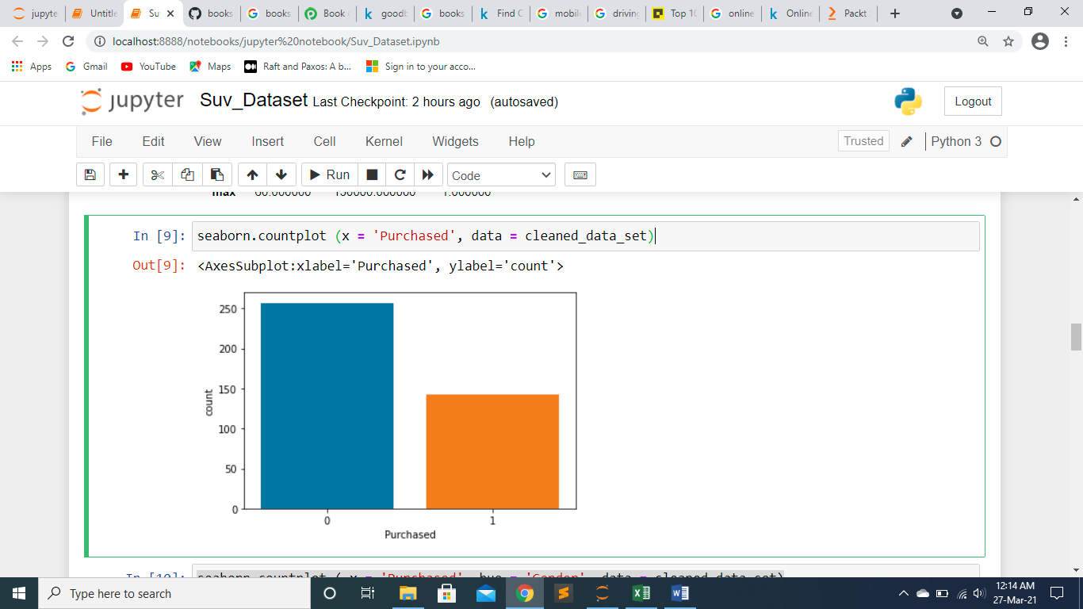

**Displaying purchased SUV by categorizing in gender**

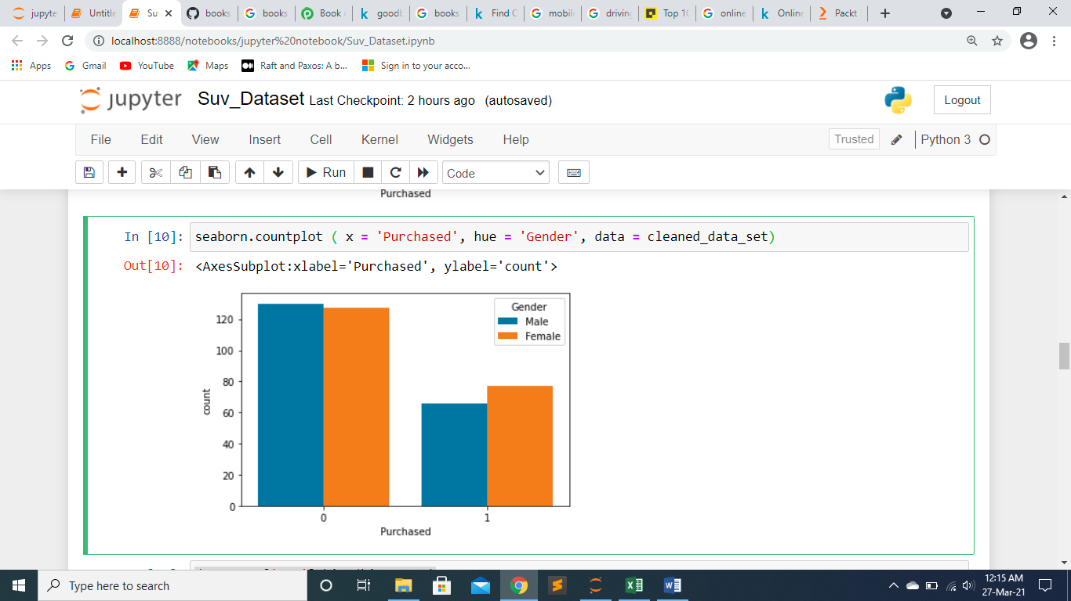

**Dataset of column “Age” in bins**

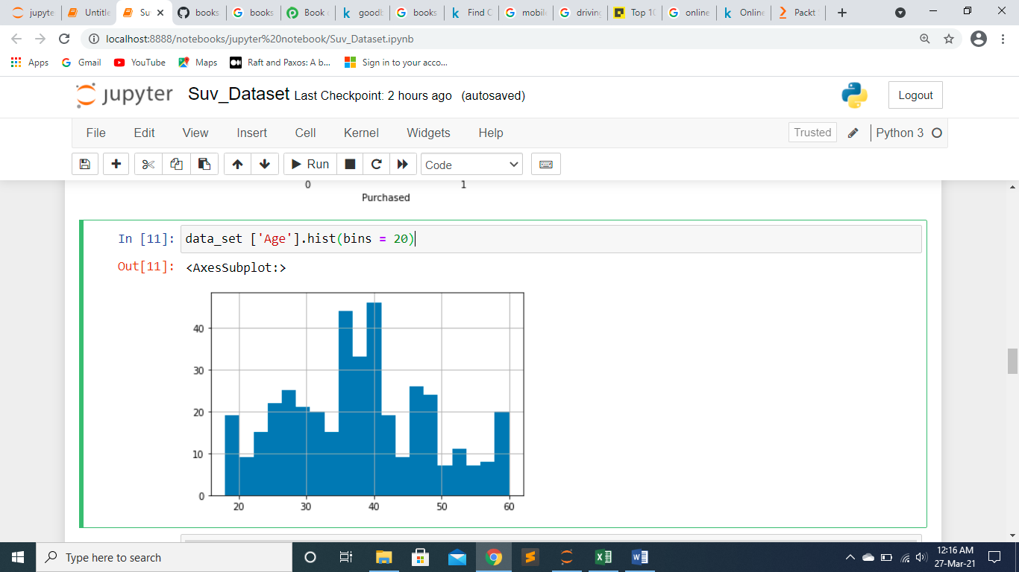

**Categorizing by age of SUV-Purchasers**

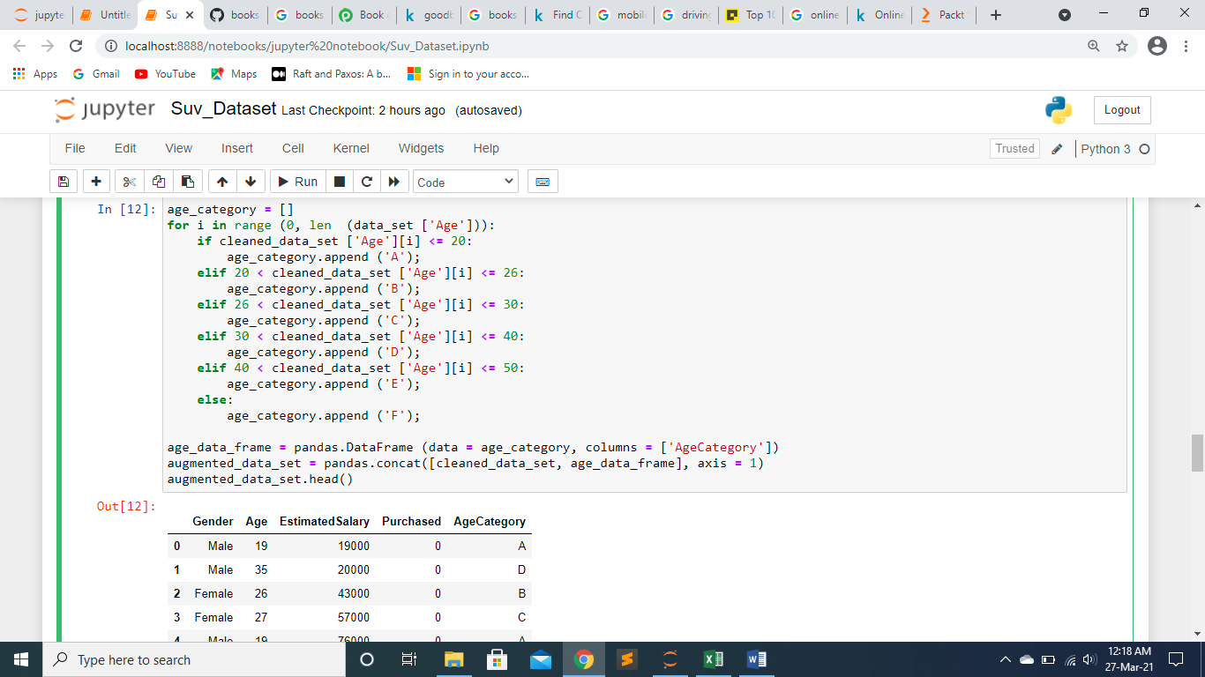

**Displaying that data in Bar Chart**

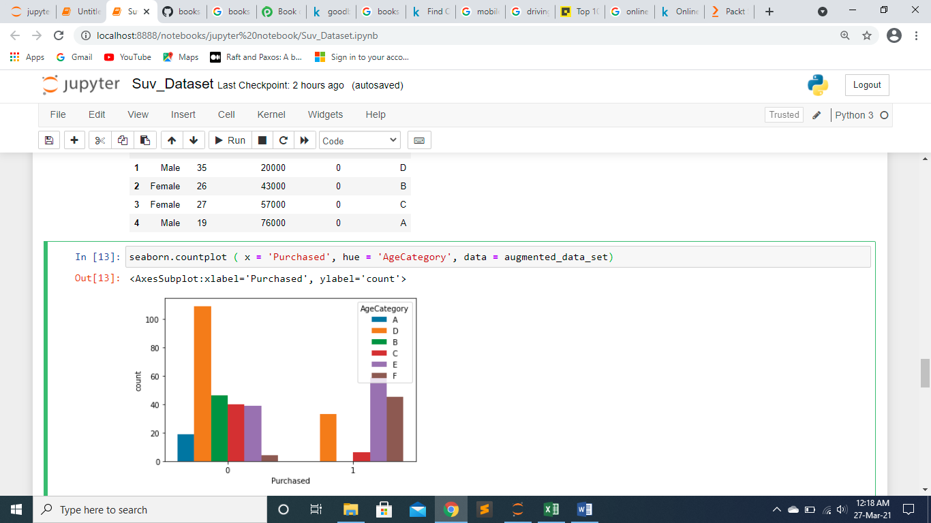

**Categorizing By Income of the SUV - Buyers**

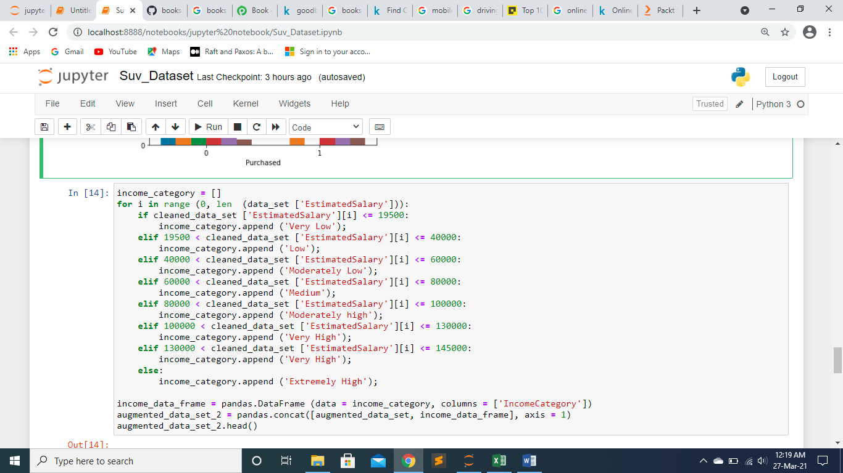

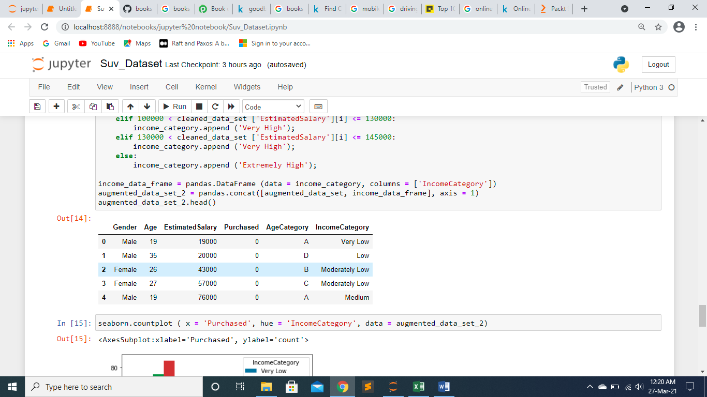

**Displaying that data in Bar Chart**

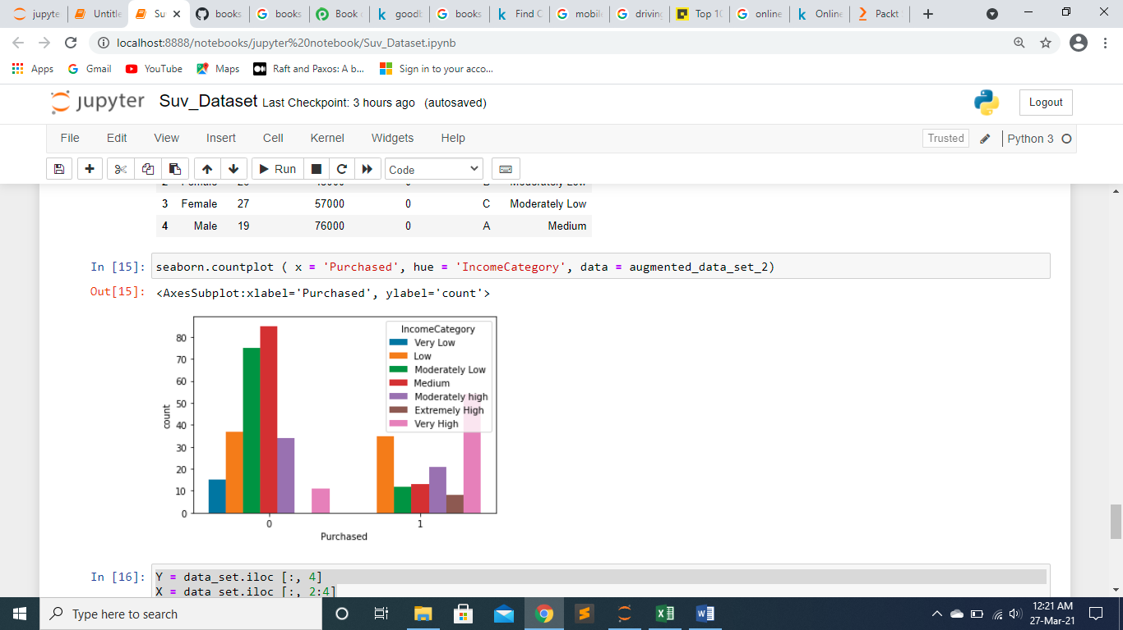

**Slicing the column**

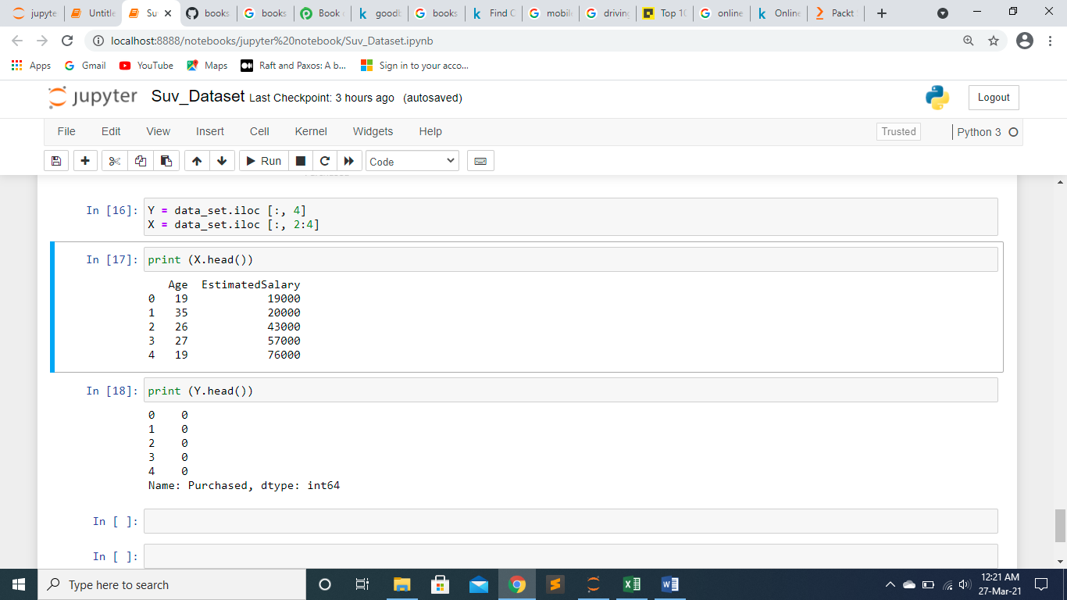

\THANK YOU MAM !!\