

**Data Science**

**Lab - 5**

Bivariate Analysis

**Name: Manikandan P**

**RegNo: 2019202030**

**WORKING WITH SUV - DATA SET**

**Importing Libraries**

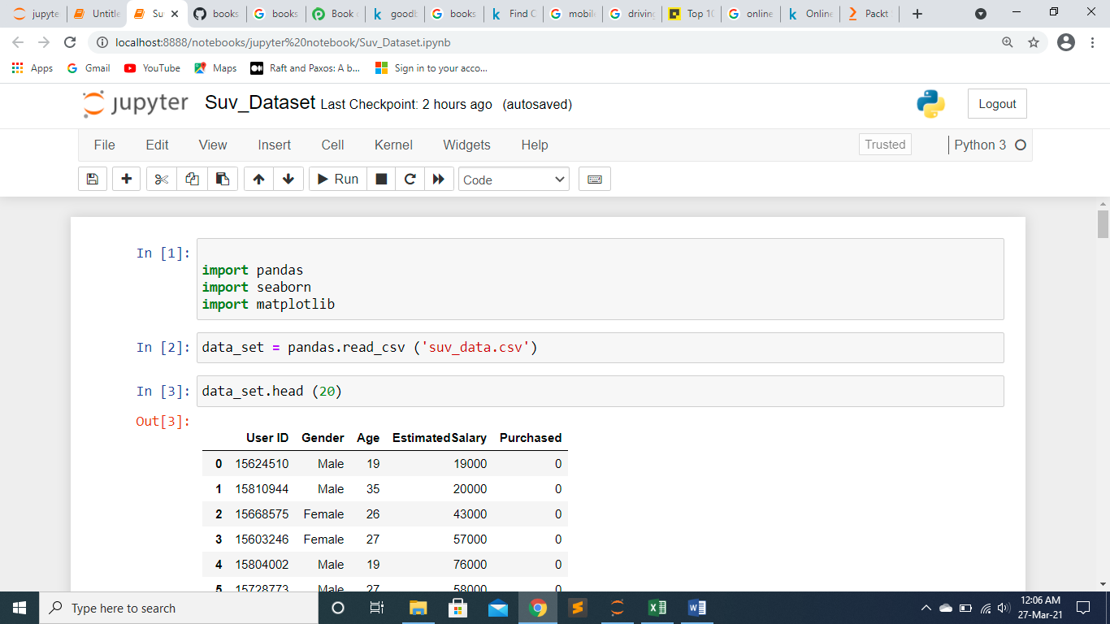

**Loading suv_data.csv data set**

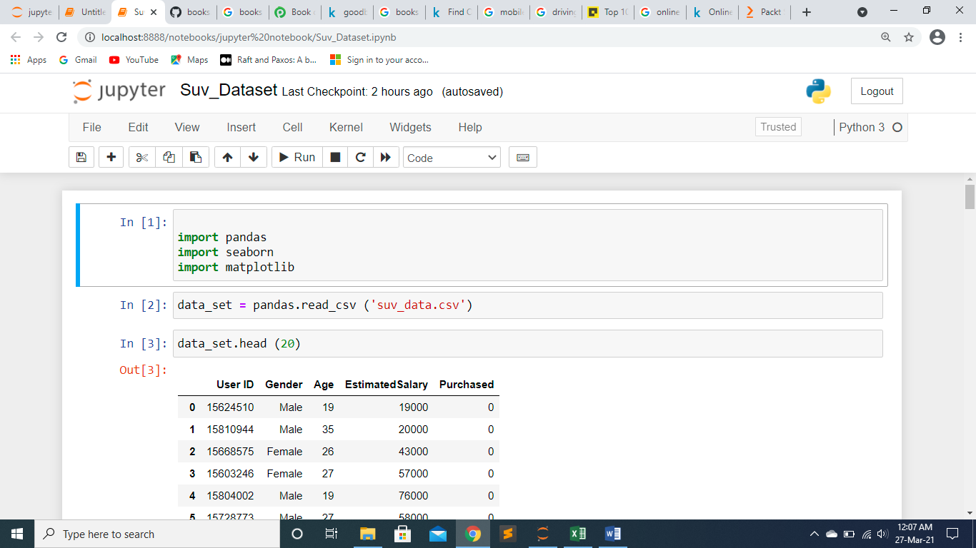

**Displaying first 20 records of data**

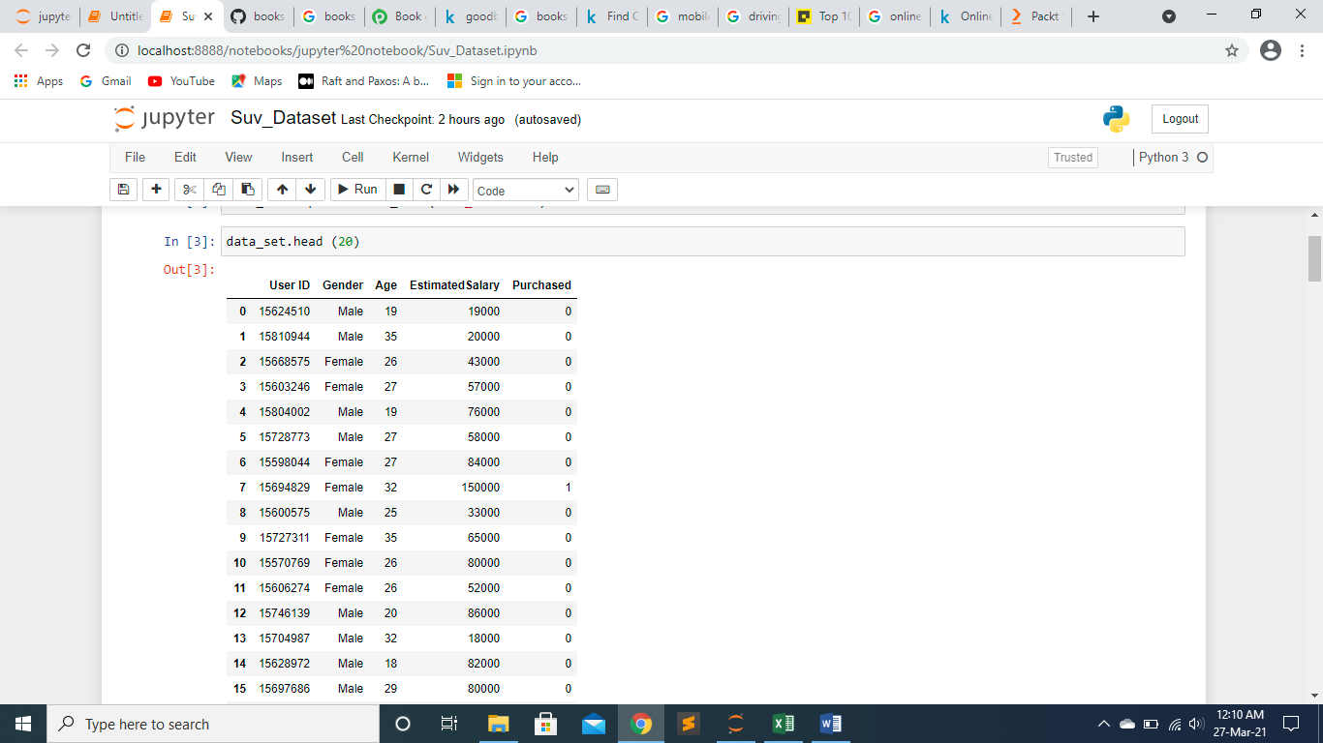

**Displaying datatypes of columns**

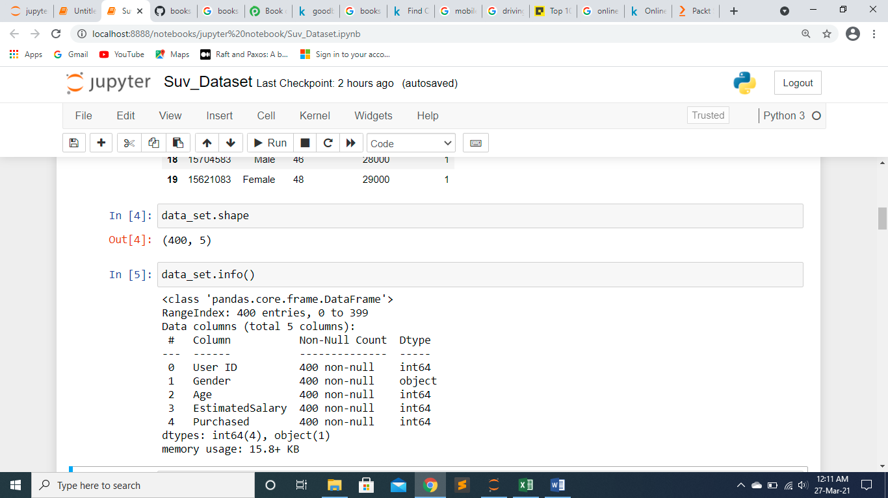

**Grouping data set by “purchased”**

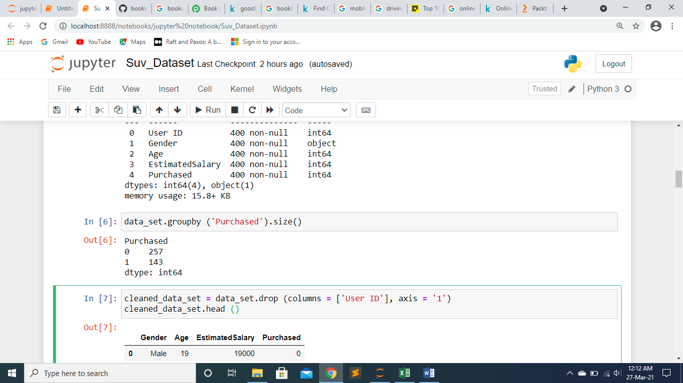

**Dropping column “User ID” and displaying**

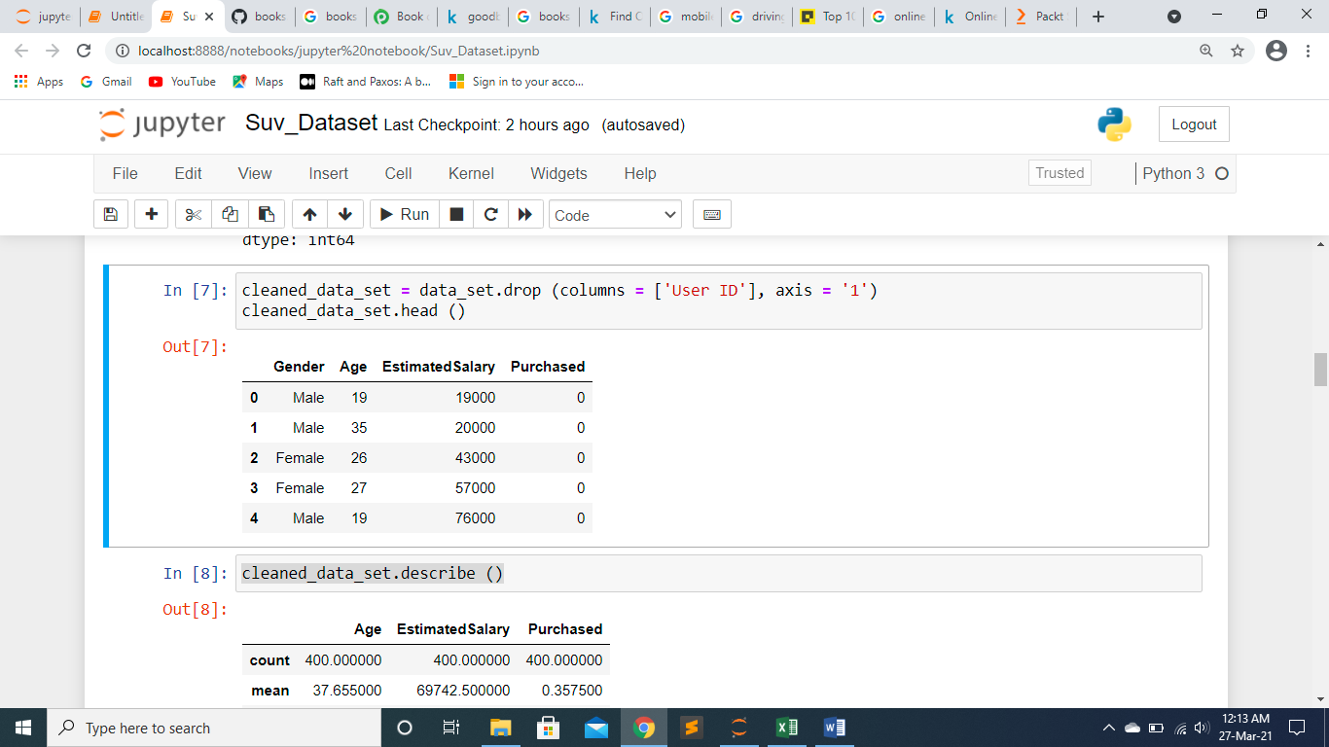

**Describing Data set**

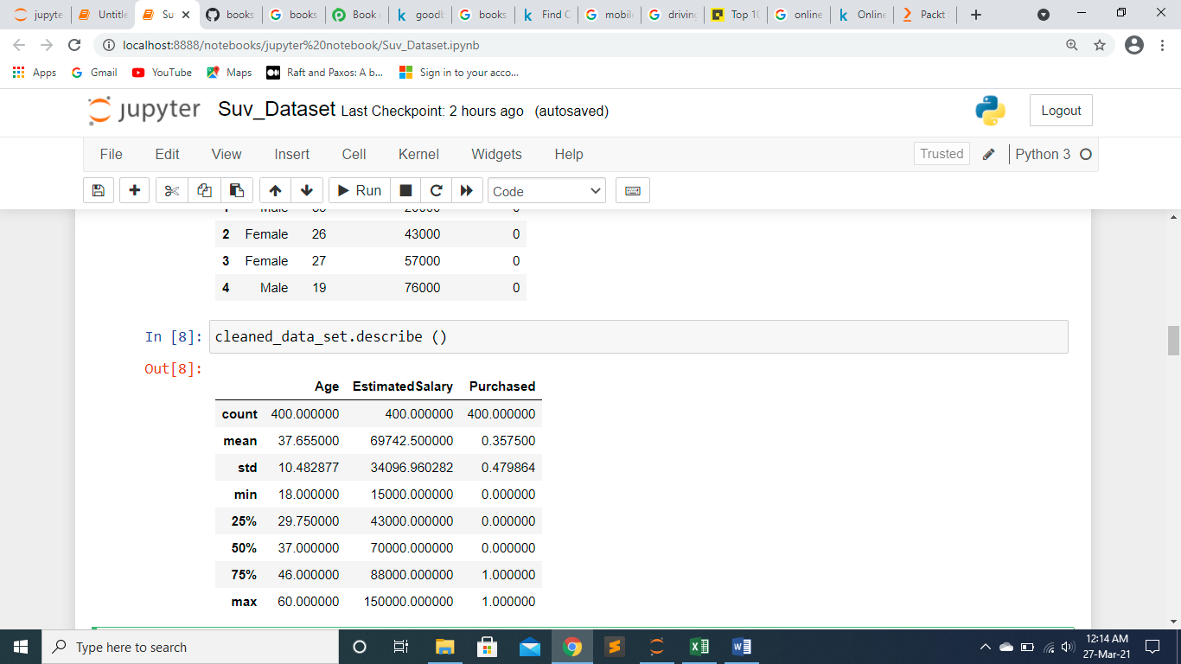

**Displaying purchased and not purchased count in Bar Diagram**

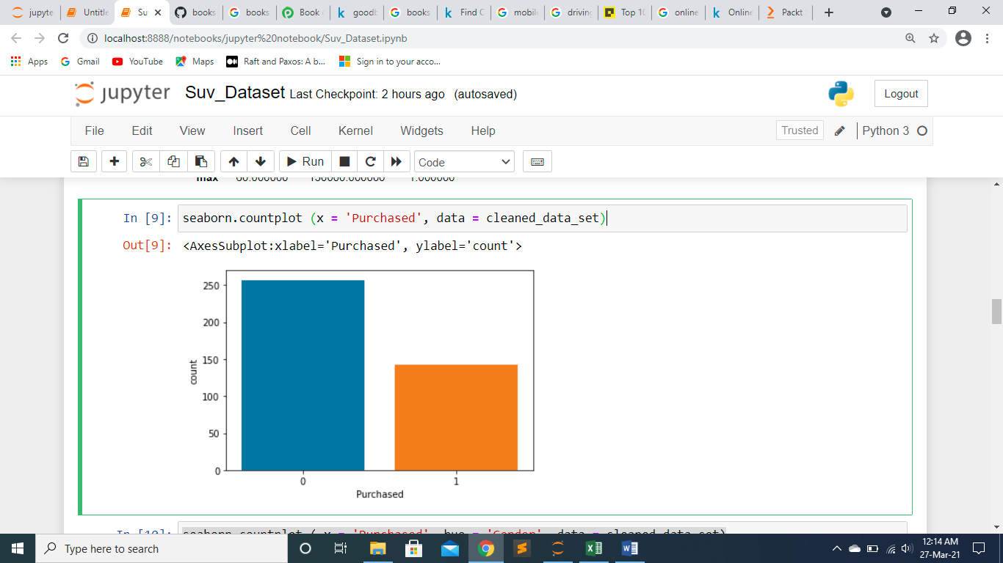

**Displaying purchased SUV by categorizing in gender**

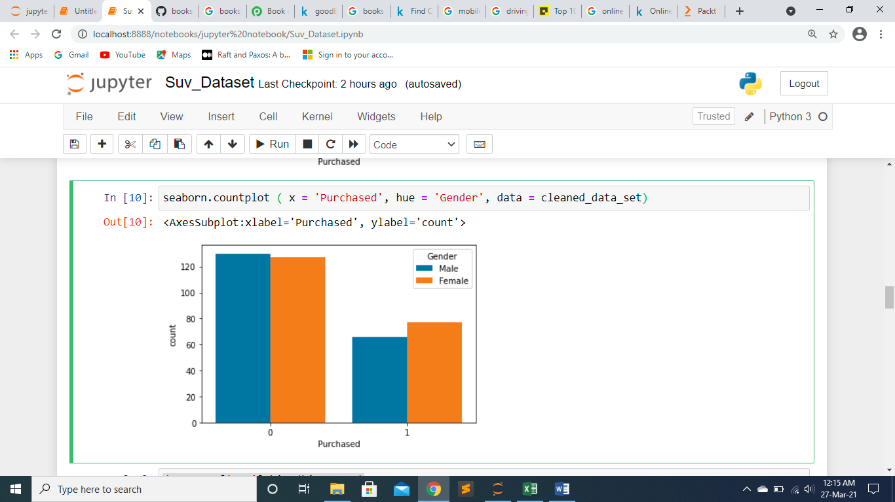

**Data set of column “Age” in bins**

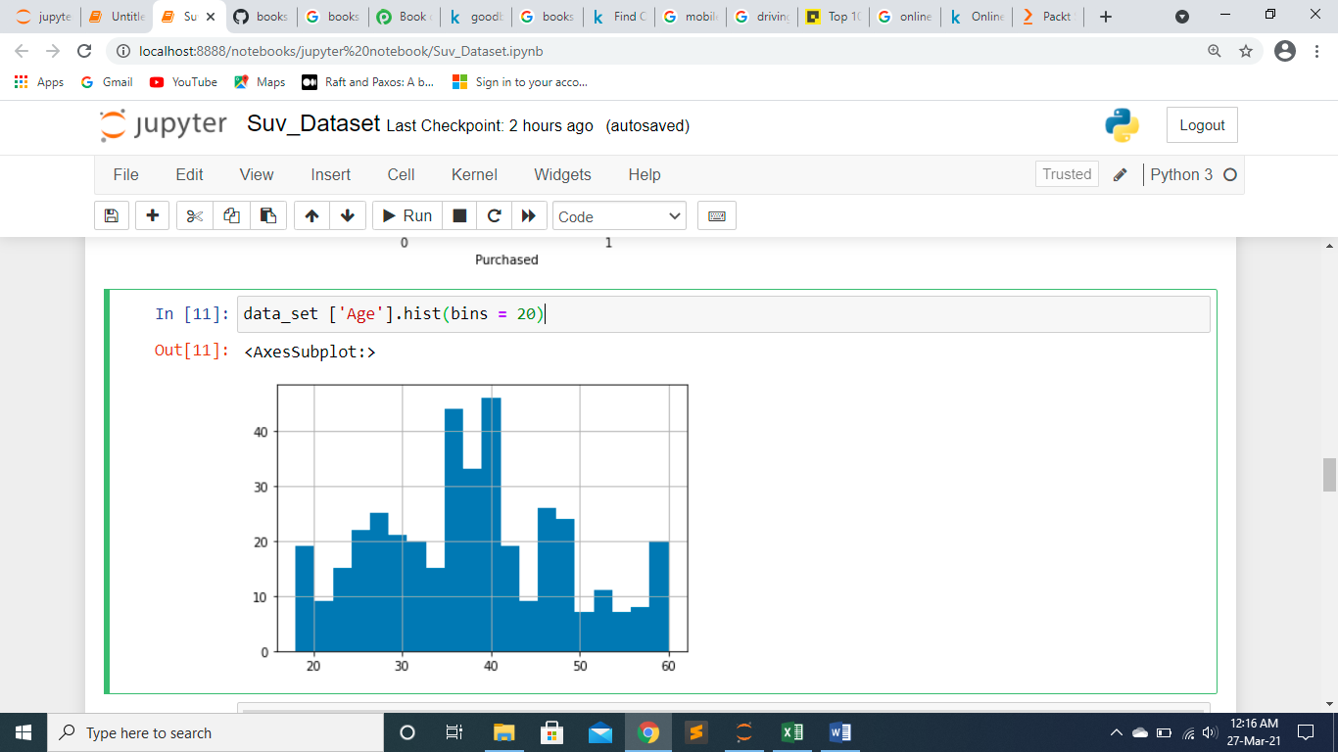

**Categorizing by age of SUV-Purchasers**

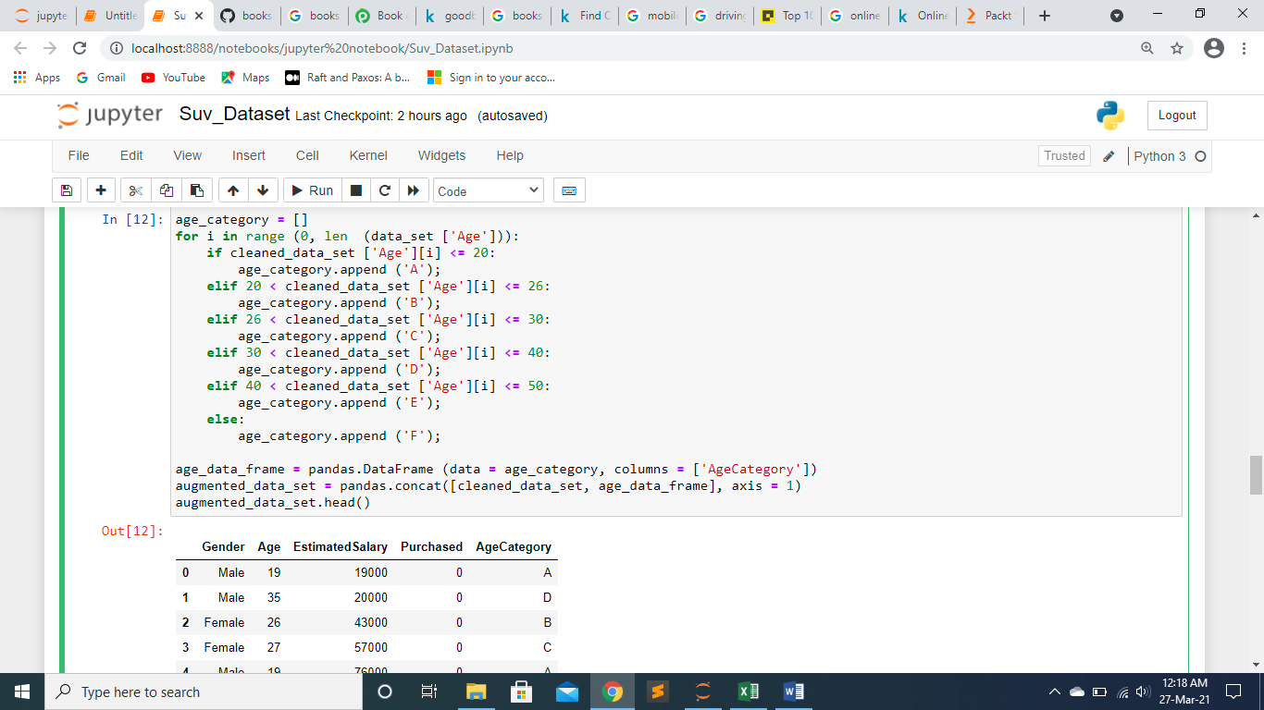

**Displaying that data in Bar Chart**

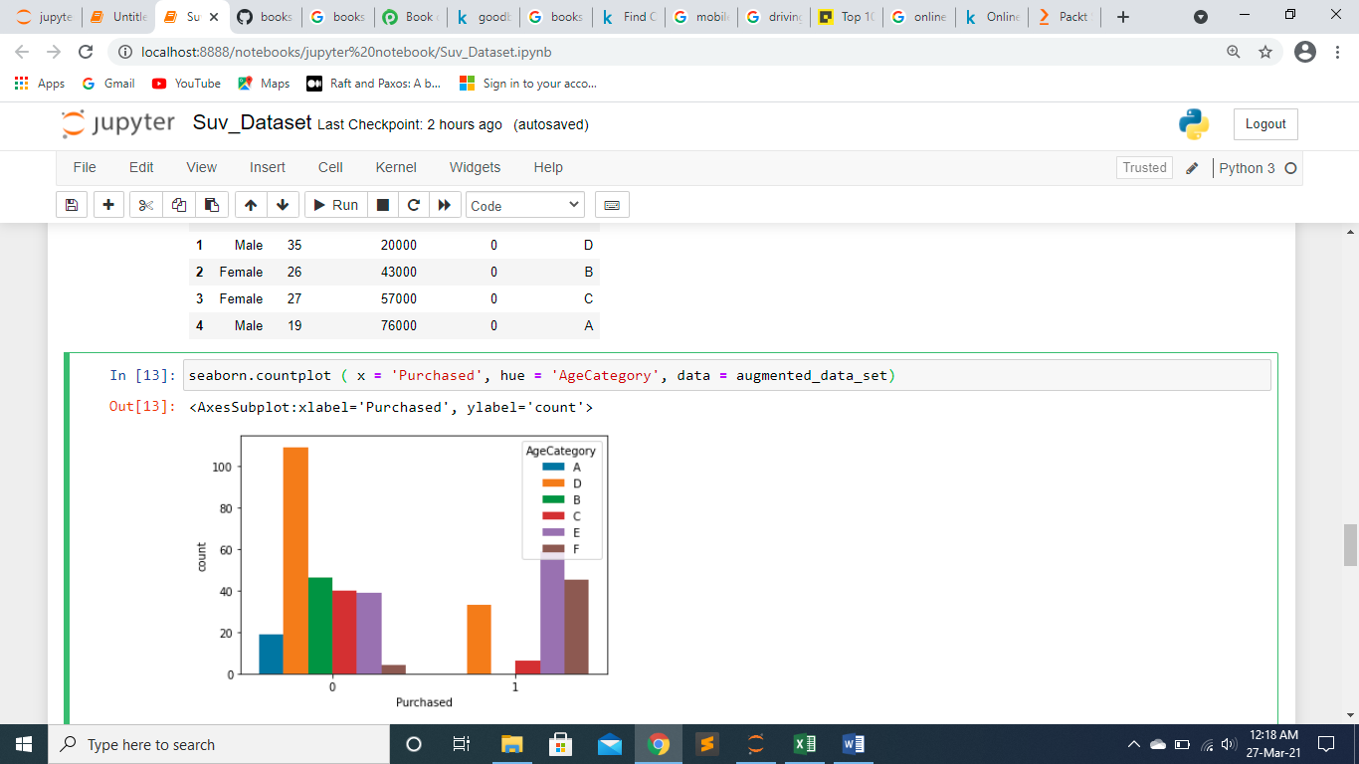

**Categorizing By Income of the SUV - Buyers**

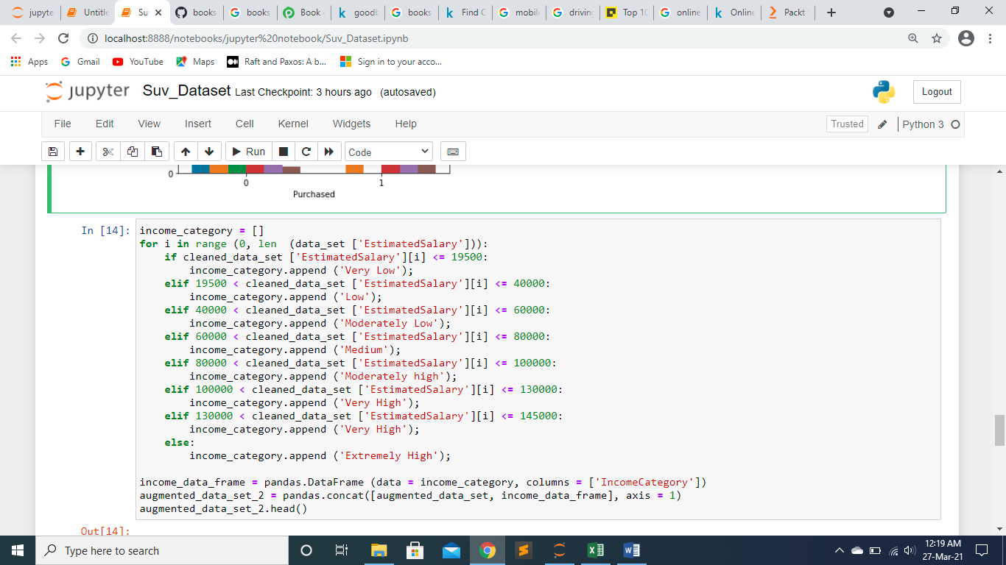

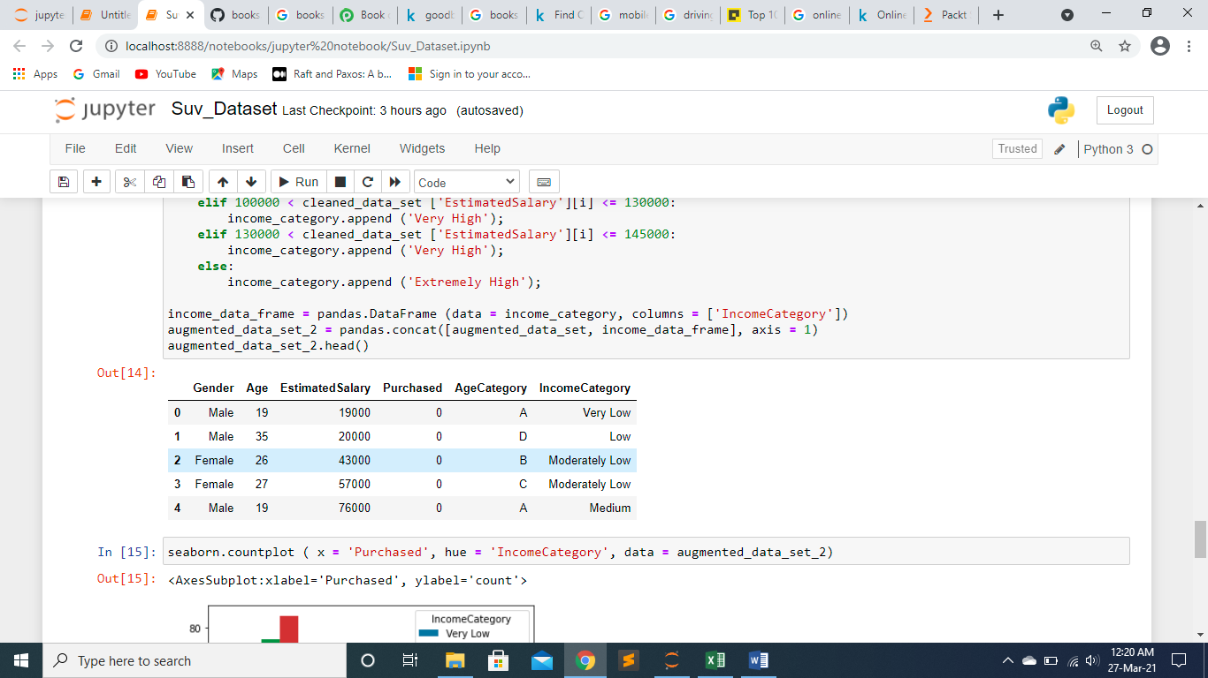

**Displaying that data in Bar Chart**

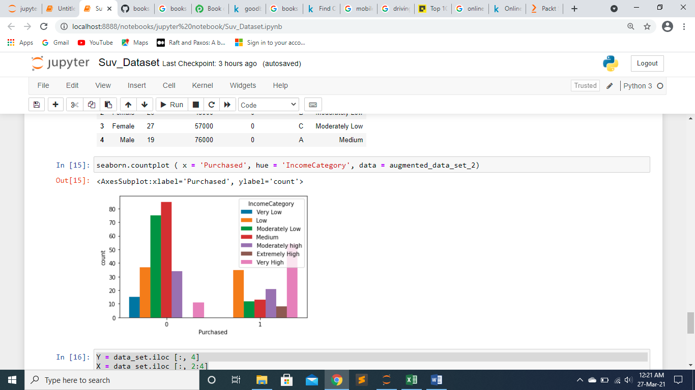

**Slicing the column**

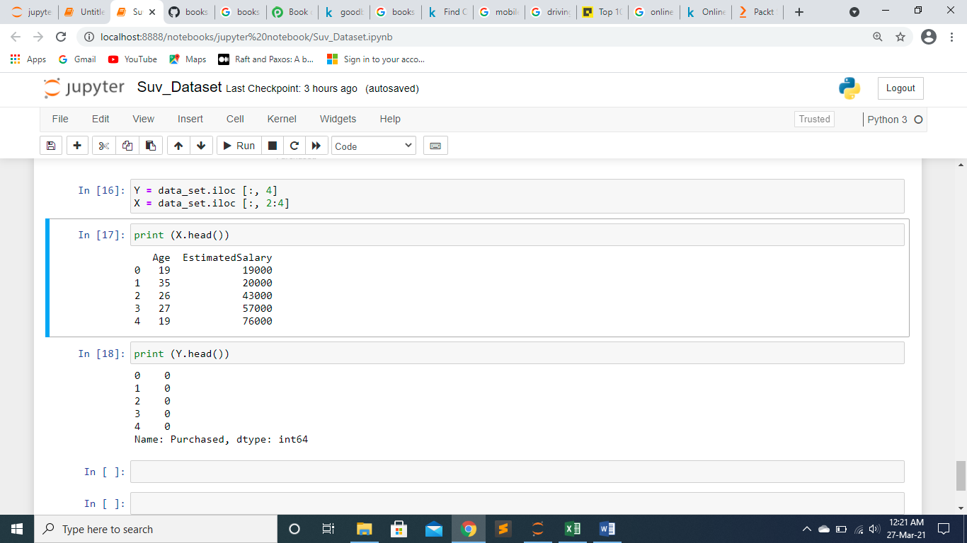

**Dataset: IPL**

**Importing required Modules:**

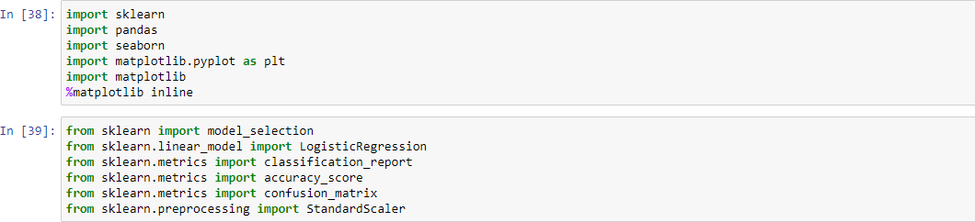

**Reading and Summarizing the SUV Dataset:**

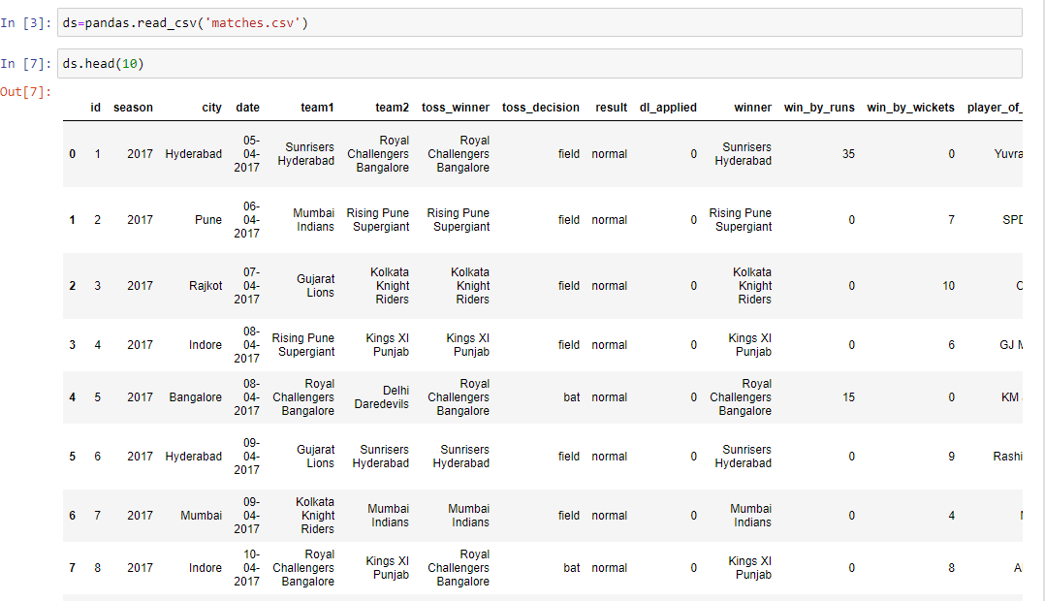

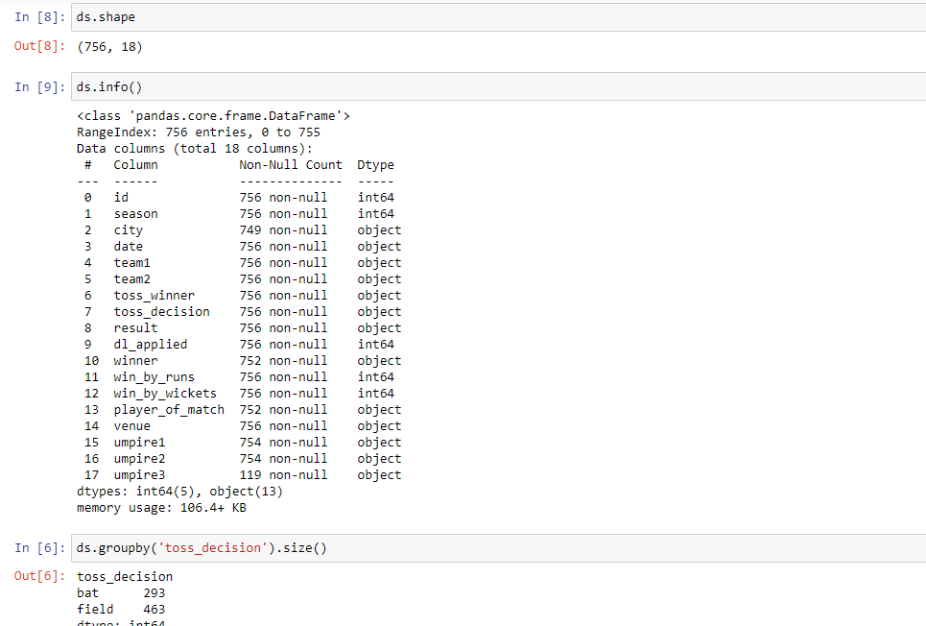

**Cleaning the dataset:**

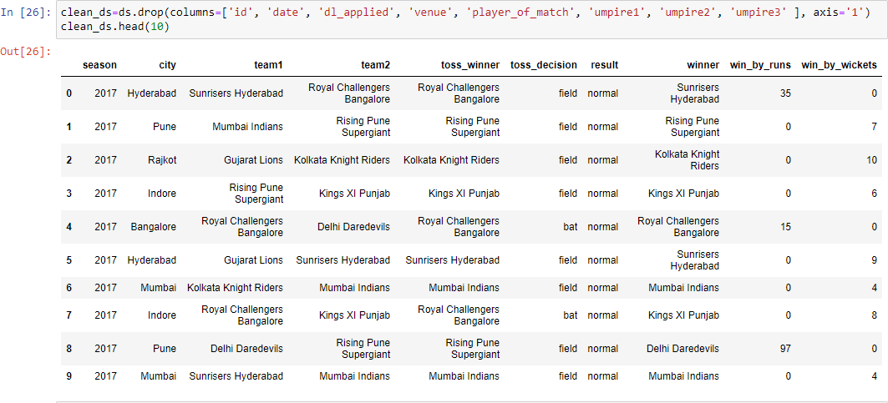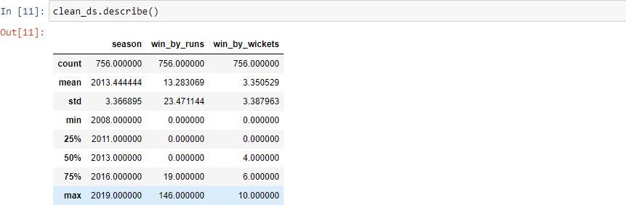

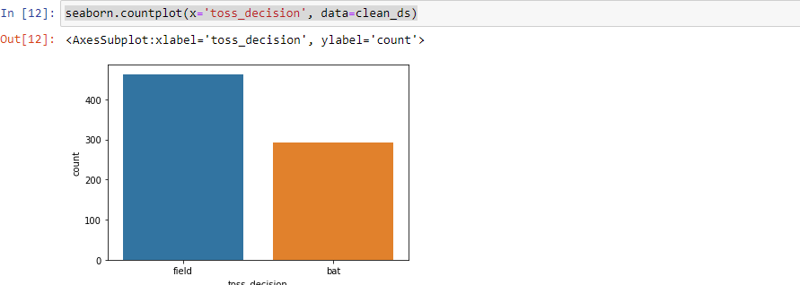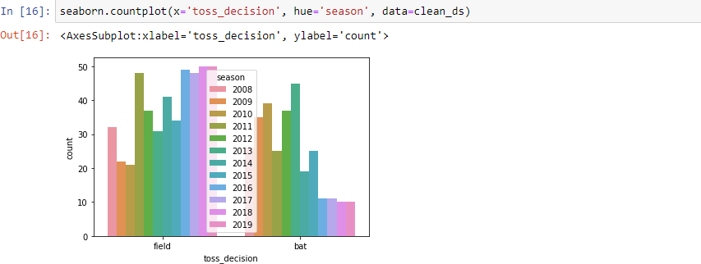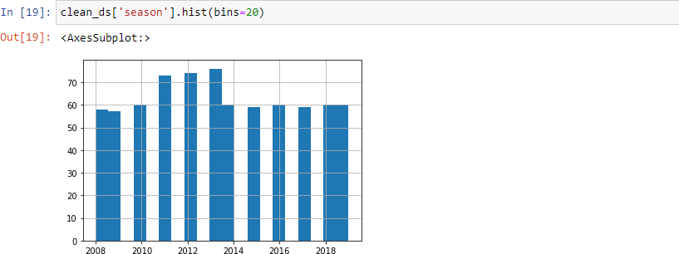**Visualizing Data:**

**Categorizing and Visualizing the dataset:**

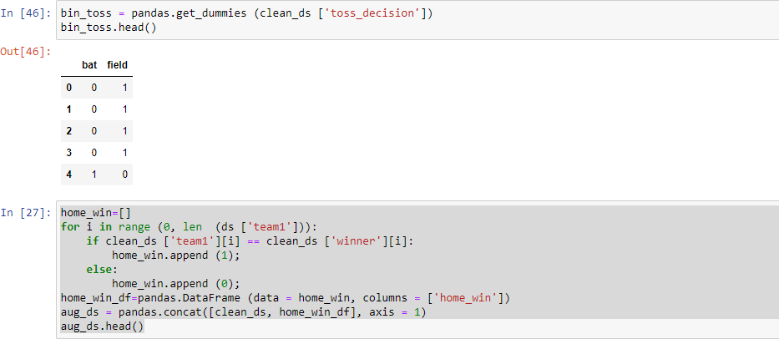

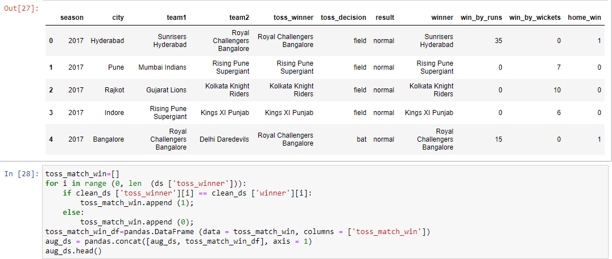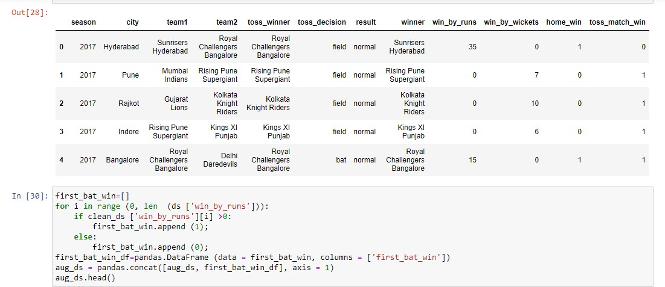

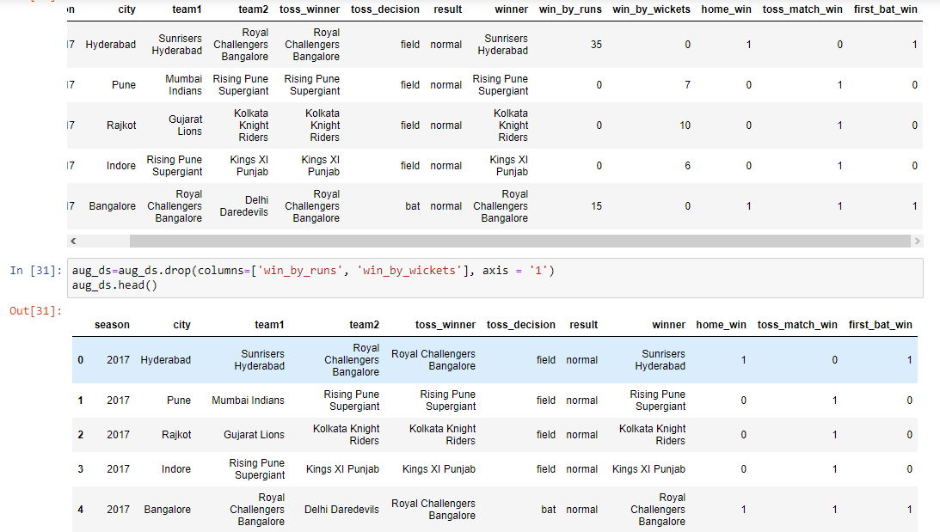

**Final Dataset:**

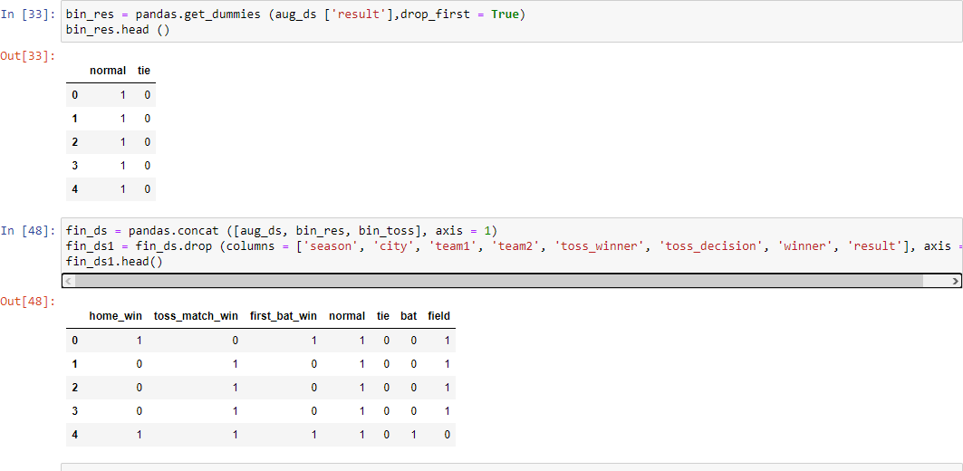

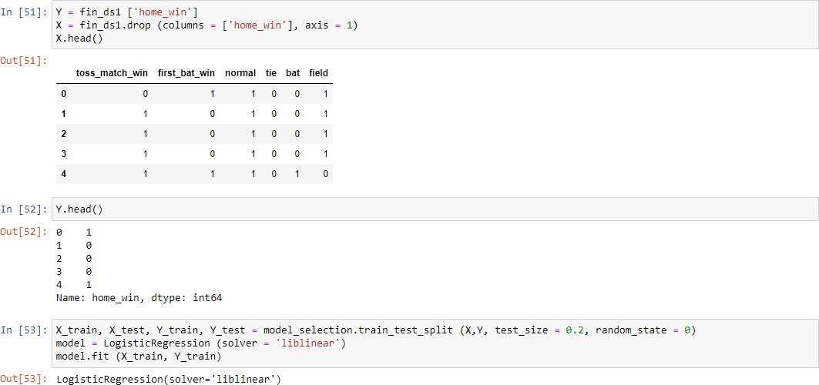**Predicting:**

\THANK YOU MAM !!\