**DHL USER MANUAL FOR ENTITY CREATION AND ASSOCIATION**

In this document we are explaining about how to on board different entities into DHL Common Platform.

To access this POC Please login into our DHL Common Platform Alpha Version 3 web app from this below URL thorough your local browser ( Google Chrome is preferred ).

[http://dpdlcpuxv3.azurewebsites.net](http://dpdlcpuxv3.azurewebsites.net/)

Once you open the web app you can see the landing page of application. Please click on “Sign in“ option to access the web app. Once you clicked on the link it will redirect us to DHL Microsoft login page and please login with your email.

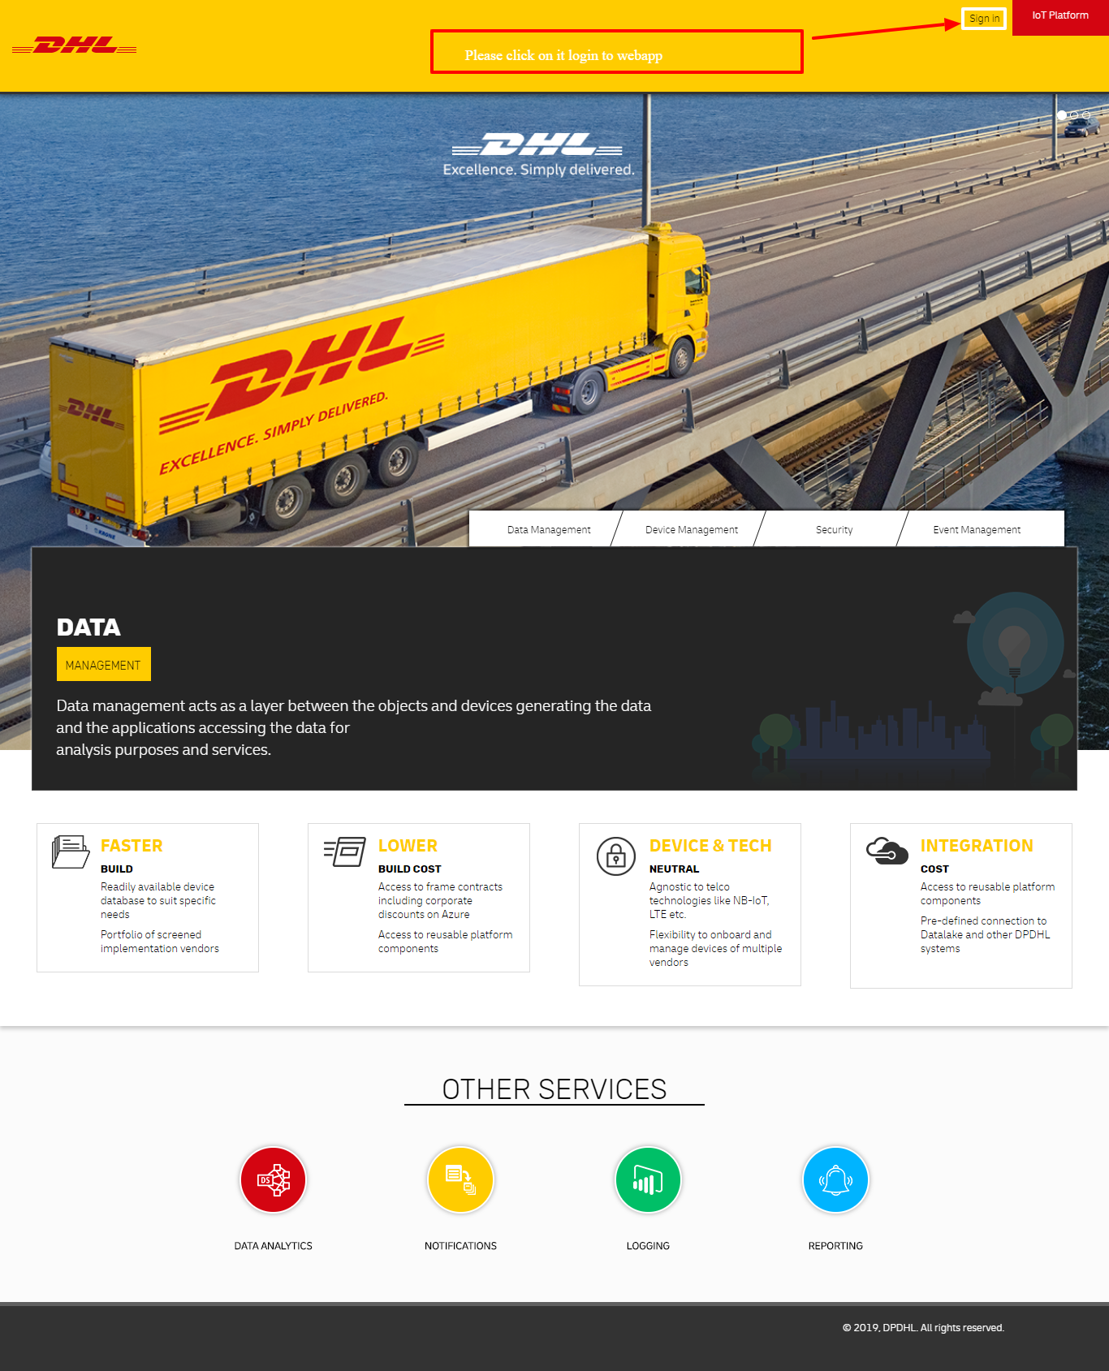

Once you sign in with your details it will redirect to dashboard page of application. Here we can see the left side menu to access the different pages like reports, association and entities etc...

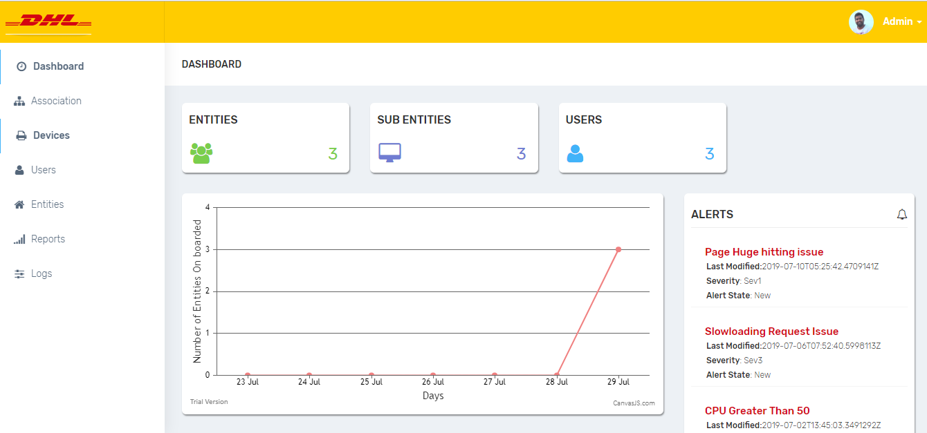

In this POC we are on boarding every entity from “Entities” Page expect “Users”.

We are on boarding Users from “Users” page.

Please follow below steps to on board entity into Common Platform.

1. Please click on Entities Menu. In this page we can see all the entities on boarded into CP.

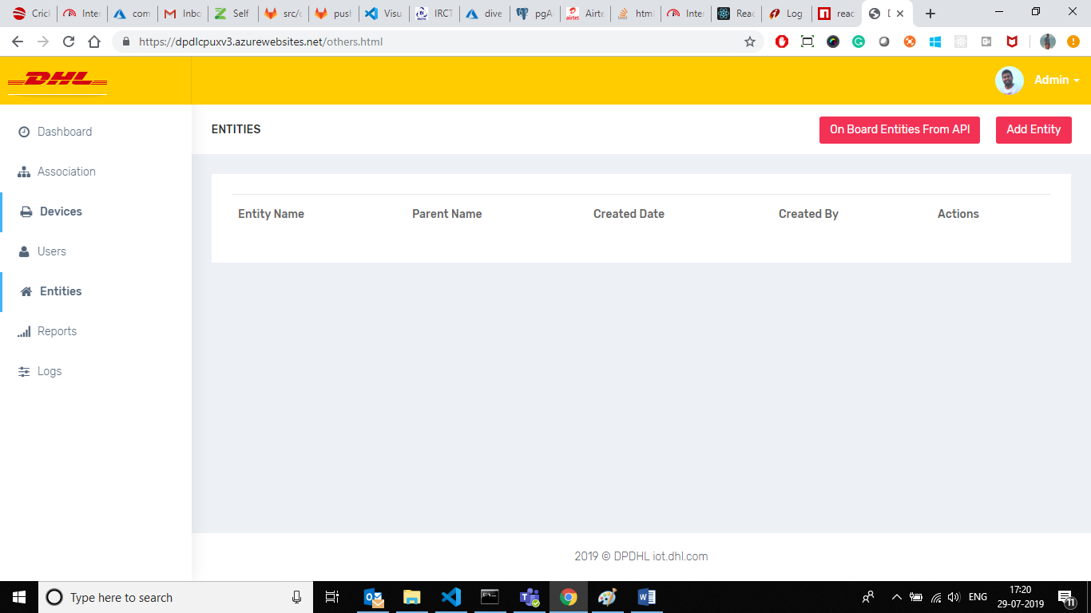

1. To on board new entity please click on the “Add Entity” button at top right corner of the page. In this below screen we can add individual entity or we can upload group of entities by uploading XLSX file.

We can download the sample documents of different entity types from right side block.

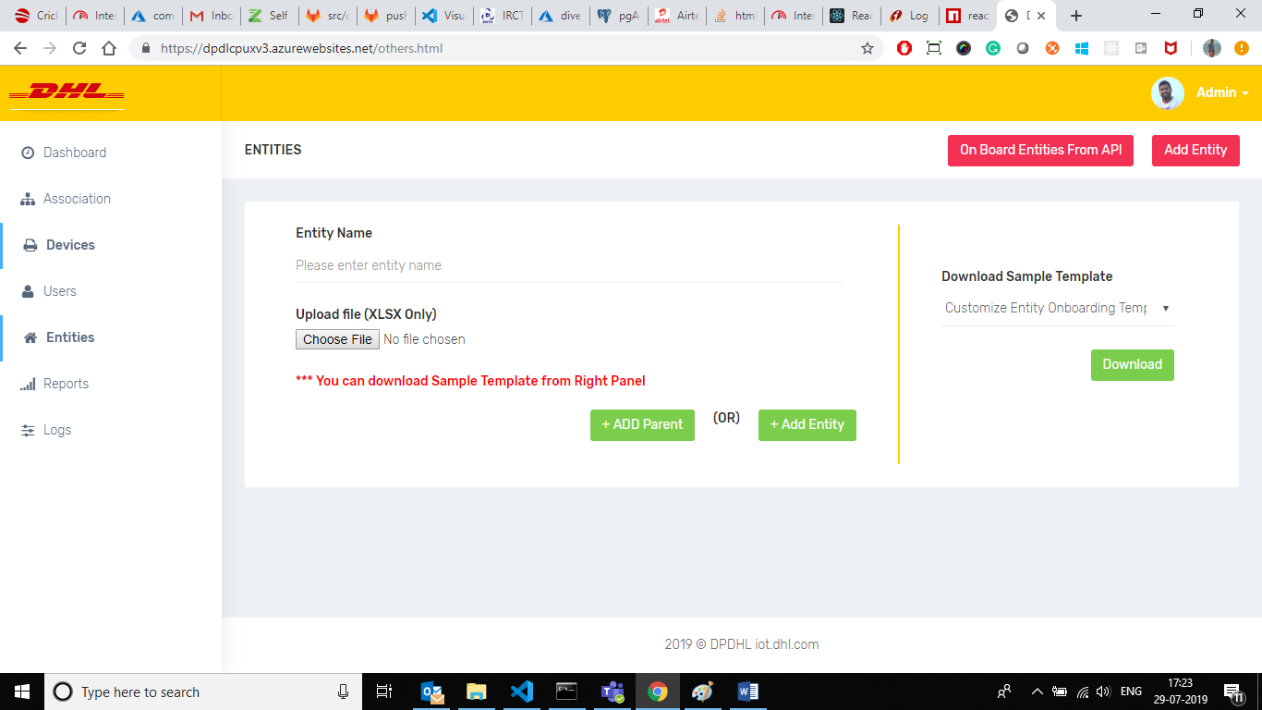

Here we can associate the entity by already uploaded entities or we can add directly without associating. If we are not associating the entity will save as like Parent.

Before adding any group of entities please prepare XLSX before uploading into page. Please check the sample excel format. In every XLSX one fields should be there with “Name” field.

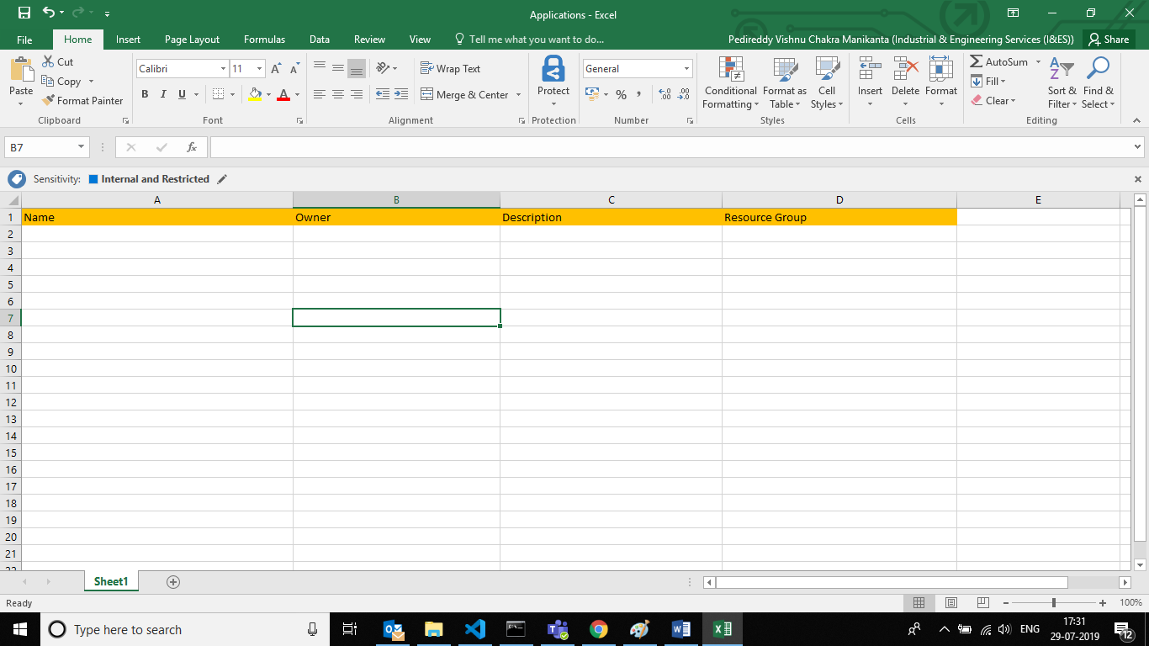

Here we are On Boarding UC4 – Customer Satisfaction use case into CP. To achieve below approach first we have to create parent entity with name “Happy Button”.

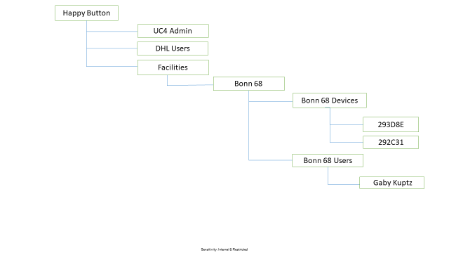

Please enter the entity name in the field and click on “+ Add Entity” button to save and submit. We are not associating this with any entity because we are thinking it’s a parent entity.

Next we have to on board facilities into “Happy Button” entity. For this we have to create facilities XLSX and we have to create and upload from “Add entity” page.

Before saving we have to associate by clicking on the “Add Parent” button. Once we click it will list out the all Parent entities in the select box and we can select and we can associate.

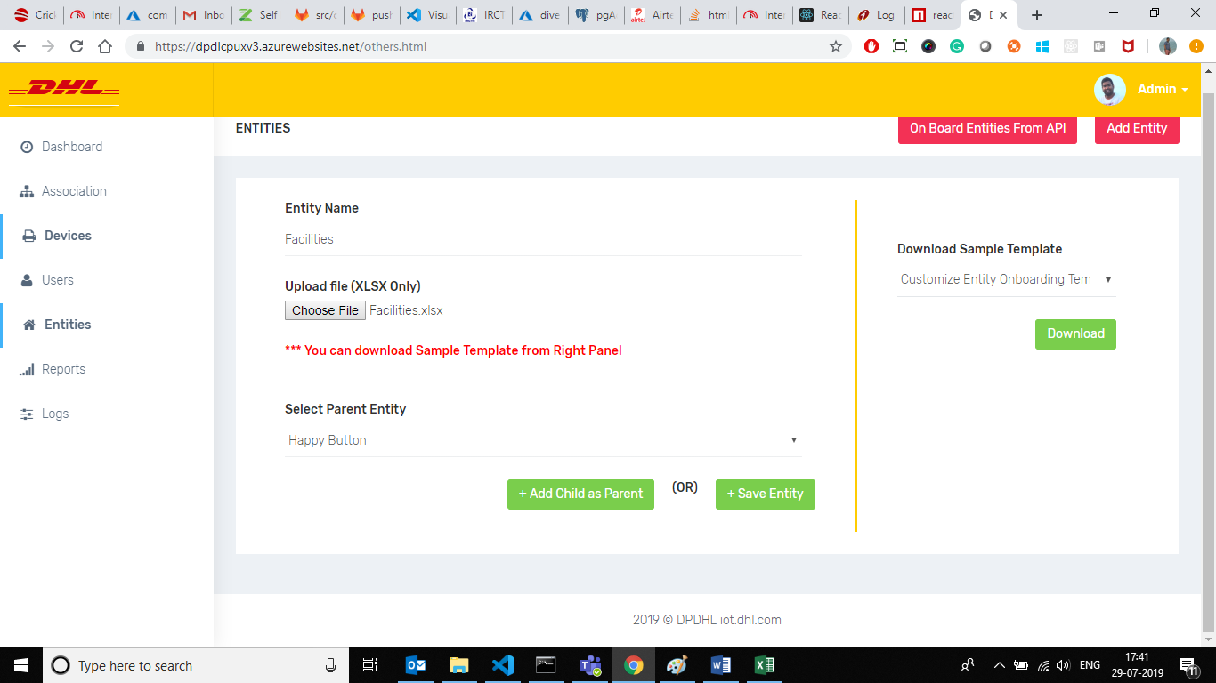

Now “Happy Button” entity will act as like Parent Entity and “Facilities” act as like sub level entity.

Same in this we have to on board devices and different entities into CP by selecting parent and child entity mapping.

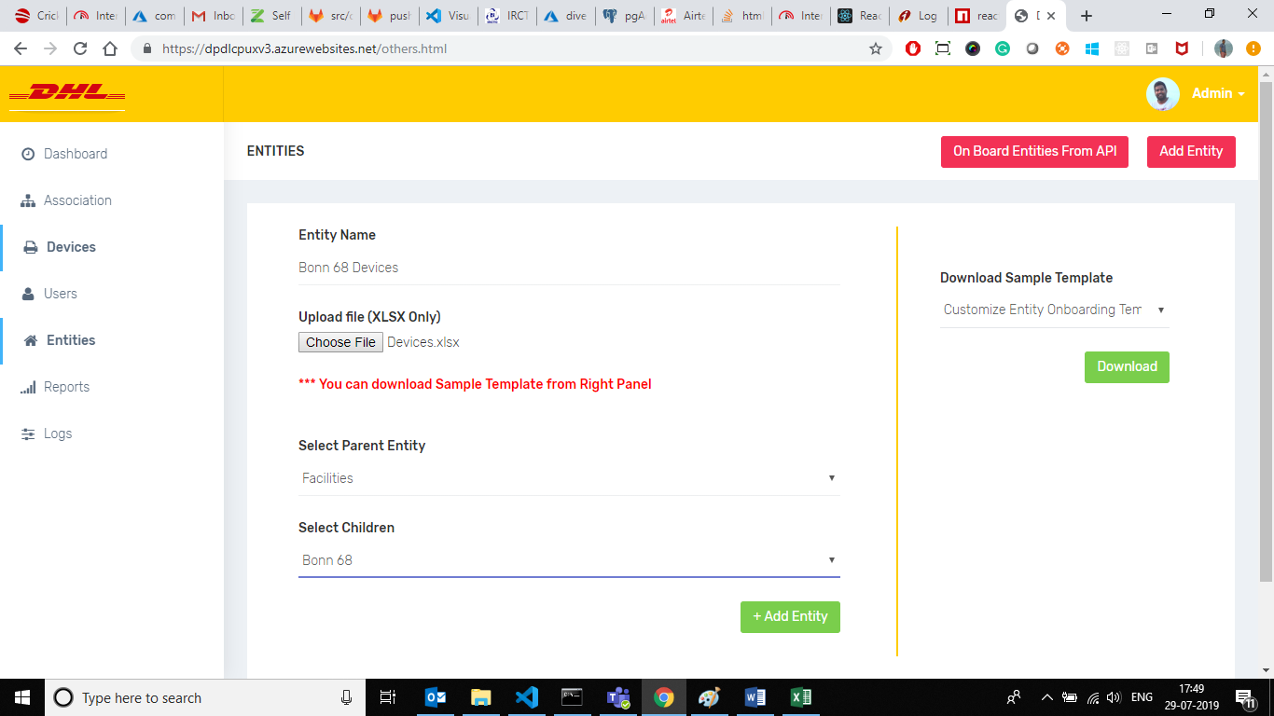

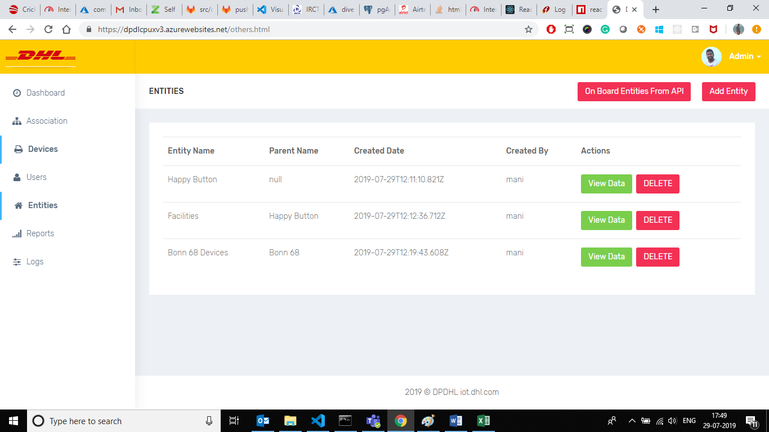

To view the assocation we have to go Association page.

Here we can see the all associated entites with their relations. Please click on “:” icon to expand the last element.

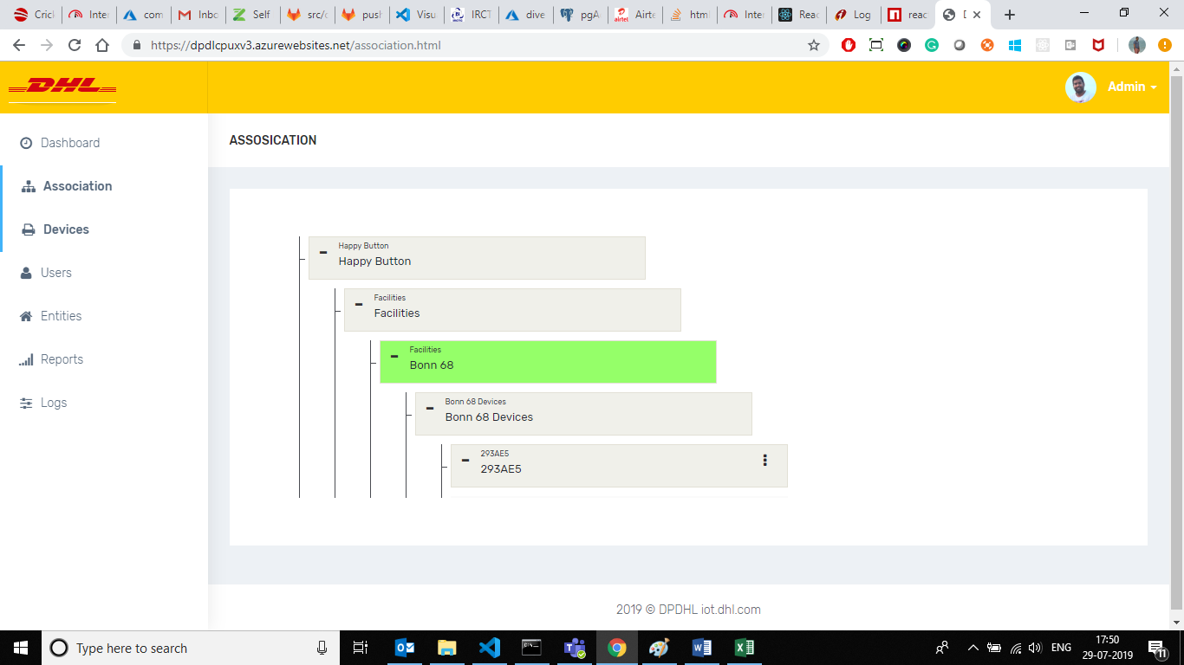

Please follow below steps to on board Users into Common Platform.

1. Please click on User menu and it will redirect to users dashboard. This page consists of user groups. To view the users in each group we have to click on “View” button in the table. Please click on “Add User” button on the top right corner to on board new user with user groups.

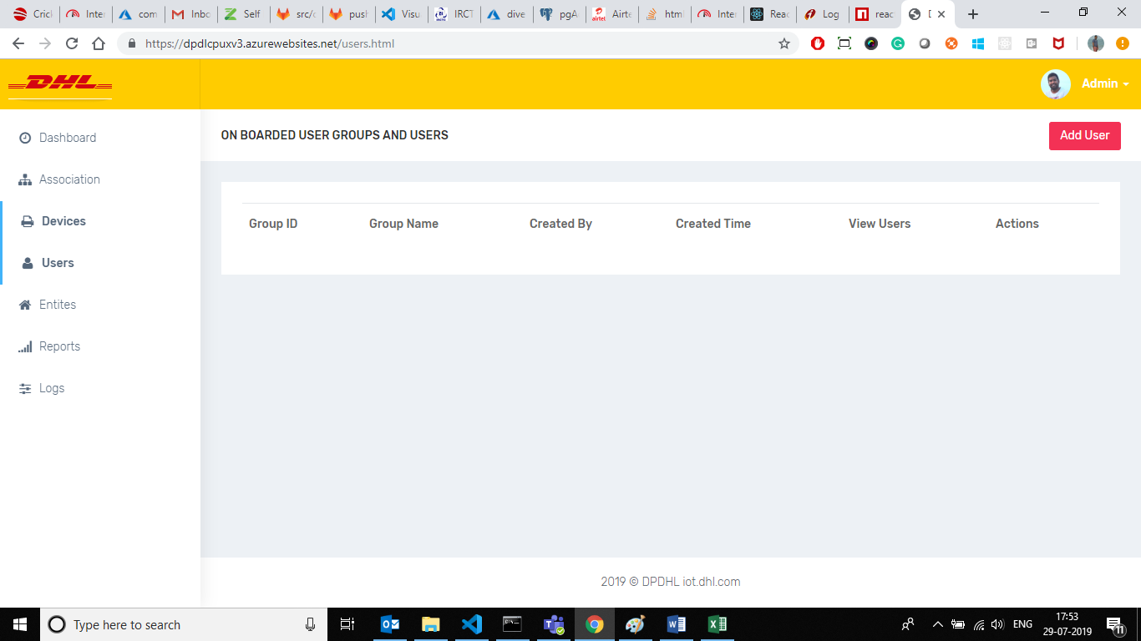

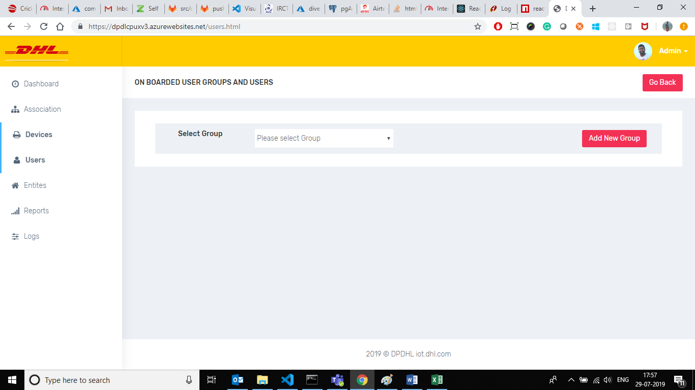

From the above page we can on board internal and external users into Common Portal.

Before going to add user we should select the group and if there is no groups and if we want go with new group we have to click on “Add New Group” button.

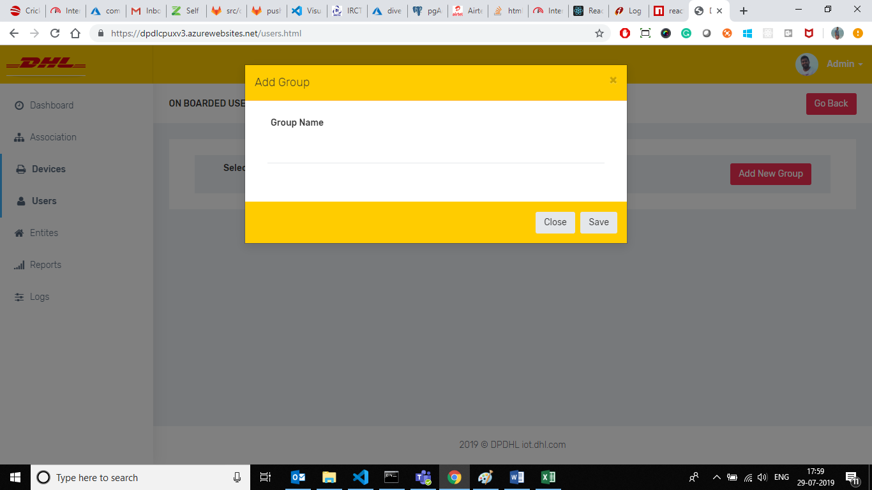

Please refer above screen to add new Group. Please enter the group name and click on save to add new group. Once if we got success message it will automatically update into group section box.

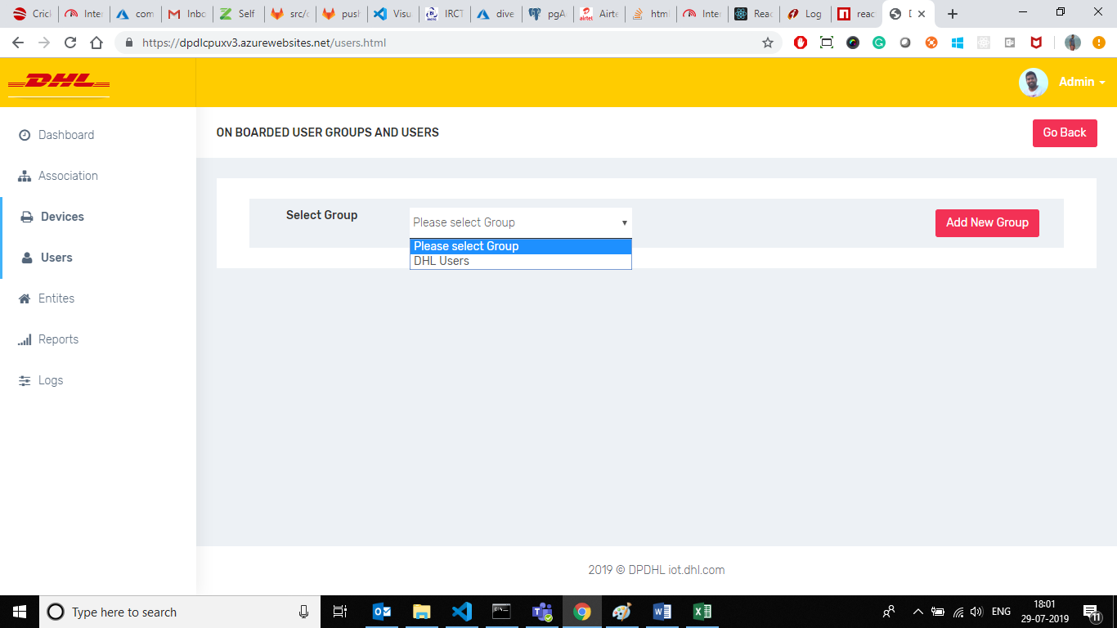

Once we select the group it will show the users adding form which have email and name field.

Here we can check whether the user is there are not it DHL Ad by entering in the email field, and if he is not there we can invite him and add into CP.

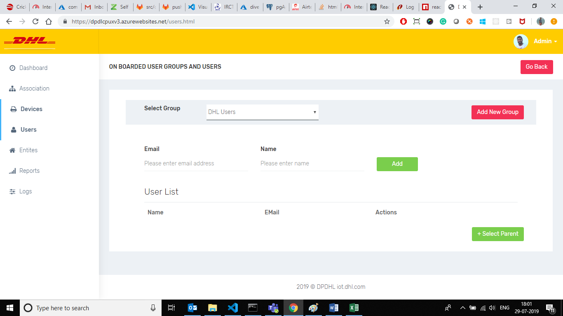

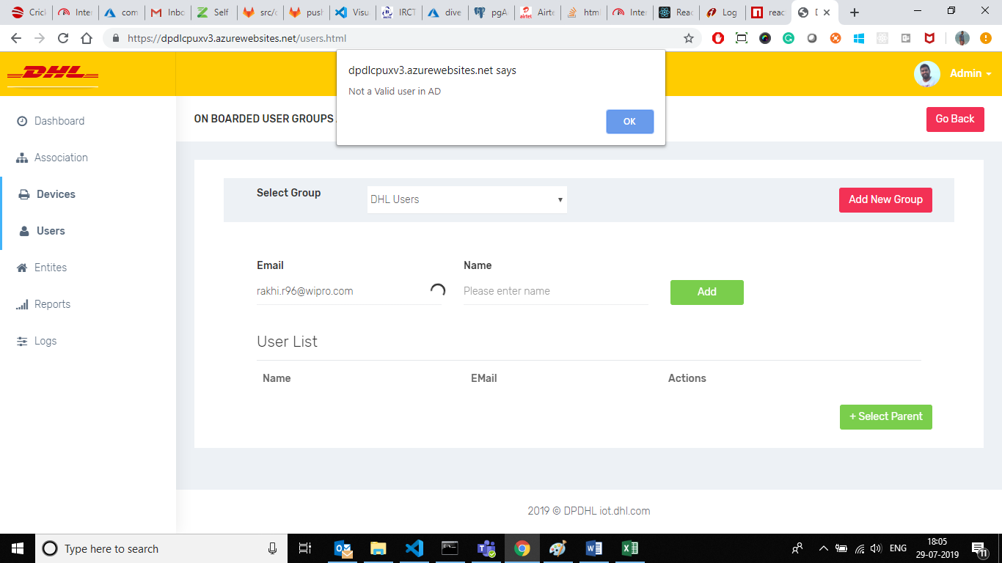

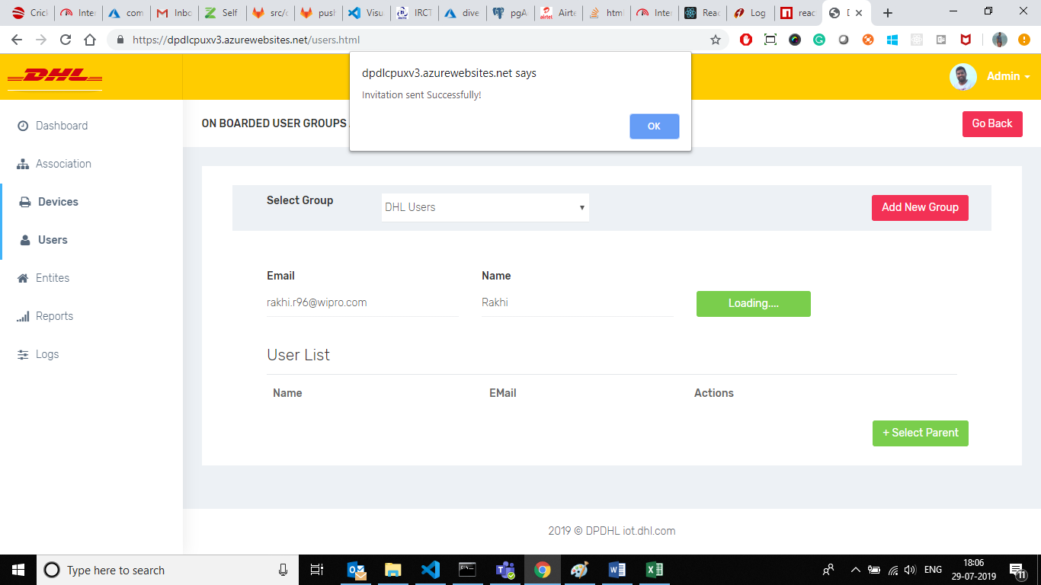

After adding into group we can select parent and child as per our requirment as like we did in entity page.

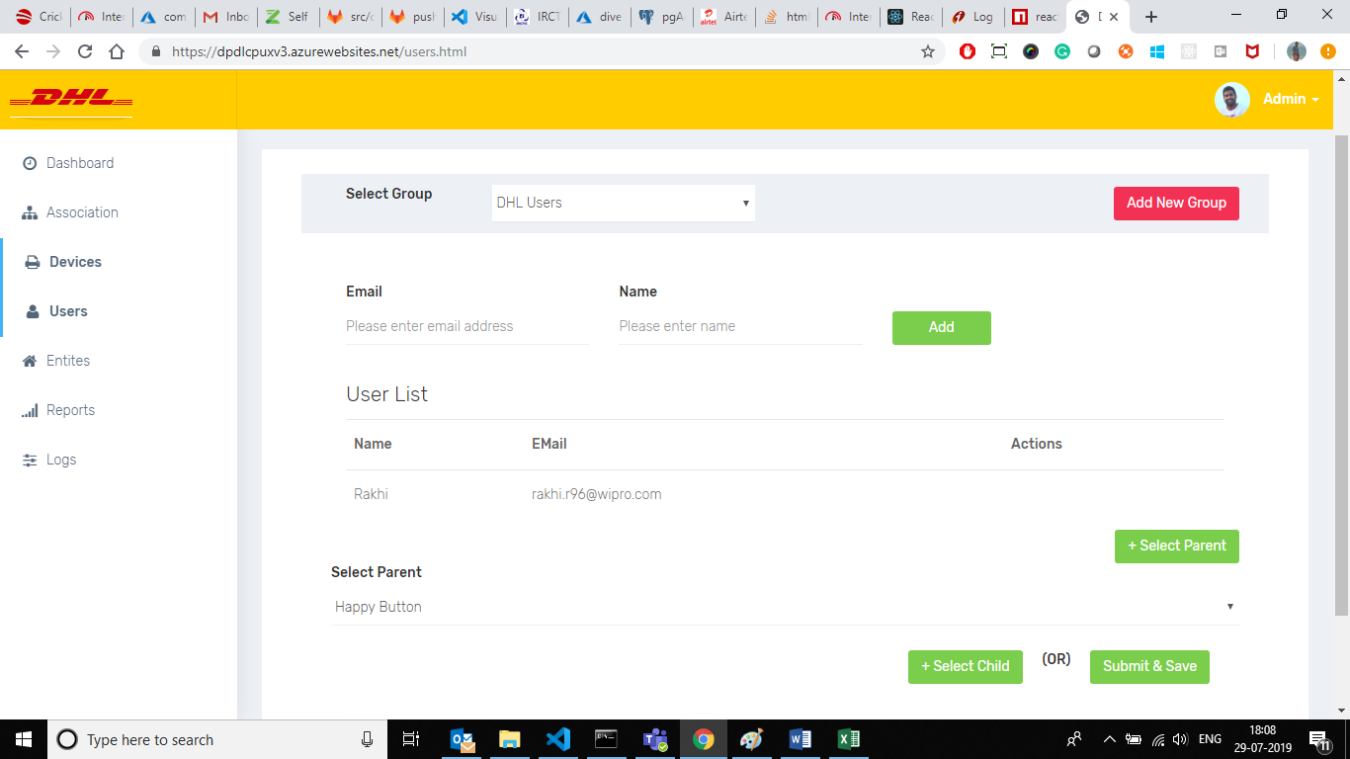

After click on “Submit & Save” we can see the user gorups in the dashboard

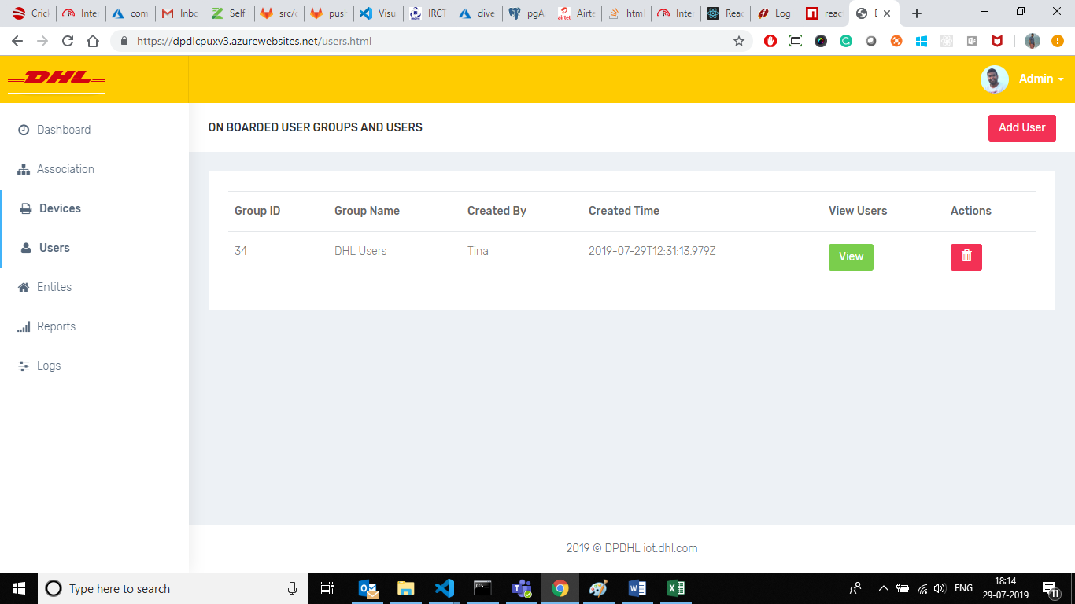

If want to see the users in the group we have to click on the view button and it will show the below screen.

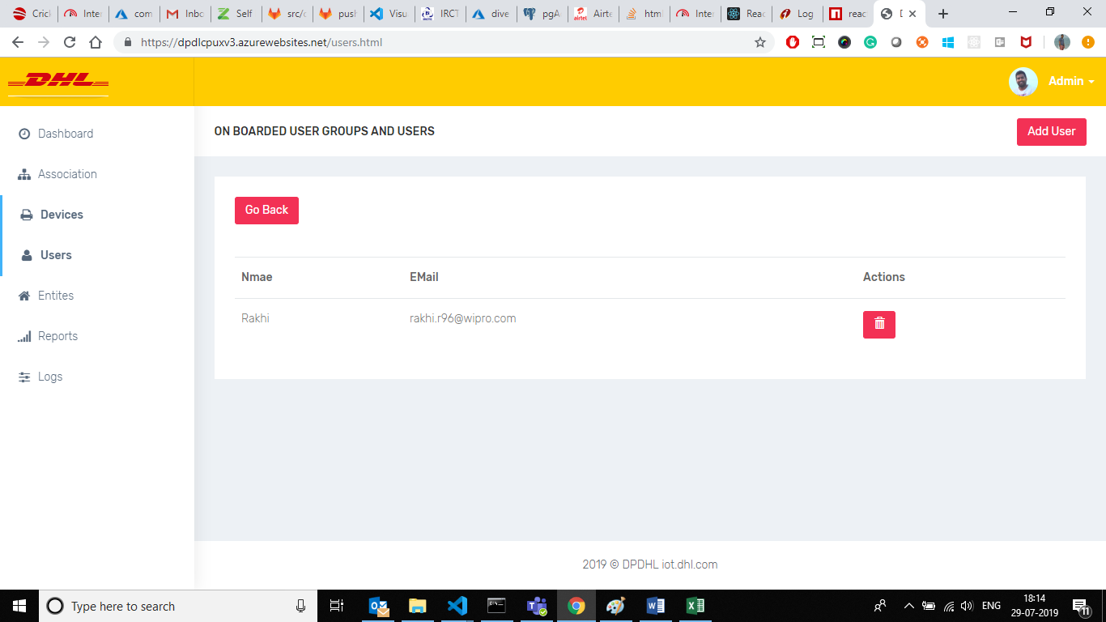

After completion of all the association please go into the association page and here we can see all the entities with their associations.

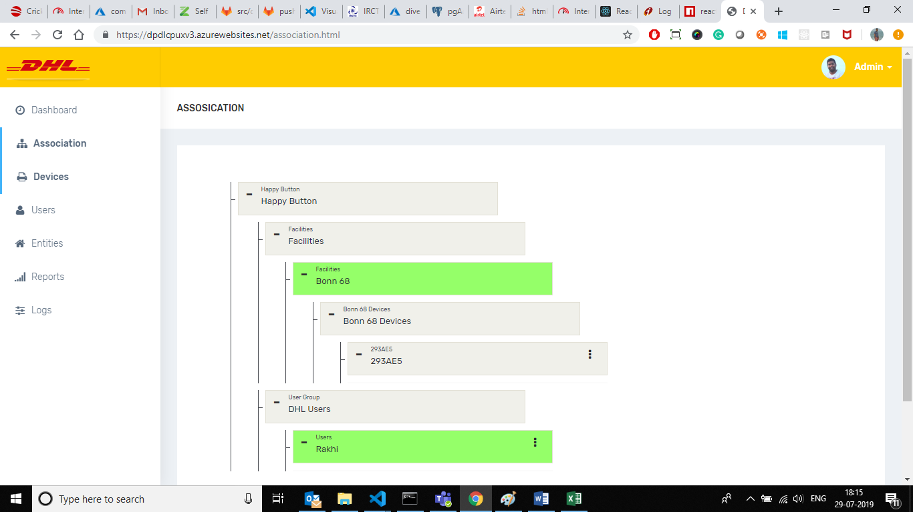

*** Here we did not handled any validation and errors handling throughout the application. Please revert us if you face anything problem,