Building/infrastructure Management



If you want to monitor, control, and automate your company’s facilities, you’re at the right place. At Rexcloud, we offer IoT solutions that make data collection and analysis simple and cost-effective for building management. We can help you control your building parameters to reduce energy consumption and enhance occupant experience. Our IoT solutions are popular for remote monitoring, home automation, smart factory, and energy monitoring systems. We develop IoT applications to help users control buildings and devices on local networks or remotely over the Internet.

With the rising popularity of connected buildings and IoT-enabled devices, manufacturers and OEMs face a major challenge of producing new products that meet the standards of tomorrow’s IoT networks. Our IoT solutions are increasingly being used by OEMs to transform traditional buildings into smart offices, smart airports, smart retail, and smart homes. Building automation OEMs use these solutions to engineer products and systems that comply with complex Building Controls Engineering standards.

We provide technological assistance to establish **communication channels** between automation systems and controller devices. For smart factories, we provide solutions to increase efficiency and productivity by gathering data from equipment and machinery. Machines and devices used in factories and warehouses are extremely expensive and vulnerable to breakdowns. To identify defects, implanting industrial-grade sensors in such machinery can prevent repair costs. A “smart building” will gather critical information relating to the assets and spaces to streamline operations, enhance workers’ safety, and reduce costs.

Building automation systems can be used for appliance control and smart metering. Building automation systems connected to the Rexcloud Platform help in saving time and money, reduce wasted energy, and allow facility managers to better monitor their operations. They optimize building performance by providing data on core building operational systems, particularly HVAC and power consumption.

Communications for building management systems into rexcloud is performed typically with Modbus masters and slaves through our Modbus interface. Alarm limits are defined, sometimes with time delays, within rexcloud to monitor digital sensors for alarms or events that are then logged and sent to email, text, or voice message with alarm notification rexcloud has many built in features like calculations and Time On and Counts that can be used to keep track of how long something has been in alarm, then escalate the notification to next level of support. Rexcloud is used to monitor environment and power usage in data centres, airport terminals, university campuses, warehouses, hospitals, prisons, food storage bins, wood kilns, and of course manufacturing facilities. Our larger customers take advantage of our programmatic interface to automate the configuration based on information from their asset management database. This makes it possible automatically update all configuration parameters based on changes to a company’s central asset inventory, eliminating human errors on setup.

Manufacturing

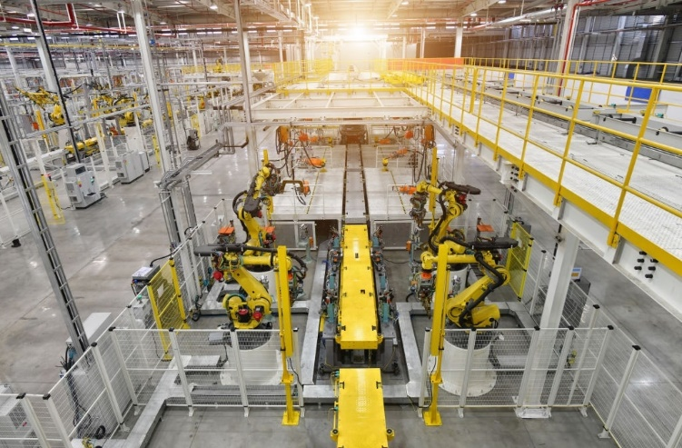

IoT has immense potential for the manufacturing industry. Top companies have already made huge investments in IoT to improve various aspects of manufacturing.  And when it comes to IoT solutions, rexcloud is the first choice of the manufacturing industry. We develop smart manufacturing Industrial IoT solutions for connecting manufacturing assets. By connecting assets throughout the enterprise, businesses achieve complete operational visibility to allow for real-time decision making and improved levels of quality and efficiency.

IoT has the potential to help businesses achieve higher efficiency by extending human capabilities. IoT along with AI, machine learning, cloud computing, and big data can transform the way businesses operate. These advanced technologies are creating new opportunities for manufacturers by improving services, increasing efficiency, minimizing downtime, and reducing manufacturing costs.

IoT allows manufacturers to create smarter factories that operate more efficiently at a lower cost. From the automation of the production process to connected consumer products and industrial equipment, Rexcloud can help you develop IoT solutions that work best for you. Irrespective of what you manufacture, Rexcloud solutions provide business insights from accurate and timely data. Real-time insights and predictive analytics can help you increase your sales and revenue by boosting your productivity and empowering staff to work smarter.

Smart Manufacturing

Smart manufacturing is the process of connecting equipment and machines over the internet for remote monitoring. It generates real-time data that can be used for making business decisions, as well as historical data for analysing trends. For instance, data analysis can help in identifying the areas where the production is less efficient or predicting when raw materials need to be ordered. The data received from the machines helps in forecasting upcoming factory trends, as well as rectify the issues before they become a problem.

Industrial IoT Solutions also include predictive maintenance and supply chain management. By connecting equipment, manufacturers can improve asset performance and optimize production. Also, monitoring the health and performance of connected machines allow manufacturing companies to avoid downtime and boost productivity. At Rexcloud, we can help you streamline manufacturing processes to achieve higher operational efficiency with the platform and tools to collect and process your data.

Water and Waste water Management

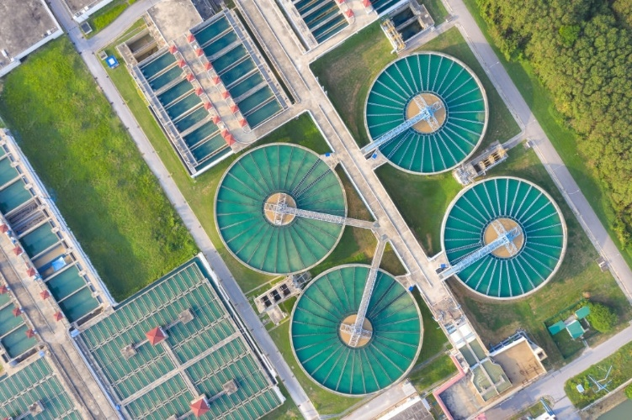

With the population explosion and rapid urbanization, water is becoming scarce. Survival of human beings, as well as many industries, depend on this most precious natural resources. As such, it’s becoming crucial to ensure the smart use of water. The water industry is increasingly adopting IoT solutions to monitor water levels, chemical leaks, and even regulate water flows. To conserve this depleting natural resource, the water industry is shifting to smart water systems based on the combination of the Internet of Things, big data and AI technologies.

The water industry encompasses both drinking water as well as wastewater collection and treatment. With the growing number of connected devices, the water industry is taking advantage of IoT sensors to monitor water levels, chemical leaks, and even regulate water flows. An IoT enabled smart water sensor can track water quality, pressure, and temperature of the water. By installing smart sensors at various points in the water system, industries can collect data for monitoring. By analyzing that data, factors like temperature changes, pressure changes, water leak detection, and chemical leakage can be determined.

Smart Water Management

At Rexcloud, we design and develop IoT and [big data solutions](https://openautomationsoftware.com/products/data/data-historian/) for sustainable and resilient use of water. Our IoT solutions can be connected to all the systems in the water supply chain: raw water; treatment plants; distribution pipes; utility companies; and consumers, etc. These IoT applications provide real-time monitoring and bring transparency to the processes in the water supply chain.

Smart water management is a system of monitoring pipes, pumps, etc. to monitor, control and regulate the usage and quality of water resources. Rexcloud has been used to monitor and archive turbidity, flow rates, levels, pH, and other key indicators within the water treatment facilities. Chemical additive systems are monitored with high accuracy for correct dosing and also to notify supplies for just-in-time supply chain. The [IoT-driven smart sensors](https://openautomationsoftware.com/products/data/iot-connector/) reduce water waste, curb excessive and unnecessary water consumption and detect leakages. Smart meters allow real-time water consumption measuring to identify overly excessive usage and waste points. The sensor-based solution can also be used for smart irrigation. Farmers can measure water status in plants to make sure they get just enough water for the best nutritional value and highest yield.

A great application of IoT is for solving the issues of Wastewater Management. A wastewater facility can install smart sensors and synthesizes the information into actionable insights. The ability to access and remotely manage pumping and treatment systems is crucial in the wastewater management system.

Energy Management



IoT has become an important tool in improving power generation, delivery, and consumption providing solutions to help power utilities adhere to industry standards while keeping critical systems and data secure. On-premise data processing is key for accuracy of all data. Rexcloud networking makes it possible to share data to remote client systems, while keeping the source secure.

Power Generation

Another feature commonly used in power generation is [data logging](https://openautomationsoftware.com/products/data/data-historian/) to archive data at specified intervals to meet county, state, and federal standards. With the Rexcloud gateway [store and forward](https://openautomationsoftware.com/videos/#store-and-forward) feature utilities never encounter data loss during a network failure or database engine failure.

HVAC

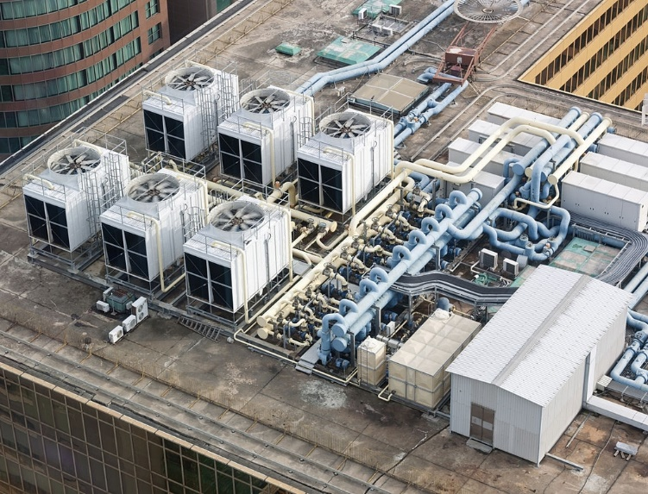

The HVAC industry is increasingly turning to IIoT sensors to monitor and control equipment. The adoption of high-tech solutions is nothing new as large scale industrial enterprises have been doing this for decades. However, recently both large and small businesses have started exploiting the benefits of high-tech low-cost systems.

The HVAC industry comprises heating, ventilation, and air conditioning. This industry is heavily driven by federal and state regulations. It is one of the largest consumers of energy and keeps looking for smart and environmentally friendly technology. That’s why the HVAC industry is one of the early adopters of IoT technology to make systems more energy-efficient and enable large cost savings. Heating, Ventilation, and Air Conditioning (HVAC) industries can be transformed by the fast-evolving Internet of Things technologies.

The Internet of Things enables HVAC systems and appliances to communicate with us in new ways. IoT devices are equipped with various sensors that are interconnected to exchange data with each other. IoT-enabled HVAC takes the form of smart thermostats and sensors monitoring environmental changes. The smart HVAC equipment [collects data](https://openautomationsoftware.com/products/data/data-historian/) and automatically adjusts the temperature as needed. The industry is also adopting IoT solutions to automate sales and services processes to help cut costs and keep prices competitive.

Rexcloud typically interfaces with BACnet via OPC DA or [OPC UA](https://openautomationsoftware.com/products/communications/opcua-iot/) as well as [Modbus](https://openautomationsoftware.com/products/communications/modbus-connector/) masters and slaves for HVAC systems. This data can the easily be shared through [web interfaces](https://openautomationsoftware.com/web-hmi/), [desktop applications](https://openautomationsoftware.com/products/hmi-scada-for-net/iot-wpf-hmi-net/), and [transferred automatically](https://openautomationsoftware.com/products/communications/opc-tunnel-connector/) to other systems.

The key benefit that IoT brings to the HVAC industry is reducing energy consumption by a large margin. HVAC devices can also be equipped with motion sensors to monitor occupancy within the building. If no movement is detected for several minutes, the system can send an alert through an app notification to turn off heating (or cooling). This helps in controlling energy usage and reducing utility bills. These sensors can also trigger adjustments to the system to conform to occupants’ preferences and comfort needs automatically.

Smart HVAC

With the help of [smart technology like mobile apps](https://openautomationsoftware.com/products/developer-tools-apis/), building managers can now control HVAC devices from one centralized point. This also allows building owners to identify when maintenance is needed. A popular smart trend in the HVAC industry is smart thermostats. This helps in controlling and detecting humidity, temperature, and motion. Smart HVAC can be integrated with systems such as Google Home and Alexa for better communication with HVAC contractors and building managers. Remote capabilities of the system allow controlling your facility’s HVAC system from anywhere. IoT-enabled HVAC devices perform more efficiently and save money. At Rexcloud, we develop software to connect IoT devices and sensors to gather operational data and move it to the cloud or third-party services for making smart decisions.

The ongoing development of the Internet of Things has changed various industrial operations for good. Devices with sensors can measure, record and share data in real-time and easily create a huge database for analysis. This data analysis provides companies better insight into what is happening in a particular process. Efficient [collection and sharing of data](https://openautomationsoftware.com/products/data/data-historian/) among the relevant stakeholders also help in making smart policies. Moreover, enterprises can use this data to understand customer behaviour, improve efficiency in business operations, and understand market trends among other numerous benefits.

Preventive and Predictive Maintenance



## **Preventive vs. Predictive Maintenance – What’s the Difference?**

Preventive maintenance is planned or scheduled maintenance that takes place on a regular basis irrespective of asset conditions, whereas predictive maintenance is performed only when it is necessary, depending on asset conditions i.e. when there is a predicted risk of equipment malfunction or failure. Although the upfront investment for predictive maintenance is comparatively higher than preventive maintenance, operational costs, in the long run, can be reduced by eliminating unnecessary maintenance.

## **How Does Predictive Maintenance Work?**

Predictive maintenance is performed by evaluating the health and performance of equipment through periodic or continuous asset condition monitoring. Data captured by IoT devices connecting different assets and systems enable businesses to predict, plan, and take proactive steps for any events like parts repair or equipment failure before it occurs. Predictive maintenance is mostly performed while the equipment is operating under normal working conditions to avoid any disruption in the business.

## **What are the Benefits of Predictive Maintenance?**

**According to a** [report by PwC](https://www.pwc.be/en/documents/20180926-pdm40-beyond-the-hype-report.pdf)**, on average, predictive maintenance in factories could:**

* **Reduce costs by 12%**
* **Improve uptime by 9%**
* **Reduce safety, health, environment, and quality risks by 14%**
* **Extend the lifetime of an aging asset by 20%**

### 1. Reduce Maintenance Costs

Each asset has multiple associated costs, and unexpected failure cost contributes significantly to the total cost of ownership of any asset. Therefore, companies can save money by being able to predict and avoid equipment failure. In asset-intensive industries, improving maintenance planning can result in huge savings. IoT-based predictive maintenance utilizes historical data from multiple sources including IoT devices and sensors to make accurate predictions about asset health, utilization, and the possibility of failure, enabling you to take action based on this information. IoT-based predictive maintenance allows you to systematically schedule the optimal maintenance and inspection routine to avoid unplanned downtime and unnecessary effort. Avoidable costs can be reduced greatly and you can also reduce the amount of time the machinery or equipment is down for maintenance.

### 2. Increase Asset Utilization

Unplanned downtime due to equipment failure, costs incurred due to production delays, and expensive maintenance and repairs drive down profitability. IoT-based predictive maintenance enables more efficient use of existing assets by providing the ability to predict machine failures and reduce maintenance issues. It can help identify the causes of delays, whether they’re internal or external, and help set up processes to address these causes. You can also detect equipment issues before they become operational, and provide early warnings thus improving asset availability, reliability and performance.

### 3. Extend Asset Life

IoT-based predictive maintenance enables you to monitor, maintain, and optimize assets for better availability, utilization and performance. You can gain better visibility into assets via real-time monitoring, allowing you to predict machine failure and identify parts that need replacement. You can schedule maintenance and repairs, predict events before they occur, and get real-time notifications that enable you to take quick action, thereby extending the life of your assets.

### 4. Improve Field Crew Efficiency

IoT-based asset monitoring solutions allow companies to monitor the health of field assets at scheduled intervals. A 360-degree view of asset health can help companies in work planning, prioritization, and scheduling. Unplanned downtime or machine failure often requires reallocation of field service crews from other work locations to address the issue, or hiring of extra personnel, or a complete rescheduling of other planned maintenance activities. This can be avoided with IoT-based predictive maintenance, thus improving the utilization and response times of field service crew and reducing maintenance duration and asset downtime.

### 5. Improve Safety and Compliance

Predictive asset maintenance enables companies to anticipate and address possible safety risks and predict potential issues before they impact workers. They can quickly take appropriate action to mitigate safety risks by analyzing data from multiple sources –both internal and external sources along with the data generated from IoT devices and sensors. By analyzing data over long periods of time, you can identify potentially hazardous conditions and estimate its impact on working conditions. By integrating with human capital management (HCM) solutions, you could then trigger instructions to reallocate resources and keep exposure levels below the threshold values, in compliance with regulations.