**12-06-2020**

<https://vimeo.com/428387342>

AWS@NIT

Certificate questions:

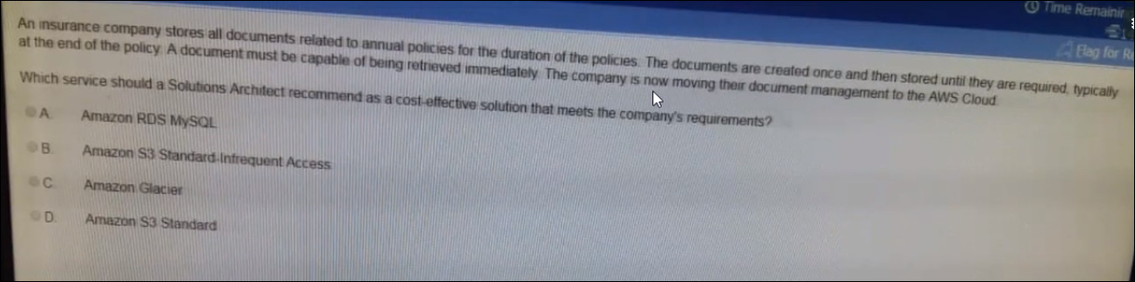

Ans: B, Amazon S3 Standard – Infrequent Access

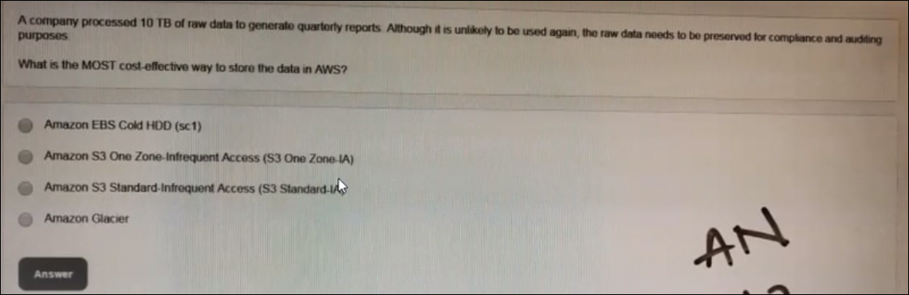

Ans: D, Amazon Glacier, coz here data is unlikely used and most cost effective way to store.

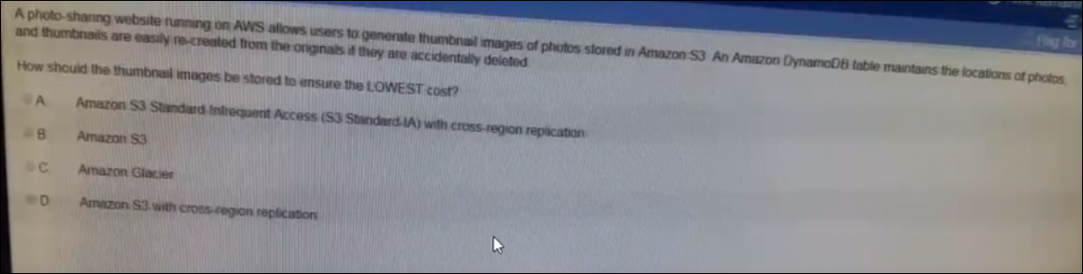

Ans: B, Amazon S3, coz when ever we go to youtube, we can see first thumbnail and it will load the all thumbnails when we access the video , it is not taking any restoration time to play the video. So thumbnails are loading immediately and accessing immediately.

Support if we choose Amazon Glacier then it requires some time, to restore the data.

Thumbnails can regenerate from the video, with small script, so here video is important not the thumbnail, so we are not going with cross region replication or same region replication.

Today’s topic:

1. S3 Versioning
2. LCM [ lifecycle management]
3. Cross region replication
4. Same region replication

S3 Versioning :

Suppose we have a file with some data and we are performing continuous modification to it. And we need to track on it what are the changes are happened regularly on that file, coz we keep on modifying it, by changing the file name with different versions. What is the advantage of maintaining in this version numbers / names coz we can easily tack the changes in them. So similar manner, what ever the file w are uploading into S3 Platform, we need to track the changes happing on the file,we can enabling “**Versioning**”

Here no need to give manually the files and all, whenever we upload same file multiple times with same name , amazon will give the different version ID and automatically it will rename it.It si pocket level option once we enable it it will automatically assign the version id’s to the file. But version enabling the version, what ever the data we have that is going to contain version id as “**NULL**”. It is bucket level option once we enable it will automatically assign the version id to the file.

If we need to delete the bucket, we need to empty the bucket then we can delete the bucket.

🡪Track all changes happening on our s3 objects

Here in the below image we don’t have any versioning option,

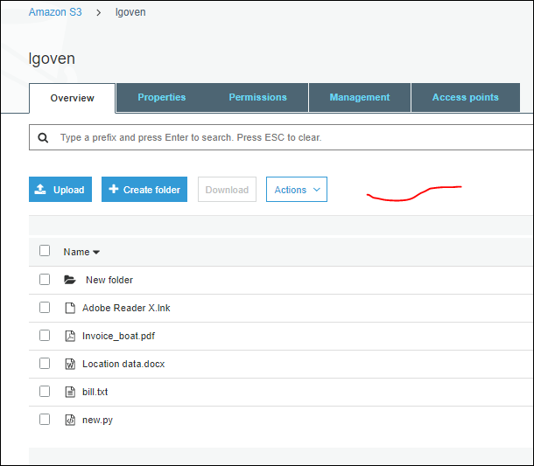

So whatever the file wee delete it, we can get it back once if we enabled the versioning.

So without enabling if we delete the file in the bucket, we can’t restore it, we can’t undo it, even we have an option in the “Actions” tab, like “Undo Delete” we can’t get back the deleted file.

So now we will create a text file with some data in it. And upload it multiple times, by every time adding data to it.

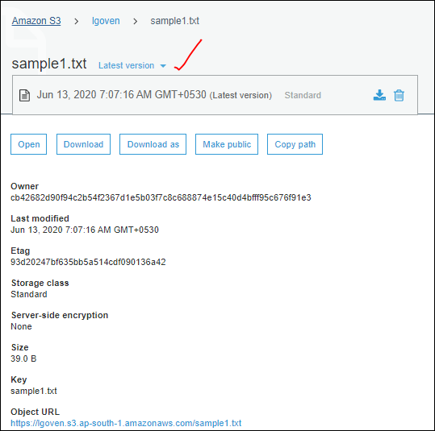

We don’t find any difference in the version naming and every time we upload the file it just updating the file with same name with the last data in it.

So if we need to see the different version id for the same file which we are uploading with updated data every time, we need to enable the versioning in it.

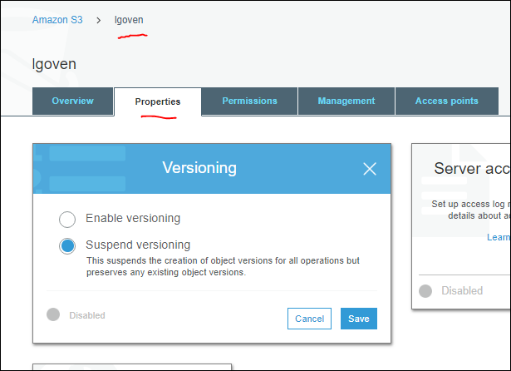

If we enabling the version, and upload a file, we can see the list of versions in it.

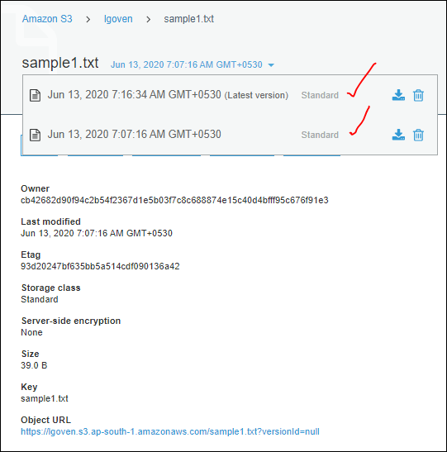

Version enabling is at Bucket level.

When we set the versioning , “versions” button is enabled next to “Actions” in Bucket page.

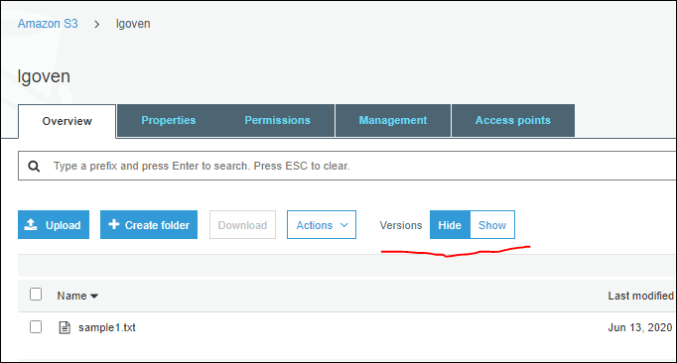

--> Works as a backup option too

If we keep the version –“Hide” then what ever we deleted the objects [files] will not available in the bucket page. so technically the object is deleted. as versioning is enabled we do have an option to get that object back. Just click on “show”, it will show the “deleted marker “ for the file which is over written for the previous versions.

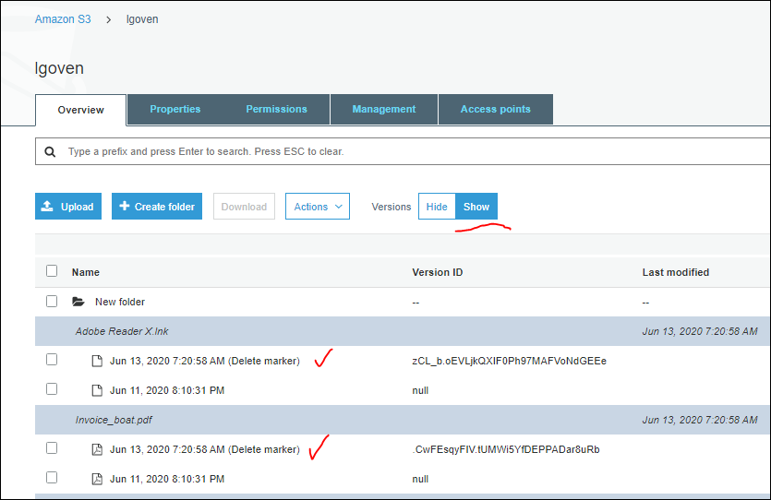

Now we will delete the delete marker,

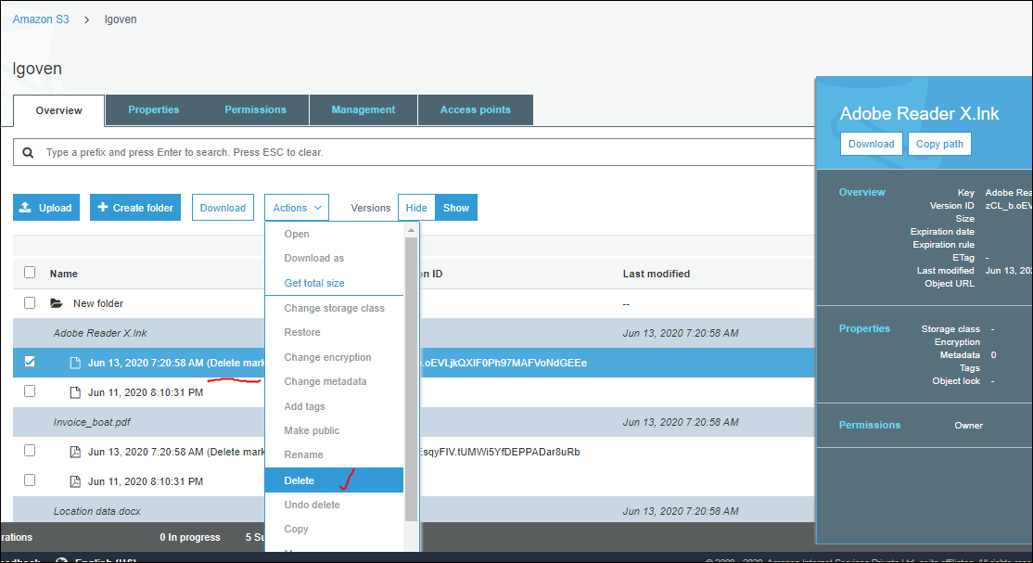

After deleting the delete marker , we have only one file under show.

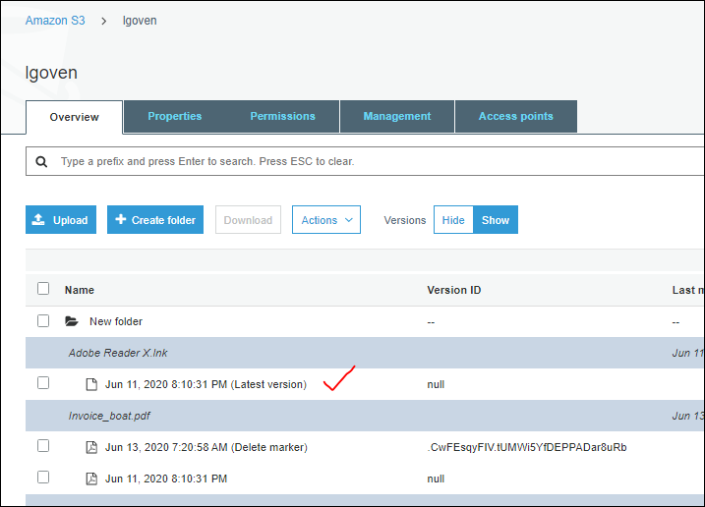

Now click on the “Hide” and check we can see the restored same file of latest version, this is due to enabling of the version in it.

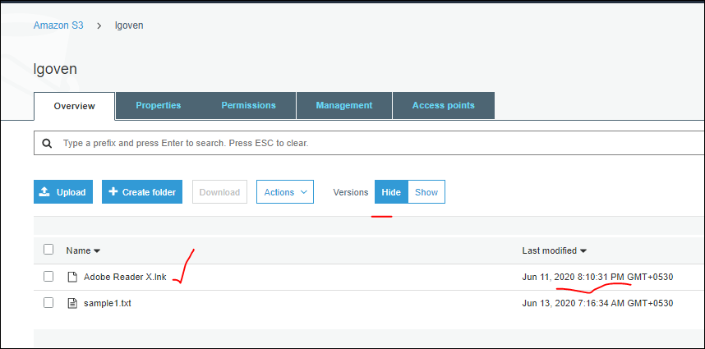

There will be no changes in the data, after even we deelte the delete marker file,

When Versioning : HIDE..

--> Whatever the file we delete, we'll get a delete marker.

--> Delete the Delete Marker to get that object back..

So when we set the version to “Show” and perform to delete the file, it will delete the fiel make the last available file as latest version.

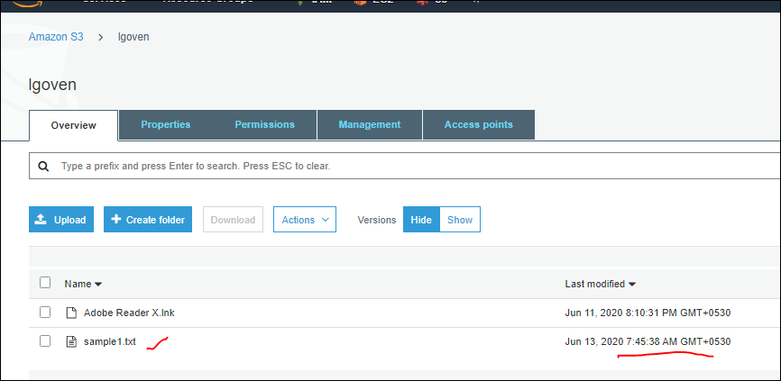

Observe the abve image with sample 1 file uploaded 7:45:38AM,

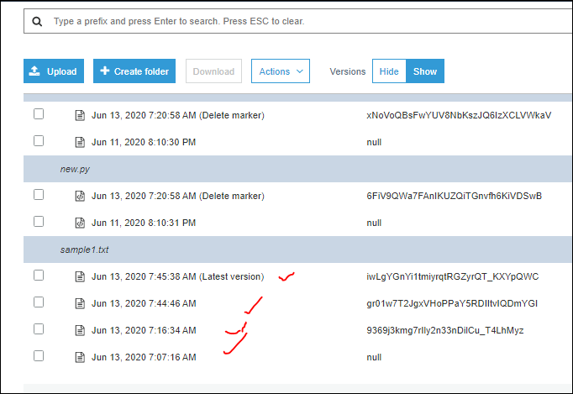

See in the “show” option.

Now we will delete the file,

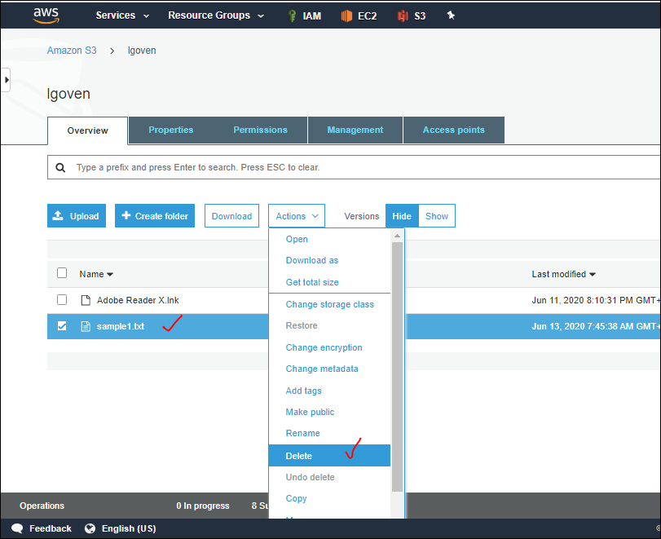

After deleteing the file

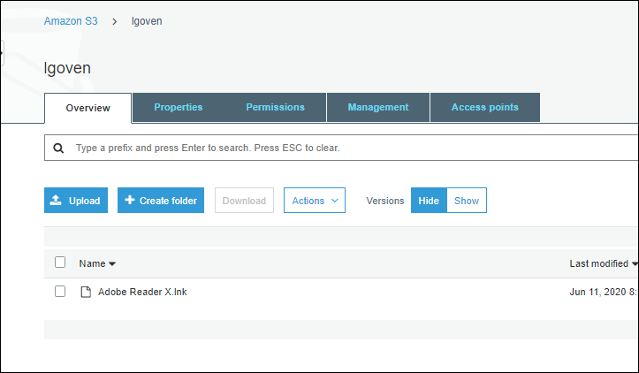

Now go to “show” we can see the deleted file with “deleteMaker”

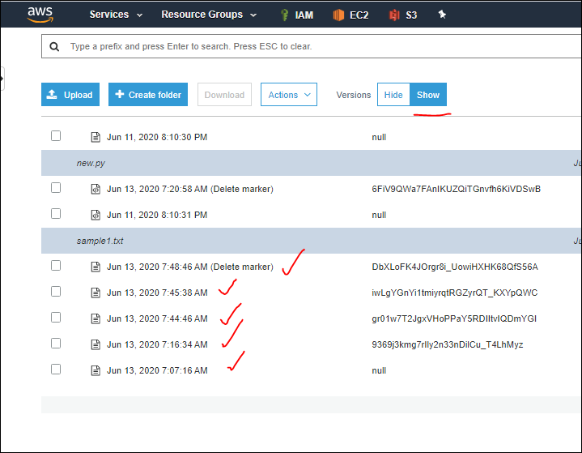

So now going to delete the delete marker file under “show”, it will delete the delete maker file and make the last available file as latest version

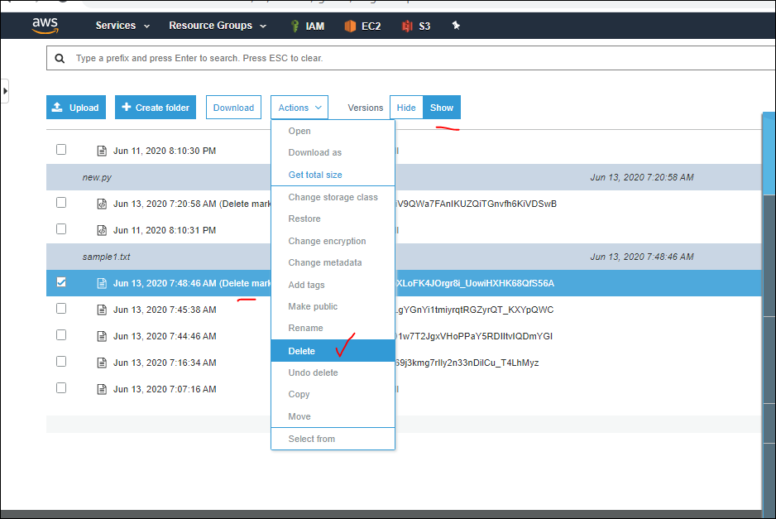

Now only 4 files and the last one as latest version file

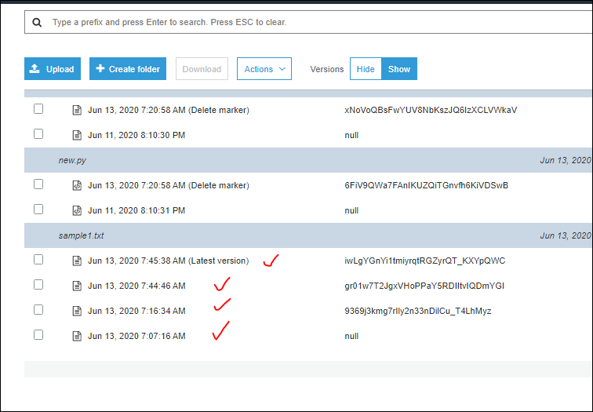

Now go to “hide”, we can see the latest version file in it,

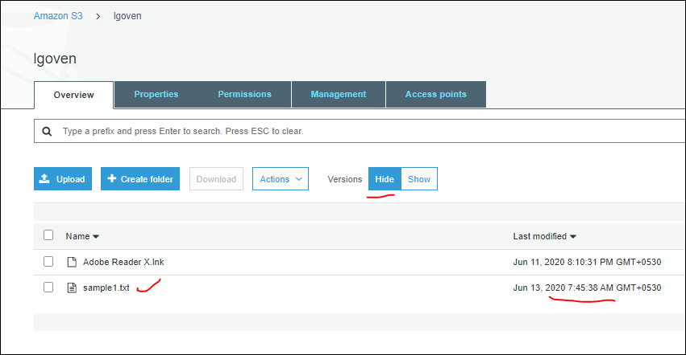

So when we delete the file from “SHOW” we won’t get any Delete Marker file which can’t be restored, it is permanent delete.

When Versioning: SHOW..

--> File delete permanently

Now we are deleting the files when versioning is set to “Show”. And observe that, files will delete permanently

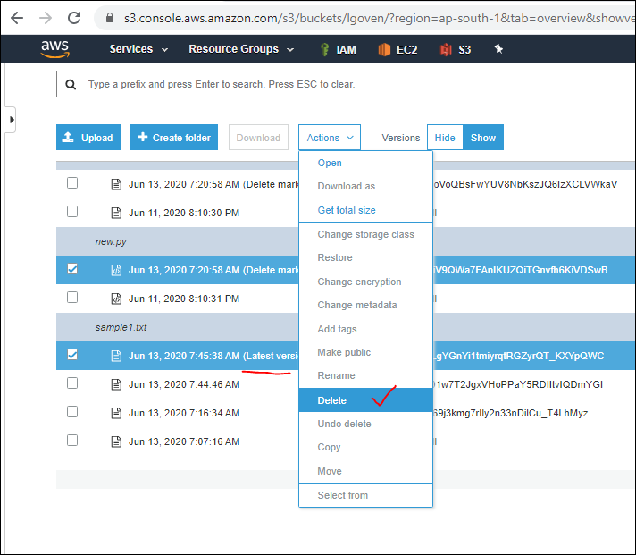

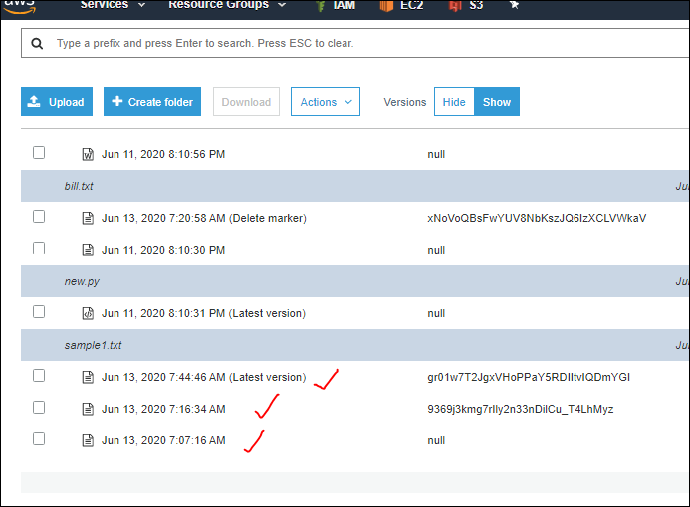

See in “Hide”, we can see the “latest version” file sample1 as below with same date and time.

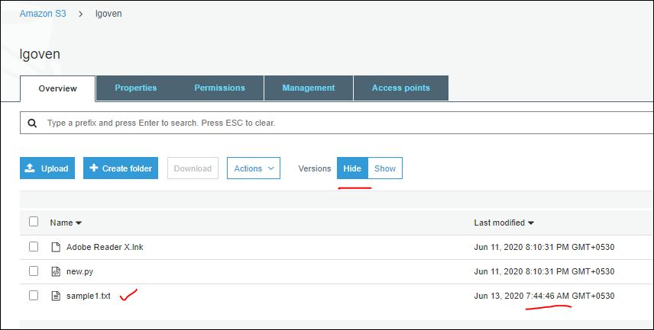

So we will delete all the files and see whether it will restore or not, definitely it won’t restore it.

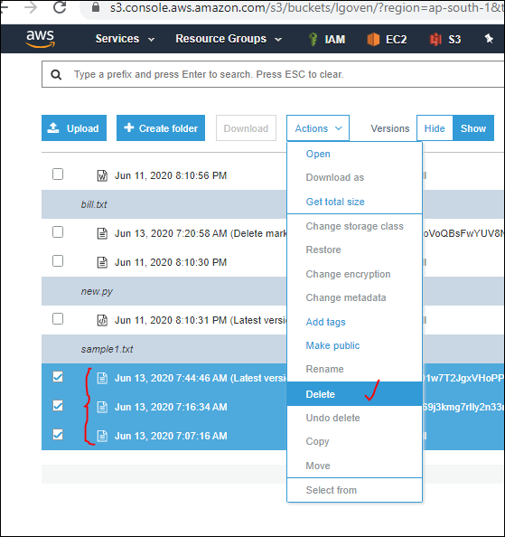

So completely we deleted the sample1 file with all versions.

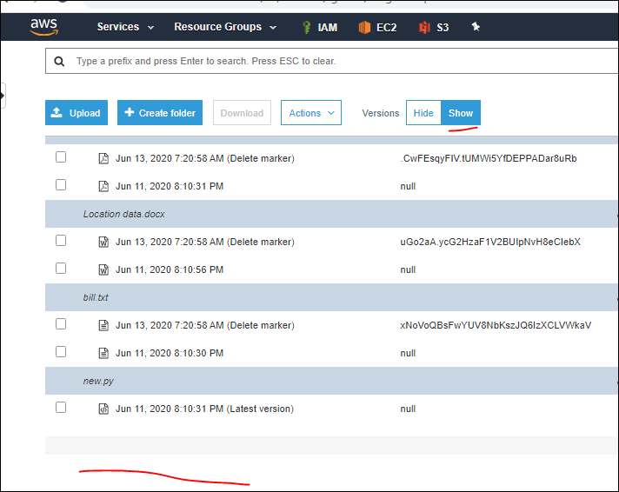

Now check in “HIDE”, sample1 file cant be restored.coz it is deleted from “SHOW” which is permanenet delete. even “Undo Delete” is also disabled.

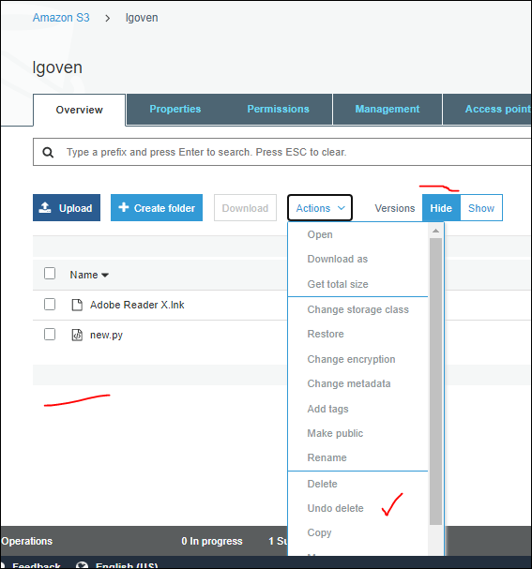

Even in show also it is disabled.

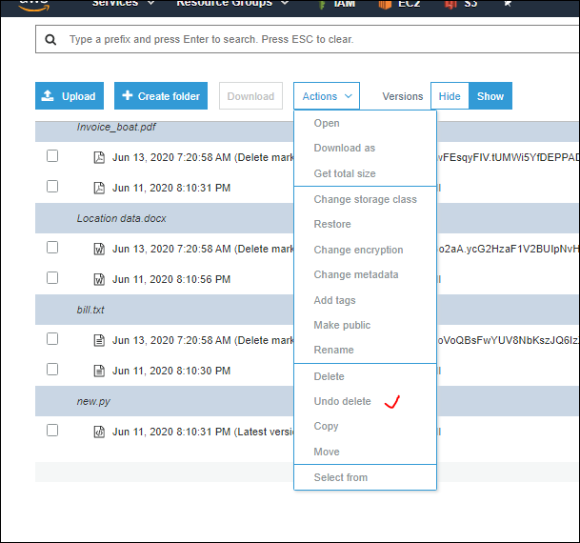

* If **file 1** is deleted from “HIDE” then it will be moved to “SHOW” with suffix “Delete Marker” and that file wont available in “HIDE”.
* If the same file 1 with “Delete Marker” is deleted from “SHOW” then File1 will be available in “HIDE”.

Take an example file “New.py” presents in **HIDE**

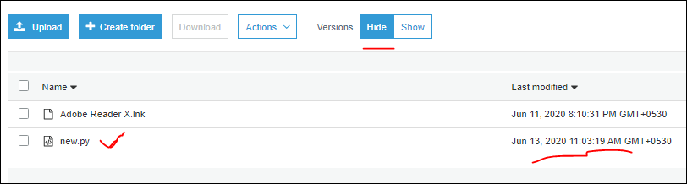

Check in “SHOW”, the movement I uploaded a file in HIDE, the same is displayed in SHOW with same time and date with suffix as “Latest Version”.

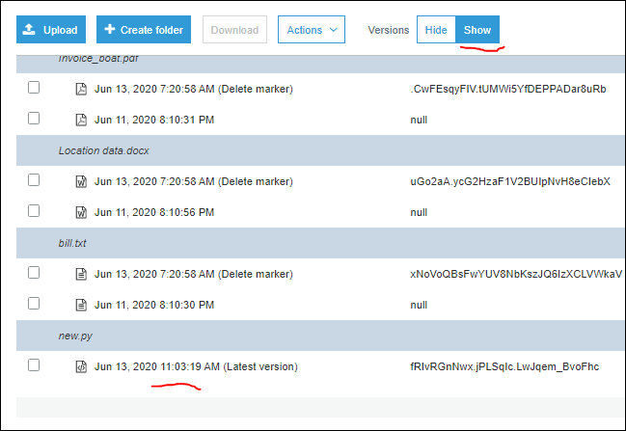

If I delete the ‘New.py” file from HIDE, then it will make a copy in SHOW with Suffix as “Delete marker”. As shown below.

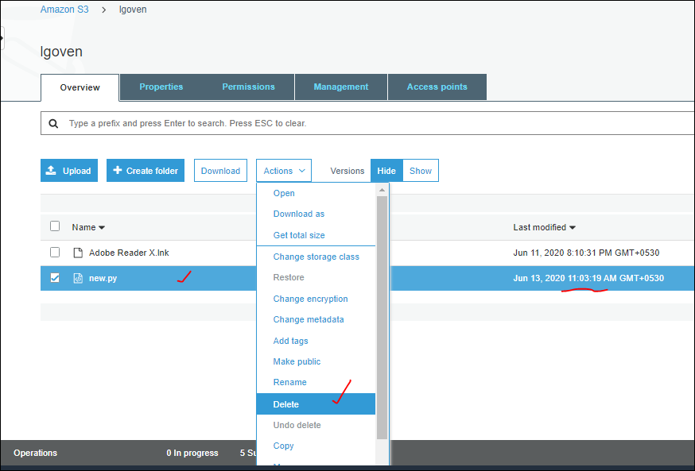

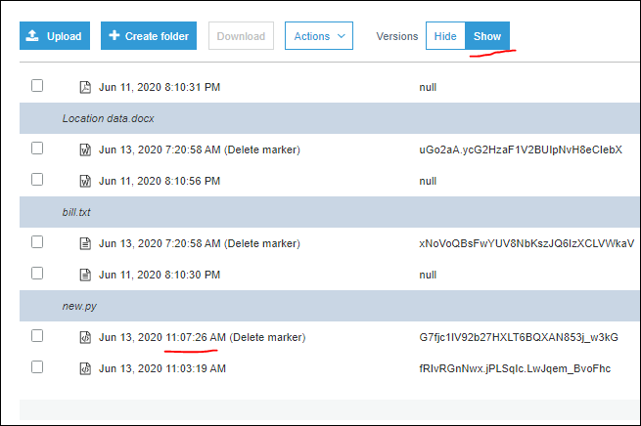

If we delete the “Delete marker” from SHOW then there will be File New.py in HIDE.

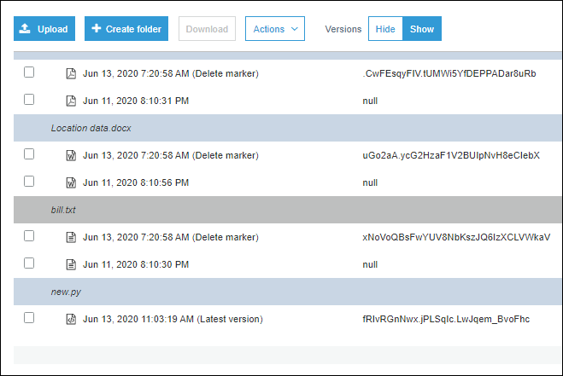

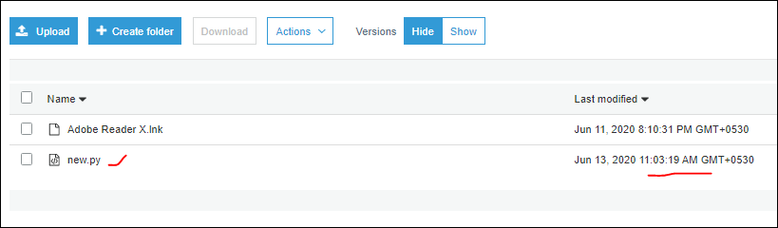

Instead of deleteing the delete marker file suppose if we delte the latest version file then

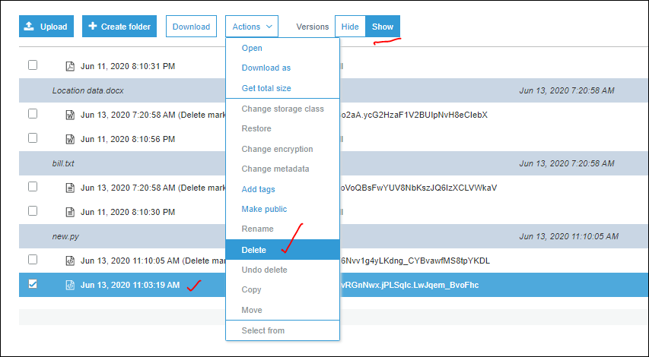

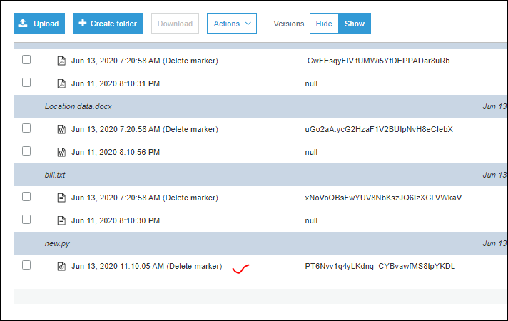

Soa fter deleting the latest version, if we check in HIDE, we wont find any file with new.py, coz we just delted the latest version , but restore file is delete marker file wich is already present in SHOW.

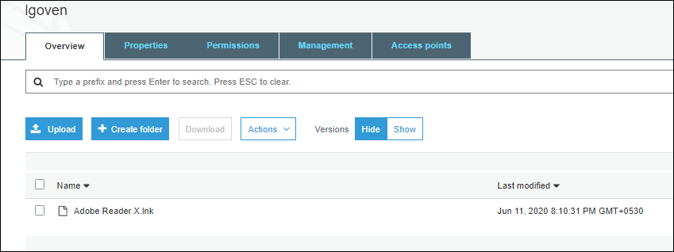

Now if we delete the Delete marker fiel also then, it iwill resotre the file to HIDE or not?

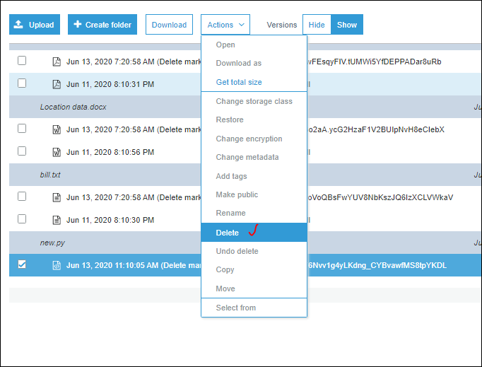

So in hide we wont find the file new.py coz, we deleted the “Latest version” file initially and later deleted the “Delete Marker “ file in SHOW due to this both files are deleted permanently .so we cant resotre the file **new.py.**

**So when ever if we need to delete the file in show , make sure to delete the “Delete Marker” file coz what ever the availability file with latest version in SHOW can be made as a copy in HIDE.**

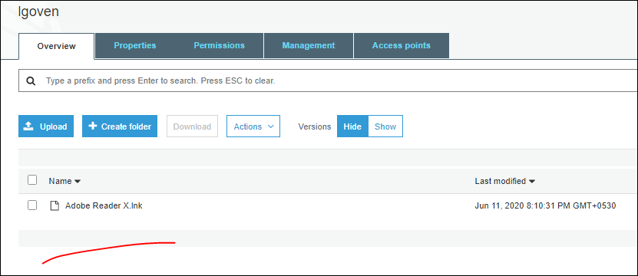

* When can we use “UNDO DELETE” for objects in Bucket under actions button, every time it is in disable mode for both “HIDE” & SHOW”?

It si not like if we upload the file once and it is getting charged even if we delete it also. How many times we upload a file and the size of the file can be charged.

----------------------------------------------------------------------------------------

Lifecycle management is another Bucket feature which we can see it under “**management”**

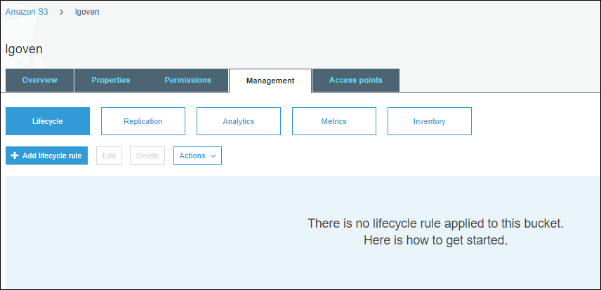

Now we need to transfer the object Storage clas to another storage class.supoose we have an object with “standard” Storage class and after some days we need to move to Glacier.

Or suppose from standard 🡪 to Standard –IA after days 🡪 to Glacier and then 🡪 Delete it,

So automatic transistion and automatic deletion need to configure. Manually maintaining this to billion of files is difficult thing.so that is why we have an option called **“LIFE CYCLE MANAGEMENT”**.

🡪 WE can transit objects storage class, and we can trigger to delete the objects automatically.

Most important topics in S3 are which we frequently use them as listed below:

1. Versioning
2. Lifecyclemanagement [LCM]
3. Cross region replication
4. Same region replication
5. Static Hosting
6. Policy

Now navigate to Management tab in Bucket. and select the Life cycle rule:

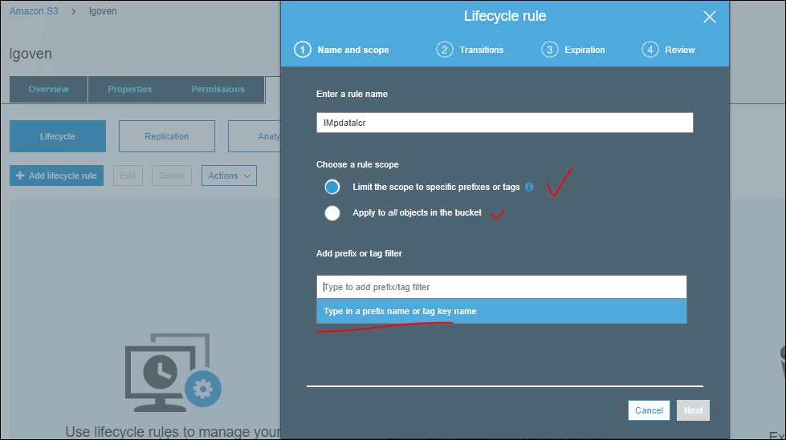

Here we can configure to entire Bucket i.e., to all objects in it. Or we can add prefix or tag and only to particular thing we can assign it.

So now we are creating a folder in the bucket. With “ NEWLCRTEST”

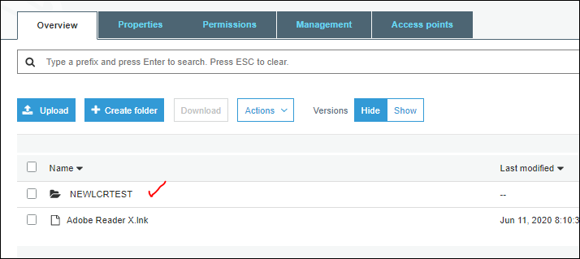

For this w can apply the Lifecycle rule, by selecting the prefix in lifecycle window.

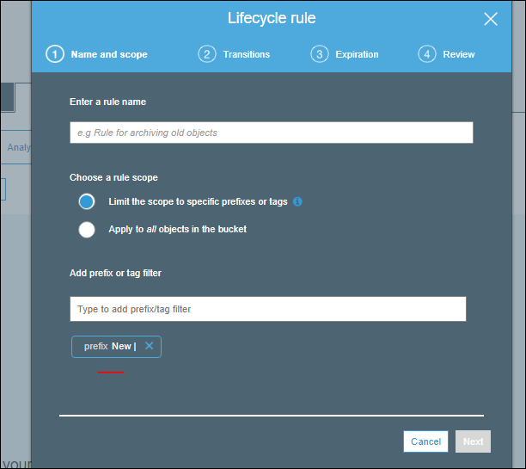

So now whatever the data present in the “prefix new” then this rule will be applied. any folder which starts with prefix “NEW”. As shown as above.

This is how we can add a rule, next is the **Transitions,** herewe have current version, previous version to do transition.

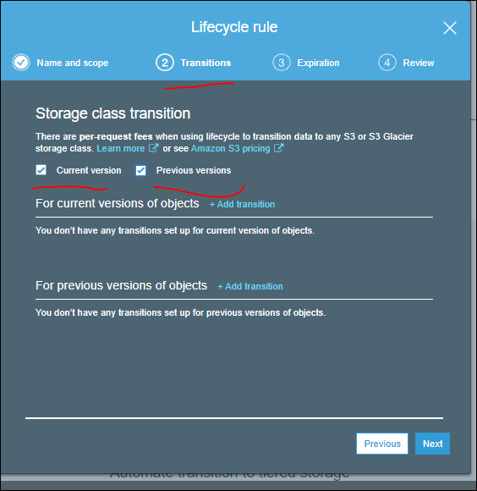

So now if we want to do transition.

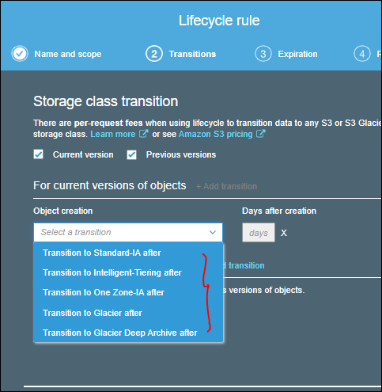

Here we can select a transition to which we need to move the objects.

The default storage class is S3 standard. let us take it in a **pictorial format** as shown below:

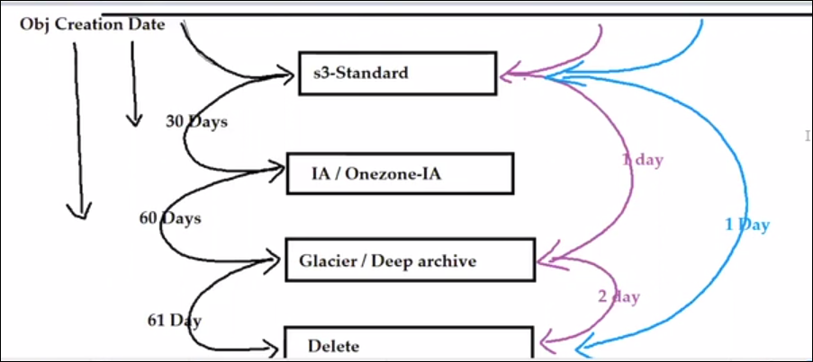

From the above image, we can understand that, by default the storage class for any object is “Standard”.

Scenario 1:-

If we need to move from standard to one Zone, after 30 days from object creation date.

Same way One zone to Glacier after 60 days from object creation date.

On 61 day we can trigger it to delete it. What event he values we are mentioning is minimum days.

Scenario2 :-

What ever data we upload it comes to standard by default.

So automatically we can trigger to move to Glacier. Immediately next day [day 1]

Then from Glacier we can trigger to delete it. Immediately next second day [day 2]

Scenario 3:-

We don’t to move to any IA, Glacier and directly to delete it.

So when upload data it is stored I standard and immediately we can delete it by next day.[1 day]

*** We can select [IA\One Zone-IA], [Glacier \deep archive]. We mentioned them in same box coz they both contain same [IA\One Zone-IA] properties and use cases.

Suppose it is a latest version of the object it will go to expire, as it has “delete Marker”.

If it is previous version then it will permanently deletes.

Now we will apply the transit, from standard to standard –IA, if the duration reduces to 30 days then it will through an error.

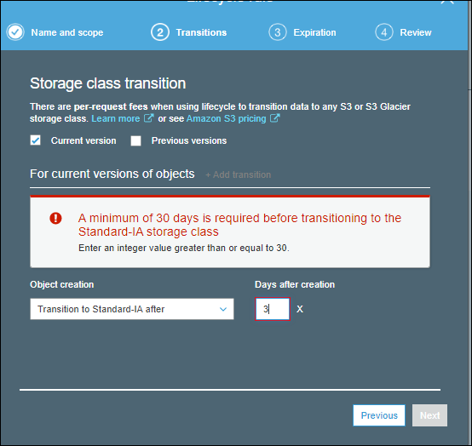

The below image represents the black color configuration as shown in **pictorial format,**

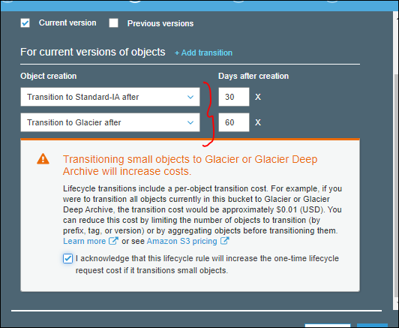

Of the combination is required as purple as shown in pictorial format, then

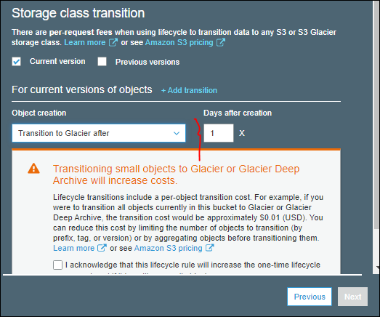

Suppose we don’t add any transition, and we are directly going to expiration then it is equal to blue color.

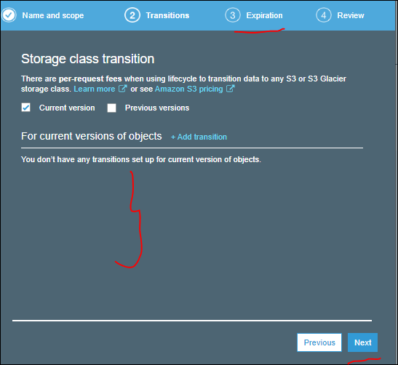

This is coz whatever data we add comes with Standard storage classes and directly it can be expired i.e., automatically deleting it.

Here we have a provision to do transition for current version and previous version, at a time,

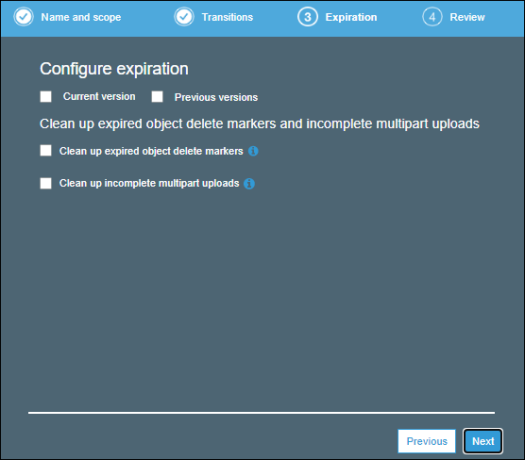

* If we don’t select any transition in lifecycle rule, then we have to enable the expiry configuration.

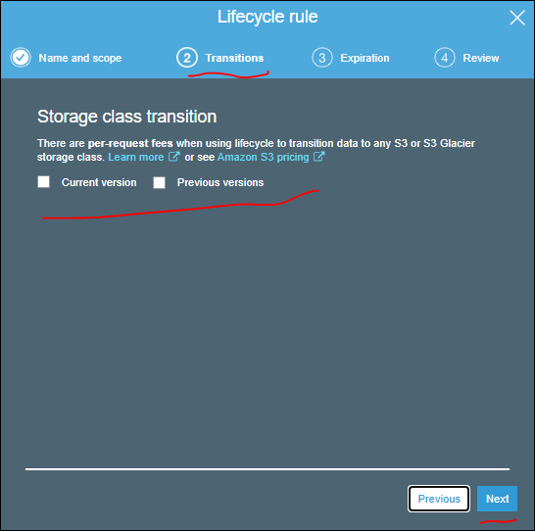

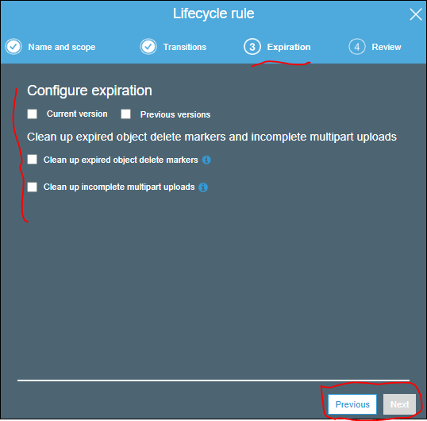

* If we set the transition then it is not required to configure the expiration.

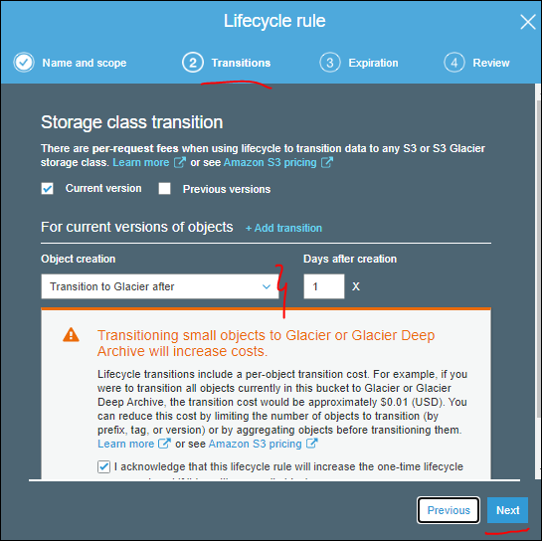

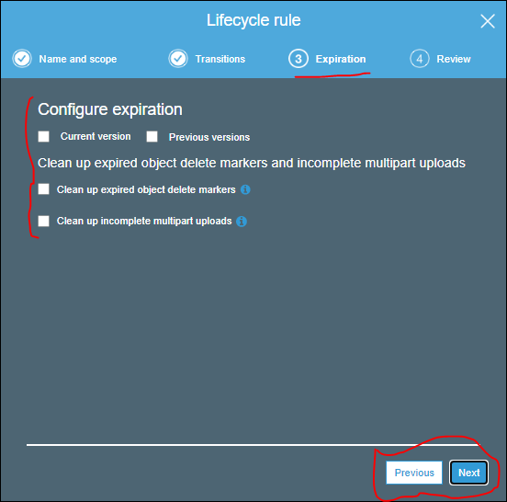

Suppose if uploaded large set of data files , which it takes days and days to upload is not completed with in given days, then what ever temporary files left over to upload, then they can be cleared with in specific days. “Clean up incomplete multipart uploads**“** As shown below and it is not part of LCM, but amazon has added it here to clean temporary un uploaded files.

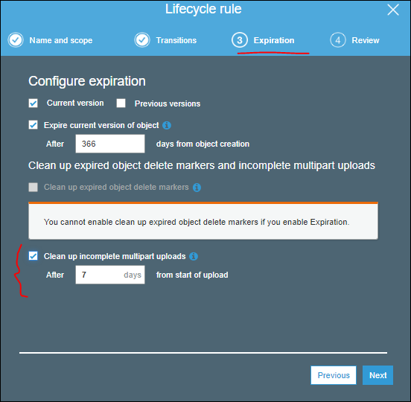

This is coz what ever large file if we upload into amazon, depends on app which we use, it will divide the file into small chucks and start to upload. if it fails to upload into amazon, then all the initial chucks files which has will be deleted.

After configuration the expiration then we need to review it.

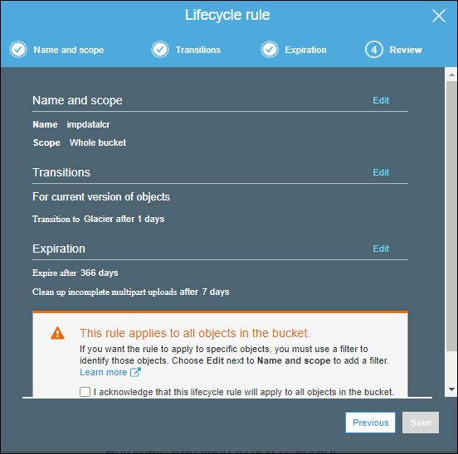

After setting all the required stages in the LCM and click on save.

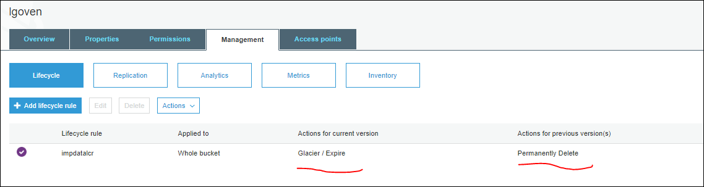

This LCM rule can be applied for whole bucket as we configured it.

Now if we need to apply for only one object that can be achieved by using the prefix or tag . here “Prefix” is nothing but the folder which is created in the bucket. “Tag” which are provided at object level by giving **key** and **value** as shown below.

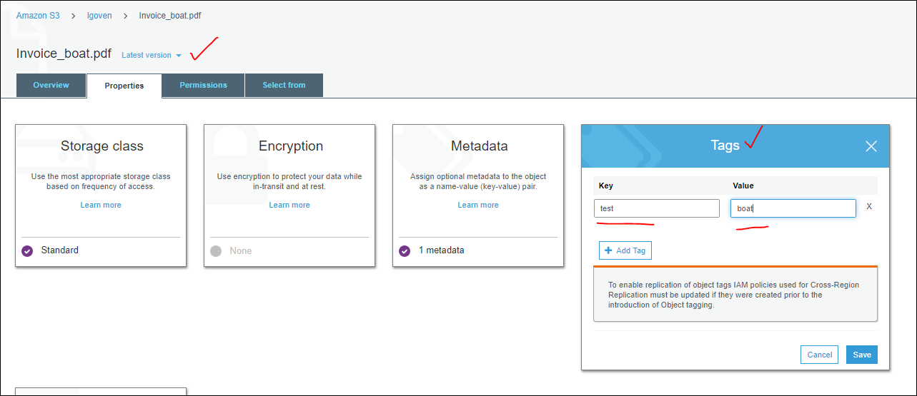

In LCM we can enable the rule for only tag based for an object.

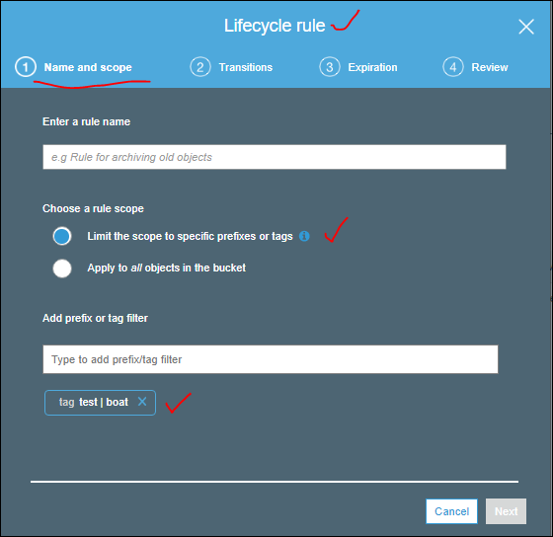

* If we won’t make any versioning also rule may apply by using LCM.
* If lifecycle is completed and data won’t be retrieved, and the memory can be scrubbed in the harddisk and destroy it. By Amazon.
* Performance can be taken care by Amazon, wee wont perform any disk defragenmentation, disk cleaning, indexing .. we have standard things if we give proper naming suffix, prefix then it will automatically have good performance. Even if we wont maintain also it will have good performace.i.e. 3500 uploads/sec and 5500 downloads/sec.
* If we delete the delete marker file then we get the current version of the object, if we delete the previous version of the object we won’t get the object. This is the reason we need to enable the versioning.

--------------------------------------------------------------------------------------------------------------

Now we are discussing the option called “ Replication” in Management.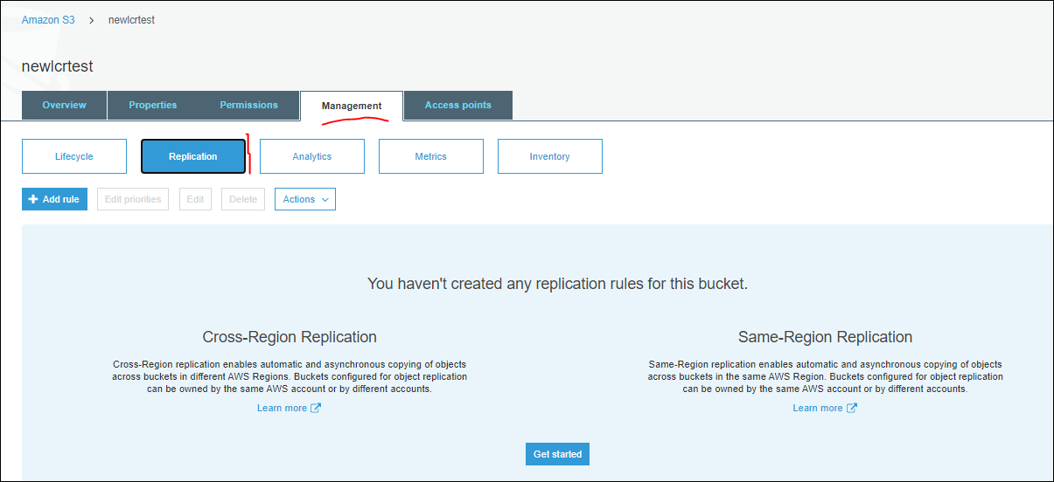

This can be explained later, for time constrains.

---------------------------------------------------------------------------------------------------------------------

Now we will have “**Static Website Hosting**” under properties in bucket.

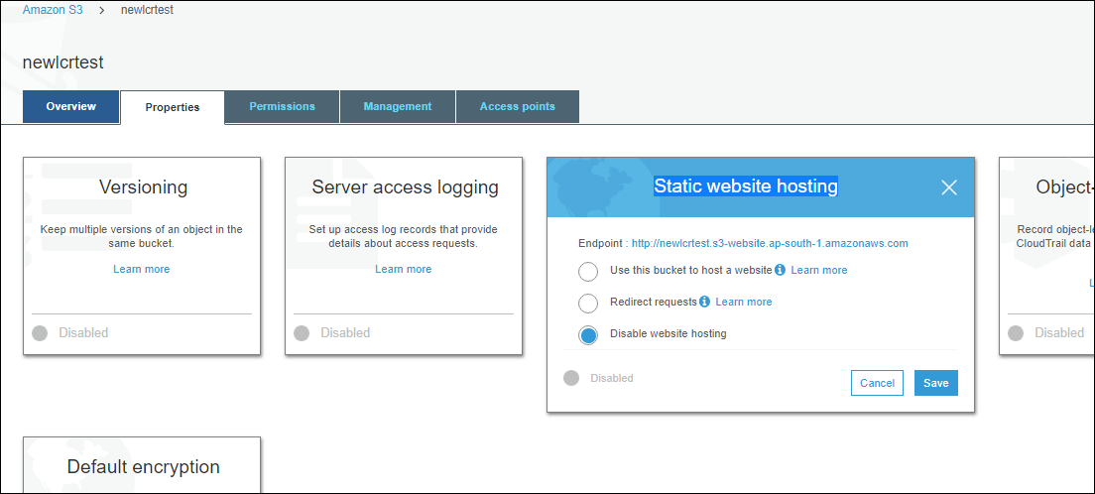

We are going to host a website, we have

Static web site : it is fixed webpage.

**Dynamic web site**: eg: it has Db, if we login ass admin we get one permission, if w login as user we get another permission. **Due to this S3 won’t support. Eg: Gmail. every person has different content .**

So S3 supports only static Web site hosting option. Eg: Wiki pedia , who ever open the page the page will be same .

If we need to support dynamic then we have EC2, litesale….

Website:

--> S3 Supports static website hosting option.

--> bucket name should be same as domain name (avinash.website), here we will get a standard url,but instead of the standard url we need to amp any domain name, we need to purchase it.

That domain name should be same as bucket name.

🡪 what is the major advantage of using this S3 platform?

Ans: For our website 99.99% avilablitiy 99.999999999% Durability

No need to maintain Operating Systems,simply if we need to upgrade without any downtime w can do it.

What ever the data we uploading, one thing we need to provide at least read only on our data to load the website.coz if we wont make it public then we cant publish the wewbsite.

So let us take a bucket and enable this feature.

We just created to html files, to tes this static website hosting, and uploaded them into Bucket “mani.com”.

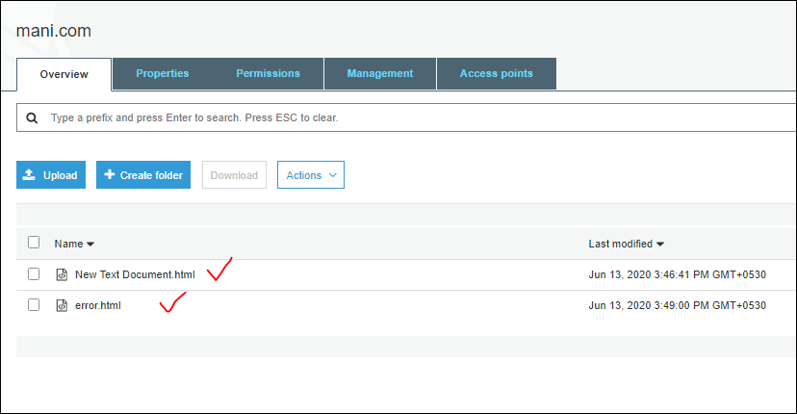

We are providing the same file names as how we stored them, in index and error documents values in it.

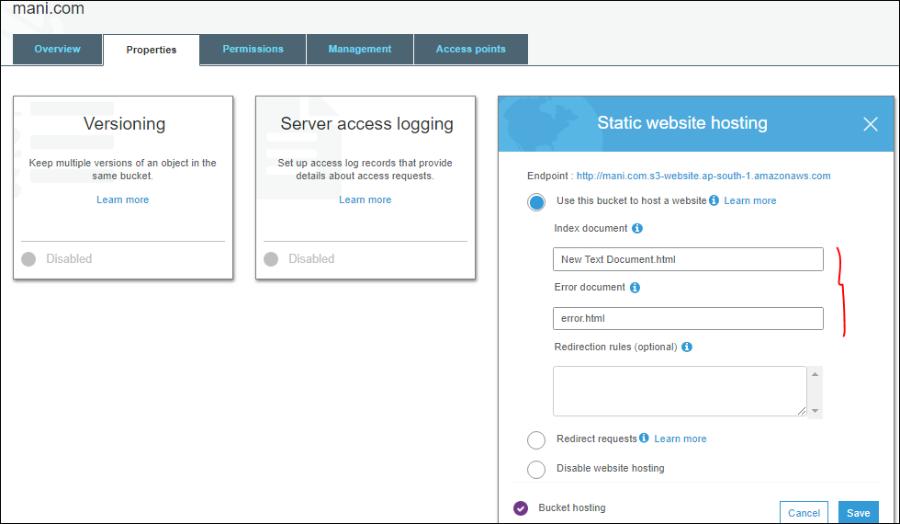

<http://mani.com.s3-website.ap-south-1.amazonaws.com>

this is the url S3 generates for us to access the website, if we use the above url , ti gets fails to load the file as shown below.

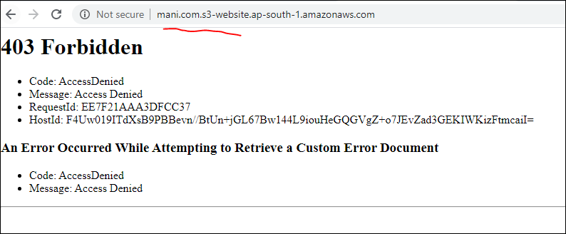

To get the data we need to prove the public access for it.

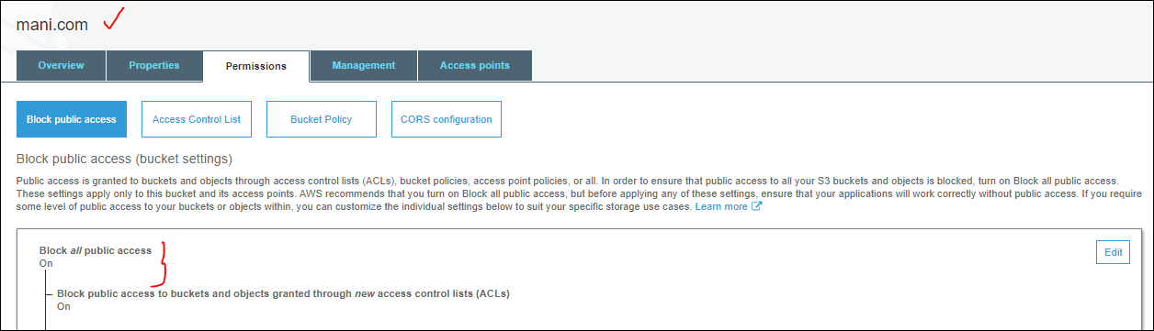

Now allow it in bucket level and object level to access the website. Even we can enable to public in single click at bucket level.

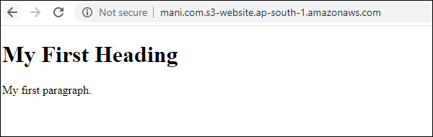

Suppose we disabled the public access, new text document.html file. Then the next file will execute with same url. i.e., downtime if web site won’t work.

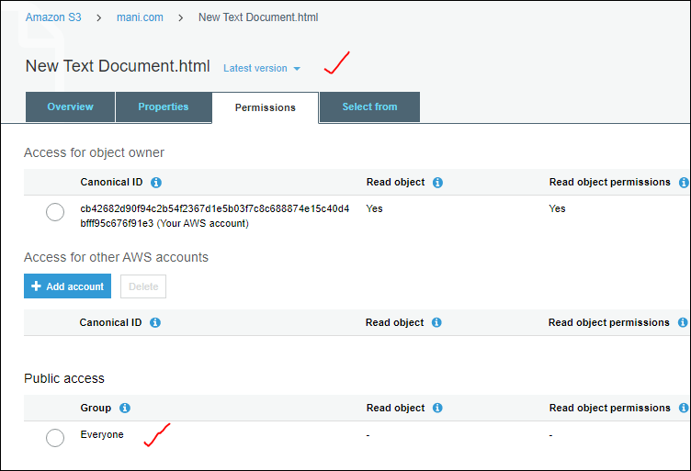

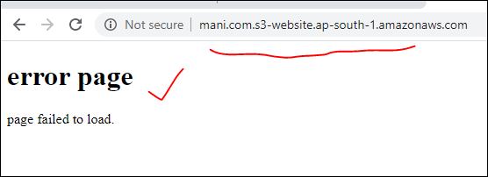

Here we can also redirect the web site, whatever request we are getting as shown below



