D: 18/06/2020

http status codes:

2XX : Success/OK

3XX : Redirection error

4XX : CLient side error

5XX : Server side error

Metrics : CLoudWatch..

CW : Service to monitor all the AWS resources.

Storage class analysis : You can enable storage class analysis for the entire bucket, shared prefix, or tags. Amazon S3 analyzes your access patterns and suggests a candidate age to transition objects to Standard - IA for a lifecycle rule.

Import / Export :

100TB : Migrate all that data to s3 :

--> AWS SnowBall : 80TB : 200$/Job.. 10 Days free..

--> AWS Snowball Edge : Comes along with compute capacity : 100TB : 250$/Job, 10days free, 20$-25$/day..

--> AWS Snowmobile : PB Scale : 1PB with 1 GBPS internet, 80% utilization.. 20-25 years for migration... !!!!!!

AWS Direct Connect : Dedicated fiber connectivity to our on-prem..

---------------------------------------------------------------------------------------------------------------------------------

Generally we don’t make buckets public access, then how our applications are going to communicate with S3? For that we have another option called roles, by using IAM roles we are going to provide the access with making our data publically accessible.

**Bucket Management Options:**

1. **Analytics**
2. **Metrics**
3. **Inventory**

Metrics: if we need any information in graphical manner we use this Metrics at bucket level. to know the size of the bucket on a particular day we can track by using metrics. in the same page we have number of objects( count/day) in a day how many objects has created can be shown here.

Basically we get only two graphs under free tier limitation, but whenever the bucket is very important we need to track everything then we can enable a **paid request metrics.**

Click on the edit option we can see the Request metrics (paid feature) (10) ,

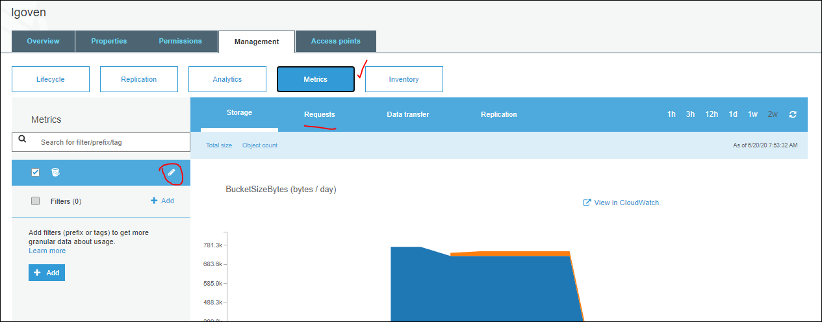

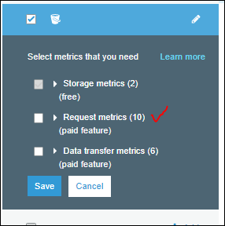 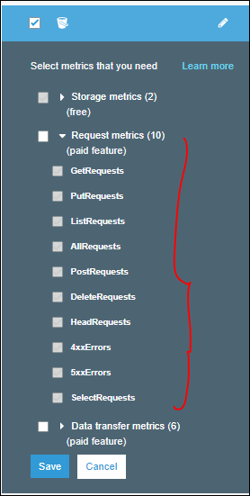

We know the Http status codes:

2XX : Success/OK [

3XX : Redirection error [ when upload is happened any redirection fails ]

4XX : Client side error [ url issue, ]

5XX : Server side error [gateway error, request timeout , gateway timeout.. ]

We can monitor all such type of codes.

Data transfer : The bucket filter is selected but paid metrics have not been enabled. Click the edit button for the bucket and enable paid metrics. Alternatively, you can add and/or select a filter to view paid metrics.

How much data upload or download graph we get in Data Transfer.

Replication: if we enable CRR /SRR then with replication time control whether data is replicated or not we can get that option here.we can choose the replication Id wht ever replication id we have , it will tell us that it is inn progress or not.

Finially we will monitor thee bucket if it si important.

Metrics: we have a service not only this pocket bucket metrics, thru out AWS , we can view or monitor it, it is “**CloudWatch**” to monitor all AWS Services.

**Analytics :**

You can enable storage class analysis for the entire bucket, shared prefix, or tags. Amazon S3 analyzes your access patterns and suggests a candidate age to transition objects to Standard - IA for a lifecycle rule.(paid feature)

This report help us to apply LCM Role in the bucket, suppose we have data in S3 standard for morethan 2-3 months, if we run this storage class analysis report , byclcik on the + add button, we can provide required data and it can be stored in CSV format report, or we can choos a bucket to store all this data , then click on save.

You can enable storage class analysis for the entire bucket, shared prefix, or tags. Amazon S3 analyzes your access patterns and suggests a candidate age to transition objects to Standard - IA for a lifecycle rule.

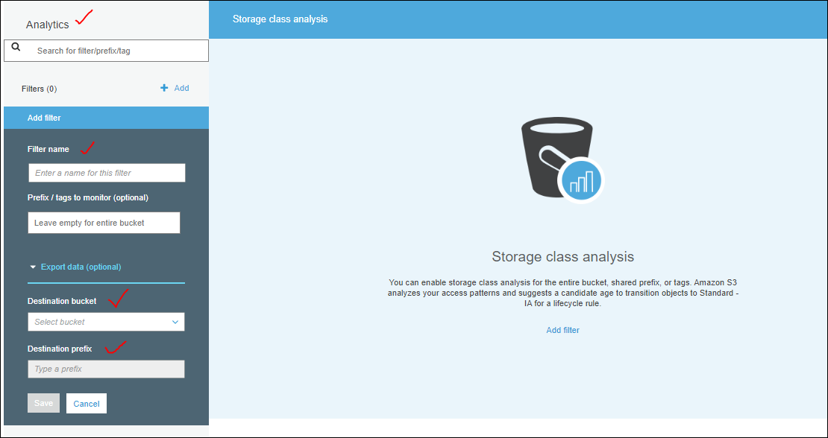

Here we can information just about the storage ,and its access partten,

**Inventory:**

This gives complete information about the S3 Bucket.

You can receive a file of your object inventory on a daily or weekly basis for the entire bucket or a shared prefix.

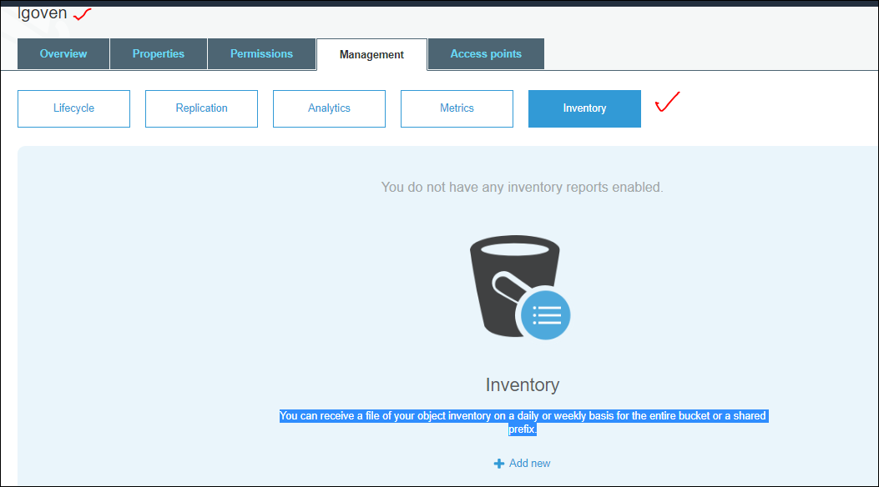

We can run this inventory Daily bases or weekly bases, output will be in CSV file , or apche ORC file. We can choose it.

**By adding this we can have**

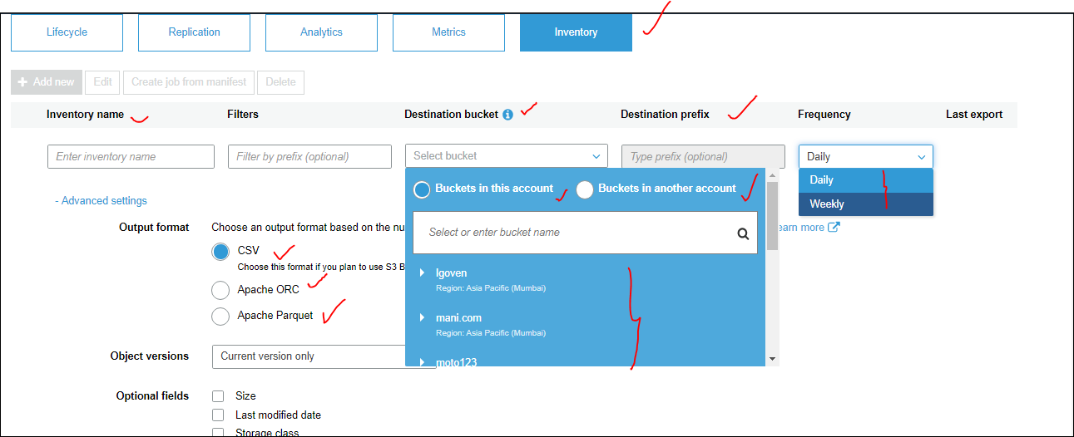

To sotre the Inventory report in destination Bucket,

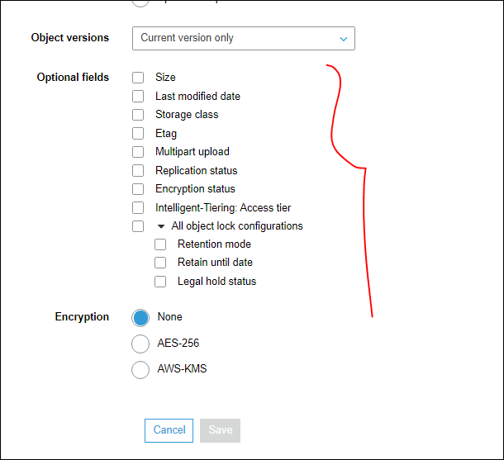

It might take 48hrs to generate the First report in the destination bucket.

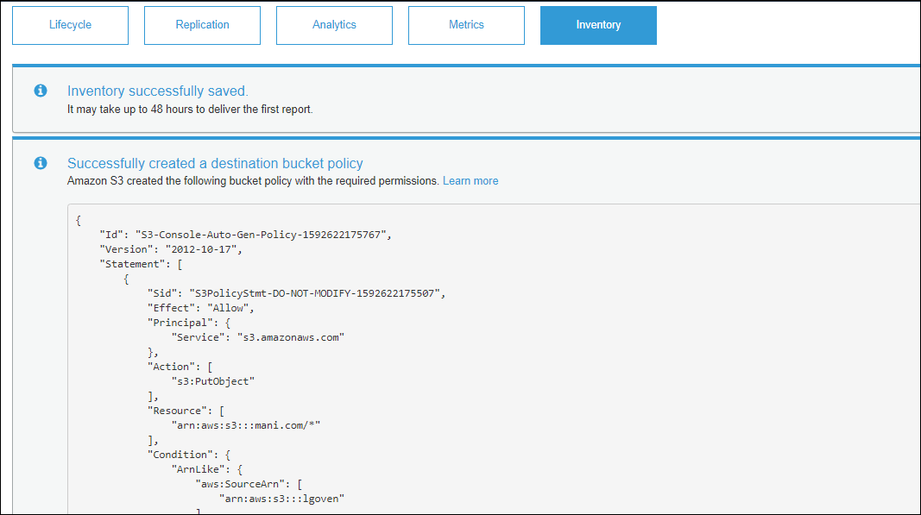

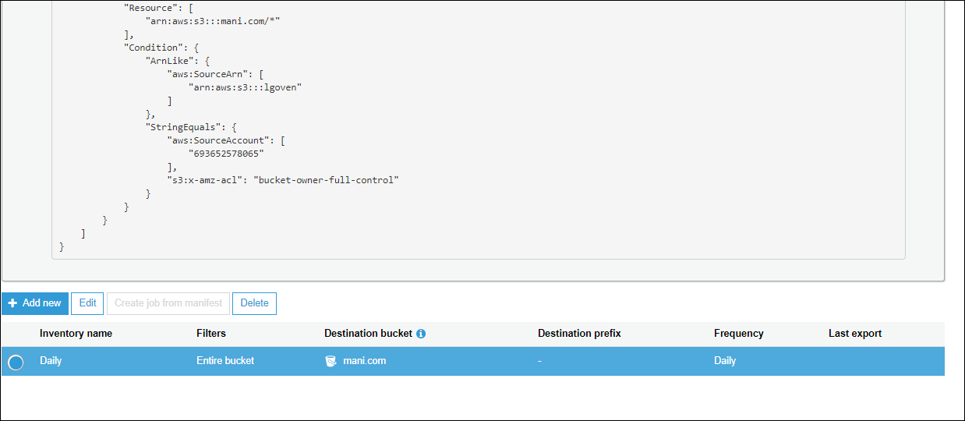

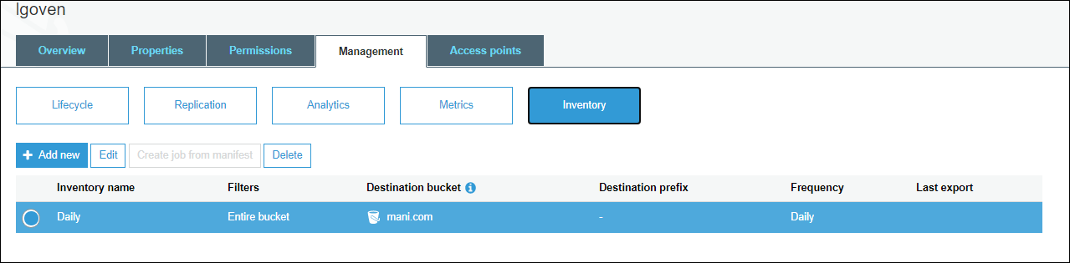

Basically we don’t use these options.

In Inventory given object info, when it create what is the current class storage. it given object and its properties, we get last modified time in the inventory that to optional feature if we enable ti will give info

In Analytics we can get how many times it got opened, when it is opened. It is only access how many times accessing , when it si accessing what is the suggested storage classes for the data.

**Access Points:**

Access points can be used to provide access to your bucket. The S3 console doesn't support using virtual private cloud (VPC) access points to access bucket resources. To access bucket resources from a VPC access point, you’ll need to use the AWS CLI, AWS SDK, or Amazon S3 REST API.

This is related to Networking , ther we can discuss about it, without internet also we can provide S3 bucket in EC2.

**Import / Export :**

In S3 we have an option called Import /export.

We have 100TB data on premises, how to Migrate all that data to s3 . This can be studied in Import / export.

We can order, a device and Amazon will send that device to use , we can connect that device to our local network and then we can initialize the data transfer , then after the job is completed, disconnect and sent the device back to AWS, then Amazon will copy that data into our Bucket and delete the data from the device. for security data can be encrypted end to end there is no option to disable this. while we are moving the data to the devices.

We have three such types of device :

1) AWS SnowBall: 80TB: [ it is not fixed size, basic default it is 80TB ] 200$/Job.. 10 Days free.. [ soon this will be discontinued ] 200$ +tax, for every day after 10 days they will charge 15$ per day.

2) AWS Snowball Edge : Comes along with compute capacity : 100TB : 250$/Job, 10days free, 20$-25$/day..

3) AWS Snowmobile : PB Scale : 1PB with 1 GBPS internet, 80% utilization.. 20-25 years for migration... !!!!!! so it is not easy to transfer data thru internet, so we oopt for this snowball services.

Based on the capacity we select it will charge not for the transfer data from local to device.

We can find this snowball – navigate to AWS Management Console 🡪Migration & transfer 🡪AWS Snow Family.

Still if we want to use the devices locally we can use, suppose we need a 80 TB capacity device, but don’t want to purchase teh device from the market, so we can order the device from AWS and use it locally for how many months we need to use or years we can, once usage is completed, we can clear all the data and return the device, so such type of scenarios we call it as local use.

Import/ export data if we want any operations.

Basically to create this job in India we need to have a GST Number, so for time being we can see in North Virginia.

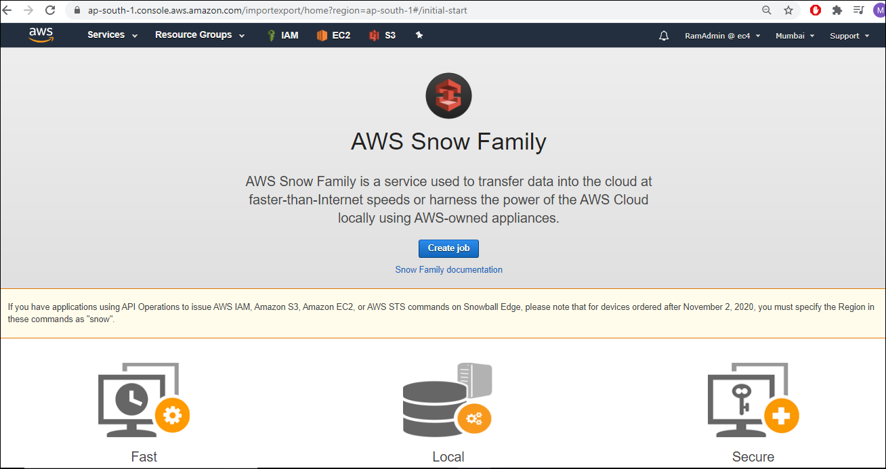

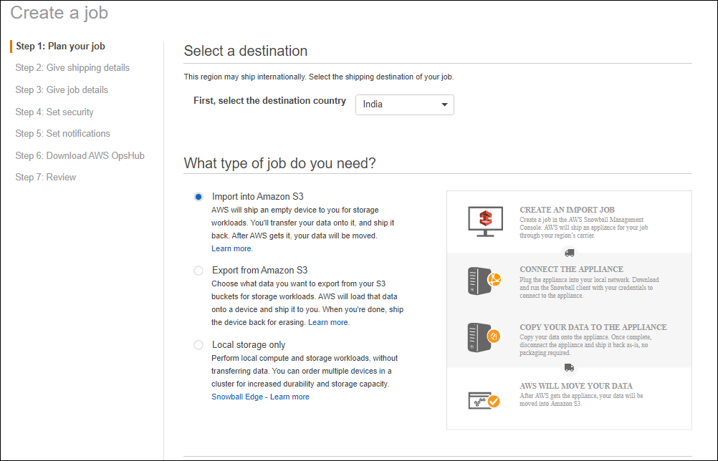

Import into Amazon S3

AWS will ship an empty device to you for storage workloads. You'll transfer your data onto it, and ship it back. After AWS gets it, your data will be moved.

Export from Amazon S3

Choose what data you want to export from your S3 buckets for storage workloads. AWS will load that data onto a device and ship it to you. When you're done, ship the device back for erasing

Local storage only

Perform local compute and storage workloads, without transferring data. You can order multiple devices in a cluster for increased durability and storage capacity. With in this deivce we can have server also,for this option.. wecan make it as cluster also.

We are selecting the Import into Amazon S3.

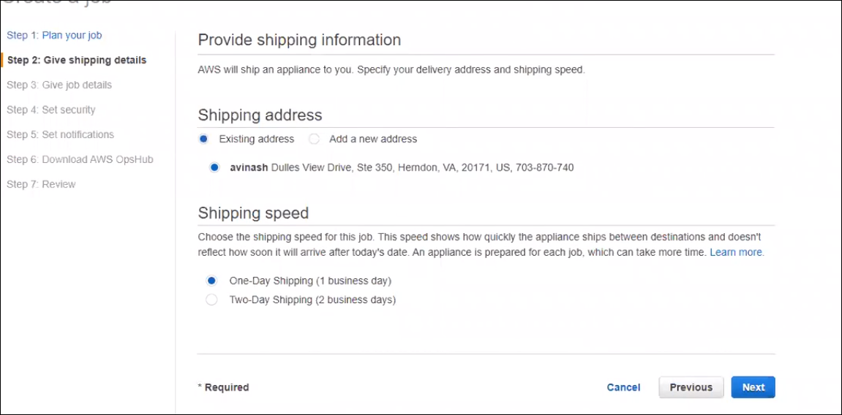

Click on next, and enter the job name, and select the device for import job,

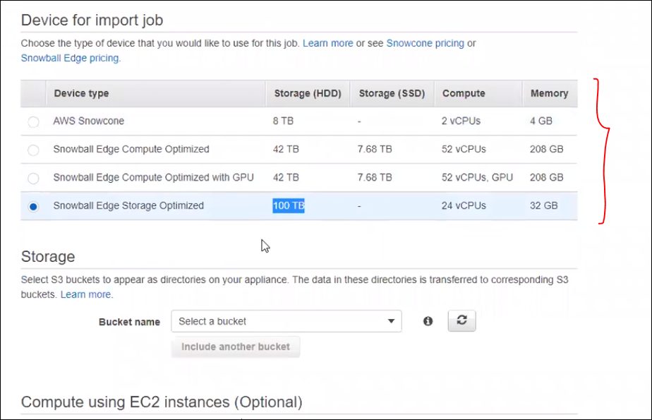

All the above shown are Snow ball Edge devices, as we are getting them with servers and memeory. [ 24 vCPUs, 32 GB ]

For how amny days we use this snowball Edge for those many days we can use this Compute capacity also.i.e., servers and memeory.

The snowball is already discontinued in North virgina.thats the reason we are not ableto view it.

HDD [ Hard disk drive ], SSD [ Solid state drive ].

Then now chose a bucket and so what ever data we are going to perform they will use this bucket to copy / move the data from local to snowball , we need to sue this bucketname. This device wont comme with any interface, we need to unlock it and proceed further.

Even we can compute with EC2 instance, communication will happen between our selected compute and the Ec2 instance.

EC2 and lambda are the optional , now we are ignoring them.clcik on next,

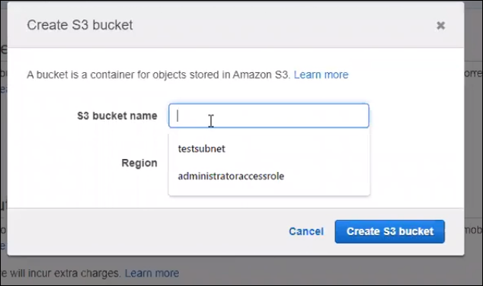

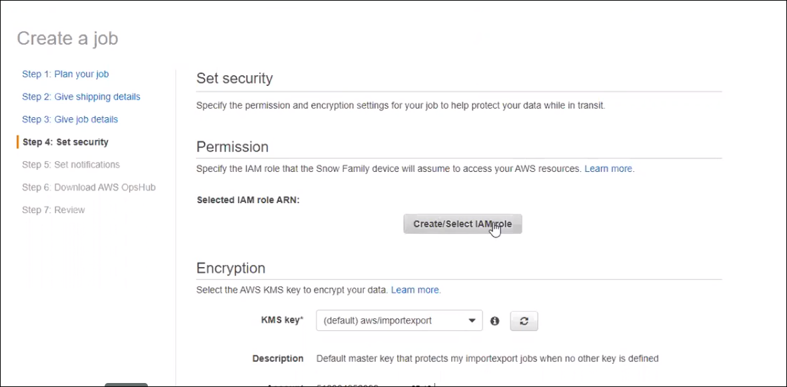

Here we can **create the select IAMrole**, click on it, and create a role, one click role will be created, and we are going to give the permissions.

Now security for the data can be done as, there is no option to disable this encryption, we must do it.

After the job creation once the device is arrived on premesis,wea re going to get a unlock code and manifestly, without these two we can start the device or unblock the device.those two will be available in AWS account only.

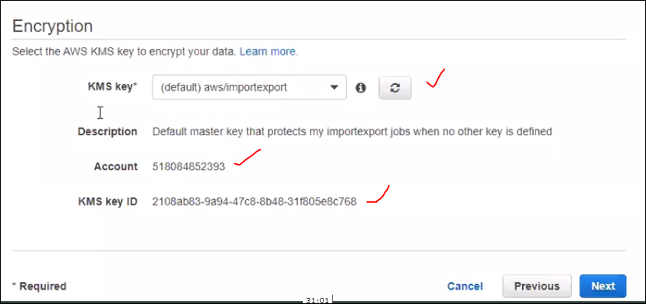

If we need any notifications we can create the SNS service

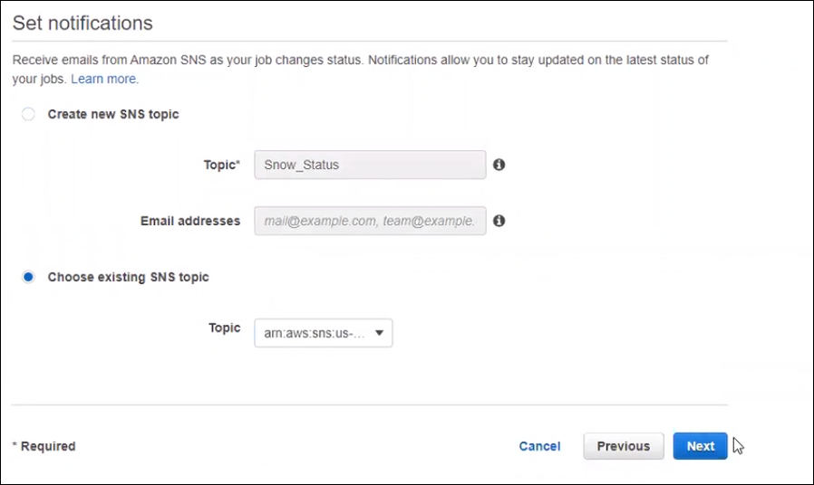

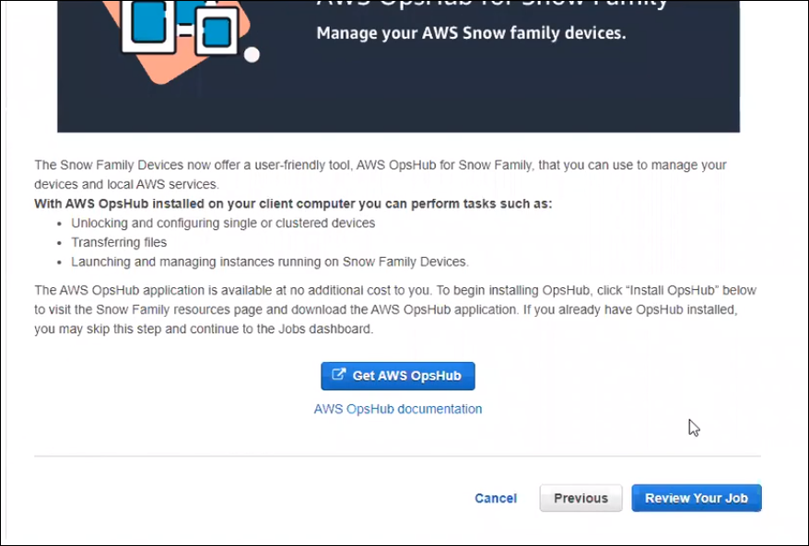skip this at movement.then click on review your job.

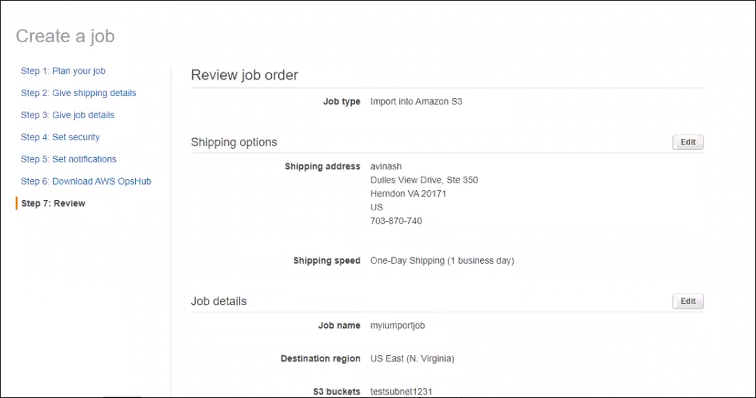

If we click on the create job , amazon will going to sent eh device to mentioned address.

If it is created a accidentally we can delte it with an hour, they wont charge.

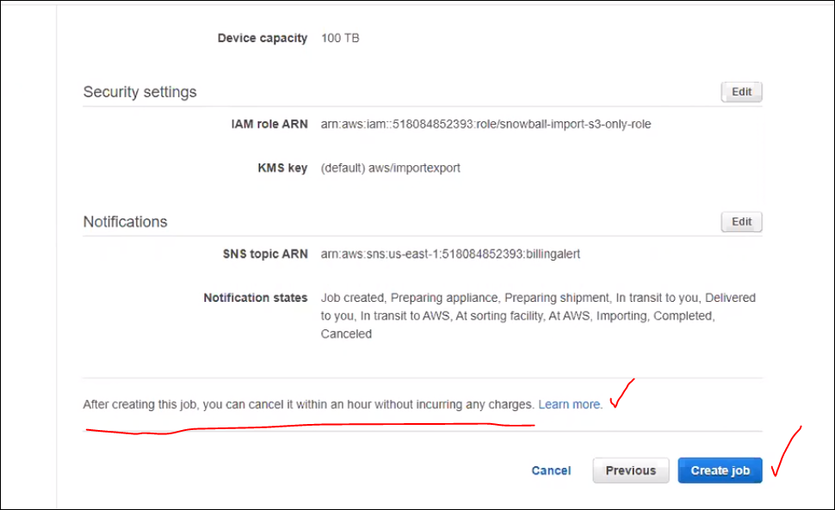

<https://aws.amazon.com/snowball/faqs/>

all details about snow ball in the above link.

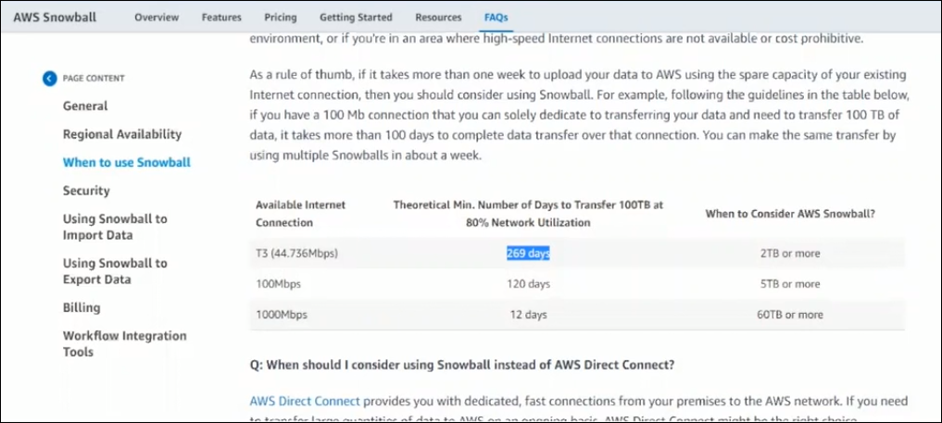

Once this is completed, we will have job details like this,

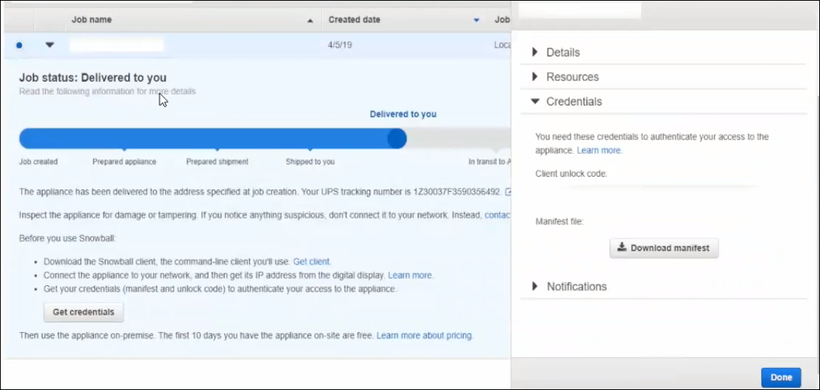

Here we can see the created date, and status as ddelived to you, and right side we can see the client unlock code and manifest file, without these two we cant do any thing witht deivce.

We are not going to share these deteails with courier guys or whi ever is shipping this deivce.

To start the device we need client unlock code and Manifest file, so we need to download the Manifest file, and copy the Client Unlock code and run couple of commands.

We need to install snowball/ snowball edge client , basically we will have this option , from what server will going to initital this,tri=ansfer, or what deivce,

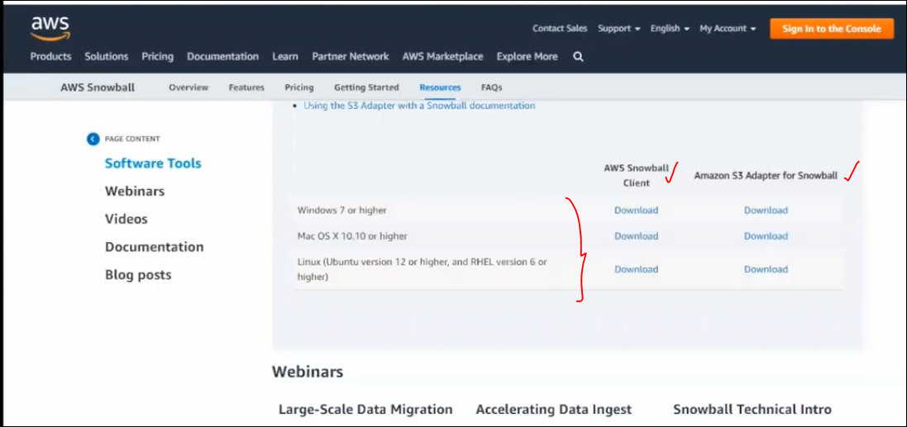

Even we have snow ball edge resources also, from this site we can down the client and install.

<https://aws.amazon.com/snowball/resources/>

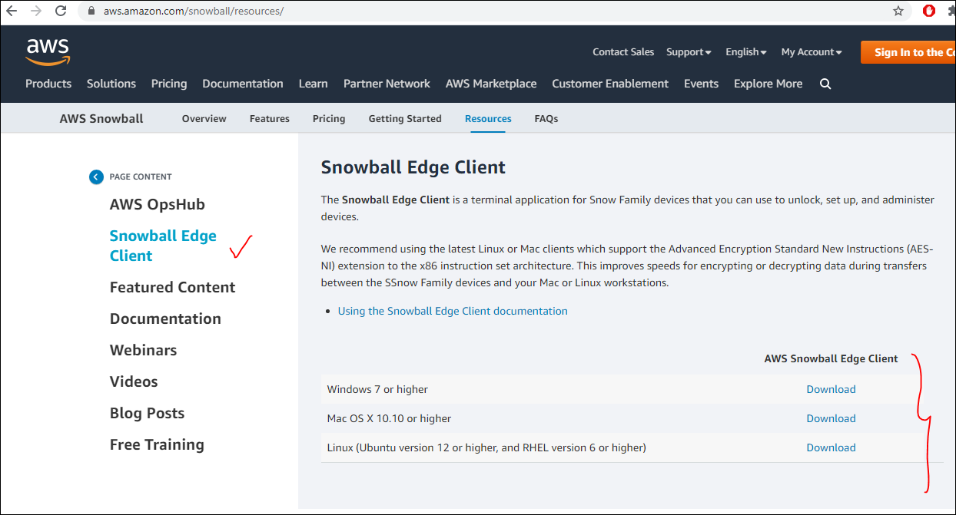

After running this , we nedd to run the command called awssnowball commands.

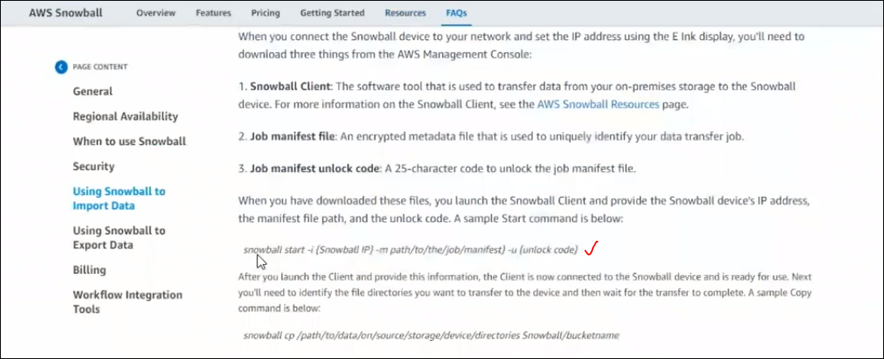

When ever we connect this snowball device to our network, we will get an ip address, that ip address will be provided by local dhcp server.

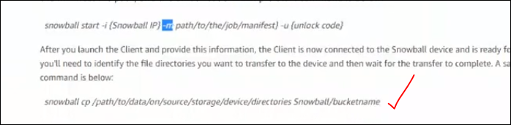

While creating the job we have given the bucket name that name we need to provide here.

We will have touch screen on the device, by using that we will the the ip address and all.

* Snowball doesn’t have any GUI.
* Suppose if we need entire data [ OS, dB running is Sap app ] to replicate then how we are going to do it,actually we don’t use snowball, we use Migration Hub related applications, by using these apps we will migrate them.
* Snow ball is used to share any kind / format file to AWS. Like we have data [flat files ]at D drive and need to move to AWS, we can achieve with Snowball. But not he OS, and lift and shift things.
* There is no limit for S3 bucket, there is unlimited storage, there is not pre provision is required, i.e, defining the size before using. It wil scale automatically.

We can google for snow mobile.

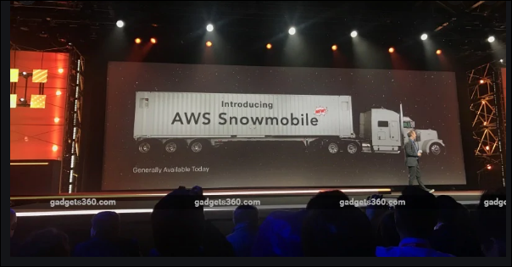

<https://aws.amazon.com/snowmobile/#:~:text=AWS%20Snowmobile%20is%20an%20Exabyte,by%20a%20semi%2Dtrailer%20truck.&text=Transferring%20data%20with%20Snowmobile%20is%20more%20secure%2C%20fast%20and%20cost%20effective.>

There is no direct option to order, we need to contact AWS to get this, Amazon will sent this device to our Data center. and connect to our data center, and copy all the data from the data center ON- primesis, and sent it back to AWS. It is Petabyte scale container.

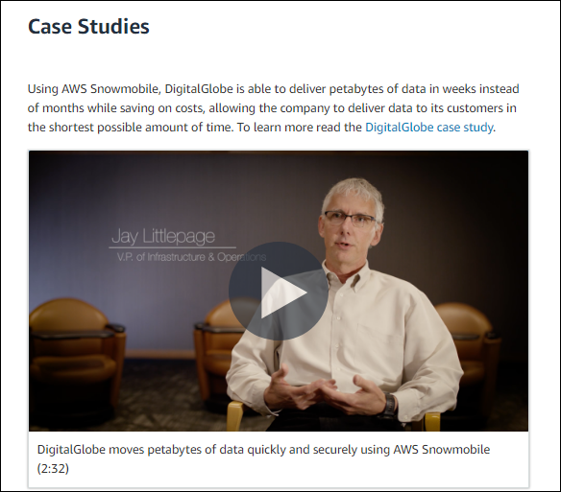

By sing this options we can migrate the data.

Without internet we can establish communication between our on premesis resources and AWS resources. By using an option AWS Direct Connect: we are going to get a dedecaited fiber cable to our on premesis enviramonet.

AWS won’t make any fiber cable from Mumbai to Hyd, basically they will have parters, with theire help,

<https://aws.amazon.com/directconnect/#:~:text=Using%20AWS%20Direct%20Connect%2C%20you,experience%20than%20Internet%2Dbased%20connections.>

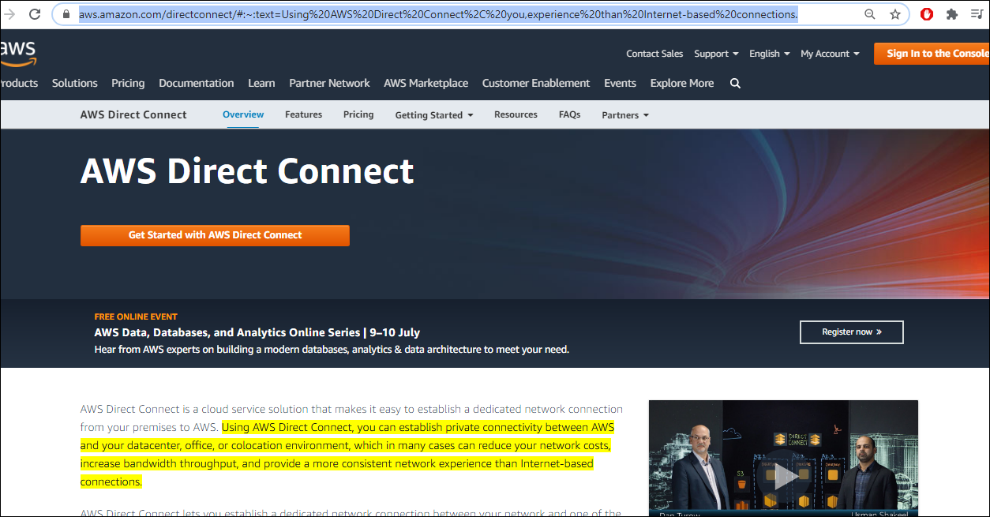

We can find it in AWS management concole, 🡪 networking & Content delivery,

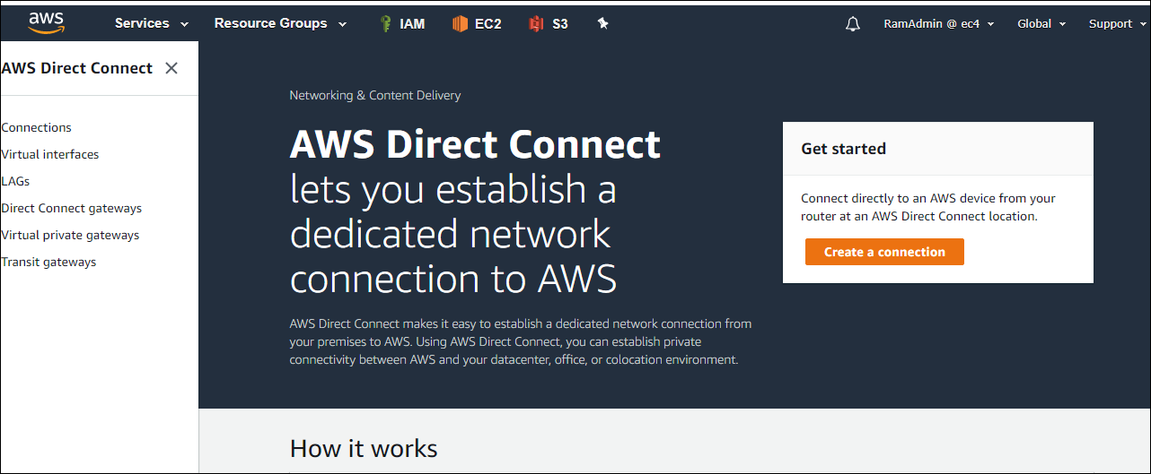

Create connection

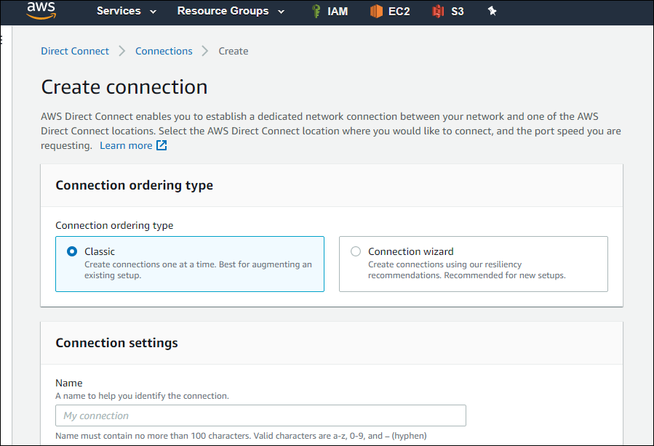

This is how we will select the requied options to make direct connect.

So if we don’t to use allt he swowball options to upload or download data to S3, w can go for AWS Direct Connect.