D: 27/06/2020

Step 1 : Choose an AMI.

--> Choose an Amazon Linux 2 AMI (Amazon Linux AMI, Redhat, Ubuntu, Suse)

Step 2 : Choose instance type (t2.micro)

Step 3 : Choose additional option

Step 4 : Choose Storage.

Amazon Linux: 8 GB Standard / Magnetic

Step 5 : Add tags

Step 6 : Configure Security Groups

Windows : RDP : 3389

Linux : SSH (Secure Shell) : 22 : 0.0.0.0/0 / Custom / MyIP

Step 7: Review and Create a Key pair.

General in Organizations we will create on Windows security Group and for Linux we will maintain another one.

Basically Amazon will give 5 years of support for this OS.if we face any issues amazon wil fix it.

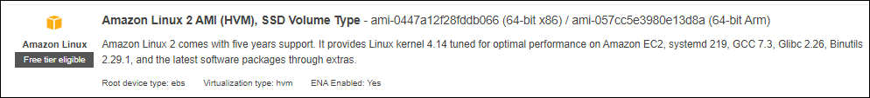

So that the reason most of the organizations will go with this. For Red hat and all we need to pay for the support.

It is similar as how we create the instance for windows.

But we don’t need any additional application/ software to connect to use /run the Linux instance, in that case select the Linux instance go to actions 🡪 select connect 🡪 here by default it will select the standard SSh client, by using this connection method we can connect to the instance, with help of putty.

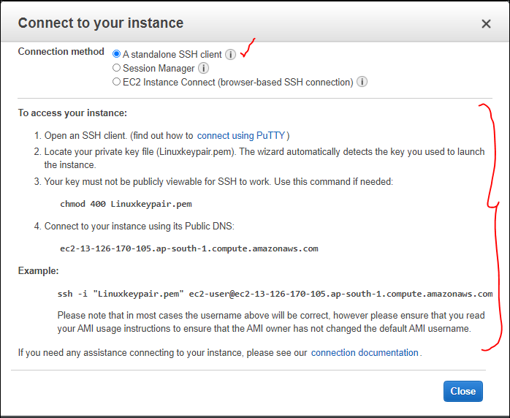

This is browser based we can connect to instance.

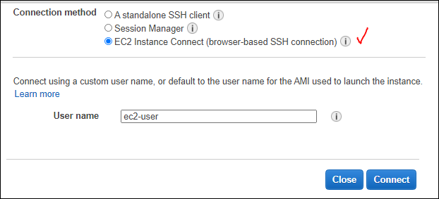

Default Username for Most of the Linux Instance i.e., “ [ ec2-user ]”.

redhat : ec2-user / redhat

ubuntu : ec2-user / ubuntu

when we click on the connect a session will estrablish to connect via browser as shown below:

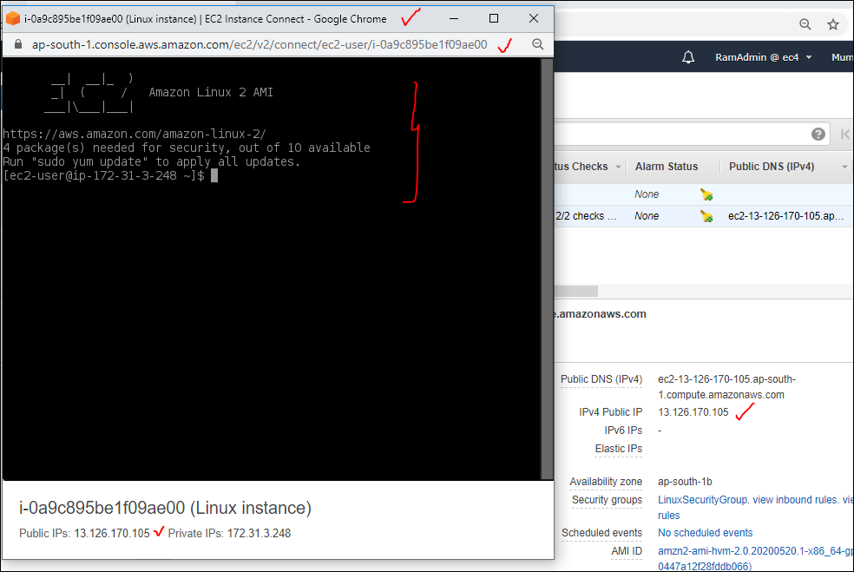

Now type a command “ sudo su “ , then we will connect to root user.

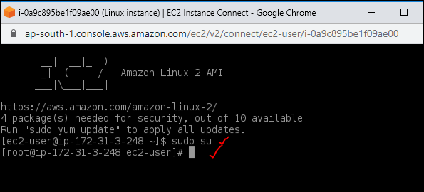

There are different ways to connect to the instance, as listed below:

Option 1 : Select Instance, Navigate to "Actions" --> Choose "Connect" -->EC2 Instance Connect (browser-based SSH connection) and the Default UN is “ ec2-user”.

Option 2 : Enable Open SSH on your windows Desktop and Use your command prompt to connect to Linux Instance..

https://winaero.com/blog/enable-openssh-server-windows-10/

If SSH is not enabled in the windows system, then an error msg will be displayed in the CMD.

**“ SSH is not recognized as an internal or external command, operable program or batch file.”**

So to enable that go to **App and Features** in windows

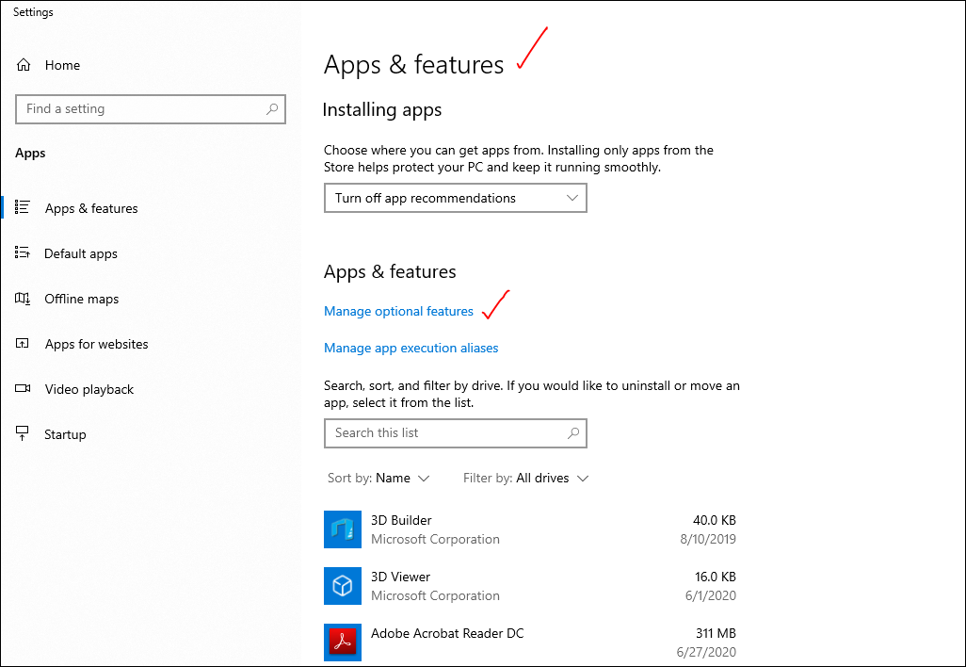

Here we need to install it open SSH client.

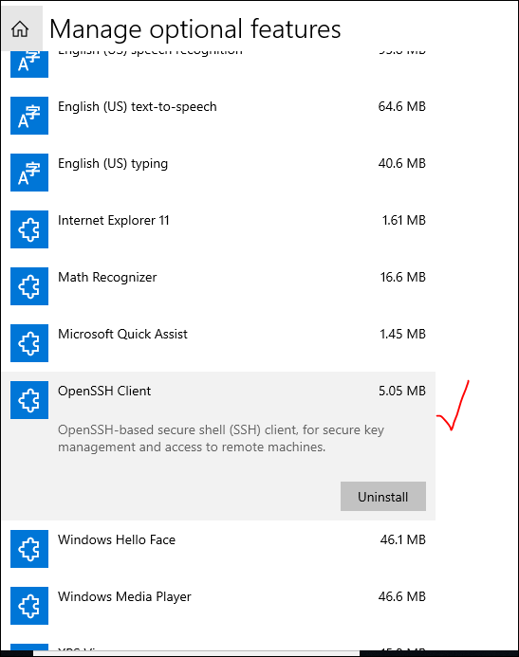

Once those settings we change then we can use cmd to connect to it

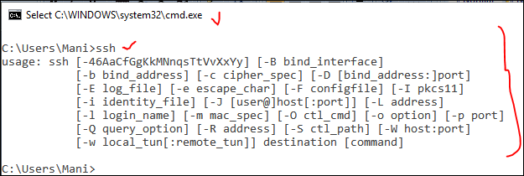

--> Navigate to the path where our keypair is stored and select the folder path and type cmd to directly open the command prompt from that location.

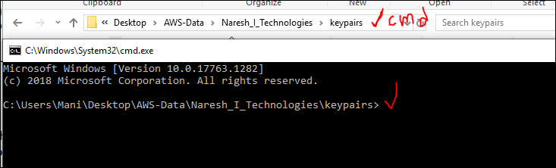

To verify that Key pair is available in that location or not type “ **dir “**

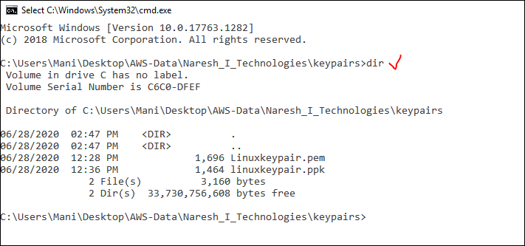

So after getting confirmation, that .pem file is available in the location, we can execute command from this location.

Suppose if we are in different path and trying to connect to it, where the .pem file is not available, it wont connect and end up with error.

The command for Mac/Linux is “ [ ssh –i keypairname defaultusername@publicaddress ]” here -i means providing our identity.

Mac/linux: ssh -i keypairname ec2-user@publicaddress

So here in linux we don’t have a concept of username and password, only by using the the keypair we are going to connect.

Command [ssh –i linnuxkeypair.pem ec2-user@13.126.170.105]

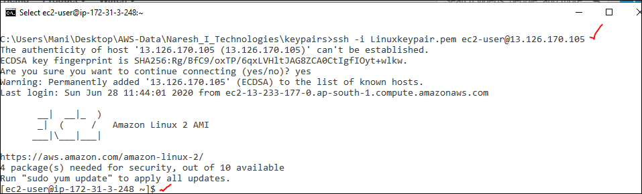

This is how we connect to instance by using cmd.

Use cmd [ whoami ] we can see the user name

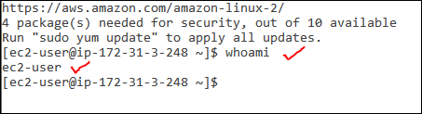

So if we give exit it will logout from the instance and again if we give whoami then it will show the current windows user name.

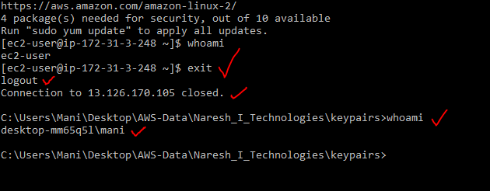

This ssh option is available in windows 10 , for any other veriosn of the windows we can use this below

option 3 : Use GIT option.

--> Install "GIT for Windows" and use GIT bash.

https://git-scm.com/download/win

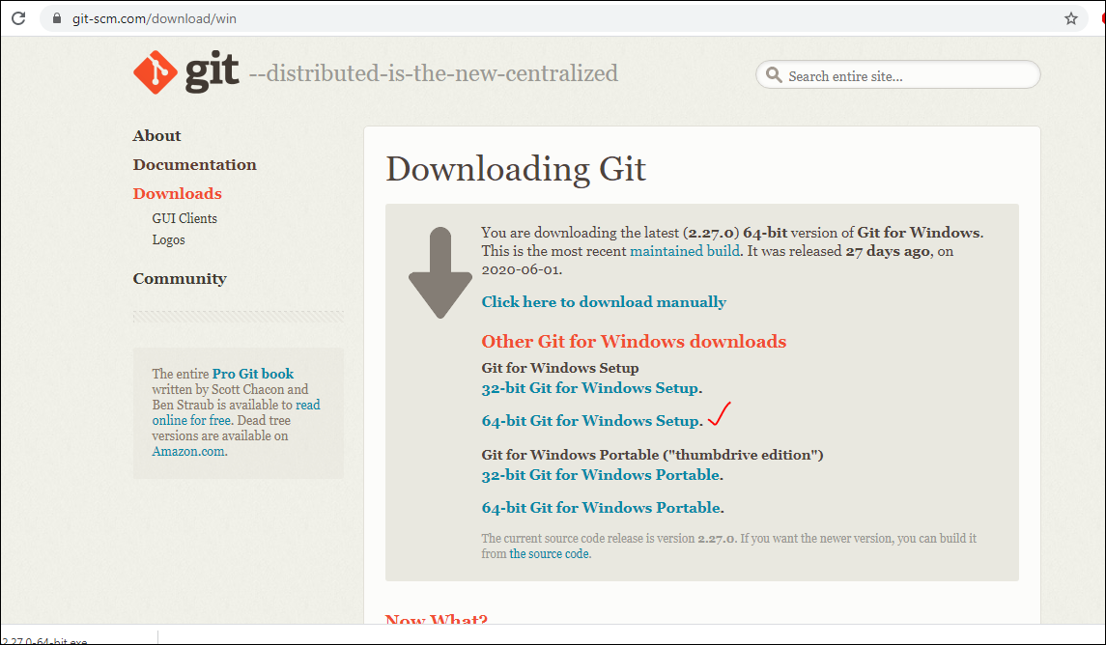

once installation is completed then we get two options like “**Git GUI Here “ & Git Bash Here”**

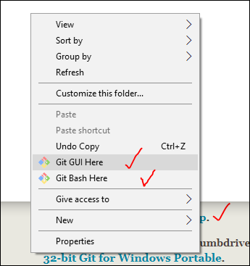

After installation Git, now go to the key pair where it is stored, right click and slect ethe **Git bash Here** ,

Go to the folder, where our keypair is stored. Right click --> "Git Bash Here"

Here we have an advantage that all the linux commands we can give it in windows also.

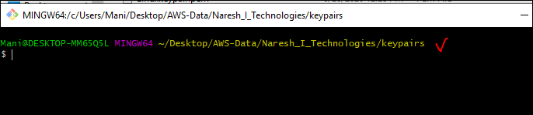

So for example if, we open thewindows cmd and type **ls** it will give an error. But if we use the same command in Git we can get the results.

All available files it will list here.

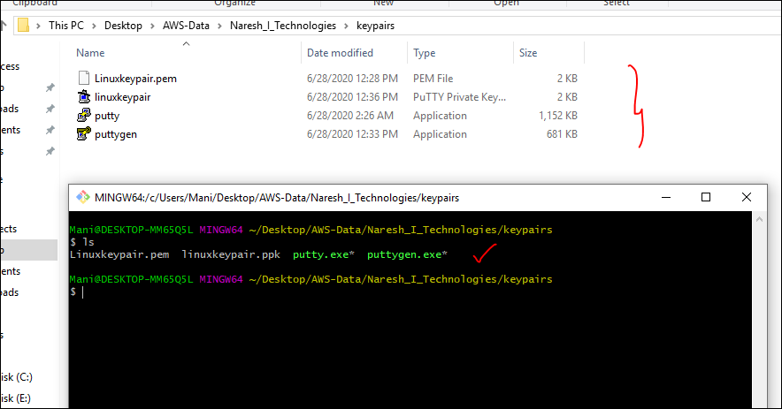

Basically **ls**  is a linux command but it is working in the windows machine also with help of Git.

So use the same command

ssh –i linuxkeypair.pem ec2-user@ 13.126.170.105. it will connect [ here keypair name and publicaddress will vary ]

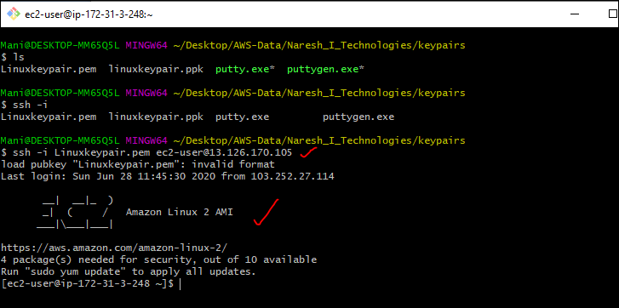

ssh -i keypairname ec2-user@publicaddress

**Option 4** : Using Putty. It an application , it involuves many steps.

Go to 🡪 putty.org and download the "Putty" and "PuttyGen" then we anuse it to connect to instance.

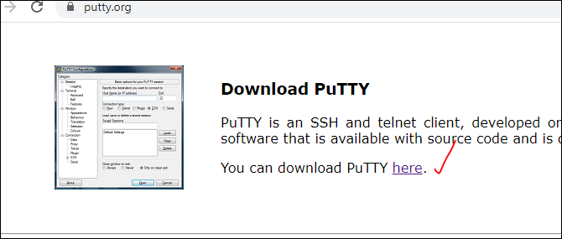

Any thing we can download, if we nned it to be installed or direct to execute it.

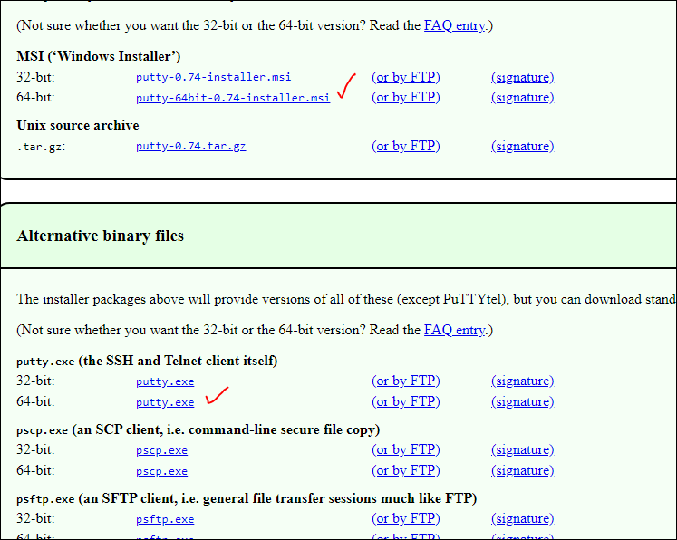

Putty application doesn't support .PEM format, It needs .ppk file. Now we need to convert the existing .pem file to .ppk file using "PuttyGen".

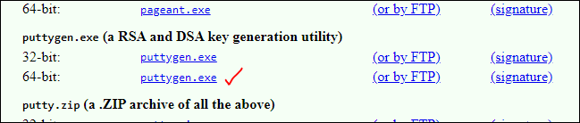

Or while generatignt he keypair from AWS we can select ppk :

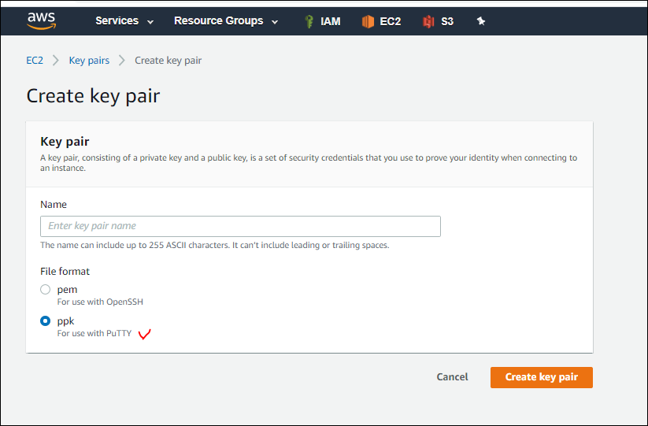

Putty gen will look like this

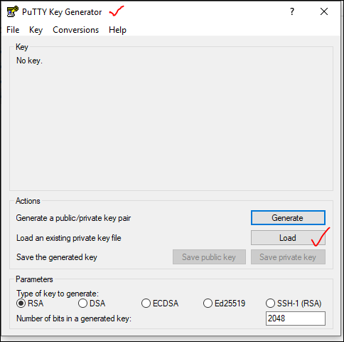

So if we click on the generate it will generate the public kley and private key but, we already have apublic key bu the format is in .pem, so we will load that .pem file to get the .ppk file.

After loading the file we wll ge thte ppk file

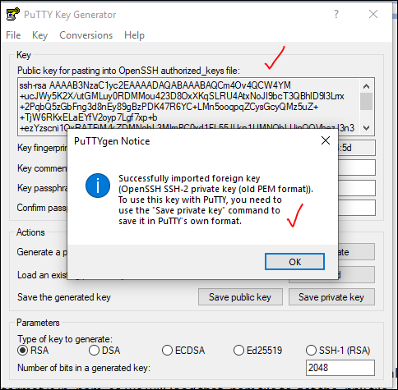

After generation, we need tto save the key as private key, so select the “ save private key “

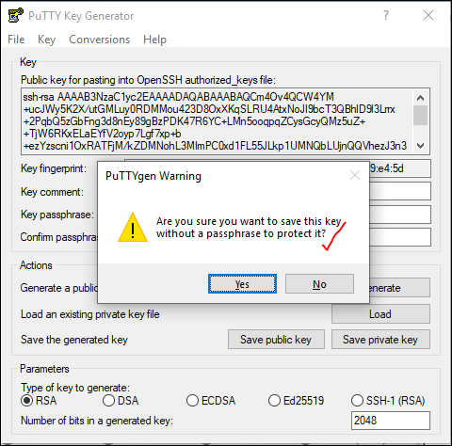

Then we can save the key in our local machine.

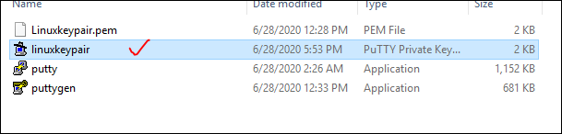

So by using this ppk file along with the putty fiel to conenc to AWS instance.

Now open the putty configuration and provide the IP address,

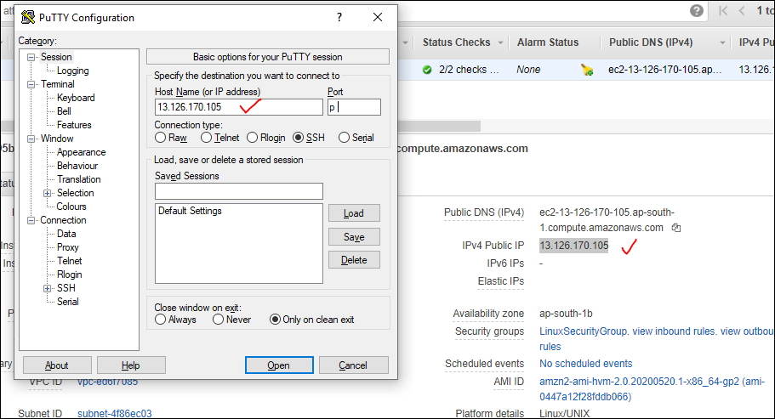

And expand the SSH and select the Auth

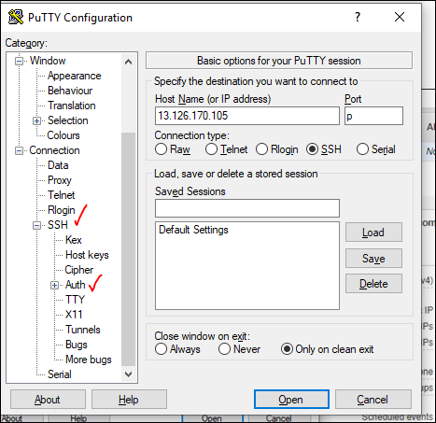

Here select the Auth [ authentication] and browse for the .ppk file

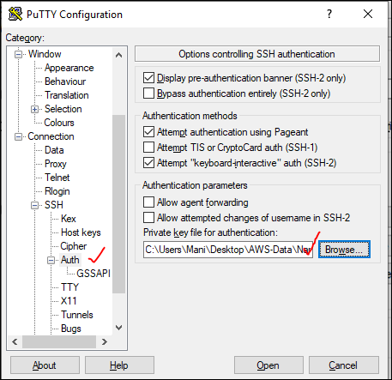

Then click on open ,we can see the putty cmd , then eneter the default user name “ ec2-user’

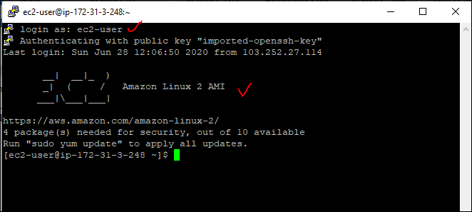

Open putty --> Give the "PublicIP", Navigate to COnenction --> SSH --> Select "Auth" --> Browse the Converted .ppk file. CLick on connect.

If we give the .pem file instead of ppk, then it will end up with the error msg.

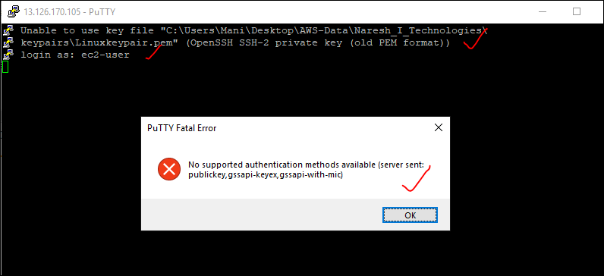

In cmd line we can see the old pem format, and after that if we eneter the user name, then Putty fatal error will come.

Along with the putty we have another app like **mobaxterm,**  we use to connec tot Linux instance.

**The Best PuTTY Alternatives for SSH clients**

1. **KiTTY**. **KiTTY** is a fork of PuTTY. ...
2. MobaXterm. MobaXterm is free of charge for home use and there is also a paid version for businesses. ...
3. mRemoteNG. ...
4. Bitvise **SSH** Client. ...
5. Xshell 6. ...
6. SuperPuTTY. ...
7. PuTTYTray. ...
8. mintty.

__________________

We are going to Make Linux instance as a Web Server..!!

Once connected to the Linux instance , we can know which user is working we can gie the command [ **whoami** ].

Even this whoami will for work local cmd also.

Coming to Linux : ec2-user is a member of an administrator user.

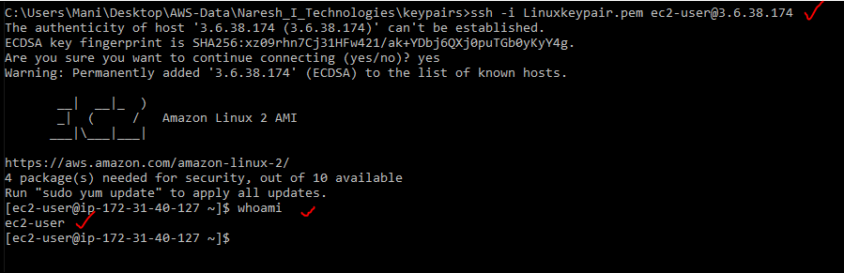

If we need to execute any command with admin permissions we need to give “**sudo”**

These are some of linux commands as listed below:

1. whoami --> tells us as a what user we are working now.
2. sudo su --> Switch to root user.
3. yum update -y --> update our OS with latest patches (updates).

🡪most of the windows patches will be released on second week Tuesday.

🡪there is no particular day for the linux, as it is community , lot of releases, fix, bugs and patches will be happned.

So if we give any commands it will show a msg that we need to be as a root user to perform any thing.

**[ec2-user@ip-172-31-40-127 ~]$ yum update -y**

**Loaded plugins: extras_suggestions, langpacks, priorities, update-motd**

**You need to be root to perform this command.**

Even in windows we use cmd as **Run as administrator** by right click on it.so to perform any commands we need to be as root user.

So to perform any action as a ec2-user , w can use **sudo** as a prefix to the command ,

Now changing from ec2-user to root **sudo su**

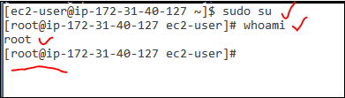

If again we need to be ec2 user from root then give **exit**.

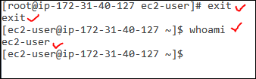

Simply if we give **yum update**  it will ask in middle permissions, to directly we are giving the yes option as **yum update –y**

What ever application we need to install into linux we can use the command **yum,**

yum --> **Yellowdog Updater Modified**

we will have all the applications from the trusted repositories. Only the thing we should know the package name to get install it.

**yum install “package name”**

ex: yum install httpd -🡪 it is for apache server.

We will try to install mysql and will cancel it

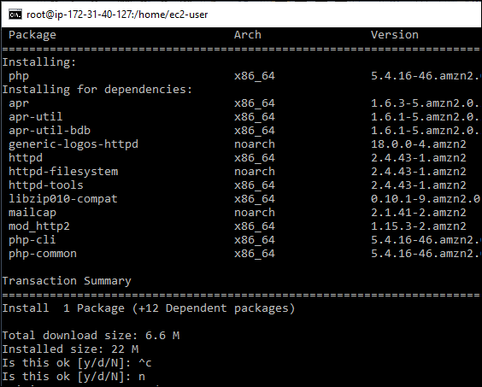

We no need to download any file to execute it, it will get all the required packages from the trusted repositories.

Before **yum** we have **rpm** --> Redhat package manager, it has to download and need to perform the actions, but now it doesn’t required to do so.

yum install "packagename"

now we are making a web server by using this command [ **yum install httpd –y** ]

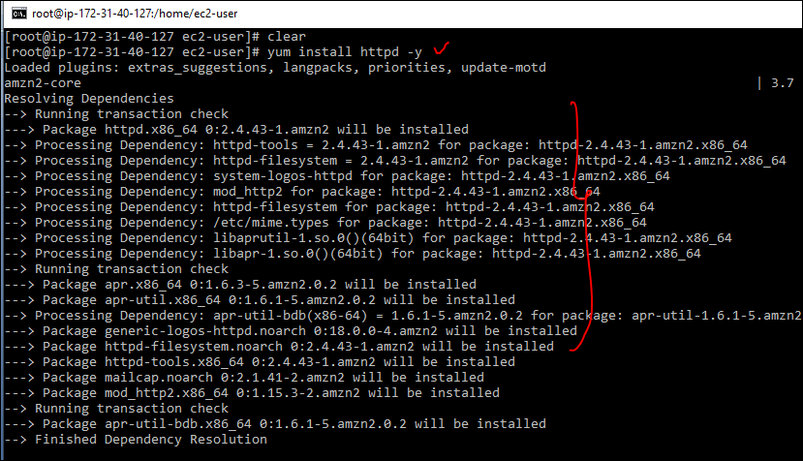

But how to know the output, no the reason is we have installed but what abt service status. In windows we have [ services.msc ].there wee can see which service is working or not.

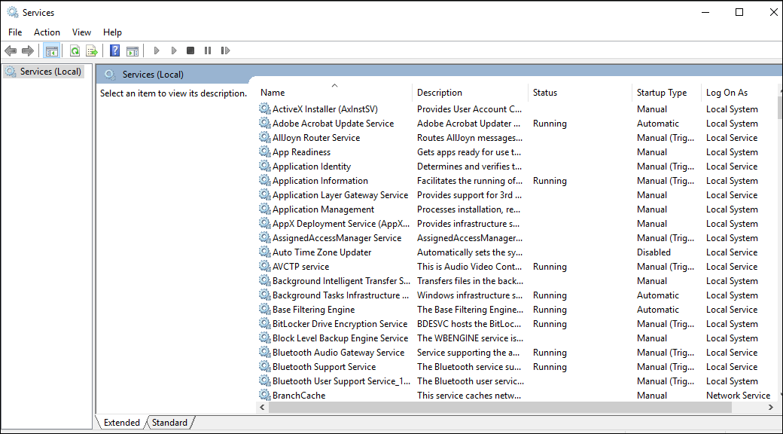

So similarly we need to know the service status, so we use the command [ **service httpd status** ]

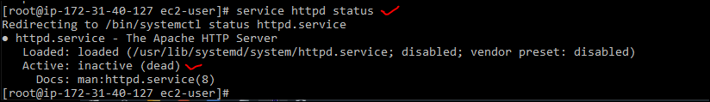

Here actually the service is not active, so we need to make it active.

service httpd start / stop / restart / status

so we can use the above once to start/ stop/ restart/ status.

So now we will start the service httpd i.e., apache server.



Now we can check the status of the service httpd.

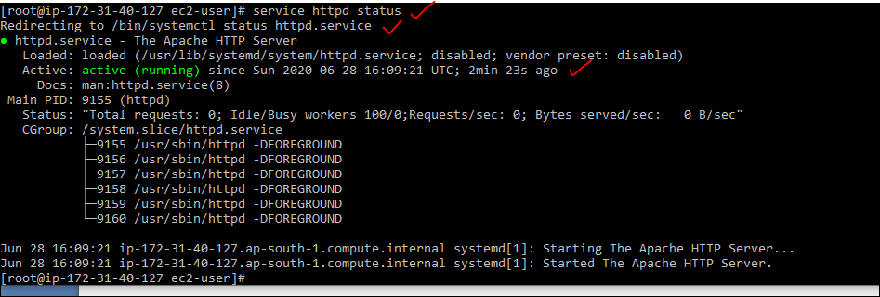

Now we will try the id address in browser to load the web page.as we created the web server.

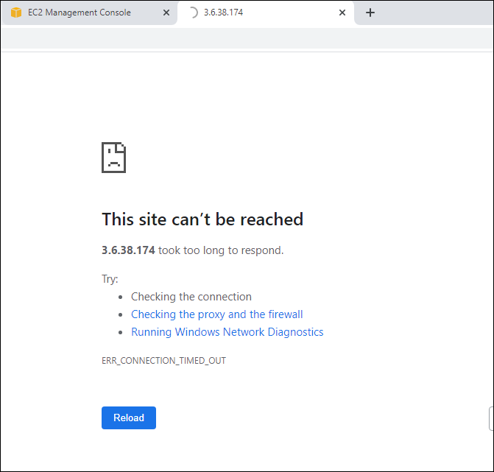

There is no issue with the server as it is active , but we need to give open the http port in the security group in bound rules.

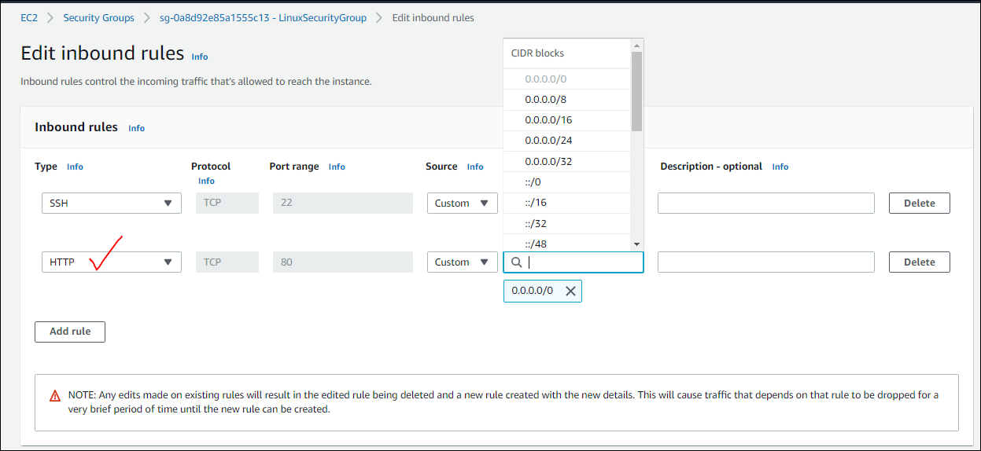

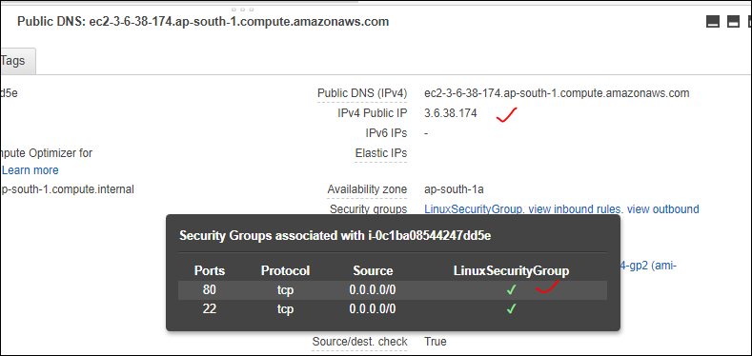

Now we can see the test web page of apache

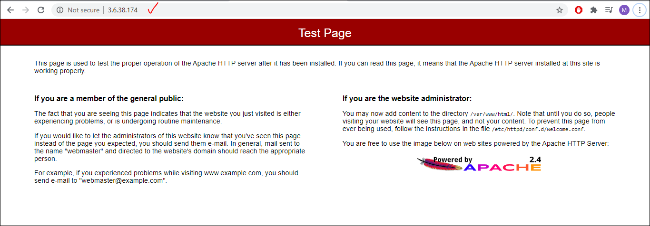

Suppose if we reboot the instance in AWS in the actions then IP address will change,

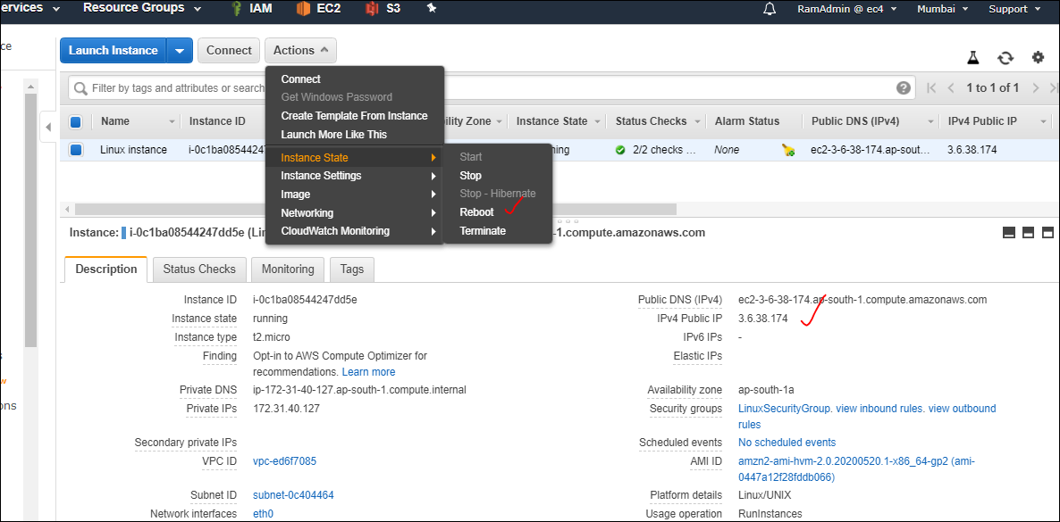

As service is active but it is disabled as manually we need to start it as login / start up service.

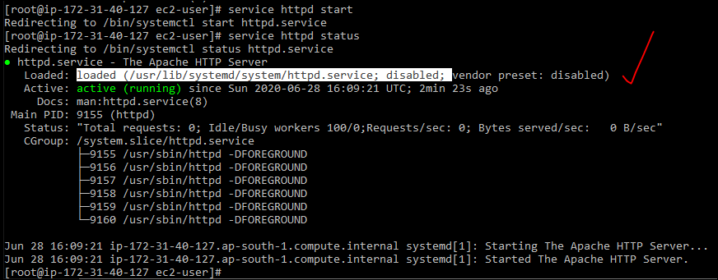

For ex: we can see in windows we will get an idea,

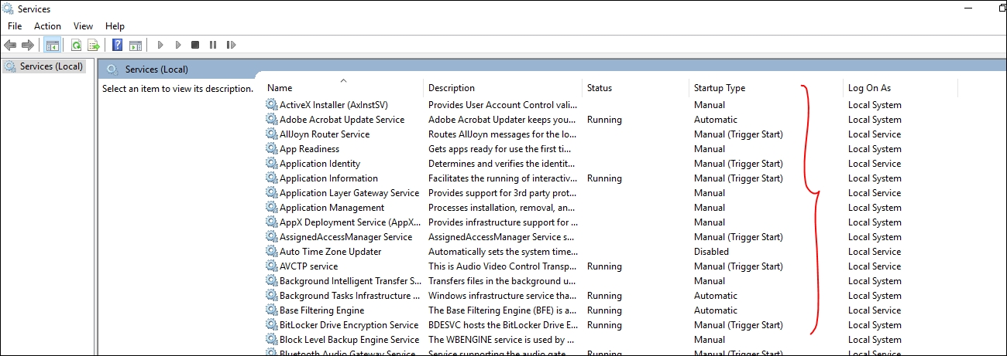

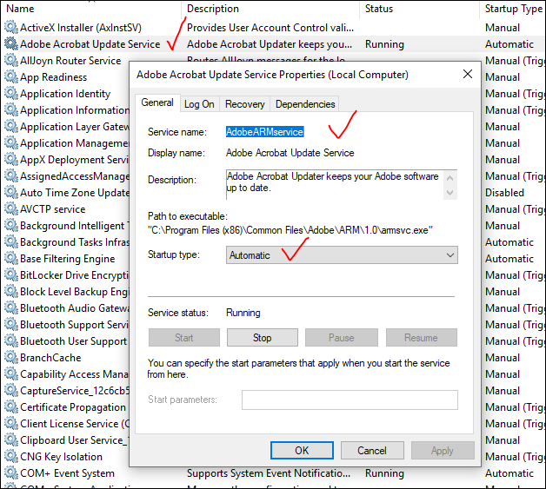

In the same manner we are going to achieve the service as logon / start up service.

1. service httpd start --> To start the Apache service
2. chkconfig httpd on --> To make httpd as a logon service / startup type as automatic



this is how we will make a web server,as we did with apache server.as a part of task 1

Task : Launch a Linux instance and make it as a Apache webserver.

-------------------------------------------------------------------------------------------------

Task 2 : Launch an Linux Instance and make it as Nginx web server.

Now we are launching the Aws Linux and we are using the command **yum install nginx.**

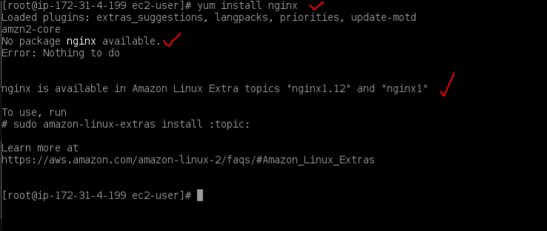

And found the error, as nginx package is not available and we need to run the command as

As nginx is available in amazon linux extra topics “nginx1.12 ans nginx1”

[ sudo amazon-linux-extras install nginx1 ], [ sudo amazon-linux-extras install nginx1.12 ]

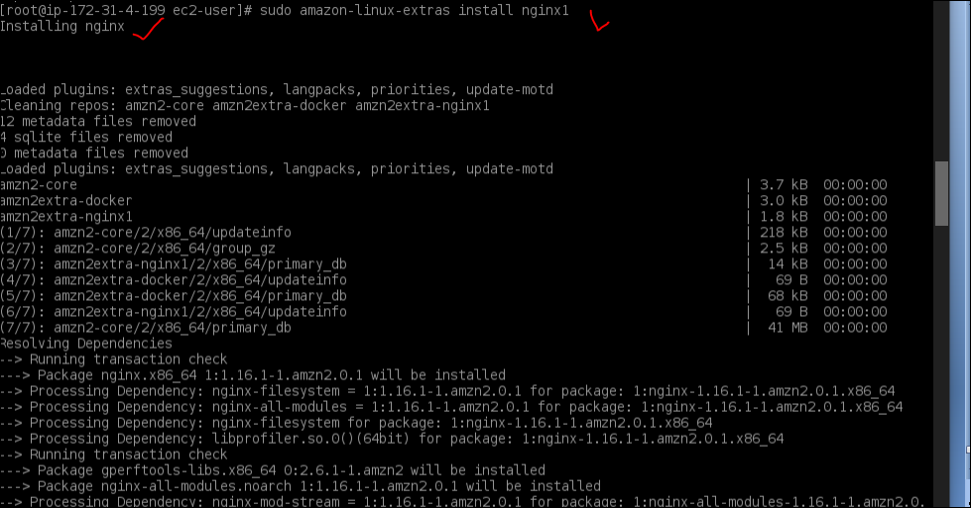

In middle we need to make it as yum install nginx

And again y

Installation finished now we need to start it.

Now check the status of the nginx

**Sudo service nginx status**

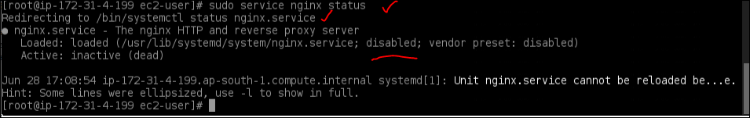

It is disabled state, so need to start the service.

Sudo service nginx start

After we can see the nginx web page with same ip address.



