**KAMARAJAR GOVT ARTS COLLEGE**

**SURANDAI**

**TENKASI – DISTRICT**



**April – 2023**

**Identify Patterns & Trends In Campus Placement Using Machine Learning**

**Team ID : NM2023TMIDI9488**

**Team Leader : Maniammal. M**

**Register No : 20201061506116**

**Member 1 : Anusha. A**

**Register No : 20201061506103**

**Member 2 : Arul Merlin. M**

**Register No : 20201061506104**

**Member 3 : Murugeshwari . M**

**Register No : 20201061506126**

**Member 4 : Aswini. B**

**Register No : 20201061506106**

**Table Of Content**

**1 . Introduction Machine Learning : 4**

**2 . Overview : 4**

**3 . Result : 7**

**4 . Advantages & Disadvantages : 13**

**5 . Applications : 15**

**6 . Conclusion : 15**

**7 . Future scope : 16**

**8 . Appendix : 16**

**PROJECT REPORT TEMPLATE**

1. **Introduction**

**Campus placement are the process of providing job opportunities to graduating students from educational institutions . Over the years, campus placements have evolved significantly, with new trends and patterns ysing these patterns and trends can help students make informed decisions about their career paths and prepare themselves better for the job market. In this report, we will explore the various patterns and trends that can be observed in campus placements, including industry preferences, job roles, salary packages, company preferences, gender diversity, the impact of COVID-19, and location preferences. By understanding these trends and patterns, students can plan their career paths better and universities can tailor their programs to better prepare students for the job market.**

**1.1 Overview**

**Identifying patterns and trends in campus placements is essential for students, universities, and companies alike. By staying up-to-date with the latest trends and patterns, students can position themselves for success in their careers, while universities can better prepare their students for the job market, and companies can attract the best talent for their organizations.**

* 1. **Purpose**

**Career planning : By understanding the current trends and patterns in the job market, students can make informed decisions about their career paths, focusing on industries and job roles that are in demand.**

**Curriculum development : Universities can use this information to tailor their programs to better prepare their students for the job market, offering courses and training programs that align with the current demands of the industry.**

1. **Problem Definition & Design Thinking**

**2.1 Empathy Map**

**Educational institutions see a large number of students participating in campus placements.**

**Organizations see a pool of fresh talent to recruit from.**

**Organizations may face challenges in finding the right talent that fits their business requirements and culture.**

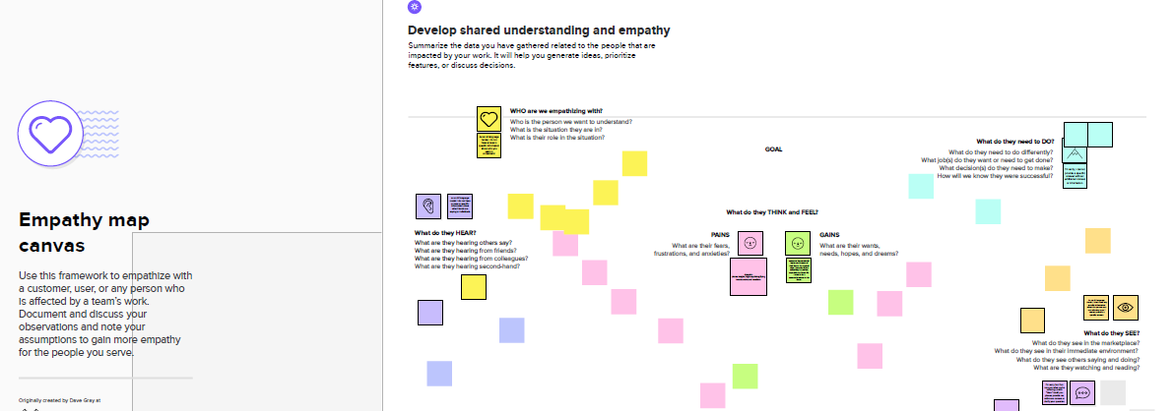

* 1. **Ideation & Brainstorming Map**

**Update the curriculum to align with industry demands and emerging job profiles.**

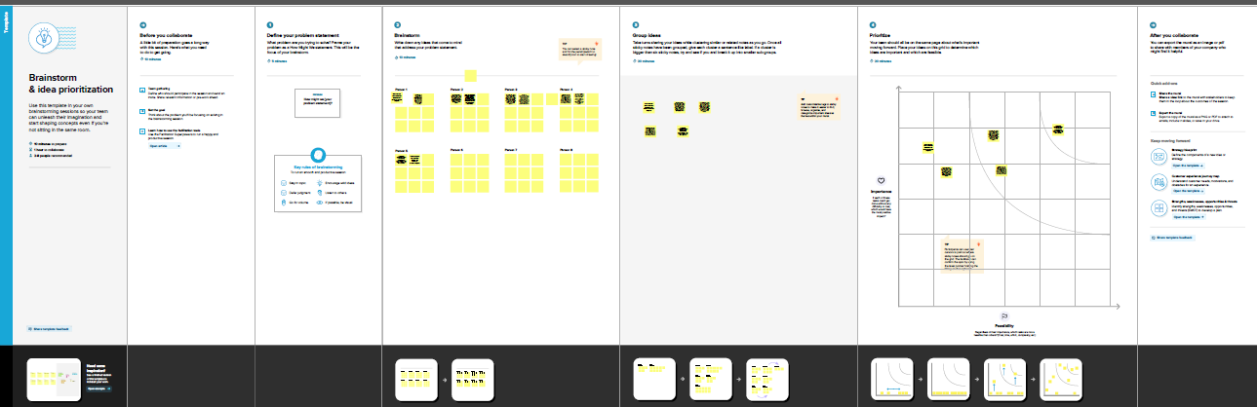

1. **RESULT**

**Activity 1: Collect the Dataset**

**1.1 Importing the libraries**

**1.2 Read the Dataset**

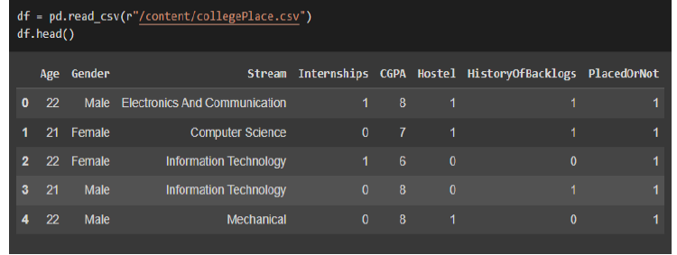

**Activity 2: Data Preparation**

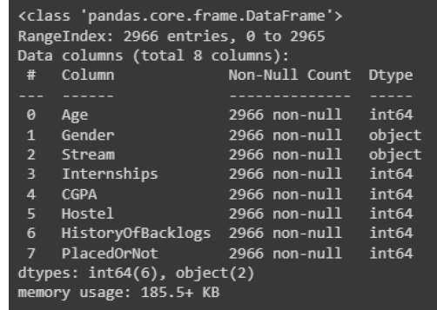

**Activity 2: Data Preparation**

**2.1: Handling missing values**

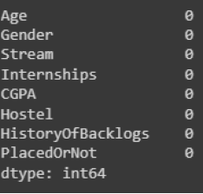

**2.2 Handling outliers**

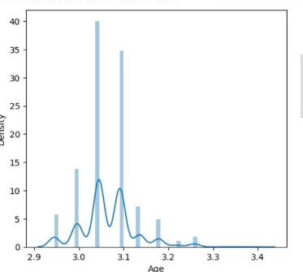

**2.3 Handling categorical values**

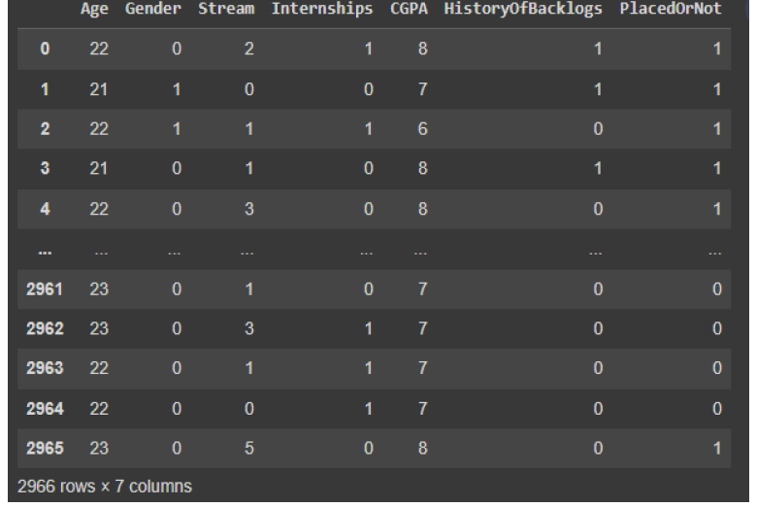

**Activity 3: Exploratory Data Analysis**

**1: Visual analysis**

**1.1: Univariate analysis**

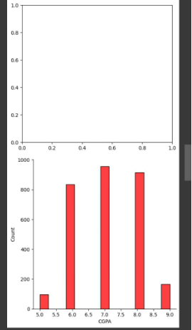

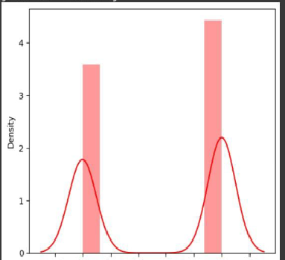

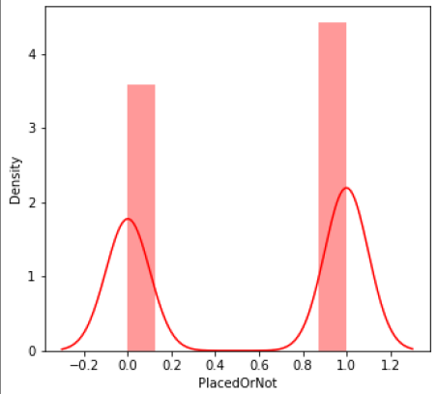

**1.3: Multivariate analysis**

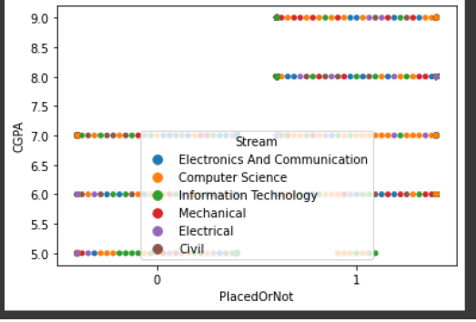

1. **ADVANTAGES & DISADVANTAGES**

**Advantages:**

* **Improving decisions-making : By analyzing patterns and trends in campus placement, institutions can make more informed decisions about recruitment strategies, placement procedures, and program offerings.**

* **Enhancing student preparation : Institutions can use data on placement trends to better prepare students for the job market by identifying the skills and experiences that are in high demand.**
* **Improving job placement rates : By identifying patterns and trends in job placement, institutions can develop more effective career services programs that help students find jobs in their desired field.**

**Disadvantages :**

* **Limited data : Depending on the size of the institution and the number of graduates, there may not be enough data available to identify meaningful patterns and trends.**
* **Unpredictable job market : The job market can be unpredictable, and past placement trends may not accurately predict future outcomes.**
* **Incomplete picture : Placement data may not account for students who pursue further education are start their own businesses, which can skew the overall placement rates.**

1. **APPLICATIONS**

* **Curriculum development : Analyzing the types of jobs and industries where students are being placed can help educational institutions in developing their curriculum to better align with the current job market.**
* **Career counselling : Identifying the patterns and trends in campus placement can help career counsellors in providing better guidance to students about the career paths they should pursue.**
* **Marketing and branding : Institutions can use the data on placement patterns and trends to showcase their success stories and brand themselves as institutions that prepare students for the job market.**

1. **CONCLUSION**

**In conclusion, identifying patterns and trends in campus placement can be beneficial for both students and educational institutions. It can help institutions develop their curriculum to align better with the current job market, provide better career counseling, engage with potential employers, and improve alumni engagement efforts.**

1. **FUTURE SCOPE**

**The future scope of identifying patterns and trends in campus placement is vast and promising. With the advent of technology, the process of data collection and analysis is becoming more efficient and sophisticated, which can lead to better insight and predictions. With the help of technology and data analytics, educational institution can provide better services to their students and prepare them for the future job market.**

1. **APPENDIX**

**A . Source Code**



