Karta is a system test automation framework which can be highly customized. The customization can be achieved using plugins. The core functionality itself can be extended via plugins.

Why another test framework:
Functional/System test automation frameworks are typically built by extending a unit testing frameworks which are more suited for development needs rather than functional and non functional system tests. This issue only gets compounded by the fact that test automation engineers prefer simpler development environment for tests compared to software developers. Another reason is existing mature test frameworks were built initially for on-premise applications and cloud/cluster/distributed and micro-services based applications need features like remote execution, execution in a distributed environment which are difficult to incorporate into existing frameworks. Also specialized tests like reliability tests like longevity tests, chaos(resilience) tests, cycle tests to measure failure rates need framework support and are difficult to implement with existing test frameworks.

Figure 1: 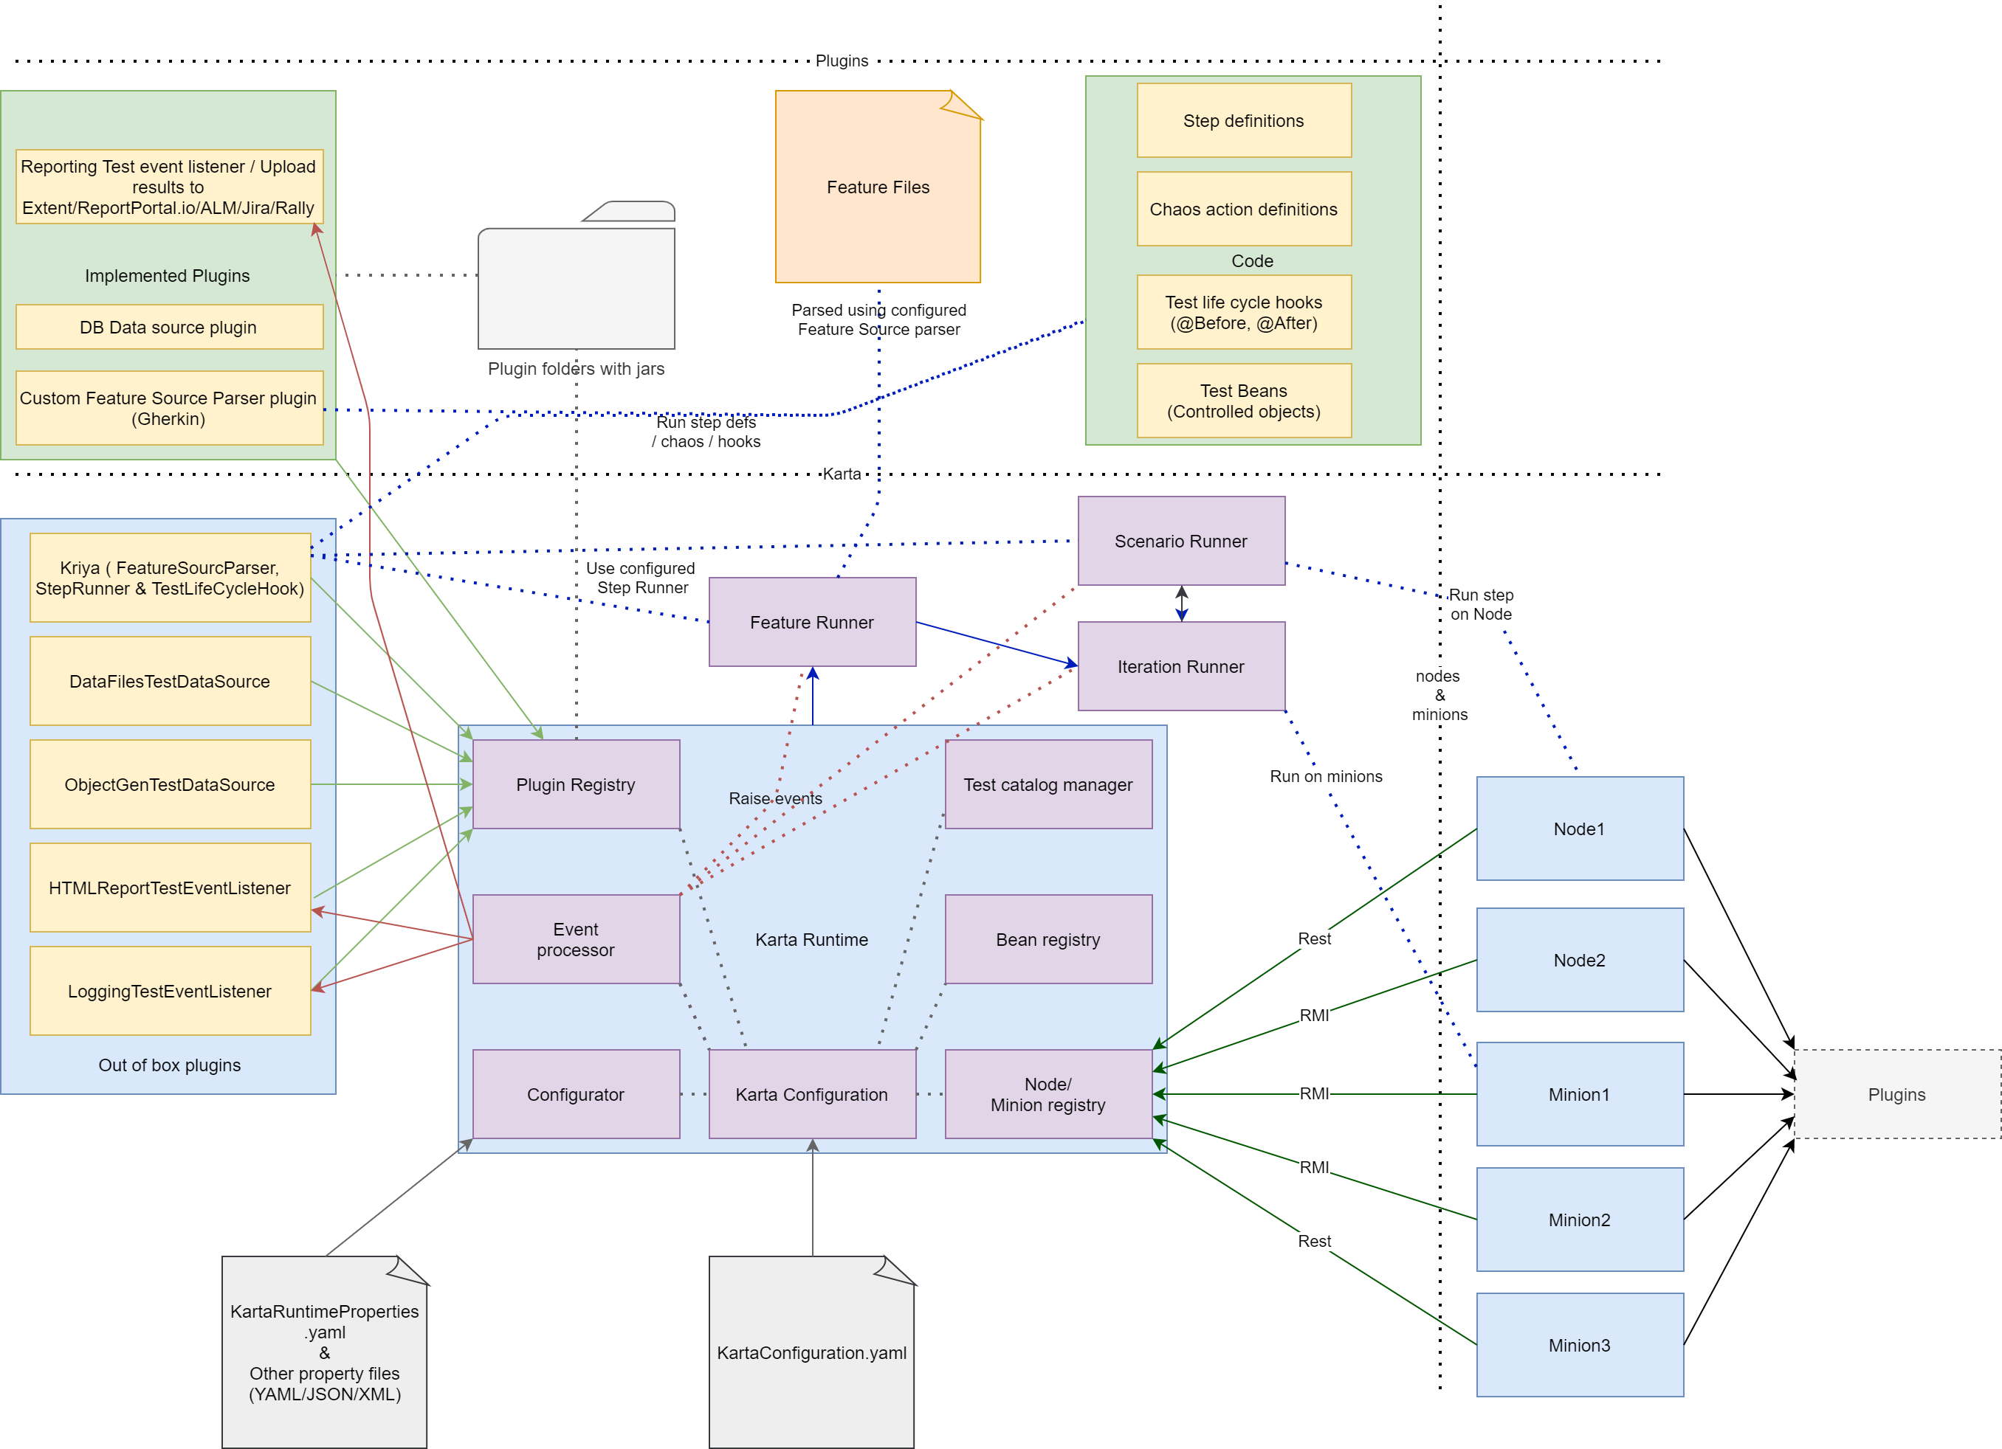Karta Runtime High level overview

Karta is designed primarily for BDD style component, system integration and reliability testing. Gherkin schema is compatible with Karta.

Test related entities/models:

TestStep: this entity describes a test step. Following are the fields of a test step.
- “identifier” (String): the BDD step identifier used to identify the step to run by step runners. The identifier can hold conjunctions like Given/When/Then and also inline test data depending on the notation supported by the step runner.
- “testData” (Map<String, Serializable): test data embedded into step definition analogous to Gherkin’s data tables read as map object.
- “testDataSet” (Map<String, List<Serializable>): possible values of test data embedded into the step definition analogous to Gherkin’s data tables read as object list. The values are cycled through each time the scenario is run.

TestScenario: this entity describes a test scenario. Following are the fields of a test scenario.
- “name” (String): the name of the scenario. Should be unique within a Feature.
- “description” (String)
- “probability” (float 0-1.0): this field indicates the probability that this scenario should be picked for execution when running random scenarios every iteration at feature(test) level.
- “setupSteps” (List<TestStep>): the list of scenario specific setup steps.
- “chaosConfiguration” (ChaosActionTreeNode): the configuration for performing a chaos action after performing scenario specific setup steps before running the run steps. This is used if performing chaos testing.
- “executionSteps” (List<TestStep>): the list of execution steps for scenario.
- “tearDownSteps” (List<TestStep>): the list of scenario specific tear-down steps.
- “testDataSet” (Map<String, List<Serializable>): possible values of test data common for all scenario steps analogous to Gherkin’s examples for scenario outline. The values are cycled through each time the scenario is run.

TestJob: this entity describes a test job. Jobs are like daemon process running throughout the life cycle of a test feature. Following are the fields of a test job.
- “name” (String): the name of the scenario. Should be unique within a Feature.
- “repeat” (boolean): indicates whether this is a one time job or a chronically repeating job.
- “interval” (long): this field indicates the probability that this scenario should be picked for execution when running random scenarios every iteration at feature(test) level.
- “jobType” (JobType enum): the list of scenario specific setup steps. Possible values are STEPS, CHAOS.
- “chaosConfiguration” (ChaosActionTreeNode): the configuration for performing a chaos action after if the job type is chaos action.
- “steps” (List<TestStep>): the list of execution steps for job if job type is steps.
- “iterationCount” (int): number of iterations for the job -1 for indefinite.
- “node” (String): the node on which to run the test job.
- “testDataSet” (Map<String, List<Serializable>): possible values of test data common for all job steps. The values are cycled through each time the job iteration is run.

TestFeature: this entity describes a test feature. Following are the fields of a test feature.
- “name” (String): the name of the feature. This should be unique to avoid ambiguity in reporting.
- “description” (String): the description of the feature.
- “testJobs” (List<TestJob>): this list of test jobs for the test feature.
- “setupSteps” (List<TestStep>): the list of feature setup steps. Runs once per feature.
- “scenarioSetupSteps” (List<TestStep>): the list of common scenario setup steps. Run for every scenario.
- “testScenarios” (List<TestScenario>): this list of test scenarios for the test feature.
- “scenarioTearDownSteps” (List<TestStep>): the list of common scenario tear-down steps. Run for every scenario.
- “tearDownSteps” (List<TestStep>): the list of feature level tear-down steps. Run once per feature.
- “testDataSet” (Map<String, List<Serializable>): possible values of test data common for all steps of the feature. The values are cycled based on the consuming entity like scenario or feature setup/teardown steps.

Interfaces

Plugin: A generic plugin class which other plugin types extend and generic plugins can implement. Every plugin is initialized once using the initialize() interface method and should implement close() method for cleanup (AutoCloseable).

FeatureSourceParser: A plugin interface which allows to parse test feature from source code. The in-built feature source parser plugin is Kriya which uses YAML for feature source format.

StepRunner: This is a plugin interface which runs prepared step definitions and chaos actions. This plugin should typically build a repository of step definitions code mapped to step identifiers strings. The in-built step runner plugin is Kriya which uses annotations @StepDefinition and @ChaosActionDefinition for mappings. The step runner will be called by KartaRuntime to run PreparedSteps and PreparedChaosActions and should return StepResult.

TestDataSource: This plugin interface fetches test data for a given step based on step identifer, scenario name, iteration index and feature name in the TestExecutionContext parameter and should return corresponding test data in the format HashMap<String, Serializable>. In-built test data source plugins are DataFileTestDataSource and ObjectGenTestDataSource.

TestLifeCycleHook: This plugin interface allows definition of life cycle hooks. The in-built test life cycle hook plugin is Kriya. Kriya uses @BeforeRun, @BeforeFeature, @BeforeScenario, @AfterScenario, @AfterFeature, and @AfterRun annotations to run user extensions based on test tag pattern (regex). Typically used to prepare automation environment and drivers before run, feature or scenario level and cleanup after. The hooks are called synchronously and set variables and beans in the scenario context registry.

TestEventListener: This plugin interface allows definition of listeners to test events typically used to implement reporting listeners. Out-of-box test event listener definitions are DumpToFileTestEventListener, HTMLReportTestEventListener, LoggingTestEventListener and RabbitMQTestEventListener.

