In this guide we will go through how to create a Karta test project from scratch using basic features and out of box plugins.

We want to create a sample UI automation project which opens chrome browser and does some UI interactions using Selenium web driver.

Prerequisites:
- JDK 1.8 (Sun/Open JDK)
- Maven for building
- An IDE (eclipse used for the example) with Lombok installed.
- Chrome browser and chrome driver.

Step1:
Create an eclipse project with java and maven natures.
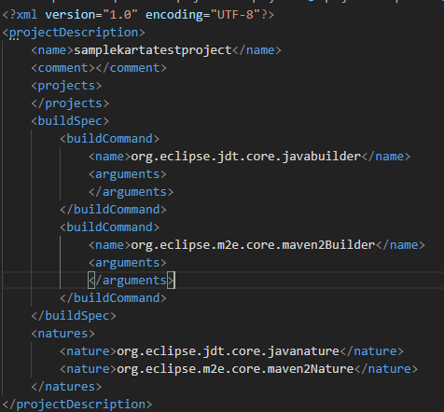

Figure 1: Project Attached as 7z archive

Step2:
Modify pom xml with dependencies and build plugin to copy dependencies (non provided) as jars to output.

<project xmlns="http://maven.apache.org/POM/4.0.0"
xmlns:xsi="http://www.w3.org/2001/XMLSchema-instance"
xsi:schemaLocation="http://maven.apache.org/POM/4.0.0 https://maven.apache.org/xsd/maven-4.0.0.xsd">
<modelVersion>4.0.0</modelVersion>
<groupId>org.mvss.samples</groupId>
<artifactId>samplekartatestproject</artifactId>
<version>0.0.1</version>
<description>Sample test project</description>

<properties>
<project.build.sourceEncoding>UTF-8</project.build.sourceEncoding>
<java.version>1.8</java.version>
<maven.compiler.target>1.8</maven.compiler.target>
<maven.compiler.source>1.8</maven.compiler.source>
</properties>

<dependencies>
<dependency>
<groupId>org.mvss.karta</groupId>
<artifactId>framework</artifactId>
<version>0.0.9</version>
<scope>provided</scope>
</dependency>

<dependency>
<groupId>org.seleniumhq.selenium</groupId>
<artifactId>selenium-java</artifactId>
<version>3.141.59</version>
</dependency>
</dependencies>

<build>
<plugins>
<plugin>
<groupId>org.apache.maven.plugins</groupId>
<artifactId>maven-dependency-plugin</artifactId>
<executions>
<execution>
<id>copy-dependencies</id>
<phase>prepare-package</phase>
<goals>
<goal>copy-dependencies</goal>
</goals>
<configuration>
<outputDirectory>${project.build.directory}</outputDirectory>
<overWriteReleases>false</overWriteReleases>
<overWriteSnapshots>false</overWriteSnapshots>
<overWriteIfNewer>true</overWriteIfNewer>
<excludeScope>provided</excludeScope>
</configuration>
</execution>
</executions>
</plugin>
</plugins>
</build>
</project>

Step3:
Adding UI automation feature file “SampleFeatureFile.yaml” to “src/main/resources”
---
name: MyUIAutomationFeature
description: This is a sample UI Automation test project with Karta

testScenarios:
- name: ClickButtons
executionSteps:
- identifier: When the application is launched
- identifier: And the first button is clicked
- identifier: And the home button is clicked
- identifier: And the second button is clicked

Adding test catalog file “KartaTestCatalogFragment.yaml” to “src/main/resources”
---
name: Samples
description: sample tests category

tags:
- sample

featureSourceParserPlugin: Kriya
stepRunnerPlugin: Kriya
testDataSourcePlugins:
- DataFilesTestDataSource
- ObjectGenTestDataSource

tests:
- name: SampleFeature
description: sample feature file
tags:
- cycle
- UI
featureFileName: SampleFeatureFile.yaml
numberOfIterations: 10
numberOfThreads: 5

subCategories: []
Add a package for step definitions in src/main/java say “mysample.stepdefinitions”
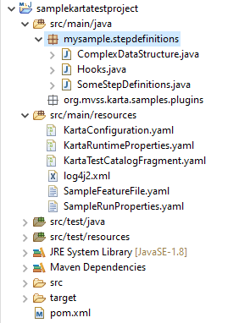

Add a Hooks.java to initialize WebDriver on scenario start and close web driver on scenario end.

package mysample.stepdefinitions;

import java.util.ArrayList;

import org.mvss.karta.framework.core.AfterFeature;
import org.mvss.karta.framework.core.AfterRun;
import org.mvss.karta.framework.core.AfterScenario;
import org.mvss.karta.framework.core.BeforeFeature;
import org.mvss.karta.framework.core.BeforeRun;
import org.mvss.karta.framework.core.BeforeScenario;
import org.mvss.karta.framework.core.PreparedScenario;
import org.mvss.karta.framework.core.TestFeature;
import org.mvss.karta.framework.runtime.interfaces.PropertyMapping;
import org.openqa.selenium.WebDriver;
import org.openqa.selenium.chrome.ChromeDriver;

import lombok.extern.log4j.Log4j2;

/**
* This class defines the life cycle hooks for Karta using Kriya plug-in. </br>
*
* @author Manian
*/
@Log4j2
public class Hooks
{
@PropertyMapping( group = "Kriya", value = "stepDefinitionPackageNames" )
private ArrayList<String> stepDefinitionPackageNames = null;

@BeforeRun( ".*" )
public void beforeRun( String runName )
{
log.info( "@BeforeRun Kriya tag check " + runName );
}

@BeforeFeature( "cy.*" )
public void beforeCycleFeatures( String runName, TestFeature feature )
{
log.info( "@BeforeFeature Kriya tag check " + runName + " " + feature.getName() );
}

@BeforeScenario( "UI" )
public void beforeUIScenarios( String runName, String featureName, PreparedScenario scenario )
{
log.info( "Test hooks property mapping step definition package names: " + stepDefinitionPackageNames );
log.info( "@BeforeScenario Kriya tag check " + runName + " " + featureName + " " + scenario.getName() );
WebDriver automationDriver = new ChromeDriver();
scenario.getContextBeanRegistry().add( "WebDriverObject", automationDriver );
}

@AfterScenario( "UI" )
public void afterUIScenarios( String runName, String featureName, PreparedScenario scenario )
{
log.info( "@AfterScenario Kriya tag check " + runName + " " + featureName + " " + scenario.getName() );
try
{
WebDriver driver = ( (WebDriver) scenario.getContextBeanRegistry().get( "WebDriverObject" ) );

if ( driver != null )
{
driver.quit();
}
}
catch ( Exception e )
{
log.error( "", e );
}
}

@AfterFeature( "cy.*" )
public void afterCycleFeatures( String runName, TestFeature feature )
{
log.info( "@AfterFeature Kriya tag check " + runName + " " + feature.getName() );
}

@AfterRun( ".*" )
public void afterRun( String runName )
{
log.info( "@AfterRun Kriya tag check " + runName );
}

}

Adding “KartaRuntimeProperties.yaml” to “src/main/resources”

Kriya:
stepDefinitionPackageNames:
- mysample.stepdefinitions
chaosActionDefinitionPackageNames:
- mysample.stepdefinitions

DumpToFileTestEventListener:
fileName: KartaEventsRawDump.bin

ExtentReportTestEventListener:
reportFile: ExtentRunReport.html

HTMLReportTestEventListener:
runReportsBaseFolderName: sampleReports

Adding properties file “SampleRunProperties.yaml” to “src/main/resources”

WebAutomation:
startURL: https://www.w3schools.com/
xpaths:
button1: //*[@id="mySidenav"]/div/a[1]
home: /html/body/div[1]/a
button2: //*[@id="mySidenav"]/div/a[2]

Adding properties file “KartaConfiguration.yaml” to “src/main/resources”
pluginsDirectories:
- "${KARTA_HOME}/plugins/"
- "."
enabledPlugins:
- Kriya
- DataFilesTestDataSource
- ObjectGenTestDataSource
- LoggingTestEventListener
- DumpToFileTestEventListener
- HTMLReportTestEventListener
# - ExtentReportTestEventListener

defaultFeatureSourceParserPlugin: Kriya
defaultStepRunnerPlugin: Kriya
defaultTestDataSourcePlugins:
- DataFilesTestDataSource
# - RandomTestDataSource

propertyFiles:
- KartaRuntimeProperties.yaml
- SampleRunProperties.yaml

sslProperties:
trustStoreType: jks
trustStore: "${KARTA_HOME}/bin/trustStore.jks"
trustStorePassword: changeit
keyStoreType: pkcs12
keyStore: "${KARTA_HOME}/bin/keyStore.p12"
keyStorePassword: changeit

nodeName: local

nodes: []

minionsEnabled: false

testThreadCount: 1

configurationScanPackages: []

testCatalogFragmentFiles: []

Adding step definitions

package mysample.stepdefinitions;

import java.util.HashMap;

import org.mvss.karta.framework.core.ParameterMapping;
import org.mvss.karta.framework.core.StepDefinition;
import org.mvss.karta.framework.core.StepParam;
import org.mvss.karta.framework.runtime.interfaces.PropertyMapping;
import org.mvss.karta.framework.utils.WaitUtil;
import org.openqa.selenium.By;
import org.openqa.selenium.WebDriver;

public class SomeStepDefinitions
{
@PropertyMapping( group = "WebAutomation", value = "startURL" )
private String startURL;

@PropertyMapping( group = "WebAutomation", value = "xpaths" )
private HashMap<String, String> xpathMap;

@StepDefinition( "the application is launched" )
public void the_application_is_launched( @StepParam( value = "WebDriverObject", mapto = ParameterMapping.CONTEXT_BEAN ) WebDriver driver )
{
driver.navigate().to( startURL );
WaitUtil.sleep( 1000 );
}

@StepDefinition( "the home button is clicked" )
public void the_home_button_is_clicked( @StepParam( value = "WebDriverObject", mapto = ParameterMapping.CONTEXT_BEAN ) WebDriver driver )
{
driver.findElement( By.xpath( xpathMap.get( "home" ) ) ).click();
WaitUtil.sleep( 1000 );
}

@StepDefinition( "the first button is clicked" )
public void the_first_button_is_clicked( @StepParam( value = "WebDriverObject", mapto = ParameterMapping.CONTEXT_BEAN ) WebDriver driver )
{
driver.findElement( By.xpath( xpathMap.get( "button1" ) ) ).click();
WaitUtil.sleep( 1000 );
}

@StepDefinition( "the second button is clicked" )
public void the_second_button_is_clicked( @StepParam( value = "WebDriverObject", mapto = ParameterMapping.CONTEXT_BEAN ) WebDriver driver )
{
driver.findElement( By.xpath( xpathMap.get( "button2" ) ) ).click();
WaitUtil.sleep( 1000 );
}

}

Adding log configuration file “log4j2.xml” to “src/main/resources”

<?xml version="1.0" encoding="UTF-8"?>
<Configuration status="warn">
<Appenders>
<RollingFile name="fileLogger" fileName="karta-run.log"
filePattern="karta-run-%d{yyyy-MM-dd}.log">
<PatternLayout>
<pattern>[%-5level] %d{yyyy-MM-dd HH:mm:ss.SSS} [%t] %c{1} - %msg%n
</pattern>
</PatternLayout>
<Policies>
<TimeBasedTriggeringPolicy interval="1"
modulate="true" />
</Policies>
</RollingFile>

<Console name="console" target="SYSTEM_OUT">
<PatternLayout
pattern="[%-5level] %d{yyyy-MM-dd HH:mm:ss.SSS} [%t] %c{1} - %msg%n" />
</Console>
</Appenders>
<Loggers>
<!-- <Logger name="com.bbb.ccc" level="debug" additivity="true"> <appender-ref
ref="fileLogger" level="debug" /> </Logger> -->
<Root level="info" additivity="false">
<appender-ref ref="console" />
<appender-ref ref="fileLogger" />
</Root>
</Loggers>
</Configuration>

Building the project:
Maven build the project using “mvn clean install” command or maven run configuration
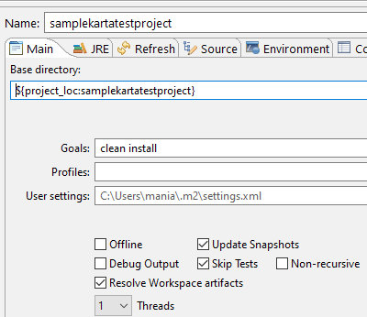

Running the project from eclipse

Create a run configuration for java application as follows

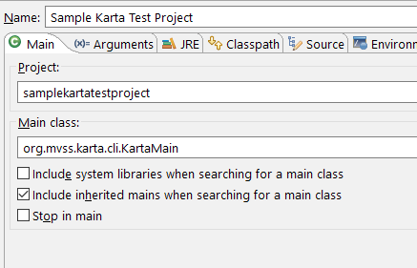

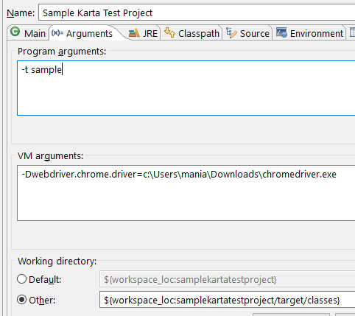

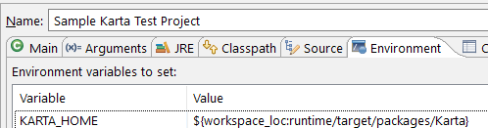

To run with Karta runtime, put all jars from target and all resource files from target/classes to the test project directory
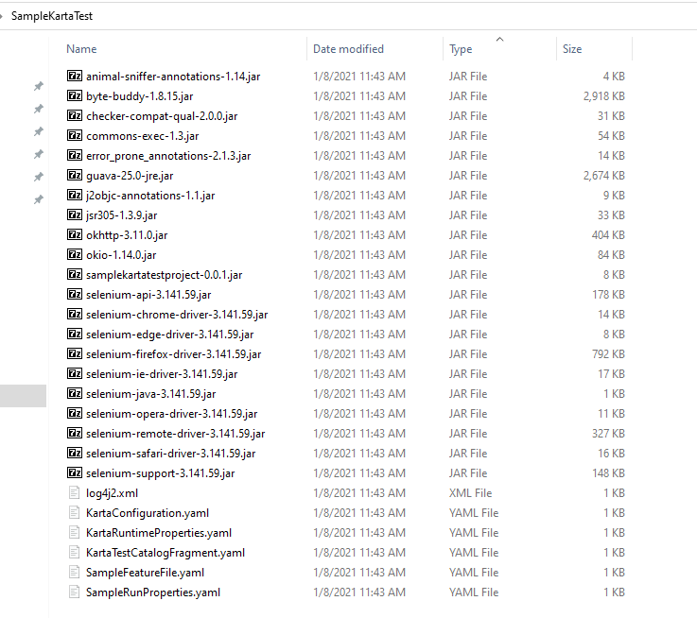

To run the project
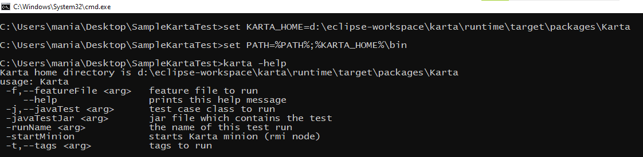
karta -runName sampleRun -t sample
(Note: jvm system properties for selenium driver is needed for this sample to run in this way).

Looking at sample HTML reports
