For Eclipse IDE:
Please ensure JDK 1.8 is setup with eclipse and compliance.

Maven build configuration:
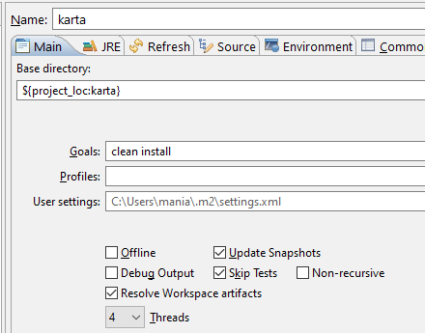

Running Minion Server and sample test project
Create a Java run configuration on the test project(sample) with main class org.mvss.karta.cli.KartaMain with arguments “-startMinion” running the directory ${workspace_loc:samples/target/classes} with environment variable “KARTA_HOME” set to the ${workspace_loc:runtime/target/packages/Karta} or the Karta runtime location e.g. “${HOME}/Karta/”.
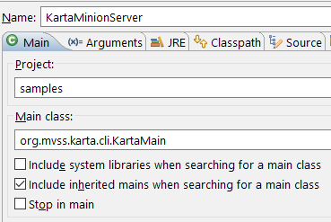
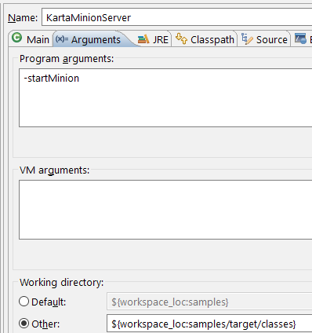

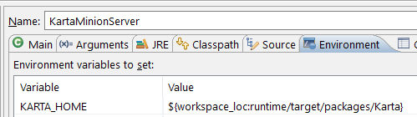

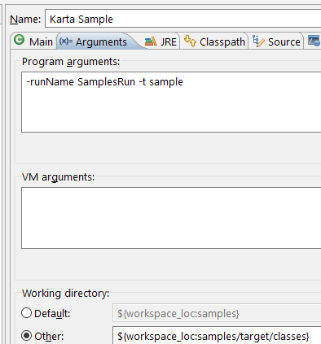
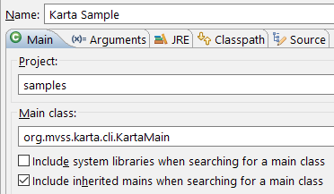

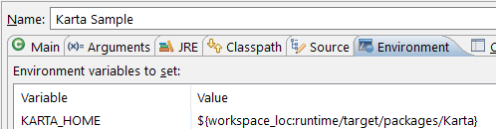

Maven build Karta first. Then to run sample tests run “KartaMinionServer” run configuration first as shown and then run “Karta Sample” run configuration for sample tests. Similar to sample tests, a new test project can be run from eclipse IDE.

For command line:

Setup:
Need JDK1.8 and maven for build and just JRE8 for running tests
Checkout Karta (or extract Package ZIP)
(e.g. %USERPROFILE%\Desktop\Karta or $HOME/Karta)

Set the KARTA_HOME environmental variable (optional for windows)
This variable denotes the home directory for Karta runtime environment.
For development, the packager's target directory can be directly used (runtime\target\packages\Karta)

e.g.
set KARTA_HOME=%USERPROFILE%\Desktop\Karta\runtime\target\packages\Karta
or
export KARTA_HOME=$HOME/Karta/runtime/target/packages/Karta

Building Karta:
mvn -T 4 -DskipTests=true clean install

Starting Minion server:
Minion server should be started with the test artifact directory as the current directory (containing test jar files and config files)
and invoking "%KARTA_HOME\bin\KartaMinion.bat"
e.g.
start "KartaMinionServer" /D "runtime\target\packages\Karta\Samples" "..\bin\KartaMinion.bat"

Starting Karta REST server:
Rest server can also act as a minion and just needs the minion type configuration to be “REST” and port(18080) set in Karta configuration
e.g.
start "KartaRESTServer" /D "runtime\target\packages\Karta\Samples" "..\bin\KartaServer.bat"

Running sample Tests:
e.g.
cd runtime\target\packages\Karta\samples\ && ..\bin\Karta.bat -runName SamplesRun -t sample && cd ..\..\..\..\..

