Codebook for tidyData

Autogenerated data summary from dataMaid

2020-06-14 14:10:20

# Data report overview

The dataset examined has the following dimensions:

|  |  |
| --- | --- |
| Feature | Result |
| Number of observations | 180 |
| Number of variables | 81 |

# Codebook summary table

|  |  |  |  |  |  |
| --- | --- | --- | --- | --- | --- |
| Label | Variable | Class | # unique values | Missing | Description |
|  | **ActivityType** | factor | 6 | 0.00 % |  |
|  | **SubjectId** | integer | 30 | 0.00 % |  |
|  | **TimeBodyAccelerometer-Mean-X** | numeric | 180 | 0.00 % |  |
|  | **TimeBodyAccelerometer-Mean-Y** | numeric | 180 | 0.00 % |  |
|  | **TimeBodyAccelerometer-Mean-Z** | numeric | 180 | 0.00 % |  |
|  | **TimeBodyAccelerometer-Std-X** | numeric | 180 | 0.00 % |  |
|  | **TimeBodyAccelerometer-Std-Y** | numeric | 180 | 0.00 % |  |
|  | **TimeBodyAccelerometer-Std-Z** | numeric | 180 | 0.00 % |  |
|  | **TimeGravityAccelerometer-Mean-X** | numeric | 180 | 0.00 % |  |
|  | **TimeGravityAccelerometer-Mean-Y** | numeric | 180 | 0.00 % |  |
|  | **TimeGravityAccelerometer-Mean-Z** | numeric | 180 | 0.00 % |  |
|  | **TimeGravityAccelerometer-Std-X** | numeric | 180 | 0.00 % |  |
|  | **TimeGravityAccelerometer-Std-Y** | numeric | 180 | 0.00 % |  |
|  | **TimeGravityAccelerometer-Std-Z** | numeric | 180 | 0.00 % |  |
|  | **TimeBodyAccelerometerJerk-Mean-X** | numeric | 180 | 0.00 % |  |
|  | **TimeBodyAccelerometerJerk-Mean-Y** | numeric | 180 | 0.00 % |  |
|  | **TimeBodyAccelerometerJerk-Mean-Z** | numeric | 180 | 0.00 % |  |
|  | **TimeBodyAccelerometerJerk-Std-X** | numeric | 180 | 0.00 % |  |
|  | **TimeBodyAccelerometerJerk-Std-Y** | numeric | 180 | 0.00 % |  |
|  | **TimeBodyAccelerometerJerk-Std-Z** | numeric | 180 | 0.00 % |  |
|  | **TimeBodyGyroscope-Mean-X** | numeric | 180 | 0.00 % |  |
|  | **TimeBodyGyroscope-Mean-Y** | numeric | 180 | 0.00 % |  |
|  | **TimeBodyGyroscope-Mean-Z** | numeric | 180 | 0.00 % |  |
|  | **TimeBodyGyroscope-Std-X** | numeric | 180 | 0.00 % |  |
|  | **TimeBodyGyroscope-Std-Y** | numeric | 180 | 0.00 % |  |
|  | **TimeBodyGyroscope-Std-Z** | numeric | 180 | 0.00 % |  |
|  | **TimeBodyGyroscopeJerk-Mean-X** | numeric | 180 | 0.00 % |  |
|  | **TimeBodyGyroscopeJerk-Mean-Y** | numeric | 180 | 0.00 % |  |
|  | **TimeBodyGyroscopeJerk-Mean-Z** | numeric | 180 | 0.00 % |  |
|  | **TimeBodyGyroscopeJerk-Std-X** | numeric | 180 | 0.00 % |  |
|  | **TimeBodyGyroscopeJerk-Std-Y** | numeric | 180 | 0.00 % |  |
|  | **TimeBodyGyroscopeJerk-Std-Z** | numeric | 180 | 0.00 % |  |
|  | **TimeBodyAccelerometerMagnitude-Mean** | numeric | 180 | 0.00 % |  |
|  | **TimeBodyAccelerometerMagnitude-Std** | numeric | 180 | 0.00 % |  |
|  | **TimeGravityAccelerometerMagnitude-Mean** | numeric | 180 | 0.00 % |  |
|  | **TimeGravityAccelerometerMagnitude-Std** | numeric | 180 | 0.00 % |  |
|  | **TimeBodyAccelerometerJerkMagnitude-Mean** | numeric | 180 | 0.00 % |  |
|  | **TimeBodyAccelerometerJerkMagnitude-Std** | numeric | 180 | 0.00 % |  |
|  | **TimeBodyGyroscopeMagnitude-Mean** | numeric | 180 | 0.00 % |  |
|  | **TimeBodyGyroscopeMagnitude-Std** | numeric | 180 | 0.00 % |  |
|  | **TimeBodyGyroscopeJerkMagnitude-Mean** | numeric | 180 | 0.00 % |  |
|  | **TimeBodyGyroscopeJerkMagnitude-Std** | numeric | 180 | 0.00 % |  |
|  | **FreqBodyAccelerometer-Mean-X** | numeric | 180 | 0.00 % |  |
|  | **FreqBodyAccelerometer-Mean-Y** | numeric | 180 | 0.00 % |  |
|  | **FreqBodyAccelerometer-Mean-Z** | numeric | 180 | 0.00 % |  |
|  | **FreqBodyAccelerometer-Std-X** | numeric | 180 | 0.00 % |  |
|  | **FreqBodyAccelerometer-Std-Y** | numeric | 180 | 0.00 % |  |
|  | **FreqBodyAccelerometer-Std-Z** | numeric | 180 | 0.00 % |  |
|  | **FreqBodyAccelerometer-MeanFreq-X** | numeric | 180 | 0.00 % |  |
|  | **FreqBodyAccelerometer-MeanFreq-Y** | numeric | 180 | 0.00 % |  |
|  | **FreqBodyAccelerometer-MeanFreq-Z** | numeric | 180 | 0.00 % |  |
|  | **FreqBodyAccelerometerJerk-Mean-X** | numeric | 180 | 0.00 % |  |
|  | **FreqBodyAccelerometerJerk-Mean-Y** | numeric | 180 | 0.00 % |  |
|  | **FreqBodyAccelerometerJerk-Mean-Z** | numeric | 180 | 0.00 % |  |
|  | **FreqBodyAccelerometerJerk-Std-X** | numeric | 180 | 0.00 % |  |
|  | **FreqBodyAccelerometerJerk-Std-Y** | numeric | 180 | 0.00 % |  |
|  | **FreqBodyAccelerometerJerk-Std-Z** | numeric | 180 | 0.00 % |  |
|  | **FreqBodyAccelerometerJerk-MeanFreq-X** | numeric | 180 | 0.00 % |  |
|  | **FreqBodyAccelerometerJerk-MeanFreq-Y** | numeric | 180 | 0.00 % |  |
|  | **FreqBodyAccelerometerJerk-MeanFreq-Z** | numeric | 180 | 0.00 % |  |
|  | **FreqBodyGyroscope-Mean-X** | numeric | 180 | 0.00 % |  |
|  | **FreqBodyGyroscope-Mean-Y** | numeric | 180 | 0.00 % |  |
|  | **FreqBodyGyroscope-Mean-Z** | numeric | 180 | 0.00 % |  |
|  | **FreqBodyGyroscope-Std-X** | numeric | 180 | 0.00 % |  |
|  | **FreqBodyGyroscope-Std-Y** | numeric | 180 | 0.00 % |  |
|  | **FreqBodyGyroscope-Std-Z** | numeric | 180 | 0.00 % |  |
|  | **FreqBodyGyroscope-MeanFreq-X** | numeric | 180 | 0.00 % |  |
|  | **FreqBodyGyroscope-MeanFreq-Y** | numeric | 180 | 0.00 % |  |
|  | **FreqBodyGyroscope-MeanFreq-Z** | numeric | 180 | 0.00 % |  |
|  | **FreqBodyAccelerometerMagnitude-Mean** | numeric | 180 | 0.00 % |  |
|  | **FreqBodyAccelerometerMagnitude-Std** | numeric | 180 | 0.00 % |  |
|  | **FreqBodyAccelerometerMagnitude-MeanFreq** | numeric | 180 | 0.00 % |  |
|  | **FreqBodyAccelerometerJerkMagnitude-Mean** | numeric | 180 | 0.00 % |  |
|  | **FreqBodyAccelerometerJerkMagnitude-Std** | numeric | 180 | 0.00 % |  |
|  | **FreqBodyAccelerometerJerkMagnitude-MeanFreq** | numeric | 180 | 0.00 % |  |
|  | **FreqBodyGyroscopeMagnitude-Mean** | numeric | 180 | 0.00 % |  |
|  | **FreqBodyGyroscopeMagnitude-Std** | numeric | 180 | 0.00 % |  |
|  | **FreqBodyGyroscopeMagnitude-MeanFreq** | numeric | 180 | 0.00 % |  |
|  | **FreqBodyGyroscopeJerkMagnitude-Mean** | numeric | 180 | 0.00 % |  |
|  | **FreqBodyGyroscopeJerkMagnitude-Std** | numeric | 180 | 0.00 % |  |
|  | **FreqBodyGyroscopeJerkMagnitude-MeanFreq** | numeric | 180 | 0.00 % |  |

# Variable list

## ActivityType

|  |  |
| --- | --- |
| Feature | Result |
| Variable type | factor |
| Number of missing obs. | 0 (0 %) |
| Number of unique values | 6 |
| Mode | “LAYING” |
| Reference category | LAYING |

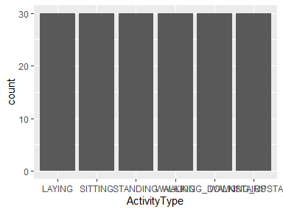

* Observed factor levels: "LAYING", "SITTING", "STANDING", "WALKING", "WALKING_DOWNSTAIRS", "WALKING_UPSTAIRS".

## SubjectId

|  |  |
| --- | --- |
| Feature | Result |
| Variable type | integer |
| Number of missing obs. | 0 (0 %) |
| Number of unique values | 30 |
| Median | 15.5 |
| 1st and 3rd quartiles | 8; 23 |
| Min. and max. | 1; 30 |

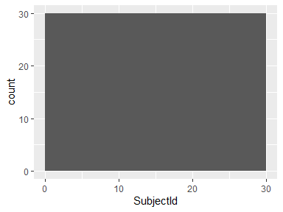

## TimeBodyAccelerometer-Mean-X

|  |  |
| --- | --- |
| Feature | Result |
| Variable type | numeric |
| Number of missing obs. | 0 (0 %) |
| Number of unique values | 180 |
| Median | 0.28 |
| 1st and 3rd quartiles | 0.27; 0.28 |
| Min. and max. | 0.22; 0.3 |

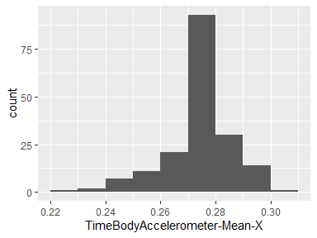

## TimeBodyAccelerometer-Mean-Y

|  |  |
| --- | --- |
| Feature | Result |
| Variable type | numeric |
| Number of missing obs. | 0 (0 %) |
| Number of unique values | 180 |
| Median | -0.02 |
| 1st and 3rd quartiles | -0.02; -0.01 |
| Min. and max. | -0.04; 0 |

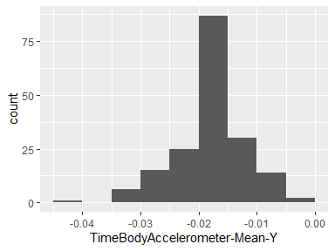

## TimeBodyAccelerometer-Mean-Z

|  |  |
| --- | --- |
| Feature | Result |
| Variable type | numeric |
| Number of missing obs. | 0 (0 %) |
| Number of unique values | 180 |
| Median | -0.11 |
| 1st and 3rd quartiles | -0.11; -0.1 |
| Min. and max. | -0.15; -0.08 |

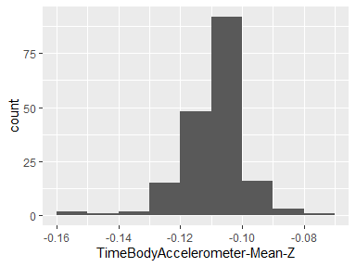

## TimeBodyAccelerometer-Std-X

|  |  |
| --- | --- |
| Feature | Result |
| Variable type | numeric |
| Number of missing obs. | 0 (0 %) |
| Number of unique values | 180 |
| Median | -0.75 |
| 1st and 3rd quartiles | -0.98; -0.2 |
| Min. and max. | -1; 0.63 |

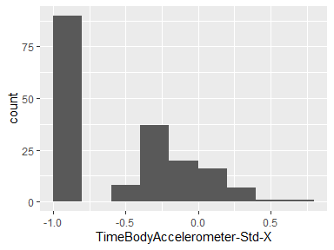

## TimeBodyAccelerometer-Std-Y

|  |  |
| --- | --- |
| Feature | Result |
| Variable type | numeric |
| Number of missing obs. | 0 (0 %) |
| Number of unique values | 180 |
| Median | -0.51 |
| 1st and 3rd quartiles | -0.94; -0.03 |
| Min. and max. | -0.99; 0.62 |

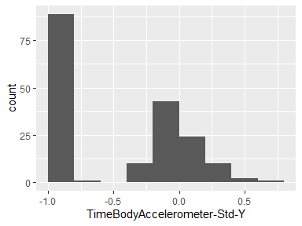

## TimeBodyAccelerometer-Std-Z

|  |  |
| --- | --- |
| Feature | Result |
| Variable type | numeric |
| Number of missing obs. | 0 (0 %) |
| Number of unique values | 180 |
| Median | -0.65 |
| 1st and 3rd quartiles | -0.95; -0.23 |
| Min. and max. | -0.99; 0.61 |

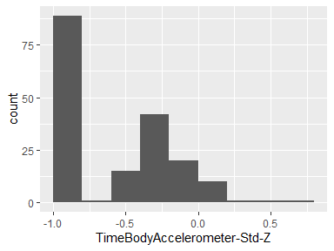

## TimeGravityAccelerometer-Mean-X

|  |  |
| --- | --- |
| Feature | Result |
| Variable type | numeric |
| Number of missing obs. | 0 (0 %) |
| Number of unique values | 180 |
| Median | 0.92 |
| 1st and 3rd quartiles | 0.84; 0.94 |
| Min. and max. | -0.68; 0.97 |

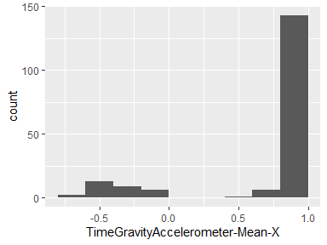

## TimeGravityAccelerometer-Mean-Y

|  |  |
| --- | --- |
| Feature | Result |
| Variable type | numeric |
| Number of missing obs. | 0 (0 %) |
| Number of unique values | 180 |
| Median | -0.13 |
| 1st and 3rd quartiles | -0.23; 0.09 |
| Min. and max. | -0.48; 0.96 |

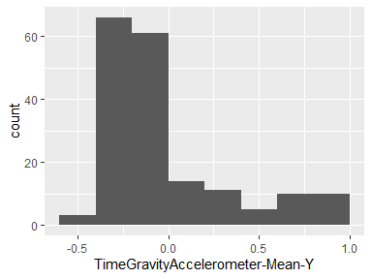

## TimeGravityAccelerometer-Mean-Z

|  |  |
| --- | --- |
| Feature | Result |
| Variable type | numeric |
| Number of missing obs. | 0 (0 %) |
| Number of unique values | 180 |
| Median | 0.02 |
| 1st and 3rd quartiles | -0.12; 0.15 |
| Min. and max. | -0.5; 0.96 |

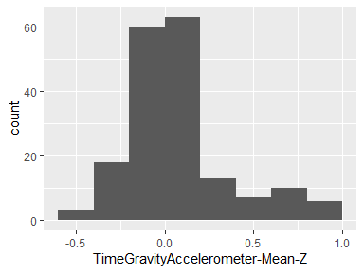

## TimeGravityAccelerometer-Std-X

|  |  |
| --- | --- |
| Feature | Result |
| Variable type | numeric |
| Number of missing obs. | 0 (0 %) |
| Number of unique values | 180 |
| Median | -0.97 |
| 1st and 3rd quartiles | -0.98; -0.95 |
| Min. and max. | -1; -0.83 |

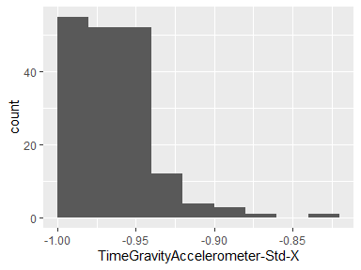

## TimeGravityAccelerometer-Std-Y

|  |  |
| --- | --- |
| Feature | Result |
| Variable type | numeric |
| Number of missing obs. | 0 (0 %) |
| Number of unique values | 180 |
| Median | -0.96 |
| 1st and 3rd quartiles | -0.97; -0.94 |
| Min. and max. | -0.99; -0.64 |

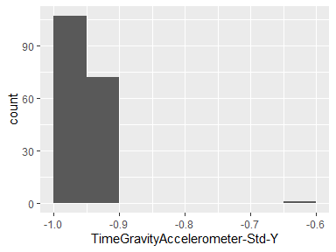

## TimeGravityAccelerometer-Std-Z

|  |  |
| --- | --- |
| Feature | Result |
| Variable type | numeric |
| Number of missing obs. | 0 (0 %) |
| Number of unique values | 180 |
| Median | -0.95 |
| 1st and 3rd quartiles | -0.96; -0.92 |
| Min. and max. | -0.99; -0.61 |

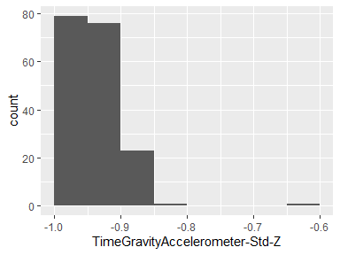

## TimeBodyAccelerometerJerk-Mean-X

|  |  |
| --- | --- |
| Feature | Result |
| Variable type | numeric |
| Number of missing obs. | 0 (0 %) |
| Number of unique values | 180 |
| Median | 0.08 |
| 1st and 3rd quartiles | 0.07; 0.08 |
| Min. and max. | 0.04; 0.13 |

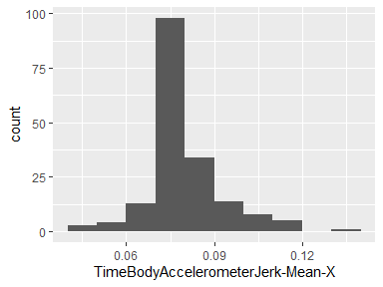

## TimeBodyAccelerometerJerk-Mean-Y

|  |  |
| --- | --- |
| Feature | Result |
| Variable type | numeric |
| Number of missing obs. | 0 (0 %) |
| Number of unique values | 180 |
| Median | 0.01 |
| 1st and 3rd quartiles | 0; 0.01 |
| Min. and max. | -0.04; 0.06 |

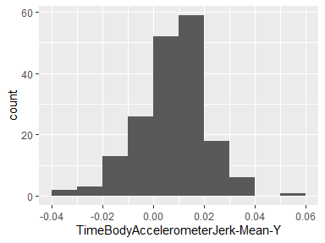

## TimeBodyAccelerometerJerk-Mean-Z

|  |  |
| --- | --- |
| Feature | Result |
| Variable type | numeric |
| Number of missing obs. | 0 (0 %) |
| Number of unique values | 180 |
| Median | 0 |
| 1st and 3rd quartiles | -0.01; 0 |
| Min. and max. | -0.07; 0.04 |

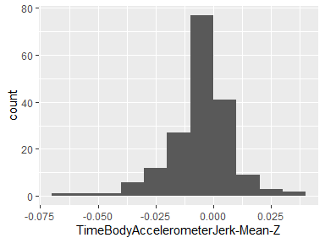

## TimeBodyAccelerometerJerk-Std-X

|  |  |
| --- | --- |
| Feature | Result |
| Variable type | numeric |
| Number of missing obs. | 0 (0 %) |
| Number of unique values | 180 |
| Median | -0.81 |
| 1st and 3rd quartiles | -0.98; -0.22 |
| Min. and max. | -0.99; 0.54 |

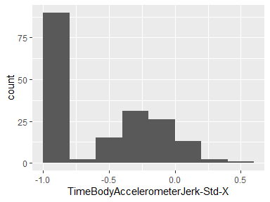

## TimeBodyAccelerometerJerk-Std-Y

|  |  |
| --- | --- |
| Feature | Result |
| Variable type | numeric |
| Number of missing obs. | 0 (0 %) |
| Number of unique values | 180 |
| Median | -0.78 |
| 1st and 3rd quartiles | -0.97; -0.15 |
| Min. and max. | -0.99; 0.36 |

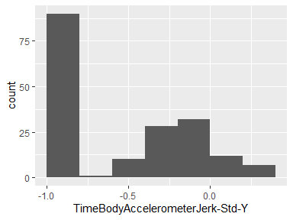

## TimeBodyAccelerometerJerk-Std-Z

|  |  |
| --- | --- |
| Feature | Result |
| Variable type | numeric |
| Number of missing obs. | 0 (0 %) |
| Number of unique values | 180 |
| Median | -0.88 |
| 1st and 3rd quartiles | -0.98; -0.51 |
| Min. and max. | -0.99; 0.03 |

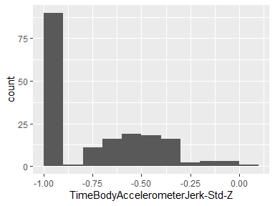

## TimeBodyGyroscope-Mean-X

|  |  |
| --- | --- |
| Feature | Result |
| Variable type | numeric |
| Number of missing obs. | 0 (0 %) |
| Number of unique values | 180 |
| Median | -0.03 |
| 1st and 3rd quartiles | -0.05; -0.02 |
| Min. and max. | -0.21; 0.19 |

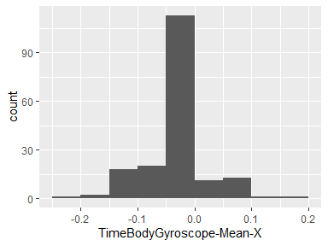

## TimeBodyGyroscope-Mean-Y

|  |  |
| --- | --- |
| Feature | Result |
| Variable type | numeric |
| Number of missing obs. | 0 (0 %) |
| Number of unique values | 180 |
| Median | -0.07 |
| 1st and 3rd quartiles | -0.09; -0.06 |
| Min. and max. | -0.2; 0.03 |

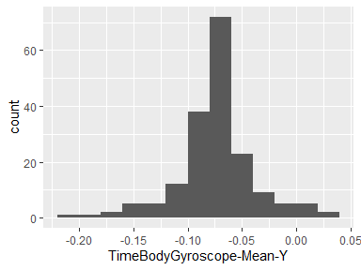

## TimeBodyGyroscope-Mean-Z

|  |  |
| --- | --- |
| Feature | Result |
| Variable type | numeric |
| Number of missing obs. | 0 (0 %) |
| Number of unique values | 180 |
| Median | 0.09 |
| 1st and 3rd quartiles | 0.07; 0.1 |
| Min. and max. | -0.07; 0.18 |

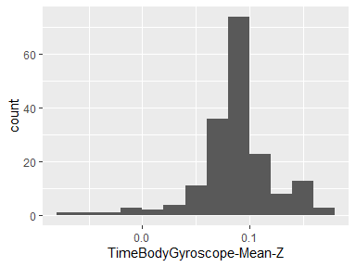

## TimeBodyGyroscope-Std-X

|  |  |
| --- | --- |
| Feature | Result |
| Variable type | numeric |
| Number of missing obs. | 0 (0 %) |
| Number of unique values | 180 |
| Median | -0.79 |
| 1st and 3rd quartiles | -0.97; -0.44 |
| Min. and max. | -0.99; 0.27 |

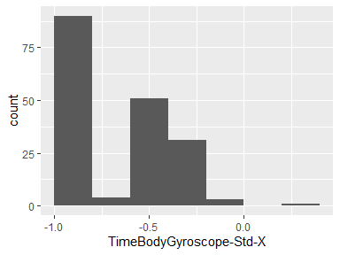

## TimeBodyGyroscope-Std-Y

|  |  |
| --- | --- |
| Feature | Result |
| Variable type | numeric |
| Number of missing obs. | 0 (0 %) |
| Number of unique values | 180 |
| Median | -0.8 |
| 1st and 3rd quartiles | -0.96; -0.42 |
| Min. and max. | -0.99; 0.48 |

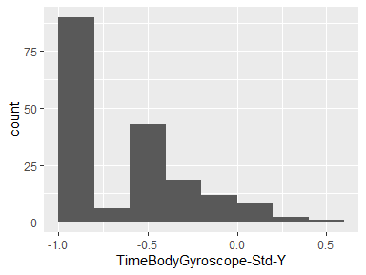

## TimeBodyGyroscope-Std-Z

|  |  |
| --- | --- |
| Feature | Result |
| Variable type | numeric |
| Number of missing obs. | 0 (0 %) |
| Number of unique values | 180 |
| Median | -0.8 |
| 1st and 3rd quartiles | -0.96; -0.31 |
| Min. and max. | -0.99; 0.56 |

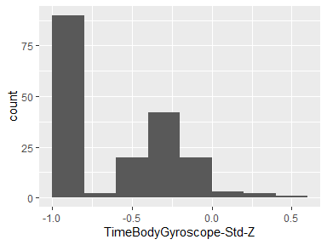

## TimeBodyGyroscopeJerk-Mean-X

|  |  |
| --- | --- |
| Feature | Result |
| Variable type | numeric |
| Number of missing obs. | 0 (0 %) |
| Number of unique values | 180 |
| Median | -0.1 |
| 1st and 3rd quartiles | -0.1; -0.09 |
| Min. and max. | -0.16; -0.02 |

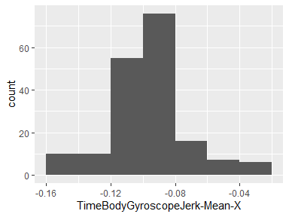

## TimeBodyGyroscopeJerk-Mean-Y

|  |  |
| --- | --- |
| Feature | Result |
| Variable type | numeric |
| Number of missing obs. | 0 (0 %) |
| Number of unique values | 180 |
| Median | -0.04 |
| 1st and 3rd quartiles | -0.05; -0.04 |
| Min. and max. | -0.08; -0.01 |

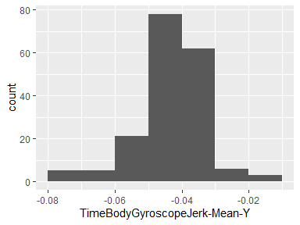

## TimeBodyGyroscopeJerk-Mean-Z

|  |  |
| --- | --- |
| Feature | Result |
| Variable type | numeric |
| Number of missing obs. | 0 (0 %) |
| Number of unique values | 180 |
| Median | -0.05 |
| 1st and 3rd quartiles | -0.06; -0.05 |
| Min. and max. | -0.09; -0.01 |

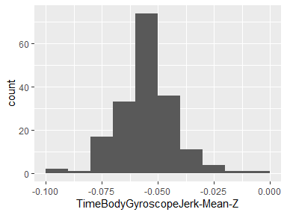

## TimeBodyGyroscopeJerk-Std-X

|  |  |
| --- | --- |
| Feature | Result |
| Variable type | numeric |
| Number of missing obs. | 0 (0 %) |
| Number of unique values | 180 |
| Median | -0.84 |
| 1st and 3rd quartiles | -0.98; -0.46 |
| Min. and max. | -1; 0.18 |

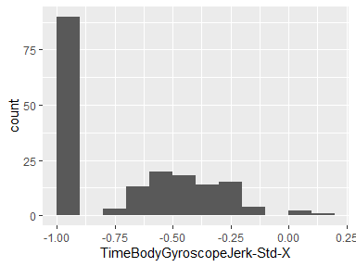

## TimeBodyGyroscopeJerk-Std-Y

|  |  |
| --- | --- |
| Feature | Result |
| Variable type | numeric |
| Number of missing obs. | 0 (0 %) |
| Number of unique values | 180 |
| Median | -0.89 |
| 1st and 3rd quartiles | -0.98; -0.59 |
| Min. and max. | -1; 0.3 |

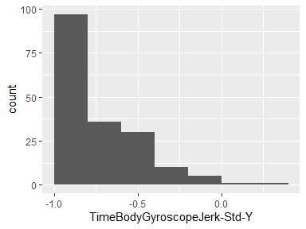

## TimeBodyGyroscopeJerk-Std-Z

|  |  |
| --- | --- |
| Feature | Result |
| Variable type | numeric |
| Number of missing obs. | 0 (0 %) |
| Number of unique values | 180 |
| Median | -0.86 |
| 1st and 3rd quartiles | -0.98; -0.47 |
| Min. and max. | -1; 0.19 |

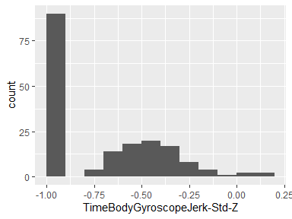

## TimeBodyAccelerometerMagnitude-Mean

|  |  |
| --- | --- |
| Feature | Result |
| Variable type | numeric |
| Number of missing obs. | 0 (0 %) |
| Number of unique values | 180 |
| Median | -0.48 |
| 1st and 3rd quartiles | -0.96; -0.09 |
| Min. and max. | -0.99; 0.64 |

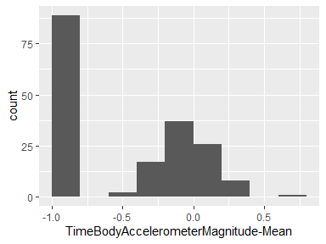

## TimeBodyAccelerometerMagnitude-Std

|  |  |
| --- | --- |
| Feature | Result |
| Variable type | numeric |
| Number of missing obs. | 0 (0 %) |
| Number of unique values | 180 |
| Median | -0.61 |
| 1st and 3rd quartiles | -0.94; -0.21 |
| Min. and max. | -0.99; 0.43 |

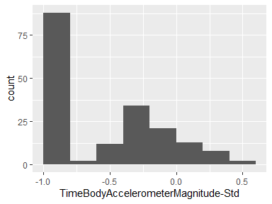

## TimeGravityAccelerometerMagnitude-Mean

|  |  |
| --- | --- |
| Feature | Result |
| Variable type | numeric |
| Number of missing obs. | 0 (0 %) |
| Number of unique values | 180 |
| Median | -0.48 |
| 1st and 3rd quartiles | -0.96; -0.09 |
| Min. and max. | -0.99; 0.64 |

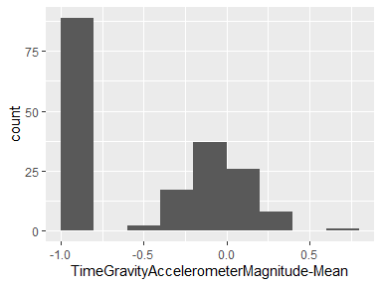

## TimeGravityAccelerometerMagnitude-Std

|  |  |
| --- | --- |
| Feature | Result |
| Variable type | numeric |
| Number of missing obs. | 0 (0 %) |
| Number of unique values | 180 |
| Median | -0.61 |
| 1st and 3rd quartiles | -0.94; -0.21 |
| Min. and max. | -0.99; 0.43 |

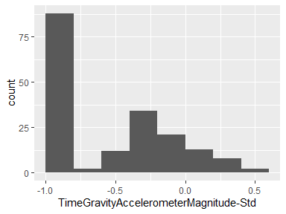

## TimeBodyAccelerometerJerkMagnitude-Mean

|  |  |
| --- | --- |
| Feature | Result |
| Variable type | numeric |
| Number of missing obs. | 0 (0 %) |
| Number of unique values | 180 |
| Median | -0.82 |
| 1st and 3rd quartiles | -0.98; -0.25 |
| Min. and max. | -0.99; 0.43 |

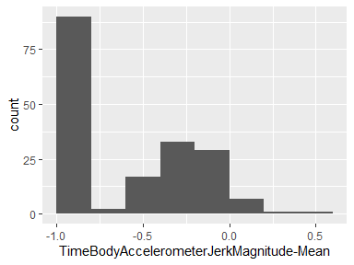

## TimeBodyAccelerometerJerkMagnitude-Std

|  |  |
| --- | --- |
| Feature | Result |
| Variable type | numeric |
| Number of missing obs. | 0 (0 %) |
| Number of unique values | 180 |
| Median | -0.8 |
| 1st and 3rd quartiles | -0.98; -0.22 |
| Min. and max. | -0.99; 0.45 |

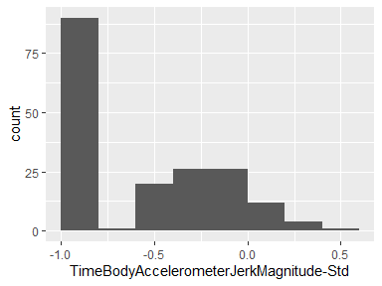

## TimeBodyGyroscopeMagnitude-Mean

|  |  |
| --- | --- |
| Feature | Result |
| Variable type | numeric |
| Number of missing obs. | 0 (0 %) |
| Number of unique values | 180 |
| Median | -0.66 |
| 1st and 3rd quartiles | -0.95; -0.22 |
| Min. and max. | -0.98; 0.42 |

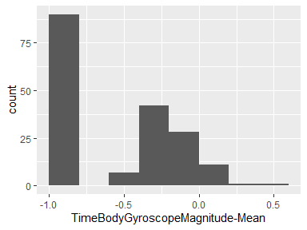

## TimeBodyGyroscopeMagnitude-Std

|  |  |
| --- | --- |
| Feature | Result |
| Variable type | numeric |
| Number of missing obs. | 0 (0 %) |
| Number of unique values | 180 |
| Median | -0.74 |
| 1st and 3rd quartiles | -0.95; -0.36 |
| Min. and max. | -0.98; 0.3 |

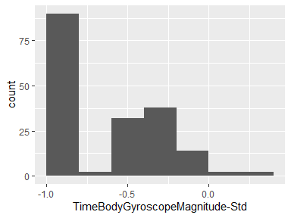

## TimeBodyGyroscopeJerkMagnitude-Mean

|  |  |
| --- | --- |
| Feature | Result |
| Variable type | numeric |
| Number of missing obs. | 0 (0 %) |
| Number of unique values | 180 |
| Median | -0.86 |
| 1st and 3rd quartiles | -0.99; -0.51 |
| Min. and max. | -1; 0.09 |

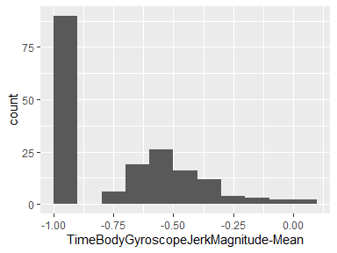

## TimeBodyGyroscopeJerkMagnitude-Std

|  |  |
| --- | --- |
| Feature | Result |
| Variable type | numeric |
| Number of missing obs. | 0 (0 %) |
| Number of unique values | 180 |
| Median | -0.88 |
| 1st and 3rd quartiles | -0.98; -0.58 |
| Min. and max. | -1; 0.25 |

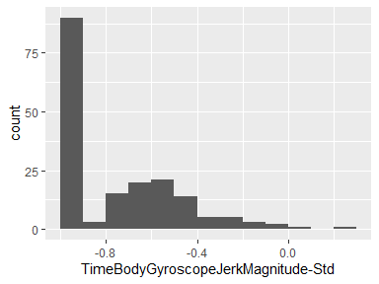

## FreqBodyAccelerometer-Mean-X

|  |  |
| --- | --- |
| Feature | Result |
| Variable type | numeric |
| Number of missing obs. | 0 (0 %) |
| Number of unique values | 180 |
| Median | -0.77 |
| 1st and 3rd quartiles | -0.98; -0.22 |
| Min. and max. | -1; 0.54 |

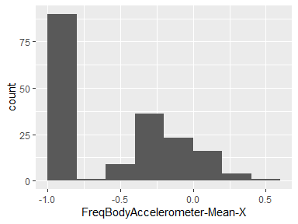

## FreqBodyAccelerometer-Mean-Y

|  |  |
| --- | --- |
| Feature | Result |
| Variable type | numeric |
| Number of missing obs. | 0 (0 %) |
| Number of unique values | 180 |
| Median | -0.59 |
| 1st and 3rd quartiles | -0.95; -0.06 |
| Min. and max. | -0.99; 0.52 |

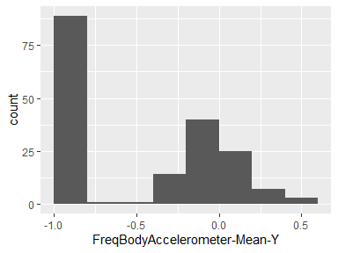

## FreqBodyAccelerometer-Mean-Z

|  |  |
| --- | --- |
| Feature | Result |
| Variable type | numeric |
| Number of missing obs. | 0 (0 %) |
| Number of unique values | 180 |
| Median | -0.72 |
| 1st and 3rd quartiles | -0.96; -0.32 |
| Min. and max. | -0.99; 0.28 |

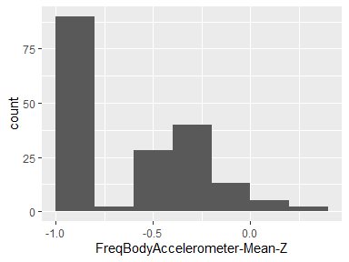

## FreqBodyAccelerometer-Std-X

|  |  |
| --- | --- |
| Feature | Result |
| Variable type | numeric |
| Number of missing obs. | 0 (0 %) |
| Number of unique values | 180 |
| Median | -0.75 |
| 1st and 3rd quartiles | -0.98; -0.2 |
| Min. and max. | -1; 0.66 |

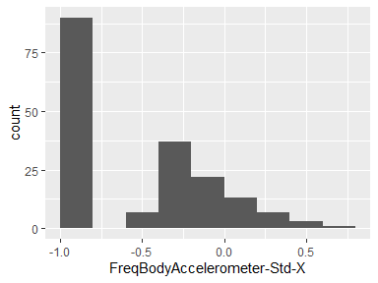

## FreqBodyAccelerometer-Std-Y

|  |  |
| --- | --- |
| Feature | Result |
| Variable type | numeric |
| Number of missing obs. | 0 (0 %) |
| Number of unique values | 180 |
| Median | -0.51 |
| 1st and 3rd quartiles | -0.94; -0.08 |
| Min. and max. | -0.99; 0.56 |

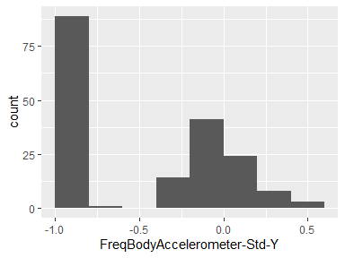

## FreqBodyAccelerometer-Std-Z

|  |  |
| --- | --- |
| Feature | Result |
| Variable type | numeric |
| Number of missing obs. | 0 (0 %) |
| Number of unique values | 180 |
| Median | -0.64 |
| 1st and 3rd quartiles | -0.95; -0.27 |
| Min. and max. | -0.99; 0.69 |

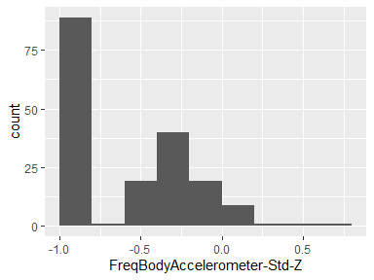

## FreqBodyAccelerometer-MeanFreq-X

|  |  |
| --- | --- |
| Feature | Result |
| Variable type | numeric |
| Number of missing obs. | 0 (0 %) |
| Number of unique values | 180 |
| Median | -0.26 |
| 1st and 3rd quartiles | -0.39; -0.06 |
| Min. and max. | -0.64; 0.16 |

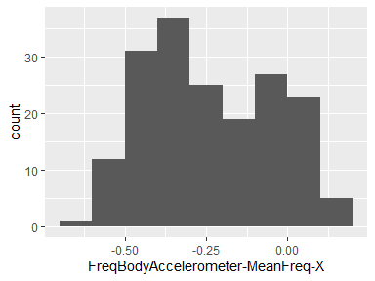

## FreqBodyAccelerometer-MeanFreq-Y

|  |  |
| --- | --- |
| Feature | Result |
| Variable type | numeric |
| Number of missing obs. | 0 (0 %) |
| Number of unique values | 180 |
| Median | 0.01 |
| 1st and 3rd quartiles | -0.08; 0.09 |
| Min. and max. | -0.38; 0.47 |

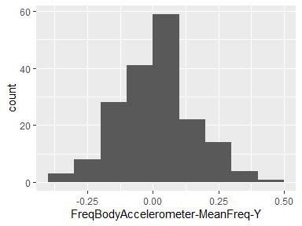

## FreqBodyAccelerometer-MeanFreq-Z

|  |  |
| --- | --- |
| Feature | Result |
| Variable type | numeric |
| Number of missing obs. | 0 (0 %) |
| Number of unique values | 180 |
| Median | 0.07 |
| 1st and 3rd quartiles | -0.04; 0.18 |
| Min. and max. | -0.52; 0.4 |

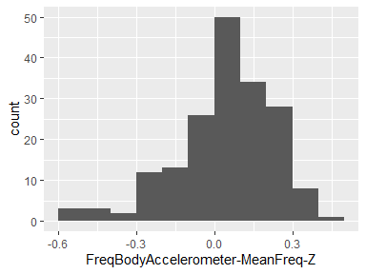

## FreqBodyAccelerometerJerk-Mean-X

|  |  |
| --- | --- |
| Feature | Result |
| Variable type | numeric |
| Number of missing obs. | 0 (0 %) |
| Number of unique values | 180 |
| Median | -0.81 |
| 1st and 3rd quartiles | -0.98; -0.28 |
| Min. and max. | -0.99; 0.47 |

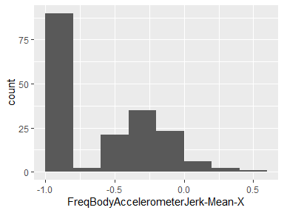

## FreqBodyAccelerometerJerk-Mean-Y

|  |  |
| --- | --- |
| Feature | Result |
| Variable type | numeric |
| Number of missing obs. | 0 (0 %) |
| Number of unique values | 180 |
| Median | -0.78 |
| 1st and 3rd quartiles | -0.97; -0.2 |
| Min. and max. | -0.99; 0.28 |

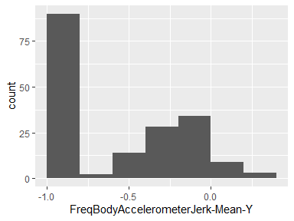

## FreqBodyAccelerometerJerk-Mean-Z

|  |  |
| --- | --- |
| Feature | Result |
| Variable type | numeric |
| Number of missing obs. | 0 (0 %) |
| Number of unique values | 180 |
| Median | -0.87 |
| 1st and 3rd quartiles | -0.98; -0.47 |
| Min. and max. | -0.99; 0.16 |

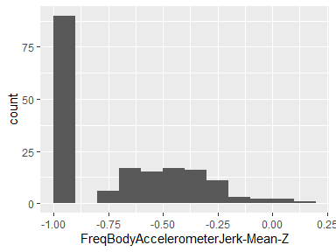

## FreqBodyAccelerometerJerk-Std-X

|  |  |
| --- | --- |
| Feature | Result |
| Variable type | numeric |
| Number of missing obs. | 0 (0 %) |
| Number of unique values | 180 |
| Median | -0.83 |
| 1st and 3rd quartiles | -0.98; -0.25 |
| Min. and max. | -1; 0.48 |

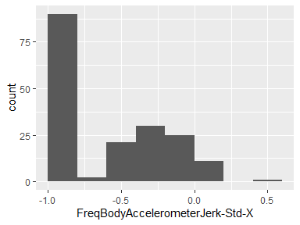

## FreqBodyAccelerometerJerk-Std-Y

|  |  |
| --- | --- |
| Feature | Result |
| Variable type | numeric |
| Number of missing obs. | 0 (0 %) |
| Number of unique values | 180 |
| Median | -0.79 |
| 1st and 3rd quartiles | -0.97; -0.17 |
| Min. and max. | -0.99; 0.35 |

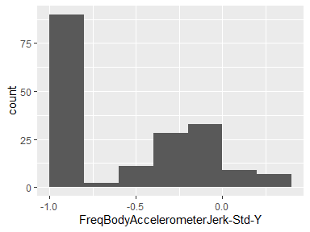

## FreqBodyAccelerometerJerk-Std-Z

|  |  |
| --- | --- |
| Feature | Result |
| Variable type | numeric |
| Number of missing obs. | 0 (0 %) |
| Number of unique values | 180 |
| Median | -0.9 |
| 1st and 3rd quartiles | -0.98; -0.54 |
| Min. and max. | -0.99; -0.01 |

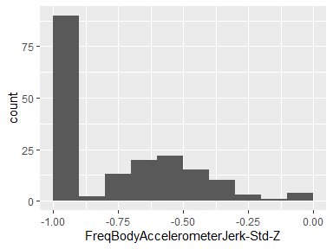

## FreqBodyAccelerometerJerk-MeanFreq-X

|  |  |
| --- | --- |
| Feature | Result |
| Variable type | numeric |
| Number of missing obs. | 0 (0 %) |
| Number of unique values | 180 |
| Median | -0.06 |
| 1st and 3rd quartiles | -0.29; 0.18 |
| Min. and max. | -0.58; 0.33 |

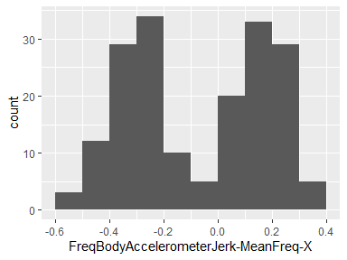

## FreqBodyAccelerometerJerk-MeanFreq-Y

|  |  |
| --- | --- |
| Feature | Result |
| Variable type | numeric |
| Number of missing obs. | 0 (0 %) |
| Number of unique values | 180 |
| Median | -0.23 |
| 1st and 3rd quartiles | -0.4; -0.05 |
| Min. and max. | -0.6; 0.2 |

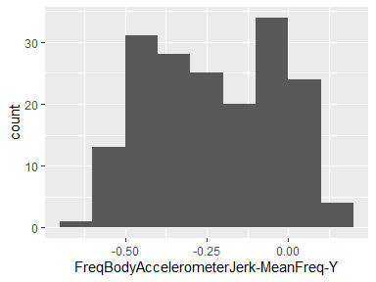

## FreqBodyAccelerometerJerk-MeanFreq-Z

|  |  |
| --- | --- |
| Feature | Result |
| Variable type | numeric |
| Number of missing obs. | 0 (0 %) |
| Number of unique values | 180 |
| Median | -0.09 |
| 1st and 3rd quartiles | -0.31; 0.04 |
| Min. and max. | -0.63; 0.23 |

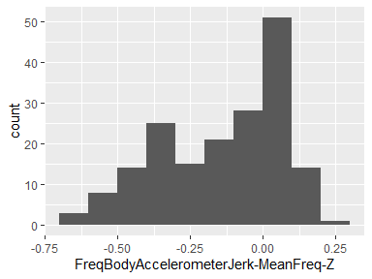

## FreqBodyGyroscope-Mean-X

|  |  |
| --- | --- |
| Feature | Result |
| Variable type | numeric |
| Number of missing obs. | 0 (0 %) |
| Number of unique values | 180 |
| Median | -0.73 |
| 1st and 3rd quartiles | -0.97; -0.34 |
| Min. and max. | -0.99; 0.47 |

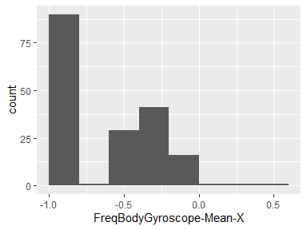

## FreqBodyGyroscope-Mean-Y

|  |  |
| --- | --- |
| Feature | Result |
| Variable type | numeric |
| Number of missing obs. | 0 (0 %) |
| Number of unique values | 180 |
| Median | -0.81 |
| 1st and 3rd quartiles | -0.97; -0.45 |
| Min. and max. | -0.99; 0.33 |

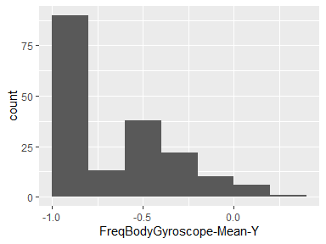

## FreqBodyGyroscope-Mean-Z

|  |  |
| --- | --- |
| Feature | Result |
| Variable type | numeric |
| Number of missing obs. | 0 (0 %) |
| Number of unique values | 180 |
| Median | -0.79 |
| 1st and 3rd quartiles | -0.96; -0.26 |
| Min. and max. | -0.99; 0.49 |

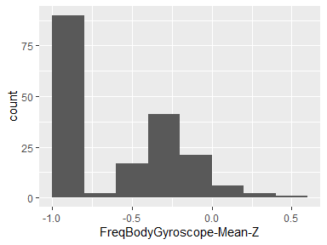

## FreqBodyGyroscope-Std-X

|  |  |
| --- | --- |
| Feature | Result |
| Variable type | numeric |
| Number of missing obs. | 0 (0 %) |
| Number of unique values | 180 |
| Median | -0.81 |
| 1st and 3rd quartiles | -0.98; -0.48 |
| Min. and max. | -0.99; 0.2 |

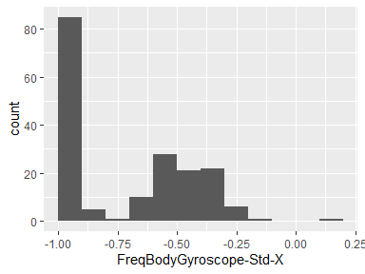

## FreqBodyGyroscope-Std-Y

|  |  |
| --- | --- |
| Feature | Result |
| Variable type | numeric |
| Number of missing obs. | 0 (0 %) |
| Number of unique values | 180 |
| Median | -0.8 |
| 1st and 3rd quartiles | -0.96; -0.42 |
| Min. and max. | -0.99; 0.65 |

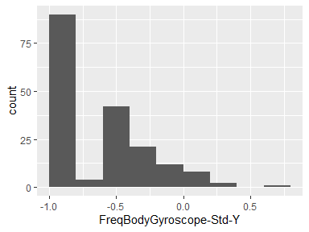

## FreqBodyGyroscope-Std-Z

|  |  |
| --- | --- |
| Feature | Result |
| Variable type | numeric |
| Number of missing obs. | 0 (0 %) |
| Number of unique values | 180 |
| Median | -0.82 |
| 1st and 3rd quartiles | -0.96; -0.39 |
| Min. and max. | -0.99; 0.52 |

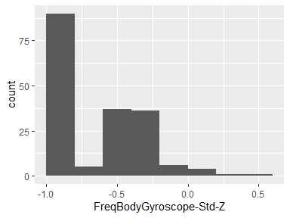

## FreqBodyGyroscope-MeanFreq-X

|  |  |
| --- | --- |
| Feature | Result |
| Variable type | numeric |
| Number of missing obs. | 0 (0 %) |
| Number of unique values | 180 |
| Median | -0.12 |
| 1st and 3rd quartiles | -0.21; 0 |
| Min. and max. | -0.4; 0.25 |

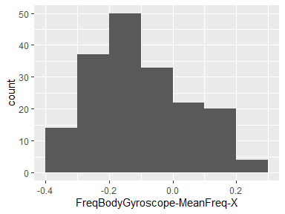

## FreqBodyGyroscope-MeanFreq-Y

|  |  |
| --- | --- |
| Feature | Result |
| Variable type | numeric |
| Number of missing obs. | 0 (0 %) |
| Number of unique values | 180 |
| Median | -0.16 |
| 1st and 3rd quartiles | -0.29; -0.04 |
| Min. and max. | -0.67; 0.27 |

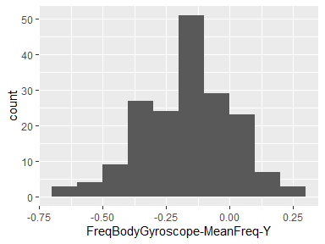

## FreqBodyGyroscope-MeanFreq-Z

|  |  |
| --- | --- |
| Feature | Result |
| Variable type | numeric |
| Number of missing obs. | 0 (0 %) |
| Number of unique values | 180 |
| Median | -0.05 |
| 1st and 3rd quartiles | -0.15; 0.04 |
| Min. and max. | -0.51; 0.38 |

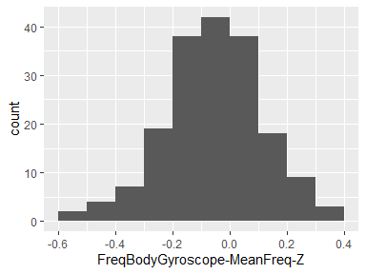

## FreqBodyAccelerometerMagnitude-Mean

|  |  |
| --- | --- |
| Feature | Result |
| Variable type | numeric |
| Number of missing obs. | 0 (0 %) |
| Number of unique values | 180 |
| Median | -0.67 |
| 1st and 3rd quartiles | -0.96; -0.16 |
| Min. and max. | -0.99; 0.59 |

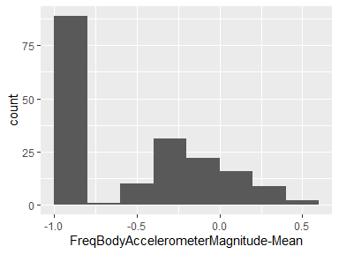

## FreqBodyAccelerometerMagnitude-Std

|  |  |
| --- | --- |
| Feature | Result |
| Variable type | numeric |
| Number of missing obs. | 0 (0 %) |
| Number of unique values | 180 |
| Median | -0.65 |
| 1st and 3rd quartiles | -0.95; -0.37 |
| Min. and max. | -0.99; 0.18 |

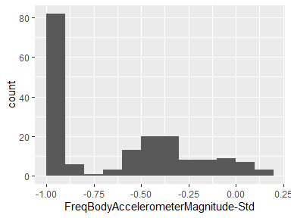

## FreqBodyAccelerometerMagnitude-MeanFreq

|  |  |
| --- | --- |
| Feature | Result |
| Variable type | numeric |
| Number of missing obs. | 0 (0 %) |
| Number of unique values | 180 |
| Median | 0.08 |
| 1st and 3rd quartiles | -0.01; 0.17 |
| Min. and max. | -0.31; 0.44 |

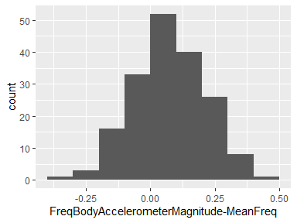

## FreqBodyAccelerometerJerkMagnitude-Mean

|  |  |
| --- | --- |
| Feature | Result |
| Variable type | numeric |
| Number of missing obs. | 0 (0 %) |
| Number of unique values | 180 |
| Median | -0.79 |
| 1st and 3rd quartiles | -0.98; -0.19 |
| Min. and max. | -0.99; 0.54 |

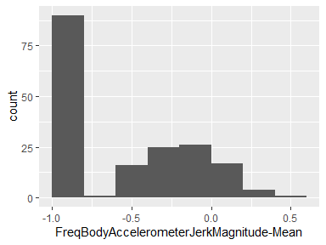

## FreqBodyAccelerometerJerkMagnitude-Std

|  |  |
| --- | --- |
| Feature | Result |
| Variable type | numeric |
| Number of missing obs. | 0 (0 %) |
| Number of unique values | 180 |
| Median | -0.81 |
| 1st and 3rd quartiles | -0.98; -0.27 |
| Min. and max. | -0.99; 0.32 |

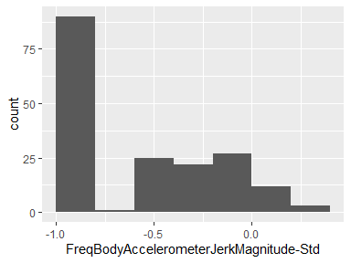

## FreqBodyAccelerometerJerkMagnitude-MeanFreq

|  |  |
| --- | --- |
| Feature | Result |
| Variable type | numeric |
| Number of missing obs. | 0 (0 %) |
| Number of unique values | 180 |
| Median | 0.17 |
| 1st and 3rd quartiles | 0.05; 0.28 |
| Min. and max. | -0.13; 0.49 |

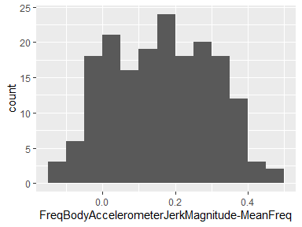

## FreqBodyGyroscopeMagnitude-Mean

|  |  |
| --- | --- |
| Feature | Result |
| Variable type | numeric |
| Number of missing obs. | 0 (0 %) |
| Number of unique values | 180 |
| Median | -0.77 |
| 1st and 3rd quartiles | -0.96; -0.41 |
| Min. and max. | -0.99; 0.2 |

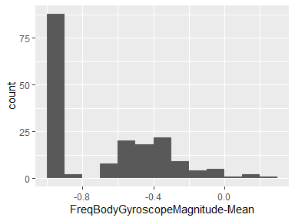

## FreqBodyGyroscopeMagnitude-Std

|  |  |
| --- | --- |
| Feature | Result |
| Variable type | numeric |
| Number of missing obs. | 0 (0 %) |
| Number of unique values | 180 |
| Median | -0.77 |
| 1st and 3rd quartiles | -0.95; -0.43 |
| Min. and max. | -0.98; 0.24 |

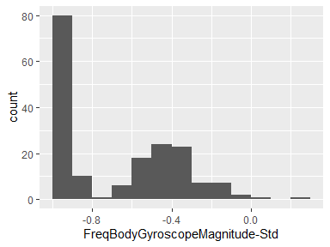

## FreqBodyGyroscopeMagnitude-MeanFreq

|  |  |
| --- | --- |
| Feature | Result |
| Variable type | numeric |
| Number of missing obs. | 0 (0 %) |
| Number of unique values | 180 |
| Median | -0.05 |
| 1st and 3rd quartiles | -0.17; 0.08 |
| Min. and max. | -0.46; 0.41 |

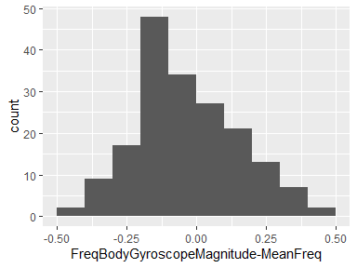

## FreqBodyGyroscopeJerkMagnitude-Mean

|  |  |
| --- | --- |
| Feature | Result |
| Variable type | numeric |
| Number of missing obs. | 0 (0 %) |
| Number of unique values | 180 |
| Median | -0.88 |
| 1st and 3rd quartiles | -0.98; -0.58 |
| Min. and max. | -1; 0.15 |

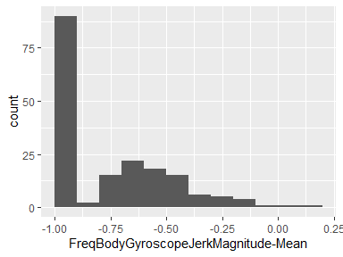

## FreqBodyGyroscopeJerkMagnitude-Std

|  |  |
| --- | --- |
| Feature | Result |
| Variable type | numeric |
| Number of missing obs. | 0 (0 %) |
| Number of unique values | 180 |
| Median | -0.89 |
| 1st and 3rd quartiles | -0.98; -0.61 |
| Min. and max. | -1; 0.29 |

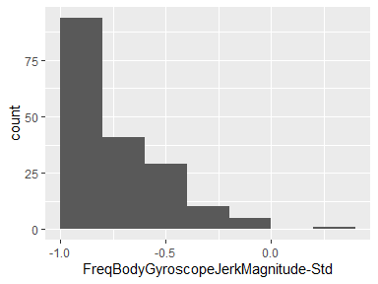

## FreqBodyGyroscopeJerkMagnitude-MeanFreq

|  |  |
| --- | --- |
| Feature | Result |
| Variable type | numeric |
| Number of missing obs. | 0 (0 %) |
| Number of unique values | 180 |
| Median | 0.11 |
| 1st and 3rd quartiles | 0.05; 0.21 |
| Min. and max. | -0.18; 0.43 |

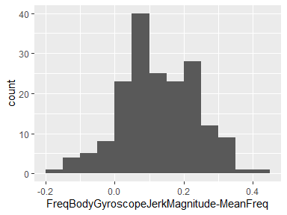

Report generation information:

* Created by: error: invalid key: UPADHYAYA/.gitconfig (username: MANTHAN UPADHYAYA).
* Report creation time: Sun Jun 14 2020 14:10:22
* Report was run from directory: C:/Users/MANTHAN UPADHYAYA/Desktop/R/CourseraR/GetCleanData/UCI HAR Dataset
* dataMaid v1.4.0 [Pkg: 2019-12-10 from CRAN (R 3.6.3)]
* R version 3.6.2 (2019-12-12).
* Platform: x86_64-w64-mingw32/x64 (64-bit)(Windows 10 x64 (build 18363)).
* Function call: dataMaid::makeDataReport(data = tidyData, mode = c("summarize", "visualize", "check"), smartNum = FALSE, file = "codebook_tidyData.Rmd", checks = list(character = "showAllFactorLevels", factor = "showAllFactorLevels", labelled = "showAllFactorLevels", haven_labelled = "showAllFactorLevels", numeric = NULL, integer = NULL, logical = NULL, Date = NULL), listChecks = FALSE, maxProbVals = Inf, codebook = TRUE, reportTitle = "Codebook for tidyData")