ShopEZ
E-Commerce Application

BACKEND TECHNICAL DOCUMENTATION
(ASP.NET Core — MicroServices Application)

Program: Cognizant uGE_DotNet FSD (Angular)
Project Submitted by: Maniar Roshan
Under the Guidance of: Narasimha Sir

Technology Stack: ASP.NET Core 8 • Microservices • Ocelot Gateway • SQL Server • EF Core + Dapper • Docker

Table of Contents
Table of Contents 1
1. Backend Overview 1
1.1 Microservices at a Glance 1
2. Microservices Architecture 1
2.1 Architecture Description 1
2.2 Architecture Diagram 1
2.3 Inter-Service Communication 1
3. API Gateway Architecture (Ocelot) 1
3.1 Ocelot Overview 1
3.2 Route Configuration (Ocelot.json) 1
3.3 Docker Gateway Configuration 1
4. UserService — Authentication & Users 1
4.1 Service Responsibility 1
4.2 Controllers 1
4.3 Password Security 1
4.4 JWT Token Generation 1
4.5 Data Models 1
5. ProductService — Products & Images 1
5.1 Service Responsibility 1
5.2 Controllers 1
5.3 Dapper Usage 1
5.4 Product Data Model 1
5.5 Image Upload Flow 1
6. CartService — Shopping Cart 1
6.1 Service Responsibility 1
6.2 Endpoints 1
6.3 Data Models 1
6.4 Cart Flow 1
7. OrderService — Order Management 1
7.1 Service Responsibility 1
7.2 Endpoints 1
7.3 Order Data Models 1
7.4 Order Creation Flow 1
8. JWT Authentication Flow 1
8.1 Token Generation (UserService) 1
8.2 Token Validation (Gateway + Microservices) 1
8.3 Role-Based Authorization 1
9. Database Design 1
9.1 Database Overview 1
9.2 Table Schema 1
9.3 Key Relationships 1
9.4 EF Core Migrations 1
10. Technology Stack Details 1
11. Docker Configuration 1
11.1 Docker Compose Services 1
11.2 Key Docker Commands 1
11.3 Environment Variables (Docker) 1
11.4 Volume Configuration 1
12. API Screenshots (Swagger & Postman) 1
12.1 Swagger API Documentation 1
Figure 1 — UserService Swagger 1
Figure 2 — ProductService Swagger 1
Figure 3 — CartService Swagger 1
Figure 4 — OrderService Swagger 1
12.2 Postman API Test Results 1
Figure 5 — User Registration (Success) 1
Figure 6 — User Login (Success) 1
Figure 7 — Admin Login (Success) 1
Figure 8 — Get All Products (Success) 1
Figure 9 — Get Product by ID (Success) 1
Figure 10 — Add Product by Admin (Success) 1
Figure 11 — Update Product by Admin (Success) 1
Figure 12 — Delete Product by Admin (Success) 1
Figure 13 — Delete Product Without Admin Role (Forbidden) 1
Figure 14 — Add to Cart (Unauthorized Without Login) 1
Figure 15 — Add to Cart (Success) 1
Figure 16 — Delete Cart Item (Success) 1
Figure 17 — Create Order (Success) 1
Figure 18 — Get My Orders (Customer Success) 1
Figure 19 — Get All Orders (Unauthorized) 1
Figure 20 — Get All Users by Admin (Success) 1
Figure 21 — Get User Profile (Success) 1
Figure 22 — Get User Orders (Success) 1
Figure 23 — All Products View at LocalHost:5000 1
Figure 24 — Docker Running Successfully 1
13. Unit Testing 1
13.1 Testing Framework 1
13.2 Test Coverage 1
13.3 Test Evidence 1
13.4 Running Tests 1
14. Deployment Guide 1
14.1 Prerequisites 1
14.2 Deployment Steps 1
14.3 Applying Migrations 1
14.4 Seeding Product Data 1
15. Future Enhancements 1
16. Conclusion 1

1. Backend Overview
ShopEZ's backend is built using the Microservices Architecture pattern on ASP.NET Core 8. Instead of a single monolithic API, the application is divided into four independent, loosely coupled microservices, each responsible for a specific business domain. These services communicate through an Ocelot API Gateway, which acts as a single entry point for all client requests.

Each microservice has its own dedicated responsibility, its own connection to the shared SQL Server database (ECommerceDb), and its own Docker container. JWT authentication is validated at both the Gateway level and the individual service level, providing layered security.

ENTERPRISE PATTERNS DEMONSTRATED: API Gateway Pattern | Domain-Driven Microservices | Defence-in-Depth JWT Security | Dual-ORM Strategy (Dapper + EF Core) | Data Denormalisation for Audit Integrity | Docker-Compose Orchestration | xUnit + Moq Unit Testing

1.1 Microservices at a Glance
Service | Port (Local) | Port (Docker) | Responsibility
UserService | 5001 | 8080 (internal) | Registration, Login, JWT Generation, User Management
ProductService | 5002 | 8080 (internal) | Product CRUD, Image Upload, Stock Management
CartService | 5003 | 8080 (internal) | Cart operations — Add, View, Update, Remove, Clear
OrderService | 5004 | 8080 (internal) | Order creation, order history, order cancellation
ApiGateway | 5000 | 5000 (exposed) | Route all requests to correct microservices via Ocelot

2. Microservices Architecture

2.1 Architecture Description
ShopEZ follows a Domain-Driven Microservices Architecture where each service is independently deployable and scalable. The architecture components are:

- API Gateway (Ocelot): Single entry point for all Angular frontend requests. Handles JWT validation and route forwarding.
- UserService: Manages user registration, login, password hashing (BCrypt-style), JWT token generation, and admin user management.
- ProductService: Manages the product catalogue using Dapper for read queries and EF Core for writes. Handles image upload via multipart form data.
- CartService: Manages per-user shopping cart persistence in SQL Server. Validates product existence via internal HTTP call to ProductService.
- OrderService: Creates orders from cart data, decrements product stock via ProductService, and manages order lifecycle (Active / Cancelled).

2.2 Architecture Diagram
SYSTEM ARCHITECTURE — ShopEZ Microservices Overview
┌─────────────────────────────────────────────────────────────────────┐
│ Angular Frontend (Port 4200) │
└────────────────────────────┬────────────────────────────────────────┘
│ All API Requests
▼
┌─────────────────────────────────────────────────────────────────────┐
│ Ocelot API Gateway (Port 5000) │
│ JWT Validation • Route Matching • Request Forwarding │
└──────┬──────────────┬──────────────┬──────────────┬─────────────────┘
│ │ │ │
▼ ▼ ▼ ▼
┌──────────┐ ┌───────────┐ ┌──────────┐ ┌──────────────┐
│UserService│ │ProductSvc │ │CartSvc │ │OrderService │
│ :5001 │ │ :5002 │ │ :5003 │ │ :5004 │
└────┬─────┘ └─────┬─────┘ └────┬─────┘ └──────┬───────┘
│ │ │ │
└──────────────┴──────────────┴───────────────┘
│
▼
┌──────────────────────────┐
│ SQL Server — ECommerceDb │
│ (Shared Database) │
└──────────────────────────┘

2.3 Inter-Service Communication

DESIGN PATTERN: The bypass of the API Gateway for internal service communication is a deliberate performance optimisation. Direct HTTP calls (via typed HttpClient) eliminate gateway overhead for high-frequency internal operations, while still maintaining full JWT security at the microservice level.

CartService and OrderService communicate internally with ProductService via HTTP. This is implemented using typed HttpClient clients (IProductApiClient / ProductApiClient). These internal calls bypass the API Gateway and go directly to the ProductService endpoint, enabling:

- CartService: Fetch product details (price, name, imageUrl) when adding items to cart
- OrderService: Fetch product details and decrement stock when an order is placed

3. API Gateway Architecture (Ocelot)

3.1 Ocelot Overview
Ocelot is a .NET API Gateway library configured in ApiGateway/Ocelot.json. It acts as a reverse proxy that matches incoming request URLs and forwards them to the appropriate downstream microservice. Ocelot also handles JWT Bearer token validation before forwarding protected requests.

3.2 Route Configuration (Ocelot.json)
Upstream Path (Client) | Downstream Service | Auth Required
/api/auth/{everything} | UserService :5001 | No
/api/users / /api/user/{everything} | UserService :5001 | Yes (Bearer)
/api/products (GET) | ProductService :5002 | No
/api/products (POST/PUT/DELETE) | ProductService :5002 | Yes (Bearer)
/api/products/{everything} (GET) | ProductService :5002 | No
/api/products/{everything} (POST/PUT/DELETE) | ProductService :5002 | Yes (Bearer)
/api/products/admin/{everything} | ProductService :5002 | Yes (Bearer)
/api/images/upload (POST) | ProductService :5002 | Yes (Bearer)
/images/{everything} (GET) | ProductService :5002 | No (public)
/api/cart, /api/cart/{everything} | CartService :5003 | Yes (Bearer)
/api/orders, /api/orders/{everything} | OrderService :5004 | Yes (Bearer)

3.3 Docker Gateway Configuration
For Docker deployment, a separate Ocelot.Docker.json is used where downstream hosts are replaced by Docker service names (userservice, productservice, cartservice, orderservice) with port 8080, since containers communicate over Docker's internal network. The OCELOT_CONFIG environment variable selects this file at runtime.

4. UserService — Authentication & Users

4.1 Service Responsibility
UserService is the authentication authority of ShopEZ. It manages user accounts, handles registration and login, generates JWT tokens, and provides admin-only endpoints for user management.

4.2 Controllers
Controller | Endpoints
AuthController (/api/auth) | POST /register — new customer registration; POST /login — returns JWT token
UsersController (/api/users) | [Admin] GET /api/users — all users; PUT /api/users/:id/toggle-role — toggle Admin/Customer
UserProfileController (/api/user/profile) | [Authenticated] GET — own profile; PUT — update own profile

4.3 Password Security
Passwords are hashed using a BCrypt-style PasswordHasher utility before storage. The Login endpoint supports backward compatibility — if a password is stored in plain text (legacy), it accepts the direct match. New registrations always hash the password before storing.

4.4 JWT Token Generation
On successful login, UserService generates a signed JWT token containing: userId (as nameid claim), name (as unique_name), email, and role ('Customer' or 'Admin'). The token is signed with the configured JWT Key, Issuer (ShopEZ), and Audience (ShopEZUsers).

4.5 Data Models
Model / DTO | Fields
User (Entity) | UserId, Name, Email, Password (hashed), Role
RegisterDto | Name, Email, Password
LoginDto | Email, Password
UserAdminDto | UserId, Name, Email, Role
UserProfileDto | Name, Email (read-only profile fields)

5. ProductService — Products & Images

5.1 Service Responsibility
ProductService manages the entire product catalogue. It uses Dapper for all read queries (high-performance raw SQL) and handles image file uploads stored in the wwwroot/images directory served as static files.

5.2 Controllers
Controller | Endpoints
ProductsController (/api/products) | GET / — all products; GET /search — paginated filter search; GET /:id — by ID; POST / [Admin] — add; PUT /:id [Admin] — update; DELETE /:id [Admin] — soft delete; GET /admin/all [Admin] — including inactive; PUT /:id/stock — update stock (internal use)
ImagesController (/api/images) | POST /upload [Auth] — upload image; GET /images/:filename — serve static image

5.3 Dapper Usage
ProductService's read operations (GetProducts, GetProduct, GetProductsWithFilters, GetProductsForAdmin) use Dapper directly on a SqlConnection for maximum query performance. Write operations (Add, Update, SoftDelete, UpdateStock) use EF Core's DbContext for change tracking and migration support.

5.4 Product Data Model
Field | Type & Notes
Id | int — Primary Key, auto-increment
Name | string — Product display name
Description | string — Product description text
Price | decimal — Unit price
Category | string — Product category (Electronics, Accessories, etc.)
Stock | int — Current inventory count
ImageUrl | string — Relative path to uploaded image (e.g., /images/product.jpg)
IsActive | bool — Soft delete flag (false = removed from public catalogue)

5.5 Image Upload Flow
- Admin POSTs a multipart/form-data request to /api/images/upload
- ImagesController receives the IFormFile
- File is saved to wwwroot/images/ with a unique GUID filename
- Response returns the relative URL (/images/{guid}.jpg)
- Admin uses this URL when creating or updating a product
- The Angular ProductService sets the imageUrl field in the ProductDTO
- Static file middleware serves images at GET /images/{filename}

6. CartService — Shopping Cart

6.1 Service Responsibility
CartService manages persistent per-user shopping carts stored in SQL Server. It validates JWT claims to identify the user, and fetches current product information from ProductService via internal HTTP calls.

6.2 Endpoints
Method + Endpoint | Action | Auth
GET /api/cart | Fetch current user's cart items with product details | Bearer Token
POST /api/cart | Add item to cart (or increase quantity if exists) | Bearer Token
PUT /api/cart/:productId | Update quantity of specific cart item | Bearer Token
DELETE /api/cart/:productId | Remove specific item from cart | Bearer Token
DELETE /api/cart | Clear all items in user's cart | Bearer Token

6.3 Data Models
Model / DTO | Fields
CartItem (Entity) | Id, UserId, ProductId, Quantity
AddToCartDto | ProductId, Quantity
CartResponseDto | ProductId, ProductName, Price, Quantity, ImageUrl, TotalPrice

6.4 Cart Flow
- User authenticates — JWT carries UserId claim
- CartController extracts UserId from ClaimTypes.NameIdentifier
- CartService.AddToCart() checks if item exists — updates quantity or inserts new row
- For GetCart(), CartService calls ProductApiClient.GetProduct(productId) to enrich cart items with product details
- CartService returns CartResponseDto list with computed TotalPrice per item

7. OrderService — Order Management

7.1 Service Responsibility
OrderService handles the complete order lifecycle in ShopEZ. It creates orders from customer checkout data, fetches product details from ProductService, decrements product stock, and provides order history retrieval for customers and admins.

7.2 Endpoints
Method + Endpoint | Action | Auth
POST /api/orders | Create a new order from checkout data | Bearer Token
GET /api/orders | Get all orders — Admin only | Bearer + Admin Role
GET /api/orders/:id | Get specific order by ID | No extra guard
GET /api/orders/myorders | Get current user's order history | Bearer Token
PUT /api/orders/:id/cancel | Cancel a specific order | Bearer Token

7.3 Order Data Models
Model / DTO | Fields
Order (Entity) | OrderId, UserId, OrderDate, TotalAmount, Status, ShippingAddress, City, ZipCode, Phone, PaymentMethod, Notes, Items[]
OrderItem (Entity) | Id, OrderId, ProductId, ProductName, Quantity, Price, ImageUrl
OrderDTO | UserId, Items[], ShippingAddress, City, ZipCode, Phone, PaymentMethod, Notes
OrderResponseDto | OrderId, UserId, OrderDate, TotalAmount, Status, address fields, Items[]
ProductFromProductService | Id, Name, Price, Stock, ImageUrl (fetched from ProductService)

7.4 Order Creation Flow
- Customer submits checkout — Angular sends POST /api/orders with OrderDTO
- OrderService.CreateOrder() receives the DTO
- For each order item, ProductApiClient.GetProduct() fetches current price and availability from ProductService
- Order entity is created with computed TotalAmount, Status = 'Active', and current timestamp
- ProductApiClient.UpdateStock() decrements stock for each ordered product
- Order and OrderItems are saved to database
- OrderResponseDto is returned to Angular
- Angular navigates to /order-success

8. JWT Authentication Flow

8.1 Token Generation (UserService)
- User POSTs credentials to POST /api/auth/login
- UserService retrieves the User from the database by email
- PasswordHasher.Verify() compares the submitted password with the stored hash
- On success, JwtSecurityTokenHandler creates a signed JWT with claims: nameid (userId), unique_name (name), email, role
- Token is signed using HMACSHA256 with the configured Jwt:Key
- Token is returned to the client as { token: "eyJ..." }

8.2 Token Validation (Gateway + Microservices)
JWT validation is configured in two places:
- Ocelot API Gateway: AuthenticationOptions with AuthenticationProviderKey: 'Bearer' validates the token before forwarding to protected routes.
- Individual Microservices: Each service's Program.cs configures AddAuthentication().AddJwtBearer() with the same Jwt:Key, Jwt:Issuer, and Jwt:Audience. This double-validation ensures security even if the gateway is bypassed.

8.3 Role-Based Authorization
Role-based access control is enforced via the [Authorize(Roles = "Admin")] attribute on controller actions. The Admin role claim in the JWT is checked by ASP.NET Core's authorization middleware. This pattern protects:

SECURITY NOTE: ShopEZ implements a double-validation JWT strategy: the Ocelot Gateway validates tokens before routing, AND each individual microservice re-validates independently. This defence-in-depth approach ensures security even if a service is directly accessed bypassing the gateway — a key enterprise security pattern.

POST/PUT/DELETE /api/products — only Admin can modify the catalogue
- GET /api/products/admin/all — Admin-only full product view including inactive
- GET /api/orders — Admin-only all-orders view
- GET /api/users — Admin-only user list
- PUT /api/users/:id/toggle-role — Admin-only role management

9. Database Design

9.1 Database Overview
ShopEZ uses a single SQL Server database named ECommerceDb shared across all microservices. Entity Framework Core migrations are used for CartService, OrderService, and UserService to manage schema evolution. ProductService uses a combination of Dapper (reads) and EF Core migrations (writes/schema).

9.2 Table Schema
Table Name | Key Columns
Users | UserId (PK, int), Name (nvarchar), Email (nvarchar, unique), Password (nvarchar, hashed), Role (nvarchar)
Products | Id (PK, int), Name, Description, Price (decimal), Category, Stock (int), ImageUrl (nvarchar), IsActive (bit)
CartItems | Id (PK, int), UserId (int, FK), ProductId (int), Quantity (int)
Orders | OrderId (PK, int), UserId (int), OrderDate (datetime), TotalAmount (decimal), Status (nvarchar), ShippingAddress, City, ZipCode, Phone, PaymentMethod, Notes
OrderItems | Id (PK, int), OrderId (int, FK), ProductId (int), ProductName, Quantity (int), Price (decimal), ImageUrl

9.3 Key Relationships
- Users → CartItems: One-to-Many (one user has many cart items)
- Users → Orders: One-to-Many (one user has many orders)
- Orders → OrderItems: One-to-Many (one order has many items)
- Products → CartItems: Referenced by ProductId (no FK constraint enforced — microservice boundary)

DATA INTEGRITY INSIGHT: Product details are intentionally denormalized into OrderItems at the moment of order creation. This means order history remains accurate even if a product is later renamed, repriced, or deleted — a critical design decision for audit-compliant e-commerce systems.

Products → OrderItems: Product details are copied to OrderItem at order creation time (denormalized for order history integrity)

9.4 EF Core Migrations
All database schema changes are managed through EF Core migrations. Each service has its own DbContext and Migrations folder:
- UserService: UserDbContext — manages Users table
- CartService: CartDbContext — manages CartItems table
- OrderService: OrderDbContext — manages Orders and OrderItems tables
- ProductService: DapperContext (reads) — EF Core used only for Product table schema
10. Technology Stack Details

Technology | Version & Usage
ASP.NET Core | 8.0 — Web API framework for all microservices
C# | .NET 8 — Primary programming language
Entity Framework Core | 8.x — ORM for schema migrations and write operations
Dapper | 2.x — Micro-ORM for high-performance raw SQL queries (ProductService reads)
SQL Server | 2022 (Docker: mcr.microsoft.com/mssql/server:2022-latest)
Ocelot | 23.x — API Gateway library for .NET
JWT Bearer | Microsoft.AspNetCore.Authentication.JwtBearer — token validation
xUnit / Moq | Unit testing framework + mocking library
Swagger / Swashbuckle  PERFORMANCE STRATEGY: The dual-ORM strategy (Dapper for reads, EF Core for writes) is a deliberate architectural choice. Dapper executes raw SQL with near-zero overhead for the read-heavy product catalogue queries, while EF Core provides change tracking, migrations, and relationship management for write operations. This pattern is widely used in high-performance enterprise applications. | OpenAPI documentation for each microservice
Docker | Containerization — all services have Dockerfiles
Docker Compose | Orchestration of all 6 containers (SQL, 4 services, gateway, frontend)

11. Docker Configuration

11.1 Docker Compose Services
Service Name | Description
sql | SQL Server 2022 container — ECommerceDb database — Port 14333:1433
userservice | UserService ASP.NET Core — internal port 8080
productservice | ProductService ASP.NET Core — image volume mounted — internal 8080
cartservice | CartService — depends on sql and productservice — internal 8080
orderservice | OrderService — depends on sql and productservice — internal 8080
apigateway | Ocelot API Gateway — exposed on port 5000 — depends on all services
shopez-web | Angular frontend Nginx container — exposed on port 4200

11.2 Key Docker Commands
docker compose up --build # Build all images and start all containers
docker compose up -d # Run in detached (background) mode
docker compose logs -f apigateway # Stream gateway logs
docker compose down # Stop and remove all containers

11.3 Environment Variables (Docker)
All services receive database connection strings and JWT configuration via Docker Compose environment variables. No secrets are hardcoded in Dockerfiles. The Jwt:Key is consistent across all services for cross-service token validation.

11.4 Volume Configuration
The ProductService container mounts a volume for product images: ./ProductService/wwwroot/images:/app/wwwroot/images. This ensures uploaded product images persist across container restarts.

12. API Screenshots (Swagger & Postman)

12.1 Swagger API Documentation

Figure 1 — UserService Swagger
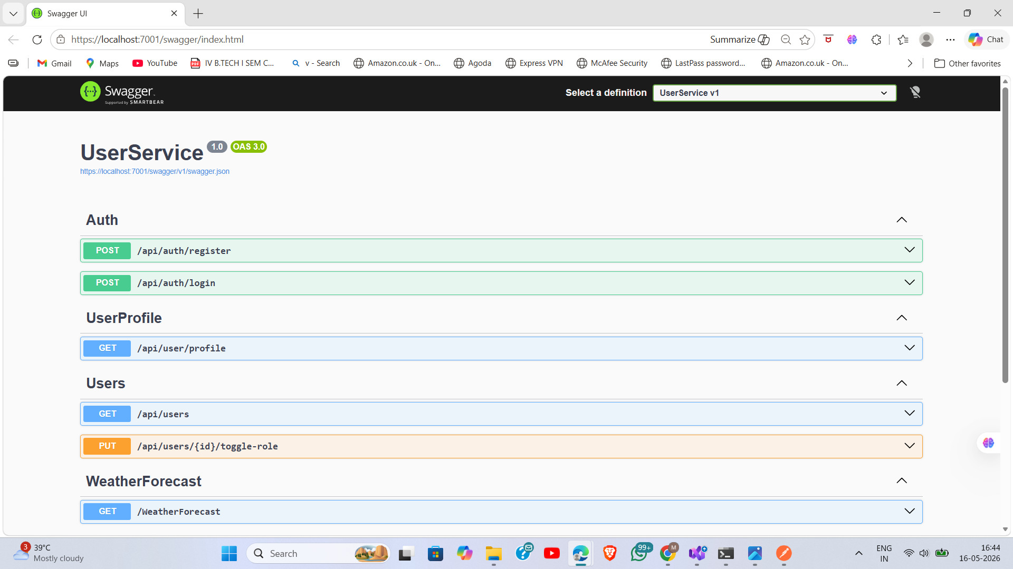
Figure 1: UserService Swagger UI — Auth and User Profile endpoints documented

Figure 2 — ProductService Swagger
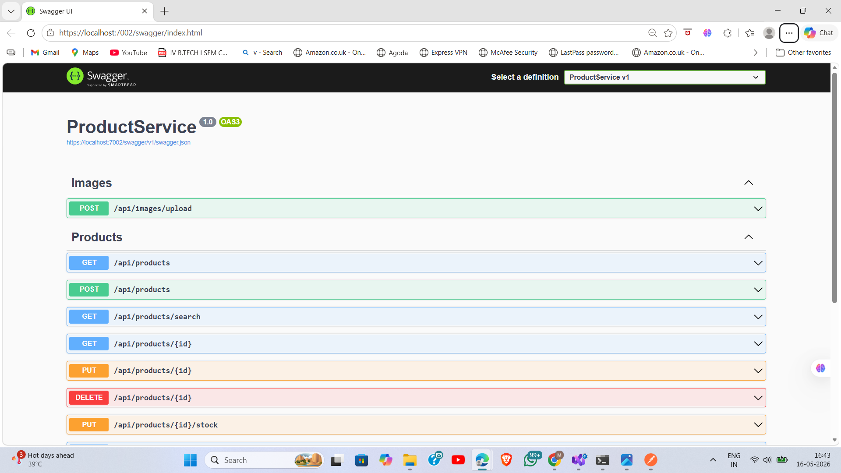
Figure 2: ProductService Swagger UI — Product CRUD and Image upload endpoints

Figure 3 — CartService Swagger
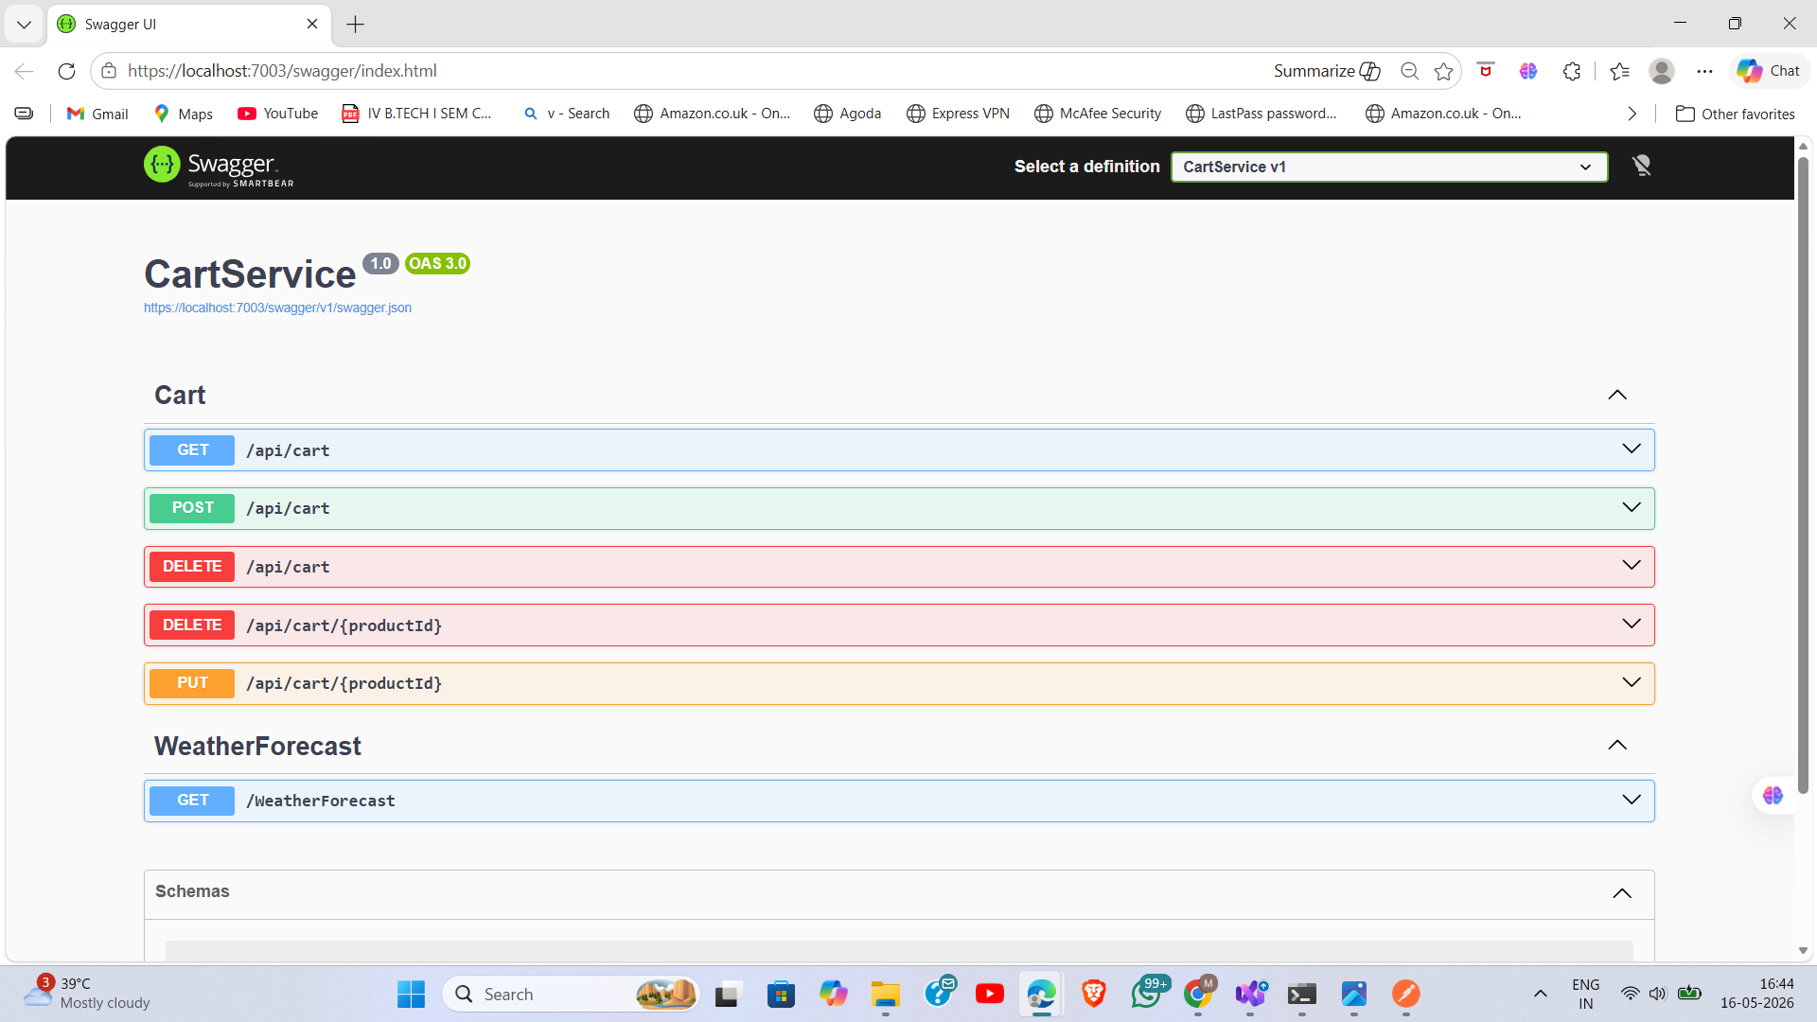
Figure 3: CartService Swagger UI — Cart management endpoints (GET, POST, PUT, DELETE)

Figure 4 — OrderService Swagger
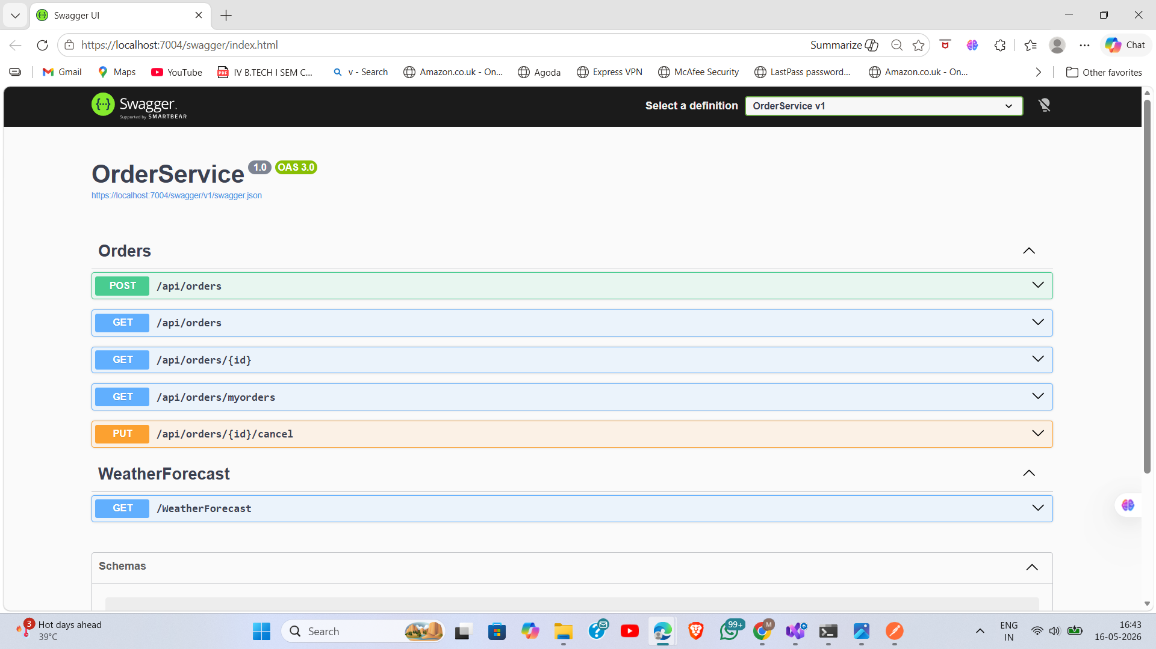
Figure 4: OrderService Swagger UI — Order creation and management endpoints

12.2 Postman API Test Results

Figure 5 — User Registration (Success)
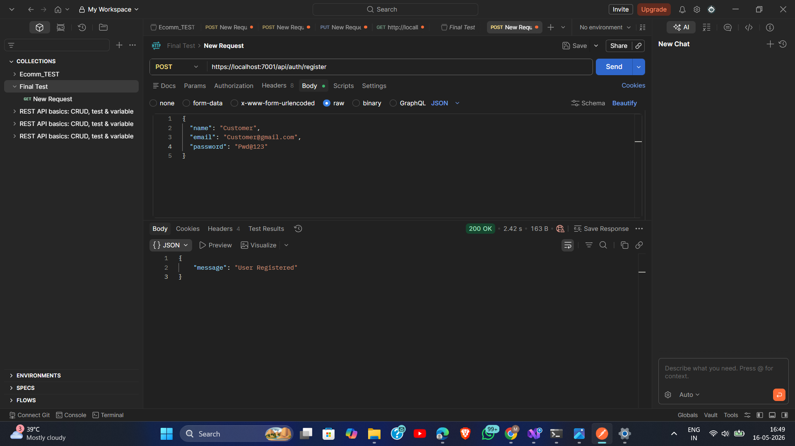
Figure 5: POST /api/auth/register — New customer registered successfully (200 OK)

Figure 6 — User Login (Success)
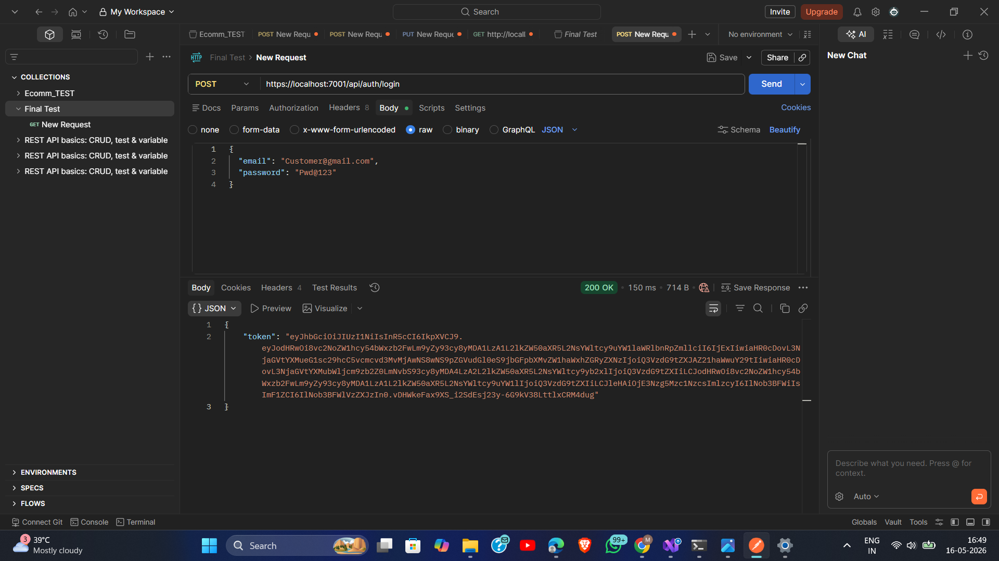
Figure 6: POST /api/auth/login — Customer login returns JWT token (200 OK)

Figure 7 — Admin Login (Success)
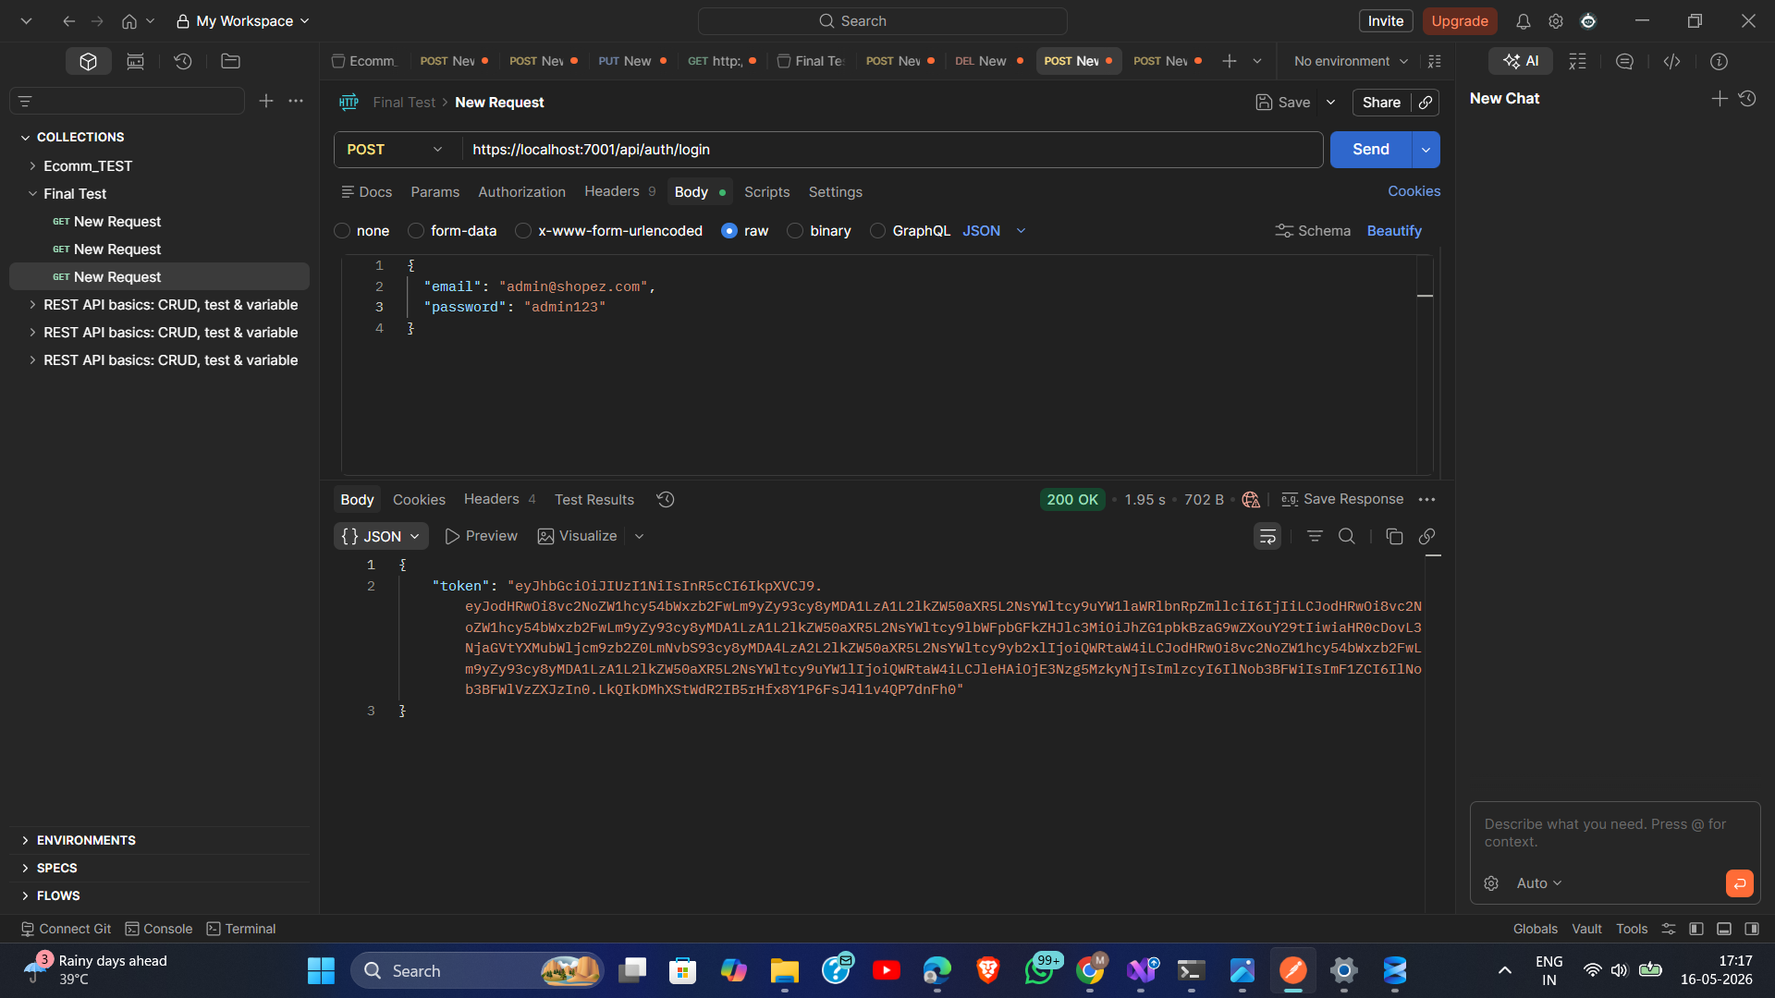
Figure 7: POST /api/auth/login — Admin login with role=Admin in JWT payload (200 OK)

Figure 8 — Get All Products (Success)
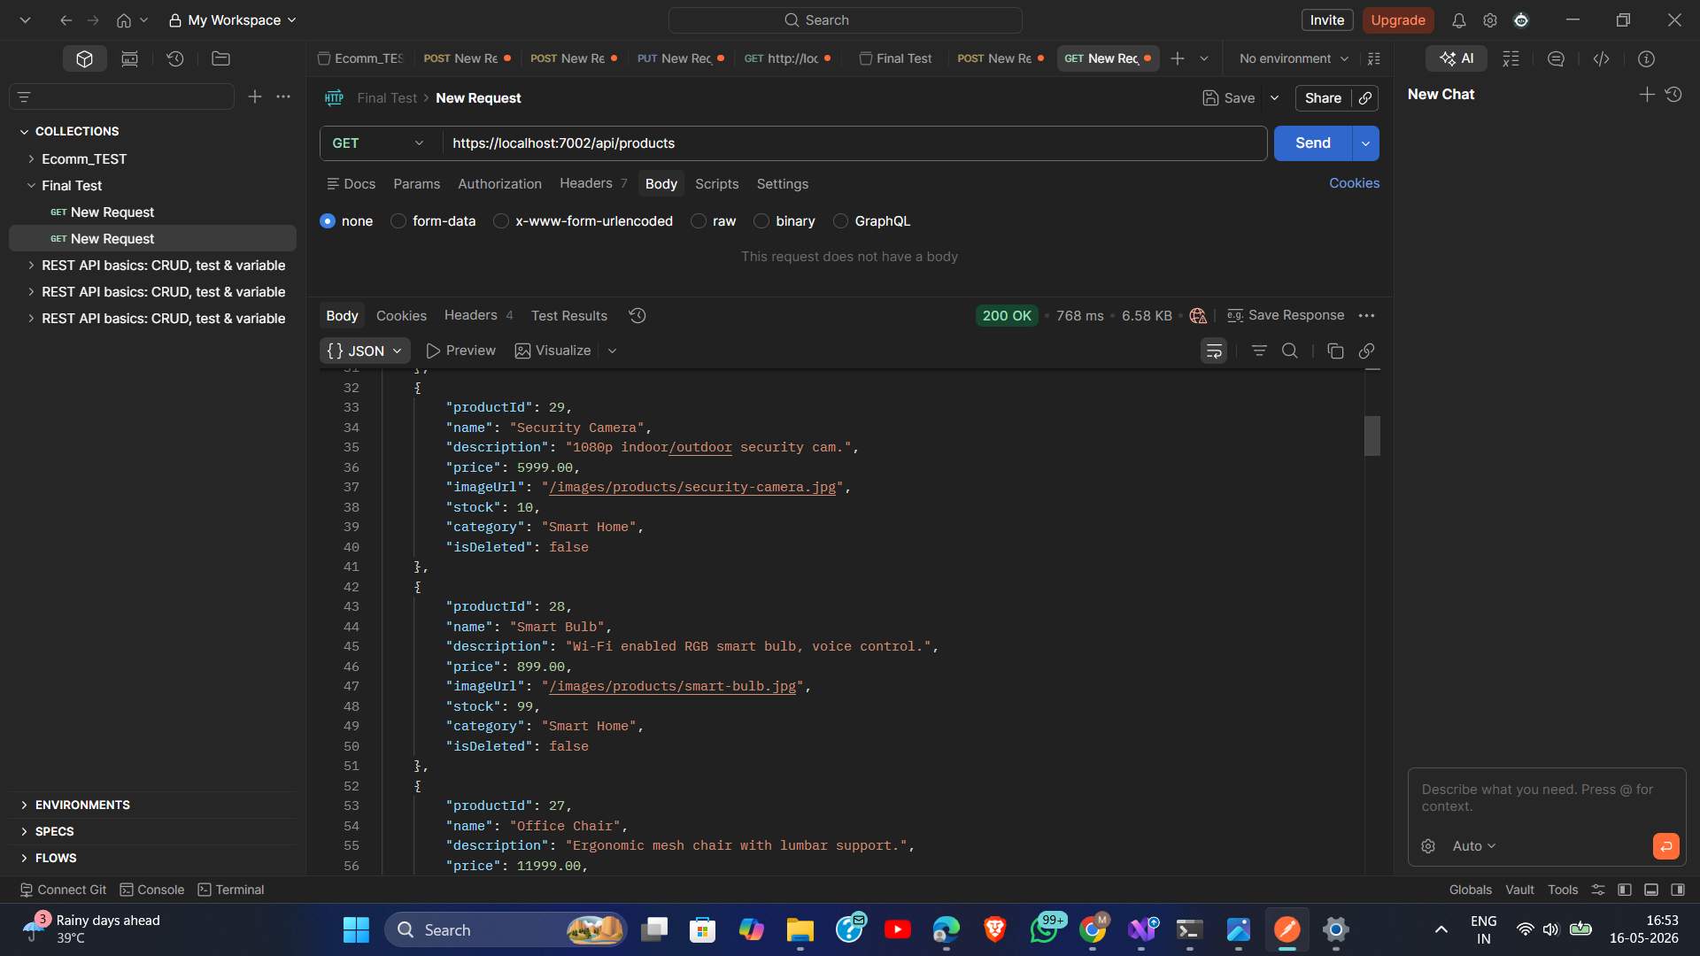
Figure 8: GET /api/products — All products fetched successfully without authentication

Figure 9 — Get Product by ID (Success)
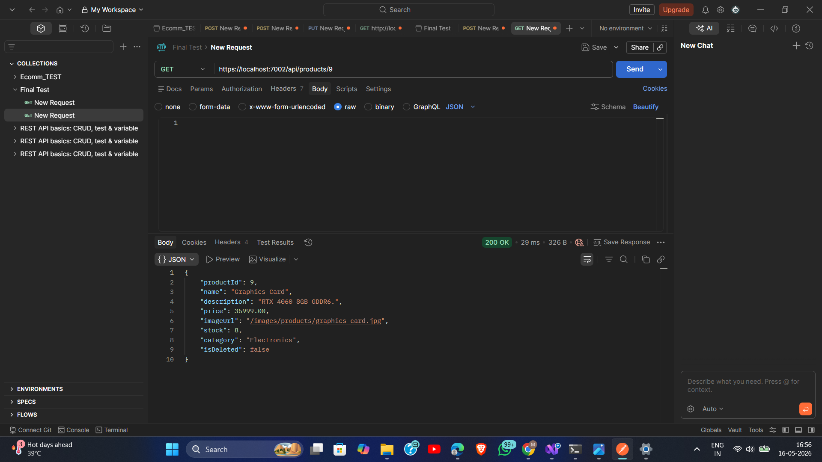
Figure 9: GET /api/products/:id — Single product fetched by ID (200 OK)

Figure 10 — Add Product by Admin (Success)
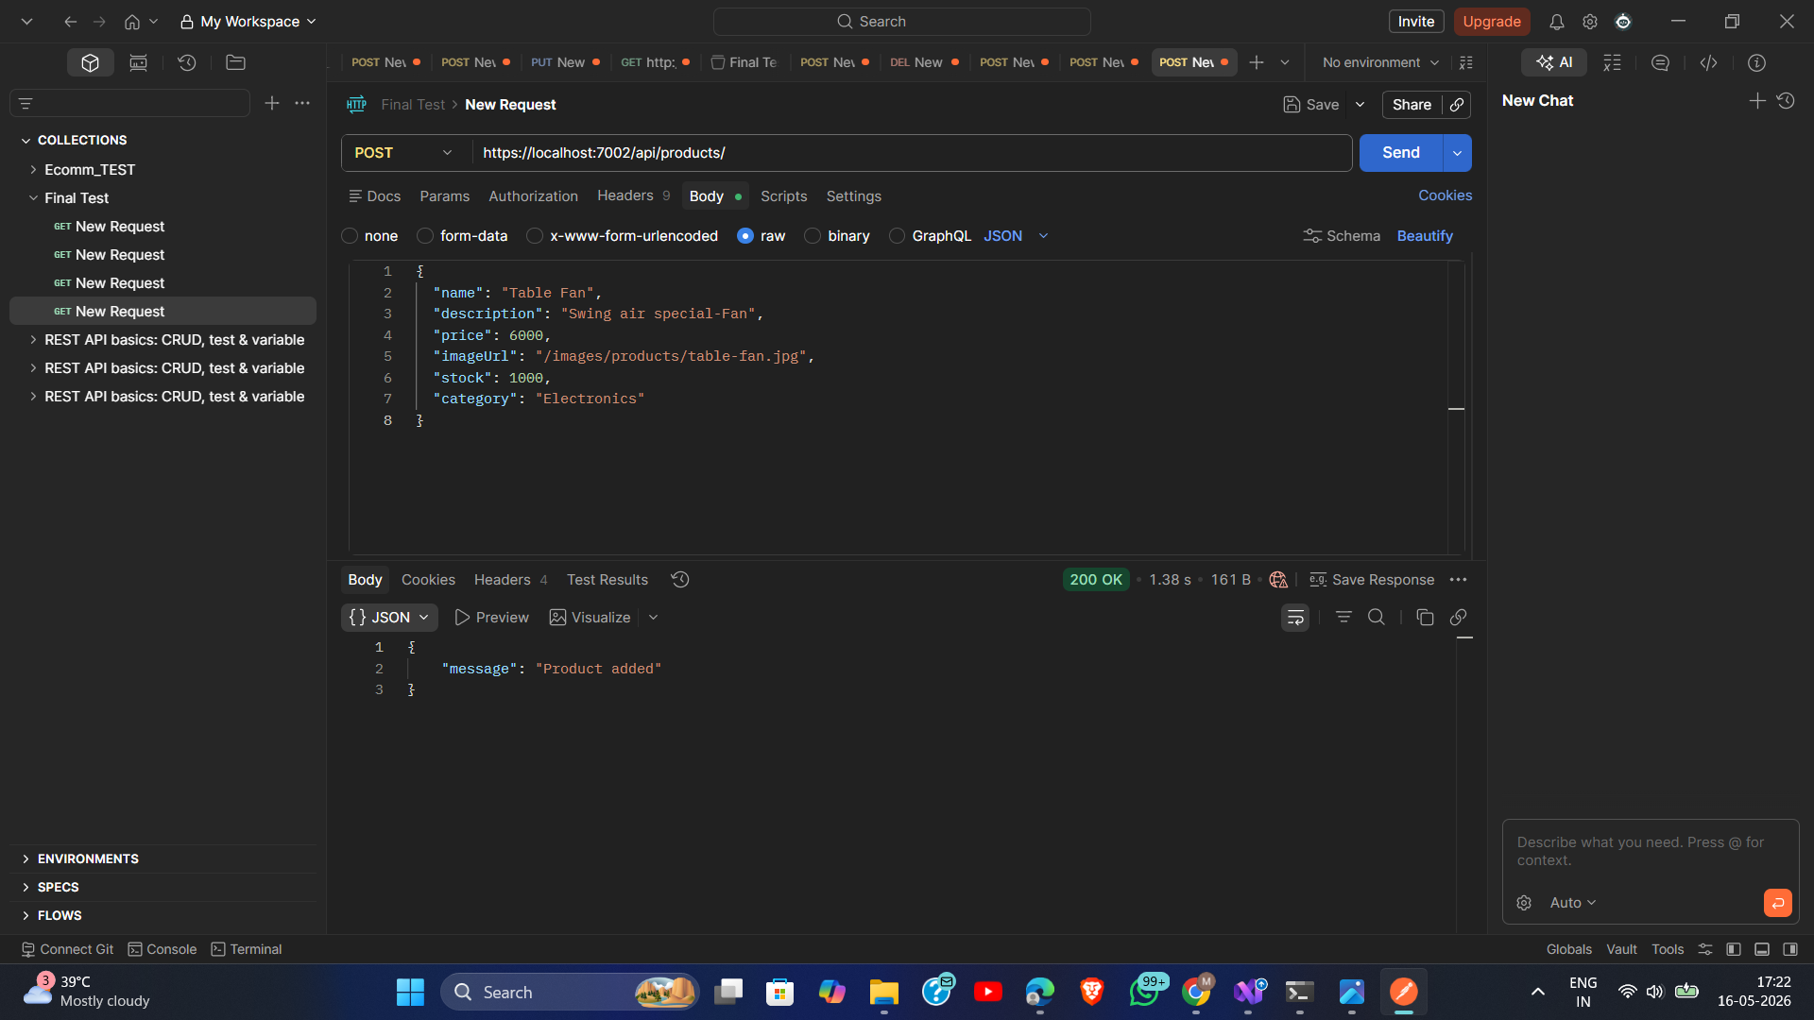
Figure 10: POST /api/products — Admin adds a new product with Authorization header (200 OK)

Figure 11 — Update Product by Admin (Success)
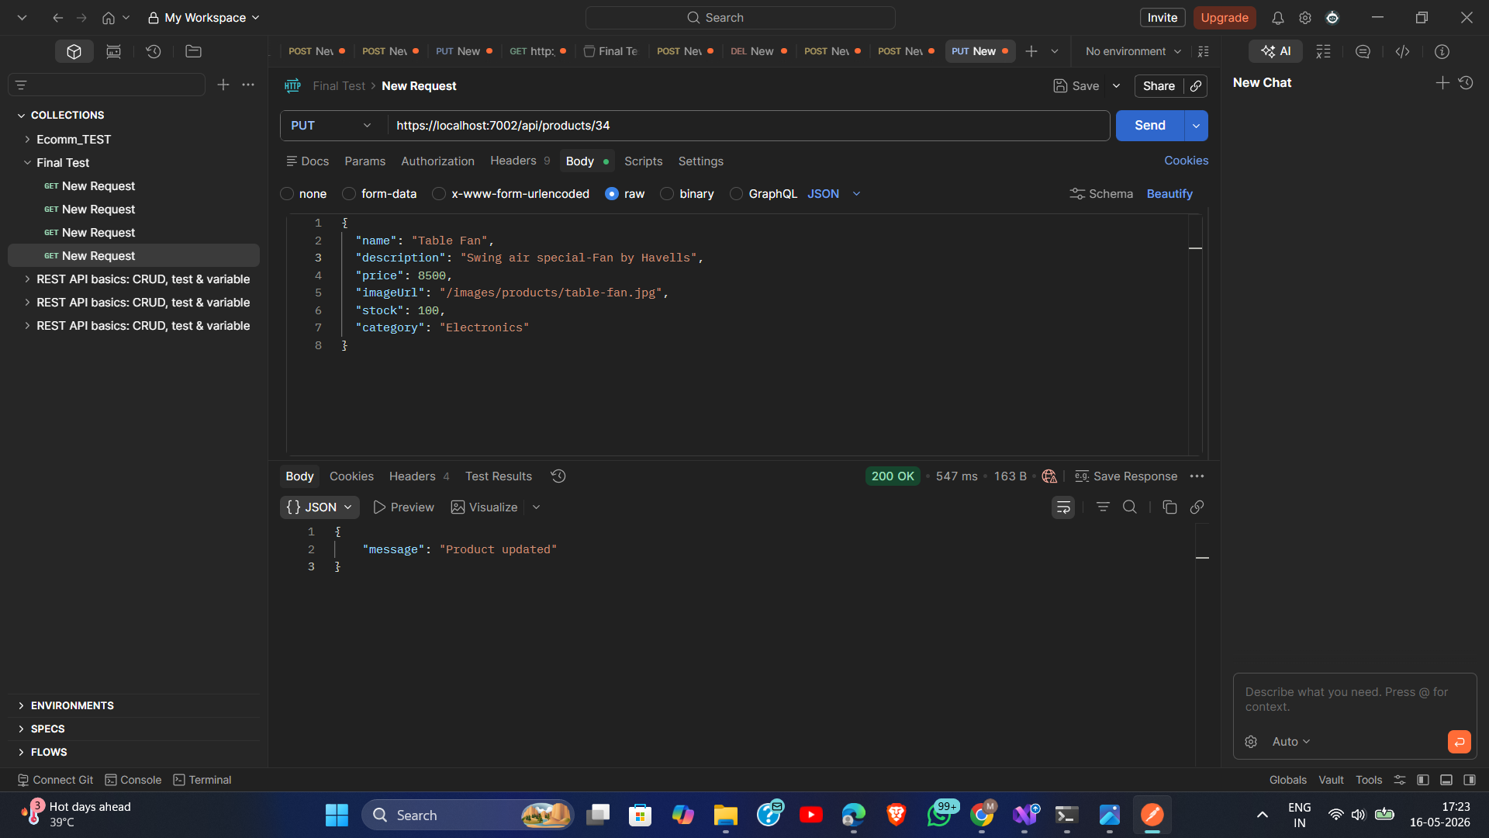
Figure 11: PUT /api/products/:id — Admin updates product details (200 OK)

Figure 12 — Delete Product by Admin (Success)
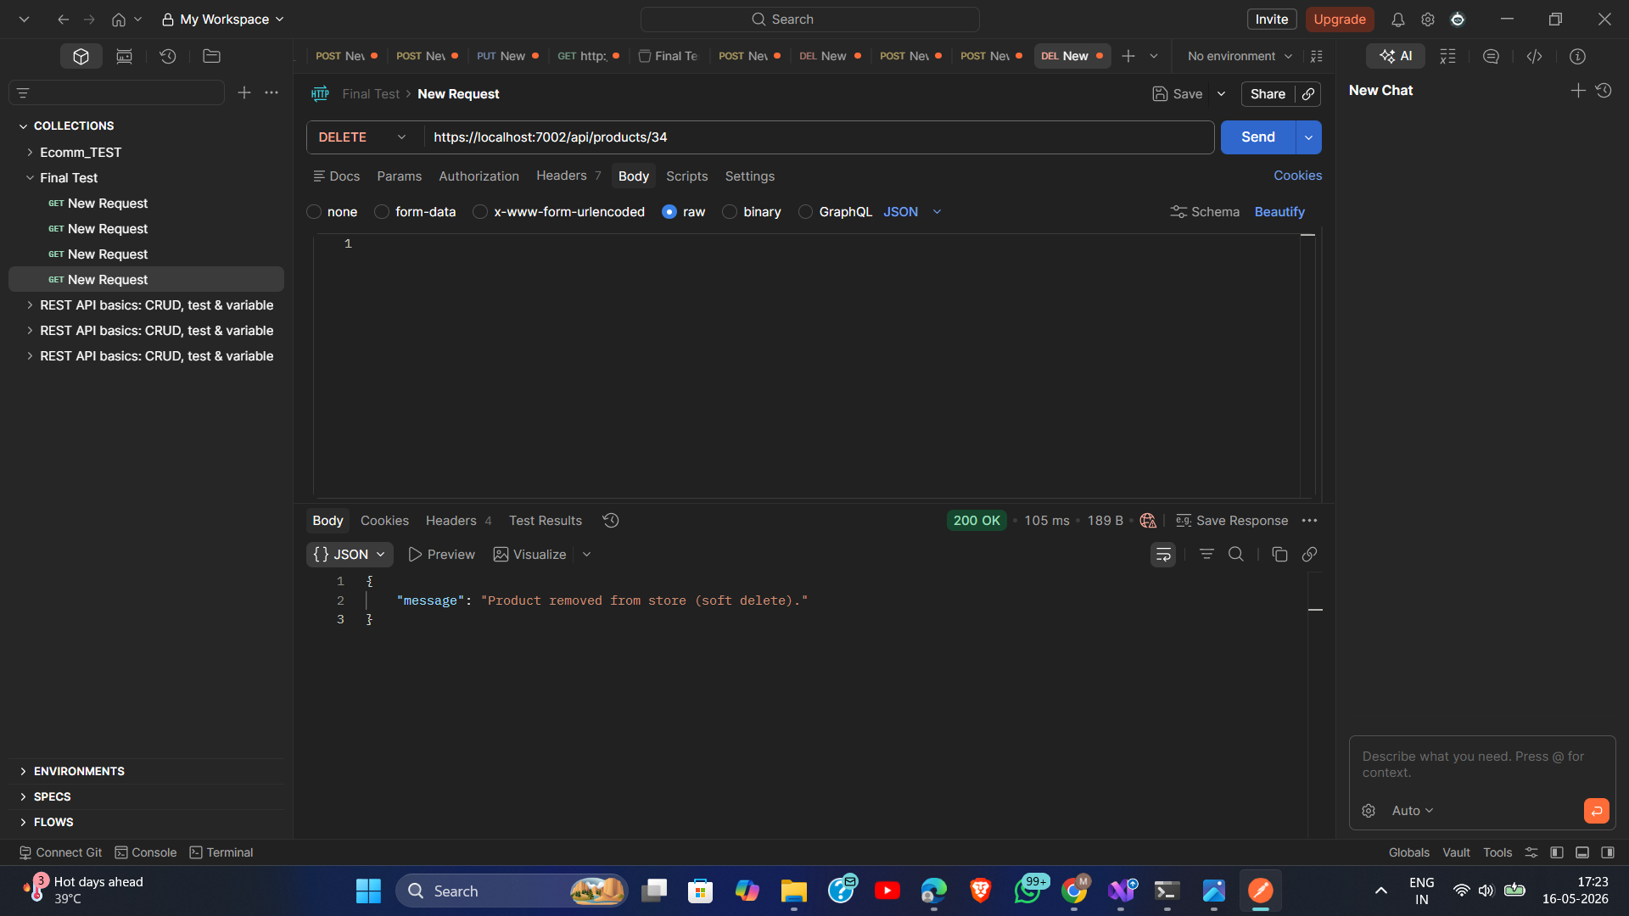
Figure 12: DELETE /api/products/:id — Admin soft-deletes product (200 OK)

Figure 13 — Delete Product Without Admin Role (Forbidden)
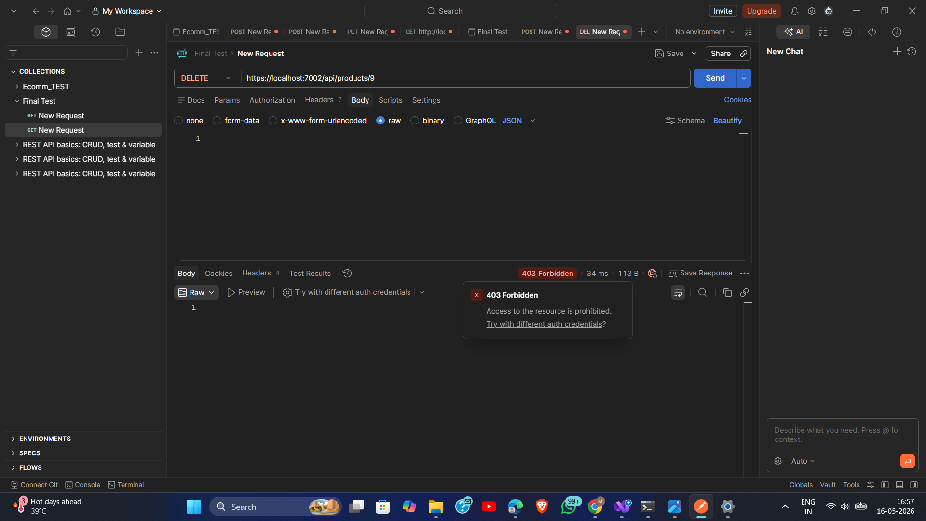
Figure 13: DELETE /api/products/:id — Forbidden (403) when called without Admin role

Figure 14 — Add to Cart (Unauthorized Without Login)
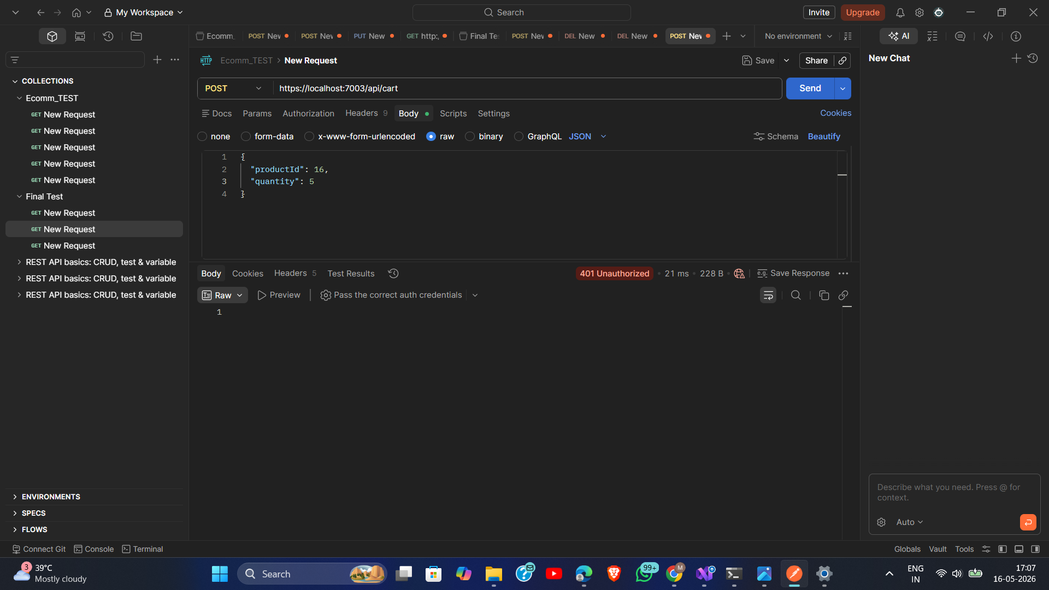
Figure 14: POST /api/cart — 401 Unauthorized when no Bearer token is sent

Figure 15 — Add to Cart (Success)
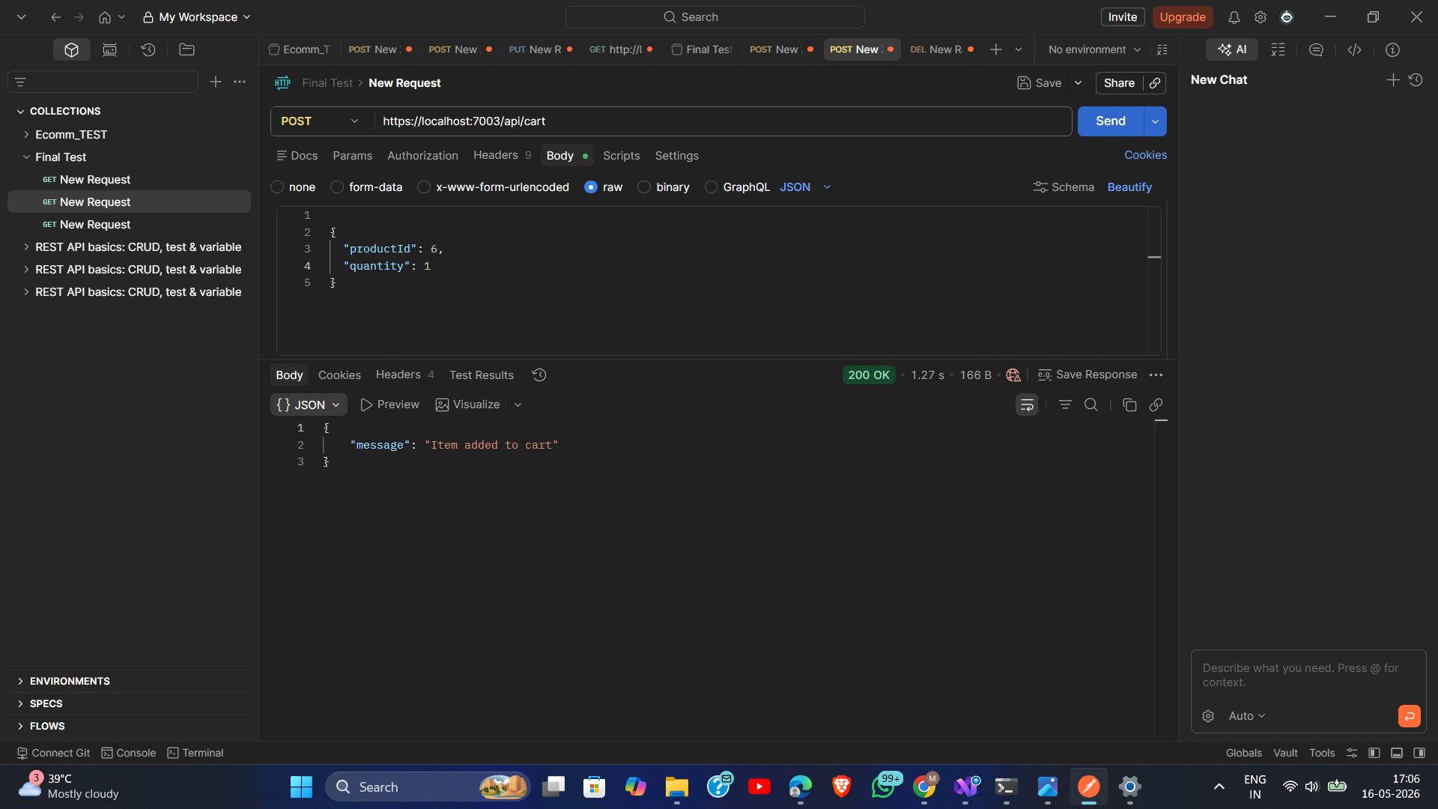
Figure 15: POST /api/cart — Item added to cart successfully with valid JWT (200 OK)

Figure 16 — Delete Cart Item (Success)
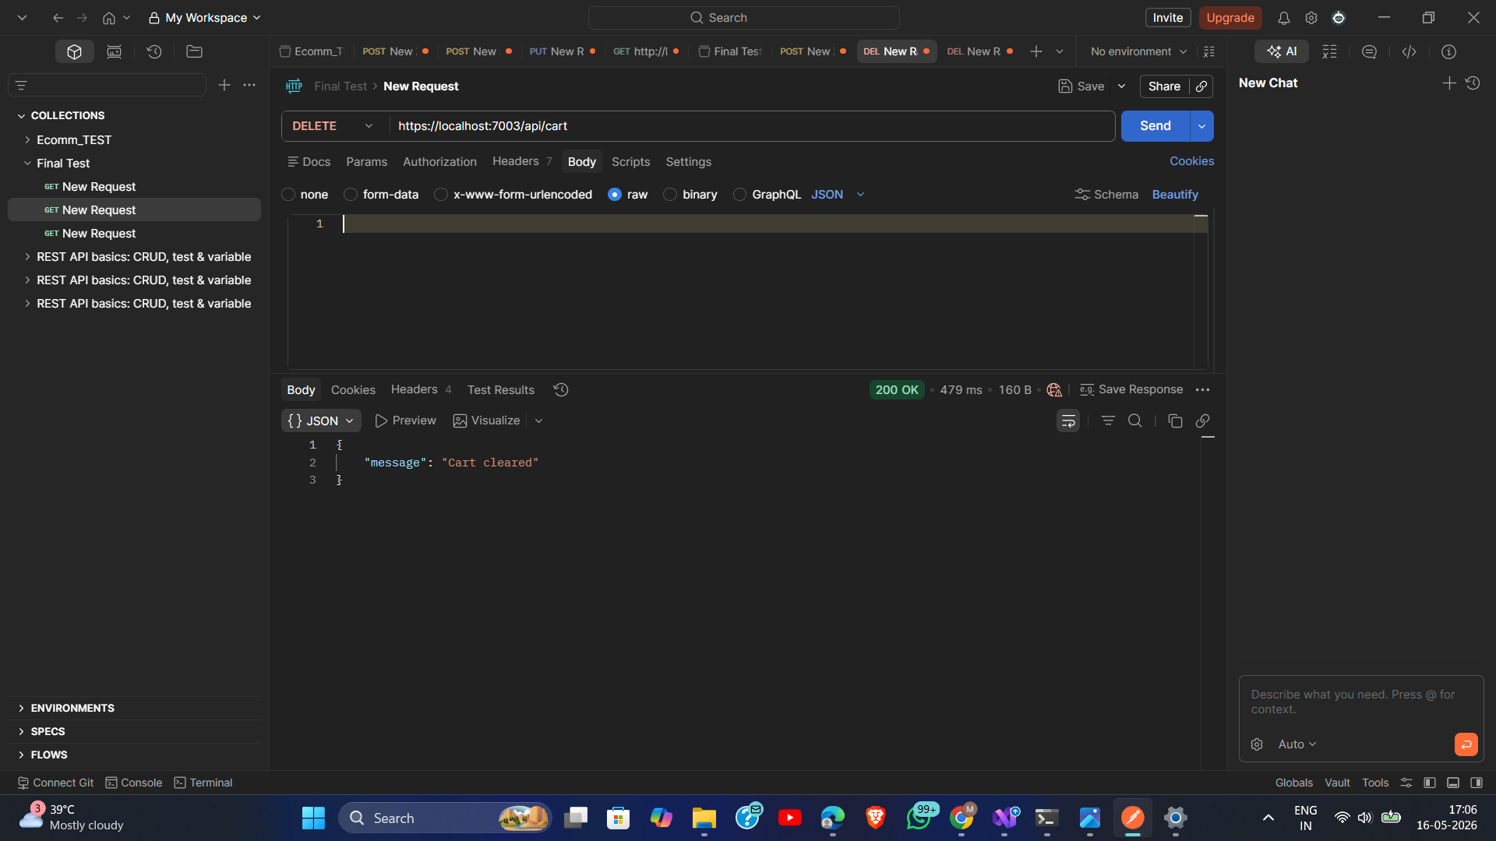
Figure 16: DELETE /api/cart/:productId — Cart item removed successfully (200 OK)

Figure 17 — Create Order (Success)
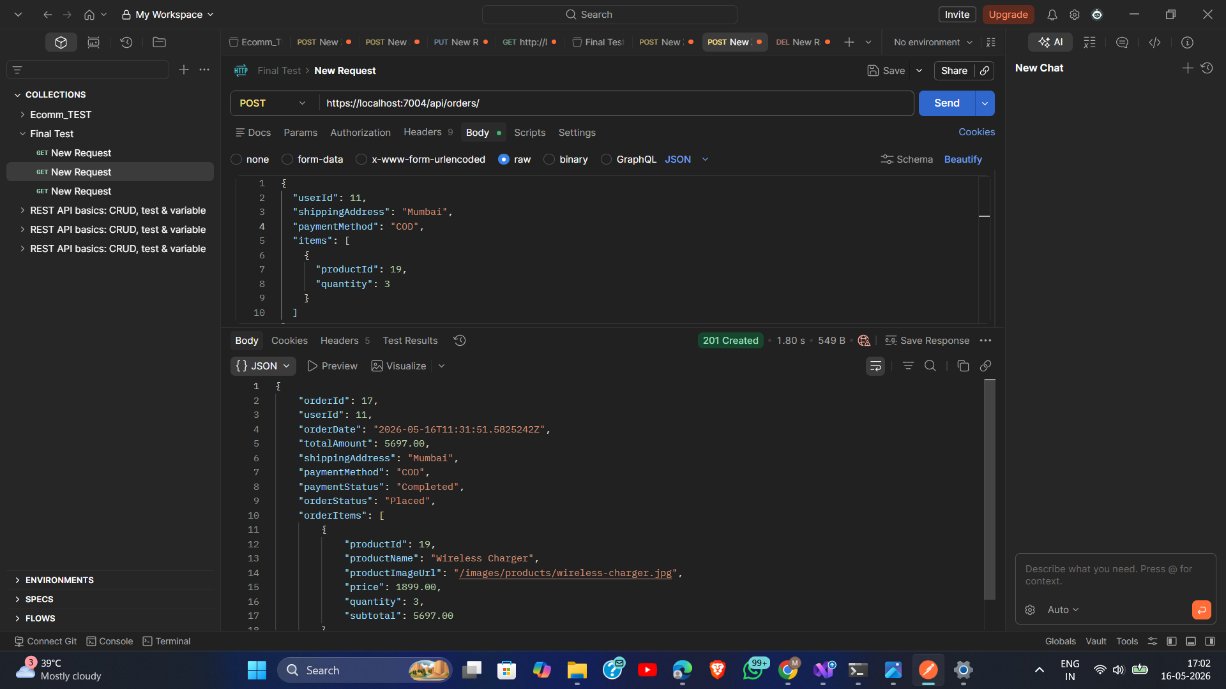
Figure 17: POST /api/orders — Order created successfully from checkout data (201 Created)

Figure 18 — Get My Orders (Customer Success)
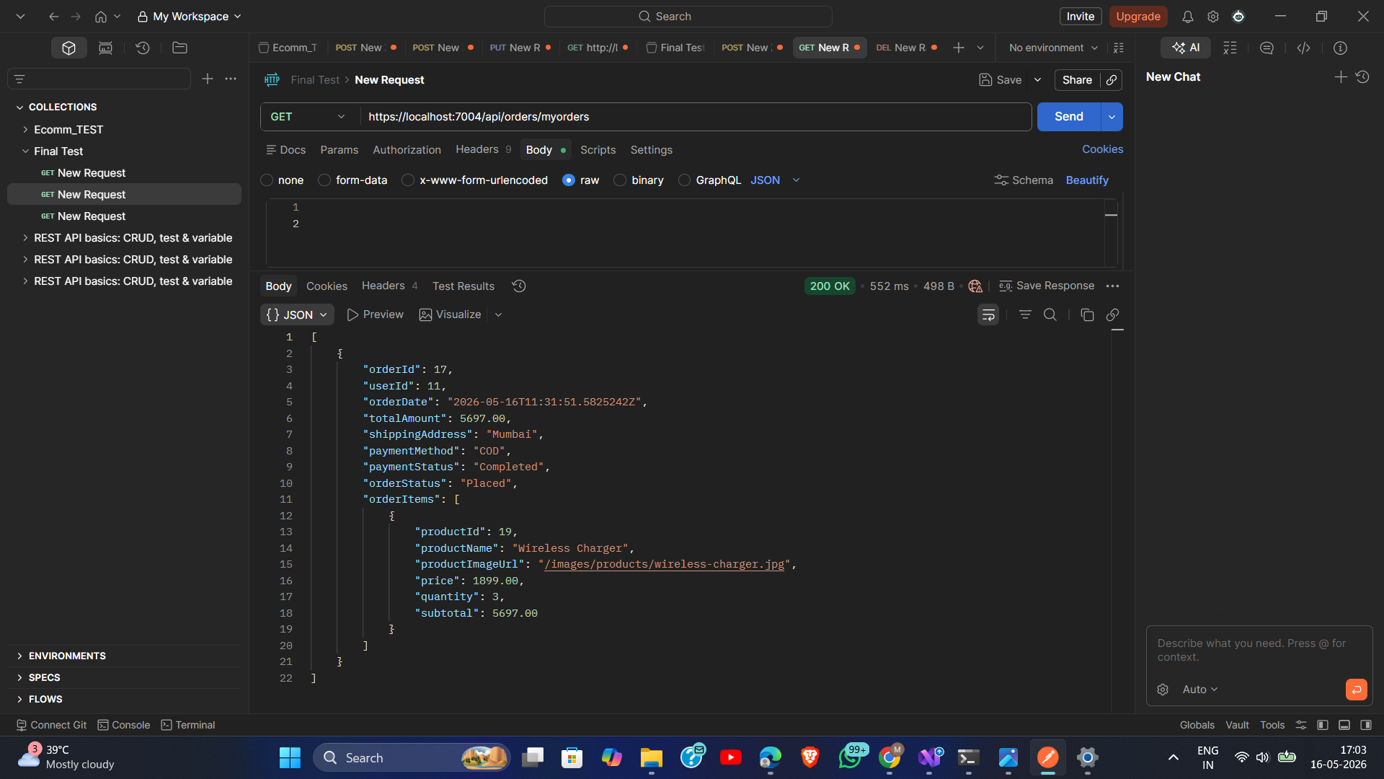
Figure 18: GET /api/orders/myorders — Customer's order history retrieved (200 OK)

Figure 19 — Get All Orders (Unauthorized)
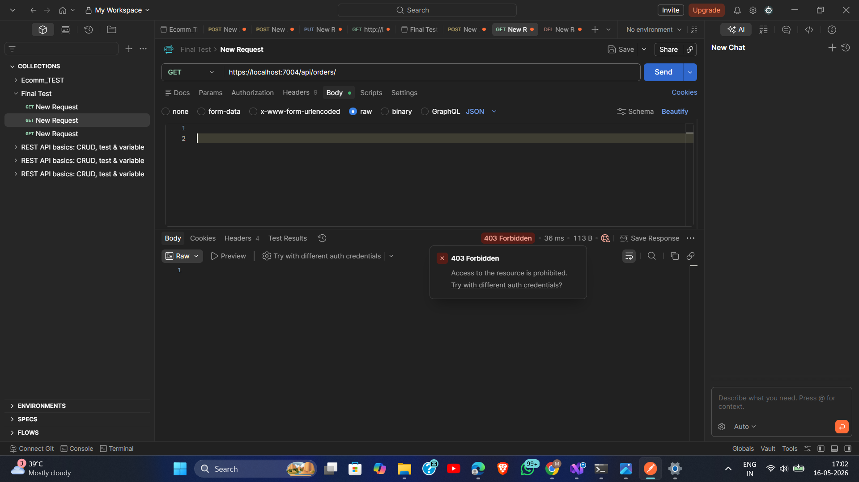
Figure 19: GET /api/orders — 401 Unauthorized when no token provided (protected admin endpoint)

Figure 20 — Get All Users by Admin (Success)
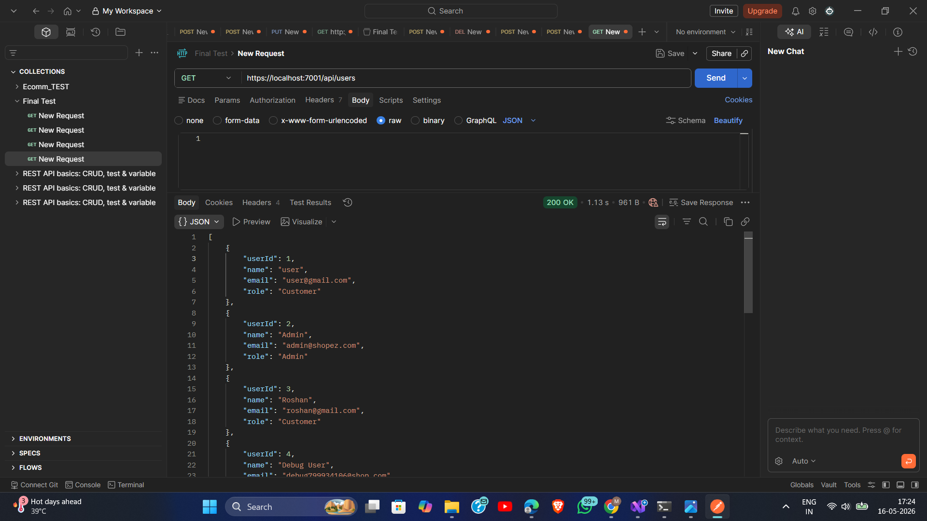
Figure 20: GET /api/users — Admin retrieves all users with roles (200 OK)

Figure 21 — Get User Profile (Success)
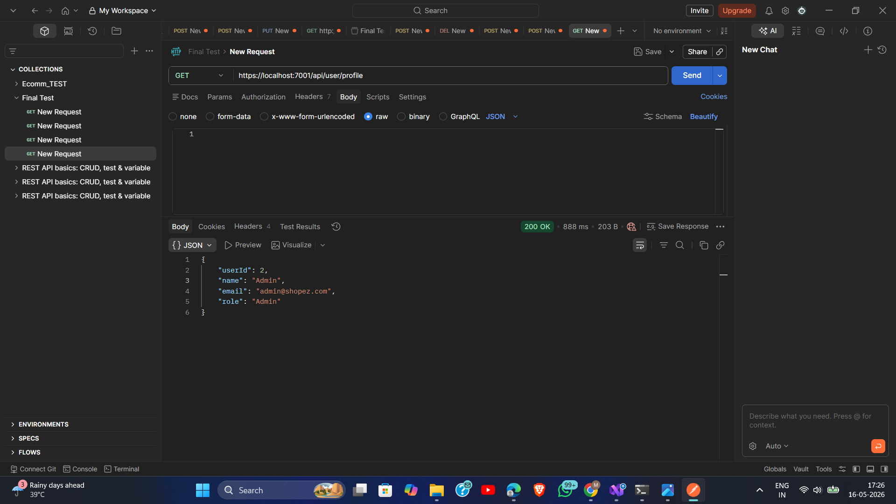
Figure 21: GET /api/user/profile — Authenticated user retrieves their own profile (200 OK)

Figure 22 — Get User Orders (Success)
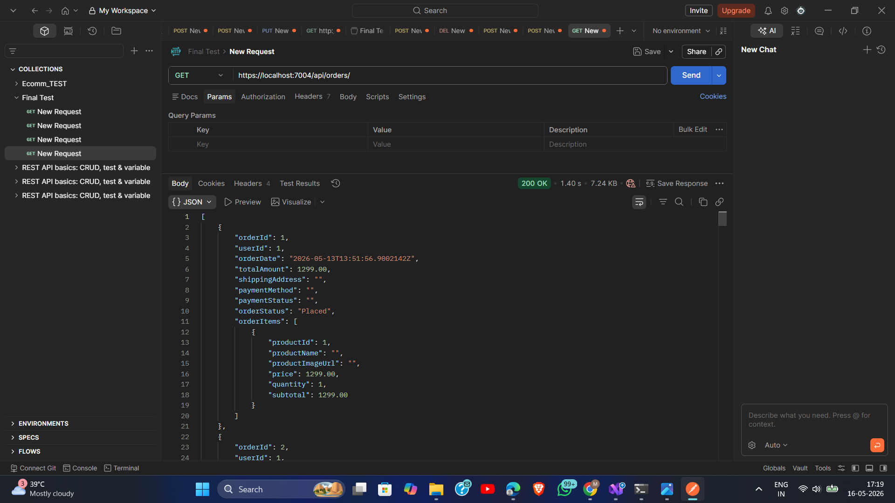
Figure 22: GET /api/orders/myorders — User-specific order list returned correctly

Figure 23 — All Products View at LocalHost:5000
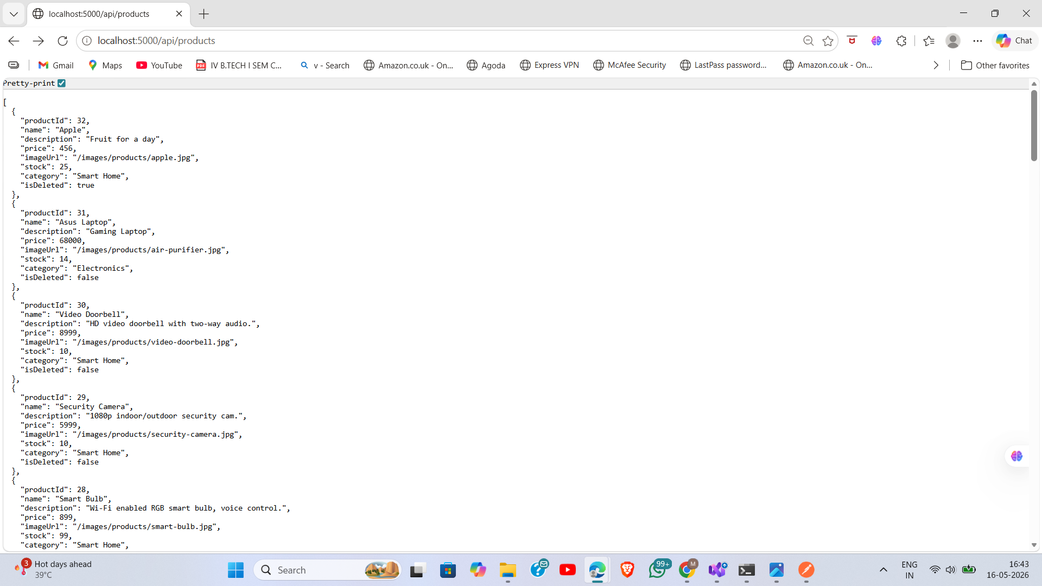
Figure 23: Angular app displaying all products via the Ocelot Gateway at localhost:5000

Figure 24 — Docker Running Successfully
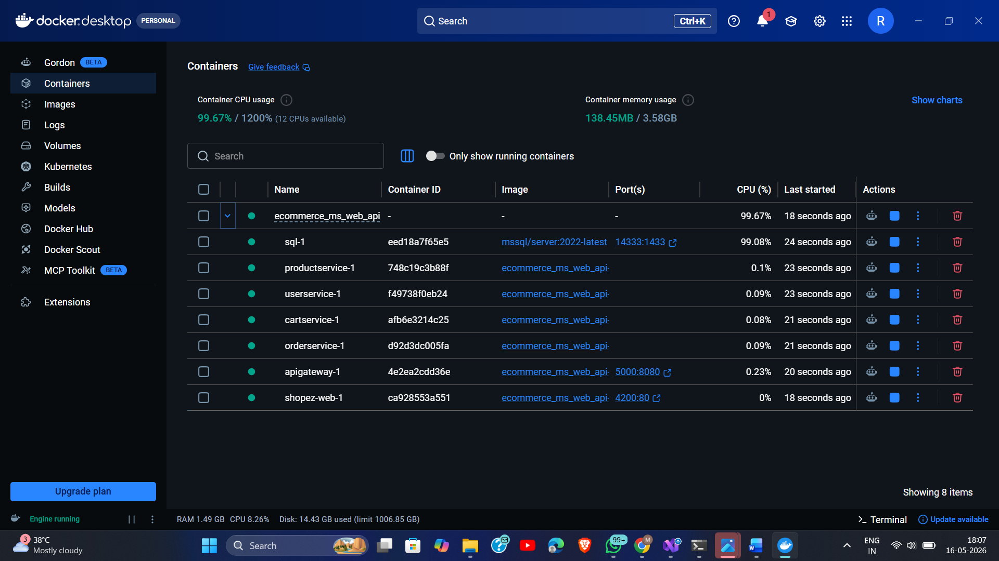
Figure 24: Docker Compose — All ShopEZ microservices running successfully in Docker containers

13. Unit Testing

13.1 Testing Framework
The backend uses xUnit as the test framework with Moq for mocking dependencies. Each microservice has a corresponding .Tests project (ApiGateway.Tests, CartService.Tests, OrderService.Tests). Tests validate business logic without requiring a live database.

13.2 Test Coverage
Test Project | Tests Included
CartService.Tests | CartAddTests — validates AddToCart logic: item addition, quantity increment, unauthorized access
OrderService.Tests | OrderCreateTests — validates order creation logic: successful order, stock check, invalid product handling
ApiGateway.Tests | GatewaySmokeTests — validates gateway bootstrapping and configuration loading

13.3 Test Evidence
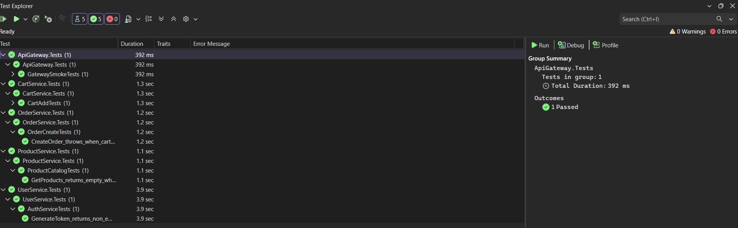
Figure 25: Unit Test Results — All backend test cases passing with code coverage report

13.4 Running Tests
dotnet test # Run all tests in the solution
dotnet test --collect:"XPlat Code Coverage" # With coverage collection

14. Deployment Guide

14.1 Prerequisites
- Docker Desktop (Windows/Mac) or Docker Engine + Compose (Linux)
- SQL Server 2022 (provided via Docker — no separate install needed)
- .NET 8 SDK (only needed for local development without Docker)
- Node.js 20+ and Angular CLI (only for local frontend development)

14.2 Deployment Steps
- Clone the repository or extract the project ZIP
- Navigate to the Backend/Ecommerce_MS_Web_API directory
- Run: docker compose up --build (builds all containers)
- Wait for SQL Server to fully initialize (approximately 30–60 seconds)
- Apply EF Core migrations to ECommerceDb database
- Navigate to http://localhost:4200 — ShopEZ frontend is live
- API Gateway is accessible at http://localhost:5000

14.3 Applying Migrations
# For each service, run from the service directory:
dotnet ef database update # Applies all pending migrations to ECommerceDb

14.4 Seeding Product Data
A SQL seed script is provided at Frontend/Shop_Ez/products-data.sql. Run this script against the ECommerceDb database after migrations to populate the initial product catalogue.

15. Future Enhancements
- Message Queue Integration: RabbitMQ or Azure Service Bus for asynchronous inter-service communication
- Separate Databases per Service: Move each microservice to its own isolated database for true domain separation
- Redis Cache: Cache product listings and search results for improved performance
- HTTPS / TLS: Enable SSL certificates on the Ocelot Gateway for secure production deployment
- Health Checks: Add ASP.NET Core health check endpoints for Docker health monitoring
- Rate Limiting: Implement API rate limiting at the gateway level to prevent abuse
- Centralized Logging: Serilog + Elasticsearch + Kibana (ELK stack) for distributed log aggregation
- gRPC Internal Communication: Replace ProductApiClient HTTP calls with gRPC for higher performance inter-service calls
- CQRS Pattern: Apply Command Query Responsibility Segregation in OrderService for better read/write separation
- Payment Gateway: Integrate Razorpay or Stripe API for live payment processing in OrderService

16. Conclusion
ShopEZ's backend is a well-architected microservices application built on ASP.NET Core 8, demonstrating real-world enterprise software engineering patterns. The use of Ocelot as an API Gateway provides a clean single entry point, JWT for stateless authentication ensures scalability, and the combination of Dapper and EF Core demonstrates knowledge of both micro-ORM and full ORM approaches.

Each microservice is independently deployable, has its own unit test project, and is containerized with Docker — making the system production-ready and cloud-adaptable. The architecture supports future enhancement with message queues, separate databases, and cloud deployment with minimal restructuring.

This backend demonstrates strong competence in distributed systems design, REST API development, database management, authentication architecture, containerization, and automated testing — all key skills for enterprise software development roles.
KEY SKILLS DEMONSTRATED IN THIS PROJECT
Distributed Systems Design
• REST API Architecture
• JWT Security
• ORM + Micro-ORM
• SQL Server Schema Design
• Docker Containerisation
• API Gateway Pattern
• Unit Testing + Mocking
• Clean Architecture Principles
• Microservice Boundary Design

