ShopEZ
E-Commerce Application

FRONTEND TECHNICAL DOCUMENTATION
(Angular E-Commerce Application)

Program: Cognizant uGE_DotNet FSD (Angular)
Project Submitted by: Maniar Roshan
Under the Guidance of: Narasimha Sir

Technology Stack: Angular 19 • TypeScript • Bootstrap 5 • JWT Authentication

Table of Contents
Table of Contents 1
1. Introduction 1
2. Purpose & Problem Statement 1
2.1 Problem Statement 1
2.2 Proposed Solution 1
3. Technology Stack 1
4. Angular Architecture Overview 1
4.1 Architecture Layers 1
4.2 Bootstrapping Flow 1
5. Module & Component Structure 1
5.1 Project Directory Structure 1
6. Component Details 1
6.1 Component Inventory 1
6.2 Key Component Descriptions 1
HomeComponent 1
ProductsComponent 1
CartComponent 1
CheckoutComponent 1
AdminComponent 1
7. Routing Flow 1
7.1 Route Configuration (app.routes.ts) 1
7.2 Route Navigation Flow 1
8. JWT Authentication Flow 1
8.1 Customer Login Flow 1
8.2 Admin Login Flow 1
8.3 Token Lifecycle 1
8.4 JWT Payload Structure 1
9. Services Layer 1
9.1 Service Inventory 1
9.2 API Endpoint Mapping 1
10. Guards & Interceptors 1
10.1 authGuard 1
10.2 adminGuard 1
10.3 authInterceptor 1
11. Models & State Management 1
11.1 TypeScript Models 1
11.2 State Management Strategy 1
11.3 Custom Pipe — ObjectUrlPipe 1
12. API Integration Flow 1
12.1 Environment Configuration 1
12.2 End-to-End Request Flow 1
12.3 Error Handling 1
13. UI Screenshots 1
Figure 1 – Customer Home Page 1
Figure 2 – Products Page 1
Figure 3 – Login Page 1
Figure 4 – View Cart Page 1
Figure 5 – Checkout Page 1
Figure 6 – Orders Page 1
Figure 7 – Orders Acknowledgement 1
Figure 8 – Admin Login Page 1
Figure 9 – Admin Home Page 1
Figure 10 – Admin Dashboard 1
Figure 11 – Admin Panel (Product Management) 1
Figure 12 – Customer Orders in Admin Panel 1
Figure 13 – Customer to Admin Role Change 1
Figure 14 – Docker Running Successfully 1
Figure 15 – Unit Testing with Karma 1
14. UML Diagrams 1
14.1 Component Hierarchy Diagram 1
14.2 JWT Authentication Flow Diagram 1
14.3 Data Flow Diagram 1
15. Unit Testing 1
15.1 Testing Setup 1
15.2 Test Coverage 1
15.3 Running Tests 1
16. Docker & Deployment 1
16.1 Frontend Dockerfile 1
16.2 Running with Docker Compose 1
16.3 Local Development 1
17. Future Scope 1
18. Conclusion 1

1. Introduction
ShopEZ is a full-stack E-Commerce web application developed as an academic and professional project by Maniar Roshan. It provides a seamless online shopping experience for customers, while offering a robust administrative panel for product and order management. The frontend is built with Angular 19, leveraging the latest standalone component architecture, reactive programming with RxJS, and a clean modular design that is both scalable and maintainable.

This document presents a complete technical overview of the ShopEZ frontend application — covering its architecture, component design, routing, authentication, API integration, testing, and deployment strategy. The documentation is structured to be evaluation-ready, interview-friendly, and suitable for academic project review.

ANGULAR BEST PRACTICES APPLIED: Standalone Component Architecture (Angular 19) | Functional Route Guards | HTTP Interceptor Pattern | RxJS Reactive State | TypeScript Strong Typing | Karma + Jasmine Unit Testing | Docker + Nginx Production Build

2. Purpose & Problem Statement

2.1 Problem Statement
Traditional retail shopping requires physical presence, limited product comparison, and manual order tracking. Existing e-commerce solutions are often too complex for small-scale deployment or lack proper administrative controls. ShopEZ addresses the following challenges:

- No centralized platform for customers to browse, filter, and purchase tech products online
- Lack of real-time cart management with product availability validation
- Absence of a role-based access system differentiating customers from administrators
- No streamlined order tracking and management system for users and admins
- Difficulty in image-based product catalogue management for administrators

2.2 Proposed Solution
ShopEZ solves these problems by delivering:

- A responsive Angular 19 SPA with product browsing, search, and filtering
- A secure JWT-based authentication system with role-based access (Customer / Admin)
- A real-time cart system connected to live backend inventory
- A full order lifecycle — from checkout to order history — for customers
- A comprehensive admin panel for product CRUD, image uploads, and user management
- A microservices backend communicating through an Ocelot API Gateway

3. Technology Stack
Technology | Details
Framework | Angular 19 (Standalone Components, no NgModules)
Language | TypeScript 5.x
UI Library | Bootstrap 5.3 + Custom CSS
HTTP Client | Angular HttpClient (Interceptor-based)
Authentication | JWT (JSON Web Token) — stored in localStorage
Routing | Angular Router with lazy-loading guards
State Management | RxJS BehaviorSubject (no NgRx)
Testing | Karma + Jasmine (unit tests for all services and components)
Build Tool | Angular CLI (ng build, ng serve)
Container | Docker + Nginx (for production build)
API Communication | REST APIs via Ocelot Gateway at http://localhost:5000
Node.js | v20+ (for Angular CLI)
Package Manager | npm
Environment Config | environment.ts / environment.prod.ts

4. Angular Architecture Overview
ShopEZ uses Angular 19's modern standalone component architecture. There are no NgModules (app.module.ts is absent). Each component is declared as standalone: true and imports only what it needs. The app is bootstrapped via bootstrapApplication() in main.ts, with app.config.ts providing global providers.

4.1 Architecture Layers
Layer | Responsibility
Presentation Layer | Standalone Angular Components rendering HTML templates with data binding
Service Layer | Injectable services handling HTTP API calls and business logic
Guard Layer | Route protection using functional guards (authGuard, adminGuard)
Interceptor Layer | HTTP interceptor attaching JWT Bearer token to all protected requests
Model Layer | TypeScript interfaces and models for type-safe data contracts
Routing Layer | app.routes.ts defining all routes with guard-based protection
Environment Layer | environment.ts / environment.prod.ts for API URL configuration
Pipe Layer | Custom ObjectUrlPipe for handling blob image URLs
Utils Layer | product.utils.ts for shared product helper functions

4.2 Bootstrapping Flow
- main.ts calls bootstrapApplication(AppComponent, appConfig)
- appConfig (app.config.ts) provides: provideRouter(routes), provideHttpClient(withInterceptors([authInterceptor]))
- AppComponent renders the root <router-outlet> and the <app-navbar>
- Angular Router matches the current URL and renders the appropriate standalone component
ARCHITECTURE INSIGHT: Angular 19 Standalone Architecture eliminates the traditional NgModule boilerplate, reducing bundle size and improving lazy-loading granularity. Each component declares its own imports, making dependency trees explicit and tree-shakeable — a significant improvement over module-based architecture for production performance.

5. Module & Component Structure

5.1 Project Directory Structure
src/
├── app/
│ ├── components/
│ │ ├── home/
│ │ ├── navbar-component/
│ │ ├── footer/
│ │ ├── products-component/
│ │ ├── product-details-component/
│ │ ├── cart-component/
│ │ ├── checkout-component/
│ │ ├── orders-component/
│ │ ├── order-success-component/
│ │ ├── login-component/
│ │ ├── register-component/
│ │ ├── admin-login-component/
│ │ ├── admin-dashboard-component/
│ │ ├── admin-component/
│ │ ├── toast-component/
│ │ └── page-back-button/
│ ├── services/ (AuthService, ProductService, CartService, etc.)
│ ├── guards/ (authGuard, adminGuard)
│ ├── interceptors/ (authInterceptor)
│ ├── models/ (user.model, product.model, cart.model, order.model)
│ ├── pipes/ (object-url-pipe)
│ ├── utils/ (product.utils.ts)
│ ├── testing/ (test-routes.ts)
│ ├── app.ts (Root component)
│ ├── app.routes.ts (Route definitions)
│ └── app.config.ts (App-wide providers)
├── assets/images/products/ (Static product images)
├── environments/ (environment.ts, environment.prod.ts)
├── styles.css (Global styles)
└── index.html

6. Component Details

6.1 Component Inventory
Component | Purpose | Route
HomeComponent | Landing page with featured products and hero banner | /home
ProductsComponent | Product listing with search, filter, pagination | /products
ProductDetailsComponent | Single product view with add-to-cart | /product/:id
CartComponent | Cart item management — view, update, remove | /cart
CheckoutComponent | Checkout form with address and payment fields | /checkout
OrdersComponent | Customer order history listing | /orders
OrderSuccessComponent | Order confirmation acknowledgement page | /order-success
LoginComponent | Customer login form with JWT token handling | /login
RegisterComponent | New customer registration form | /register
AdminLoginComponent | Separate admin login with role verification | /admin-login
AdminDashboardComponent | Admin stats — user counts, product counts | /admin-dashboard
AdminComponent | Full admin panel: products, users, orders management | (admin)
NavbarComponent | Top navigation with dynamic auth state and cart count | Global
FooterComponent | Footer with links and copyright | Global
ToastComponent | Popup notification for success/error messages | Global
PageBackButtonComponent | Reusable back navigation button | Shared

6.2 Key Component Descriptions

HomeComponent
Displays a hero banner, featured products carousel, and category tiles. It fetches products from ProductService using the /api/products endpoint and filters the top 8 for featured display. The component uses Angular's @for control flow (not ngFor) introduced in Angular 17+.

ProductsComponent
Renders the full product catalogue with client-side search filtering by name and category. Implements pagination with configurable page size. Connects to the ProductService to fetch paginated results from /api/products/search.

CartComponent
Protected by authGuard. Displays the current user's cart items fetched from CartService (/api/cart). Supports quantity updates and item removal. The cart total is computed reactively. On proceeding to checkout, it navigates to /checkout.

CheckoutComponent
Protected by authGuard. Collects the shipping address (name, address, city, zip, phone), payment method selection (Credit Card / Cash on Delivery), and order notes. On form submission, it calls OrderService to create an order and navigates to /order-success.

AdminComponent
Protected by adminGuard. A multi-tab interface allowing the admin to: add/edit/delete products, upload product images, view all users with role-toggle capability, and view all orders across users. This component integrates AdminDashboardService and UserAdminService.

7. Routing Flow

7.1 Route Configuration (app.routes.ts)
Route Path | Component | Guard
'' → /home | HomeComponent | None (redirect)
/home | HomeComponent | None (public)
/products | ProductsComponent | None (public)
/product/:id | ProductDetailsComponent | None (public)
/login | LoginComponent | None (public)
/register | RegisterComponent | None (public)
/admin-login | AdminLoginComponent | None (public)
/cart | CartComponent | authGuard
/checkout | CheckoutComponent | authGuard
/orders | OrdersComponent | authGuard
/order-success | OrderSuccessComponent | None
/admin-dashboard | AdminDashboardComponent | adminGuard
** (wildcard) | → /home | None (redirect)

7.2 Route Navigation Flow
The user lands on /home (default redirect). Public pages (products, product details) are accessible without login. Protected routes (/cart, /checkout, /orders) redirect to /login if no valid JWT is present (authGuard). Admin routes (/admin-dashboard) redirect to /admin-login if the user's role is not 'Admin' (adminGuard). The wildcard route (**) catches all unmatched paths and redirects to /home.

8. JWT Authentication Flow

8.1 Customer Login Flow
- User submits email and password on /login
- LoginComponent calls AuthService.login(dto)
- AuthService POST /api/auth/login → receives JWT token from UserService
- JWT payload is Base64 decoded to extract: userId, name, email, role
- Token stored in localStorage as 'token'; user object stored as 'user'
- BehaviorSubject authState$ emits true — NavbarComponent reactively updates
- User is redirected to /home

8.2 Admin Login Flow
- Admin submits credentials on /admin-login
- AdminLoginComponent calls AuthService.login(dto)
- On success, checks role from decoded JWT — must be 'Admin'
- If role is not Admin, token is cleared and error is shown
- Admin is navigated to /admin-dashboard

8.3 Token Lifecycle
- Token expiry is checked in AuthService.isLoggedIn() by reading payload.exp
- If expired, logout() is called automatically
- On logout: localStorage token and user are cleared; authState$ emits false
- The authInterceptor reads the token before every HTTP request
SECURITY INSIGHT: The authInterceptor implements automatic token expiry detection — checking payload.exp on every request before attaching the Bearer header. This proactive approach prevents sending expired tokens to the server, providing a better UX by redirecting to login before receiving a 401 error response.

8.4 JWT Payload Structure
{ "nameid": "1", "unique_name": "Roshan", "email": "roshan@test.com",
"role": "Customer", "exp": 1748000000 }

9. Services Layer

9.1 Service Inventory
Service | Responsibility
AuthService | Login, register, token storage, JWT decode, logout, role checking
ProductService | Fetch all products, search with filters, fetch by ID
CartService | Get cart, add item, remove item, update quantity, clear cart
OrderService | Create order, fetch my orders
ImageService | Upload product image (FormData multipart POST)
AdminDashboardService | Fetch dashboard stats — user count, product count, order count
UserAdminService | Fetch all users (admin), toggle user role
ToastService | Show success/error toast notifications across components

9.2 API Endpoint Mapping
Service Method | HTTP Method + Endpoint | Auth Required
AuthService.login() | POST /api/auth/login | No
AuthService.register() | POST /api/auth/register | No
ProductService.getProducts() | GET /api/products | No
ProductService.getProductsWithFilters() | GET /api/products/search?... | No
ProductService.getProductById() | GET /api/products/:id | No
CartService.getCart() | GET /api/cart | Yes (Bearer)
CartService.addToCart() | POST /api/cart | Yes (Bearer)
CartService.removeFromCart() | DELETE /api/cart/:productId | Yes (Bearer)
CartService.updateQuantity() | PUT /api/cart/:productId | Yes (Bearer)
CartService.clearCart() | DELETE /api/cart | Yes (Bearer)
OrderService.createOrder() | POST /api/orders | Yes (Bearer)
OrderService.getMyOrders() | GET /api/orders/myorders | Yes (Bearer)
ImageService.uploadImage() | POST /api/images/upload | Yes (Bearer)
UserAdminService.getAllUsers() | GET /api/users | Admin Only
UserAdminService.toggleRole() | PUT /api/users/:id/toggle-role | Admin Only

10. Guards & Interceptors

10.1 authGuard
The authGuard is a functional route guard defined in src/app/guards/auth.guard.ts. It calls AuthService.isLoggedIn() which validates the JWT expiry timestamp. If the user is not authenticated, the guard redirects to /login using Angular Router. If authenticated, it returns true and the route loads normally.

10.2 adminGuard
The adminGuard extends authGuard behaviour by also verifying the user role. After confirming login, it calls AuthService.isAdmin() to check if the user's role is 'Admin'. If not, the guard redirects to /admin-login. This dual-layer protection ensures the admin panel is inaccessible to regular customers even if they manually navigate to /admin-dashboard.

10.3 authInterceptor
The authInterceptor is a functional HTTP interceptor registered globally via provideHttpClient(withInterceptors([authInterceptor])). It intercepts all outgoing HTTP requests and:
- Reads the JWT token from AuthService.getToken()
- Identifies public endpoints (login, register, public GET /api/products, /images/)
- Attaches Authorization: Bearer <token> header to all non-public requests
- Catches HTTP 401 errors on protected endpoints and triggers automatic logout + redirect to /login
SECURITY DEPTH: ShopEZ implements three-layer frontend security: (1) Route Guards prevent unauthorized navigation, (2) the authInterceptor attaches tokens to outgoing requests, and (3) 401 error handling in the interceptor provides automatic session cleanup. This matches enterprise Angular security standards.

11. Models & State Management

11.1 TypeScript Models
Model File | Interfaces Defined
user.model.ts | User { userId, name, email, role }, RegisterDto, LoginDto
product.model.ts | Product { id, name, description, price, category, stock, imageUrl, isActive }
cart.model.ts | CartItem { productId, productName, price, quantity, imageUrl }
order.model.ts | Order, OrderItem, OrderDTO { userId, items[], address, payment, notes }

11.2 State Management Strategy
ShopEZ does not use NgRx or any external state management library. State is managed using RxJS BehaviorSubject within services:
- AuthService.authState$ — a BehaviorSubject<boolean> that emits on login/logout. NavbarComponent subscribes to this to reactively update the navigation links.
- Cart state is server-side — the cart is fetched fresh from the API on every CartComponent load. No local cart state is persisted between sessions.
- Toast notifications are managed by ToastService which holds a simple array of active messages.
- Product data is fetched per component — no global product store.
DESIGN DECISION: The deliberate choice of RxJS BehaviorSubject over NgRx demonstrates pragmatic architecture thinking. NgRx adds significant boilerplate for simple auth state. The BehaviorSubject pattern provides reactive state with less complexity — appropriate for this scale. NgRx is listed as a future enhancement once the application grows in complexity.

11.3 Custom Pipe — ObjectUrlPipe
The ObjectUrlPipe (src/app/pipes/object-url-pipe.ts) transforms a File or Blob object into an object URL (blob:http://...) for temporary image preview during product upload in the admin panel. This avoids the need for base64 conversion and provides instant image preview before upload completion.

12. API Integration Flow

12.1 Environment Configuration
The API base URL is configured in environment files:

Development: apiUrl = 'http://localhost:5000/api'
Production: apiUrl = 'http://localhost:5000/api' (update before cloud deploy)

12.2 End-to-End Request Flow
- Angular Component calls a Service method
- Service constructs the HTTP request with the full URL (environment.apiUrl + path)
- authInterceptor intercepts the request and attaches Bearer token (if needed)
- Request reaches Ocelot API Gateway on port 5000
- Ocelot routes the request to the correct microservice (UserService:5001, ProductService:5002, CartService:5003, OrderService:5004)
- Microservice processes the request, queries SQL Server, and returns a response
- Response flows back through Ocelot → Angular HttpClient → Observable
- Component receives data and renders it via data binding

12.3 Error Handling
HTTP errors are caught at two layers: the authInterceptor handles 401 Unauthorized globally by logging out the user. Individual service calls return Observables — components subscribe and handle errors using catchError or try/catch in async pipes. The ToastService is used to display user-friendly error messages.

13. UI Screenshots

Figure 1 – Customer Home Page
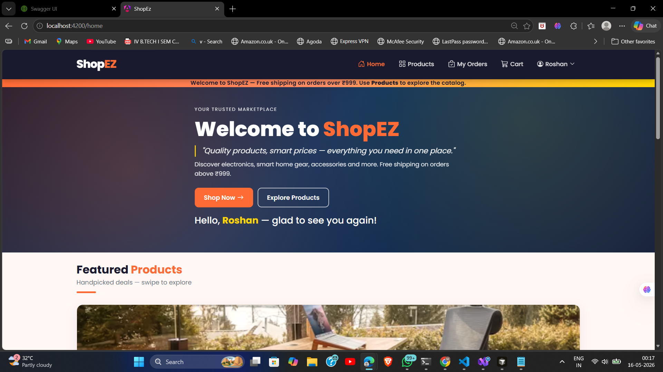
Figure 1: ShopEZ Customer Home Page — Hero banner with featured products and category navigation

Figure 2 – Products Page
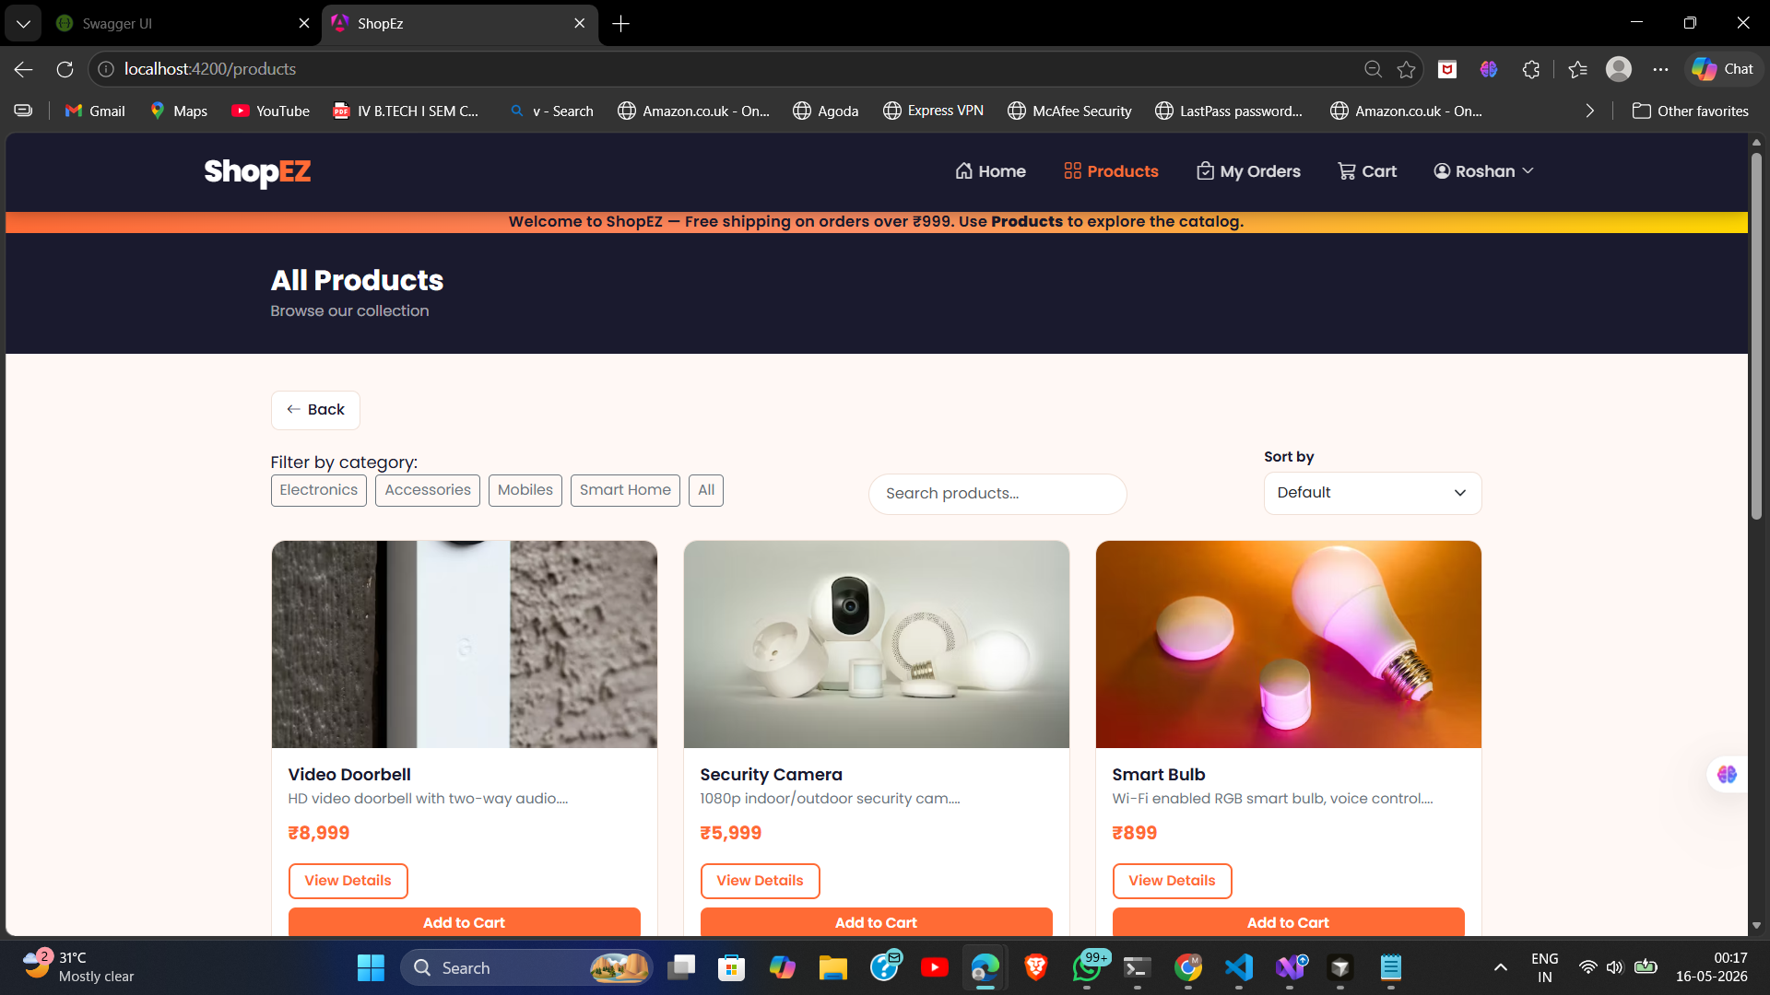
Figure 2: ShopEZ Products Page — Full product catalogue with search and filter functionality

Figure 3 – Login Page
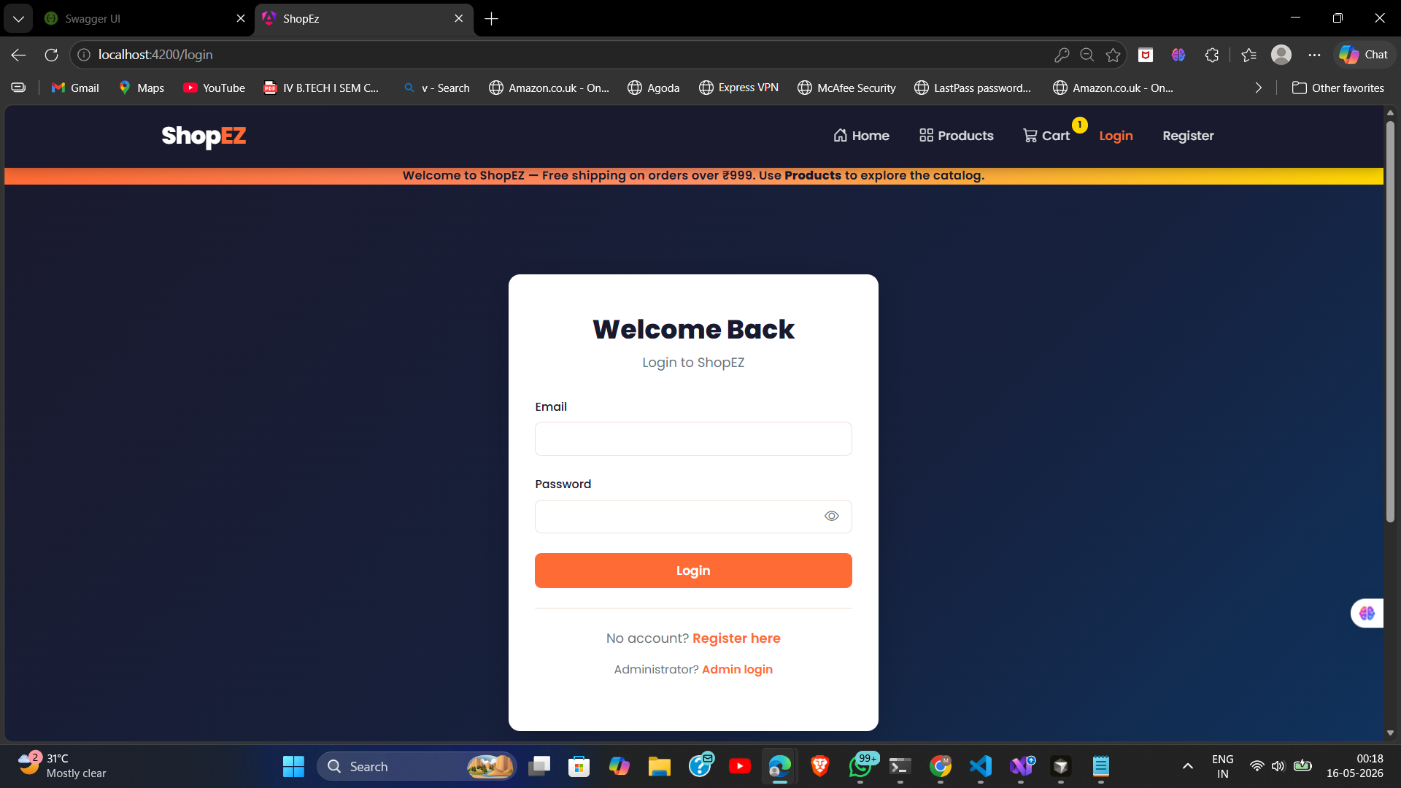
Figure 3: ShopEZ Customer Login Page — Secure JWT-based authentication form

Figure 4 – View Cart Page
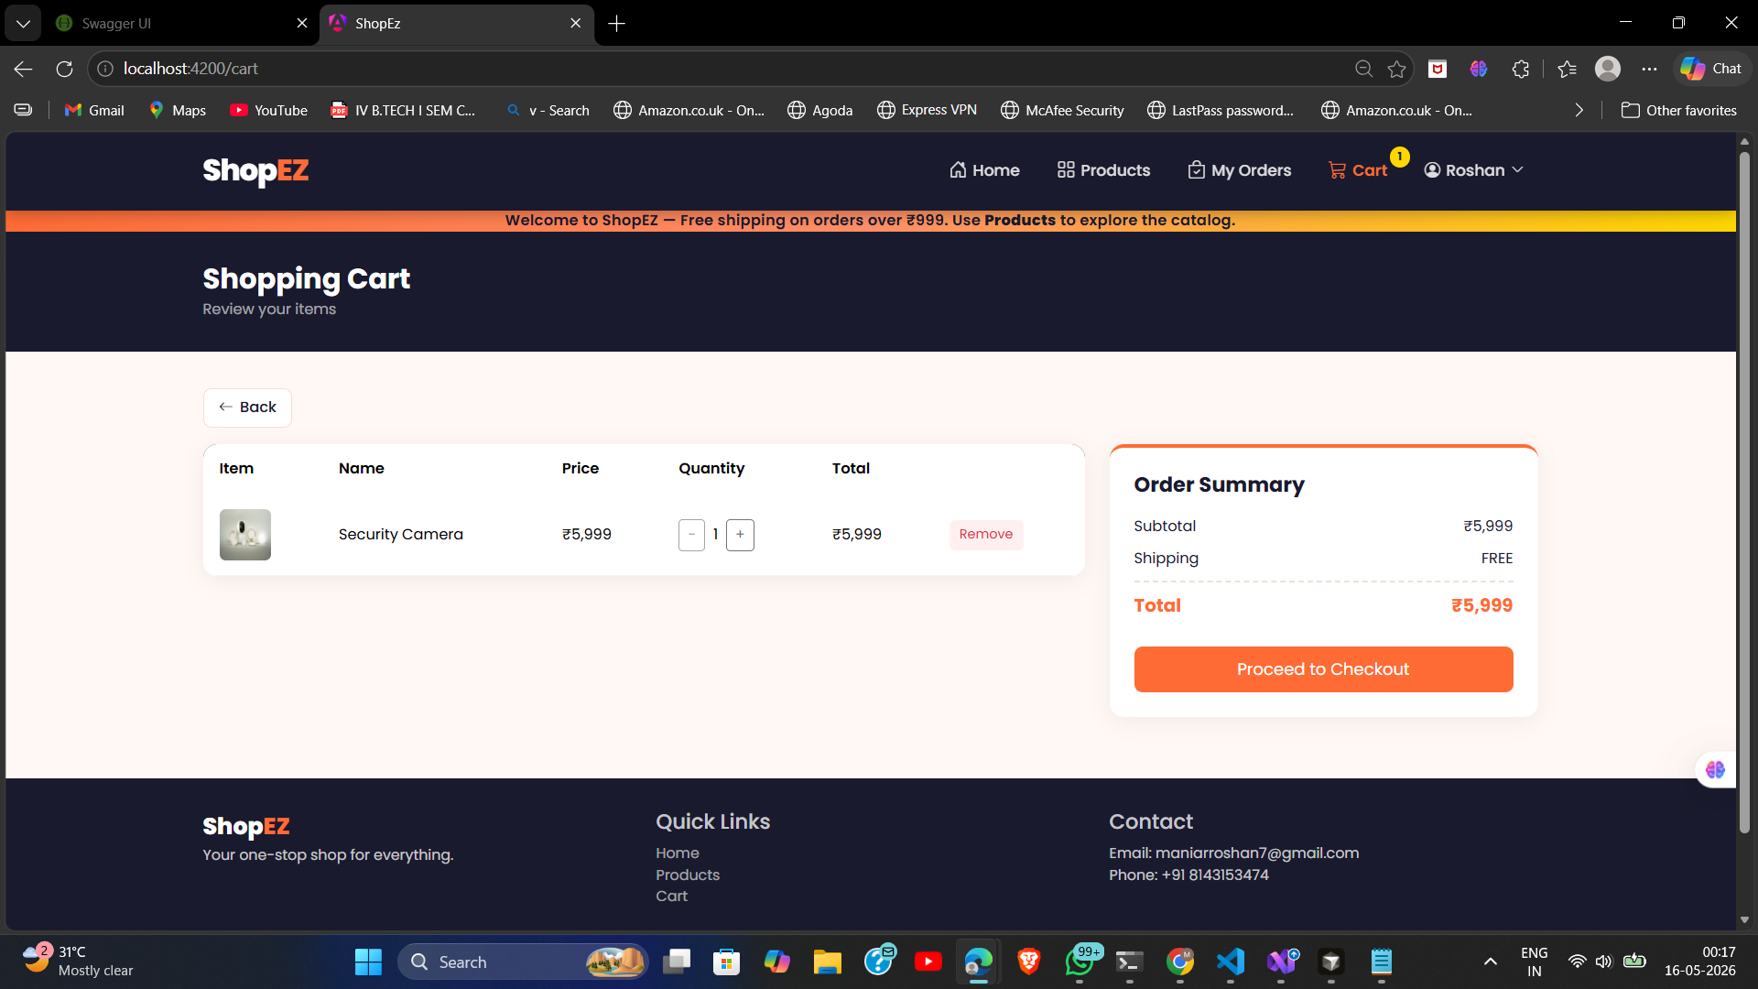
Figure 4: ShopEZ Cart Page — Cart item listing with quantity update and removal controls

Figure 5 – Checkout Page
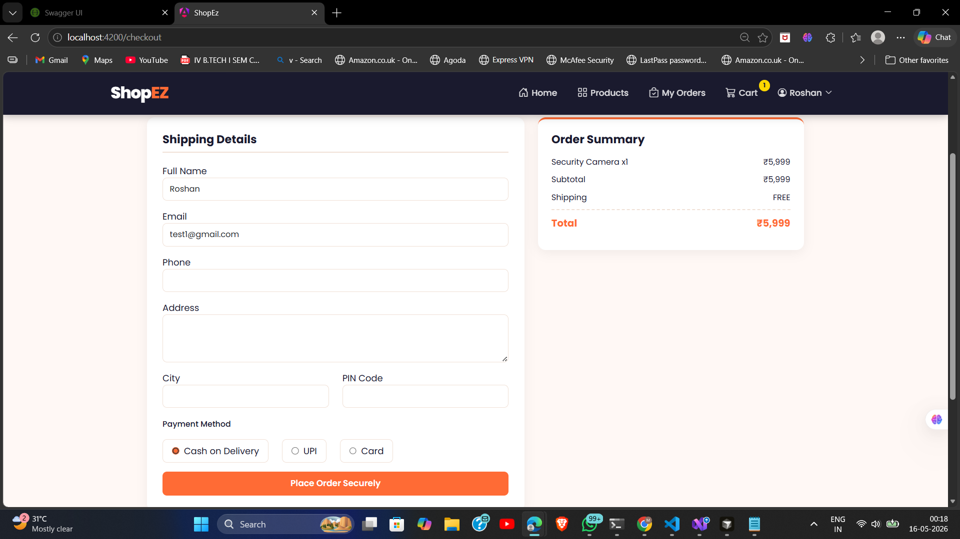
Figure 5: ShopEZ Checkout Page — Shipping address and payment method selection form

Figure 6 – Orders Page
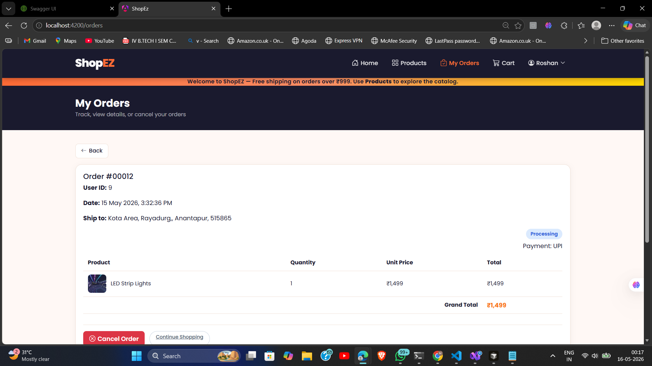
Figure 6: ShopEZ Orders Page — Customer order history with status tracking

Figure 7 – Orders Acknowledgement
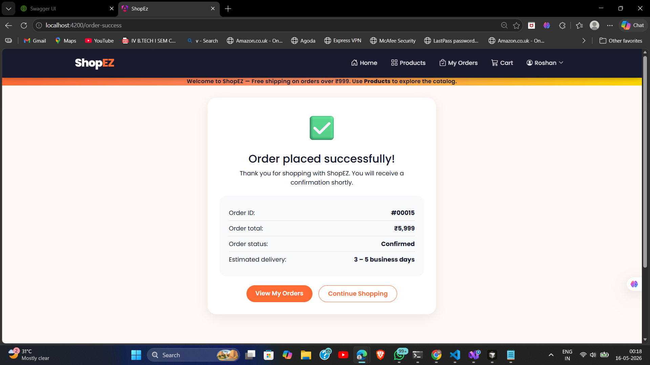
Figure 7: ShopEZ Order Success Page — Order placed confirmation with order details

Figure 8 – Admin Login Page
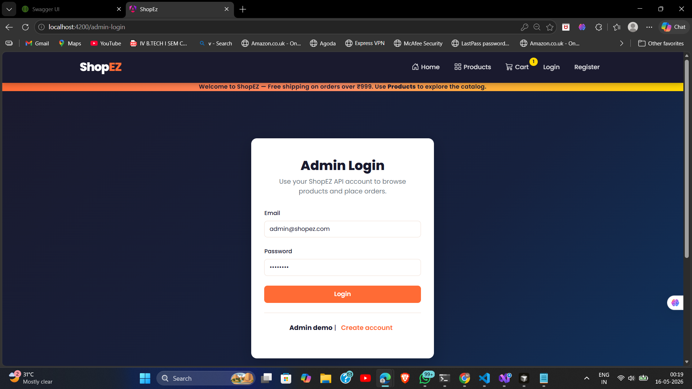
Figure 8: ShopEZ Admin Login Page — Separate admin authentication portal

Figure 9 – Admin Home Page
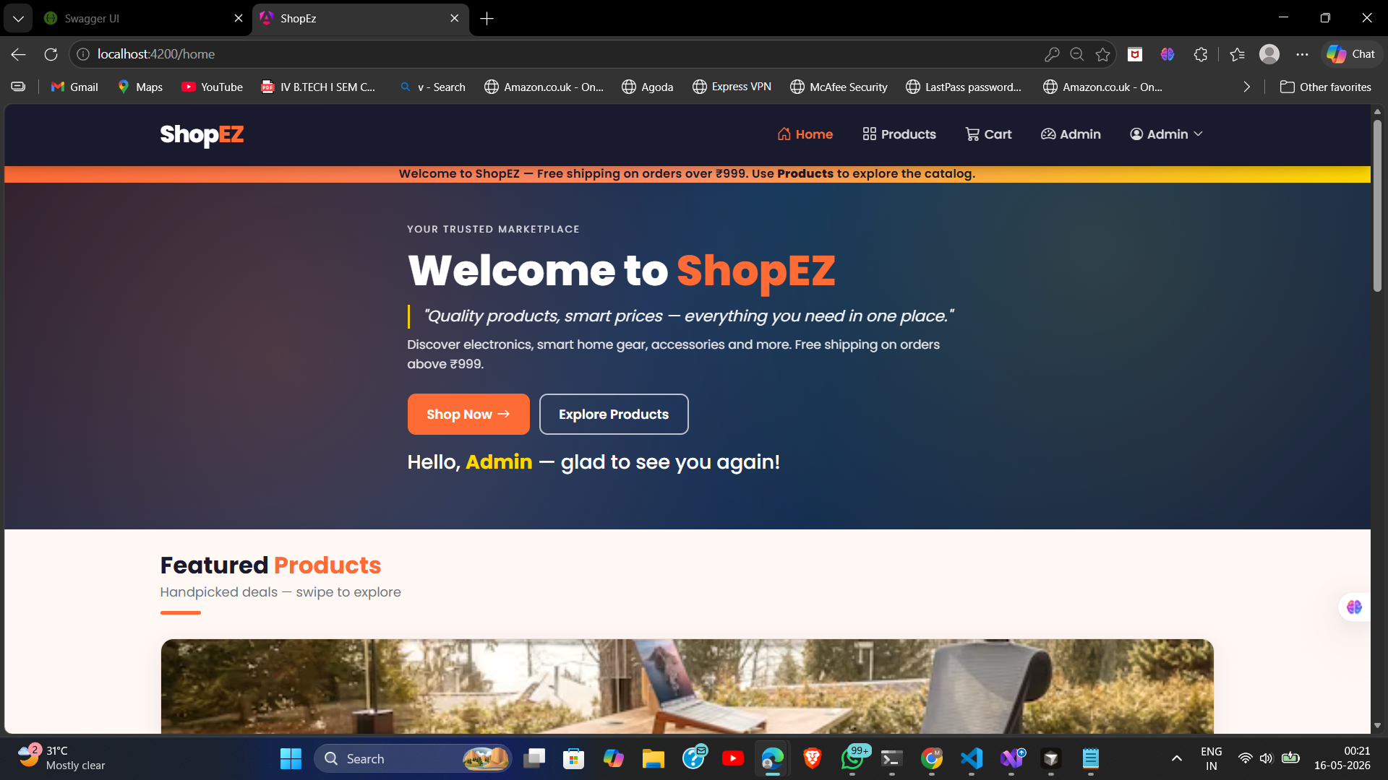
Figure 9: ShopEZ Admin Home Page — Admin welcome dashboard with quick navigation

Figure 10 – Admin Dashboard
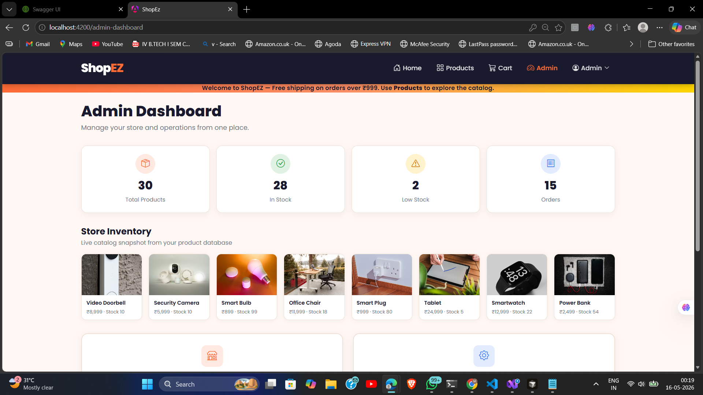
Figure 10: ShopEZ Admin Dashboard — Summary statistics: users, products, orders

Figure 11 – Admin Panel (Product Management)
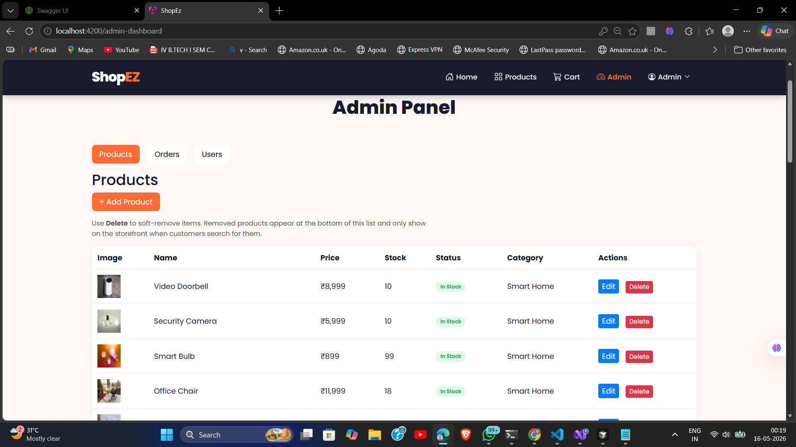
Figure 11: ShopEZ Admin Panel — Product CRUD operations with image upload capability

Figure 12 – Customer Orders in Admin Panel
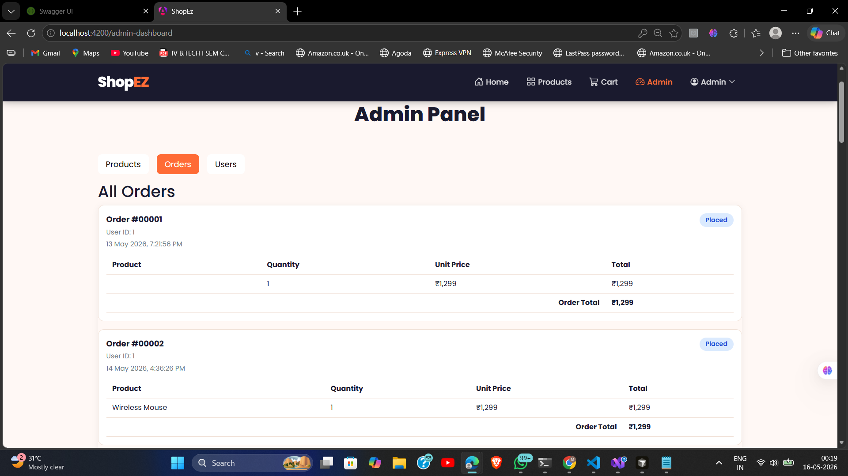
Figure 12: ShopEZ Admin Panel — All customer orders with order details visible to admin

Figure 13 – Customer to Admin Role Change
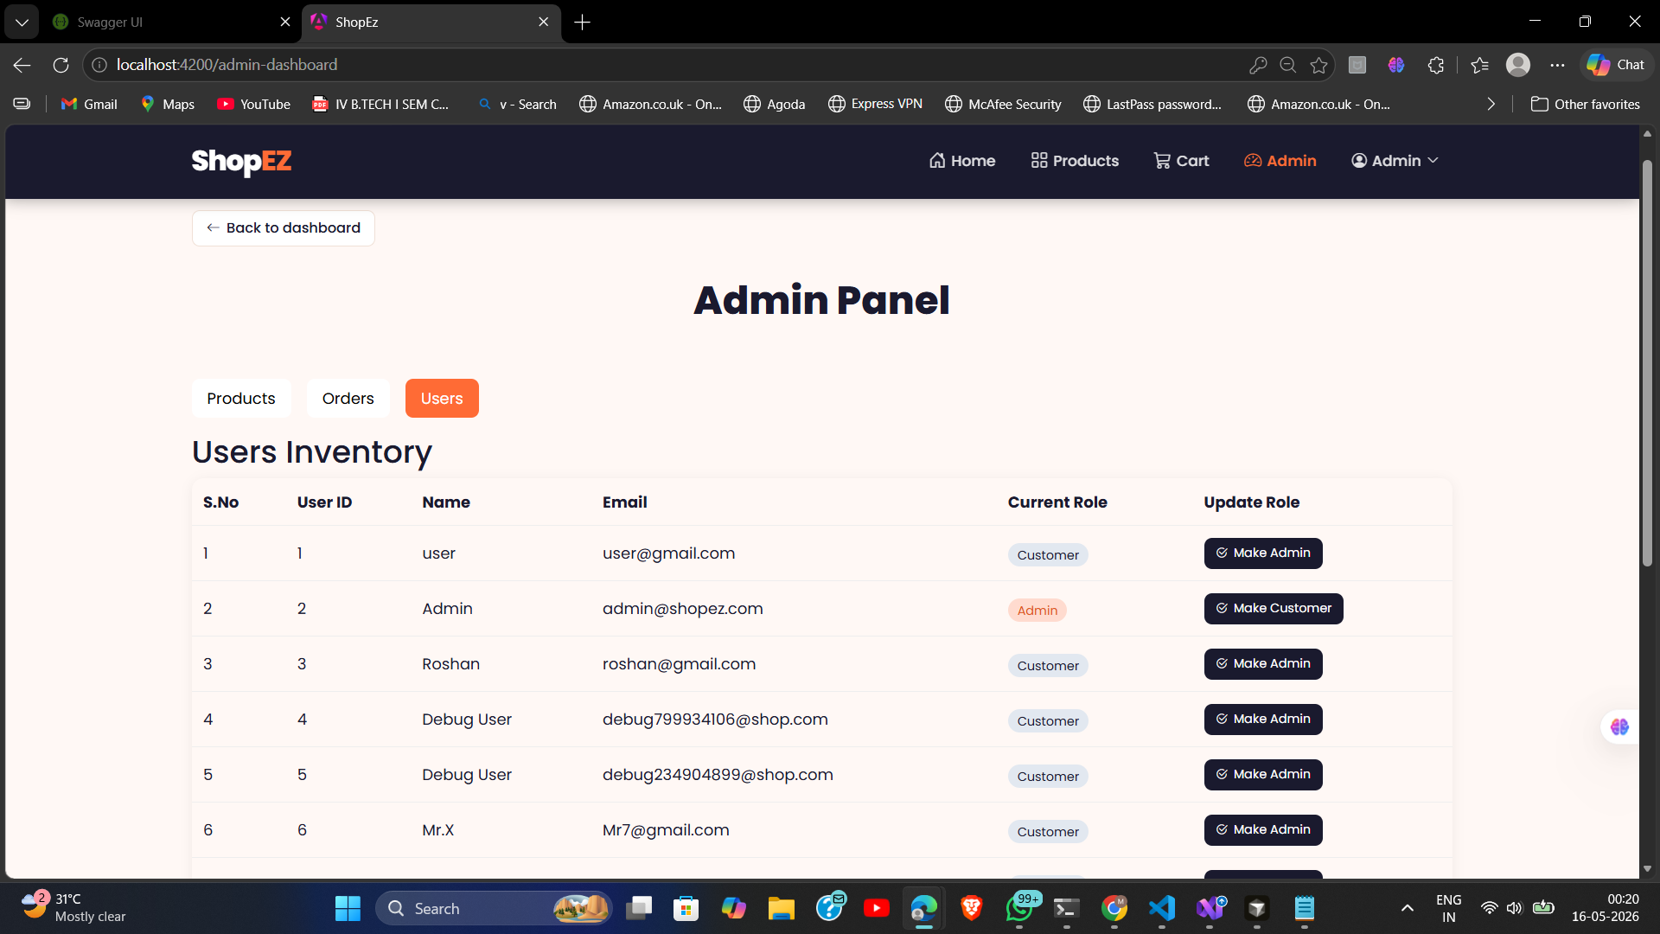
Figure 13: ShopEZ Admin Panel — User management with role toggle (Customer ↔ Admin)

Figure 14 – Docker Running Successfully
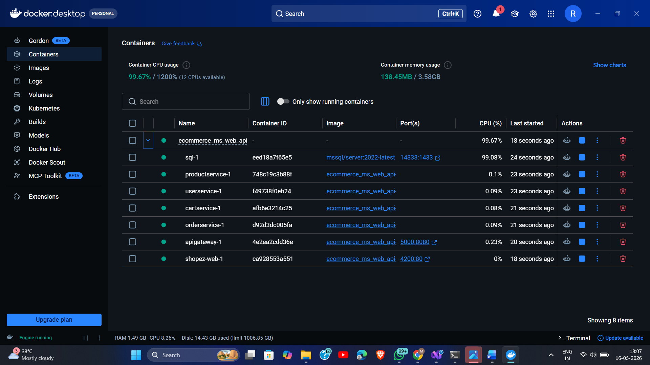
Figure 14: Docker Compose — All ShopEZ services running successfully in containers

Figure 15 – Unit Testing with Karma
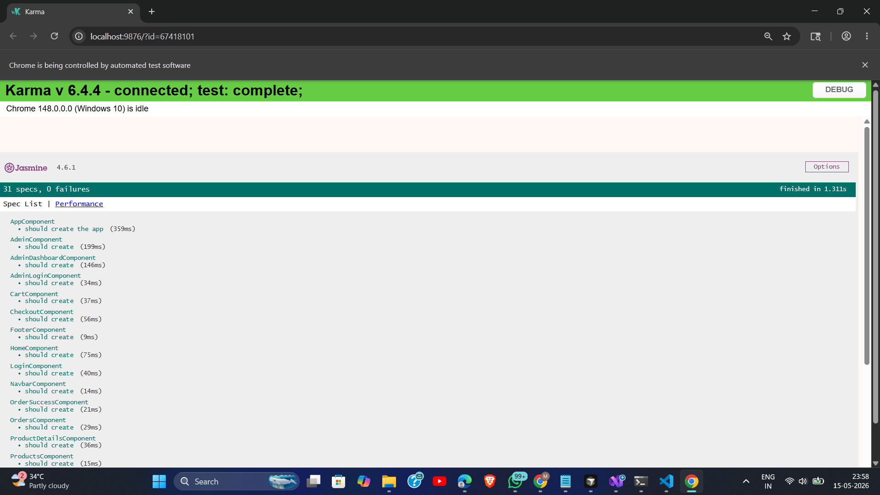
Figure 15: Karma Test Runner — Angular unit tests passing for all components and services

14. UML Diagrams

14.1 Component Hierarchy Diagram
The following diagram illustrates the Angular component tree of ShopEZ, showing all components and their guard protections.

ShopEZ — Component Hierarchy
AppComponent (Root)
├── NavbarComponent [always visible]
├── Router Outlet
│ ├── HomeComponent [public]
│ ├── ProductsComponent [public]
│ ├── ProductDetailsComponent [public]
│ ├── CartComponent [authGuard ✓]
│ ├── CheckoutComponent [authGuard ✓]
│ ├── OrdersComponent [authGuard ✓]
│ ├── OrderSuccessComponent
│ ├── LoginComponent [public]
│ ├── RegisterComponent [public]
│ ├── AdminLoginComponent [public]
│ ├── AdminDashboardComponent [adminGuard ✓]
│ └── AdminComponent [adminGuard ✓]
├── FooterComponent [always visible]
└── ToastComponent [global overlay]

14.2 JWT Authentication Flow Diagram
The sequence diagram below shows the complete JWT authentication flow from user login to authenticated API access.

JWT Authentication Flow
User Angular App API Gateway UserService
| | | |
|-- Login Form -----> | | |
| |-- POST /api/auth/login -------------> |
| | | |
| |<------- JWT Token (200 OK) -----------|
| | | |
| | Store token in localStorage |
| | Decode JWT payload (role, userId) |
| | BehaviorSubject authState$.next(true) |
|<--- Redirect /home | | |
| | | |
|-- Access /cart ----> | | |
| | authInterceptor attaches Bearer token |
| |-- GET /api/cart -----> CartService --> |
|<--- Cart Data ------ | | |
| | | |
|-- Logout ---------> | | |
| | Clear localStorage token |
| | authState$.next(false) |
|<--- Redirect /login | | |

14.3 Data Flow Diagram
The ShopEZ frontend follows a unidirectional data flow pattern. The diagram below illustrates the complete data flow from user action to UI update.

ShopEZ — Unidirectional Data Flow
User Action (click / form submit)
↓
Angular Component
↓ calls Service method
Service (AuthService / ProductService / CartService / OrderService)
↓ constructs HTTP request
authInterceptor (attaches Bearer token)
↓
Ocelot API Gateway (port 5000)
↓ route matching + JWT validation
┌──────────────────────────────────────────────────────┐
│ UserService :5001 │ ProductService :5002 │
│ CartService :5003 │ OrderService :5004 │
└──────────────────────────────────────────────────────┘
↓ queries SQL Server (ECommerceDb)
SQL Server Response
↓
Microservice → Ocelot → Angular HttpClient → Observable
↓ async pipe / subscribe
Component Template (data binding)
↓
UI Updates (re-render)

15. Unit Testing

15.1 Testing Setup
ShopEZ uses Karma as the test runner and Jasmine as the test framework, as configured in karma.conf.js and tsconfig.spec.json. Tests are located alongside each source file with the .spec.ts suffix.

15.2 Test Coverage
Test File | What Is Tested
app.spec.ts | Root AppComponent creation and rendering
auth.spec.ts | AuthService login, token storage, isLoggedIn, isAdmin
product-service.spec.ts | ProductService.getProducts(), getProductById()
cart-service.spec.ts | CartService.getCart(), addToCart()
order-service.spec.ts | OrderService.createOrder(), getMyOrders()
admin-dashboard.service.spec.ts | AdminDashboardService stats fetching
image-service.spec.ts | ImageService.uploadImage() FormData POST
product.utils.spec.ts | Product utility helper functions
admin-component.spec.ts | AdminComponent DOM rendering and initialization
home.spec.ts | HomeComponent product fetch and rendering
login-component.spec.ts | LoginComponent form submission
checkout-component.spec.ts | CheckoutComponent form validation
object-url-pipe.spec.ts | ObjectUrlPipe blob URL transformation

15.3 Running Tests
ng test # Run all unit tests with Karma browser
ng test --code-coverage # Generate coverage report

16. Docker & Deployment

16.1 Frontend Dockerfile
# Stage 1: Build
FROM node:20-alpine AS builder
WORKDIR /app
COPY package*.json ./
RUN npm ci
COPY . .
RUN npm run build

# Stage 2: Serve with Nginx
FROM nginx:alpine
COPY --from=builder /app/dist/Shop_Ez/browser /usr/share/nginx/html
EXPOSE 80
CMD ["nginx", "-g", "daemon off;"]

16.2 Running with Docker Compose
The ShopEZ frontend is part of the full docker-compose.yml stack. The shopez-web container builds from the Shop_Ez directory, serves the Angular production build on port 4200, and depends on the apigateway container.

docker compose up --build # Build and start all services

16.3 Local Development
ng serve --open # Start dev server at http://localhost:4200

17. Future Scope
- Lazy loading: Implement lazy-loaded route modules for admin and checkout to reduce initial bundle size
- NgRx State Management: Replace BehaviorSubject with NgRx Store for scalable state management
- Product Reviews: Add customer review and star rating system per product
- Wishlist Feature: Allow customers to save products for later purchase
- Payment Gateway Integration: Integrate Razorpay or Stripe for live payment processing
- Progressive Web App (PWA): Convert to PWA for offline support and mobile install capability
- Server-Side Rendering (SSR): Angular Universal for improved SEO and initial load performance
- Real-time Notifications: WebSocket-based live order status updates
- Advanced Search: Elasticsearch integration for fast full-text product search
- Internationalization (i18n): Multi-language support using Angular's built-in i18n module

18. Conclusion
ShopEZ is a well-structured, production-quality Angular 19 frontend application demonstrating modern web development practices. The standalone component architecture eliminates the boilerplate of NgModules, making the codebase cleaner and more maintainable. The JWT-based authentication, functional route guards, and HTTP interceptor together provide a robust security layer without third-party authentication libraries.

The service-oriented architecture, combined with RxJS Observables, ensures clean separation of concerns and reactive UI updates. The comprehensive unit test suite using Karma and Jasmine validates every service and key component. The Docker-based deployment strategy ensures consistency across development and production environments.

This project demonstrates strong competence in Angular architecture, REST API integration, JWT authentication, TypeScript, and modern frontend DevOps practices — making it a strong addition to any professional or academic portfolio.

KEY SKILLS DEMONSTRATED IN THIS PROJECT
Angular 19 Standalone Architecture
• JWT Authentication
• Reactive Programming (RxJS)
• Route Guards + Interceptors
• TypeScript Strong Typing
• REST API Integration
• Unit Testing (Karma + Jasmine)
• Docker + Nginx Deployment
• Component-Driven Design
• Responsive UI (Bootstrap 5)

