**COVID-19 CASES ANALYSIS**

**(Phase-2)**

**SUBMITTED BY:**

**MANI BHARATHI M**

**INNOVATION:**

Innovation in the analysis of COVID-19 cases has been crucial in managing the pandemic. Here are some key areas of innovation:

**1.AI AND MACHINE LEARNING:**

Artificial intelligence and machine learning have been employed to analyze vast amounts of data, predict outbreak hotspots, and model the spread of the virus. Machine learning algorithms can also assist in diagnosing COVID-19 through image analysis of chest X-rays and CT scans.

**2.GENOMIC SEQUENCING:**

The rapid sequencing of the SARS-CoV-2 genome has allowed scientists to track the virus's mutations, understand its evolution, and develop more effective vaccines. Innovations in sequencing technology have sped up this process.

**3.CONTACT TRACING APPS:**

Various countries and organizations have developed contact tracing apps that use Bluetooth and GPS technology to identify and notify individuals who have been in close proximity to someone with COVID-19. These apps have been crucial in tracking and controlling the spread of the virus.

**4.RAPID TESTING:**

The development of rapid antigen tests has been a game-changer in COVID-19 analysis. These tests provide quick results and are less resource-intensive than PCR tests, enabling faster identification and isolation of infected individuals.

**5.DATA VISUALIZATION TOOLS:**

Innovative data visualization tools and dashboards have been created to make COVID-19 data more accessible and understandable to the public and policymakers. These tools help in tracking the spread of the virus, hospital capacities, and vaccination progress.

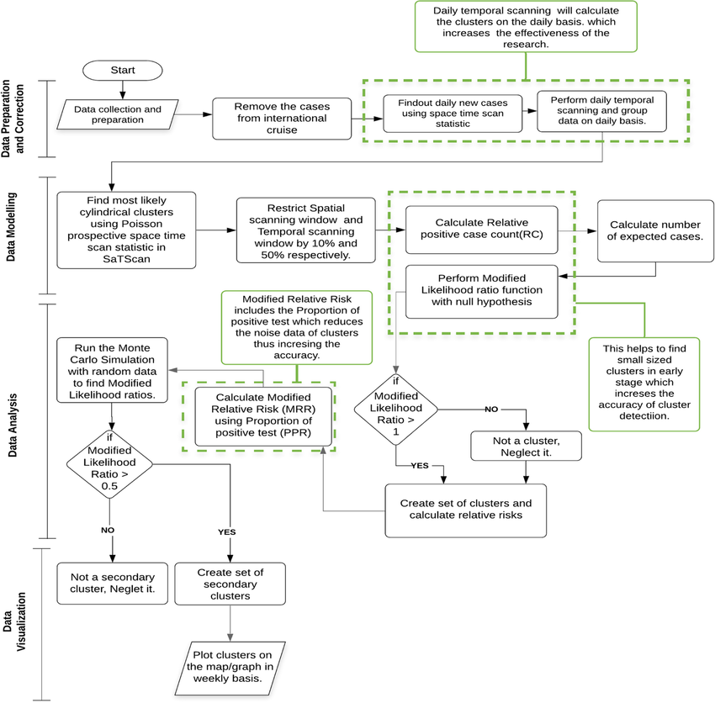

**6.REMOTE MONITORING DEVICES:**

Wearable devices, such as smartwatches and fitness trackers, have been repurposed to monitor vital signs and detect early symptoms of COVID-19. This data can be used for early diagnosis and to track the progress of the disease.

**7.TELEMEDICINE AND TELEHEALTH:**

The widespread adoption of telemedicine has enabled remote diagnosis and treatment of COVID-19 cases, reducing the burden on healthcare facilities and minimizing the risk of infection transmission.

**8.DRUG DISCOVERY AND VACCINE DEVELOPMENT:**

Innovations in drug discovery, such as the use of AI and high-throughput screening, have accelerated the development of potential treatments for COVID-19. Similarly, the rapid development of multiple COVID-19 vaccines has been a testament to scientific innovation.

**9.COMMUNITY SURVEILLANCE:**

Some countries have used wastewater analysis to monitor the presence of SARS-CoV-2 in communities. This can provide an early warning system for outbreaks.

**10.BEHAVIORAL ANALYSIS:**

Innovations in social and behavioral analysis have helped understand and predict the public's response to COVID-19 restrictions and guidelines. This data is essential for shaping public health campaigns.

**11.DASHBOARD INTEGRATION:**

Integration of data from various sources and authorities into unified dashboards, allowing healthcare professionals and policymakers to make data-driven decisions.

**12.HYBRID MODELS:**

Using a combination of epidemiological models and AI to predict and analyze the spread of the virus, considering both biological and social factors.

Innovations in these areas have played a significant role in managing and responding to the COVID-19 pandemic. As the situation evolves, ongoing innovation is crucial to adapt to new challenges and optimize response strategies.

**DESIGNS:**

Designing a system for COVID-19 cases analysis involves various components and considerations, from data collection to analysis and reporting. Below is a high-level design for such a system:

**1. DATA COLLECTION:**

Data Sources: Collect data from various sources, including health departments, hospitals, testing centers, and mobile applications. These sources should provide information on COVID-19 cases, tests, hospitalizations, and vaccinations.

Data Integration: Integrate data from different sources into a centralized data repository. This may require data transformation to ensure consistency and compatibility.

Real-time Data Feeds: Set up mechanisms to receive real-time data updates to ensure that the system always has the latest information.

**2. DATA STORAGE:**

Data Warehouse: Store the integrated data in a secure and scalable data warehouse, ensuring data security and compliance with privacy regulations.

**3. DATA PROCESSING:**

ETL (Extract, Transform, Load): Implement ETL processes to clean, enrich, and prepare the data for analysis. This may involve removing duplicates, handling missing data, and standardizing formats.

Data Validation: Implement data validation checks to identify and flag potentially inaccurate or inconsistent data.

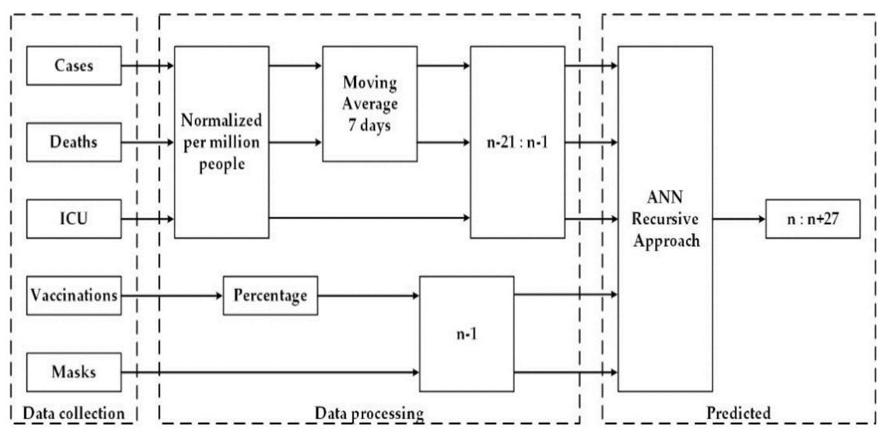

**4. DATA ANALYSIS:**

Statistical Analysis: Perform statistical analysis to identify trends, patterns, and correlations in the COVID-19 data. This can help in understanding the progression of the disease and predicting future trends.

Machine Learning Models: Develop machine learning models for tasks such as predictive modeling, cluster analysis, and anomaly detection. These models can be used to predict disease spread, identify high-risk areas, and detect unusual patterns in the data.

Geospatial Analysis: Utilize geospatial analysis to map COVID-19 cases, hotspots, and healthcare resources. Geographic information systems (GIS) can be valuable for this purpose.

Epidemiological Models: Implement epidemiological models like SEIR (Susceptible, Exposed, Infected, Recovered) to simulate disease spread and estimate parameters like the effective reproduction number (R0).

**5. DATA VISUALIZATION:**

Dashboard Creation: Develop interactive dashboards that provide real-time visualizations of COVID-19 data. Include charts, maps, and tables to present the information in an accessible format.

User-Friendly Interface: Ensure the dashboard is user-friendly, allowing healthcare professionals, policymakers, and the public to easily access and understand the data.

**6. ALERTING AND REPORTING:**

Automated Alerts: Set up automated alerts for critical thresholds and trends. For example, when the number of cases in a specific area exceeds a certain limit.

Scheduled Reports: Generate and distribute scheduled reports to relevant stakeholders, providing a summary of key metrics and insights.

**7. DATA SECURITY AND PRIVACY:**

Data Encryption: Implement encryption to protect data both in transit and at rest.

Access Control: Define strict access controls to ensure that only authorized individuals can access sensitive data.

Compliance: Ensure compliance with data protection regulations (e.g., HIPAA, GDPR) when handling personal health data.

**8. SCALABILITY AND PERFORMANCE:**

Design the system to be scalable, capable of handling increasing data volumes and users.

**9. DISASTER RECOVERY AND REDUNDANCY:**

Implement redundancy and disaster recovery mechanisms to ensure data availability and system continuity in case of failures.

**10. USER TRAINING AND SUPPORT:**

Provide training and support to users, ensuring they can effectively use the system and interpret the data.

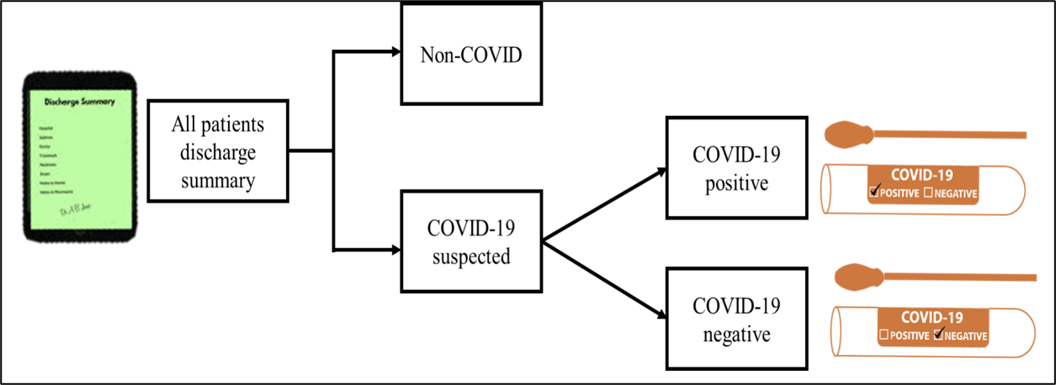

**11. CONTINUOUS IMPROVEMENT:**

Regularly update and improve the system based on user feedback and evolving data analysis needs.

Designing a COVID-19 cases analysis system is a complex task that requires a multidisciplinary approach, involving data scientists, epidemiologists, data engineers, and software developers. It should also be adaptable to changing circumstances and evolving data analysis requirements as the pandemic situation develops.