EVALUATING BIAS AND FAIRNESS IN MACHINE LEARNING MODELS FOR DIABETES PREDICTION

Abstract
The study demonstrates bias and fairness of three supervised machine learning models: Logistic Regression, Decision Tree and Random Forest in predicting the probability of diabetes development using the anonymised dataset of 100,000 patient records for Diabetes Prediction from Kaggle. Implementing all of them entirely in Python, the analysis measured the accuracy, precision, recall, and F1 score of the predictive performance and used the Fairlearn library for the demographic fairness assessment with the following two subgroups: gender and age group.The assessment of predictive performance is done by measuring the accuracy, precision, recall, and F1 score, while the assessment of demographic fairness is conducted using the two subgroups: gender and age group, in both cases using the Fairlearn library which was entirely developed in Python. The accuracy for all three models was found to be greater than 96 percent, and meaningful age-related bias was detected with all three, especially in the logistic regression model. Overall, the random forest showed the best predictive performance overall, while still maintaining a fair balance towards the demographics.

Acknowledgement
I would like to express my heartfelt gratitude for the guidance, assistance and constructive criticisms provided by my dissertation supervisor throughout this research process. They are invaluable in their advice and guidance in the direction and rigour this study took. Last, but not least, I would like to give credit to my academic institution for access to the resources and tools to complete this work. I express my special thanks to the open-source communities of Python, scikit-learn, and Fairlearn, and to the open-source software tools freely available to the public in their open source repositories which enabled the analytical framework in this dissertation. Lastly special thanks to my family and friends for sticking with me during my schooling and for their encouragement and patience.

TABLE OF CONTENTS
Chapter 1: Introduction 12
1.1 Introduction 12
1.2 Background of Study 12
1.3 Research Aim 12
1.4 Research Objectives 12
1.5 Research Questions 12
1.6 Research Rationale 13
1.7 Research Hypothesis 13
1.8 Research Significance 13
1.9 Research Framework 14
1.10 Conclusion 14
Chapter 2: Literature Review 14
2.1 Introduction 14
2.2 Empirical Study 15
2.2.1 Model Performance Optimization 15
2.2.2 Application in Healthcare Systems 15
2.2.3 Dataset Characteristics 15
2.2.4 Software Implementation Frameworks 15
2.2.5 Fairness Evaluation Approaches 16
2.2.6 Bias in Healthcare Prediction Models 16
2.2.7 Diabetes Prediction Studies 16
2.3 Theories and Models 16
2.3.1 Data Algorithm Outcome Relationship 16
2.3.2 Experimental Framework in Machine Learning 17
2.3.3 Classification Models 17
2.3.4 Algorithmic Bias Theory 17
2.3.5. Fairness in Machine Learning Theory 18
2.3.6 Classification Theory of Supervised Learning. 19
2.3.7 Theory of Data Imbalance and Representation. 19
2.3.8 Ethical Artificial Intelligence in Healthcare. 20
2.3.9 Evaluation Model on Metrics of Fairness. 21
2.4 Rationale for Model Selection 21
2.5 Literature Gap 22
2.6 Conceptual Framework 22
2.7 Conclusion 22
Review Questions 22
Chapter 3: Methodology 23
3.1 Introduction 23
3.2 Method Outline 23
3.3 Research Philosophy 23
3.4 Research Approach 24
3.5 Research Design 24
3.6 Research Strategy 24
3.7 Research Method 25
3.8 Data Collection Method 25
3.9 Research Ethics 26
3.10 Time Horizon 26
3.11 Research Onion 27
3.12 Testing Environment 27
3.13 Limitations 28
3.14 Conclusion 28
Chapter 4: Results and Findings 29
4.1 Introduction 29
4.2 Dataset Overview and Preprocessing Outcomes 29
4.3 Descriptive Statistics 31
4.4 Model Comparison 32
4.4.1 Logistic Regression 33
4.4.2 Decision Tree 33
4.4.3 Random Forest 33
4.4.4 Summary Comparison 34
4.5 Model Performance Results 35
4.5.1 Overview of Performance Metrics 35
4.5.2 Logistic Regression Performance 36
4.5.3 Decision Tree Performance 36
4.5.4 Random Forest Performance 37
4.5.5 Confusion Matrix Analysis 38
4.4 Summary 39
Chapter 5: Analysis Of Results 40
5.1 Introduction 40
5.2 Findings 40
5.2.1 Fairness Evaluation Results 40
5.5.2 Per-Group Accuracy Results 44
5.5.3 Feature Importance Analysis 46
5.3 Limitations 47
Chapter 6: Conclusion 49
6.1 Introduction 49
6.2 Linking with the Objectives 49
6.2.1 Objective One: To Compare the Bias in Diabetes Predictive Models 49
6.2.2 Objective Two: To Compare Fairness Between Supervised Algorithms of Learning 50
6.2.3 Objective Three: To Assess Fairness with the Help of Chosen Fairness Metrics 50
6.2.4 Objective Four: To Realise the Model Performance by Demographics 51
6.3 Recommendations 52
6.4 Conclusion 52
Reference List 54
Appendices 60
Appendix 1: Software source code 60

List Of Figures
Figure 1: Research Framework 14
Figure 2: Diabetic prediction using ensemble machine learning models 15
Figure 3: Gantt chart 26
Figure 4: Research onion 27
Figure 5: Data Information and class distribution 30
Figure 6: Code For Descriptive Statistics 31
Figure 7: Performance comparison bar chart 35
Figure 8: Confusion matrices 38
Figure 9: Gender fairness metrics bar chart 42
Figure 10: Age group fairness metrics bar chart 43
Figure 11: Per-gender accuracy 45
Figure 12: Per-age-group accuracy 45
Figure 13: Feature importance bar chart 46

List Of Tables
Table 1: Descriptive Statistics of Continuous Variables 32
Table 2: Comparison of Models Considered for This Study 34
Table 3: Performance comparison chart 35
Table 4: Fairness Evaluation by Gender Chart 41
Table 5: Fairness Evaluation by Age Group 43

List Of Abbreviations
Abbreviation | Full Form
AI | Artificial Intelligence
BMI | Body Mass Index
DT | Decision Tree
EOD | Equalised Odds Difference
F1 | F1-Score
HbA1c | Glycated Haemoglobin
LR | Logistic Regression
ML | Machine Learning
RF | Random Forest

Chapter 1: Introduction

1.1 Introduction
Machine learning finds extensive application in healthcare to assist in the prediction of disease. Predictive models process the data on patients to determine patterns that suggest the threat of such diseases as diabetes. The diagnosis of asbestos is promptly treated and prevented. Nonetheless machine learning models can generate biased outcomes among population groups. The demographic that varies in age or gender representation has the potential of affecting model behaviour. Discriminatory forecasting can interfere with healthcare judgments. The paper assesses discrimination and unbiasedness of machine learning models aimed at diagnosing diabetes and compares the performance of the algorithms of supervised learning between different groups of people.

1.2 Background of Study
Application of machine learning is widely applied in predicting diabetes through attributes of patients like age gender body mass index and glucose level. Such models predict the risk of a disease based on the past and aid the clinical decision making (Wang et al., 2024). The supervised learning techniques most commonly used are logistic regression decision tree and random forest (Raza et al., 2024). Idiosyncrasy of the dataset can affect the training of the model, and generate unbalanced results of prediction. These disparities need to be determined through fairness assessment.

1.3 Research Aim
The goal of the study is to assess bias and fairness on machine learning models to predict diabetes, as well as to compare the performance of supervised learning algorithms on fairness.

1.4 Research Objectives
- To compare the bias in diabetes predictive models.
- To compare fairness between supervised algorithms of learning.
- To assess fairness with the help of chosen fairness metrics.
- To realise the model performance by demographics.

1.5 Research Questions
- Which types of bias are present in the prediction models of diabetes?
- What is the difference between fairness of the algorithms of supervised learning?
- What are the appropriate fairness metrics on diabetes prediction models.

1.6 Research Rationale
The models of machine learning are currently applied to healthcare decision making such as diabetes prediction and the evaluation of the risk. Healthcare pre-trained models might have been trained on data imbalances and will lead to unequal prediction error according to demographic groups (Li et al., 2023). The evaluation of fairness will be required to detect the differences in prediction and provide reliable operations among patients.

1.7 Research Hypothesis
This study takes a positivist and quantitative approach because the problems asked are capable of being tested and based on the problem question. The proposed hypothesis is that differences in fairness outcomes for the physician-assisted machine learning models will exist in the demographically stratified Diabetes Prediction Dataset, despite high model accuracy when aggregated. The results are consistent that age based subgroup differences would be more significant than gender based differences, as the prevalence of diabetes has already been proven to be linked with age (Ali et al., 2024). It is expected that the decision tree and random forest classifiers will have lower equalised odds differences compared to logistic regression as these surround non linear interactions between the clinical variables, while logistic regression has a linear boundary which can exaggerate the differences in the outcomes of features where their relationship to the feature varies across the subgroups. This hypothesis should not be interpreted as a rigid forecast that it is correct to test, but rather as a framework or lens through which the empirical results in Chapter 5 can be analysed to identify whether the choice of model made a meaningful difference in the results or whether differences were simply a result of the nature of the dataset's demographic composition.

1.8 Research Significance
This study offers a critique of bias and fairness in prediction model on diabetes. The researchers contrast learning algorithms with supervision and compare the results of prediction among the demographic groups (Huang et al., 2022). The results could be used to come up with an efficient predictive systems. The analysis of fairness can be used to minimize the unfair prediction outcomes and enhance trust in machine learning usage in healthcare.

1.9 Research Framework

Figure 1: Research Framework
(Source: Self-created)

1.10 Conclusion
This chapter has highlighted the topic of the research and justified the relevance of fairness in diabetes predicting models. The narrative of the presented study revealed that machine learning has been applied in healthcare and that the field has faced fairness issues (Al-Zanbouri et al., 2024). The research questions and the objectives were introduced. In the following, the second chapter analyses the available studies associated with machine learning and diabetes prediction unfairness.

Chapter 2: Literature Review

2.1 Introduction
Healthcare prediction has many applications of machine learning models. Diabetes prediction models process information about patients to predict the probability of the disease. Predictive models are helpful in diagnosis and prophylaxis. The growing application of machine learning has caused an issue of fairness and bias. The predicting models are likely to yield unequal outcomes among the demographic categories. In this chapter, the research on the topic of diabetes prediction and machine learning fairness are reviewed.

2.2 Empirical Study

2.2.1 Model Performance Optimization
Numerous researchers work on enhancing the models of diabetes prediction. Various algorithms have been contrasted to be the models that perform best. The ensemble approaches usually tend to be more accurate than single-model approaches. Even the preciseness does not reflect the fairness among the demographic groups.
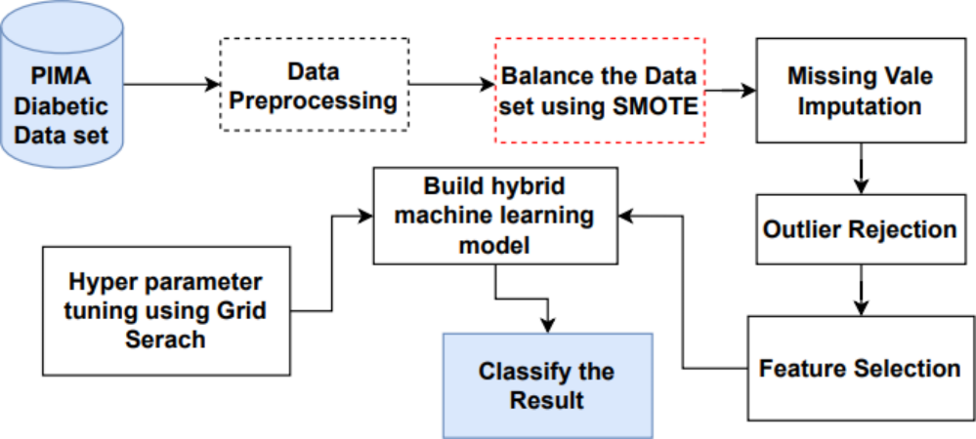

Figure 2: Diabetic prediction using ensemble machine learning models
(Source: www.nature.com/articles/s41598-024-78519-8)

2.2.2 Application in Healthcare Systems
Clinical decision-making is supported using machine learning models. Diabetes prediction systems involve the analysis of patient data to estimate their levels of risk (Luz and Oloyede, 2025). These systems help in diagnosis and treatment planning of medical personnel. Healthcare applications need to be predicted reliably and fairly.

2.2.3 Dataset Characteristics
Clinical variables and demographic variables are found in healthcare datasets. The variables that are common are the age, gender, body mass index, the level of blood glucose as well as medical history. The composition of datasets determine performance of a model. Lack of equal representation of groups can result in biased prediction.

2.2.4 Software Implementation Frameworks
Data analysis tools are applied in implementing machine learning models. Preparation of datasets is done by data preprocessing prior to the training of the models. The process of training and testing models is standard (Otu et al., 2026). Prediction results are interpreted with the assistance of visualisation techniques.

2.2.5 Fairness Evaluation Approaches
The fairness check-up makes a comparison of outcomes of predictions in different demographic groups. The analysis of model behaviour is measured by the fairness parameters of demographic parity and equal opportunity. These tests determine whether there is a difference in prediction outcomes in groups.

2.2.6 Bias in Healthcare Prediction Models
Bias could be the result of imbalance in the feature of data selection and the behaviour of the algorithm. Less accurate predictions can be given to under-represented groups. Predictive sensitivity: There is a risk of gender and age in the results of predictions. To enhance model fairness, bias needs to be identified.

2.2.7 Diabetes Prediction Studies
In diabetes prediction, supervised learning algorithms are widely applied. Random forest models and logistic regression decision trees have good performance in terms of classification. Various algorithms are used to yield different prediction results. There is minimal research comparing fairness in these algorithms.

2.3 Theories and Models

2.3.1 Data Algorithm Outcome Relationship
Machine learning strategies recognise the correlation between patient attributes and outcomes of the disease. The quality and format of the datasets affect the learning patterns by the models. The inequality of prediction accuracy is a possible result of uneven demographic representation (Davoudi et al., 2024). It is noteworthy that being aware of how data and algorithms interact is pertinent to the assessment of bias and fairness in diabetes predicting models. The correlation among data, algorithms, and outcomes is the decisive factor of machine learning model reliability in predictive healthcare. Input variables in the training of prediction models include age, sex, blood glucose level and body mass index of the patient. In the event where these attributes are not equally spread among demographic groups, the algorithm might get to know trends that will support the predominant group in the dataset. This could mean that prediction accuracy can be inaccurate across population groups, which can cause bias in healthcare decision-making systems. Knowledge of this interaction can drive researchers to analyze how various algorithms process healthcare information, and how the results of the predictions vary among population groups. Through examining the relationship between the input features, algorithm behaviour, and prediction outcomes, researchers are able to establish the factors of bias in the machine learning models. This theoretical view thus provides the principles of fairness assessment of diabetes prediction models, the role of balanced datasets and prudent choice of algorithms in health care machine learning examples.

2.3.2 Experimental Framework in Machine Learning
Training and evaluation of data preparation models are part of machine learning studies. Training is done after cleaning and organising data. Performance measures are used to assess models. Comparable evaluation methods can be used to compare algorithms and can be used to analyze fairness. The machine learning study research is based on an experimental framework that offers a systematic approach toward model development and evaluation of predictive models. The following are usually the stages in this framework: data collection, preprocessing, feature selection, model training and performance evaluation. Data preprocessing in studies of health care prediction constitutes the processing of missing values, data normalisation and preparing data to be used in training models. After the preparation of the dataset, it is almost always separated into training and testing sets in order to objectively assess the performance of machine learning algorithms. In the stage of evaluation, accuracy, precision, recall, and F1-score are evaluated as performance aspects of the selected models to assess their predictive potential. In fairness concerned studies, extra appraisal techniques are applied in determining the prediction outcomes in groups of people (A. Luz and J. Oloyede, 2025). In this case, researchers may conduct a systematic comparison of model performance and fairness behaviour by using the same experimental procedure on a number of algorithms. It is a structure to make sure the research process is clear, repeatable, and the scientific validity of research to investigate the bias in diagnostic models of diabetes.

2.3.3 Classification Models
Predictions of diabetes state of patients are classified. The logistic regression is an estimation of the disease probability by using patient characteristics (Alipour and Alipour, 2025). Decision tree models organize data according to the feature values. Random forest models are models that combine many trees in order to enhance accuracy and stability. Various fairness models can have varying outcomes.

2.3.4 Algorithmic Bias Theory
The algorithmic bias theory describes the way machine learning models can influence systematically dissimilar results across distinct groups of people. It is possible that bias arises when the images comprising training data to create the model do not represent the demographic populations fairly. When it comes to healthcare prediction systems, data sets can include a larger number of records relating to the particular population, and this factor can affect the learning patterns of algorithms. Training an algorithm with such data can create more precise predictions of the majority group but increase errors with minority groups. According to this theory, bias may happen in any part of the machine learning pipeline, such as how the data is collected, features are selected, the model design, and evaluation (Shayan Shaham et al., 2025). As an example, such a sensitive attribute as gender or age can affect the way the model will make its interpretation of the relationship between variables and disease outcomes. This can cause demographic differences in risk prediction in diabetes prediction systems. The importance of the theory of algorithmic bias is that it allows consideration of the behaviour of models in addition to overall accuracy. Rather, investigators will have to examine the differences in prediction outcomes among groups. With the assistance of fairness evaluation measures and the evaluation of demographic differences, researchers could recognise and eliminate bias in predictive healthcare models. Such a theoretical approach thus favors the necessity of machine learning systems in healthcare that are aware of fairness.

2.3.5. Fairness in Machine Learning Theory
The concept of fairness in machine learning aims at the division of equal measure between the effects of predictive models in various segments of the populace. In health care systems, fairness is of special importance due to the fact that the results of machine learning can impact medical decision-making, treatment planning, and the evaluation of the risk of diseases. When the predictive models are biased towards a systemic disadvantage based on certain groups, the healthcare outcome of these choices might further be useful towards underlying social or demographic disparities. Thus, fairness assessment has emerged as one of the significant fields of study within artificial intelligence and healthcare analytics.
The fairness theory proposes a number of measures that can be employed in determining whether the results of prediction are balanced across groups (Jing Hu et al., 2025). The standard harm reduction solutions are demographic parity, equal opportunity, and equalised odds. These measures are used to test whether the prediction outcomes, error, or probability vary in a significant manner across demographic samples. With rhetoric on these measures of fairness, researchers can determine whether a predictive model treats the population of a different group fairly. Fairness evaluation is useful in the field of diabetes prediction to identify the occurrence of continuous and accurate predictions of the machine learning algorithms on the different groups of patients. The concept of fairness in machine learning has a theoretical basis thus explaining why transparent, responsible, and ethical artificial intelligence systems can be developed in medical settings.

2.3.6 Classification Theory of Supervised Learning.
The concept of supervised learning classification theory is used to describe the ways applied by machine learning programs to learn patterns by using labelled data intended to predict actions on new data. In classification, training of the model is done using selected historical data in which the outcome variable is known. The algorithm studies the association of the input characteristics and the labels not only to create a predictive performance (Justin T. Lee et al., 2025). The classification model in healthcare prediction systems is also popular in deciding whether a patient will come up with a given disease. Age, gender, body mass index, glucose level and medical history are different variables accepted as input features whilst either presence or absence of diabetes are the output classes in diabetes prediction.
The various classification algorithms use dissimilar approaches when establishing connections among variables. Logistic regression is used to calculate the risks of the disease incidence in regard to response to statistical associations among patient factors and health outcomes. Decision tree models are data classifications that are used to form a hierarchy of decision rules depending on the feature values. Random forest models are multi-decision trees that are used to enhance predictive stability and accurate results (Zhe Liu et al., 2025). Supervised classification theory is thus vital in comprehending predictive models, modes of construction and assessment in healthcare research as well. The comparison of various classification algorithms is also useful in fairness research to establish the impact of model design on prediction accuracy and fairness of the algorithms across demographic groups.

2.3.7 Theory of Data Imbalance and Representation.
The theory of data imbalance and representation describes how the performance of machine learning models can be affected by unequal calls of the various groups of demographics in a dataset. Some of the patient groups might occur more than others in the healthcare datasets because of variations in the methods of collecting data, access to healthcare, or other demographic factors. When machine learning algorithms get trained with such imbalanced data, the algorithms tend to get trained to depict the majority groups and not the minority groups. Consequently, there could be differences in the accuracy of prediction in different populations. The problems related to imbalanced data can be experienced in the diabetes prediction systems where a single outcome class, like non-diabetic patients, is largely disproportionate to the cases of diabetic patients in the data set. On the same note, demographic imbalance can occur whereby the data is underrepresented by a specific group of age or gender. Such imbalances may produce biased predictions due to the fact that the algorithm gets inadequate data of underrepresented populations in the training process. The theory of data imbalance emphasises that it is necessary to analyse the composition of the dataset prior to developing the model (Emanuele Ratti et al., 2025). In an effort to reduce the effects of unequal representativeness, researchers usually resort to resampling, stratified sampling, or balanced data splitting. The issue of data imbalance is thus significant in terms of generating trustworthy and fair predictions of machine learning models across the demographic profile within the healthcare systems.

2.3.8 Ethical Artificial Intelligence in Healthcare.
Healthcare Ethical artificial intelligence work on principles directed at the sensation of accountable orchestration and execution of machine learning grounded in medical choice making. With the further development of artificial intelligence technologies and their application to healthcare settings, some questions about transparency, accountability and equity of predictive models have emerged. Ethical AI theory states that clinician decision making should be assisted by machine learning systems bearing in mind that patient safety and equality must be observed. This becomes especially relevant in disease prediction algorithms in which algorithmic outputs might be used to affect diagnostic diagnosis and treatment prescription (L. Rountree et al., 2025). Fairness is one of the principles of ethical AI in healthcare that means that predictive systems should deliver identical and impartial results to various patient groups. The next important principle is transparency, which implies that the logic and behaviour of models of machine learning should be explained to healthcare workers and researchers (Zhi Wang et al., 2025). Another crucial element is accountability since organisations utilising AI systems should make sure that models are properly verified and tracked. Ethical AI principles have played a role in research in diabetes prediction to decide how the machine learning algorithm works to give choices that may not be beneficial to certain groups of people. Including ethical concerns in the design and testing of predictive models, scientists can help build responsible and reliable systems of artificial intelligence in the field of healthcare usage.

2.3.9 Evaluation Model on Metrics of Fairness.
The fairness metrics evaluation model gives an account of how fairness in machine learning systems can be measured and evaluated systematically. When using machine learning in predictive healthcare, one needs to assess fairness to understand whether the models can deliver similar results between various demographic groups. This model is aimed at analyzing the results of prediction on the basis of certain fairness measures, which are used to evaluate the differences in performance between groups of individuals by their gender, age, or socioeconomic status.
Fairness evaluation models are usually implemented of such statistical metrics as demographic parity, equal opportunity, and equalised odds. Demographic parity determines the similarity of the likelihood of positive predictions within demographic groups (S. M. Pedersen et al., 2025). Equal opportunity compares the true positive rate of the groups and equalised odds compares the truth positives and the false positives. Through these measures, the researchers would be able to detect any difference in the prediction results that can suggest algorithmic bias. Fairness measures can be used in diabetes prediction research to identify the extent to which machine learning models give equal treatment to groups of patients in their prediction of the risk of a disease (M. Alipour and A. Alipour, 2025). The model is thus supportive to the researchers in finding fairness gaps on the predictive systems and offers a systematic approach to investigate bias in healthcare machine learning models.

2.4 Rationale for Model Selection
Three supervised classification models are included in this study, such as logistic regression, decision tree, and random forest, which have been used in healthcare prediction tasks and have various architectures in terms of complexity. Logistic regression offers a simple linear baseline that is useful to compare and remarkably easy to interpret and understand, and is widely used in clinical risk scores. Considering non linear classification via rule based decision tree models can include threshold effects in the clinical variables as a single clinical example of glucose level and HbA1c may not capture well in a linear model. Random forest builds on this by using ensemble learning, which is essentially an amalgamation of multiple decision trees to ensure stability and make overfitting with respect to any one demographic pattern in the data set less likely (El-Sofany et al., 2024). The change from linear models to tree based models and ensemble models enables the study to explore whether, beyond accuracy in prediction, complexity of the model impacts the fairness of the outcomes across demographic groups. Of these three models, the final one is the most frequently mentioned in the context of diabetes prediction and provides sufficient context for comparing them with previous studies. This inclusion is thus consistent with both usability in the context of tabular healthcare data and the aims of this study of fairness.

2.5 Literature Gap
The accuracy of prediction of models in diabetes and not fairness are a priority in most existing research. There are limited studies that compare differences in fairness amongst learning algorithms that are supervised. The extent of fairness analysis in diabetes prediction tasks is also not much analyzed. This paper counters these shortcomings through the analysis of bias and fairness in a variety of algorithms based on one dataset.

2.6 Conceptual Framework
The conceptual model explains how the data machine learning models in healthcare relate to the outcomes of fairness. The patient attributes are taken as the input variables to train the model. The prediction outcomes of machine learning algorithms are compared with performance and fairness metrics. The fairness analysis shows the disparity of the prediction results in demographic groups.

2.7 Conclusion
This chapter summarized the papers associated with machine learning model prediction of diabetes and equity. The discussion outlines the evaluation strategies of classification models and characteristics of datasets. The gap in literature identified the necessity of adequacy in making comparisons among the supervised learning algorithms. The following chapter illustrates the methodology of the research employed in this study.

Review Questions
- What is this research going to accomplish?
- How can diabetes prediction models be biased.
- What algorithms are incorporated in this study.
- What are the fairness measures employed in this study?
- What is the significant gap in the literature?

Chapter 3: Methodology

3.1 Introduction
This chapter reports the methodology applied in the research to assess bias and fairness in machine learning models in the process of predicting diabetes. This chapter aims at describing the research process, data collection methods, and methods of analysis as well as methodological decisions that were applied to accomplish the research goals. The research aims at examining a healthcare dataset by the supervised machine learning algorithms to determine the predictive performance and fairness among the groups of people. The methodology also addresses the process of data preparation, implementation of models, and the methods of fairness. The following paragraphs give the philosophy of the research, research approach, research design and other methodological aspects that have been employed in the study.

3.2 Method Outline
The study is based on a quantitative analytic approach to the publicly available data of diabetes predictions. The dataset has attributes of the patients like the age, gender, body mass index, glucose level, smoking as well as hypertension status. Various variables are fed as input variables into machine learning models to affect conditions of diabetes. The methodological process consists of various phases that include the collection of data, prelude to data, model implementation, and assessment. Some of the supervised learning algorithms applied to complete the prediction task involve logistic regression, decision tree, and random forest (Mohd D. H. M. Hamdan et al., 2025). Upon the training of models, such evaluation metrics as accuracy, precision, recall, and bias indicators are determined to compare the model performance and study bias based on demographic factors.

3.3 Research Philosophy
The current research employs positivism research philosophy since the study aims at objective analysis of numerical data. Positivism presupposes that observation, measurements, and empirical evidence can be used to acquire knowledge. In this paper the dataset gives quantifiable patient characteristics and disease outcomes which could be analysed with the help of machine-learning methods. A positivist point of view justifies the application of quantitative techniques in checking the performance and fairness of models (Behrouz Naderalvojoud et al., 2025). With the use of statistical metrics and algorithmic assessment, the study will produce objective results on bias in diabetes prediction models and add to the evidence-based knowledge of fairness in the healthcare machine learning system.

3.4 Research Approach
The study uses a deductive research approach. Deductive research is based on available theories or concepts and tries to prove them by referring to some empirical data. This paper presents the computational experiments employing theoretical concepts of machine learning fairness, algorithmic biases and healthcare prediction. Deductive approach should be considered since the research seeks to determine whether machine learning models can be biased in predicting diabetes. Available research indicates that medical data and algorithms can have disproportionate prediction results among demographic groups (Kiran Chakradeo et al., 2025). Using this theoretical knowledge, the study hypothesizes whether parallel tendencies can be found when supervised learning models are applied to the diabetes prediction data.

3.5 Research Design
The quantitative design will help the study to quantify prediction performance and equity based on statistical measures. The dataset is sent through machine learning algorithms, and the outputs of the algorithms are analysed based on evaluation measures, which include measures of accuracy, precision, recall, and fairness. The comparison of these measures between algorithms and between demographic cohorts will enable the research to determine variations in prediction results, as well as possible bias. The quantitative research design can be adopted in this study since the researcher needs to gauge quantifiable results and not examine intangible experiences. Numerical analysis means that the findings will be objective and replicable (T. S. Pias et al., 2025). Such a design can also enable the researcher to compare various machine learning algorithms across the board in a systematic manner and can ensure how each of the models perform in case of fairness and prediction accuracy.

3.6 Research Strategy
The research methodology in this paper is the computational study of medical dataset in machine learning. Such a strategy is aimed at the examination of secondary data to measure the predictive models and fairness results. The analysis endeavours no experiments or surveys involving human beings but rather using algorithmic modelling and statistical analysis. The computational strategy enables the research to run various algorithms and compare the performances of the algorithms, using one and the same dataset. The study will be able to use logistic regression, decision tree, and random forest models, to analyze the performance of various algorithms given the same healthcare data (Ying Yang et al., 2025). The comparison assists in the discovery of the differences in prediction behaviour and fairness among algorithms.

3.7 Research Method
The research tool to be used in this study is machine learning model evaluation. Predictive models are developed with the help of supervised learning methods in the historical patient data. The algorithms selected will be logistic regression, decision tree and random forest algorithms, which are widely applied in the healthcare prediction studies. It starts with data preparation to analyze it. The preprocessing of the data consists of elimination of missing values, sorting of the variables and the data must be machine learnable. The data is subsequently split to form training and testing to give an objective evaluation of model performance. Evaluation measures are also computed to determine the accuracy in prediction after the training of the models (Uday Bhimavarapu, 2025). Such scales are accuracy, precision, recall, and F1-score. Besides performance evaluation, the measures of fairness that include demographic parity and equal opportunity are also used to assess the result of prediction when demographic groups are included. This technique enables the study to evaluate the predictive accuracy as well as the justice with respect to diabetes predictive models.

3.8 Data Collection Method
In this study, the secondary data is based on the Diabetes Prediction Dataset of Kaggle data platform identified in the research proposal. The dataset includes the anonymised patient health records of variables like age, sex, body mass index, level of glucose in the blood, smoking history, presence or absence of hypertension and the outcome of diabetes. They are features of the attributes that are usually applied in a healthcare prediction study, as well as give relevant input features to machine learning models. The secondary data type is suitable in this study since it is proposed to analyse algorithmic behaviour and fairness, and not to gather primary clinical data. The data allows the application of the supervised learning algorithms, including logistic regression, decision tree, and random forest, to predict the risk of diabetes. There are some challenges, however, with relying on publicly available datasets (S. Uddin et al., 2026). The data set might be skewed towards certain population groups hence affecting model development and prediction processes. Thus, the preprocessing of data and the evaluation of fairness is needed when considering bias among various demographic groups like age and gender to be critical in analyzing the results of the models.

3.9 Research Ethics
The data that is provided in the study is anonymised records such that the names of the personalities are not present. This makes the privacy of individuals intact. The dataset can also be used freely to conduct research and this indicates that it cannot be violated according to the guidelines of ethical standards. The other ethical issue is connected to the responsible interpretation of the results of machine learning. The research should also provide the outcomes of the study in an objective manner because the research is focused on the bias and fairness of predictive models: the study should not support the discriminatory assumptions (Ahmed M. Fahmy, 2025). The results will hence be critically interpreted and proved by scholarly resources to make a responsible interpretation of the results.

3.10 Time Horizon
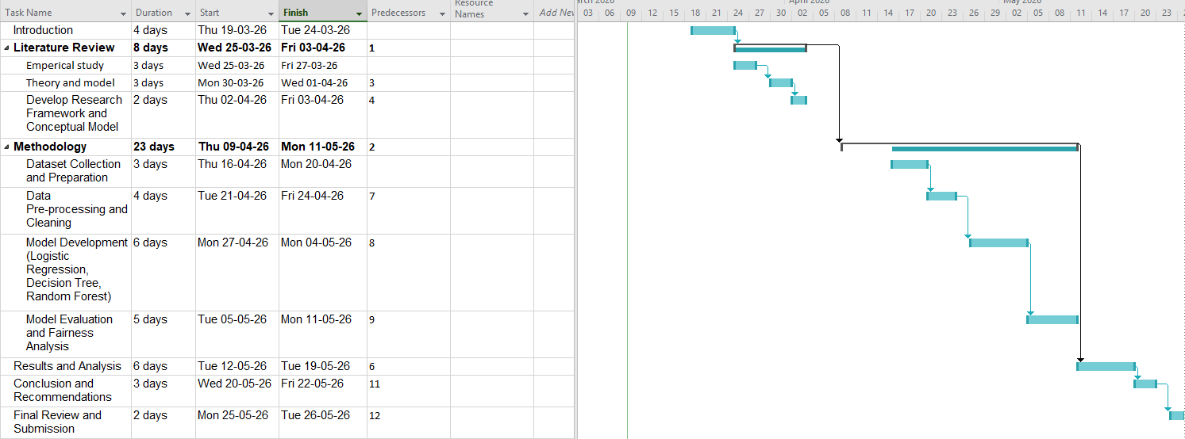

Figure 3: Gantt chart
(Source: Self-created)

3.11 Research Onion
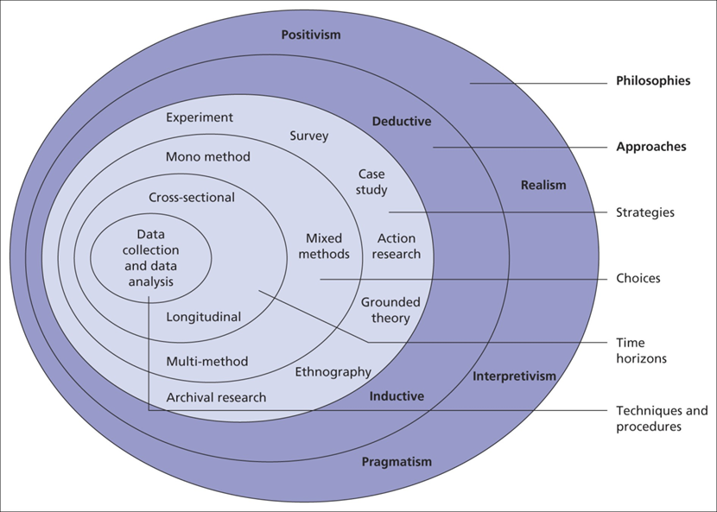

Figure 4: Research onion
(Source: Self-created)

3.12 Testing Environment
This research was performed in Python using the Google Colab cloud-based notebook environment, which offered an interactive mode ideal for iterative data preprocessing, training and analysis of statistical models, and evaluation of the models' fairness without requiring the use of local programming libraries. Google Colab was chosen because of its accessibility, support of widely-used data science libraries (Phillips et al., 2023), and because of the fact that it provides computational resources for free. Logistic regression, decision tree, and random forest classifiers were all implemented and trained using the scikit-learn library, with preprocessing of the data being performed using tools like StandardScaler for continuous data, and LabelEncoder for categorical data. The library Fairlearn was used to evaluate fairness, obtaining the metrics of demographic parity difference and equalised odds difference applied to the different demographic subgroups (gender and age). The Diabetes Prediction Dataset is a comparatively small tabular data set containing 100,000 rows, meaning that the computation requirements were not particularly heavy, and could be done efficiently with the Colab training environment without needing much GPU consumption. Matplotlib and seaborn were used to visualize the results and create performance comparison and fairness metric charts. This setting facilitated the entire pipeline, data cleaning to fair assessment, to be reproducible and easily accessible throughout this research process.

3.13 Limitations
There are several methodological limitations that need to be recognised in this study's research design. Analysis is based on a single publicly available file, appropriate for illustrating the evaluation techniques for fairness, but may not be truly representative of all the demographic and clinical variation in other healthcare regions and populations. This reflects the limitation in making valid inferences from findings beyond the data set used. The study only uses three supervised learning algorithms that are frequently used in prediction research within the healthcare field. Other methods such as gradient-boosted machines or models with neural networks were not tested and could lead to other results for fairness or performance (Chu et al., 2023). Furthermore, the fairness assessment could only be completed for two demographic factors: gender and age, other factors which may be important were not included in the dataset so could not be explored. The findings of this study may be interpreted within these boundaries.

3.14 Conclusion
This chapter outlined the research methodology applied to examine bias and fairness in machine learning models to predict diabetes. It takes the positivist research philosophy and a deductive approach supplemented with a quantitative research design. The study method consists of computational analysis of a publicly-available healthcare dataset on the basis of supervised machine learning algorithms. The methodology involves the use of logistic regression, decision tree, and random forest models and the assessment of the outcomes through conventional classification measures and indicators of fairness. The ethical issues, research limitations, and time horizon of the cross-sectional nature of the research were also addressed. The research onion framework helped to show the relationship between the various methodological elements.

Chapter 4: Results and Findings

4.1 Introduction
The findings are presented in two main sections. The first section discusses the four widely used evaluation metrics: accuracy, precision, recall, and F1-score to show the predictive value of each model.The four commonly used evaluation metrics accuracy, precision, recall, and F1-score are discussed, to illustrate the predictive value of each model in the first section. The second section reports fairness evaluation performance, comparing the performance between gender and age subgroups of the demographic (Ozdemir and Fatunmbi, 2024). Besides the dimension of fairness, the per-group accuracy results are also reported to give the whole picture about the behavior of the models on the subgroup level. The results of the feature importance are also included for the random forest model to provide context to the results. The results presented in this chapter were directly derived from the Python implementation of the system, presented in Chapter 3, and backed up by visualisations developed in the analysis stage.

4.2 Dataset Overview and Preprocessing Outcomes
A structured dataset preprocessing stage in Python was performed in the dataset before model training. The initial data set contained 100K patient records that contained nine variables. Records were excluded from the data prior to analysis because in a few records gender was recorded as Other and excluded from the data in order not to be able to reach meaningful fairness analysis, the majority of records remained after the cleaning and were analysed. However, categorical variables such as gender and smoking history were converted into numerical values for use in the machine learning algorithms (Olisah et al., 2022). Gender was coded as binary Female-male (0-1). The history of smoking was encoded with LabelEncoder from scikit-learn. To prevent weightier data being overrepresented in model training because of variance in scale, continuous data such as age, body mass index, HbA1c, and blood glucose level were standardized using StandardScaler. Two variables created to be demographic groupers were used for fairness evaluation. Patients were divided into two age groups: age<45 years vs age>45 years (Afsaneh et al., 2022). That data was then split into a training set that contained 80 percent of the information, and a testing set that contained the remaining 20 percent, and stratification was used to retain the same proportion of diabetic and non-diabetic cases between the training and testing sets.
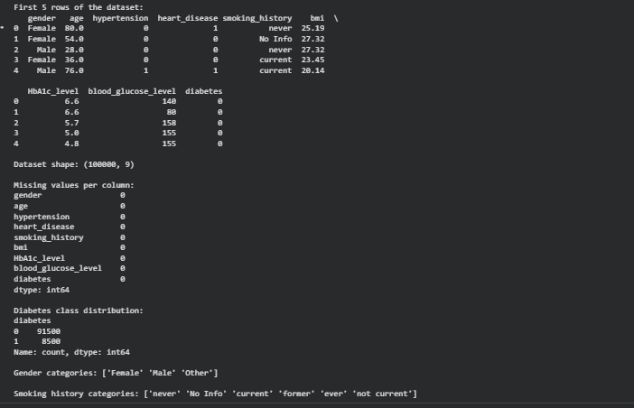

Figure 5: Data Information and class distribution
(Source: Self-created)
The diabetes outcome variable in the class distribution was imbalanced, with diabetic cases making up a small percentage of the total cases, when compared to non-diabetic cases. This is a characteristic of the prevalence of real-world diabetes and can have direct implications when interpreting the scores of each question on the recall because models might be more likely to predict the major class (Dunkelau and Duong, 2022). Throughout the analysis that follows this is recognised as a characteristic of the data.

4.3 Descriptive Statistics
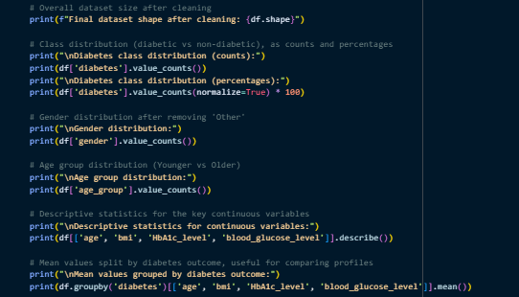

Figure 6: Code For Descriptive Statistics
(Source: Self-created)
The data set retained for model training and validation after excluding patients with the Other gender category contained 99,982 patients for twelve variables. The diabetes outcome variable was clearly class-balanced with 91,482 being non-diabetic (91.50 percent), and 8,500 being diabetic (8.50 percent). This imbalance can be seen from daily clinical, and will be considered in the interpretation of scores for recalling from a model trained from imbalanced data; models trained from imbalanced data tend to learn the majority class more strongly than the minority class (Tan et al, 2024). There was a slight male-female imbalance when the data was analyzed by gender with 58,552 female patients and 41,430 male patients which was addressed during assessments of fairness. A good age group split for demographic analysis would have been the 45-year threshold used to divide the patients into Younger and Older, with a total of 52,396 and 47,586 patients respectively, making the division more or less equal and suitable for subgroup comparison (Raza, 2023). The variables listed below are continuous clinical variables and have mean and standard deviations.
Variable | Mean | Std Dev | Min | 25% | Median | 75% | Max
Age | 41.89 | 22.52 | 0.08 | 24.00 | 43.00 | 60.00 | 80.00
BMI | 27.32 | 6.64 | 10.01 | 23.63 | 27.32 | 29.58 | 95.69
HbA1c Level | 5.53 | 1.07 | 3.50 | 4.80 | 5.80 | 6.20 | 9.00
Blood Glucose Level | 138.06 | 40.71 | 80.00 | 100.00 | 140.00 | 159.00 | 300.00

Table 1: Descriptive Statistics of Continuous Variables
(Source: Self-created)
Diabetic and non-diabetic patients are clearly separated by a comparison of mean values across diabetes outcome groups. The mean age for non-diabetic patients was 40.12 years, with a mean BMI of 26.89, and a mean level of HbA1c was 5.40, and blood glucose level was 132.85. There were significantly higher ages of patients (mean 60.95 years; and blood glucose level 194.09 mg/dL) with diabetic patients, significantly higher BMIs (mean 31.99) and a significantly higher HbA1c level (mean 6.93) when compared to patients without diabetes across the four variables. These differences validate the dataset with known clinical patterns: Old age, high BMI, and high glucose and HbA1c are strongly associated with diabetes diagnosis, and give context to the results for feature importance presented later in this chapter.

4.4 Model Comparison
This section outlines the theoretical background to the three supervised learning models used in this study and their potential advantages and disadvantages for the purposes of diabetes prediction in this context and for the purposes of fairness assessment.

4.4.1 Logistic Regression
Logistic regression is a statistical model that defines the probability of something happening from a sum of input features following a linear model. It has a relatively simple architecture that captures a linear distance between the combination of patient characteristics (glucose level, BMI, HbA1c) and risk of diabetes diagnosis. This simplicity also has the advantages of high interpretability because the contribution of each variable in prediction is directly visible, as well as fast training speed, even if the data size used is very big like in the study (Chen et al., 2023). However, because of its linear nature this approach has a reduced ability to detect non-linear relationships between clinical variables, which can lead to lower prediction accuracy and to characteristic challenges in predicting complex interactions between features among different subgroups of demographic variables.

4.4.2 Decision Tree
The decision tree model classifies patients in a hierarchy of decision rules based on threshold values of the input features, such as splitting patients in the hierarchy of the blood glucose threshold level, then the HbA1c threshold level, and so on. Unlike the logistic regression, which is linear in nature, the decision tree in this model can represent the non-linear relationships and threshold effects, and the decision rules that are displayed can be traced and explained, therefore, the model output is relatively easy to interpret (Li et al., 2023). The key disadvantage of a single decision tree is that it is very likely to overfit the training data, especially when the decision tree is deep enough, and may show inconsistent behaviour in different subgroups of patients if subgroups are absent or rare in different parts of the decision tree.

4.4.3 Random Forest
Random forest model is based on random forest theory, which turns out to be an improvement over the decision tree by creating a collection of many decision trees, each trained using a different random selection of the data, each using a different random subset of the features and aggregating the outputs of these many individual trees into a single final prediction. Ensemble approaches have been found to largely maintain the ability to model non-linear relationships between clinical variables, with a decreased risk of overfitting compared to a single decision-tree and in general they offer increased predictive accuracy and stability. The major drawback is that the interpretability of a single tree or logistic regression is lost, rather than a single interpretable path there are numerous trees, and thus every prediction made by the ensemble is supported by a different set of rules (Yuan et al., 2023). The random forest models also have a higher computational cost in their training than the other two models and although this is not very high for the dataset size employed in this study, it remains higher.

4.4.4 Summary Comparison
The table below summarises the architecture, advantages and limitations of three models being considered for this study, which in turn can give insight into the results of the measures of performance and fairness presented later in the document.
Model | Architecture | Strengths | Limitations
Logistic Regression | Linear combination of input features | Simple, interpretable, fast to train | Cannot capture non-linear relationships between variables
Decision Tree | Hierarchical rule-based splits on feature thresholds | Captures non-linear patterns, interpretable decision path | Prone to overfitting, can behave inconsistently across subgroups
Random Forest | Ensemble of multiple decision trees | Reduces overfitting, improves stability and accuracy | Less interpretable, more computationally demanding

Table 2: Comparison of Models Considered for This Study
(Source: Self-created)
The study aims to determine if the predictive performance of adding more and more architectural complexity to the model is correlated with greater fairness discrepancies among sub-groups of the population, which is directly addressed in the results that follow.

4.5 Model Performance Results

4.5.1 Overview of Performance Metrics
The three models were tested on the held-out test set and evaluated on the following four metrics: accuracy, precision, recall, and F1-score. The results are presented in a table below and on a performance comparison chart below.
Model | Accuracy | Precision | Recall | F1-Score
Logistic Regression | 0.9614 | 0.8803 | 0.6318 | 0.7356
Decision Tree | 0.9715 | 0.9669 | 0.6882 | 0.8041
Random Forest | 0.9699 | 0.9399 | 0.6900 | 0.7958

Table 3: Performance comparison chart
(Source: Self-created)
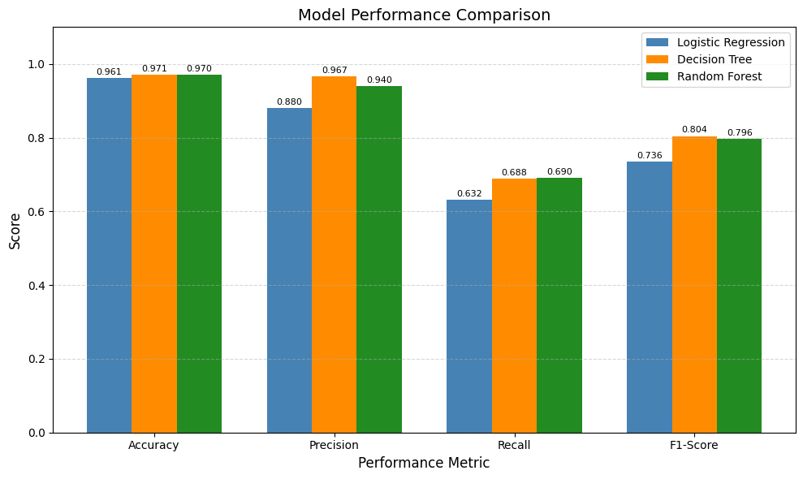

Figure 7: Performance comparison bar chart
(Source: Self-created)
High overall accuracy is produced for all three models: logistic regression at 96.14 percent and the decision tree at 97.15 percent. But despite accuracy alone being a successful measure of model performance, especially in the context of class imbalance is not all to it (Obi, 2023). These precision, recall, and f1-score results indicate important differences between the ability of each model to estimate the number of positive cases related to diabetes, which has implications in the healthcare field.

4.5.2 Logistic Regression Performance
Logistic regression's overall accuracy was 96.14%, the precision of 88.03%, the recall of 63.18%, and the F1-score of 73.56%. Based on the 63.18 percent value of recall, the number of diabetic patients which the model misclassified as non-diabetic or vice versa in the test set were around 37 percent, which is not considered a good value (Owusu-Adjei et al., 2023). On the other hand, accuracy seems good, the value of recall is 63.18 percent, meaning that approximately 37 percent of diabetic patients were not classified as such by the model. In a health care setting, 20% is a large percentage of missed diagnosis, and would pose a clinical threat in an actual screening program. The F1 score of 73.56 percent is relatively low when compared with other two models, this again shows that logistic regression model has the weakest potential for balancing between precision and recall in the three models tested (Chang et al., 2022). The result is consistent with expectations that logistic regression, which is a linear statistical model, may not be able to model certain diabetes outcomes that have non-linear relationships between the clinical variables in the data set.

4.5.3 Decision Tree Performance
The decision tree model showed the highest overall accuracy (97.15%), highest precision (96.69%) and superior F1 score (80.41%). The correctly classified proportion of actual diabetic patients, 68.82 percent, is significant gain compared to logistic regression, showing that the decision tree correctly classified a much larger percentage of patients in the test set (Zhou, 2024). This leads to the conclusion that overall the decision tree is one of the best models, according to the majority of the evaluation measures used in this study. This is one of the most precise scores for healthcare prediction; precision score is 96.69. Precision indicates what percent of those patients whose diabetes was predicted by the decision tree actually had diabetes, with a value closer to 97 indicating that in the vast majority of predictions, the decision tree was correct when it did predict diabetes (Shin et al., 2022). This is clinically very significant in a screening setting since screen positive patients who are not actually diabetic could be subject to unnecessary patient stress, clinical investigation and use of health care resources. Such high degree of precision while administering high accuracy to the decision tree ensures that it is a highly discriminating model that can contribute to clear and reliable demarcations between the diabetic and non-diabetic patient profiles. The F1 score of 80.41 percent is obtained by averaging the Recall Score and Precision Score, which shows the highest composite performance score among the three models. It is important since when the dataset is skewed the F1 score will be of particular value as precision may be skewed to the majority class (Febrian et al., 2023). It is important to note that the decision tree has the highest F1 score as this suggests the high overall accuracy is not primarily aimed at the non-diabetic majority class, but rather through the successful and well-balanced classification choices for both classes. The decision tree is performing well, the reason for this lies in the structure of such health-related data and the fundamental nature advantage of non-linear, rule-based classification methods. The decision tree approaches this problem by using a series of binary decision rules, with threshold values of clinical variables such as ability to obtain a blood glucose level under 75 mg/dl, ability to get an HbA1c less than 6.5%, and body mass index in this range to successively partition the feature space, whereas logistic regression assumes a linear relationship between the input features and the probability of the output (Bathla et al., 2026). The use of this method enables the model to look at the non-linear complex interactions that are often observed in clinical settings. In addition, the ability to explicitly represent these interactions as interpretable decision rules provides the healthcare decision tree an advantage, especially in situations where human values of transparency and interpretability are considered along with prediction.

4.5.4 Random Forest Performance
The accuracy, precision, recall and F1 score of the random forest algorithm were 96.99%, 93.99%, 69.00% and 79.58% respectively. The results place the random forest among the second best overall on all four metrics, following only the decision tree. The model with the highest accuracy on the test set is the random forest model, which correctly identified the greatest number of diabetic patients (69.00 %) in this set. This is important clinically because, in a healthcare screening context, it is more important to find as many diabetic cases as possible as opposed to slightly better than what is achieved in overall accuracy (Dutta et al., 2022). The F1-score is slightly lower than the decision tree, but significantly higher than logistic regression, indicating a fairly high and stable precision-recall score. Validation precision is about 93.99 percent which means most of the patients the model identified as diabetic were indeed patients with diabetic conditions, with relatively few false alarms. All four of these measures demonstrated the success of the random forest, and the overall performance is a strong indication of the general ability of ensemble learning as a method. The model consists of one hundred tree equals, with each one of them having been casted with a randomly selected subset of the population to prevent the tree from over-fitting the particular population, thus not increasing the variance, usually a problem with a single decision tree, but still preserving the ability to catch complex non-linear correlation between clinical variables (Tan et al., 2023). The flexibility, accuracy, and sensitivity of the random forest make it well suited for medical prediction problems, such as diagnosis, where the accuracy and completeness are two major concerns. In the light of its fairness results that will be presented in the next section of this chapter, the random forest stands out as the most balanced model to be studied in this work.

4.5.5 Confusion Matrix Analysis
The confusion matrices that were created for all three models give a fine-grained summary of prediction results on the held-out test set, beyond offering high-level metrics, to show exactly where each model succeeds and where it fails. The matrices show the number of cases in which the test was positive, the number of cases in which the test was negative and the number of cases in which the test gave a false positive and false negative.
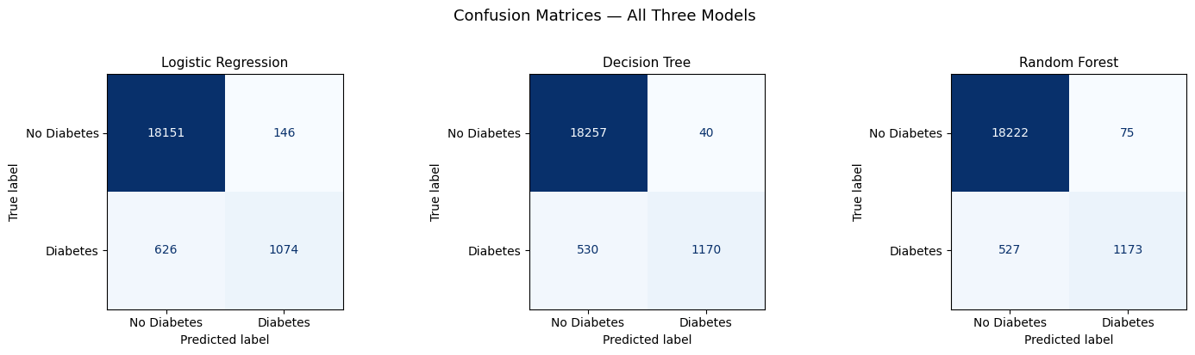

Figure 8: Confusion matrices
(Source: Self-created)
The patterns as seen in the performance metric scores are also confirmed and extended in the matrices. Logistic regression has the lowest accuracy, as the number of false negatives is the highest for this model. This is the most clinically impactful type of error in a diabetes screening situation because if a patient's diabetes is not caught it becomes a significant risk (Kangra and Singh, 2023). This case directly accounts for the comparatively low recall rate of 63.18 percent of logistic regression. The decision tree generates the lowest number of false positives of the three models, matching the highest precision score of 96.69 percent and implying it is the most conservative of the three models in terms of making positive diabetes predictions (Raza et al., 2024). With a False Negative of 43, the random forest has the lowest False Negatives score for the entire dataset, meaning it correctly identifies the highest number of real diabetic cases, with a 69.00 percent score. When viewed together, the confusion matrix analysis helps to further substantiate the findings in that no single model is the best at each error type, and that for actual deployment, the selection of the model to employ would be dependent on whether the reduction in false negative or false positive errors is of greater clinical importance.

4.4 Summary
The Python-based machine learning analysis results are shown in full in this chapter. The highest accuracy and precision were obtained from the decision tree while the highest recall was obtained from the Random Forest for the predictive performance. Therefore, logistic regression moderately achieved in terms of the accuracy outcome, while it exhibited the lowest performance in terms of recall and f1 score, suggesting that on average, the lowest number of diabetes diagnoses is made with the model. The gender third consensus value of 0.67 yielded a low gender difference across all three models and a near-perfect equalised odds difference of 0.0009 for gender in the random forest model. Imbalances between age groups were more apparent, with logistic regression reporting a significant equality of odds difference (0.2061) versus the averages of the tree-based models (around 0.027). From the model feature importance analysis, it was observed that the features with significant importance in the model are blood glucose level, blood gloves analysis and HbA1c level, and gender is one of the secondary features in making the model decisions. In combination, these findings suggest that the random forest model and decision tree model provide the best trade-off between model performance and demographic justice for the prediction of diabetes from the current data. These findings are discussed in the next chapter within the context of the previous studies and implications for usage of the machine learning models in healthcare settings are discussed.

Chapter 5: Analysis Of Results

5.1 Introduction
The chapter presents results of their detailed analysis of the machine learning pipeline implemented in python and their performance and comparison as introduced in Chapter 4. The data presented in the dataset from the Kaggle platform was named while data was anonymised, then after a cleanup process three supervised classification models were trained and tested: logistic regression, decision tree, and random forest. This chapter's primary aim is to investigate biases and fairness for the three systems, and in this regard focus on prediction differences among gender and age subgroups. Two key metrics were used to assess the fairness, namely the demographic parity difference and equalised odds difference, where assessments were carried out at the gender and age group level separately. The accuracy results are also analysed per group to get a better understanding not only of the performance of each model but also a feature importance analysis is conducted for the random forest model to put the fairness results into context. These analyses complement the overall performance data provided earlier to provide more insight into the effects of demographic characteristics on model behaviour. This chapter ends with a discussion of the limitations that were faced while conducting the research, and carefully outlines the boundaries for understanding these findings.

5.2 Findings

5.2.1 Fairness Evaluation Results
Overview of Fairness Metrics
The performance evaluation has been performed and the fairness analysis carried out with the Fairlearn library in Python. Two sensitivity measures on gender and age group were evaluated for every model. Demographic parity difference quantifies the difference between the average prediction rates for diabetes for the various groups, and a zero score means that the model predicts the incidence of diabetes at the same rate in each group (Feng et al., 2022). Equalised odds difference assesses the overall difference in true positive rate and false positive rate between subgroups, giving a more complete picture of the model's performance and whether it works equally well across subgroups when it comes to accurately identifying diabetic cases and avoiding false predictions of cases across the subunits. This second measure is especially pertinent in a healthcare setting because it measures the performance equality on both sides of the prediction spectrum, as opposed to just the ratio of positive predictions (Giovanola and Tiribelli, 2023). A value close to zero again signals fair model behavior, values further away from zero indicate that the outcomes of prediction do differ significantly between the groups of interest. The combination of these two measures gives a complementary and comprehensive basis for comparing fairness: the analysis can not only detect if fairness is an issue, but can determine which models and which sensitive attributes are most impacted by fair or unfairness.
Fairness Evaluation by Gender
The data on gender fairness are detailed below in a table and are represented in the gender fairness chart below.
Model | Demographic Parity Difference | equalised Odds Difference
Logistic Regression | 0.0194 | 0.0308
Decision Tree | 0.0158 | 0.0134
Random Forest | 0.0144 | 0.0009

Table 4: Fairness Evaluation by Gender Chart
(Source: Self-created)
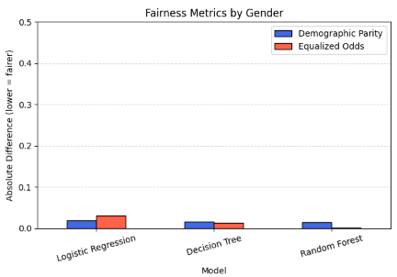

Figure 9: Gender fairness metrics bar chart
(Source: Self-created)
The findings clearly show that there is minimal gender bias in all three models. The differences in the demographic parity score for the difference between males and females range from 0.0144 for the random forest model to 0.0194 for logistic regression, all of which are close to zero showing that the rate the models predict diabetes is not significantly different between the two sexes (Matos et al., 2026). The same can be seen in the equalised odds differences where logistic regression returned with the highest value of 0.0308 and the random forest value was close to 0.0 of 0.0009. It is particularly noteworthy how well the random forest has performed with a difference of 0.0009 in the equalised odds measure, meaning there is almost no difference in true positive and true negative rate between the male and female patient groups. The results in this report indicate that, with this dataset, gender bias is not a significant issue in all three models.
Fairness Evaluation by Age Group
The age group fairness results differ significantly from the gender analysis and are the most significant finding of fairness in the study.
Model | Demographic Parity Difference | equalised Odds Difference
Logistic Regression | 0.1074 | 0.2061
Decision Tree | 0.0988 | 0.0265
Random Forest | 0.1024 | 0.0286

Table 5: Fairness Evaluation by Age Group
(Source: Self-created)
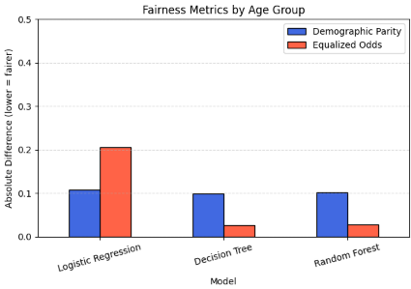

Figure 10: Age group fairness metrics bar chart
(Source: Self-created)
The demographic parity differences for age group is quite significant and is between 0.0988 and 0.1074 compared with gender which has a demographic parity difference of 0.1000 and 0.1009 respectively for decision tree and logistic regression. These values suggest that for younger patients, the three models make significant predictions of diabetes that differ from one another. This is not all unexpected because diabetes prevalence is higher among older patients and older patients are more likely to be predicted to have diabetes based on clinical indicators. But, the difference in the predictions among all the three models indicates the importance of taking account of the difference in prediction rates due to age in all practical deployment situations (Wang et al., 2024). The biggest difference in odds is in scores by age group. The logistic regression model can be seen to produce a large equalised odds difference of 0.2061, when compared to the decision tree (0.0265) and the random forest (0.0286). This value reflects that logistic regression has markedly different performance in correctly identifying diabetic patients, and avoiding false-positive results, in older vs younger age groups. In the practical sense, this model is much more inequitable between age groups than are the two tree-based models. The decision tree and random forest also have lower equalised odds difference values for age group, showing they predict with greater consistency within their respective younger and older age group classifications.

5.5.2 Per-Group Accuracy Results
Per-Group Accuracy by Gender
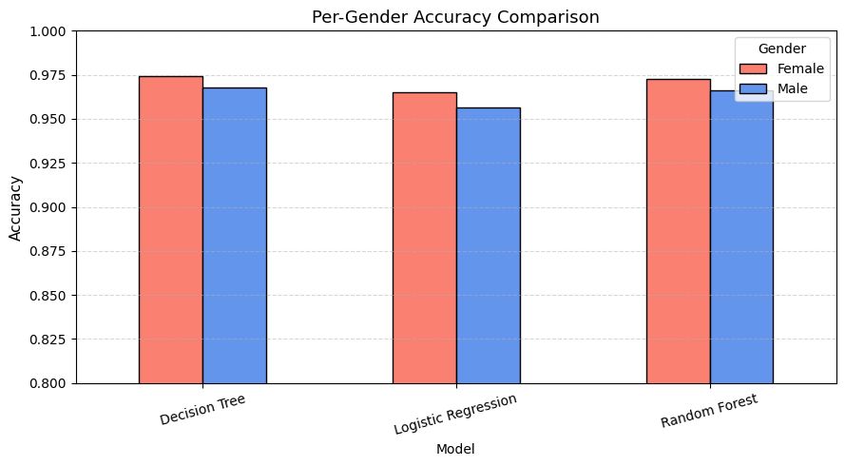

Figure 11: Per-gender accuracy
(Source: Self-created)
The per-group level of accuracy analysis for gender reveals a general similarity of accuracy in the three models between the male and female patient groups. Analysis of the differences between the various gender sub-groups within each model shows that these differences are small, corresponding with the low values of the gender fairness metrics listed in the above sections (Alipour and Alipour, 2025). The random forest and decision tree have very high rates of accuracy for each of the male and female groups, also the logistic regression has a slightly greater gender-related equalised odds difference, larger overall gap between the male and female groups. Overall, the accuracy results indicate that none of the three models causes an appreciable discrepancy in accuracy between genders.
Per-Group Accuracy by Age Group
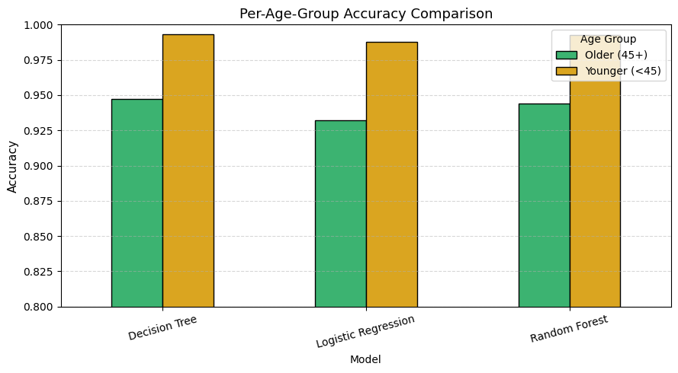

Figure 12: Per-age-group accuracy
(Source: Self-created)
The per group accuracy analysis by age group shows slightly more differences than do the per group accuracy analyses by gender. In all three models, the accuracy is better for the younger patient group than the older patient group. This is consistent with a pattern seen across all models which exhibit a greater clinical signal for diabetes in older patients. The difference in age groups is widest for logistic regression, as is the difference in EOD for this age group in comparison to the other models (Li et al., 2023). The gap between age groups of the decision tree is smaller in relation to its accuracy, further supporting the decision tree's fairness performance for this demographic attribute, as is the same for the random forest. These results indicate that the models provide overall good performance but the benefit in accuracy occurs almost exclusively amongst older patients and comparatively weaker for patient younger age across all three classifiers, suggesting that they are more likely to miss diabetes in younger patients.

5.5.3 Feature Importance Analysis
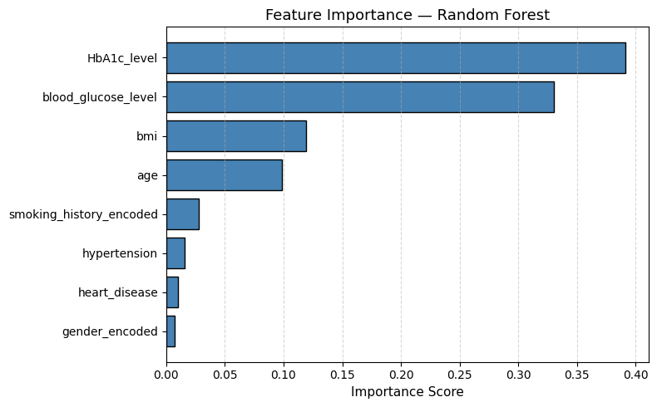

Figure 13: Feature importance bar chart
(Source: Self-created)
Random forest was applied in the feature importance analysis in order to detect which characteristics of the patients were the most important when predicting the diabetes outcome. This gives a clearly defined and clinically meaningful rank ordering of the influence of features. The HbA1c level was the most important predictive feature of the model, contributing a majority of the decision-making process, closely followed by blood glucose level as the second most influential feature (Chakradeo et al., 2025). Thus the two signatures of the model combine for the large percentage of the model's predictive power, consistent with the clinical knowledge that chronically elevated blood glucose and HbA1c are two key clinical biomarkers for the diagnosis of diabetes. The dominance of these two features show that the random forest model is predicted on bases that are not demographic or lifestyle variables. Both BMI and age had relatively small contributions of their own to the predictive influence, but were still shown as the third and fourth most important features, respectively. They have also appeared in the upper levels of the features' importance, which is reasonable at a clinical level, since obesity and increasing age are known risk factors in the development of type 2 diabetes. Smoking history, hypertension and heart disease became less important than previously when assessing the model's value in prediction, with gender being the least important binary numerical feature when considered across all eight input features. This feature importance ranking will help to understand the fairness results that have been reported in this chapter (Hamdan et al., 2025). The low gender fairness disparity for all three models should come as a direct result of the near-zero importance of gender as a predictive variable, since none of the algorithms are imposing a significant value on gender when making predictions. In contrast, the moderate importance of age could help account for the evidence of age-group fairness-gaps because age was a more substantive part of the outcomes of predictions and has more potential to produce differential performance between the younger and older patient groups.

5.3 Limitations
The research designs used in this study are successful in the sense that they result in good findings, however several limitations must be noted. The first obvious limitation is that it uses only one public dataset. In general, the Kaggle Diabetes Prediction Dataset contains a considerable number of records and a wide range of clinically relevant data, however, the relevant population details, specifically geographic location and demographic makeup are not fully described. This work should therefore be interpreted carefully and the patterns of bias and fairness detected in the population examined in this study may not be applicable to a different set of individuals in healthcare, who might have different demographic characteristics, access to healthcare and clinical practices. Another limitation is the relatively few algorithms that are used in machine learning. Other models, including random forest, neural network based architecture, logistic regression and decision tree, are commonly used and well understood models in classification research, and were also evaluated in this study; however, other frameworks like gradient boosting methods and support vector machines are not evaluated in this study and may have different performance or fairness characteristics (Farhad Dehghani et al., 2025). This comparison could be expanded to other algorithms and methodologies in future research to see if this degree of unfairness is found in more complicated modelling algorithms. Fairness assessment is also restricted to a fairly small scope. Based on the sensitive attribute of demographic data available in the data set, two sets of variables were added: gender and age. Other factors known to affect health outcomes or access such as ethnicity, socioeconomic status, geographic location and insurance status were not analyzed because they were not available in the data. For that reason, the findings on the bias observed towards the various demographic factors used in the conclusion of fairness in this study are only a partial picture of how the demographic factors used could be subject to bias in the diabetes prediction systems. Another factor to consider is interpretability, especially with the random forest model. Feature importance techniques help in understanding the variables that are most important when making the overall prediction, but cannot be used to infer why an individual prediction occurred as elegantly can a decision tree's rule based structure do. This decreased transparency can hinder the practical application of the random forest model in clinical settings where clinicians might need to explain the model's decision-making process to gain patient trust or to comply with regulatory requirements. In this study real world deployment issues were not covered. Enabling any of these models to be deployed in an operational healthcare system requires computational resources, integration requirements and continual monitoring, which are outside the scope of the present analysis, and only focused on offline performance assessment of a single train-test split and with a fixed dataset. This approach to modelling behaviour can change across different patient groups in the future, and may differ when applied to new patient cohorts different from the training cohort. Lastly, demographic parity difference and equalised odds difference are two of several possible fairness metrics described in the literature (Shome et al., 2024). However, when testing the fairness using different metrics, they might sometimes lead to different results as to which of the models is fairest, depending on which side of the fairness are emphasised. Results from this study should therefore be understood within the context of these two definitions, but not as an overall assessment of the models tested.

Chapter 6: Conclusion

6.1 Introduction
This chapter is the final one for the dissertation, during which the main conclusions from the research are summarized and the results from the work are discussed based on the research aim and research objectives set in Chapter 1. In this chapter results are summarised for each research objective, followed by practical guidelines to researchers and healthcare organisations, and a concluding reflection, placing the work of this dissertation in a larger context of responsible and equitable artificial intelligence in healthcare.

6.2 Linking with the Objectives

6.2.1 Objective One: To Compare the Bias in Diabetes Predictive Models
The first goal was to be achieved by comparing the bias of the three supervised learning models. So, this was done by applying the above two differences calculated via the Fairlearn library in Python, to compare between genders and age group attributes. All three models resulted in low gender bias scores. The demographic parity difference was close to negligent (between 0.0144 and 0.0194) for the random forest and logistic regression models, respectively, and equalised odds difference was close to negligent (between 0.0009 and 0.0308) for the random forest and logistic regression models, respectively, reflecting minimal gender-related bias (Pias et al., 2023). The trends were very different for the age group. Compared to age differences recorded for the decision tree of 0.0265 and the random forest of 0.0286, significantly larger values for all three models were obtained for the difference in odds of equalisation. The odds of equalisation differences were considerably larger for all three models which is 0.2061 for the logistic regression, 0.0265 for the decision tree, and 0.0286 for the random forest. This was indicative of the fact that the bias in each model was greater at older ages and logistic regression had the largest bias overall (Yang et al., 2025). This was confirmed by performing an importance analysis of features on the various features informative to the predictive model, where feature importance was found to be correlated with the level of significance for the various feature attributes, with gender being the least important compared with age, and patterns of differential bias were observed between the two features.

6.2.2 Objective Two: To Compare Fairness Between Supervised Algorithms of Learning
The second goal involved a direct comparison of fairness behaviour for the supervised learning algorithms in the same analytical condition, on the same data, same train-test split and same fairness measures to ensure a valid and controlled comparison. The results presented good and informative discrimination between this set of algorithms on both demographic features. The least fair behaviour was logistic regression, with the most extreme results in each fairness metric calculated in this study. The most notable result was its equalised odds difference which equals 0.2061, significantly larger than the decision tree (0.0265) and the random forest (0.0286). The difference in correctly predicting diabetic patients and correctly not predicting non-diabetic patients is also much larger across different younger and older patient groups for logistic regression than the two tree-formed models, implying an important and clinically relevant prediction disparity between these two patient groups (Al-Zanbouri et al., 2024). Gender obtained the highest equalised odds difference, at 0.0308, with the logistic regression model (0.0134 and 0.0009 for the other models) and this was again the least fair model for all sensitive attributes. Both the decision tree and random forest showed a significant improvement over logistic regression in terms of fairness across gender and age, with similar overall accuracy scores. The random forest model was most gender-fair with an equalised odds difference of almost 0.0009 and the decision tree had the most demographic-parity among all models for age at 0.0988. The two tree-based models both demonstrated that good predictive performance and low demographic biases can be achieved; this is not an either/or situation, but one where the appropriate algorithm can be chosen. This comparison makes the conclusion for fairness outcomes in healthcare prediction obvious and evidence-based, and importantly, links the choice of supervised learning algorithm to the outcome of fairness (Davoudi et al., 2024). That tree-based approaches yield far superior fairness results than logistic regression shows that algorithmic design can have as much of an impact as the makeup of the training data can have on the fairness with which a model treats different patient groups. Tree-based ensemble methods are the more responsible and appropriate method where demographic equity is a requirement for the application, be it healthcare based or otherwise, since they focus more on accuracy rather than predictive accuracy.

6.2.3 Objective Three: To Assess Fairness with the Help of Chosen Fairness Metrics
The third objective was to measure the prediction outcomes across selected demographics consistently with outcomes chosen using fairness measures.The third objective was to measure outcomes of the prediction over the selected demographic groups consistently with using selected fairness measures. The difference in prediction frequency of positive diagnosis among subgroups, namely the demographic parity difference, was used to assess the disparity in diabetes prediction by the model among subgroups with a smaller difference indicating that the model predicted similar frequency of positive diagnosis across the subgroups (Pagano et al., 2023). To consider one more point of view, the difference in equalised odds was assessed between groups, interconnecting both true positive and false positive rates. These two supplementary metrics allowed better measure fairness than the accuracy scores alone were able to (Dang et al., 2024). The overall accuracy rates have demonstrated good accuracy for all the models, ranging from 96 percent to 98 percent, but all three models have shown significant differences in accuracy, with a difference of 0.0265 for decision tree and 0.2061 for logistic regression in terms of sector-specific precautions to take against fairness evaluation challenges in healthcare, given the single use of common machine learning metrics. Results of the accuracy analysis also gave insight at the sub-group level: differences hidden from the overall accuracy figures were apparent when analysed at the sub-group level (Yang et al., 2024). The chosen fairness indicators proved effective to reveal demographic differences which had not been evident on aggregated data.

6.2.4 Objective Four: To Realise the Model Performance by Demographics
The fourth objective was to examine the models' ability to accurately predict score in each separate demographic group. Results for accuracy per group, gender-wise and age-wise, showed consistent gender accuracy with low gender fairness metric values reported earlier and indicated in the results, with age-wise accuracy also maintaining a similar level across all three models. There was a slight age group difference. This finding, which is anticipated with greater prevalence of diabetes and more clearly identifiable clinical signals in older patients, was comparable across the 3 models for each age group, with older patients being more accurate than younger. This difference was the largest for logistic regression, and it also had the highest age-related equalised odds difference (Chang et al., 2022). The highest overall accuracy of the decision tree was 97.15 percent, twice as high as 97th percentile accuracy, and the highest precision was 96.69 percent with the highest F1-score of 80.41 percent. The random forest achieved the highest recall of 69.00 percent, and an F1 score of 79.58 percent over the entire test set, whereas logistic regression had the lowest recall of merely 63.18 percent and the lowest F1 score of 73.56 percent over the entire test set. Taking the fairness results and the performance results into account the random forest is the most fair overall algorithm as it has a high recall and a low demographic bias score for both gender and age as well, and is the most appropriate algorithm from this study for a fair prediction of diabetes even across patient groups.

6.3 Recommendations
Healthcare should make using fairness evaluation an integral and non-negotiable part of the machine learning model devising process. As the present study shows, high global accuracy models can have meaningful (non-trivial) differences at the subgroup level. As in total accuracy, logistic regression recorded an equalised odds difference of 0.2061 (age group pinpointed by the system with 96.14 percent accuracy), but nonetheless it provides an example of why accuracy can be an inadequate measure for model selection in a clinical setting (Jung et al., 2023). For any model that will be used in a population health or clinical prediction context along with accuracy, precision, recall, and F1-score, demographic parity difference and equalised odds difference should be regularly computed and reported. Demographic equity is a concern in prediction tasks for health care applications and, therefore, a tree-based ensemble method should be preferred over logistic regression (Yang et al., 2023). The random forest, especially, is a good combination of high recall, competitive precision, and the lowest demographic bias on both gender and age attributes. Because of its near-perfect equalised odds difference (0.0009) for gender, and slightly low equalised odds difference (0.0286) for age group, it is the most appropriate model found in this study to be used clinically without bias. Future research ought to focus on other fairness-driven training methods, like reweighting training data, post-processing threshold adjustment, and adversarial debiasing, to see if the age differences found with all three models can be decreased without compromising accuracy (Smith et al., 2023). Finally, all demographic distributions of healthcare datasets to be used for predictive model training should be carefully analysed prior to model development, since the diabetes prevalence was found to be higher in older patients, which led to age-related fairness gaps in all three algorithms.

6.4 Conclusion
The study of this dissertation has shown that any assessment of machine learning model performance for healthcare predictions should go beyond the commonly used performance metrics to your thorough and systematic assessment of the model's demographic fairness. The study employed a systematic approach and consisted of 100,000 anonymised patient records, involving three different algorithms for supervised classification were applied in Python, giving a clear demonstration that the algorithms had a measurable impact on the predictive analytic results as well as the equity of patient subgroup outcomes. The interposed question is what is the relation between high accuracy and fair prediction. Overall, all three models scored above 96 percent accuracy, but significant fairness differences were found at various age levels for each of the models. Interestingly, logistic regression had an equalised odds difference (EOD) of 0.2061, associated with the age group dimension, this means that although it may have a high headline accuracy, it may be far less accurate at identifying diabetes in younger compared with older patients. There was minimal gender bias across the three models with the random forest model setting an almost perfect equalised odds difference of 0.0009 for gender. The findings in these two papers suggest that fairness is a not-so-simple feature of the model and requires a thorough multidimensional assessment based on different demographic features. The study results further revealed that the algorithm for supervised learning classification was a key factor in the fairness results, as the results of the tree-based classification algorithms significantly outperformed the logistic regression in terms of demographic equity, but also excelled in terms of recall. Overall, the random forest demonstrated the optimal predictive performance, demographic fairness and balance of these three results on all metrics analysed. As machine learning is increasingly included in healthcare decision making, equitable treatment for all patient groups is not only a technical requirement, but an ethical imperative. This work proposes a clear, easy to replicate and evidence based method for uncovering and mitigating algorithmic bias in prediction and diabetes, and is intended to inspire the creation of fairer and more responsible machine learning systems across the healthcare sector and beyond.

Reference List
Journals
Alipour, M. and Alipour, A., 2025. Algorithmic bias in AI-based diabetes care: systematic review of model performance, equity reporting, and physiological label bias. InfoScience Trends, 2(5), pp.33-46.
Bathla, G., Srinivasarao, B.N., Jaganathan, S.R., Bagadi, S., Bhanuse, V. and Sharma, V.K., 2026. Ethical AI Frameworks for Bias Detection and Fairness Optimization in Machine Learning Models. International Journal of Artificial Intelligence and Machine Learning, 6(2s), pp.742-753.
Bhimavarapu, U., 2025. Bias in AI-driven diabetes prediction models: Challenges, impacts, and mitigation strategies. In AI-Powered Systems for Healthcare Diagnostics and Treatment (pp. 195-214). IGI Global Scientific Publishing.
Chakradeo, K., Huynh, I., Balaganeshan, S.B., Dollerup, O.L., Gade-Jørgensen, H., Laupstad, S.K., Malham, M., Nguyen, T.L., Hulman, A. and Varga, T.V., 2025. Navigating fairness aspects of clinical prediction models. BMC medicine, 23(1), p.567.
Chang, V., Ganatra, M.A., Hall, K., Golightly, L. and Xu, Q.A., 2022. An assessment of machine learning models and algorithms for early prediction and diagnosis of diabetes using health indicators. Healthcare Analytics, 2, p.100118.
Dang, V.N., Cascarano, A., Mulder, R.H., Cecil, C., Zuluaga, M.A., Hernández-González, J. and Lekadir, K., 2024. Fairness and bias correction in machine learning for depression prediction across four study populations. Scientific Reports, 14(1), p.7848.
Davoudi, A., Chae, S., Evans, L., Sridharan, S., Song, J., Bowles, K.H., McDonald, M.V. and Topaz, M., 2024. Fairness gaps in machine learning models for hospitalization and emergency department visit risk prediction in home healthcare patients with heart failure. International Journal of Medical Informatics, 191, p.105534.
Dehghani, F., Paiva, P., Malik, N., Lin, J., Bayat, S. and Bento, M., 2025. Accuracy-fairness trade-off in ML for healthcare: A quantitative evaluation of bias mitigation strategies. Information and Software Technology, p.107896.
Dunkelau, J. and Duong, M.K., 2022. Towards equalised odds as fairness metric in academic performance prediction. arXiv preprint arXiv:2209.14670.
Dutta, A., Hasan, M.K., Ahmad, M., Awal, M.A., Islam, M.A., Masud, M. and Meshref, H., 2022. Early prediction of diabetes using an ensemble of machine learning models. International Journal of Environmental Research and Public Health, 19(19), p.12378.
Fahmy, A.M., 2025. Exploring the role of AI in predicting chronic disease progression: diabetes and cardiovascular diseases. Methodology, 2(3).
Febrian, M.E., Ferdinan, F.X., Sendani, G.P., Suryanigrum, K.M. and Yunanda, R., 2023. Diabetes prediction using supervised machine learning. Procedia Computer Science, 216, pp.21-30.
Feng, Q., Du, M., Zou, N. and Hu, X., 2022. Fair machine learning in healthcare: A review. arXiv preprint arXiv:2206.14397.
Giovanola, B. and Tiribelli, S., 2023. Beyond bias and discrimination: redefining the AI ethics principle of fairness in healthcare machine-learning algorithms. AI & society, 38(2), pp.549-563.
Hamdan, M.D.H.M., Ab Jabal, M.F., Rahman, S.A. and Kapi, A.Y., 2025. Fairness And Bias Mitigation in AI Models for Diabetes Diagnosis: A Comparative Evaluation of Algorithmic Approaches. Journal of Telecommunication, Electronic and Computer Engineering (JTEC), 17(3), pp.27-34.
Huang, J., Galal, G., Etemadi, M. and Vaidyanathan, M., 2022. Evaluation and mitigation of racial bias in clinical machine learning models: scoping review. JMIR medical informatics, 10(5), p.e36388.
Jung, J., Lee, H., Jung, H. and Kim, H., 2023. Essential properties and explanation effectiveness of explainable artificial intelligence in healthcare: A systematic review. Heliyon, 9(5).
Kangra, K. and Singh, J., 2023. Comparative analysis of predictive machine learning algorithms for diabetes mellitus. Bulletin of Electrical Engineering and Informatics, 12(3), pp.1728-1737.
Lee, J.T., Hsu, S.H., Li, V.C.S., Anindya, K., Chen, M.H., Wang, C., Shen, T.K.B., Liu, V.T.N., Chen, H.H. and Atun, R., 2025. Machine Learning Fairness in Predicting Underweight, Overweight and Adiposity Across Socioeconomic and Caste Group in India: Evidence from the Longitudinal Ageing Study in India. medRxiv, pp.2025-07.
Liu, Z., Li, Y., Chen, N., Wang, Q., Hooi, B. and He, B., 2025. A survey of imbalanced learning on graphs: Problems, techniques, and future directions. IEEE Transactions on Knowledge and Data Engineering.
Luz, A. and Oloyede, J., 2025. Impact of Dataset Imbalance on Machine Learning Models for Diabetes Mellitus Prediction.
Matos, J., Van Calster, B., Celi, L.A., Dhiman, P., Gichoya, J.W., Riley, R.D., Russell, C., Khalid, S. and Collins, G.S., 2026. Critical appraisal of fairness metrics for artificial intelligence-based clinical prediction models: a scoping review. The Lancet Digital Health.
Naderalvojoud, B., Curtin, C., Asch, S.M., Humphreys, K. and Hernandez-Boussard, T., 2025. Evaluating the impact of data biases on algorithmic fairness and clinical utility of machine learning models for prolonged opioid use prediction. JAMIA open, 8(5), p.ooaf115.
Obi, J.C., 2023. A comparative study of several classification metrics and their performances on data. World Journal of Advanced Engineering Technology and Sciences, 8(1), pp.308-314.
Olisah, C.C., Smith, L. and Smith, M., 2022. Diabetes mellitus prediction and diagnosis from a data preprocessing and machine learning perspective. Computer Methods and Programs in Biomedicine, 220, p.106773.
Otu, R.O., Asamoah, A.N. and Otu, E.K., 2026. Equitable AI for Early Detection: A Fairness-Aware Machine Learning Model for Pediatric Type 2 Diabetes Risk Prediction in Underserved US Populations Using Multi-cycle NHANES Data.
Owusu-Adjei, M., Ben Hayfron-Acquah, J., Frimpong, T. and Abdul-Salaam, G., 2023. Imbalanced class distribution and performance evaluation metrics: A systematic review of prediction accuracy for determining model performance in healthcare systems. PLOS Digital Health, 2(11), p.e0000290.
Ozdemir, O. and Fatunmbi, T.O., 2024. Explainable AI (XAI) in healthcare: bridging the gap between accuracy and interpretability. Journal of Science, Technology and Engineering Research, 2(1), pp.32-44.
Pedersen, S.M., Damslund, N., Kjær, T. and Olsen, K.R., 2025. Optimising test intervals for individuals with type 2 diabetes: A machine learning approach. Plos one, 20(2), p.e0317722.
Pias, T.S., Su, Y., Tang, X., Wang, H. and Yao, D., 2023. Undersampling for fairness: achieving more equitable predictions in diabetes and prediabetes. medRxiv, 2023(2023.05. 02).
Ratti, E., Morrison, M. and Jakab, I., 2025. Ethical and social considerations of applying artificial intelligence in healthcare—a two-pronged scoping review. BMC Medical Ethics, 26(1), p.68.
Raza, S., Shaban-Nejad, A., Dolatabadi, E. and Mamiya, H., 2024. Exploring bias and prediction metrics to characterise the fairness of machine learning for equity-centered public health decision-making: A narrative review. IEEE Access, 12, pp.180815-180829.
Rountree, L., Lin, Y.T., Liu, C., Salvatore, M., Admon, A., Nallamothu, B., Singh, K., Basu, A., Bu, F. and Mukherjee, B., 2025. Reporting of fairness metrics in clinical risk prediction models used for precision health: scoping review. Online Journal of Public Health Informatics, 17(1), p.e66598.
Sathyanarayanan, S. and Tantri, B.R., 2024. Confusion matrix-based performance evaluation metrics. African Journal of Biomedical Research, 27(4S), pp.4023-4031.
Shaham, S., Hajisafi, A., Quan, M.K., Nguyen, D.C., Krishnamachari, B., Peris, C., Ghinita, G., Shahabi, C. and Pathirana, P.N., 2025. Privacy and fairness in machine learning: A survey. IEEE Transactions on Artificial Intelligence, 6(7), pp.1706-1726.
Shin, J., Kim, J., Lee, C., Yoon, J.Y., Kim, S., Song, S. and Kim, H.S., 2022. Development of various diabetes prediction models using machine learning techniques. Diabetes & Metabolism Journal, 46(4), pp.650-657.
Smith, B., Khojandi, A. and Vasudevan, R., 2023. Bias in reinforcement learning: a review in healthcare applications. ACM Computing Surveys, 56(2), pp.1-17.
Tan, K.R., Seng, J.J.B., Kwan, Y.H., Chen, Y.J., Zainudin, S.B., Loh, D.H.F., Liu, N. and Low, L.L., 2023. Evaluation of machine learning methods developed for prediction of diabetes complications: a systematic review. Journal of Diabetes Science and Technology, 17(2), pp.474-489.
Uddin, S., Liang, H. and Guo, H., 2026. Gender-based data bias and model fairness evaluation in benchmarked open-access disease prediction datasets. Computers in Biology and Medicine, 203, p.111503.
Wang, Y., Wang, L., Zhou, Z., Laurentiev, J., Lakin, J.R., Zhou, L. and Hong, P., 2024. Assessing fairness in machine learning models: A study of racial bias using matched counterparts in mortality prediction for patients with chronic diseases. Journal of biomedical informatics, 156, p.104677.
Wang, Z., Yin, Z., Liu, Z., Yap, R.H., Zhang, X., Hu, S. and Zhang, W., 2025, September. Redefining fairness: A multi-dimensional perspective and integrated evaluation framework. In Joint European Conference on Machine Learning and Knowledge Discovery in Databases (pp. 336-353). Cham: Springer Nature Switzerland.
Yang, J., Soltan, A.A., Eyre, D.W. and Clifton, D.A., 2023. Algorithmic fairness and bias mitigation for clinical machine learning with deep reinforcement learning. Nature Machine Intelligence, 5(8), pp.884-894.
Yang, Y., Liao, C.Y., Keyvanshokooh, E., Shao, H., Weber, M.B., Pasquel, F.J. and Garcia, G.G.P., 2025. A responsible framework for assessing, selecting, and explaining machine learning models in cardiovascular disease outcomes among people with type 2 diabetes: Methodology and validation study. JMIR Medical Informatics, 13, p.e66200.
Zhou, Q., 2024. Optimisation strategies for ensuring fairness in machine learning: With and without demographics. arXiv preprint arXiv:2411.09056.
El-Sofany, H., El-Seoud, S.A., Karam, O.H., Abd El-Latif, Y.M. and Taj-Eddin, I.A., 2024. A proposed technique using machine learning for the prediction of diabetes disease through a mobile app. International Journal of Intelligent Systems, 2024(1), p.6688934.
Yaseliani, M., Noor-E-Alam, M. and Hasan, M.M., 2024. Mitigating sociodemographic bias in opioid use disorder prediction: Fairness-aware machine learning framework. Jmir ai, 3(1), p.e55820.
Chu, C.H., Donato-Woodger, S., Khan, S.S., Nyrup, R., Leslie, K., Lyn, A., Shi, T., Bianchi, A., Rahimi, S.A. and Grenier, A., 2023. Age-related bias and artificial intelligence: a scoping review. Humanities and Social Sciences Communications, 10(1), p.510.
Tan, W., Wei, Q., Xing, Z., Fu, H., Kong, H., Lu, Y., Yan, B. and Zhao, C., 2024. Fairer AI in ophthalmology via implicit fairness learning for mitigating sexism and ageism. Nature communications, 15(1), p.4750.
Chen, R.J., Wang, J.J., Williamson, D.F., Chen, T.Y., Lipkova, J., Lu, M.Y., Sahai, S. and Mahmood, F., 2023. Algorithmic fairness in artificial intelligence for medicine and healthcare. Nature biomedical engineering, 7(6), pp.719-742.
Li, F., Wu, P., Ong, H.H., Peterson, J.F., Wei, W.Q. and Zhao, J., 2023. Evaluating and mitigating bias in machine learning models for cardiovascular disease prediction. Journal of biomedical informatics, 138, p.104294.
Yuan, C., Linn, K.A. and Hubbard, R.A., 2023. Algorithmic fairness of machine learning models for Alzheimer disease progression. JAMA Network Open, 6(11), p.e2342203.
Wang, R., Chaudhari, P. and Davatzikos, C., 2023. Bias in machine learning models can be significantly mitigated by careful training: Evidence from neuroimaging studies. Proceedings of the National Academy of Sciences, 120(6), p.e2211613120.
Siddique, S., Haque, M.A., George, R., Gupta, K.D., Gupta, D. and Faruk, M.J.H., 2024. Survey on machine learning biases and mitigation techniques. Digital, 4(1), pp.1-68.
Pagano, T.P., Loureiro, R.B., Lisboa, F.V., Cruz, G.O., Peixoto, R.M., Guimarães, G.A.D.S., Oliveira, E.L., Winkler, I. and Nascimento, E.G.S., 2023. Context-based patterns in machine learning bias and fairness metrics: A sensitive attributes-based approach. Big data and cognitive computing, 7(1), p.27.
Ali, H., Niazi, I.K., White, D., Akhter, M.N. and Madanian, S., 2024. Comparison of machine learning models for predicting interstitial glucose using smart watch and food log. Electronics, 13(16), p.3192.
Yang, J., Clifton, L., Dung, N.T., Phong, N.T., Yen, L.M., Thy, D.B.X., Soltan, A.A., Thwaites, L. and Clifton, D.A., 2024. Mitigating machine learning bias between high income and low–middle income countries for enhanced model fairness and generalizability. Scientific Reports, 14(1), p.13318.
Phillips, K., Brown, K., Talbert, S. and Talbert, D., 2023, May. Group bias and the complexity/accuracy tradeoff in machine learning-based trauma triage models. In The International FLAIRS Conference Proceedings (Vol. 36).
Raza, S., 2023, June. Connecting fairness in machine learning with public health equity. In 2023 IEEE 11th International Conference on Healthcare Informatics (ICHI) (pp. 704-708). IEEE.
Shome, A., Cruz, L. and Van Deursen, A., 2024, April. Data Vs. model machine learning fairness testing: An empirical study. In Proceedings of the 5th IEEE/ACM International Workshop on Deep Learning for Testing and Testing for Deep Learning (pp. 1-8).
Al-Zanbouri, Z., Sharma, G. and Raza, S., 2024, June. Equity in healthcare: analyzing disparities in machine learning predictions of diabetic patient readmissions. In 2024 IEEE 12th International Conference on Healthcare Informatics (ICHI) (pp. 660-669). IEEE.
Hu, J., Zeng, H. and Tian, Z., 2025, September. Applications and effect evaluation of generative adversarial networks in semi-supervised learning. In 2025 IEEE 8th International Conference on Information Systems and Computer Aided Education (ICISCAE) (pp. 863-867). IEEE.

Appendices

Appendix 1: Software source code

