Create Database in phpMyAdmin
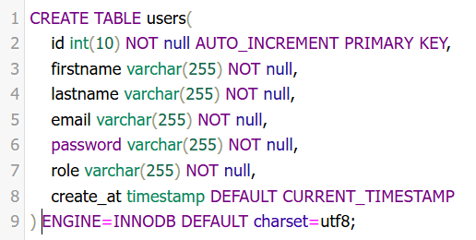

Pdo connect db => PHP MySQL Connect to database
