1. Write a query to insert a new employee into the Employees table with values (1,'John', 'HR', 50000).

Ans:

create database sqlpraticequestion;

use sqlpraticequestion;

create table employees(slno int , Name varchar(20),Designation varchar(10),salary int);

insert into employees values(1,'john','HR',50000);

1. Write a query to insert multiple rows into a table in a single query.

Ans:

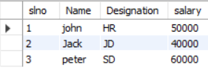 insert into employees values(2,'Jack','JD',40000),(3,'peter','SD',60000);

1. Write an INSERT query where only some columns are provided (not all).

Ans:

insert into employees(slno,Name,Designation,Salary) values(4,'Manick',null,40000),(3,'SM','SD',null);

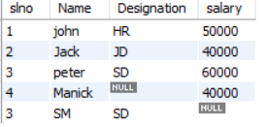

1. Write a query to update the salary of an employee with ID = 101 to 60000.

Ans:

update employees modify set salary = 60000 where employeeid = 101;

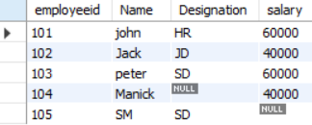

1. Update the department of all employees from 'Sales' to 'Marketing'.

Ans:

update employees modify set Department = 'Marketing' where Department = 'sales';

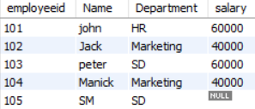

1. Increase salary by 10% for all employees in the 'IT' department.

Ans:

update employees modify set salary = salary * 1.10 where Department = 'IT';

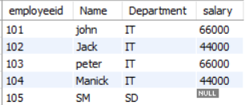

1. Write a query to update multiple columns in a table using a single statement.

Ans:

update employees modify set salary = salary * 0.9,Department = 'SD' where Department = 'IT';

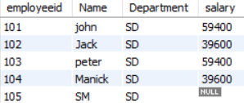

1. Write a query to delete a record from the Employees table where ID = 5.

Ans:

delete from employees where employeeid = 105;

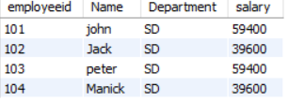

1. Delete all employees whose department is 'HR'.

Ans:

delete from employees where Department = 'HR';

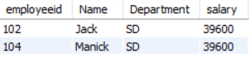

1. Delete all records from a table but keep the structure.

Ans:

Truncate table employees;



1. Write a delete query using a subquery to delete specific rows.

Ans:

DELETE FROM employees WHERE salary IN (SELECT salary FROM employees WHERE employeeid = 1);

1. Write a query to create a table called Students with columns: ID, Name, Age, and Email.

Ans:

create table Students(Id int,Name varchar(30),Age tinyint,Email varchar(30));

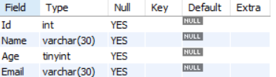

1. Create a table Orders with a foreign key referencing the Customers table.

Ans:

create table Customer(Id int primary key, Name varchar(30), Product varchar(30),Amount int);

create table orders(ProductId int, Product_Name varchar(30) , CustomerId int,foreign key (customerID)

references Customer(Id));

Customer:

Order:

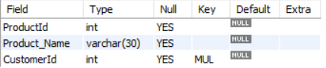

1. Write a query to create a table with a unique constraint on the email column.

Ans:

create table Customer(Id int Primary key, Name varchar(30) Unique, Product varchar(30),Amount int);

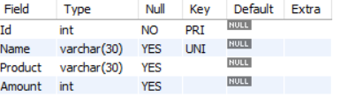

1. Create a table and set the default value of the status column to 'Active'.

Ans:

create table Activity(id int, name varchar(30), status varchar(20) default 'Active');



1. Create a table with a primary key on multiple columns.

Ans:

create table Customer(Id int NOt Null, Name varchar(30),Email varchar(30) Not null ,Product

varchar(30),Amount int,primary key(Id,email));

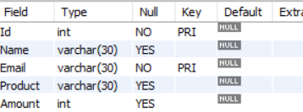

1. Write a query to drop a table named TempData.

Ans:

Drop table TempData;

1. Drop only the primary key constraint from a table.

Ans:

alter table Customer drop primary key;

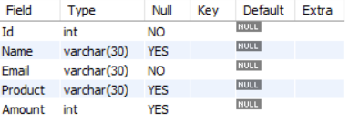

1. Write a query to drop a column from an existing table.

Ans:

alter table Customer drop column Email;

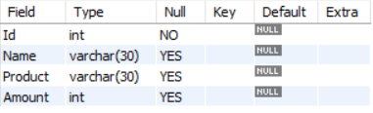

1. Drop all indexes on a given table.

Ans:

drop index slno on Customer;

1. Write a query to add a new column DOB of type DATE to the Employees table.

Ans:

alter table employees add column DOB date;

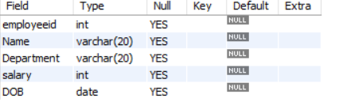

1. Modify the data type of the column Salary from INT to FLOAT.

Ans:

alter table employees modify salary float;

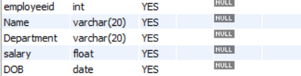

1. Rename a column in a table from fullname to name.

Ans:

alter table employees rename column name to FullName;

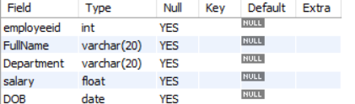

1. Rename the table Customers to Clients.

Ans:

alter table Customer rename to Clients;

1. Add a NOT NULL constraint to the email column in the Users table.

Ans:

alter table Clients modify column Email varchar(30) Not null;

1. Truncate a table and insert one row back using INSERT.

Ans:

Truncate table Clients;

Insert into Clients Values(1,’ms’,’Pen’,10,’manicks@gmail.com’);

1. Truncate multiple tables in one transaction (if supported);

Ans:

NO Truncating the Multiple table is not possible in Mysql(it is possible in Postgre Sql);