1. Retrieve all columns from the product table.

Ans:

select * from Products;

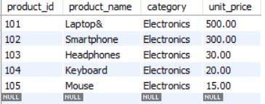

1. Retrieve the product_name and unit_price from the Products table.

Ans:

Select product_name,unit_price from Products;

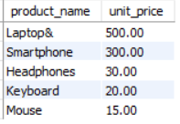

1. Filter the Products table to show only products in the &#39;Electronics&#39; category.

Ans:

select * from Products where category = 'Electronics';

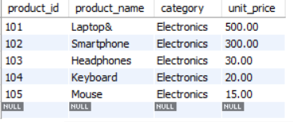

1. Retrieve the product_id and product_name from the Products table for products with a unit_price greater than $100.

Ans:

select product_id,product_name from products where unit_price > 100;

1. Calculate the average unit_price of products in the Products table

Ans:

select round(sum(unit_price)/count(product_id),2) as Average_unit_price from products;



1. Retrieve product_name and unit_price from the Products table with the Highest Unit Price

Ans:

select product_name,unit_price from products order by unit_price desc Limit 1;



1. Retrieve the product_name and unit_price from the Products table, ordering the results by unit_price in descending order.

Ans:

select product_name,unit_price from products order by unit_price desc;

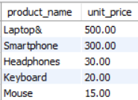

1. Retrieve the product_name and unit_price from the Products table, filtering the unit_price to show only values between $20 and $600.

Ans:

select product_name, unit_price from products where unit_price between 20 and 600;

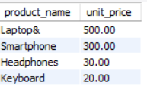

1. Retrieve the product_name and category from the Products table, ordering the results by category in ascending order.

Ans:

select product_name,category from products order by category;

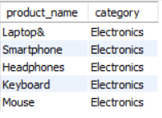

1. Retrieve all columns from the Sales table.

Ans:

select * from sales;

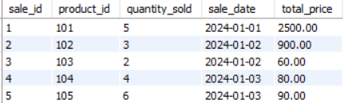

1. Retrieve the sale_id and sale_date from the Sales table.

Ans:

select sale_id, sale_date from sales;

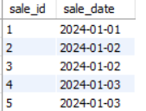

1. Filter the Sales table to show only sales with a total_price greater than $100.

Ans:

select * from sales where total_price >100;

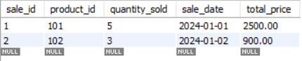

1. Retrieve the sale_id and total_price from the Sales table for sales made on January 3, 2024.

Ans:

select sale_id,total_price from sales where sale_date = '2024-01-03';

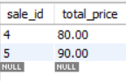

1. Calculate the total revenue generated from all sales in the Sales table.

Ans:

select sum(total_price) as Total_revenue from sales;

1. Calculate the total quantity_sold from the Sales table.

Ans:

select sum(quantity_sold) as Total_quantity from sales;

1. Retrieve the sale_id, product_id, and total_price from the Sales table for sales with a quantity_sold greater than 4.

Ans:

select sale_id,product_id,total_price from sales where quantity_sold > 4;

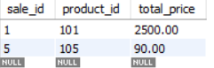

1. Calculate the average total_price of sales in the Sales table.

Ans:

select round(sum(total_price)/count(total_price),2) as Average_sales_price from sales;

