1. Display students with marks between 70 and 90.

Ans:

select * from student where marks between 70 and 90;

1. List students aged between 20 and 22.

Ans:

select * from student where age between 20 and 22;

1. Find students whose name starts with 'P'.

Ans:

select Student_id ,name from student where name like 'P%';



1. Find students whose city contains 'ai'.

Ans:

select * from student where city like '%ai%';

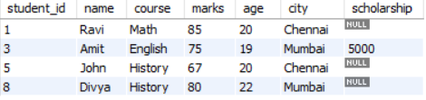

1. Find names where the second character is 'r'.

Ans:

select name from student where name like '_r%'

1. Show top 3 students with highest marks.

Ans:

select * from student order by marks desc limit 3;

1. Show students who have a scholarship.

Ans:

select *from student where scholarship is not null;

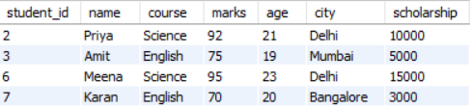

1. Show students only if there is at least one student from 'Delhi'

Ans:

select * from student where (select count(city) from student where city = 'Delhi') >=1 And city = 'Delhi';

1. Show students with marks greater than ANY student in the 'History' course.

Ans:

select * from student where marks > (select min(marks) from student where course = 'History');

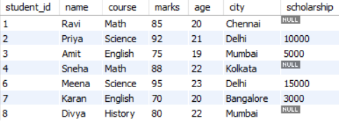

1. Show students with marks greater than ALL students in the 'English' course.

Ans:

select * from student where marks > all (select marks from student where course = 'English');

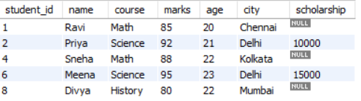

1. Show students in 'Math' course AND age > 21.

Ans:

select * from student where course = 'Math' and age>21;



1. Show students in 'Science' OR 'English' course.

Ans:

select * from student where course = 'Science'or course = 'English';

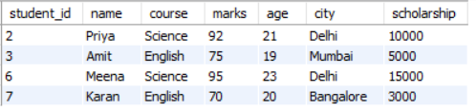

1. Show students NOT from 'Mumbai'.

Ans:

select * from student where not city = 'Mumbai';

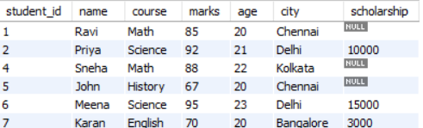

1. Show students who don’t have a scholarship.

Ans:

select * from student where scholarship is null;

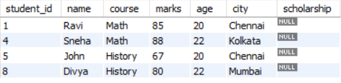

1. Replace NULL scholarship with 0 using IFNULL.

Ans:

select student_id,name,course,marks,age,city,ifnull(scholarship,0) from student;

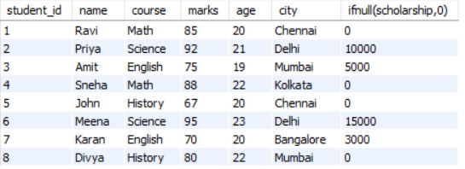

1. Replace NULL scholarship with 0 using COALESCE

Ans:

select student_id,name,course,marks,age,city,coalesce(scholarship,0) from student;

