1. Find employees who are in the ‘IT’ department.

Ans:

select e.*,d.dept_name from employees e Inner join department d on e.dept_id = d.dept_id where d.dept_name = 'IT';

1. List departments with no employees.

Ans:

select d.dept_id,d.dept_name from employees e right join department d on e.dept_id = d.dept_id where e.emp_id is null;

1. Show each employee’s name along with every department they could potentially work in.

Ans:

select e.name , d.dept_name from employees e cross join department d;

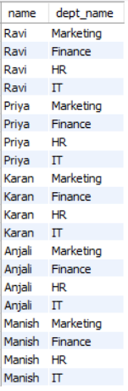

1. Get all employees and all departments (even if no match).

Ans:

select e.name ,d.dept_name from employees e left join department d on e.dept_id = d.dept_id union

select e.name,d.dept_name from employees e right join department d on e.dept_id = d.dept_id;

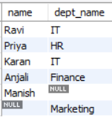

1. Find employees who do not belong to any department.

Ans:

select e.emp_id,e.name from employees e left join department d on e.dept_id = d.dept_id where e.dept_id is null;

