**CROP DISEASE DETECTION**

**Introduction:**

**Aim:** Crop disease prediction using AI and Raspberry pi

**Objective**: The objective of this project is to design a device to give accurate early stage prediction about disease occurring in plant and suggest solutions for curing the disease. The project is done using AI preprocessing modules, a raspberry pi and a web cam. This project is using a public dataset of 54,305 images of diseased and healthy plant leaves. The main objective is that the trained model achieves an accuracy of 99% on a held-out test set.

Crop Disease Prediction is an application of Machine learning, where it predicts the disease of the Crop and suggests the best medicine to cure the disease. Crop diseases are a major threat to food security, but their rapid identification remains difficult in many parts of the world due to the lack of the necessary infrastructure. Plant diseases are one of major reasons behind the production and economic losses in agriculture.

The combination of Deep learning and recent advances in computer vision has paved the way for Crop disease diagnosis.

Neural networks provide a mapping between an input such as an image of a diseased plant to an output such as a crop disease pair.

To develop such a precise image classifier aimed at diagnosis of diseases of plant, we need a large, processed and verified dataset containing various diseased and healthy plant images.

**DESIGN PROCESS:**

**Requirements:**

* **Raspberry pi 4 model B**

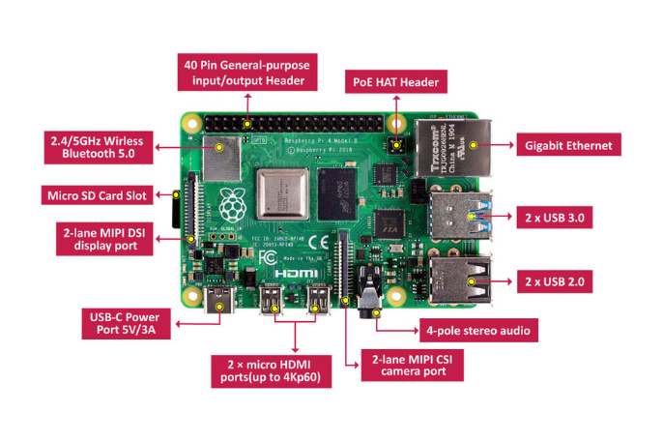

Fig-1

* **Micro SD card** (size of minimum 8GB)
* **Webcam** (Image Quality of 1.2 Mega pixel):- To take the real time leaf image as an input.
* **Python programming language**
* **In-built preprocessing modules**(i.e Keras and Tensorflow modules):- To train the model and predict the disease of the plant
* **Plant leaves dataset**(Both healthy and diseased leaves):- This dataset is used in preprocessing tensorflow model.

**Block Diagram:**

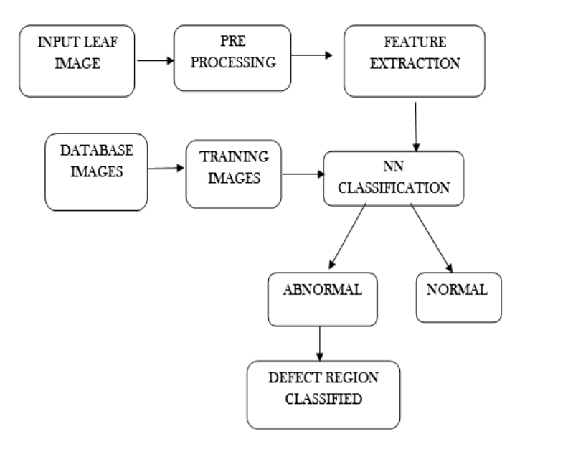

Fig-2

**Execution Process:**

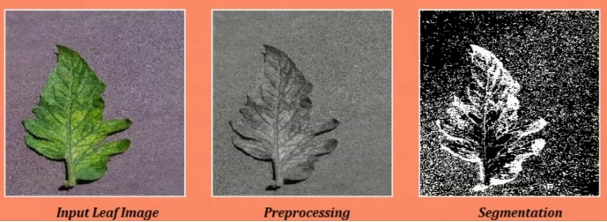

Fig-3

**PROGRAM:**

**Import the modules and Dataset:**

import numpy as np

import pandas as pd

import matplotlib.pyplot as plt

import os

import keras

from keras.preprocessing.image import ImageDataGenerator, img_to_array, load_img

from keras.applications.vgg19 import VGG19,preprocess_input, decode_predictions

train_datagen = ImageDataGenerator(zoom_range= 0.5, shear_range= 0.3, rescale= 1/255, horizontal_flip= True, preprocessing_function= preprocess_input)

val_datagen=ImageDataGenerator(preprocessing_function=preprocess_input)

train= train_datagen.flow_from_directory(directory= "cropdataset/crop disease wise", target_size= (256,256), batch_size=32)

val= val_datagen.flow_from_directory(directory= "cropdataset/crop disease wise", target_size= (256,256), batch_size=32)

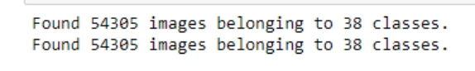

**Train the Model:**

from keras.layers import Dense,Flatten

from keras.models import Model

from keras.applications.vgg19 import VGG19

import keras

base_model= VGG19(input_shape=(256,256,3), include_top= False)

for layer in base_model.layers:

layer.trainable= False

x= Flatten()(base_model.output)

x=Dense(units= 38, activation='softmax')(x)

model= Model(base_model.input,x)

model.compile(optimizer='adam',loss=keras.losses.categorical_crossentropy, metrics=['accuracy'])

from keras.callbacks import ModelCheckpoint, EarlyStopping

es=EarlyStopping(monitor= 'val_accuracy',min_delta=0.01, patience=3, verbose=1)

mc= ModelCheckpoint(filepath="new_best_model50.h5",monitor= 'val_accuracy',min_delta=0.01, patience=3, verbose=1, save_best_only= True)

cb=[es,mc]

his= model.fit_generator(train, steps_per_epoch=16, epochs=50, verbose=1, callbacks= cb,validation_data= val, validation_steps=16)

**Now load the Tensorflow model and predict the results:**

from keras.models import load_model

model= load_model("best_model50.h5")

def prediction(path):

img=load_img(path, target_size=(256,256))

i=img_to_array(img)

im=preprocess_input(i)

img= np.expand_dims(im, axis=0)

pred= np.argmax(model.predict(img))

if(pred==7):

print("This is Corn gray leaf spot disease. A one-year rotation away from corn, followed by tillage is recommended to prevent disease development in the subsequent corn crop. In no-till or reduced-till fields with a history of gray leaf spot, a two-year rotation out of corn may be needed to reduce the amount of disease in the following corn crop.")

elif(pred==8):

print("This is Corn common rust disease. To reduce the incidence of corn rust, plant only corn that has resistance to the fungus. Resistance is either in the form of race-specific resistance or partial rust resistance. In either case, no sweet corn is completely resistant. If the corn begins to show symptoms of infection, immediately spray with a fungicide. The fungicide is most effective when startedat the first sign of infection.")

elif(pred==11):

print("This is Grape Black rot disease. Sanitation is extremely important. Destroy mummies, remove diseased tendrils from the wires, and select fruiting canes without lesions. It is very important not to leave mummies attached to the vine.Plant grapes in sunny open areas that allow good air movement. If your vines are planted under trees in the shade where they do not get all day sunlight, black rot will be much more difficult to control. Shaded areas keep the leaves and fruits from drying and provide excellent conditions for black rot infection and disease development.")

elif(pred==15):

print("This is Orange cirtus greening disease. One of the most effective ways to prevent the disease is to avoid moving plants and plant materials from areas under regulatory quarantine or where the insect or disease is present.To avoid or minimize the impact of the disease, use an integrated approach: use only certified-clean plantstock; monitor plants regularly to detect and control any population of Asian citrus psyllid; if you suspect HLB, send a sample of the foliage to the appropriate diagnostic laboratory; and remove and destroy trees that are confirmed infected with HLB.")

elif(pred==16):

print("This is Peach Bacterial spot disease. This disease is difficult to control, and chemical sprays are not practical for the home gardener. Varieties are available that are moderately resistant but not immune. These varieties are ‘Ambergem’, ‘Belle of Georgia’, ‘Cardinal’, ‘Cherryred’, ‘Dixired’, ‘Candor,’ ‘Challenger’, ‘Carolina Gold’, ‘Norman,’ ‘Loring,’ ‘Bisco’, ‘Southhaven’, and ‘Red Haven’ in a yellow peach, and ‘Southern Pearl’, ‘White County’, and ‘White River’ in a white peach. Bacterial spot is usually more severe on poorly nourished trees or where nematodes are a problem, so proper cultural care is important.")

elif(pred==28):

print("This is Tomato Bacterial spot disease. The most effective management strategy is the use of pathogen-free certified seeds and disease-free transplants to prevent the introduction of the pathogen into greenhouses and field production areas. Eliminate solanaceous weeds in and around tomato production areas. Keep cull piles away from field operations. Do not spray, tie, harvest, or handle wet plants as that can spread the disease.")

elif(pred==32):

print("This is Tomato septoria leaf spot disease. Remove diseased leaves. Improve air circulation around the plants. Mulch around the base of the plants.Do not use overhead watering. Control weeds.Use crop rotation. Apply chlorothalonil, maneb, macozeb, or a copper-based fungicide, such as Bordeaux mixture, copper hydroxide, copper sulfate, or copper oxychloride sulfate.")

elif(pred==20):

print("This is Potato Early Blight disease. Treatment of early blight includes prevention by planting potato varieties that are resistant to the disease; late maturing are more resistant than early maturing varieties. Avoid overhead irrigation and allow for sufficient aeration between plants to allow the foliage to dry as quickly as possible.")

**Now give the path of the test image:**

path="test.JPG"

prediction(path)

#this will return the result

**RESULTS:**

Using the Raspberry pi and Pi cam take the image of the real life leaf and attach the path of the image to the prediction function.

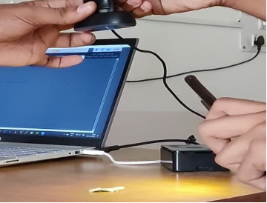

Fig-4

path="tomato_leafmold.JPG"

prediction(path)

**Then the output will be displayed as:**

This is Tomato septoria leaf spot disease. Remove diseased leaves. Improve air circulation around the plants. Mulch around the base of the plants. Do not use overhead watering. Control weeds.Use crop rotation. Apply chlorothalonil, maneb, macozeb, or a copper-based fungicide, such as Bordeaux mixture, copper hydroxide, copper sulfate, or copper oxychloriesulfate.

**CONCLUSION:**

We designed a device that gave accurate early stage predictions about the disease occurred in plant and suggested solutions for curing the disease of the crop. The project is done using AI preprocessing modules, a raspberry pi and a web cam.

This project proposes a CNN model for Crop disease prediction by processing the leaf images of diseased crops. Building such a neural network with high efficiency is a difficult task. But using this project atleast some of the major issues in agriculture will decrease and crop yield increases.

**FUTURE SCOPE:**

This Project can be made in the form of an app or website in future. So, crop disease prediction can be done with the help of a mobile phone and this app can be accessible by anyone having a mobile.