LOGSENSE
Plain-English Question Answering over HDFS Failure Logs
Big Data Course Project: Final Report
CSE412 Big Data & Large-Scale Computing
Applied Project, Track D (Kafka → Spark Streaming → Hive/HDFS)
Submitted by
Name | Roll Number
[Your name] | [Roll number]
Project repository: [add link]
October 2026
ABSTRACT
When something breaks in a large system, the people fixing it ask two kinds of questions. Some are about numbers: how many blocks failed in the last hour, or when was the worst spike? Others are about meaning: what does this error message mean, and how do we fix it? SQL is good at the first kind but cannot understand text, and semantic search is the other way round. In our project, LogSense, we built a pipeline and an assistant that answers both kinds from one question box. Real HDFS logs from the Loghub HDFS_v1 dataset (396,692 lines, 20,434 blocks, 614 of them labelled anomalous) are replayed into an Apache Kafka topic. A Spark Structured Streaming job reads the topic, groups the lines into 10-minute windows of the original 2008 log time, joins every block with its anomaly label and writes the counts as Parquet files, which Hive exposes as external tables. Separately, 240 public outage post-mortems and 7 HDFS runbooks we wrote are embedded with sentence-transformers and stored in Qdrant. An LLM on Groq reads each question and calls query_hive (one SELECT statement, checked by a safety guard), search_docs, or both, and a Streamlit page shows the answer together with the SQL or documents it used. The job produced 231 windows, and the worst one was 10 Nov 2008, 10:30 to 10:40, with 103 anomalous blocks. The main limitations are that everything runs on one laptop and the dataset has no ERROR lines, so failures are measured through the block labels.
1. Introduction
HDFS stores files as blocks spread over many machines, and the NameNode and every DataNode write log lines about what happens to each block. When a block goes wrong, the evidence is scattered across thousands of lines. An engineer on call usually needs two things: the numbers (how many, when, which component) and an explanation (what does this message mean, and what did other teams do when it happened to them).
These two needs call for different tools. Counting needs exact data and SQL. Explaining needs text that is matched by meaning, because the person asking rarely uses the same words as the document that answers them. Our project, LogSense, tries to answer one question: what is going wrong in the cluster, and what should be done about it? Number questions go to SQL over Hive, meaning questions go to a vector search, and an LLM agent decides which one each question needs:
number: "How many anomalous blocks in the last hour?" -> query_hive
meaning: "What does 'Could not read from stream' mean?" -> search_docs
both: "When was the worst spike, and why?" -> both
The agent never answers from memory. Every number it gives comes from a Hive query and every explanation comes from a stored document, and the interface shows which ones were used. The course requires that Kafka, Spark Structured Streaming and Hive are all actually used. Everything runs in Docker on a Windows laptop under WSL2 with 11 GB of RAM given to Linux, so we kept memory use low at every step.
2. Literature Survey
The HDFS logs used in this project were first collected by Xu et al. (2009) from a Hadoop cluster of more than 200 nodes. They labelled each block as normal or anomalous and showed that grouping log lines by an identifier such as the block ID exposes problems that single lines hide. He et al. (2016) later compared classical anomaly detection methods on the same data, and Du et al. (2017) used an LSTM model (DeepLog) on it. Zhu et al. (2023) collected these and many other system logs into Loghub, which is where we downloaded the dataset. Following Xu et al., we count anomalous blocks per window and not individual lines.
For stream processing, Kreps et al. (2011) designed Kafka as a distributed, replayable log, which lets a consumer stop and continue from a saved offset. Armbrust et al. (2018) introduced Spark Structured Streaming, which treats a stream as a table that keeps growing and supports event-time windows and watermarks. Thusoo et al. (2009) built Hive to give SQL access to data stored as files, which is exactly what our external tables depend on.
For semantic search, Reimers and Gurevych (2019) showed with Sentence-BERT that sentences with similar meaning end up close together as vectors, so cosine similarity can be used to compare meaning. Wang et al. (2020) distilled such models into small MiniLM networks that run on a CPU, and we use all-MiniLM-L6-v2 from this family. Malkov and Yashunin (2018) describe HNSW, the nearest-neighbour index used inside vector databases such as Qdrant.
Finally, Lewis et al. (2020) proposed retrieval-augmented generation (RAG), where a language model answers from retrieved documents instead of its own memory. Yao et al. (2023, ReAct) and Schick et al. (2023, Toolformer) showed that language models can decide when to call an external tool and use what it returns. Text-to-SQL work such as the Spider benchmark (Yu et al., 2018) shows that models can write SQL from a description of the schema. Our agent combines these ideas: one model chooses between a SQL tool and a retrieval tool, and a rule-based guard limits what its SQL is allowed to do.
3. Tools and Technologies
Table 1. Technologies used (versions from docker-compose.yml and requirements.txt)
Tool / technology | Version | Role in project
Python | 3.12 | Replay script, indexing, agent, web app
Apache Kafka (official apache/kafka, KRaft, no ZooKeeper); confluent-kafka | 3.9.1; client 2.6.1 | Streaming ingestion, topic hdfs-logs
Apache Spark, PySpark (official apache/spark, local mode); spark-sql-kafka-0-10_2.12 | 3.5.6 | Structured Streaming job
Apache Hive (official apache/hive, HiveServer2, embedded Derby metastore); PyHive | 4.0.1; PyHive 0.7.0 | SQL layer (external tables)
Qdrant; qdrant-client | 1.13.6; client 1.13.3 | Vector store for documents
sentence-transformers (all-MiniLM-L6-v2), PyTorch (CPU) | 3.3.1; torch 2.5.1 | Local text embeddings (384 dimensions)
Groq API (openai/gpt-oss-120b); groq SDK | SDK 1.7.0 | LLM for tool choice, SQL and answers
Streamlit, pandas, python-dotenv | 1.41.1, -, 1.2.4 | Web interface, .env config
Docker Desktop, Docker Compose; WSL2 Ubuntu 24.04 | - | Runs the 4-container stack

4. System Architecture
Figure 1 shows the architecture as implemented. There are two separate paths that only meet at the agent. The left path is the required streaming pipeline (Kafka, Spark Structured Streaming, Hive). The right path loads the documents into Qdrant once, ahead of time. Spark and Hive never talk to each other directly: Spark writes Parquet files into ./warehouse, both containers mount this folder at /data/warehouse, and the Hive tables point their LOCATION at it.
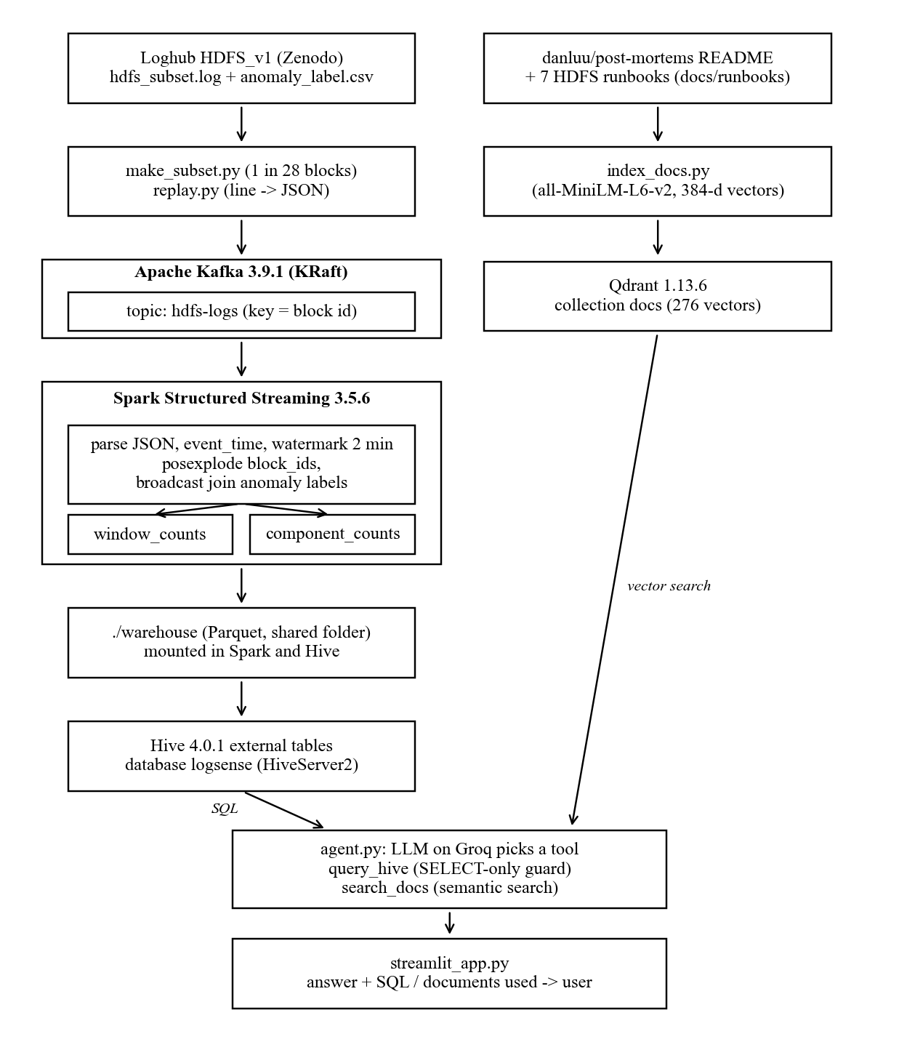
Figure 1. Overall architecture of the LogSense system
5. Project Workflow and Data Flow
Stage 1: Containers. docker compose up -d starts Kafka, Spark, Hive and Qdrant, each with a health check and a memory limit (1 GB, 2 GB, 1.5 GB and 512 MB). The Spark container stays idle and jobs are started inside it with spark-submit.
Stage 2: Getting the data and replaying it into Kafka. The full HDFS_v1 log from Zenodo has about 11 million lines (1.5 GB), which is too much for the laptop. make_subset.py keeps every line of about 1 in 28 blocks, chosen with crc32(block_id) % 28 == 0 so the subset is the same on every run. Keeping whole blocks means the per-block labels are still correct. This gives 396,692 lines, 20,434 blocks and 614 anomalous blocks. replay.py splits each line with a regular expression and sends it to the topic hdfs-logs as JSON, keyed by the first block ID:
{"ts": "2008-11-09 20:35:32", "pid": 147, "level": "INFO",
"component": "dfs.DataNode$DataXceiver", "content": "Receiving block ...",
"block_ids": ["blk_8026466674001363449"]}
The original 2008 timestamps are kept. The --rate option (default 5,000 messages per second) only controls how fast messages are sent. check_topic.sh reads the topic back, and it showed all 396,692 messages.
Stage 3: Spark reads Kafka. stream_counts.py reads the topic from the earliest offset, at most 50,000 messages per micro-batch, parses the JSON with from_json and turns ts into an event_time column with a 2-minute watermark. With --sink console it prints the window counts on screen.
Stage 4: Counts written to Hive. With --sink files the same job writes two Parquet tables, window_counts and component_counts, in append mode. Each has its own checkpoint, so running the job again only processes new messages. create_tables.sql creates matching external tables in the logsense database.
Stage 5: Documents in Qdrant. index_docs.py splits the danluu/post-mortems README into 240 outage stories (from six sections such as Config Errors and Hardware/Power Failures) and the 7 runbooks into 36 sections, one per heading. Each "title + text" is embedded and stored in the Qdrant collection docs with its source, title, category and URL. No raw log lines go into Qdrant.
Stage 6: The agent. agent.py sends the question, a system prompt that describes both tables, and two tool definitions to the LLM on Groq. The model answers with a tool call, the program runs the tool and sends back the result, and this repeats until the model writes the final answer (at most 6 tool calls per question).
Stage 7: Web interface. streamlit_app.py has three tabs. Ask talks to the agent and has a "How I got this" panel that lists every SQL query with its rows, or every document with its score. SQL runs a guarded query directly, and Search docs runs a semantic search directly.
6. Analytical Methodology
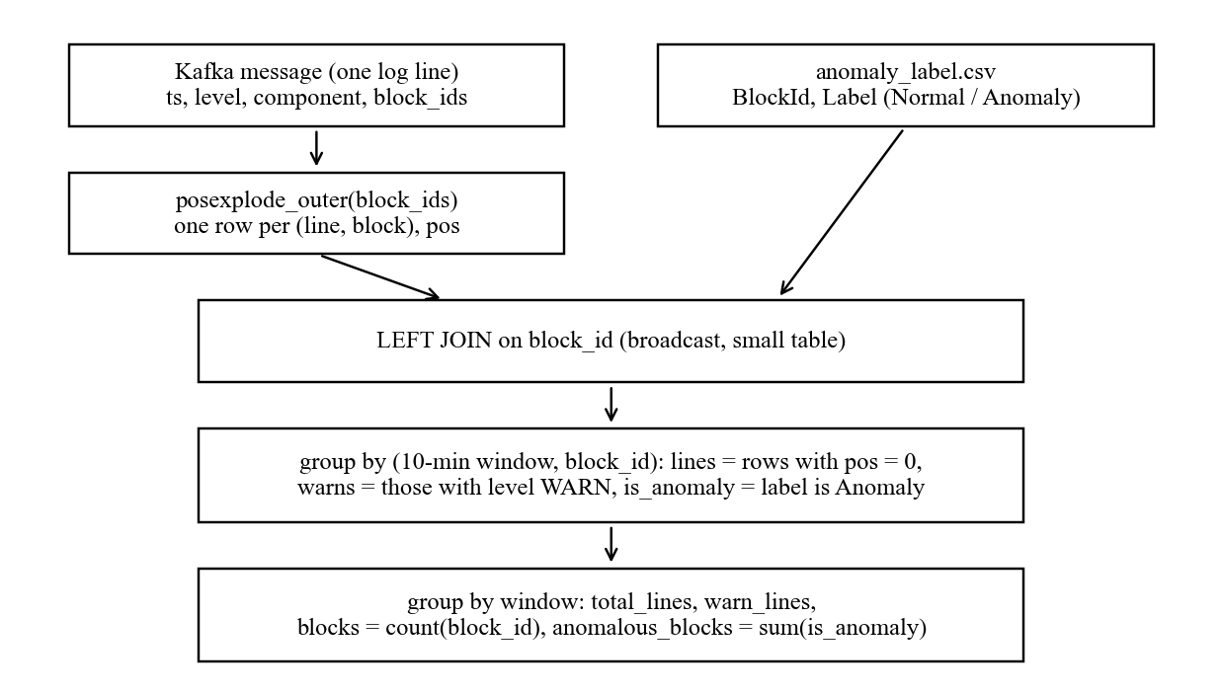
Figure 2. Counting workflow inside window_counts() in stream_counts.py
6.1 Event-time windows. Each line goes into a 10-minute tumbling window based on its own 2008 timestamp and not on the time it reached Kafka, so 10:34:12 belongs to the 10:30 to 10:40 window. The 2-minute watermark tells Spark when a window is complete, and in append mode each window is written exactly once.
6.2 Counting anomalous blocks. The labels in anomaly_label.csv are given per block, not per line, and the dataset has only INFO and WARN lines. So we measure failures as anomalous blocks. One line can mention more than one block, so the job uses posexplode_outer to make one row per (line, block) and joins the small label table with a broadcast join. It then groups twice (Figure 2): first by window and block, then by window. Grouping twice gives an exact count of distinct blocks:
lines(w, b) = number of rows for block b in window w with pos = 0
anomalous_blocks(w) = number of blocks b active in w with label(b) = 'Anomaly'
Using pos = 0 makes sure a line with two blocks is still counted once in total_lines. A block can be active in several windows, so adding anomalous_blocks across many windows counts "anomalous block-windows" and not unique blocks. The agent's prompt tells it to say this when it reports such a sum.
6.3 Component counts. A second, simpler query counts lines per window, component and level, for questions such as "which component logged the most warnings?". Table 2 shows the two Hive tables.
Table 2. Hive external tables written by the Spark job
Table | Columns (one row per ...)
window_counts | window_start, window_end, total_lines, warn_lines, blocks, anomalous_blocks (one row per 10-minute window)
component_counts | window_start, window_end, component, level, lines (one row per window, component and level)

6.4 Embeddings and similarity. Each document is embedded as "title. text" with all-MiniLM-L6-v2 into a vector of 384 numbers, normalised to length 1. A question is embedded the same way and Qdrant returns the closest documents by cosine similarity. The runbooks are split at their headings because the model only reads about 256 word pieces, so short sections match better than whole files. A source filter lets the agent search only runbooks or only post-mortems.
6.5 Tool routing. The system prompt gives the LLM the schema of both tables, the time range of the data (2008-11-09 20:30 to 2008-11-11 11:00) and simple rules: use query_hive for numbers, search_docs for meaning, and both when a question needs it. "Now" means the end of the data, so "the last hour" becomes:
WHERE window_start >=
(SELECT MAX(window_end) - INTERVAL '1' HOUR FROM window_counts)
The temperature is 0. If a tool fails (bad SQL, a service is down), the error is sent back to the model as text so it can fix the query and try again.
6.6 SQL safety guard. Since the LLM writes the SQL, check_select_only() runs before anything reaches Hive. It first removes comments and string literals, then refuses the query unless it is a single statement starting with SELECT or WITH, contains none of 35 blocked keywords (INSERT, DROP, CREATE, SET, LOAD, TRANSFORM and others, matched as whole words so functions like date_add still work), has no backtick-quoted names, and reads only from window_counts, component_counts or its own WITH names. Results are limited to 200 rows. The counting and the guard are entirely rule-based; no model is trained in this project.
7. Results
Kafka received all 396,692 messages. The Spark job wrote 231 complete windows from 20:30 on 9 Nov to 11:00 on 11 Nov 2008, holding 388,742 lines (375,988 INFO and 12,754 WARN). The other 7,950 lines are in the last window, which stays open in append mode because no later message arrives to move the watermark past it. Table 3 shows the result of the following query in Hive:
SELECT window_start, total_lines, warn_lines, blocks, anomalous_blocks
FROM logsense.window_counts ORDER BY anomalous_blocks DESC LIMIT 5
Table 3. Top five windows by anomalous blocks
Window start (2008) | Total lines | WARN lines | Active blocks | Anomalous blocks
10 Nov 10:30 | 22,923 | 44 | 3,752 | 103
10 Nov 10:40 | 3,066 | 10 | 489 | 72
11 Nov 09:00 | 6,091 | 48 | 1,480 | 66
11 Nov 08:50 | 6,309 | 0 | 1,434 | 66
11 Nov 07:50 | 9,656 | 19 | 1,397 | 52

Figure 3 shows all 231 windows. Most windows have fewer than 10 anomalous blocks, and the failures come in short bursts. The largest is on the morning of 10 Nov, and there are smaller groups of spikes on the evening of 10 Nov and the morning of 11 Nov.
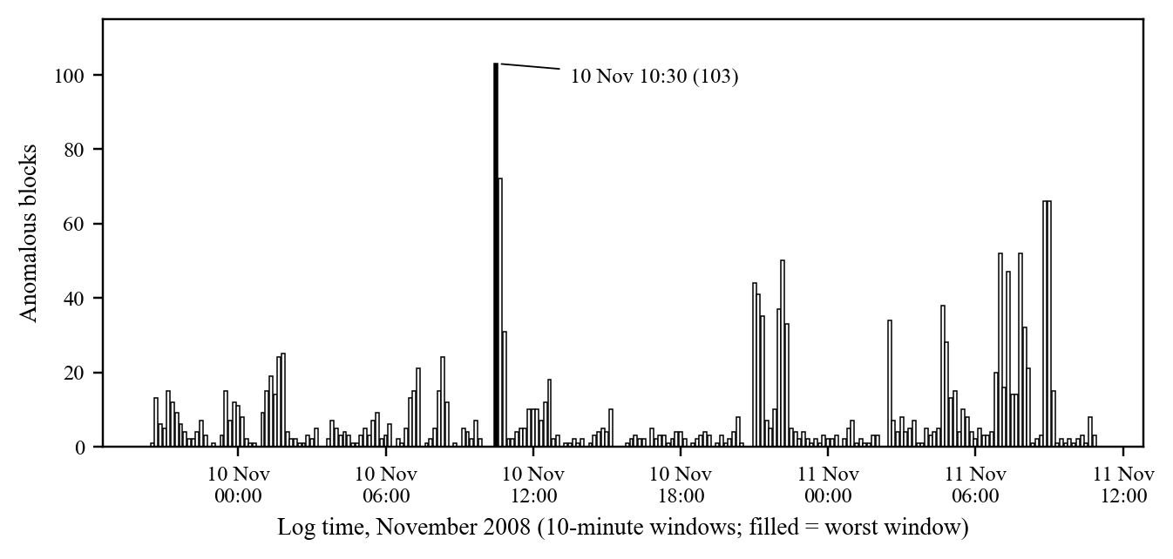
Figure 3. Anomalous blocks per 10-minute window of log time (from logsense.window_counts)
The component_counts table shows where the warnings come from: dfs.DataNode$DataXceiver wrote 12,504 of the 12,754 WARN lines (98%), followed by dfs.FSDataset with 216.
Agent routing. Table 4 lists the questions used in our demo, the tool the agent chose and the answer it gave. Each time, the "How I got this" panel showed the SQL or documents behind the answer.
Table 4. Demo questions and the tools the agent chose
Question | Tool(s) chosen | Answer
Which 10-minute window had the most anomalous blocks? | query_hive | 10 Nov 2008, 10:30 to 10:40, 103 anomalous blocks
Which component logged the most warnings? | query_hive (component_counts) | dfs.DataNode$DataXceiver, about 12,500 WARN lines
How many anomalous blocks were there in the last hour? | query_hive | Counted over the last hour of log time, not today
What does 'Could not read from stream' mean and how do I fix it? | search_docs (runbooks) | A broken write pipeline, with the runbook's checks and fix
Show me outages at other companies caused by a power failure. | search_docs (post-mortems) | Post-mortems such as Salesforce and Cloudflare
When was the worst spike, and what usually causes that? | query_hive, then search_docs | 10 Nov 10:30, plus likely causes from the runbooks

Semantic search. Qdrant holds 276 vectors (240 post-mortems and 36 runbook sections). Searching "a bad config change took everything down" returns config-related outages at large companies even though the words do not match exactly. When we added a new runbook to docs/runbooks and ran index_docs.py again, the agent used it for the very next question.
Safety. The SQL guard passed all 17 test cases: 6 queries that must run and 11 that must be refused. The refused ones include two statements in one query, DROP, INSERT OVERWRITE DIRECTORY, TRANSFORM ... USING a shell command, a DELETE hidden behind a comment and a table outside the allowed list. Running DROP TABLE window_counts in the SQL tab returns "Refused by the safety check".
8. Limitations
- Single machine. Spark runs in local mode, the Kafka topic has one partition and a local folder is used instead of HDFS, so the project shows the design, not how it scales.
- Subset of the data. Only about 1 in 28 blocks is kept (396,692 of about 11 million lines) to fit in 11 GB of RAM.
- No ERROR lines. Failures are measured with the researchers' per-block labels, which a live system would not have.
- Last window stays open. In append mode the final window (7,950 lines) is only written when later data arrives.
- Sums across windows. A block can appear in several windows, so long-period sums count block-windows, not unique blocks.
- Rule-based SQL guard. It blocks every case we tested, but it uses patterns and not a full SQL parser.
- External LLM. The Ask tab depends on the Groq API being reachable and the model following the prompt. The SQL and Search tabs work without it.
9. Conclusion
LogSense answers plain-English questions about system failures by sending each question to the right tool. Kafka carries the HDFS log stream, Spark Structured Streaming turns it into 10-minute counts of lines, warnings and anomalous blocks, and Hive makes those counts available through SQL. Qdrant and a local embedding model answer meaning questions from post-mortems and runbooks. An LLM agent picks between them and shows the SQL or documents behind every answer. On 396,692 real log lines the job produced 231 windows and found the worst burst at 10:30 on 10 Nov 2008 (103 anomalous blocks), the agent sent number, meaning and mixed questions to the right tools, and the guard refused every unsafe query in our tests. The next steps are running on the full 11 million lines across several nodes, replacing the guard's patterns with a proper SQL parser, and raising an alert when a window's anomalous blocks pass a threshold.
10. References
[1] J. Zhu, S. He, P. He, J. Liu, M. R. Lyu, "Loghub: A Large Collection of System Log Datasets for AI-driven Log Analytics," ISSRE 2023. https://github.com/logpai/loghub, dataset at https://zenodo.org/records/8196385
[2] W. Xu, L. Huang, A. Fox, D. Patterson, M. I. Jordan, "Detecting Large-Scale System Problems by Mining Console Logs," SOSP 2009.
[3] S. He, J. Zhu, P. He, M. R. Lyu, "Experience Report: System Log Analysis for Anomaly Detection," ISSRE 2016.
[4] M. Du, F. Li, G. Zheng, V. Srikumar, "DeepLog: Anomaly Detection and Diagnosis from System Logs through Deep Learning," ACM CCS 2017.
[5] J. Kreps, N. Narkhede, J. Rao, "Kafka: a Distributed Messaging System for Log Processing," NetDB 2011.
[6] M. Armbrust et al., "Structured Streaming: A Declarative API for Real-Time Applications in Apache Spark," SIGMOD 2018.
[7] A. Thusoo et al., "Hive: A Warehousing Solution over a Map-Reduce Framework," VLDB 2009.
[8] N. Reimers, I. Gurevych, "Sentence-BERT: Sentence Embeddings using Siamese BERT-Networks," EMNLP 2019.
[9] W. Wang et al., "MiniLM: Deep Self-Attention Distillation for Task-Agnostic Compression of Pre-Trained Transformers," NeurIPS 2020.
[10] Y. A. Malkov, D. A. Yashunin, "Efficient and Robust Approximate Nearest Neighbor Search Using Hierarchical Navigable Small World Graphs," IEEE TPAMI 2018.
[11] P. Lewis et al., "Retrieval-Augmented Generation for Knowledge-Intensive NLP Tasks," NeurIPS 2020.
[12] S. Yao et al., "ReAct: Synergizing Reasoning and Acting in Language Models," ICLR 2023.
[13] T. Schick et al., "Toolformer: Language Models Can Teach Themselves to Use Tools," NeurIPS 2023.
[14] T. Yu et al., "Spider: A Large-Scale Human-Labeled Dataset for Complex and Cross-Domain Semantic Parsing and Text-to-SQL Task," EMNLP 2018.
[15] D. Luu, danluu/post-mortems, a collection of public post-mortems. https://github.com/danluu/post-mortems
[16] Apache Software Foundation, Apache Kafka. https://kafka.apache.org/
[17] Apache Software Foundation, Apache Spark 3.5.6 Structured Streaming Programming Guide. https://spark.apache.org/docs/3.5.6/structured-streaming-programming-guide.html
[18] Apache Software Foundation, Apache Hive. https://hive.apache.org/
[19] Qdrant vector database. https://qdrant.tech/
[20] sentence-transformers. https://www.sbert.net/
[21] Groq API documentation. https://console.groq.com/docs
[22] Streamlit. https://streamlit.io/
[23] CSE412 Big Data & Large-Scale Computing, Applied Project Guidelines (course document).

