National Institute of Technology, Warangal



NexusNotes

Code Club

Ramasani Adi Pranav 24CSB0A57
Syed Mohammad Sami 24CSB0A77
Janapala Harshavardhan Reddy 24CSB0A28

Department of Computer Science and Engineering

Table of Contents
Table of Contents 1
Abstract 1
1 Introduction 1
1.1 Purpose 1
1.2 Scope 1
1.3 Definitions, Acronyms and Abbreviations 1
1.4 Overview 1
1.5 Process Model 1
2 Problem Statement and Root Cause Analysis 1
2.1 Problem Statement 1
2.2 Fishbone (Ishikawa) Diagram 1
3 Software Requirements Specification 1
3.1 Overall Description 1
3.1.1 Product Perspective 1
3.1.2 Product Functions 1
3.1.3 User Classes and Characteristics 1
3.1.4 General Constraints 1
3.1.5 Assumptions and Dependencies 1
3.2 External Interface Requirements 1
3.2.1 User Interfaces 1
3.2.2 Hardware Interfaces 1
3.2.3 Software Interfaces 1
3.2.4 Communications Interfaces 1
3.3 System Features 1
3.3.1 Upload Academic Resource (UC-01) 1
3.3.2 Search and Download Resource (UC-02) 1
3.3.3 View Tech-Trend Feed (UC-03) 1
3.3.4 Rate and Review Resource (UC-04) 1
3.3.5 User Management (UC-05) 1
3.3.6 Content Moderation (UC-06) 1
3.4 Non-Functional Requirements 1
3.4.1 Performance Requirements 1
3.4.2 Security and Privacy Constraints 1
3.4.3 Software Quality Attributes 1
4 Use Case Document 1
4.1 Use Case Summary 1
4.2 Use Case Diagram 1
4.3 Detailed Use Cases 1
5 Project Management 1
5.1 Cost Estimation – Use Case Points (UCP) 1
5.1.1 Use Case Inventory 1
5.1.2 UCP Calculation Details 1
5.1.3 UCP Document Pages 1
5.2 Risk Table 1
5.3 Project Timeline (Gantt Chart) 1
6 Design Engineering 1
6.1 Software Architecture 1
6.1.1 Client Tier 1
6.1.2 Application Tier (API Gateway) 1
6.1.3 Data Tier 1
6.2 UML Diagrams 1
6.2.1 Sequence Diagram – Upload Academic Resource (UC-01) 1
6.2.2 Collaboration Diagram – Search and Download Resource (UC-02) 1
6.2.3 Activity Diagram – Content Moderation (UC-06) 1
6.2.4 Logical View: Class Diagram 1
6.2.5 Logical View: Statechart Diagram 1
6.2.6 Component View: Component Diagram 1
6.2.7 Deployment View: Deployment Diagram 1
7 Call Graph and Coupling Analysis 1
7.1 Source Code Structure 1
7.2 Call Graph Diagrams 1
7.2.1 Student Module Call Graph 1
7.2.2 Admin Module Call Graph 1
7.3 Module Structure Diagram 1
7.4 Coupling and Cohesion Analysis 1
7.4.1 System Coupling Diagram 1
7.4.2 Cohesion 1
7.4.3 Coupling 1
8 Vision and Product Overview 1
8.1 Business Opportunity 1
8.2 Stakeholder Summary 1
8.3 Alternatives and Competition 1
8.4 Product Capabilities Summary 1
8.5 Feature Priority 1
9 References 1

Abstract
NexusNotes is a web-based centralized academic resource management platform designed to address the persistent challenge of fragmented study materials faced by students in higher educational institutions. Academic resources are currently scattered across messaging applications, personal cloud drives, institutional portals, and informal note-sharing channels, creating significant inefficiencies in accessing reliable and up-to-date study material.
The platform provides dedicated, subject-wise digital repositories housing lecture notes, critical question banks, capstone project archives, and real-time emerging technology trend feeds. NexusNotes integrates collaborative features including a peer-to-peer resource contribution mechanism, a faculty verification layer to ensure content accuracy and academic relevance, and an intelligent categorization engine that surfaces high-quality content based on user engagement and ratings.
Built on the MERN stack (MongoDB, Express.js, React.js, Node.js), the system enforces role-based access control for students, faculty members, and administrators. The platform's estimated development effort stands at approximately 2,335 hours as calculated via the Use Case Points (UCP) methodology. By unifying fragmented academic knowledge into a single, structured, and academically validated ecosystem, NexusNotes aims to improve learning efficiency, foster knowledge sharing, and bridge the gap between theoretical coursework and current industry demands.

1 Introduction

1.1 Purpose
The purpose of this document is to define the high-level objectives, scope, and strategic direction of the NexusNotes platform. It provides a comprehensive overview of the system's goals, target users, stakeholders, and core functionalities. This document serves as a foundational reference for developers, academic stakeholders, and institutional authorities by clearly outlining the problem domain and the proposed solution.

1.2 Scope
This document applies to the NexusNotes platform, a web-based centralized academic resource management system designed for educational institutions. NexusNotes aims to unify fragmented academic resources into a structured digital repository organized subject-wise and module-wise. The system includes features such as collaborative content contribution, faculty verification mechanisms, intelligent categorization, advanced search capabilities, and real-time technology trend integration. The scope does not include automated grading systems, examination modules, or institutional administrative processes.

1.3 Definitions, Acronyms and Abbreviations
- NexusNotes: A centralized digital platform for managing and sharing academic resources.
- MERN: MongoDB, Express.js, React.js, Node.js – the technology stack used.
- P2P: Peer-to-peer content sharing mechanism among users.
- UCP: Use Case Points – a software size estimation methodology by Gustav Karner.
- SRS: Software Requirements Specification.
- UI/UX: User Interface and User Experience.
- Tech-Trend Feed: A real-time stream of technological advancements relevant to academic domains.
- JWT: JSON Web Token – used for stateless authentication.
- GridFS: MongoDB specification for storing large files such as PDFs and PPTs.
- RBAC: Role-Based Access Control.

1.4 Overview
The rest of this document deals with all the main features of NexusNotes. It not only describes various system functions but also gives details about how these functions are related to each other. The document covers the Software Requirements Specification, project management artifacts including the Gantt chart and UCP-based cost estimation, design engineering artifacts encompassing UML diagrams, module structure, call graphs, and coupling analysis.

1.5 Process Model
The NexusNotes project follows the Waterfall model for the following reasons:
- It is relatively simple and easier to understand as compared to other models.
- The requirements are well stated and understood before development commenced.
- Each phase must be completed before proceeding to the next, providing clearly defined milestones.
- The Waterfall model provides a structured approach appropriate for an academic project with a fixed deadline and defined scope.
- The requirements are fixed; therefore, work can proceed to completion in a linear manner.

2 Problem Statement and Root Cause Analysis

2.1 Problem Statement
The rapid expansion of digital learning environments has resulted in academic resources being dispersed across multiple platforms such as cloud storage services, messaging applications, institutional portals, and personal repositories. This fragmentation leads to inefficiencies in accessing reliable study materials, duplication of effort, and limited collaboration among students and faculty.

Aspect | Description
Problem | Fragmentation of academic resources across multiple platforms.
Affected Users | Students, faculty members, and academic institutions.
Impact | Inefficient access to materials, duplication of effort, and unreliable content quality.
Proposed Solution | A centralized and collaborative digital platform for academic resources.
Expected Outcome | Improved accessibility, collaboration, and structured knowledge sharing.

2.2 Fishbone (Ishikawa) Diagram
The Fishbone Diagram below identifies the six root cause categories contributing to the core problem: Difficulty in accessing reliable academic resources.
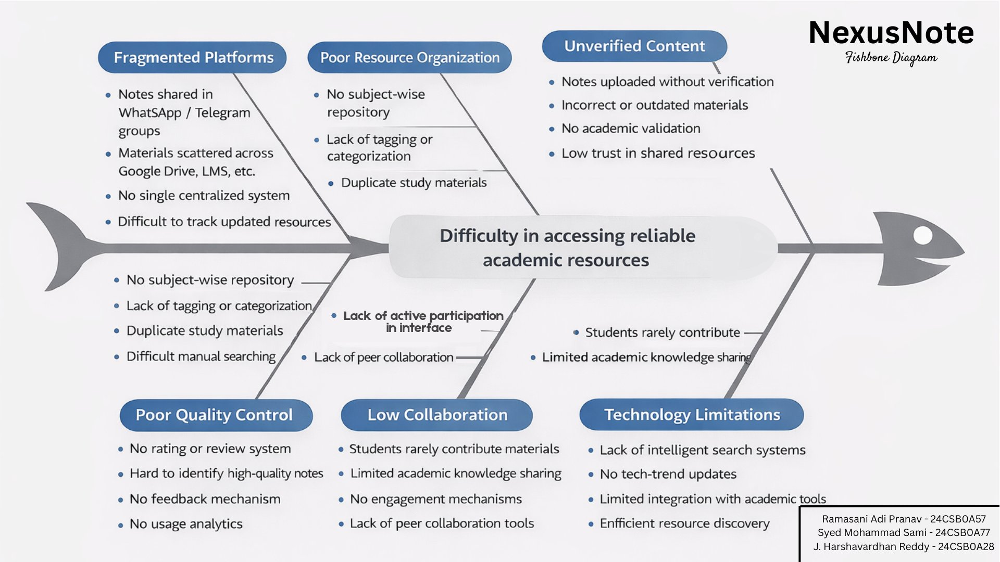
Figure 2.1: NexusNotes Fishbone (Ishikawa) Diagram

3 Software Requirements Specification

3.1 Overall Description

3.1.1 Product Perspective
NexusNotes is designed as a centralized academic knowledge platform that integrates students, faculty, and academic resources into a unified digital ecosystem. The system acts as a bridge between fragmented academic materials and structured learning processes. It complements existing institutional systems by providing an organized repository for academic content, collaboration features, and real-time technology updates.

3.1.2 Product Functions
- Centralized Repository: Provides subject-wise digital repositories for academic resources.
- Collaborative Sharing: Enables students and faculty to contribute and share content.
- Content Verification: Allows faculty members to validate and approve academic materials.
- Intelligent Categorization: Organizes content based on relevance and usage.
- Advanced Search: Supports fast and accurate retrieval of academic resources.
- Tech-Trend Integration: Displays real-time technology trends related to academic domains.

3.1.3 User Classes and Characteristics

User Class | Description
Students (Primary) | Access, search, download, and contribute academic resources to enhance learning.
Faculty Members | Review and verify uploaded content to ensure academic accuracy and relevance.
Administrators | Manage user roles, moderate content, and oversee platform governance.
Contributors | Registered users with Contributor permissions to upload and curate academic content.

3.1.4 General Constraints
- Data security and privacy of student details and academic content is a top priority.
- The system must handle a high volume of concurrent users, especially during examination periods.
- The portal must be functional across smartphones, tablets, and desktop computers.
- The system must adhere to institutional IT policies and academic data management standards.
- File uploads are constrained to a maximum size of 50MB per resource.

3.1.5 Assumptions and Dependencies
- Users have access to stable internet connectivity and compatible digital devices.
- The platform depends on institutional support for faculty participation in content verification.
- The effectiveness relies on active user engagement and continuous content contribution.
- External Tech News APIs are available and accessible for the Tech-Trend Feed.

3.2 External Interface Requirements

3.2.1 User Interfaces
Users interact with NexusNotes through modern web browsers. The interface is divided into role-based dashboards: a Student Dashboard and an Administrator Console. The Student Dashboard provides access to search, upload, download, and Tech-Trend features. The Administrator Console provides access to user management, content moderation, and system monitoring tools.

3.2.2 Hardware Interfaces
The platform supports cross-platform access via modern web browsers on laptops, tablets, and smartphones. No specialized hardware is required beyond standard computing devices with internet connectivity.

3.2.3 Software Interfaces
- Web Server: Node.js with Express.js REST API backend.
- Database: MongoDB with GridFS for file storage.
- Frontend: React.js Single Page Application (SPA).
- Authentication: JWT-based stateless session management.
- External API: Third-party Tech News APIs for the Tech-Trend Feed.

3.2.4 Communications Interfaces
All client-server communication is secured via HTTPS using REST/JSON protocols. The Tech-Trend Feed component communicates asynchronously with external APIs over HTTPS GET requests.

3.3 System Features

3.3.1 Upload Academic Resource (UC-01)
Description: A student uploads academic materials such as lecture notes, project reports, or question papers to a subject repository for sharing with peers.
Priority: High. Maximum file size: 50MB. Supported formats: PDF, DOCX, PPT.

3.3.2 Search and Download Resource (UC-02)
Description: Students search academic materials using keywords or filters (Subject, Module, Semester) and download them for study. Download count is updated on each retrieval.
Priority: Medium.

3.3.3 View Tech-Trend Feed (UC-03)
Description: Students view real-time technological updates related to their academic domains. System fetches curated updates from external APIs. Requires active internet connection.
Priority: Medium.

3.3.4 Rate and Review Resource (UC-04)
Description: Students provide star ratings (1–5) and optional text reviews for shared resources, driving an intelligent ranking system. Student must have accessed the resource first.
Priority: Low.

3.3.5 User Management (UC-05)
Description: Administrators manage user roles and permissions. Admin can create, suspend, or promote user accounts. Only administrators with appropriate privileges may perform these actions.
Priority: High.

3.3.6 Content Moderation (UC-06)
Description: Administrators review flagged resources and either delete inappropriate or duplicate content or dismiss invalid reports. System updates content visibility accordingly.
Priority: High.

3.4 Non-Functional Requirements

3.4.1 Performance Requirements
- System shall support concurrent access by multiple users without noticeable degradation.
- Search results shall be displayed within 2–3 seconds under normal load.
- File uploads up to 50MB shall be processed and validated efficiently without timeouts.
- The platform shall be scalable to accommodate increasing users and resources.

3.4.2 Security and Privacy Constraints
- User authentication via JWT shall be required to access all system features.
- Role-based access control (RBAC) restricts actions based on user type.
- Passwords and sensitive data shall be securely hashed and stored.
- All data transmission shall use HTTPS secure communication protocols.

3.4.3 Software Quality Attributes
- The system shall provide a user-friendly and intuitive interface accessible without extensive training.
- The platform shall support responsive design for different devices and screen sizes.
- Periodic database backups shall be maintained to prevent data loss.

4 Use Case Document

4.1 Use Case Summary

Primary Actor | Use Cases
Student | UC-01: Upload Academic Resource, UC-02: Search and Download Resource, UC-03: View Tech-Trend Feed, UC-04: Rate and Review Resource, UC-08: Create Personalized Learning Path, UC-09: Bookmark Resources
Administrator | UC-05: User Management, UC-06: Content Moderation, UC-07: System Monitoring, UC-10: Generate Analytics Report
Faculty Member | Content Review and Verification
External Tech API | Provides real-time technological updates for the Tech-Trend Feed (UC-03)

4.2 Use Case Diagram
The Use Case Diagram provides a high-level overview of the interactions between the system's actors and its core functionalities.
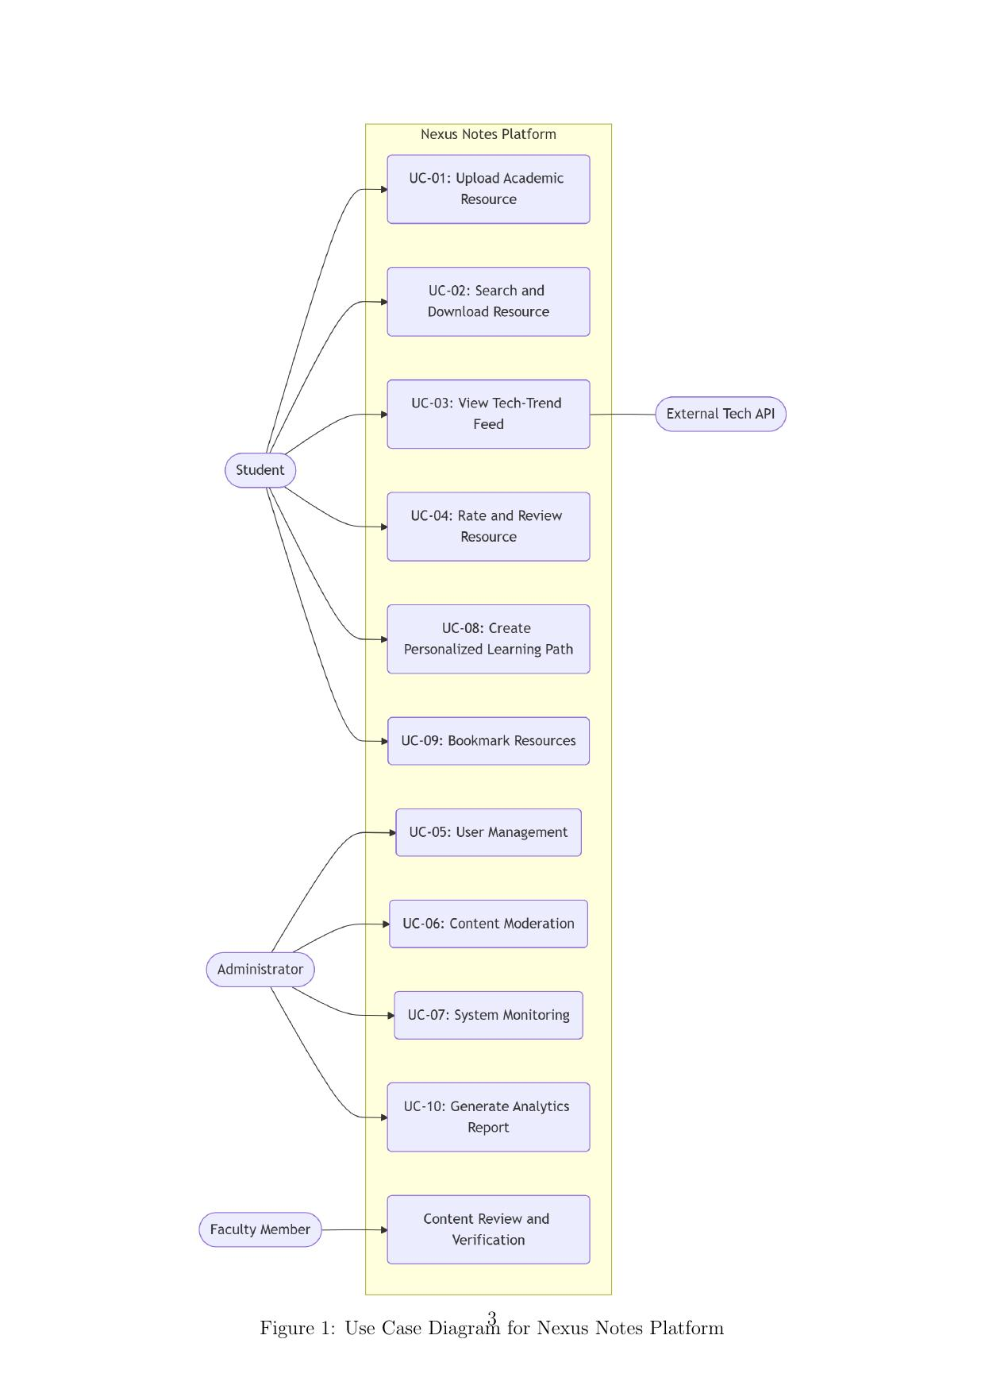
Figure 4.1: Use Case Diagram for NexusNotes Platform

4.3 Detailed Use Cases

Use Case 1: Upload Academic Resource

Field | Details
Use Case ID | UC-01
Use Case Name | Upload Academic Resource
Created By | Code Club
Date Created | February 13, 2026
Actors | Student
Description | A student uploads a digital academic resource (lecture notes, project report, or question paper) to a specific subject repository for sharing with peers.
Preconditions | 1. Student is logged into NexusNotes. 2. Student has valid "Contributor" permissions.
Postconditions | 1. Resource is stored and indexed in the database. 2. Resource is published to the repository.
Normal Flow | 1. Student navigates to the "Contribute" section.  2. System displays the upload form.  3. Student selects the Category (Lecture Notes, Question Bank, Project, Emerging Tech).  4. Student uploads the file (PDF, DOCX, PPT).  5. Student adds metadata (Subject, Topic, Tags).  6. Student submits the resource.  7. System validates file format and size (max 50MB).  8. System confirms successful upload and publishes content to the repository.
Alternative Flows | UC-01.AC.1 Bulk Upload: Student selects "Bulk Upload", drags and drops multiple files, and system applies common metadata tags to all files.
Exceptions | UC-01.EX.1 Invalid File Format: System detects unsupported file type or size > 50MB, displays error message requesting a valid format.
Priority | High
Business Rules | Maximum file size is 50MB per resource. Only registered users with Contributor permissions may upload.

Use Case 2: Search and Download Resource

Field | Details
Use Case ID | UC-02
Use Case Name | Search and Download Resource
Created By | Code Club
Date Created | February 13, 2026
Actors | Student
Description | Students search for specific academic materials using keywords, filters (Subject, Module), or tags, and download them for study.
Preconditions | Student is logged into NexusNotes.
Postconditions | File is downloaded to the student's local device and download count is updated.
Normal Flow | 1. Student enters keywords in the global search bar.  2. System displays results ranked by relevance and user rating.  3. Student applies filters (e.g., "Computer Science", "Semester 1").  4. System updates result list.  5. Student clicks on a resource to view details.  6. Student clicks "Download".  7. System increments the download count.
Alternative Flows | UC-02.AC.1 Browse by Repository: Student navigates via menu (Repository → Year → Subject) and system lists all resources in that category.
Exceptions | UC-02.EX.1 No Results: System finds no matches and suggests related topics or broader search terms.
Priority | Medium
Business Rules | Student must be logged in to search and download resources.

Use Case 3: Rate and Review Resource

Field | Details
Use Case ID | UC-04
Use Case Name | Rate and Review Resource
Created By | Code Club
Date Created | February 13, 2026
Actors | Student
Description | Students provide feedback and ratings on shared resources, helping to rank high-quality content.
Preconditions | Student has downloaded or viewed the resource.
Postconditions | Resource rating is updated in the database.
Normal Flow | 1. Student views resource details.  2. Student selects a star rating (1–5).  3. Student enters optional text comments.  4. Student submits review.  5. System recalculates average rating and displays new review.
Alternative Flows | Student may update a previously submitted review.
Exceptions | System error during submission: student is notified and prompted to retry.
Priority | Low
Business Rules | Student must have accessed the resource before rating. One review per student per resource.

Use Case 4: User Management (Admin)

Field | Details
Use Case ID | UC-05
Use Case Name | User Management
Created By | Code Club
Date Created | February 13, 2026
Actors | Administrator
Description | Administrator controls user roles, permissions, and access to the system.
Preconditions | Admin is logged in with administrative privileges.
Postconditions | User account is updated (created, suspended, or role-changed).
Normal Flow | 1. Admin navigates to "User Management" console.  2. Admin searches for a specific student or user.  3. Admin selects user account.  4. Admin updates permissions (e.g., suspend abusive user, promote to moderator).  5. System saves changes and notifies user if necessary.
Alternative Flows | Admin may bulk-update multiple user roles simultaneously.
Exceptions | Target user not found: system displays an error message.
Priority | High
Business Rules | Only administrators with appropriate privileges can modify user roles.

Use Case 5: Content Moderation (Admin)

Field | Details
Use Case ID | UC-06
Use Case Name | Content Moderation
Created By | Code Club
Date Created | February 13, 2026
Actors | Administrator
Description | Administrator monitors uploaded content and removes inappropriate, duplicate, or incorrect materials.
Preconditions | Content has been flagged or requires review. Admin is logged in with administrative privileges.
Postconditions | Content is removed or marked as safe. System updates content visibility.
Normal Flow | 1. Admin accesses "Moderation Queue" or views reported content.  2. System displays flagged resources.  3. Admin reviews content against community guidelines.  4. Admin deletes content or dismisses report.  5. System updates content visibility.
Alternative Flows | Admin may proactively review recently uploaded resources without a prior flag.
Exceptions | System error prevents moderation action; admin is notified and must retry.
Priority | High
Business Rules | Only administrators with moderation privileges can delete or approve content.

5 Project Management

5.1 Cost Estimation – Use Case Points (UCP)

5.1.1 Use Case Inventory
Use Case Points (UCP) methodology, developed by Gustav Karner, was used to estimate the software size. The weight of each use case is determined by the number of transactions.

ID | Use Case Name | Complexity | Weight
UC-01 | Upload Academic Resource | Complex | 15
UC-02 | Search and Download Resource | Average | 10
UC-03 | View Tech-Trend Feed | Average | 10
UC-04 | Rate and Review Resource | Average | 10
UC-05 | User Management | Average | 10
UC-06 | Content Moderation | Average | 10
UC-07 | System Monitoring | Simple | 5
UC-08 | Create Personalized Learning Path | Average | 10
UC-09 | Bookmark Resources | Simple | 5
UC-10 | Generate Analytics Report | Simple | 5
 |  | UUCW Total | 90

5.1.2 UCP Calculation Details
Unadjusted Actor Weight (UAW):
- Complex Actors – Weight 3 (GUI): Student, Administrator = 2 actors → 2 × 3 = 6
- Average Actors – Weight 2 (Protocol): None = 0
- Simple Actors – Weight 1 (API): External Tech API = 1 actor → 1 × 1 = 1
UAW = 7 | UUCW = 90
Technical Complexity Factor (TCF) = 0.6 + (45.5/100) = 1.055
Environmental Complexity Factor (ECF) = 1.4 + (−0.03 × 19.5) = 0.815
UCP = (90 + 7) × 1.055 × 0.815 ≈ 83.40 Use Case Points
Estimated Effort (28 man-hours per UCP) = 83.40 × 28 ≈ 2,335 Hours

5.1.3 UCP Document Pages
The following pages show the full UCP document including the C++ program used to automate the calculation.
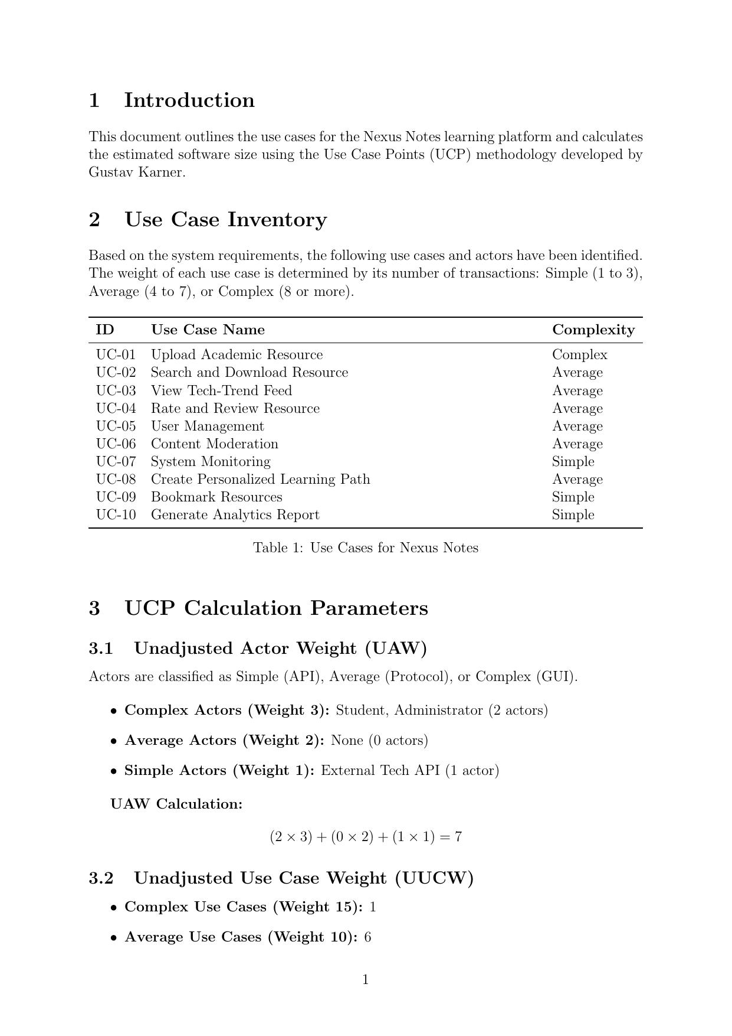
Figure 5.1: UCP Calculation Parameters
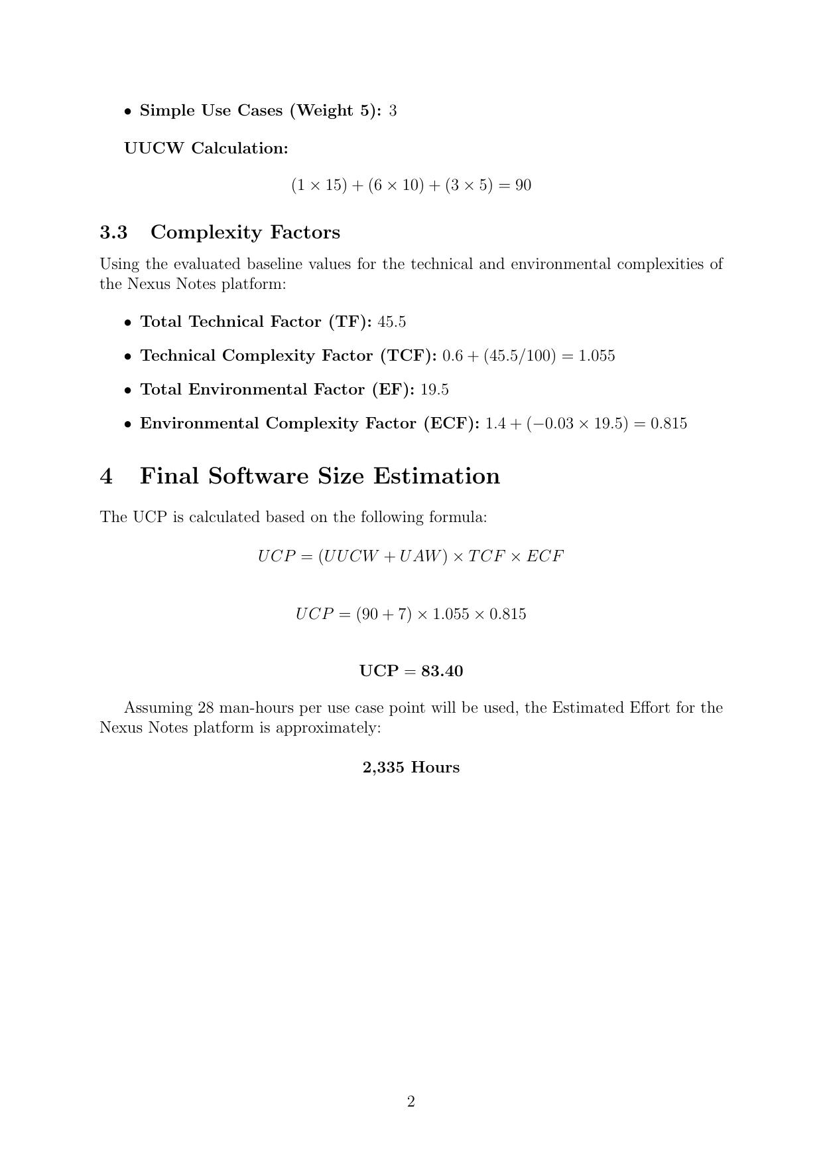

Figure 5.2: Final Software Size Estimation

5.2 Risk Table

Risk | Likelihood | Impact | Mitigation Strategy
Low user adoption and content contribution | High | High | Gamification, contribution recognition, faculty mandating platform use.
Unverified or low-quality content uploaded | High | High | Faculty verification layer, community flagging, and admin moderation queue.
Scalability issues during peak academic periods | Medium | High | Cloud-based auto-scaling architecture and load testing before deployment.
Security breach or unauthorized data access | Low | High | JWT authentication, RBAC, HTTPS enforcement, and regular security audits.
External Tech API unavailability | Medium | Low | Caching last-fetched results and providing a fallback static feed.
Team member unavailability or schedule conflicts | Medium | Medium | Clear task allocation, Gantt chart scheduling, and task overlap documentation.

5.3 Project Timeline (Gantt Chart)
The NexusNotes project was planned and executed using Microsoft Project. The total project duration is 57.6 days, commencing February 2, 2026, and concluding March 23, 2026.
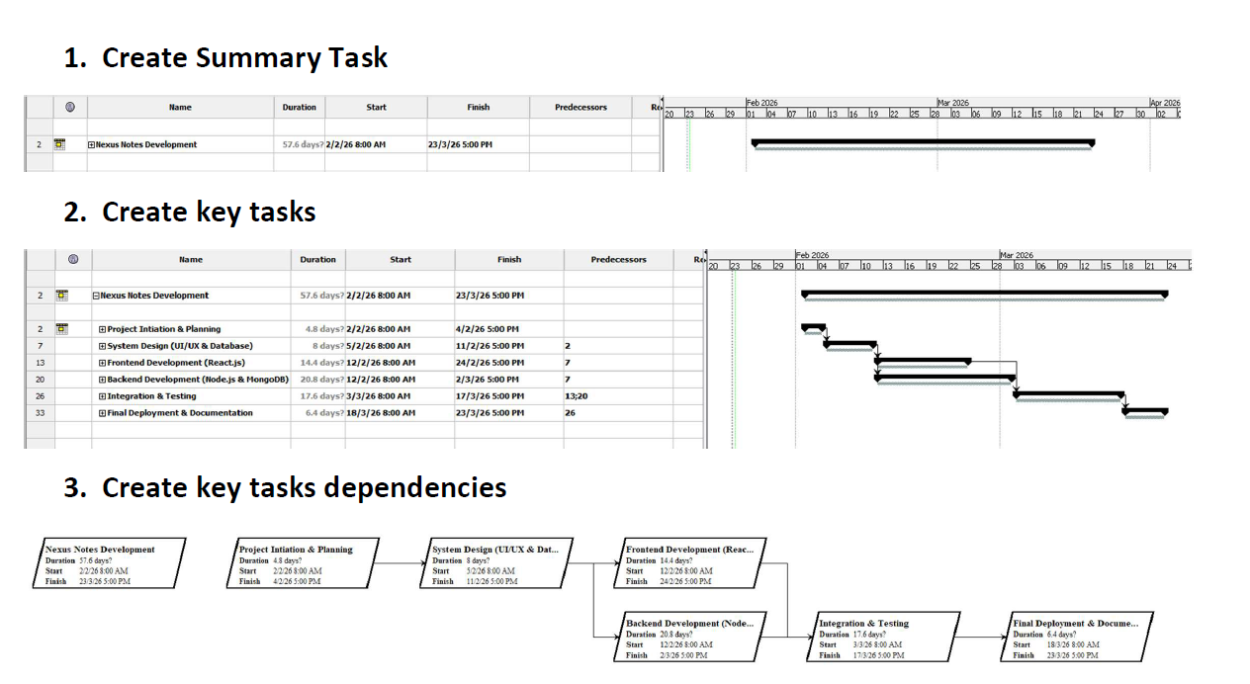

6 Design Engineering

6.1 Software Architecture
NexusNotes follows a three-tier MERN stack architecture providing clear separation between presentation, business logic, and data storage layers. The system is designed to be modular, scalable, and cloud-deployable.

6.1.1 Client Tier
The Web UI is a Single Page Application (SPA) built with React.js. It handles all user interactions and dynamic rendering of role-specific dashboards (Student Dashboard and Administrator Console). Communication with the backend is exclusively through REST/JSON over HTTPS.

6.1.2 Application Tier (API Gateway)
The Node.js and Express.js backend serves as the bridge between the frontend and database, composed of the following independent functional modules:
- Authentication & User Management Component: Handles JWT token generation, verification, and RBAC enforcement.
- Resource Management Component: Handles CRUD operations for academic files including upload, storage via GridFS, and metadata indexing.
- Search & Indexing Component: Processes search queries against indexed resource metadata and returns ranked results.
- Content Moderation Component: Provides administrative tools for reviewing flagged content.
- Tech-Trend Feed Component: Communicates asynchronously with external Tech News APIs.

6.1.3 Data Tier
The persistent storage layer is handled by a MongoDB cluster with data logically separated into: User Data, Resource & Metadata Data (with GridFS for large files), and Reviews & Ratings.

6.2 UML Diagrams

6.2.1 Sequence Diagram – Upload Academic Resource (UC-01)
The Sequence Diagram details the chronological step-by-step process of uploading an academic resource, including the validation engine interaction and exception handling.
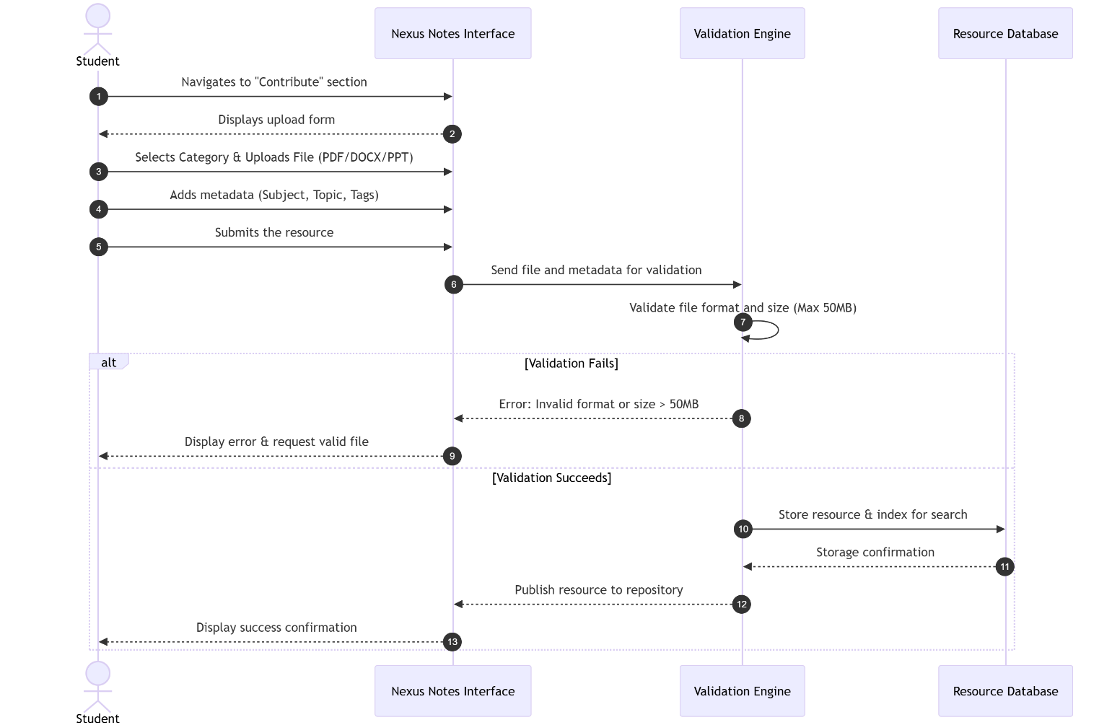
Figure 6.1: Sequence Diagram for UC-01: Upload Academic Resource

6.2.2 Collaboration Diagram – Search and Download Resource (UC-02)
The Collaboration Diagram shows the structural message passing between objects during a resource search and download operation.
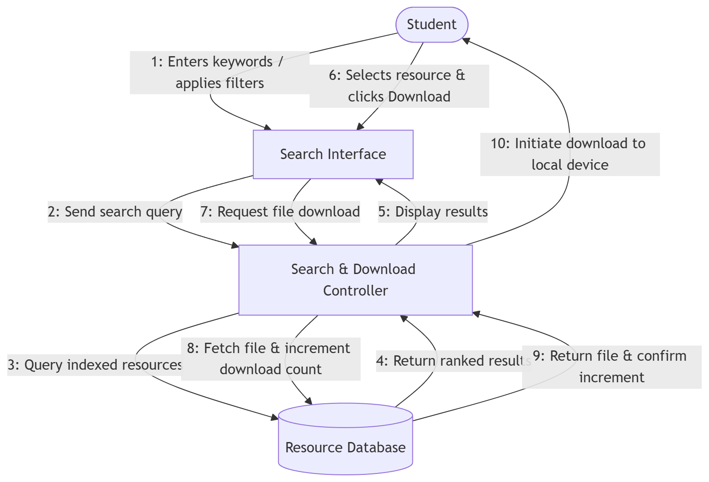
Figure 6.2: Collaboration Diagram for UC-02: Search and Download Resource

6.2.3 Activity Diagram – Content Moderation (UC-06)
The Activity Diagram illustrates the control flow involved in the administrative task of moderating flagged content.
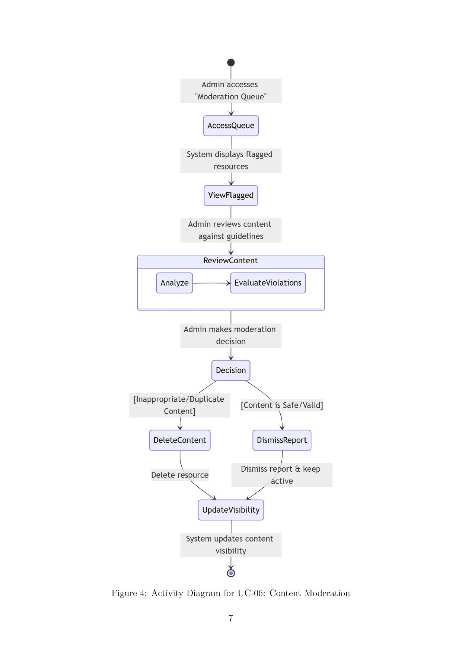
Figure 6.3: Activity Diagram for UC-06: Content Moderation

6.2.4 Logical View: Class Diagram
The Class Diagram maps the object-oriented structure of the NexusNotes system, defining the core entities, their attributes, methods, and relationships.
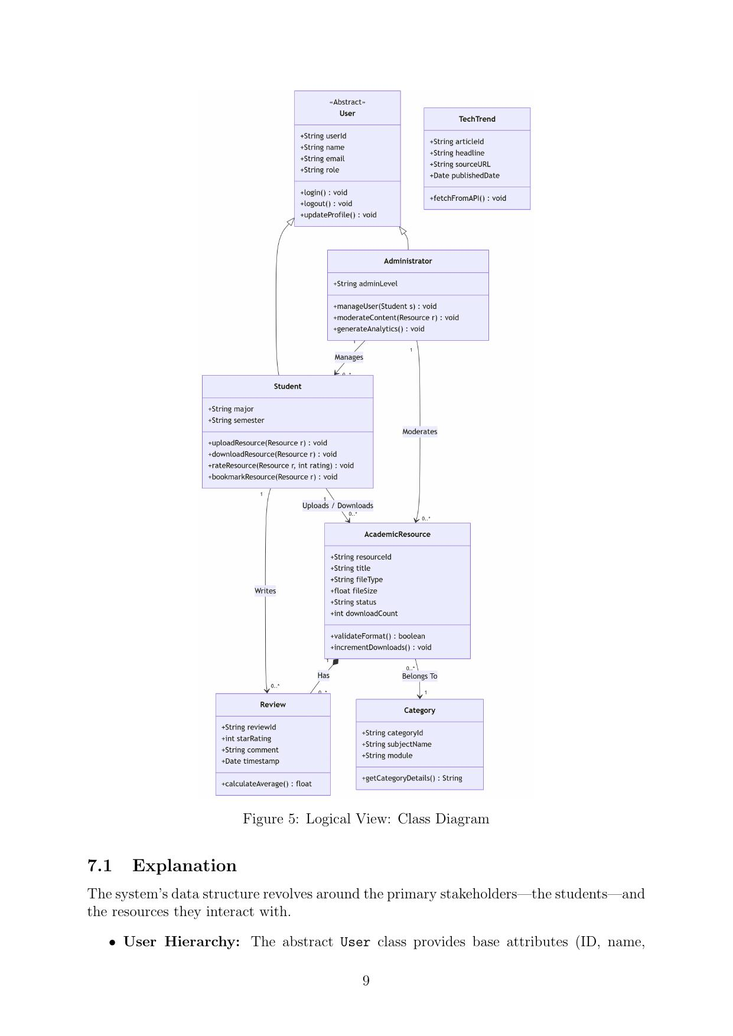
Figure 6.4: Logical View – Class Diagram

6.2.5 Logical View: Statechart Diagram
The Statechart Diagram illustrates the lifecycle and varying states of an AcademicResource within NexusNotes, from UploadInitiated through Published, Flagged, and Removed states.
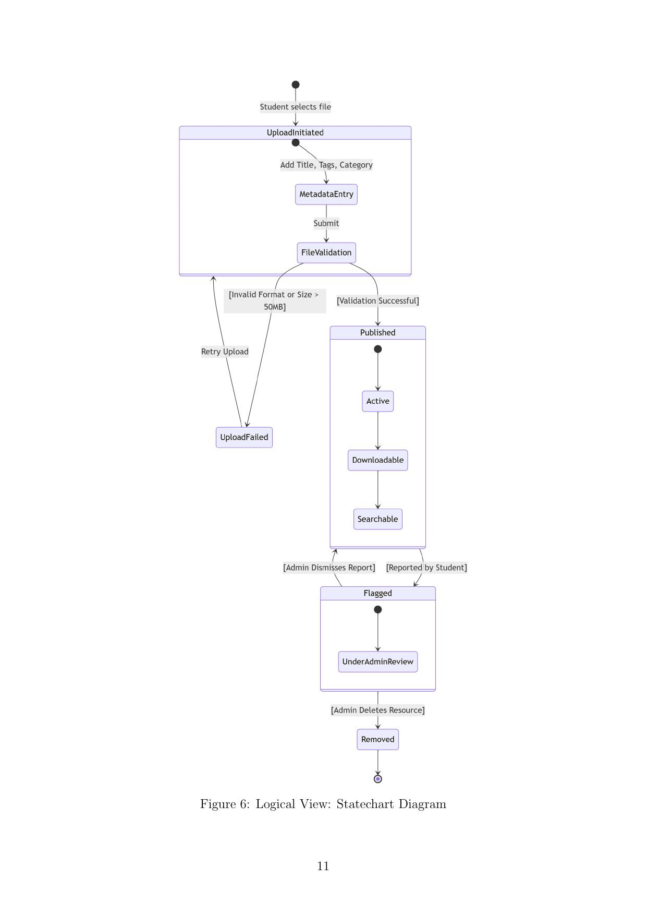
Figure 6.5: Logical View – Statechart Diagram for AcademicResource

6.2.6 Component View: Component Diagram
The Component Diagram details the modular structure of the NexusNotes software application, mapped to the MERN stack environment across three decoupled tiers.
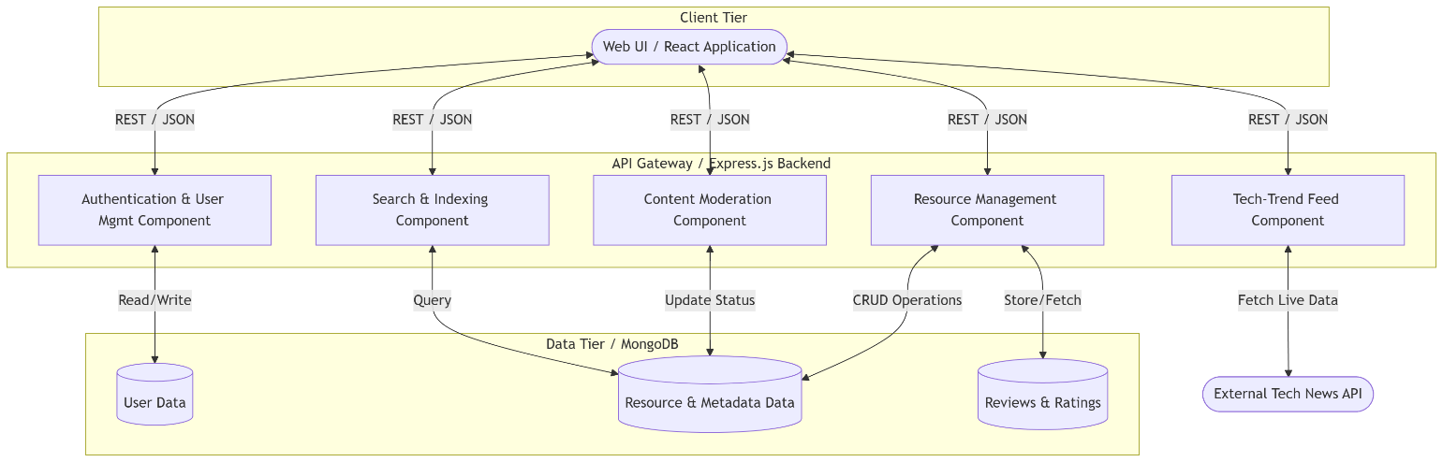
Figure 6.6: Component View – Component Diagram

6.2.7 Deployment View: Deployment Diagram
The Deployment Diagram visualizes the physical execution architecture and how software artifacts are distributed across hardware nodes including the Client Device, Application Server, Database Server, and External API environment.
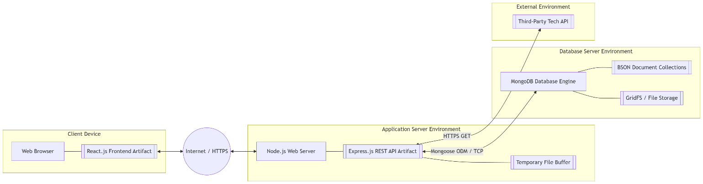
Figure 6.7: Deployment View – Deployment Diagram

7 Call Graph and Coupling Analysis

7.1 Source Code Structure
The NexusNotes system architecture consists of three primary controllers that form the backbone of the application logic: Student Controller, Admin Controller, and Authentication Controller. Each controller exposes focused functions that interact with specific modules of the system.

7.2 Call Graph Diagrams
Call graphs illustrate how functions within the system interact with each other during execution.

7.2.1 Student Module Call Graph
The Student Dashboard acts as the primary controller. It connects all major functionalities: Login (checkCredentials → generateToken), Upload Resource (validateFile → saveResource), Search Resource (fetchResources), Download Resource (incrementDownload), and View Tech Trend (fetchUpdates).
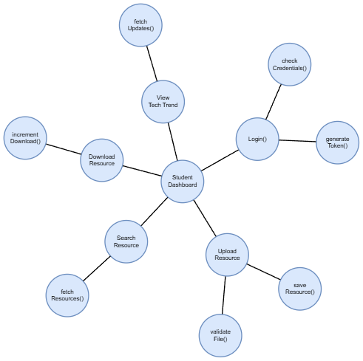

Figure 7.1: Student Module Call Graph

7.2.2 Admin Module Call Graph
The Admin Dashboard serves as the main control interface. Its call graph connects to Login (checkCredentials → generateToken), Manage Roles (verifyPrivileges → updateRole), and Moderate Content (fetchFlagged → deleteContent / updateVisibility).
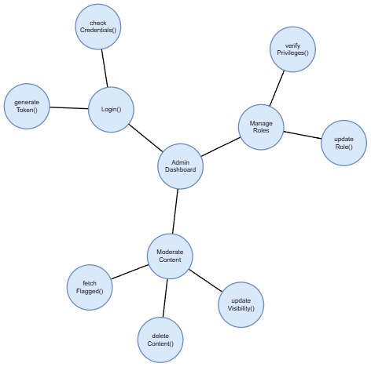
Figure 7.2: Admin Module Call Graph

7.3 Module Structure Diagram
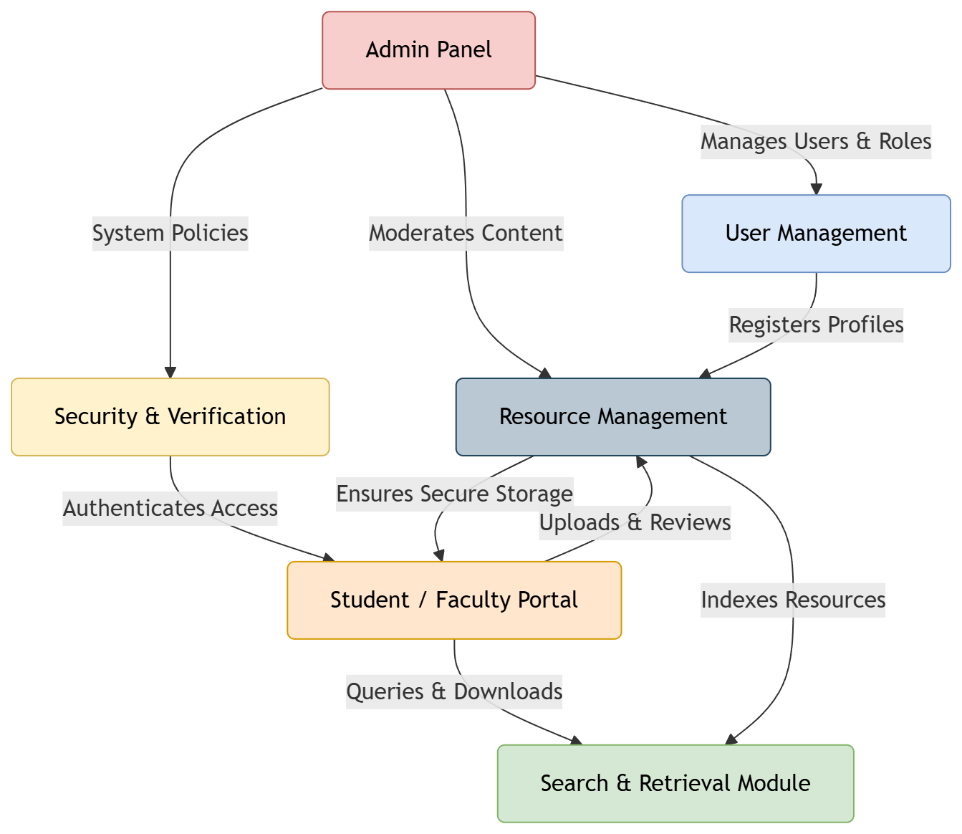
Figure 7.3: Module Structure Diagram of NexusNotes

7.4 Coupling and Cohesion Analysis

7.4.1 System Coupling Diagram
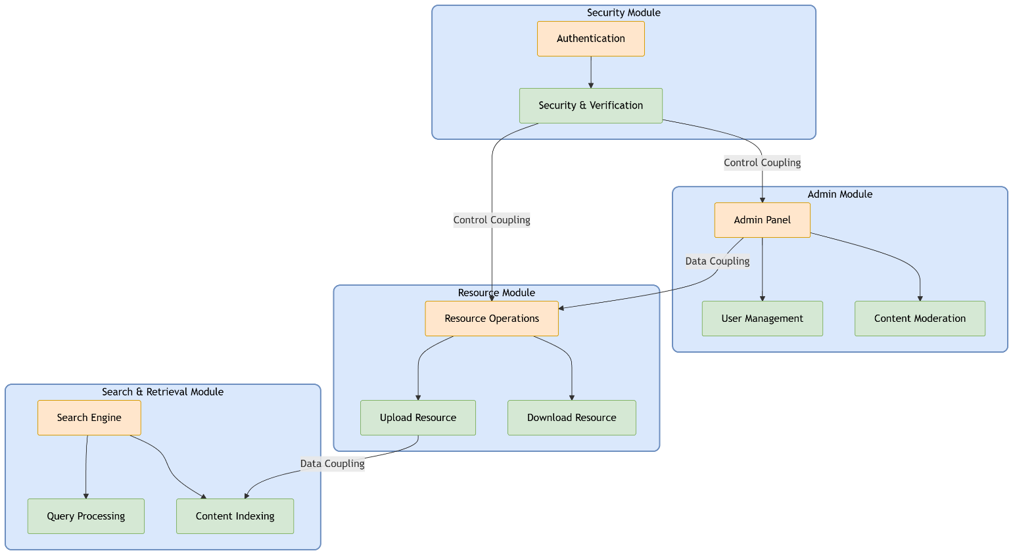
Figure 7.4: System Coupling Diagram

7.4.2 Cohesion
Cohesion refers to the degree to which the elements within a module belong together. Each module in NexusNotes performs a specific and well-defined function:
- Security Module: Focuses only on authentication and verification.
- Admin Module: Manages system governance and user roles.
- Resource Module: Handles uploading, downloading, and storage of academic materials.
- Search Module: Manages searching and indexing operations.
High cohesion improves maintainability, allows independent modification of modules, and enhances code readability and debugging efficiency.

7.4.3 Coupling
Coupling refers to the level of dependency between different modules. NexusNotes uses controlled coupling:
Control Coupling:
- Security Module → Admin Module: Authentication controls access to administrative functionalities.
- Security Module → Resource Module: User verification determines whether a user can upload or download resources.
Data Coupling:
- Resource Module → Search Module: Uploaded resources are indexed for search operations.
- Admin Module → Resource Module: Administrative moderation actions update resource visibility and availability.
Controlled module interaction maintains system integrity. Balanced coupling improves modularity while preserving functionality.

8 Vision and Product Overview

8.1 Business Opportunity
The rapid expansion of digital learning environments has resulted in academic resources being dispersed across multiple platforms. This fragmentation leads to inefficiencies in accessing reliable study materials, duplication of effort, and limited collaboration among students and faculty. NexusNotes addresses this challenge by providing a centralized academic knowledge platform that integrates scattered educational resources into a unified, structured, and accessible digital ecosystem.

8.2 Stakeholder Summary

Stakeholder | Role and Responsibility
Students | Access, contribute, and utilize academic resources to enhance learning efficiency.
Faculty Members | Verify and validate academic content to ensure accuracy and relevance.
Institution Administrators | Oversee platform usage, enforce governance policies, and manage users.
Developers | Design, develop, test, and maintain the NexusNotes system.
Academic Coordinators | Align platform content with institutional curriculum requirements.

8.3 Alternatives and Competition
Existing alternatives include cloud storage platforms (Google Drive), institutional learning management systems, messaging applications (WhatsApp, Telegram), and informal note-sharing websites. However, these solutions lack a unified structure, verified content mechanisms, and intelligent categorization. NexusNotes differentiates itself by offering a centralized, collaborative, and academically validated knowledge ecosystem.

8.4 Product Capabilities Summary

Capability | Description
Centralized Repository | Provides subject-wise digital repositories for all academic resources.
Collaborative Sharing | Enables students and faculty to contribute and share content.
Content Verification | Faculty members validate and approve academic materials for reliability.
Intelligent Categorization | Organizes content based on relevance and user engagement.
Advanced Search | Supports fast and accurate keyword and filter-based retrieval.
Tech-Trend Integration | Displays real-time technology trends related to academic domains.

8.5 Feature Priority

Feature | Priority | Description
Centralized Repository | High | Core functionality for structured academic resource storage.
User Authentication (RBAC) | High | Secure access control for students, faculty, and administrators.
Faculty Verification Layer | High | Ensures reliability and academic validity of uploaded content.
Advanced Search & Filtering | Medium | Efficient retrieval of resources by keyword and filter.
Tech-Trend Feed | Medium | Bridges academic content with real-world industry technology trends.
Rating & Review System | Low | Crowd-sourced quality signal to surface high-quality resources.
Analytics & Reports | Low | Tracks platform usage and engagement statistics for administrators.

9 References
- Vision Document, NexusNotes – Centralized Academic Resource Platform, Code Club, Version 1.0, January 30, 2026.
- Software Requirements Specification (SRS), NexusNotes, Code Club, February 20, 2026.
- Use Cases for NexusNotes, Code Club, Version 1.0, February 13, 2026.
- UCP Document – NexusNotes, Code Club, Version 1.0, March 13, 2026.
- UML Diagrams – NexusNotes, Code Club, Version 1.0, March 20, 2026.
- Call Graph and Coupling – NexusNotes, Code Club, Version 1.0, March 7, 2026.
- NexusNotes Gantt Chart (MS Project), Code Club, 2026.
- NexusNotes Fishbone (Ishikawa) Diagram, Code Club, 2026.
- Karner, G. (1993). Resource Estimation for Objectory Projects. Objective Systems SF AB.
- IEEE Std 830-1998 – IEEE Recommended Practice for Software Requirements Specifications.

