**Scenario 1:**

* Initially, click on Pipelines and select **Pipelines**

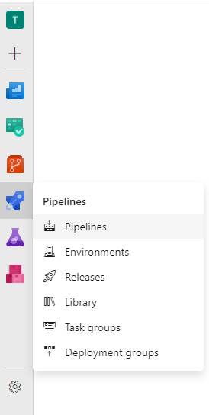

* Now, select **Create pipeline.**

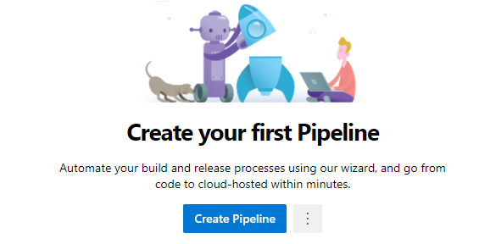

* Choose Use **classic editor without YAML**

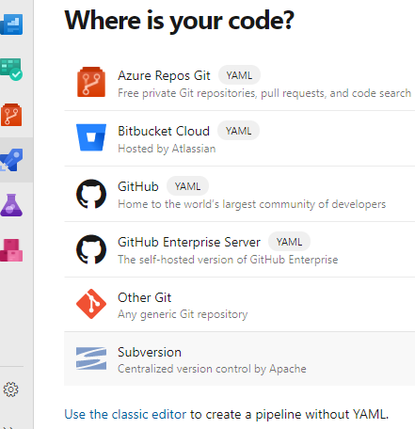

* After that, select your repository, default branch, and click on **Continue.**

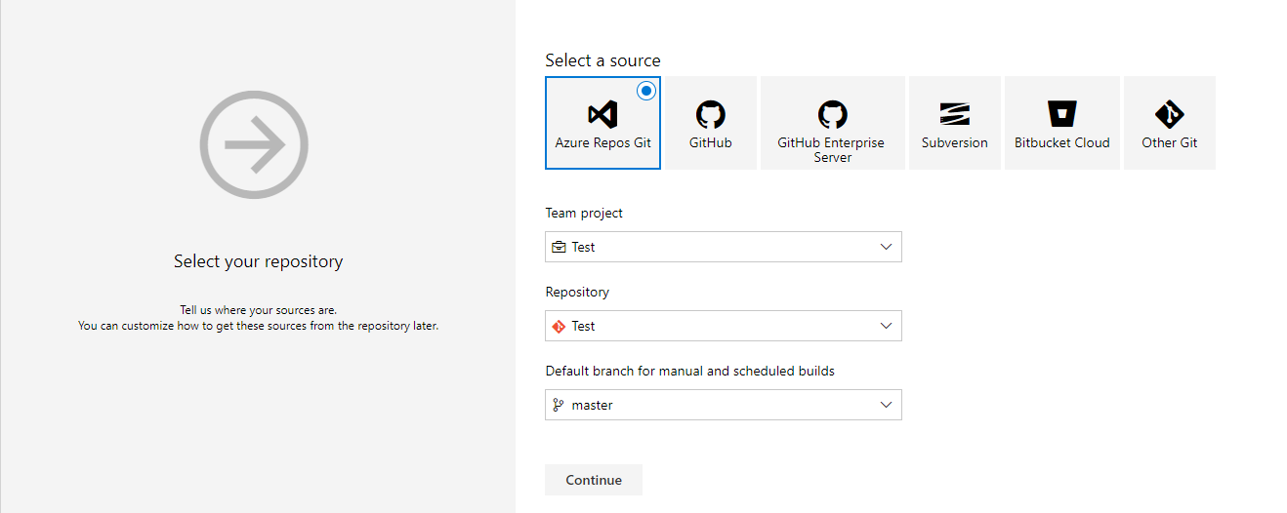

* Now, select the template ASP .NET

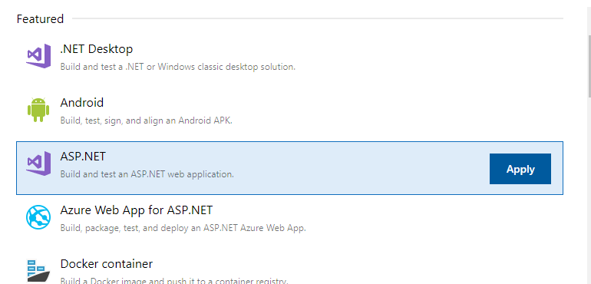

* Select **Triggers** option on top.

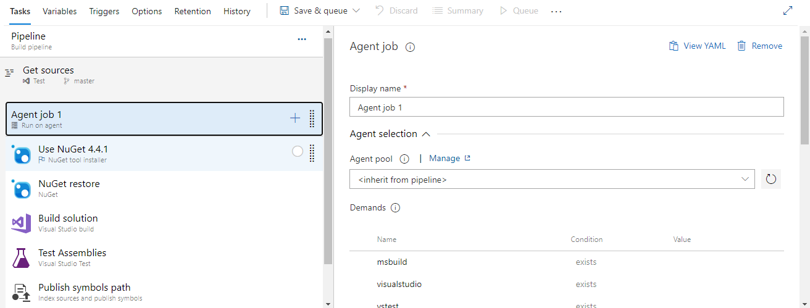

* Check-in the box of **Enable continuous Integration** and select the branch **master.**  So, whenever a developer checks in a commit, automatically **Build** triggers.

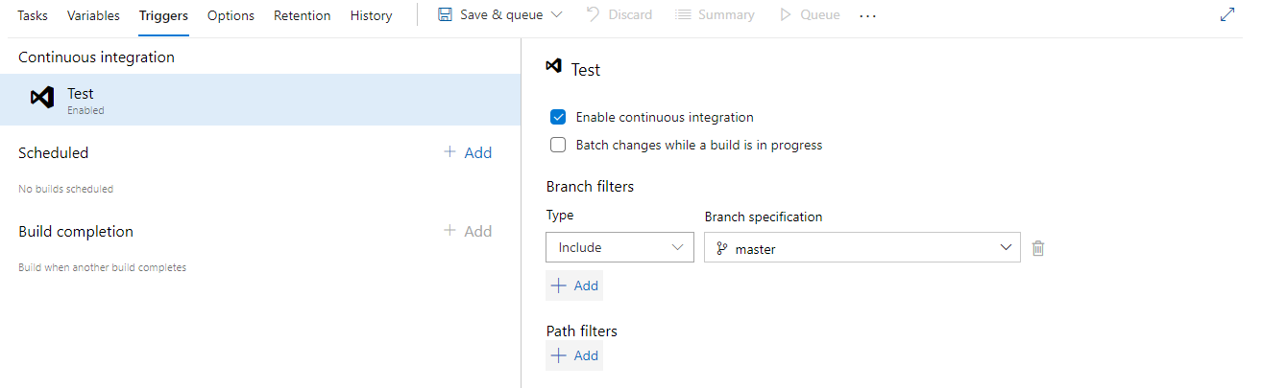

* Click on **Save and Queue** to run the pipeline now.
* Now, click on **Releases** and choose **New Pipeline**.

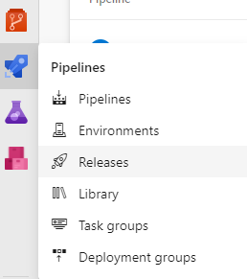

* Select the template **Azure App service Deployment.**

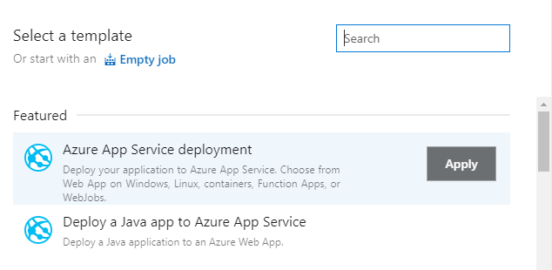

* Similarly, create the stages and name it QA and production.

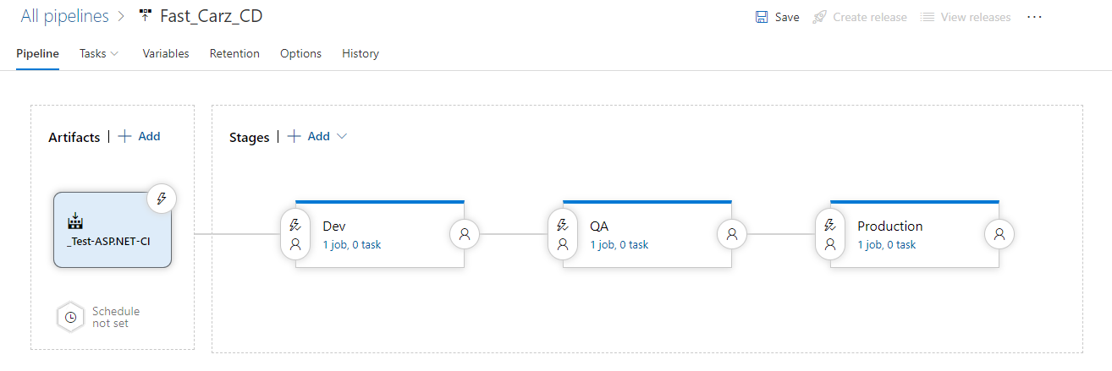

* So, whenever build is triggered, and it is successful then the release to Dev environment happens automatically and if the deployment to Dev is successful then it will proceed to QA environment and similarly for Production after QA.
* Please click this [here](https://dev.azure.com/jbsscm/FastCarz/_build) to open Azure DevOps pipelines.