Project Report

MetroScope: Strategic Metro Expansion using Random Forest and XGBoost
Submitted by:
Pranav Kumar – 102317278
BE Third Year – CSE
Submitted to:
Dr. Jasmeet Singh
Computer Science and Engineering Department
Thapar Institute of Engineering and Technology, Patiala
December 2025

TABLE OF CONTENTS

1. Introduction or Project Overview
2. Objective
3. Methodology
4. Working Model
5. Results
6. Conclusion
7. References

1. Introduction

A. Technical Background of the Project

This project applies supervised machine learning to urban transportation planning. By analyzing data from established metropolitan cities, it identifies patterns in population distribution, infrastructure development, land use, and mobility demand to predict suitable metro station locations. The approach leverages geospatial data processing and predictive modeling to support scientific, data-driven metro expansion.

B. Technical Concepts Used

Key technical concepts include machine learning classification (Random Forest, XGBoost), feature engineering, data preprocessing, geospatial coordinate mapping, cross-city pattern learning, and map-based visualization.

C. Motivation

Rapid urban growth demands modern, efficient metro networks. Traditional planning relies heavily on manual surveys and slow decision cycles. The motivation of this project is to automate this process using data intelligence, enabling faster, evidence-based planning aligned with smart-city goals.

D. Problem Statement

Metro station planning requires evaluating multiple factors such as population density, infrastructure availability, traffic intensity, and development trends. Manual evaluation is time-consuming and may not capture future growth zones. This project aims to solve the problem of identifying optimal metro station points in Chennai using a machine learning model trained on the patterns learned from Bangalore and Hyderabad.

E. Area of Application

The project is applicable in urban transportation planning, government infrastructure design, metro rail route expansion, city development forecasting, and smart-city analytics.

F. Dataset and Input Format

A custom integrated dataset was created using information from GeoIQ (population density), MagicBricks (rent prices), Google Maps API (traffic index, civic amenities), and public geographic maps (rail lines and coordinates).
All datasets were processed and stored in CSV format with numerical, categorical, and geospatial features.

2. Objective

A. Main Objective

To design a predictive machine learning system capable of recommending optimal metro station locations in Chennai based on patterns derived from major Indian metropolitan cities.

B. Sub-Objectives

To collect, clean, and integrate multi-source urban datasets.

To train Random Forest and XGBoost models for station suitability classification.

To evaluate the models using Accuracy and F1-Score.

To predict high-potential station points for Chennai.

To visualize the predicted metro nodes and route on a geographic map.

3. Methodology

A. Steps Followed

Data Collection: Acquired datasets from GeoIQ, MagicBricks, Google Maps API, and public maps.

Data Preprocessing: Removed inconsistencies, handled missing values, normalized features, and merged datasets into a unified format.

Model Training: Trained Random Forest and XGBoost classifiers on Bangalore and Hyderabad data.

Model Evaluation: Compared model performance using Accuracy and F1-Score.

Prediction: Applied the best-performing model to Chennai to identify suitable metro locations.

Visualization: Plotted predicted nodes and generated a potential metro route on a Chennai map.

B. Deliverables of Each Phase

Phase 1: Compiled multi-source urban dataset.

Phase 2: Cleaned, normalized, and geo-processed dataset.

Phase 3: Trained ML models with hyperparameter tuning.

Phase 4: Evaluation report with performance metrics.

Phase 5: Predicted metro station points for Chennai.

Phase 6: Final visualization of suggested metro route.

4. Working Model

A. Technical Diagram (Conceptual Flow)



Data Collection → Preprocessing → Model Training → Model Evaluation → Prediction → Visualization

B. Working Modules

Data Module: Responsible for data acquisition and cleaning.

Machine Learning Module: Handles training, testing, and prediction.

Geospatial Module: Processes coordinates and maps outputs.

Visualization Module: Generates the final map and metro route.

C. Attained Deliverables

The system successfully identifies high-potential metro station locations in Chennai and presents a mapped metro route based on model predictions, demonstrating the feasibility of automated, data-driven metro planning.

5. Results
Correlation Heatmap:
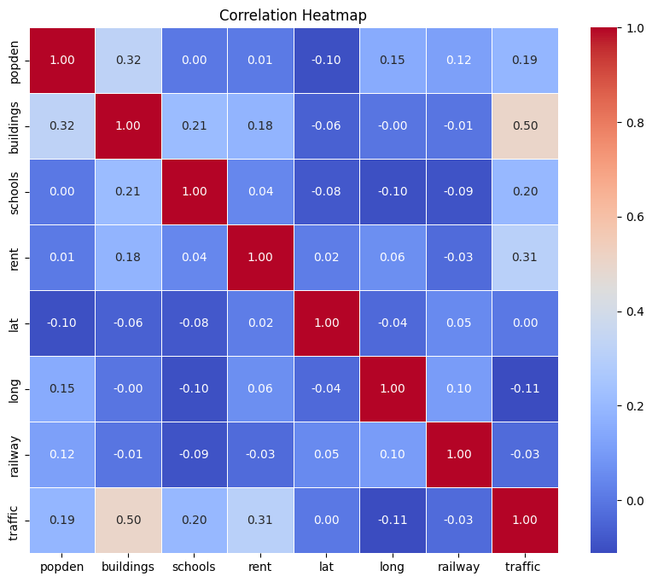
Metro Installation Prediction – Random Forest Model:
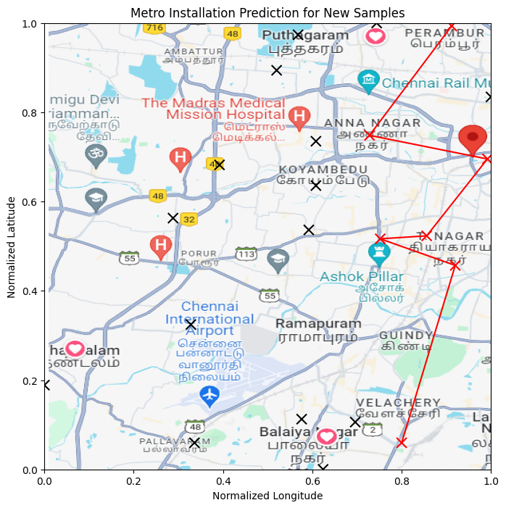
Metro Installation Prediction – XGBoost Model:
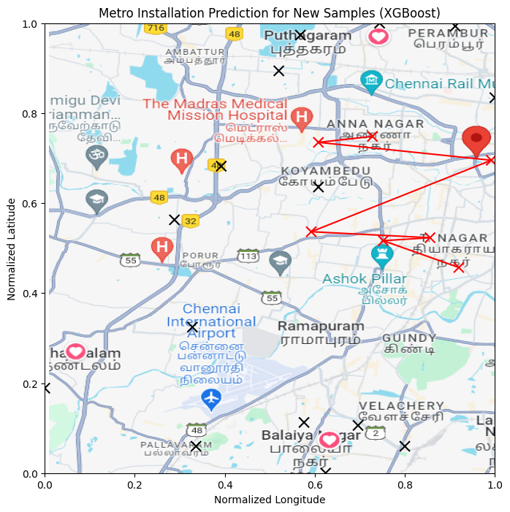
The Random Forest model achieved approximately 81% accuracy and an F1‑Score of 87%, while XGBoost achieved around 86% accuracy and a 91% F1‑Score. Due to its superior performance, XGBoost was selected for the final Chennai prediction. Both models successfully identified viable station points. The predicted XGBoost map shows a more stable clustering of locations and cleaner route generation.

6. Conclusion
This project demonstrates how machine learning can support metro expansion planning in fast‑growing cities. By analyzing real‑world urban features and learning patterns from multiple metropolitan datasets, the system can produce reliable recommendations for new metro stations. The results show that ensemble models like XGBoost perform exceptionally well for this purpose. The project can be extended by incorporating real‑time data or optimizing routes using graph algorithms to generate complete metro line designs.

- References
Karnataka Government Open Data. (2023). Urban infrastructure & demographic data for Bangalore.
Telangana Open Data Portal. (2023). Urban development datasets for Hyderabad.
Chennai Metro Rail Limited (CMRL). (2023). Metro rail maps and infrastructure data. Retrieved from https://chennaimetrorail.org

