**Objective:**

To Deploy an application in Heroku.

**Prerequisites:**

1.Expressjs

2.Angular

3.WebStorm IDE

4.Node

5.Heroku CLI

**Design / Implementation:**

1)    Created Heroku account (<https://signup.heroku.com/account>).

2)    Logged in to Heroku using Heroku login command.

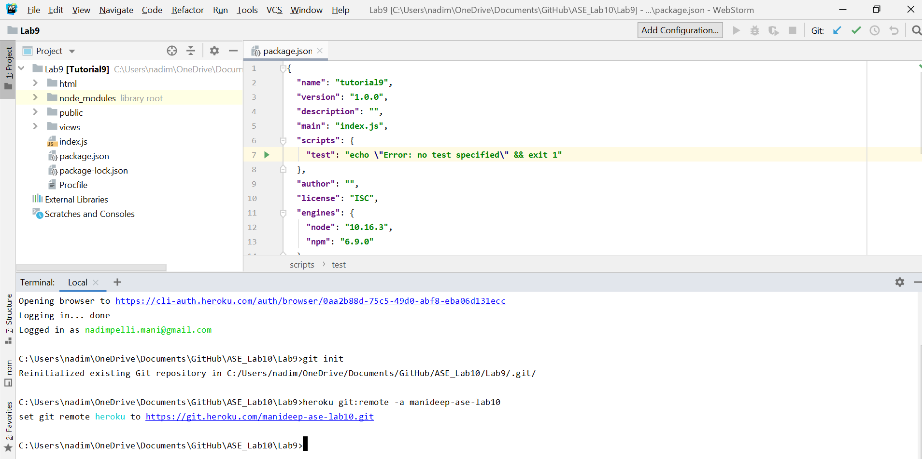

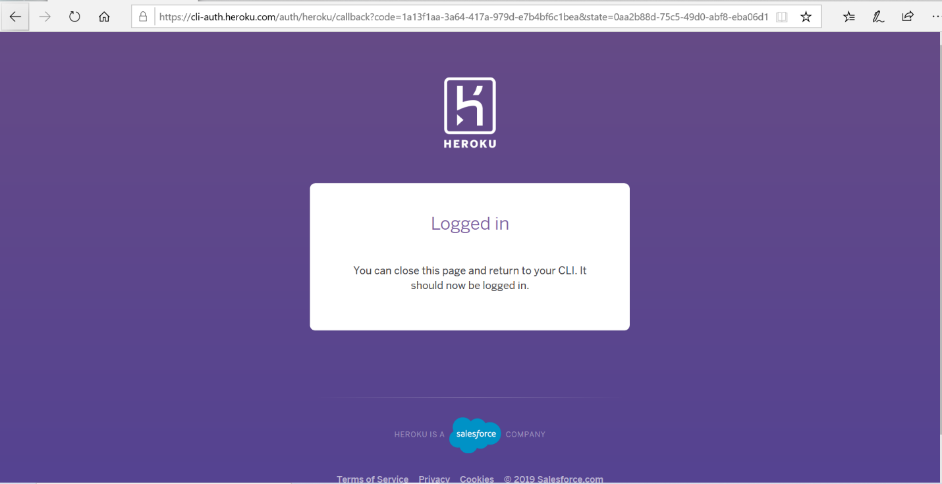

3)    Added npm and node versions in pacakage.json.Created Procfile in

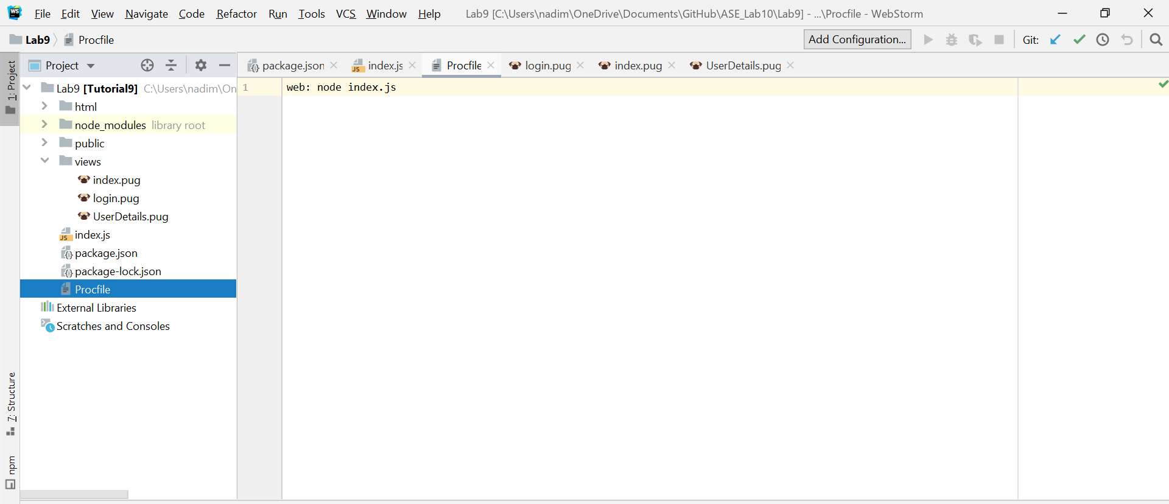

4)    In index.js file Added process.env.PORT || 3000 .

5)    Pushed the code to Heroku before that performed got commit. Using

git add . , git commit -am "Lab10" , git push heroku ma ster

6)   Deployed the application to Heroku successfully.

<https://manideep-ase-lab10.herokuapp.com/>

**Sample Output:**

1)    Login page.

2)    Sign up page.

3)    After successful sign in user data be displayed.

**Conclusion:**

·      Understood the deployment process using Heroku.