GEN AI PROJECT SUBMISSION DOCUMENT

- Project Title:

Daily Motivation Generator using Generative AI

- Summary of Work Done

Proposal and Idea Submission:

In this project, we aimed to develop a simple AI application that generates motivational quotes based on the user’s mood. The core idea is to leverage Generative AI models to encourage users emotionally by providing context-aware motivational messages.
Objectives:
- Understand the use of generative models in language generation.
- Build a simple, easy-to-use web app for motivational content.
- Generate context-aware quotes based on emotional input.
Tools Used:
- Python
- Hugging Face Transformers (local text generation with gpt2 or similar model)
- Streamlit (for web interface)
A detailed proposal was submitted outlining the problem, approach, tools, and expected output.

Execution and Demonstration:

We implemented the proposed idea in Python using Hugging Face’s transformers library and Streamlit. Key tasks accomplished:
- Built a web app interface with Streamlit.
- Used a dropdown menu to let users select their current mood.
- Created prompts based on mood and fetched motivational quotes locally using a Hugging Face text generation pipeline.
- Displayed the quote in a clean and accessible format.
The app was tested across various moods such as "Anxious", "Stressed", "Happy", and "Unmotivated"

GitHub Repository Link

You can access the complete codebase, README instructions, and any related resources at the following GitHub link:

GitHub Repository:[ https://github.com/manideepnunna/daily-motivation-generator]

Testing Phase

Testing Strategy

To ensure a smooth and reliable user experience, a structured testing strategy was adopted. The application was evaluated on four key fronts:

1. Input Validation & Handling
- Verified that the app gracefully handles various types of user input (e.g., different moods, blank entries).
- Ensured that improper inputs (like symbols or gibberish) don't crash the system.
2. Output Relevance
- Tested the relevance of the generated motivational quotes against user-selected moods such as “anxious”, “tired”, or “happy”.
- Checked for emotional alignment and coherence in AI responses.
3. UI/UX Functionality
- Evaluated the responsiveness and clarity of the Streamlit-based interface.
- Confirmed that users can easily select a mood and receive output with minimal clicks.
4. System Reliability
- Ran multiple tests to assess performance under repeated use.
- Measured response time and ensured consistent behaviour without lag or breakdown.

  - Types of Testing Conducted

Unit Testing
  - Verified individual components such as the mood input handler, prompt generator, and Hugging Face text generation function.
  - Ensured that each unit performed its specific task correctly without relying on other components.

Integration Testing
  - Assessed the smooth interaction between the user interface (Streamlit), the backend logic, and the Hugging Face generation pipeline.
  - Ensured that mood selection triggers the correct prompt and returns meaningful output.

User Testing
  - Shared the application with a group of test users and gathered feedback on the clarity, simplicity, and motivation quality of the responses.

  - Identified minor areas for UI improvement based on user interaction patterns.

Performance Testing
  - Tested response times under different moods and input patterns.
  - Ensured the app remained responsive with minimal latency across multiple queries.

Results

    - Accuracy: The AI-generated quotes aligned well with the selected user moods.
Example: For the mood "Anxious", responses like
“You’ve survived 100% of your worst days — and today is no different”
offered meaningful encouragement.

    - Response Time: The system produced motivational outputs within 1–2 seconds on average using Hugging Face’s local models.
Even under repeated or rapid queries, the app maintained low latency.
    - Edge Cases: Uncommon moods (e.g., "meh", "lost") returned generalized yet relevant motivational content.
The app did not break under unclear or blank inputs, showcasing strong input
handling.

Future Work

While the current version of the Daily Motivation Generator fulfills its primary objective, several enhancements can make the application more powerful, engaging, and user-centric in future iterations:

Daily Email Notifications
  - Integrate an email service to send users a daily motivational quote automatically based on their preferred time and mood preferences.

Save & Bookmark Quotes
  - Allow users to save their favorite quotes within the app and revisit them later, creating a personal motivational collection.

Multi-Language Support
  - Expand the model’s capabilities to generate motivational quotes in regional and international languages (e.g., Hindi, Telugu, Spanish), making the app more inclusive.

Feedback & Rating Mechanism
  - Implement a feedback system where users can rate the effectiveness of quotes. This feedback can be used to fine-tune future generations or filter preferred styles.

Mobile App Development
  - Allow users to choose between quote types (e.g., inspirational, humorous, spiritual) or select specific topics like “career stress” or “study motivation”.

Conclusion

The Daily Motivation Generator project demonstrates how Generative AI can be applied meaningfully to support emotional well-being. By leveraging the capabilities of Hugging Face’s transformer models running locally, we successfully built a lightweight, interactive application that delivers personalized motivational quotes based on the user’s mood.
Throughout the project lifecycle—from ideation and implementation to testing and feedback—we followed a structured approach that ensured both technical reliability and user satisfaction. The application proved to be fast, accurate, and engaging, offering real-world value through a simple yet impactful use case.

This project highlights the practical potential of AI in everyday life, particularly in promoting mental wellness and positivity. With further enhancements such as multilingual support, customization features, and mobile accessibility, this tool can evolve into a fully personalized motivational assistant.

7 codes:

7.1 app.py:
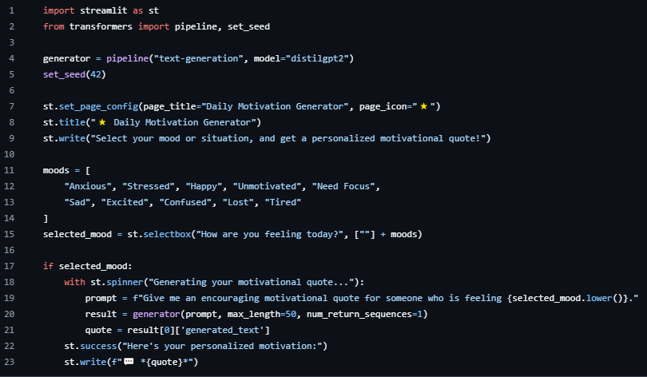
7.2: README.md
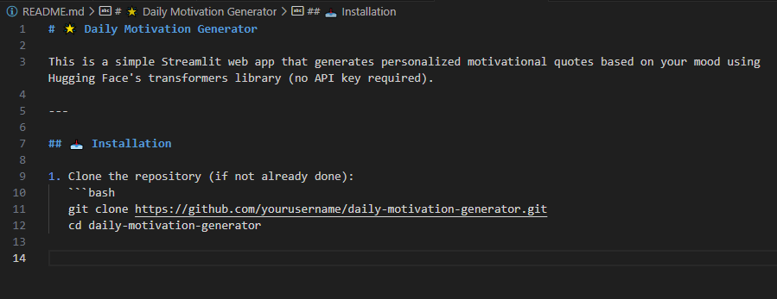
7.3 requirements.txt:
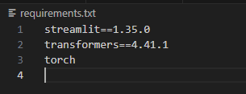

8 Outputs:

