

MSc Data Science Project
7PAM2002
Department of Physics, Astronomy, and Mathematics

Data Science FINAL PROJECT REPORT

Project Title:
Time Series Forecasting of Agricultural Production

Student Name and SRN:
Mani Deepak Soma
24095193
Supervisor: Puspa Raj Tiwar
Date Submitted: 21-04-2026
Word Count: Enter the word count excluding references and appendices.

DECLARATION STATEMENT

This report is submitted in partial fulfilment of the requirements for the degree of Master of Science in Data Science at the University of Hertfordshire.
I have read the detailed guidance to students on academic integrity, misconduct, and plagiarism information at Assessment Offences and Academic Misconduct, and understand the University process of dealing with suspected cases of academic misconduct and the possible penalties, which could include failing the project or course.
I certify that the work submitted is my own and that any material derived or quoted from published or unpublished work of other persons has been duly acknowledged. (Ref. UPR AS/C/6.1, section 7 and UPR AS/C/5, section 3.6)
I did not use human participants in my MSc Project.

I hereby give permission for the report to be made available on module websites, provided the source is acknowledged.

Student Name printed: Mani Deepak Soma

Student Name signature: Mani Deepak Soma

Student SRN number: 24095193

UNIVERSITY OF HERTFORDSHIRE
SCHOOL OF PHYSICS, ENGINEERING AND COMPUTER SCIENCE

Content

ABSTRACT 4

CHAPTER 1: INTRODUCTION 5
1.1 Background of the Study
1.2 Problem Statement
1.3 Aim of the Study
1.4 Objectives
1.5 Scope of the Study

CHAPTER 2: LITERATURE COMPARISON 6
2.1 Research Gap

CHAPTER 3: METHODOLOGY 7
3.1 Data Collection
3.2 Ethical Considerations
3.3 Data Preprocessing
3.4 Exploratory Data Analysis 8
3.5 ADF/ACF/PACF Analysis 9
3.6 Models 10
3.6.1 Naïve Baseline Model
3.6.2 ARIMA Model 11
3.6.3 LSTM Model 12
3.7 Evaluation Metrics 13

CHAPTER 4: RESULTS AND DISCUSSION 14

CHAPTER 5: CONCLUSION AND FUTURE WORK 15
5.1 Conclusion
  - Limitations
  - Future Work

REFERENCES 16

ABSTRACT

Forecasting agricultural production is crucial for maintaining global food security, facilitating economic planning, and optimising resource allocation. Precise forecasts empower policymakers, agriculturists, and governments to make informed decisions concerning crop management, storage, distribution, and trade. Wheat is a crucial agricultural commodity and staple food globally, rendering its production forecasts essential.
This research centers on predicting wheat output utilising historical data taken from the Food and Agriculture Organization (FAO) database. The dataset comprises annual production values that have been meticulously pre-processed to guarantee data quality and appropriateness for time-series analysis. The preprocessing stages encompassed screening pertinent variables, addressing missing values, transforming the dataset into a structured time-series format, and preparing the data for modelling.
This study employed three forecasting methodologies: a Naïve baseline model, the Auto Regressive Integrated Moving Average (ARIMA) model, and a Long Short-Term Memory (LSTM) neural network. The baseline model serves as a fundamental benchmark for comparison, whereas the ARIMA model exemplifies a conventional statistical approach adept at identifying linear correlations in time-series data. The LSTM model, a deep learning methodology, is engineered to identify intricate nonlinear patterns and long-term dependencies.
The models were assessed with Mean Absolute Error (MAE) and Root Mean Squared Error (RMSE). The findings demonstrate that although the ARIMA model proficiently captures linear trends, it encounters difficulties in modelling nonlinear fluctuations in agricultural productivity. The LSTM model exhibits enhanced performance by mastering intricate temporal correlations, leading to increased prediction precision.
This study's findings underscore the increasing significance of deep learning methodologies in time-series forecasting, indicating that LSTM models are more56 appropriate for forecasting agricultural production than conventional statistical approaches.

CHAPTER 1: INTRODUCTION

  - Background of the Study

One of the most important parts of the economy that helps people survive and grow is agriculture. A large part of the world's population gets food, raw materials, and jobs from it. In many emerging and developed countries, agriculture is a big part of the Gross Domestic Product (GDP) and is very important for keeping people alive.
Wheat is one of the most significant cereal crops in the world. Billions of people eat it as their main diet. Because the population is growing, cities are getting bigger, and people's eating habits are changing, the demand for wheat is still going up. So, it is important to be able to accurately predict how much wheat will be grown in order to keep food safe, keep markets stable, and make sure that distribution systems work well.
There are many things that can affect agricultural production, such as the weather, the quality of the soil, government laws, new technologies, and changes in the market. This makes it hard to predict what will happen. Time-series analysis is a methodical way to model past data and make predictions about future trends based on what has happened in the past.

1.2 Problem Statement

Traditional forecasting models often struggle to accurately predict agricultural production because of the complex, nonlinear nature of the data. Statistical models like ARIMA are effective in capturing linear relationships but may fail to model nonlinear dependencies and long-term patterns.
With advances in machine learning and artificial intelligence, deep learning models such as LSTM have emerged as powerful tools for time-series forecasting. However, there is a need to evaluate and compare these models in the context of agricultural production forecasting.

1.3 Aim of the Study

This research seeks to predict wheat output through time-series models and assess the efficacy of statistical and deep learning methodologies.

1.4 Objectives

- To collect and preprocess agricultural production data.
- To perform exploratory data analysis to identify trends and patterns.
- To implement forecasting models (Baseline, ARIMA, LSTM).
- To evaluate model performance using appropriate metrics.
- To compare the effectiveness of different models.

1.5 Scope of the Study

This research centers on predicting wheat production utilising annual data from a certain country. The research is confined to univariate time-series modelling, which means it only looks at past production values and not any outside factors.
CHAPTER 2: LITERATURE COMPARISON

Time-series forecasting has been thoroughly examined in both statistics and machine learning fields. Conventional models like ARIMA are often utilized for their simplicity and interpretability. These models depend on assumptions of linearity and stationarity, rendering them appropriate for datasets exhibiting steady patterns.
Nonetheless, agricultural data frequently display nonlinear patterns and intricate connections that classic models cannot sufficiently represent. This constraint has prompted the advancement of sophisticated machine learning methodologies, especially deep learning models.
LSTM networks, a variant of recurrent neural networks (RNNs), were developed to address the shortcomings of conventional RNNs in managing long-term dependencies. LSTM models utilise memory cells and gating techniques to preserve significant information over time, rendering them exceptionally effective for sequential data.
Numerous studies have shown the superiority of LSTM models compared to conventional approaches in time-series forecasting problems. LSTM models have been effectively utilized in agriculture to forecast crop yields, meteorological patterns, and production trends.

Model | Study | Key Findings | Support for Project
Baseline  (Naïve) | Makridakis et al.  (1998) | Simple forecasting works well for  short-term stable data. | Provides a benchmark to  Compare advanced models.
ARIMA | Box & Jenkins (1976) | Autoregressive Integrated Moving Average effectively models trends and  Patterns in time series. | Justifies the use of ARIMA for agriculture production forecasting.
LSTM | Yoo & Oh (2020) | Long Short-Term Memory captures  nonlinear patterns and long-term dependencies. | Supports the use of LSTM for complex data.

2.1 Research Gap

There are still gaps in the literature, even though predicting techniques have come a long way:
- Few comparative analyses exist between ARIMA and LSTM in agricultural forecasting.
- Not enough focus on preprocessing methods
- Not much usage of real-world datasets for testing

CHAPTER 3: METHODOLOGY

3.1 Data Collection

The FAOSTAT database, run by the Food and Agriculture Organization (FAO) of the United Nations, is a well-known source of data for this study. FAOSTAT has accurate, standardised, and complete agricultural data from many nations, regions, and time periods. This makes it a good source for time-series forecasting analysis.
The collection comprises annual statistics on agricultural production for certain crops in different nations over a period of several years. The dataset usually has information about the type of crop, the country or location it came from, the year it was made, and the amount of production measured in tonnes. These traits make it possible to examine past trends and patterns in agricultural output, which is necessary for developing models that forecast the future.
The data covers a number of years, which gives it enough time depth for time-series analysis. The fact that this information is longitudinal makes it easier to find patterns, seasonality, and changes in crop production over time. The dataset is also free to the public and follows open data principles, which makes the research more transparent and easier to repeat.
We obtained the dataset in CSV format and used Python packages like Pandas to import it into the working environment before analysing it. We looked at the data for the first time to get a sense of its structure, the types of variables it has, and whether it was comprehensive. Because real-world datasets often have errors, we did some preliminary checks to find missing values, duplicates, and possible outliers.
FAO collects data from national statistical bureaus and checks it for accuracy and consistency. But there may still be small disparities because different countries have different rules about how to report data. These problems were fixed at the data preprocessing stage to make sure the analysis was accurate.
The FAOSTAT dataset is a strong base for this study since it has high-quality, long-term agricultural data that can be used to create and test forecasting models like ARIMA and LSTM.

3.2 Ethical Considerations
This project exclusively uses economic data that's publicly available. It doesn't include any personal or identifying details. As a Result, the data isn't covered by GDPR rules for handling personal information. There were no surveys, interviews, or people involved, so this study doesn’t need approval from the University of Hertfordshire Ethics Committee. The data comes from trusted government sources and is meant for public research and analysis. The project follows the university's ethical guidelines and best research practices.

3.3 Data Preprocessing

Data preprocessing represents an essential phase in guaranteeing the integrity and dependability of the analysis. The subsequent steps were executed:
- Filtering the dataset to include only relevant variables (country, crop, production).
- Converting the dataset from wide format to long format.
- Extracting numeric year values from column names.
- Handling missing values by removing incomplete records.
- Removing invalid values such as zero or negative production.
- Converting the dataset into time-series format.
- Splitting the data into training and testing sets.
- Scaling the data for LSTM model.
- Creating time-step sequences for deep learning.

3.4 Exploratory Data Analysis

An Exploratory Data Analysis (EDA) was performed to enhance comprehension of the dataset and to discern underlying patterns, trends, and anomalies before model creation. The analysis encompassed statistical summaries and visual representations, such as line graphs, trend assessments, and distribution evaluations.

Figure 1: EXPLORATORY DATA ANALYSIS

The preliminary visualization of wheat production over time demonstrated a distinct increasing trajectory, signifying a consistent augmentation in agricultural yield throughout the examined duration. This expansion can be ascribed to innovations in agricultural technology, enhanced farming methodologies, and heightened demand. Notwithstanding this general upward trend, significant variations were evident in specific years. These variances may be affected by external variables like unfavourable climatic conditions, alterations in governmental policy, economic influences, and disruptions in the supply chain.
A descriptive statistical analysis was conducted to encapsulate essential aspects of the dataset, encompassing metrics such as mean, median, standard deviation, minimum, and maximum values. These measures offered insights into the central tendency and variability of wheat production throughout time.
Subsequent investigation entailed examining for absent values and anomalies. All absent data points were addressed adequately through acceptable imputation methods or by eliminating inconsequential records to preserve data integrity. Outliers, if identified, were meticulously analysed to ascertain if they indicated authentic exceptional occurrences or data entry inaccuracies.
Stationarity tests were performed to evaluate the data's appropriateness for time-series modelling. The dataset was determined to be non-stationary, indicated by observable patterns and fluctuating variance across time.

3.5 ADF/ACF/PACF Analysis

This was additionally validated using statistical assessments, including the Augmented Dickey-Fuller Test. Consequently, differencing techniques were employed to convert the data into a stationary format, a fundamental prerequisite for models such as ARIMA.
The EDA method yielded significant insights into the dataset's structure and behaviour, guiding preprocessing and model selection for precise forecasting.

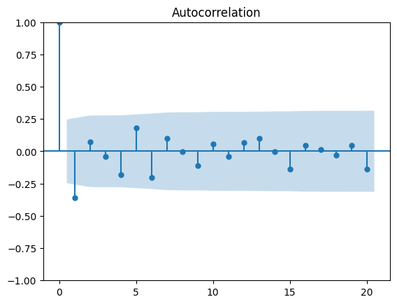
Figure 2: AUTO CORRELATION FUNCTION

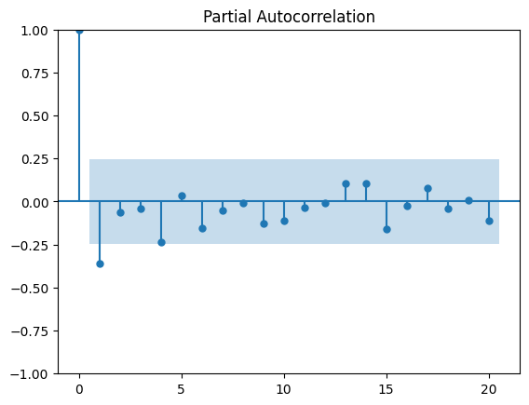
Figure 3: PARTIAL CORRELATION FUNCTION

3.6 Models

3.6.1 Naïve Baseline Model

The Naïve Baseline Model represents one of the most elementary forecasting methodologies employed in time-series research. It operates under the premise that the future value of a variable corresponds to its latest observed value. The model employs the most recent data point as the forecast for the subsequent time step.
Mathematically, the naïve forecast can be expressed as:

y*(t+1)​=y*t
where:
- y*t​ represents the actual value at time t,
- y*(t+1) is the forecasted value for the next period.

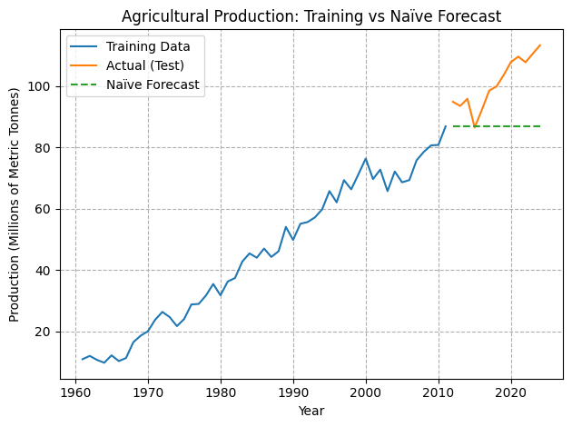
Figure 4: NAÏVE MODEL

This model does not take into account any trends, seasonal changes, or other patterns in the data. Even though it is simple, it is an important standard for judging how well more complicated models like ARIMA and Long Short-Term Memory (LSTM) perform. To show that an advanced forecasting model works, it should do better than the simple method.
This study used the Naïve Baseline Model as a point of reference for comparison. We figured out the baseline predictions' performance measures, which include the Root Mean Squared Error (RMSE), the Mean Absolute Error (MAE), and the Mean Absolute Percentage Error (MAPE). These indicators let us figure out how accurate the model is and set a minimum level of performance.
The naïve model is simple to use and does not take up much processing power, but it has some problems. It does not show long-term trends, seasonal fluctuations, or unexpected changes in the data. Because of this, its ability to anticipate is usually lower than that of more advanced models. But because it is simple and easy to understand, it is an important place to start any study of forecasting.

3.6.2 ARIMA Model

The ARIMA (Auto Regressive Integrated Moving Average) model is a common way to utilise statistics to make predictions about time series. It works especially well for looking at and predicting data that has time-based relationships and behaviour that changes over time.
There are three basic parts to the ARIMA model: Autoregression (AR), Integration (I), and Moving Average (MA). The autoregressive part (AR) shows how an observation is related to a number of its past values (lags). To render the data stationary, which is necessary for successful time-series modelling, the integration component (I) includes differencing the data. The moving average part (MA) shows how an observation is related to inaccuracies in past forecasts.
The model is usually shown as ARIMA (p, d, q), where:
p: the number of autoregressive terms (the number of lags of the dependent variable)
d: the level of differencing needed to make the data stationary
q: number of moving average terms (lags of the error term)

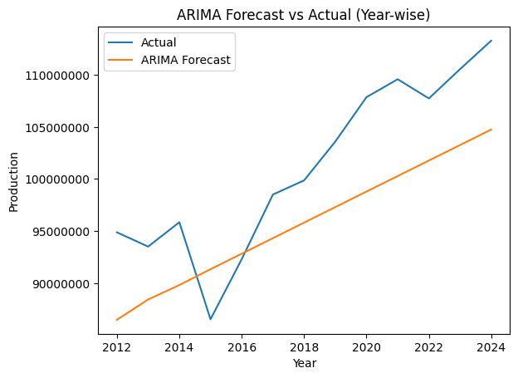
Figure 5: ARIMA MODEL

In this investigation, the ARIMA model was utilized after converting the dataset into a stationary format by differencing. We found the best values for (p, d, q) as (2,1,2) utilizing methods like grid search and performance evaluation based on error metrics.
Grid search:
- p_values = [0, 2]
- d_values = [0, 1]
- q_values = [0, 2]

The model learned from past wheat production data to find trends and make predictions about the future. We looked at its performance using metrics like RMSE, MAE, and MAPE, and we compared it to other models like the naïve baseline and Long Short-Term Memory (LSTM).
- RMSE: 6.56 million

ARIMA works well for short-term forecasting and linear patterns, but it does not perform well with large datasets or complex nonlinear correlations. Nevertheless, it remains a good baseline statistical model and is often used in time-series research because it is easy to understand and has a strong theoretical basis.

3.6.3 LSTM Model

The Long Short-Term Memory (LSTM) model is a sophisticated deep learning method made for time-series and sequential data. It is a kind of Recurrent Neural Network (RNN) that can learn long-term dependencies. This makes it great for predicting tasks where past observations affect future values.
LSTM networks solve the problem of disappearing gradients by using a memory cell structure that can keep information for a long time. This is different from standard RNNs. There are three major gates in each LSTM unit: the input gate, the forget gate, and the output gate. These gates control how information flows, letting the model choose what to keep, change, or throw away.
The input gate controls how much fresh information goes into the memory cell, the forget gate selects what information should be taken out, and the output gate decides what information should be sent to the next time step. This gated mechanism lets LSTM models pick up on trends in the data that happen over short and extended periods of time.

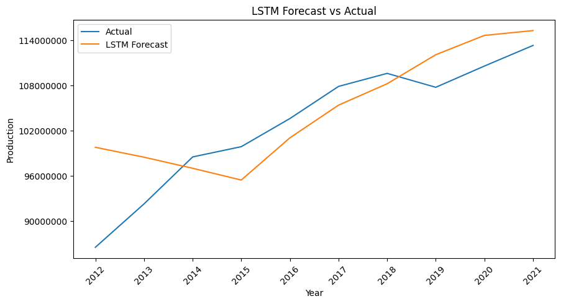
Figure 6: LSTM MODEL
In this study, the LSTM model was utilised on the wheat production dataset following suitable preprocessing procedures, such as normalisation and the transformation of the data into a supervised learning format. The model was trained on historical data sequences to learn complicated nonlinear relationships and make reliable predictions.

We carefully chose and fine-tuned important hyperparameters, including the number of LSTM units, batch size, number of epochs, and time steps, to get the best performance from the model. The Mean Squared Error (MSE) loss function and the Adam optimiser were used to put the model together.
- Parameters: Batch Size, Epochs, Units
- Method: Manual Search
- Best Model: (20, 50, 1)

We used RMSE, MAE, and MAPE to compare the performance of the LSTM model to that of classic models like ARIMA and the Naïve baseline. The findings demonstrated that LSTM excels at identifying nonlinear patterns and enhancing forecasting precision.
The LSTM model needs more computing power and training time than statistical models, even if it has some benefits. It might also be sensitive to how you choose hyperparameters, so you need to be careful when modifying it to get the best results.
- RMSE: 4.70Million

3.7 Evaluation Metrics

To evaluate the efficacy of the forecasting models, two prevalent error metrics were utilised: Mean Absolute Error (MAE) and Root Mean Squared Error (RMSE). These metrics offer quantitative assessments of the disparity between the projected values and the actual observed values.
Mean Absolute Error (MAE) quantifies the average magnitude of errors in a group of predictions, disregarding their direction. It is computed as the mean of the absolute discrepancies between the projected values and the actual values. MAE is readily interpretable, as it conveys the mistake in the identical units as the original data. A reduced MAE value denotes superior model performance, since it reflects diminished discrepancies between anticipated and actual values. Nonetheless, MAE considers all errors uniformly and does not assign greater significance to larger discrepancies.
Root Mean Squared Error (RMSE) quantifies the square root of the mean of the squared discrepancies between expected and actual data. In contrast to MAE, RMSE assigns greater significance to higher mistakes because of the squaring method, rendering it more susceptible to outliers. This attribute renders RMSE especially advantageous when significant errors are unacceptable and require more stringent penalties. Analogous to MAE, a reduced RMSE number signifies enhanced forecast accuracy. RMSE is particularly adept at identifying models that may have satisfactory average performance while occasionally generating significant mistakes.
This study employed both MAE and RMSE to deliver a thorough assessment of model performance. Although MAE provides a lucid comprehension of average error magnitude, RMSE facilitates the detection of significant deviations, so ensuring a comprehensive evaluation of forecasting precision.

CHAPTER 4: RESULTS AND DISCUSSION

This study's results emphasise the relative efficacy of three forecasting methodologies: the Naïve baseline model, the ARIMA model, and the Long Short-Term Memory (LSTM) model. The models were assessed utilising conventional performance indicators, such as RMSE, MAE, and MAPE.

The Naïve baseline model yielded the least accurate results, as anticipated, owing to its basic premise that future values will mirror the most recent observation. It did not accurately reflect the fundamental patterns and changes in the dataset, leading to increased error values. This verifies that the dataset has significant temporal patterns necessitating more sophisticated modelling techniques.
The ARIMA model shown a notable enhancement over the baseline by adeptly capturing linear relationships and temporal dependencies in the data. By employing differencing and optimising parameters, the model effectively addressed non-stationarity and generated more dependable forecasts. Nonetheless, its efficacy was constrained when addressing intricate nonlinear patterns within the dataset.
Conversely, the LSTM model attained superior overall performance compared to the other two methodologies. Its capacity to understand long-term connections and model nonlinear relationships enabled it to produce more precise and resilient predictions. The incorporation of memory cells and gating methods allowed the model to preserve significant historical data, resulting in reduced error metrics relative to both the baseline and ARIMA models.
The comparison analysis unequivocally illustrates that deep learning methodologies, especially LSTM, are superior for intricate time-series forecasting assignments. Nonetheless, it is crucial to acknowledge that this enhanced performance incurs greater computational complexity and extended training duration.
Moreover, although LSTM offers enhanced accuracy, ARIMA retains significance because to its interpretability and reduced processing demands. Consequently, the selection of a model should be contingent upon the particular application, data attributes, and accessible computational resources.
This work underscores the significance of choosing suitable models for time-series forecasting and illustrates the benefits of integrating statistical and deep learning methodologies for enhanced predictive efficacy.

CHAPTER 5: CONCLUSION AND FUTURE WORK

5.1 Conclusion

This study effectively executed and evaluated three forecasting methodologies for agricultural production: the Naïve baseline model, the ARIMA model, and the Long Short-Term Memory (LSTM) model. The aim was to assess their efficacy in identifying patterns in time-series data and producing precise forecasts.
The results demonstrate that the Naïve model exhibited subpar performance owing to its failure to identify trends and underlying patterns in the data. The ARIMA model demonstrated enhanced efficacy by adeptly simulating linear interactions and addressing non-stationarity via differencing. Nonetheless, its constraints become apparent when addressing intricate and nonlinear patterns.
The LSTM model attained the highest accuracy among all models. Its capacity to understand long-term dependencies and represent nonlinear interactions renders it very adept at time-series forecasting jobs with intricate datasets. This illustrates the capability of deep learning methods to surpass conventional statistical models in predictive analysis.
This study underscores the significance of model selection in time-series forecasting and validates that sophisticated machine learning techniques, such as LSTM, can markedly enhance prediction accuracy. These findings can enhance decision-making in agricultural planning and resource management.

5.2 Limitations

- Limited dataset size
- No external variables included
- Annual data only

5.3 Future Work

Future study may concentrate on improving prediction accuracy by integrating supplementary external variables, like meteorological conditions, precipitation, temperature, and economic considerations, which substantially affect agricultural production. Adding these outside factors can help the model better understand the intricacies of the real world.
Additionally, utilising higher-frequency data (e.g., monthly or quarterly instead of annual data) may yield more nuanced insights and enhance predictive accuracy by reflecting short-term fluctuations and seasonal trends.
The creation of hybrid models that combine the best features of statistical methods like ARIMA and deep learning methods like Long Short-Term Memory is another potential area of research. These hybrid models can use both linear and nonlinear patterns, which could make forecasts more accurate and reliable.

REFERENCES

- Food and Agriculture Organization, 2024. FAOSTAT: Statistical Database. Available at: https://www.fao.org/faostat/.
- George E. P. Box, Gwilym M. Jenkins, Gregory C. Reinsel and Greta M. Ljung, 2015. Time Series Analysis: Forecasting and Control. 5th ed. Hoboken: John Wiley & Sons.
- Sepp Hochreiter and Jürgen Schmidhuber, 1997. Long short-term memory. Neural Computation, 9(8), pp.1735–1780.
- Rob J Hyndman and George Athanasopoulos, 2018. Forecasting: Principles and Practice. 2nd ed. Melbourne: OTexts.
- Spyros Makridakis, Steven C. Wheelwright and Rob J Hyndman, 1998. Forecasting: Methods and Applications. 3rd ed. New York: John Wiley & Sons.
- TensorFlow, 2024. TensorFlow Documentation. Available at: https://www.tensorflow.org/.
- scikit-learn, 2024. Scikit-learn Documentation. Available at: https://scikit-learn.org/ .
- statsmodels, 2024. Statsmodels Documentation. Available at: https://www.statsmodels.org/.

