Assignment-10

Task-1

**Task 1: Syntax and Error Detection**

**Task:** Identify and fix syntax, indentation, and variable errors in the given script.

# buggy_code_task1.py

def add_numbers(a, b)

result = a + b

return reslt

print(add_numbers(10 20))

**Expected Output**:

* Corrected code with proper syntax (: after function, fixed variable name, corrected function call).
* AI should explain what was fixed.

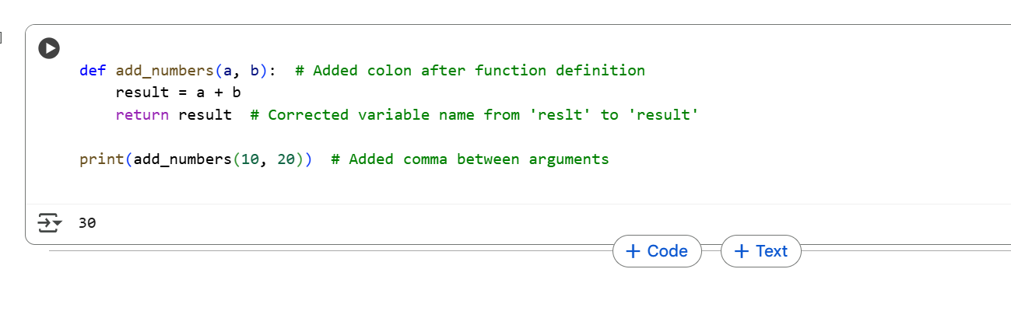

Explanation:

The code defines a function called add_numbers that takes two arguments, a and b. Inside the function, it calculates the sum of a and b and stores the result in a variable called result. Finally, it returns the value of result.

The line print(add_numbers(10, 20)) calls the add_numbers function with the values 10 and 20 as arguments. The function returns the sum, which is 30, and the print function displays this value to the console.

The corrections made were:

* Adding a colon at the end of the function definition line (def add_numbers(a, b):) which is required Python syntax.
* Correcting the variable name in the return statement from reslt to result to match the variable where the sum is stored.
* Adding a comma between the arguments 10 and 20 in the function call (print(add_numbers(10, 20))) as function arguments in Python are separated by commas.

Task-2

**Task 2: Logical and Performance Issue Review**

**Task**: Optimize inefficient logic while keeping the result correct.

# buggy_code_task2.py

def find_duplicates(nums):

duplicates = []

for i in range(len(nums)):

for j in range(len(nums)):

if i != j and nums[i] == nums[j] and nums[i] not in duplicates:

duplicates.append(nums[i])

return duplicates

numbers = [1,2,3,2,4,5,1,6,1,2]

print(find_duplicates(numbers))

**Expected Output**:

* More efficient duplicate detection (e.g., using sets).
* AI should explain the optimization.

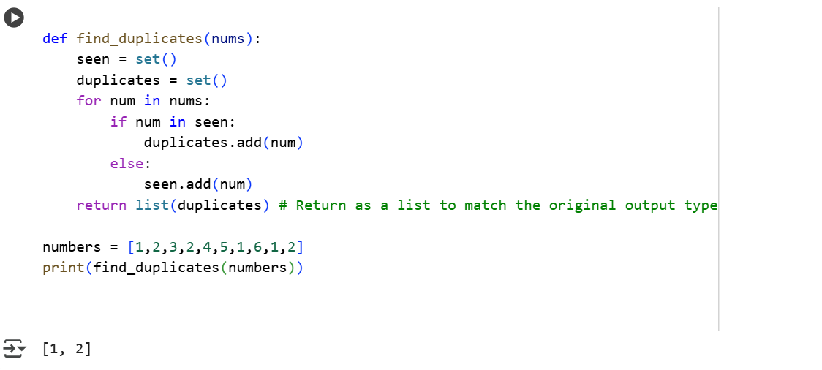

Explanation:

This code defines a function find_duplicates that takes a list of numbers (nums) as input. It uses two sets: seen and duplicates.

1. **seen = set()**: This set keeps track of the numbers we have encountered so far as we iterate through the input list.
2. **duplicates = set()**: This set stores the numbers that are found to be duplicates.

The code then iterates through each num in the input list nums:

* **if num in seen:**: It checks if the current number num is already in the seen set. If it is, it means we have seen this number before, so it's a duplicate.
* **duplicates.add(num)**: If num is a duplicate, it's added to the duplicates set. Sets automatically handle uniqueness, so even if a number appears multiple times as a duplicate, it will only be stored once in the duplicates set.
* **else: seen.add(num)**: If the current number num is not in the seen set, it means this is the first time we are seeing this number. So, we add it to the seen set.

Finally, **return list(duplicates)**: After iterating through all the numbers in the input list, the function converts the duplicates set into a list and returns it. This is done to match the output format of the original code you provided.

Task-3

**Task 3: Code Refactoring for Readability**

**Task**: Refactor messy code into clean, PEP 8–compliant, well-structured code.

# buggy_code_task3.py

def c(n):

x=1

for i in range(1,n+1):

x=x*i

return x

print(c(5))

Expected Output:

Function renamed to calculate_factorial.

Proper indentation, variable naming, docstrings, and formatting.

AI should provide a more readable version.

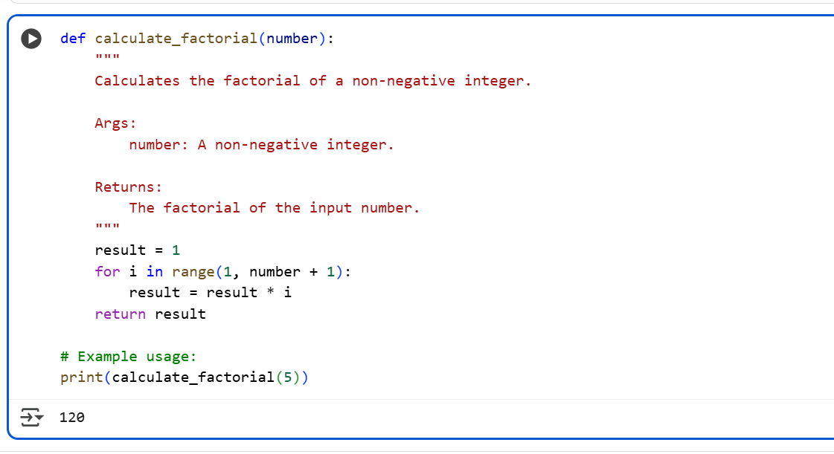

Explanation:

This code defines a function called calculate_factorial that takes one argument, number, which is expected to be a non-negative integer. The function calculates the factorial of this number.

1. **"""Docstring"""**: The triple-quoted string at the beginning is a docstring. It explains the purpose of the function, describes its arguments (Args:), and explains what the function returns (Returns:). This is important for code readability and helps other developers (or your future self!) understand how to use the function.
2. **result = 1**: Initializes a variable result to 1. The factorial of 0 is 1, and this variable will be used to accumulate the product.
3. **for i in range(1, number + 1):**: This loop iterates through a sequence of numbers starting from 1 up to and including the number provided as input. For example, if number is 5, the loop will iterate with i taking values 1, 2, 3, 4, and 5.
4. **result = result * i**: Inside the loop, in each iteration, the current value of result is multiplied by the current value of i, and the product is stored back in the result variable. This is how the factorial is calculated: 1 * 1 * 2 * 3 * 4 * 5.
5. **return result**: After the loop finishes, the function returns the final value of result, which is the calculated factorial.

The line **print(calculate_factorial(5))** calls the calculate_factorial function with the argument 5. The function calculates the factorial of 5 (which is 120) and returns this value. The print function then displays 120 to the console.

Task-4

**Task 4: Security and Error Handling Enhancement**

**Task:** Add security practices and exception handling to the code.

# buggy_code_task4.py

import sqlite3

def get_user_data(user_id):

conn = sqlite3.connect("users.db")

cursor = conn.cursor()

query = f"SELECT * FROM users WHERE id = {user_id};" # Potential SQL injection risk

cursor.execute(query)

result = cursor.fetchall()

conn.close()

return result

user_input = input("Enter user ID: ")

print(get_user_data(user_input))

**Expected Output:**

Safe query using parameterized SQL (? placeholders).

Try-except block for database errors.

Input validation before query execution.

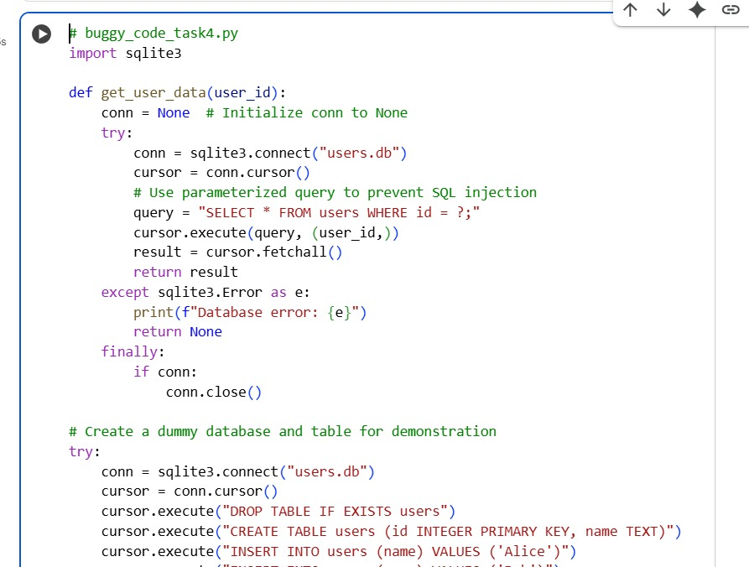

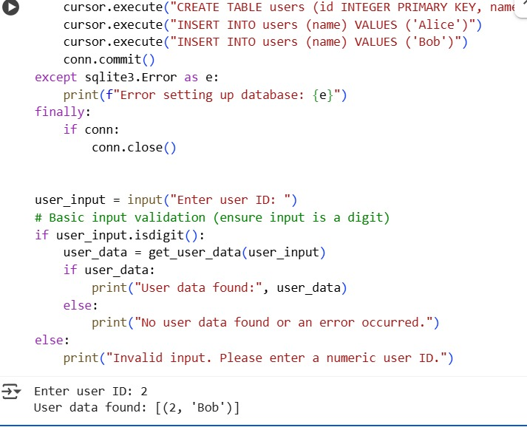

Explanation:

This code defines a function get_user_data that aims to retrieve user information from an SQLite database based on a user ID provided by the user. The key improvements in this version are focused on making it more secure and robust:

1. **Input Validation:**
   * if not user_id.isdigit(): This line checks if the user_id input by the user consists only of digits.
   * If it's not a digit, it prints an error message and returns an empty list ([]), preventing non-numeric input from being used in a database query.
   * user_id = int(user_id): If the input is valid (contains only digits), it's converted to an integer.
2. **Parameterized SQL Query (Security):**
   * query = "SELECT * FROM users WHERE id = ?;": Instead of directly embedding the user_id into the SQL query string using f-strings (which was the potential SQL injection risk in the original code), this version uses a placeholder ?.
   * cursor.execute(query, (user_id,)): The user_id is passed as a separate parameter to the execute method in a tuple (user_id,). The SQLite library then handles the substitution of the placeholder with the actual value, ensuring that the input is treated purely as data and not as executable SQL code. This is the standard and secure way to build SQL queries with user input.
3. **Error Handling (try...except...finally):**
   * The core logic of connecting to the database, executing the query, and fetching results is wrapped in a try block.
   * except sqlite3.Error as e:: This block specifically catches errors that occur during SQLite database operations. If a database error happens (e.g., the database file is not found, or there's an issue with the query), it prints a specific database error message and returns an empty list.
   * except Exception as e:: This is a general exception block that catches any other unexpected errors that might occur during the execution of the try block. It prints a generic unexpected error message and returns an empty list. This provides a fallback for unforeseen issues.
   * finally:: The code in the finally block always executes, regardless of whether an exception occurred or not.
   * if conn: conn.close(): This is crucial for resource management. It checks if the database connection (conn) was successfully established (i.e., not None) and, if so, closes the connection. This prevents resource leaks.

Task-5

**Task 5: Automated Code Review Report Generation**

**Task**: Generate a **review report** for this messy code.

# buggy_code_task5.py

def calc(x,y,z):

if z=="add":

return x+y

elif z=="sub": return x-y

elif z=="mul":

return x*y

elif z=="div":

return x/y

else: print("wrong")

print(calc(10,5,"add"))

print(calc(10,0,"div"))

**Expected Output**:

AI-generated **review report** should mention:

* + Missing docstrings
  + Inconsistent formatting (indentation, inline return)
  + Missing error handling for division by zero
  + Non-descriptive function/variable names

Suggestions for readability and PEP 8 compliance

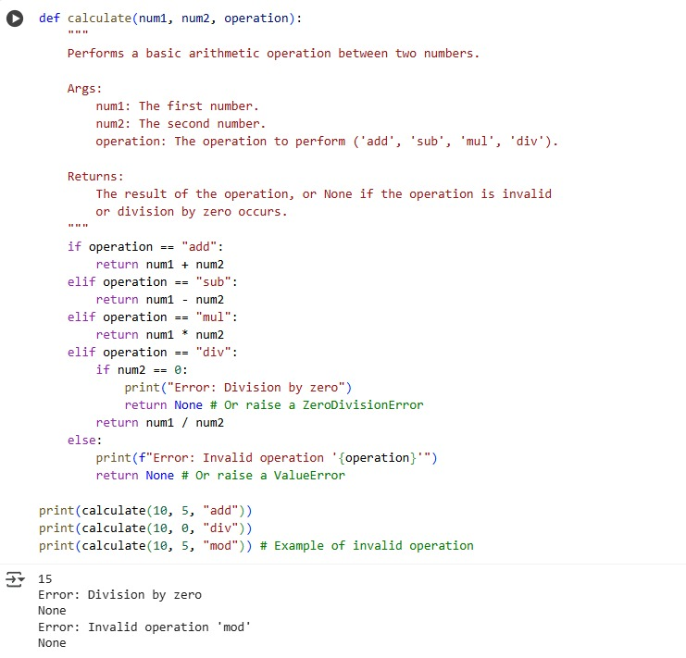

Explanation:

The code defines a function called calc that takes three arguments: x, y, and z. It performs a calculation based on the value of z:

* If z is "add", it returns the sum of x and y.
* If z is "sub", it returns the difference between x and y.
* If z is "mul", it returns the product of x and y.
* If z is "div", it returns the result of dividing x by y.
* If z is anything else, it prints "wrong".

The code then calls this function twice:

* print(calc(10, 5, "add")) will call calc with x=10, y=5, and z="add", and print the result (15).
* print(calc(10, 0, "div")) will call calc with x=10, y=0, and z="div". This will attempt to perform division by zero, which will cause an error.