ASSIGNMENT-17.4
Task 1 – Employee Data Preprocessing
Task:
Use AI to generate a Python script for cleaning an employee dataset.
Instructions:
- Handle missing values in columns (salary, department, joining_date).
- Convert the "joining_date" column into proper datetime format.
- Standardize department names (e.g., "HR", "hr", "Human Resources" → "HR").
- Encode categorical variables (department, job_role).
Expected Output:
- A cleaned Pandas DataFrame with consistent departments, proper dates, and encoded features.
CODE AND OUTPUT:
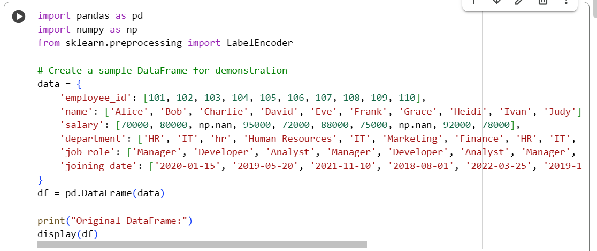
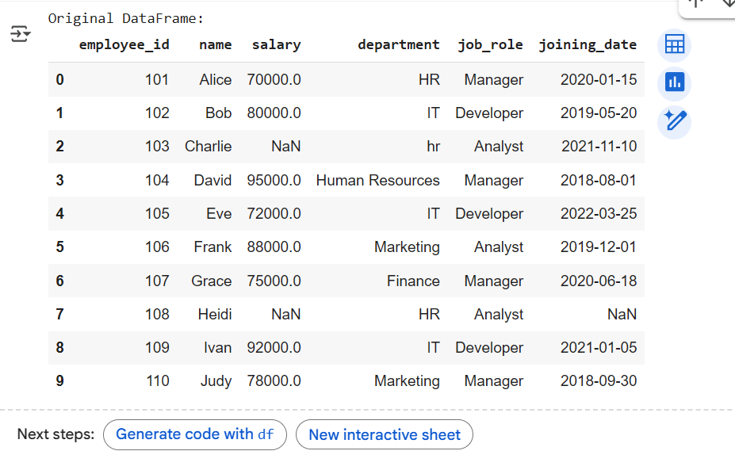
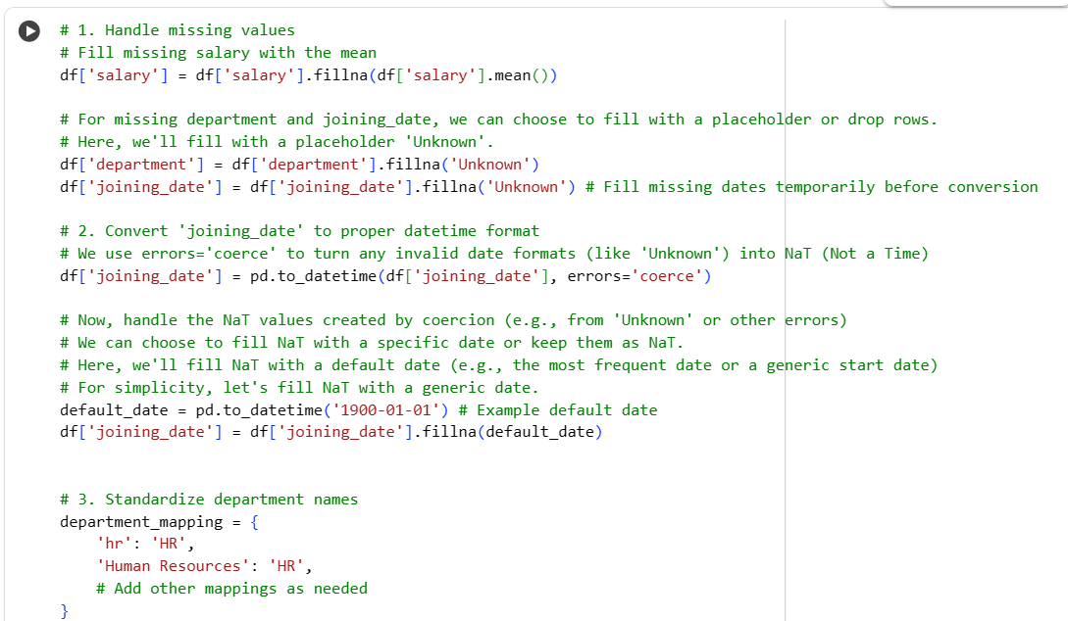
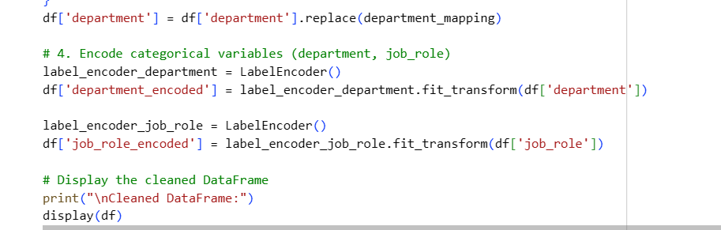
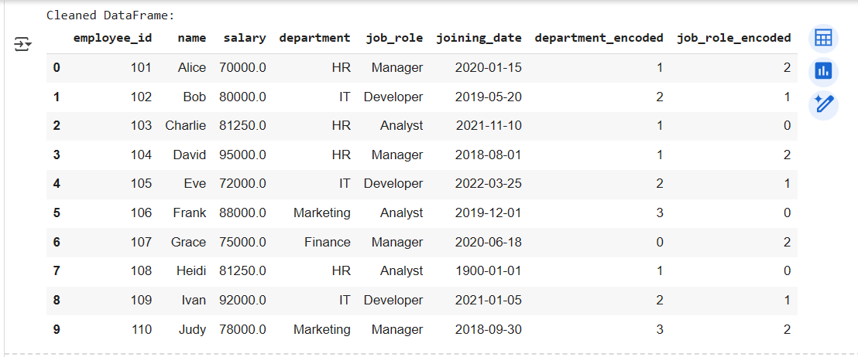
Task 2 – Sales Transaction Data Preprocessing
Task:
Use AI to generate a script for preprocessing a sales transaction dataset.
Instructions:
- Convert transaction dates to proper datetime format.
- Create a new column for “Month-Year” from the transaction date.
- Remove rows with negative or zero transaction amounts.
- Normalize the "transaction_amount" column using Min-Max scaling.
Expected Output:
- A preprocessed DataFrame with valid dates, normalized amounts, and no invalid records.
CODE AND OUPUT:

