SIMATS ENGINEERING (SAVEETHA SCHOOL OF ENGINEERING)
Department of Artificial Intelligence and Data Science ASSESSMENT TOOL 2 – Technical Presentation

Course Code: | DSA03 | Course Title: | Natural Language Processing
CO Assessed: | CO1 – Imitation (L1) | Assessment: | Assessment Tool 2 – Technical Presentation
Weightage: | 30% of CIA
CO1 Statement: | Analyse NLP models, regular expression patterns, finite state automata, morphological processing techniques and to interpret language processing. (BL-3)
Student Name: | G. Aswartha Manidheep , K. Lokesh | Reg. No.: | 192425089 , 192472020
Section / Batch: | Btech AI & ML , CSE AI | Date: | 16-07-2026

Code of Conduct
I G. Aswartha Manidheep , K. Lokesh (Name / Reg No) certify that this submission is my original work and that I have adhered to the guidelines specified for this assessment. I understand that any violation of academic integrity rules will result in disciplinary action.
Signature of the Student: G. Aswartha Manidheep , K. Lokesh

Instructions
- Suggested Team Member Roles (3 Members)
- Member 1: Theory, Concepts, and Literature Review
- Member 2: Algorithm Design, Models, and Technical Analysis • Member 3: Demonstration, Case Study, Applications, and Conclusion • GPS photo must submit.
- Duration: 30 minutes.

Section / Topic | Focus | Q Nos
Evolution of Natural Language Processing: From Rule-Based Systems to Modern NLP | NLP Models, Language Processing Evolution | TP-01
Comparative Study of NLP Models and Algorithms | Model Analysis, Algorithm Comparison | TP-02
Regular Expressions for Real-World Text Processing | Pattern Matching, Information Extraction | TP-03
Designing Efficient Regular Expression Patterns for Information Extraction | Text Mining, Data Extraction Techniques | TP-04
Finite State Automata in Natural Language Processing | State Transitions, Language Recognition | TP-05
Building a Finite State Automaton for Token Recognition | Lexical Analysis, Token Validation | TP-06
Morphology and Word Formation in Natural Languages | Morpheme Analysis, Word Structure Processing | TP-07
Inflectional Morphology: Understanding Grammatical Variations | Grammatical Analysis, Word Normalization | TP-08
Derivational Morphology and Vocabulary Expansion | Word Generation, Semantic Transformation | TP-09
Comparative Analysis of Inflectional and Derivational Morphology | Morphological Classification, Language Analysis | TP-10

Finite-State Morphological Parsing Techniques | Morphological Parsing, Finite-State Processing | TP-11
Morphological Analysis for Indian Languages | Language-Specific Morphology, NLP Challenges | TP-12
Porter Stemmer: Design, Working Mechanism, and Applications | Stemming Algorithms, Text Preprocessing | TP-13
Stemming vs Morphological Parsing: A Comparative Study | Word Reduction, Morphological Processing | TP-14
Integrated NLP Pipeline: From Regular Expressions to Morphological Processing | End-to-End Language Processing Pipeline | TP-15

Annexure A – Technical Presentation

Team  No. | Technical Presentation Title | Description
1 | Evolution of Natural Language  Processing: From Rule-Based Systems to  Modern NLP | Analyze the historical development of NLP models, key milestones, and how language processing has evolved from handcrafted rules to intelligent systems.
2 | Comparative Study of NLP Models and  Algorithms | Explore different NLP models and algorithms used for language processing, comparing their working principles, strengths, and limitations.
3 | Regular Expressions for Real-World  Text Processing | Demonstrate how regular expressions are used for data validation, text extraction, log analysis, and information retrieval in practical applications.
4 | Designing Efficient Regular Expression  Patterns for Information Extraction | Analyze complex regular expression patterns used to extract emails, phone numbers, URLs, dates, and structured information from unstructured text.
5 | Finite State Automata in Natural  Language Processing | Explain the concepts of deterministic and non-deterministic finite automata and their role in lexical analysis and language recognition.
6 | Building a Finite State Automaton for  Token Recognition | Design and demonstrate a finite state automaton that recognizes tokens such as identifiers, keywords, and numbers in textual data.
7 | Morphology and Word Formation in  Natural Languages | Investigate how words are structured and formed using morphemes, and analyze the importance of morphology in NLP systems.
8 | Inflectional Morphology: Understanding  Grammatical Variations | Examine how inflectional changes affect word forms based on tense, number, gender, and case across different languages.
9 | Derivational Morphology and  Vocabulary Expansion | Analyze derivational processes that create new words and study their impact on semantic interpretation and language understanding.
10 | Comparative Analysis of Inflectional and  Derivational Morphology | Compare the characteristics, applications, and challenges of inflectional and derivational morphology in NLP tasks.
11 | Finite-State Morphological Parsing  Techniques | Explore finite-state transducers and parsing techniques used to analyze and generate morphological structures in natural languages.
12 | Morphological Analysis for Indian  Languages | Study the challenges and solutions involved in performing morphological processing for morphologically rich Indian languages such as Tamil, Hindi, and Telugu.
13 | Porter Stemmer: Design, Working Mechanism, and Applications | Analyze the Porter Stemming algorithm, its rule-based approach, implementation steps, and role in information retrieval systems.
14 | Stemming vs Morphological Parsing: A Comparative Study | Compare stemming and morphological parsing techniques based on accuracy, computational complexity, and application scenarios.
15 | Integrated NLP Pipeline: From Regular  Expressions to Morphological Processing | Demonstrate a complete NLP preprocessing pipeline incorporating regular expressions, finite state automata, stemming, and morphological analysis for text processing.
Rubrics for Calculation

Faculty In-charge | Course Coordinator | Program Director
Dr. T. Kumaragurubaran
Signature: | Signature: | Signature:
Date: | Date: | Date:

 |  | Technical Presentation
Criteria | Weightage | Level 4 –  Exemplary | Level 3 –  Proficient | Level 2 –  Developing | Level 1 –  Beginning
Technical  Content  Accuracy | 30 | Highly accurate, indepth, and  insightful technical explanation | Technically correct content  with adequate depth and clarity | Basic concepts presented with limited  accuracy and depth | Content contains major  technical errors;  concepts poorly understood
Problem  Identification | 25 | Problem rigorously analyzed using  appropriate and advanced methods | Problem clearly defined with a logical  engineering approach | Problem  identified but analysis or  methodology is weak | Problem statement  unclear or  incorrect; no logical  approach
Use of Tools | 20 | Advanced tools, well-analyzed data,  and highly effective  visuals | Appropriate tools and data  used effectively with clear visuals | Limited use of tools and basic data  interpretation | Minimal or incorrect use of tools and data; poor visuals
Communicati on | 15 | Highly engaging, confident, and  audience-focused delivery | Clear, organized, and professional communication | Understandable but lacks clarity, structure, or confidence | Poor organization,  unclear speech, ineffective slides
Professionali sm | 10 | Exemplary professionalism, leadership, and ethical awareness | Professional conduct with  effective team collaboration | Basic professionalism  ; uneven team participation | Lacks professionalism  ; minimal contribution or ethical  awareness

Team  No. /  Criteria  Level | Technical  Content  Accuracy | Problem  Identification | Use of Tools | Communication | Professionalism | Total %
8 | 30 | 25 | 20 | 12 | 7 | 94

Text Summarization using Natural Language Processing (NLP)

DSA0306 – Natural Language Processing

K . Lokesh(192472020)
Dept. : BE CSE AI
G. Aswartha Manidheep(1924252089)
Btech AI C ML
INTRODUCTION

Introduction

- Text Summarization is an important application of Natural Language Processing (NLP).

- It converts a long document into a short and meaningful summary.

- The summary contains the most important information while removing unnecessary details.

- It helps users understand the main idea quickly and saves time.

How Text Summarization Works

Working Process  - Input Text – A long document or article is given as input.  - Text Preprocessing – Removes unnecessary words and symbols.  - Important Information Extraction – Identifies key sentences or important points.  - Summary Generation – Creates a short and meaningful summary.  - Output – Displays the final summarized text. | FLOW DIAGRAM  Long Text  ↓  Text Preprocessing  ↓  Identify Important Information ↓  Generate Summary  ↓  Short Summary
Applications

Applications of Text Summarization

- News Articles: Generates short summaries of lengthy news reports.

- Research Papers: Helps researchers understand key findings quickly.

- Business Reports: Summarizes reports for faster decision-making.

- Emails: Creates brief summaries of long email conversations.

- Education: Helps students quickly review books, notes, and study materials.

Advantages

- Saves time by reducing lengthy text.
- Highlights only important information.
- Improves reading efficiency.
- Useful for students, researchers, and businesses.
- Makes information easier to understand.

Conclusion

- Text Summarization is a valuable application of Natural Language
Processing (NLP).
- It converts long text into short and meaningful summaries.
- It is widely used in education, business, healthcare, and news.
- It helps users quickly understand the main idea and improves productivity.
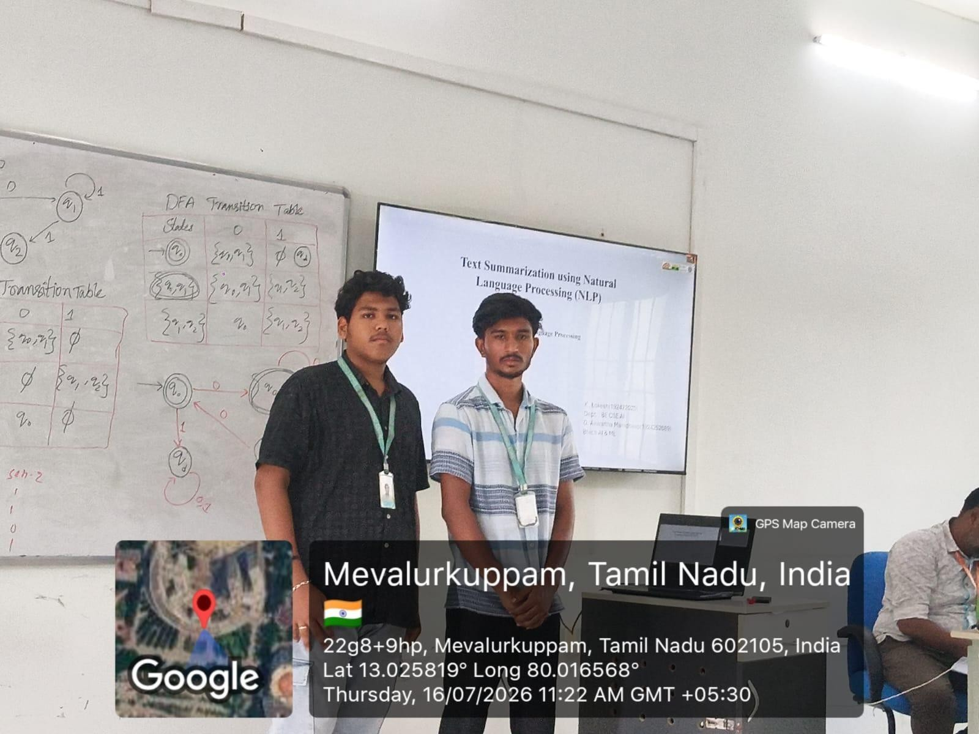
THANK

YOU

!

