CHAPTER FIVE: SYSTEM ANALYSIS AND DESIGN
CareerAI Sierra Leone
This chapter presents the analysis and design of the CareerAI Sierra Leone prototype. It covers the system architecture, use cases, database and entity relationships, interface design, recommendation logic, labour-market intelligence, AI processing, security and privacy controls.

5.1 System Architecture
CareerAI Sierra Leone is designed as a secure, layered web system. Separating presentation, application services, artificial-intelligence processing and data storage makes the system easier to test, maintain and scale. The architecture supports graceful degradation: when an external AI service is unavailable, the application layer returns deterministic recommendations from approved local data. Security and resilience are therefore built into the system from the beginning (NIST, 2022; OWASP, 2023).
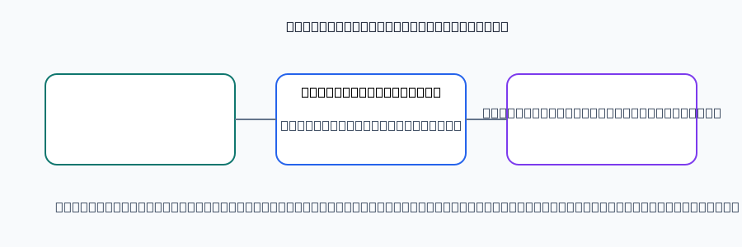
Figure 5.1: Layered system architecture
Layer
Responsibility
Examples
User interface
Collects input and presents results
Assessment, dashboard, explorer
Application
Validates requests and applies rules
Authentication, scoring, recommendations
AI and data
Processes approved data and explanations
Language model, PostgreSQL, labour records
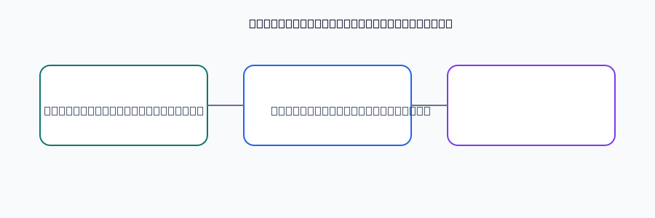
Figure: Conceptual design of the CareerAI Sierra Leone system.

5.1.1 User Interface Layer
The user interface is used by students, graduates, career advisors and administrators. It contains the landing page, account screens, assessment form, dashboard, career profile, recommendation results, labour-market dashboard, advisor, resume analysis, learning resources and profile settings. Responsive layouts support phones, tablets and laptops. Forms use labels, validation messages, sufficient contrast and keyboard-accessible controls, reflecting the perceivable, operable, understandable and robust principles of WCAG 2.2 (W3C, 2023).

5.1.2 Application Layer
The application layer contains server-side services that authenticate users, validate input, calculate RIASEC scores, rank careers, retrieve labour-market records, manage saved careers, process resume text and call the AI model. User data is always queried using the authenticated user identifier. Business rules remain on the server so browser changes cannot alter scores or permissions. Errors are logged without exposing passwords, tokens or private resume content.

5.1.3 AI and Data Layer
This layer contains the PostgreSQL database, reviewed career and labour-market datasets, recommendation engine and external language model. Structured records are the source of truth for careers, salaries, skills and demand. The model explains approved results and answers questions in natural language; it cannot create an unverified salary, vacancy or qualification. Data minimisation sends only information needed for a particular request (ICO, 2023).

5.2 Use Case Design
Use-case design defines system boundaries and the actions available to each actor. The primary actors are the student or graduate, career advisor and administrator. The AI service and database are supporting systems.
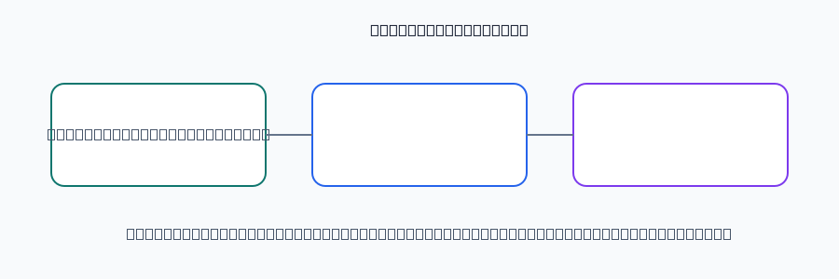
Figure 5.2: Use-case overview
Actor
Core use cases
Student or graduate
Register, assess, view profile, explore and save careers, ask advisor, analyse resume, learn
Career advisor
Review shared results, discuss recommendations, consult labour-market insight
Administrator
Manage catalogue and market data, review anonymised usage, audit access

Figure: Conceptual design of the CareerAI Sierra Leone system.

5.2.1 User Use Cases
A user registers or signs in, completes or retakes the RIASEC assessment, receives a three-letter interest code, explores ranked careers, compares requirements, saves options and asks follow-up questions. The user may upload a resume for guidance, edit the profile, request deletion of personal records and sign out. Each use case includes exception handling for invalid input, missing records and unavailable services.

5.2.2 Career Advisor Use Cases
An advisor reviews results only when the user has chosen to share them. The advisor interprets the profile, discusses ranked careers, compares current and required skills and uses labour-market information as evidence. Human judgement remains necessary; the system supports rather than replaces counselling. This human-in-the-loop arrangement reduces the risk of treating automated guidance as an unquestionable decision (UNESCO, 2021).

5.2.3 Administrator Use Cases
An administrator manages approved careers, skills, salary ranges, demand levels and labour-market indicators through a protected route. Actions are logged with administrator identity and time. Reports use aggregated or de-identified data. Private resume text and chat history are not available unless a documented support process authorises access. This follows least-privilege practice (NIST, 2022).

5.3 Database Design
A relational database is appropriate because users, assessments, careers, skills and recommendations have defined relationships. Constraints reduce duplication and improve consistency. Personal records are linked to the authenticated account, while public career and labour-market data are maintained as separate reference data. Indexes support user, career, timestamp and search queries.

5.3.1 Database Structure
The users table stores account and profile fields. Assessment tables store versioned attempts, responses and six RIASEC scores. Career tables store approved occupation information, while skills and career_skills represent required competencies. Recommendation tables store ranked careers, scores and explanation status. Other tables store saved careers, resume metadata, advisor conversations, learning resources, progress and audit events.

5.3.2 Database Tables
Table 5.1: Main database tables
Table
Purpose
Key fields
users
Accounts and profiles
user_id, email, role
assessments
Versioned attempts
assessment_id, user_id, created_at
assessment_scores
Six interest scores
R, I, A, S, E, C
careers
Approved catalogue
title, sector, demand, salary
skills / career_skills
Competency relationships
skill_id, career_id
recommendations
Ranked results
user_id, career_id, score
labour_market
Sector and regional indicators
region, period, value

Figure: Conceptual design of the CareerAI Sierra Leone system.

5.3.3 Database Relationships
One user has many assessments, recommendations, saved careers, conversations and progress records. One assessment has one score record and many recommendation rows. A career and skill have a many-to-many relationship resolved by career_skills. Labour-market records are reference data linked to sector and region. Foreign keys, uniqueness constraints and carefully selected cascading rules protect consistency without deleting public career data when a user is removed.

5.4 Entity Relationship Diagram
The entity relationship design shows that personal activity belongs to a user account, while career and labour-market information are shared reference entities.
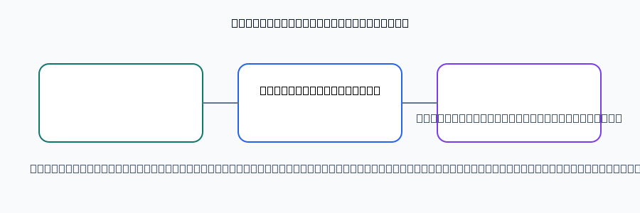
Figure 5.3: Entity relationship model
Relationship
Cardinality
Meaning
User—Assessment
1:many
A user may complete several assessments
Assessment—Recommendation
1:many
An assessment produces ranked careers
Career—Skill
many:many
Careers require multiple skills
User—Saved Career
many:many
Users save many careers
Labour record—Career
many:optional
Market indicators enrich career records

Figure: Conceptual design of the CareerAI Sierra Leone system.

5.4.1 Entities
Principal entities are User, Assessment, AssessmentScore, Career, Skill, Recommendation, SavedCareer, LabourMarketRecord, Conversation, ResumeAnalysis and LearningProgress. User owns personal activity. Career and Skill are catalogue entities. Assessment and Recommendation record decision support, while labour-market records provide context.

5.4.2 Attributes
Attributes are selected according to purpose and data minimisation. User includes an identifier, email, role and optional display details. AssessmentScore contains six numeric values. Career contains title, description, sector, education route, salary range, demand and source date. Resume and conversation fields have stricter access and retention controls.

5.4.3 Relationships
Assessment belongs to User; AssessmentScore belongs to Assessment; Recommendation belongs to User and references Career; SavedCareer joins User and Career; CareerSkill joins Career and Skill. These relationships allow efficient retrieval while preventing a supplied identifier from granting access to another user's records.

5.5 User Interface Design
The interface is task-oriented. Users should understand where they are, what was calculated and what to do next. Consistent buttons, status labels and explanatory text are used throughout. A recommendation percentage is labelled as a match indicator, not a guarantee.

5.5.1 User Dashboard
The dashboard displays assessment status, leading interests, saved careers, learning progress and an advisor shortcut. It shows the date of the latest assessment and makes retaking explicit. Empty states explain how to begin, and cards become a readable single column on small screens.

5.5.2 Career Profile Interface
The profile presents six RIASEC scores using labelled bars or a chart, followed by the leading code and plain-language interpretation. It separates observed interests from recommended careers, records the assessment date and allows the result to be shared or printed for an advisor.

5.5.3 Recommendation Interface
Results appear as ordered career cards containing title, match indicator, sector, demand, indicative salary, skills and education route. Explanations identify whether the match is based on interests, skills or market context. Users can filter, save and compare. If AI is unavailable, a transparent rule-based explanation is shown.

5.6 Career Recommendation and Skills-Matching Design

5.6.1 Career Recommendation Process
The server validates assessment responses, calculates six RIASEC scores, identifies the top three areas, compares the profile with each approved career and adds a controlled demand factor. The ranked records are returned with evidence. The AI receives only those approved records and explains them in accessible language. This separation improves explainability and reduces unsupported output (NIST, 2023).
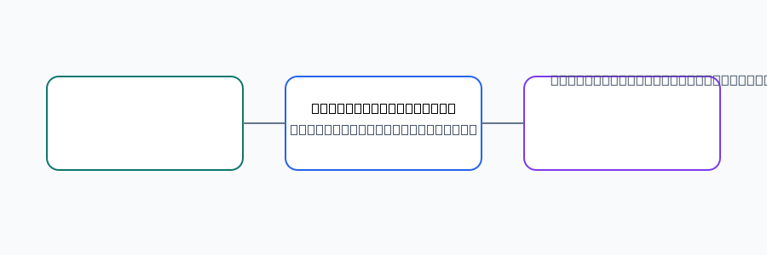
Figure 5.4: Recommendation and skills-matching flow
Step
Process
Output
1
Validate assessment
Trusted input
2
Calculate RIASEC profile
Interest code
3
Compare career vectors
Interest match
4
Compare current and required skills
Skills gap
5
Apply local demand
Ranked score
6
Check explanation
Recommendation
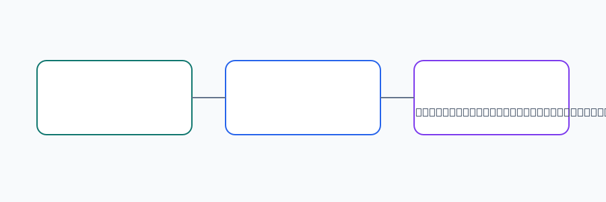
Figure: Conceptual design of the CareerAI Sierra Leone system.

5.6.2 Skills Matching Process
Skills matching compares declared or resume-derived skills with controlled skills attached to each career. Equivalent terms are normalised where appropriate. The system identifies matched skills, missing priority skills and optional development skills. Users can correct extracted skills. The output is a development plan, not a rejection decision.

5.6.3 Recommendation Results
Each result contains rank, score, explanation, career description, demand, salary, skills and next steps. Results state that indicators and salaries are indicative and should be confirmed with employers, training providers or advisors. Several options are presented rather than one supposedly correct occupation. Results are linked to the assessment and catalogue versions used.

5.7 Labour-Market Intelligence Design

5.7.1 Labour-Market Data
Data is organised by sector, region, occupation, period, demand indicator, salary range and source. Sources may include Statistics Sierra Leone, development reports, employer information, training providers and reviewed vacancy observations. Every record has a date and confidence label. Incomplete data is marked indicative or limited evidence rather than presented with false precision (ILO, 2024).

5.7.2 Employment Trends
Trends are represented as growing, stable, declining or insufficient evidence. Filters apply by sector and region, and every chart identifies its period. The system distinguishes skill demand from guaranteed vacancies and highlights transferable skills. Records are reviewed so old evidence is not presented as current.

5.7.3 Labour-Market Dashboard
The dashboard includes sector overview, regional opportunity, in-demand skills and career-demand views. Charts include text summaries and do not rely on colour alone. Tooltips show units, period and source. Administrators see warnings for missing sources, expired records and inconsistent units before publication.

5.8 AI Model and Data Processing Design

5.8.1 Data Processing
Processing follows collect, validate, minimise, normalise, classify, store and retrieve. Inputs are checked for type, length and permitted values. Resume files are checked before text extraction. Personally identifying details are not required for ranking and should not be included in prompts unless necessary. Logs contain technical events rather than full private text, supporting privacy by design (ICO, 2023).

Figure 5.5: AI data-processing pipeline
Stage
Control
Input
Validate assessment, message or resume
Minimise
Remove unnecessary personal information
Retrieve
Select approved career and labour data
Generate
Request structured explanation
Check
Validate fields, claims and safety
Present
Show result with limitations
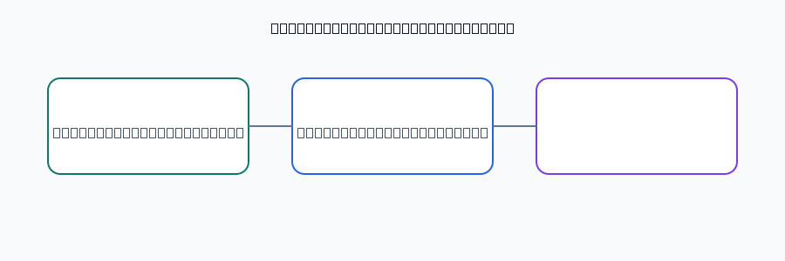
Figure: Conceptual design of the CareerAI Sierra Leone system.

5.8.2 AI Model
The AI model performs summarisation, conversational guidance and structured resume feedback. It receives a bounded prompt containing the user's question and approved context. Instructions require plain language, uncertainty where evidence is weak, no invented facts and referral to an advisor for high-stakes concerns. Outputs are untrusted until validated, following AI risk-management principles (NIST, 2023).

5.8.3 Recommendation Engine
The deterministic component produces reproducible rankings from the same assessment and catalogue version. The AI component may vary in wording but cannot alter stored scores, career identifiers or source fields. On timeout, invalid output or a safety failure, a template explanation is used and the ranked result remains available. This supports unreliable connectivity and avoids dependence on one provider.

5.9 Security and Privacy Design
Security and privacy are cross-cutting requirements because the system processes account information, interests, resumes and conversations. The design applies least privilege, secure defaults, input validation, protected sessions, auditability and data minimisation. Testing covers authentication abuse, authorisation bypass, injection, unsafe uploads, prompt injection and disclosure of another user's records (CISA, 2023; OWASP, 2023).

5.9.1 Authentication
Authentication uses email and password with maintained password hashing and secure session cookies. Passwords are never stored in plain text. Sign-in attempts are protected against brute force. Sessions expire according to policy, cookies use Secure, HttpOnly and appropriate SameSite attributes, and sign-out invalidates the session. Password recovery uses time-limited, single-use links and generic failure messages.

5.9.2 Authorization
Authorization is checked on every protected server action. Users access only their own assessments, recommendations, resumes, conversations, saved careers and progress. Advisors receive explicitly shared information. Administrators have separate catalogue, data-review and reporting permissions. Every personal-data query includes the authenticated user identifier; role checks alone are insufficient. Administrative operations are logged.

5.9.3 Data Protection
Data protection includes encrypted transport, protected credentials, restricted environment variables, validated uploads, output encoding and controlled retention. Resume files and chat content are not exposed through public URLs. Users are informed what is collected, why it is used and how to request correction or deletion. Aggregated reports remove identifiers, backups are protected, and a disclaimer states that recommendations do not guarantee employment, salary or admission.

References
CISA (2023) Secure by Design. Washington, DC: Cybersecurity and Infrastructure Security Agency.
ICO (2023) Guidance on data protection by design and default. Wilmslow: Information Commissioner's Office.
ILO (2024) World Employment and Social Outlook: Trends 2024. Geneva: International Labour Organization.
NIST (2022) Secure Software Development Framework (SSDF) Version 1.1. Gaithersburg: National Institute of Standards and Technology.
NIST (2023) Artificial Intelligence Risk Management Framework (AI RMF 1.0). Gaithersburg: National Institute of Standards and Technology.
OWASP (2023) OWASP Top 10: The Ten Most Critical Web Application Security Risks. Available at: https://owasp.org/www-project-top-ten/ (Accessed: 14 September 2026).
UNESCO (2021) Recommendation on the Ethics of Artificial Intelligence. Paris: UNESCO.
W3C (2023) Web Content Accessibility Guidelines (WCAG) 2.2. Available at: https://www.w3.org/TR/WCAG22/ (Accessed: 14 September 2026).

