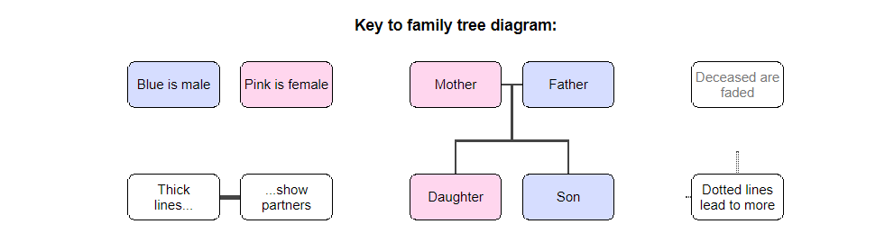

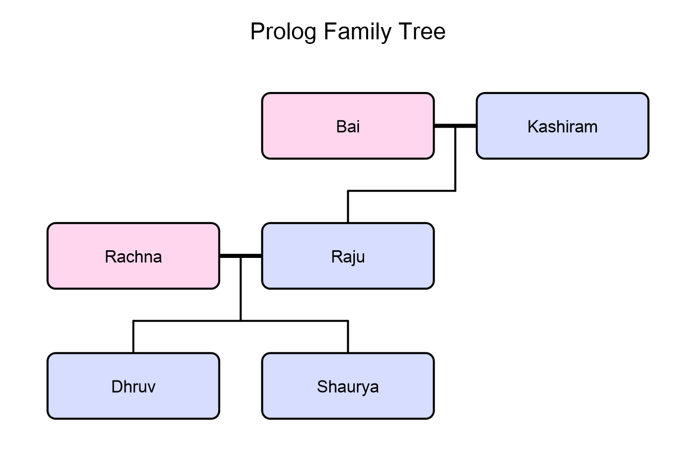

**Grand Parent ->  
  
  
  
  
  
Children and their partners(parents)->  
  
  
  
  
Grandchild->**

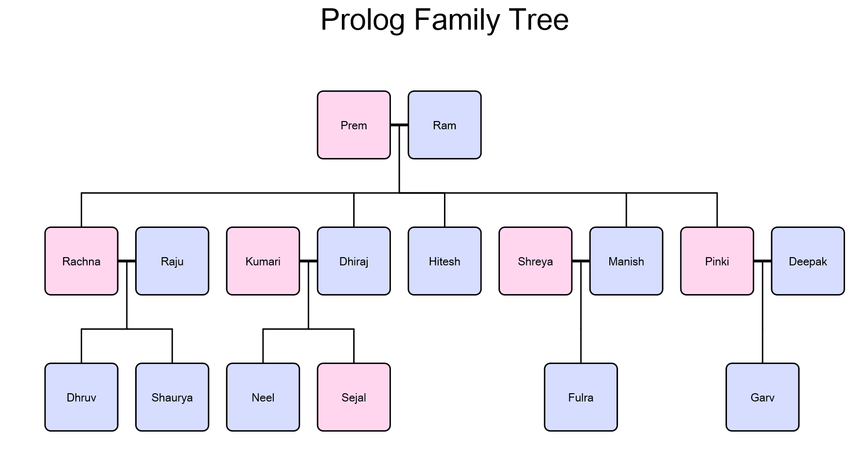

**Grand Parent ->  
  
  
  
  
  
  
Children and their partners ->  
  
  
  
  
  
  
Grandchild ->**

In the above diagrams I am showing my two families one is mine and other where my sister **‘rachna’** married to **‘Raju’** so the families are connected with this marriage so we can find out queries q with prolog

**Define Gender :-**

male(manish).

male(hitesh).

male(dhiraj).

male(kashiram).

male(ram).

male(raju).

male(deepak).

male(garv).

male(neel).

male(dhruv).

male(fulra).

male(shaurya).

female(shreya).

female(bai).

female(rachna).

female(pinki).

female(prem).

female(sejal).

female(kumari).

**Define Parent Relation:-**

parent(raju,dhruv).

parent(rachna,dhruv).

parent(rachna,shaurya).

parent(raju,shaurya).

parent(kashiram, raju).

parent(bai, raju).

parent(prem, rachna).

parent(ram, rachna).

parent(manish, fulra).

parent(shreya, fulra).

parent(ram, manish).

parent(prem, manish).

parent(deepak, garv).

parent(pinki, garv).

parent(ram, pinki).

parent(prem, pinki).

parent(dhiraj, sejal).

parent(kumari, sejal).

parent(dhiraj, neel).

parent(kumari, neel).

parent(prem, dhiraj).

parent(ram, dhiraj).

parent(prem, hitesh).

parent(ram, hitesh).

**The tests check for true and false values as well as queries of certain procedures.**

**All these tests return the proper values.**

1 ?- father(X, dhruv). /* Who is father of ‘dhruv’ */

X = raju.

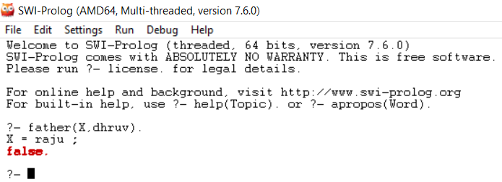

2 ?- father(raju, X). /* whose father is ‘raju’ */

X = dhruv;

X = shaurya.

3 ?- father(raju, dhruv). /* to check raju is father of dhruv ?*/

true.

4 ?- father(raju, shaurya). /* to check raju is father of shaurya?*/

true.

5 ?- mother(X, dhruv). /* who is mother of dhruv */

X = rachna.

6 ?- mother(rachna, X). /* to check whose mother is Rachna */

X = dhruv;

X = shaurya.

7 ?- mother(rachna, dhruv)./* to check rachna is mother of dhruv */

true.

8 ?- father(raju,garv). /* to check raju is father of garv?*/

false.

9 ?- male(dhruv)./* to check gender*/

true.

10 ?- female(rachna).

true.

11 ?- parent(X, dhruv). /* to fund the parents of dhruv */

X = raju;

X = rachna.

12 ?- parent(raju, dhruv). /* to check raju is parent of dhruv */

true .

13 ?- married(raju, rachna).

true.

14 ?- married(raju, X). /* to check raju married to whom? */

X = rachna.

15 ?- grandfather_of(kashiram, dhruv). /* to check kashiram is grand father of dhruv? */

true .

16 ?- grandfather_of(X, dhruv). /* to find paternal grand father and maternal grand father */

X = kashiram ;

X = ram ;

false.

17 ?- grandfather_of(ram, X)./* to check whose grand father is ram */

X = dhruv ;

X = shaurya ;

X = fulra ;

X = garv ;

X = sejal ;

X = neel ;

18 ?- grandmother_of(bai, dhruv). /* to check kashiram is grand mother of dhruv? */

true .

19 ?- grandmother_of(prem, X). /* to check whose grand mother is prem */

X = dhruv ;

X = shaurya ;

X = fulra ;

X = garv ;

X = sejal ;

X = neel ;

20 ?- grandchild(X, ram)./* to check who is grand child of ram */

X = dhruv ;

X = shaurya ;

X = fulra ;

X = garv ;

X = sejal ;

X = neel ;

false.

21 ?- sibling(rachna, X).

X = manish ;

X = pinki ;

X = dhiraj ;

X = hitesh ;

false.

22 ?- ancestor(ram, X).

X = rachna ;

X = manish ;

X = pinki ;

X = dhiraj ;

X = hitesh ;

X = dhruv ;

X = shaurya ;

X = fulra ;

X = garv ;

X = sejal ;

X = neel ;

false.

23 ?- descendent(dhruv, X).

X = raju ;

X = rachna ;

X = kashiram ;

X = bai ;

X = prem ;

X = ram ;

false.

24 ?- sister_of(rachna, X)./* Rachna is sister of whom ?*/

X = manish ;

X = pinki ;

X = dhiraj ;

X = hitesh ;

false.

25 ?- brother_of(manish,X). )./* manish is brother of whom ?*/

X = rachna ;

X = pinki ;

X = dhiraj ;

X = hitesh ;

false.