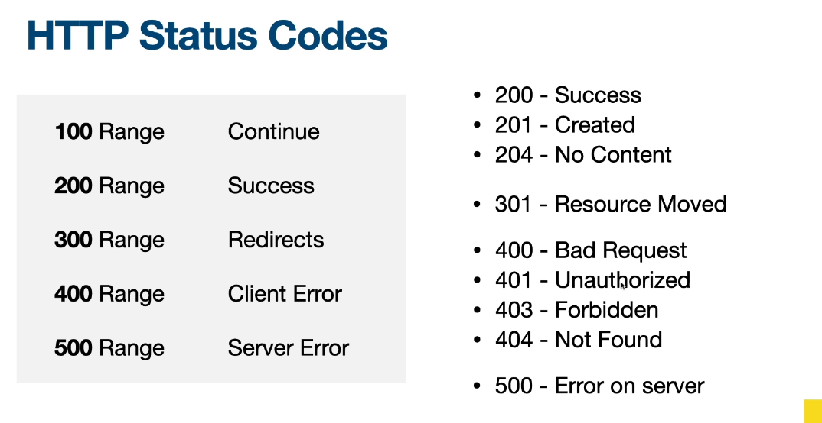

**How Ajax works:**

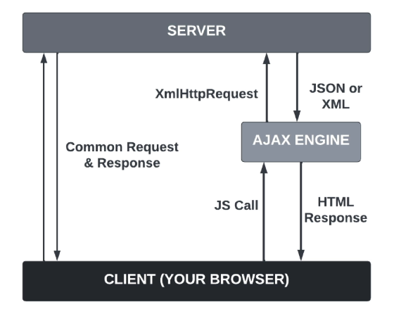

**Ajax Status Codes:**

Holds the status of the XMLHttpRequest.

0: request not initialized

1: server connection established

2: request received

3: processing request

4: request finished and response is ready