Page Link: https://manikmagarsir.github.io/portfolio-manik/
Page image/thumbnail:
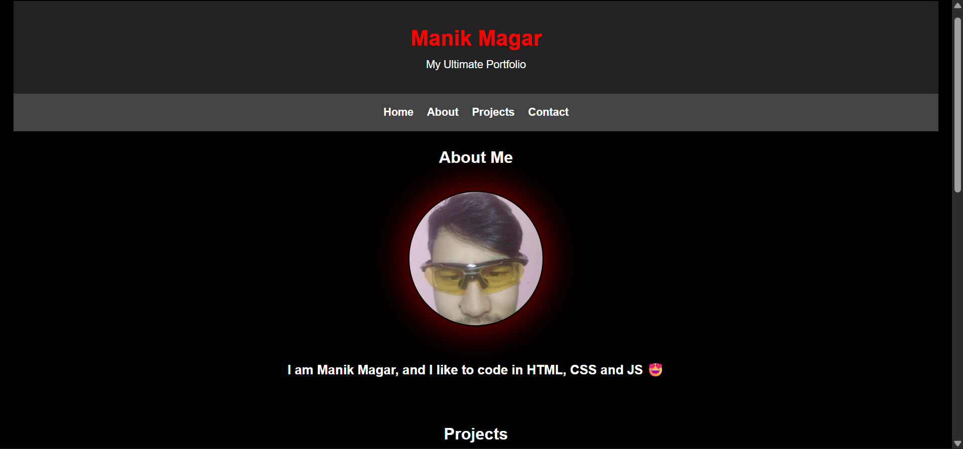
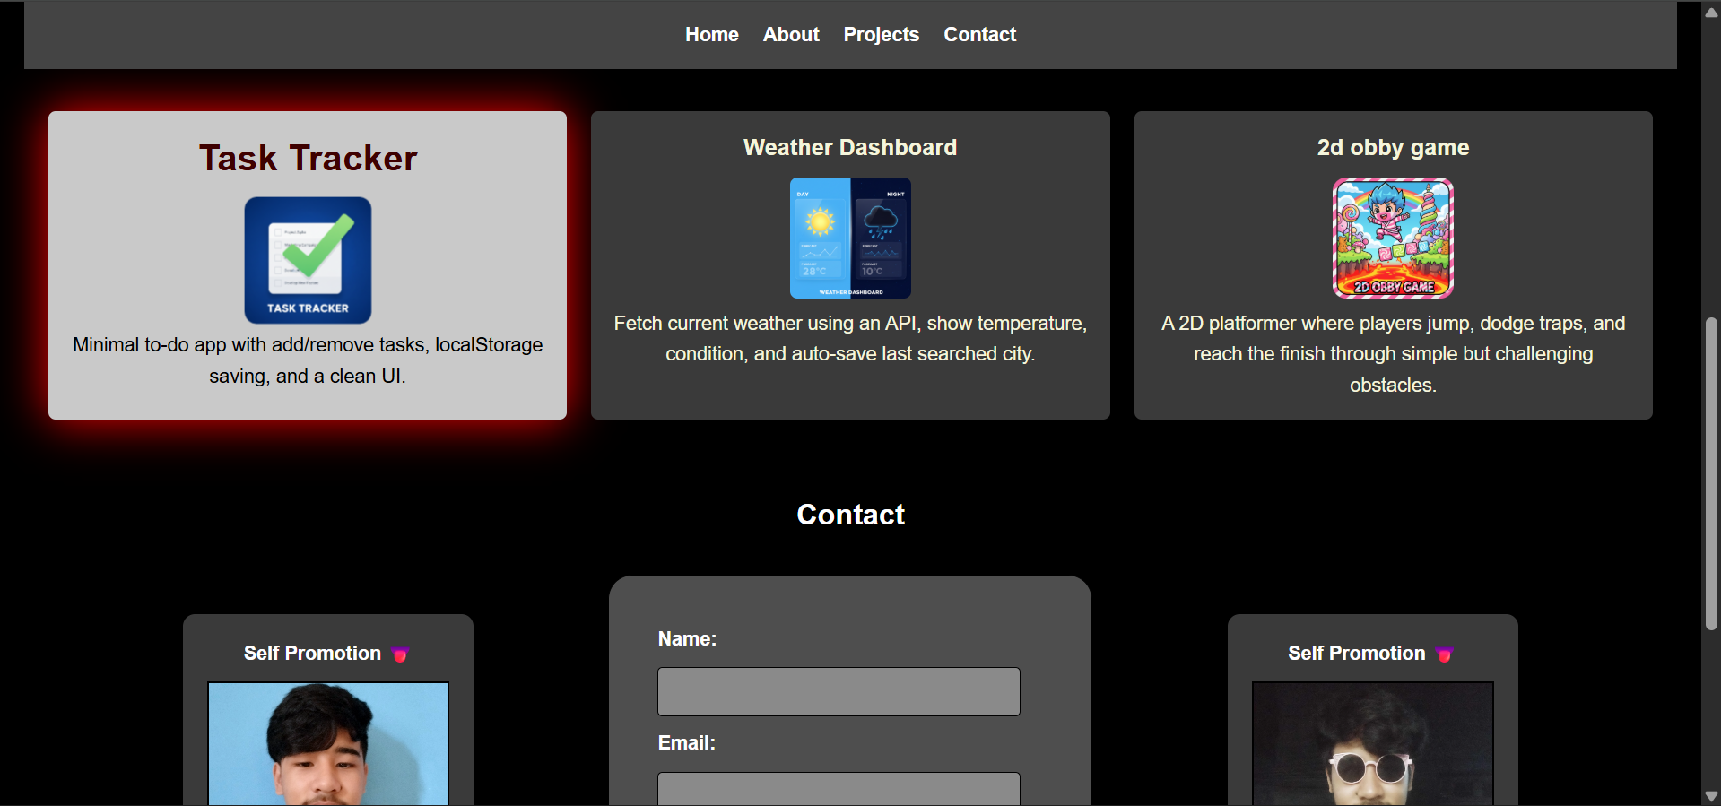

HTML (index.html)
<!DOCTYPE html>
<html lang="en">
<head>
<meta charset="UTF-8" />
<meta name="viewport" content="width=device-width, initial-scale=1.0" />
<title>Portfolio</title>
<link rel="shortcut icon" href="images/icon.png" type="image/x-icon">
<link rel="stylesheet" href="css/style.css" />
</head>
<body>

<header>
<h1>Manik Magar</h1>
<p>My Ultimate Portfolio</p>
</header>

<nav>
<ul>
<li><a href="#">Home</a></li>
<li><a href="#about">About</a></li>
<li><a href="#projects">Projects</a></li>
<li><a href="#contact">Contact</a></li>
</ul>
</nav>

<main>

<section id="about">
<h2>About Me</h2>
<img src="images/me.jpeg" alt="Manik Magar" class="haha"/>
<p style="margin-top: 50px; font-weight: bold;">I am Manik Magar, and I like to code in HTML, CSS and JS 😍</p>
</section>

<section id="projects">
<h2>Projects</h2>
<div class="proj">
<div class="project1">
<h3>Task Tracker</h3>
<img src="images/Task Manager.png" alt="Task Tracker Screenshot" />
<p>Minimal to-do app with add/remove tasks, localStorage saving, and a clean UI.</p>
</div>
<div class="project2">
<h3>Weather Dashboard</h3>
<img src="images/Weather.png" alt="Weather Dashboard Screenshot" />
<p>Fetch current weather using an API, show temperature, condition, and auto-save last searched city.</p>
</div>
<div class="project3">
<h3>2d obby game</h3>
<img src="images/2dobbygame.png" alt="2D Obby Game Screenshot"/>
<p>A 2D platformer where players jump, dodge traps, and reach the finish through simple but challenging obstacles.</p>
</div>
</section>

<section id="contact">
<h2>Contact</h2>
<div class="hehe">
<aside>
<p>Self Promotion 👅</p>
<img src="images/me3.jpg" alt="my promo pic" class="contact-img">
</aside>
<form method="POST">
<label for="name">Name:</label>
<input type="text" id="name" name="name" autocomplete="username" required>

<label for="email">Email:</label>
<input type="email" id="email" name="email" autocomplete="email">

<label for="message">Message:</label>
<textarea id="message" name="message" required placeholder="write a message......"></textarea>

<button type="submit">Send</button>
</form>
<aside>
<p>Self Promotion 👅</p>
<img src="images/me2.jpg" alt="my promo pic" class="contact-img">
</aside>
</div>
</section>

</main>

<footer>
<p>© 2025 ALL RIGHTS RESERVERD TO MANIK MAGAR </p>
</footer>

</body>
</html>

CSS(style.css)

* {
margin: 0;
padding: 0;
box-sizing: border-box;
scroll-behavior: smooth;
}
h1{
color: #ff0000;
}
body {
font-family: Arial, sans-serif;
line-height: 1.6;
background: #000000;
color: #ffffff;
padding: 20px;
text-align: center;
}
header {
text-align: center;
padding: 30px 0;
background: #222;
color: white;
}
nav{
display: block;
top: 0;
position: sticky;
}
nav ul {
list-style: none;
display: flex;
justify-content: center;
gap: 20px;
background: #444;
padding: 15px;
}
h2{
margin-bottom: 30px;
}
nav a {
color: white;
text-decoration: none;
font-weight: bold;
}
section {
padding: 20px;
margin-bottom: 20px;
border-radius: 6px;
}
form {
display: flex;
flex-direction: column;
gap: 10px;
justify-content: center;
background-color: rgb(78, 78, 78);
padding: 40px;
border: black 1px solid;
border-radius: 20px;
text-align: left;
font-weight: bold;
}

input, textarea {
background: #8a8a8a;
padding: 10px;
border: 1px solid #000000;
border-radius: 4px;
font-size: 1rem;
}
input[type="text"], input[type="email"], textarea {
width: 300px;
}
button {
width: 300px;
padding: 10px;
background: #460000;
color: white;
border: black 1px solid;
border-radius: 4px;
cursor: pointer;
transition: background ease 0.3s;
}

button:hover {
background: rgb(126, 1, 1);
}
footer {
text-align: center;
padding: 15px;
margin-top: 20px;
background: #222;
color: white;
border-radius: 6px;
}

.proj{
display: flex;
gap: 20px;
flex-direction: row;
width: 100%;
height: max-content;
}
a{
transition: color ease-in-out 0.3s;
}
a:hover{
color: red;
}

#about p{
font-size: 1.2rem;
text-align: center;
margin-top: 10px;
}

#about img{
display: block;
margin: auto;
width: 200px;
height: 200px;
border-radius: 50%;
object-fit: cover;
border: black 2px solid;
margin-top: 10px;
box-shadow: 0 0 40px 15px rgba(255, 0, 0, 0.35);
transition: transform ease-in-out 0.3s;
}

#about img:hover{
transform: scale(1.05);
}
.project1, .project2, .project3{
background-color: #3a3a3a;
color: beige;
padding: 15px;
border-radius: 6px;
flex: 1;
text-align: center;
transition: background ease-in-out 0.3s, box-shadow ease-in-out 0.3s;
}

.project1 img, .project2 img, .project3 img{
width: 100px;
height: auto;
margin: auto;
border-radius: 6px;
transition: transform ease-in-out 0.3s;
}
.project1 h3, .project2 h3, .project3 h3{
margin-bottom: 10px;
text-align: center;
transition: color ease-in-out 0.3s, font-size ease-in-out 0.3s;

}

.project1:hover, .project2:hover, .project3:hover{
h3{
color: rgb(62, 0, 0);
font-size: 30px;
}
p{
color: black;
}
box-shadow: 0 0 40px #ff0000;
background: #c9c9c9;
img{
transform: scale(1.05);
}
}
.hehe{
display: flex;
flex-direction: row;
align-items: center;
justify-content: space-evenly
}
#contact img{
width: 200px;
}
#contact form{
width: 400px;
}

.hehe aside{
height: 330px;
background-color: #3a3a3a;
padding: 20px;
border-radius: 10px;
text-align: center;
font-weight: bold;
}

.hehe aside img{
margin-top: 10px;
width: 150px;
height: 200px;
object-fit: cover;
border: black 2px solid;
}

aside{
display: flex;
flex-direction: column;
}

