Mathematical Calculations for IBD Model (GPR Model)

1. Xscaled​=(X−μ)/σ​

Where:
- X is the original value of the feature.
- μ is the mean of the feature.
- σ is the standard deviation of the feature.
2.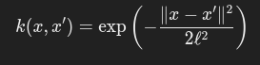
- kernel = RBF(1.0, (1e-4, 1e3))

- ℓ is 1.0 initially.
- k(x,x′) is the similarity (or 6kernel) between two input points x and x′.
- ∥x−x′∥^2 is the squared Euclidean distance between the two points x and x′:
∥x−x′∥^2=i=1∑n(xi​−xi′​)2 where xi​ and xi′​ are the individual components of the vectors x and x′.
- 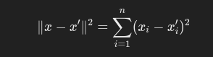
- ℓ is the length scale parameter, which controls the width of the kernel. This is determined during the model training process, with bounds defined by (1e−4,1e3).
3. Train-Test Split (train_test_split)
The train_test_split function splits your dataset into training and testing datasets.
The formula for splitting the data into training and testing sets:
Xtrain​,Xtest​=train_test_split(Xencoded​,yencoded​,test_size=0.5,random_state=100)
Where:
- Xencoded​ is the feature matrix.
- yencoded​ is the target variable.
- The test size is 50% of the data (test_size=0.5), meaning you use 50% for training and 50% for testing.
- random_state=100 is used to control the randomness of the data splitting.
4. Prediction and Thresolding
ypred​,σpred​=GPR.predict(Xtest​,return_std=True)
Where:
- ypred​ are the predicted continuous values.
- σpred​ is the uncertainty (standard deviation) of the predictions.
Since we're performing classification (CKD vs. non-CKD), we apply a threshold of 0.7 to convert the continuous predictions into binary values (0 or 1):
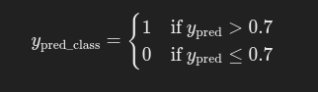
5. Confusion Matrix
The confusion matrix is computed using:
MatrixConfusion Matrix=confusion_matrix(ytest​,ypred_class​)
This matrix gives:
- True Positives (TP): Predicted 1, Actual 1
- True Negatives (TN): Predicted 0, Actual 0
- False Positives (FP): Predicted 1, Actual 0
- False Negatives (FN): Predicted 0, Actual 1

6. Accuracy Calculation
The accuracy is computed using:
Accuracy=(TP+TN)/(FP+FN+TP+TN)​
Where:
- TP = True Positives
- TN = True Negatives
- FP = False Positives
- FN = False Negatives
7. Accuracy per Point
The accuracy per point is calculated by measuring how close each predicted value is to the actual value:
Accuracy per point=1−∣ytest​−ypred​∣

