1. **Introduction**

**Online e Learning Platform**

online education, catering to learners from various backgrounds. Designed for ease of use, it allows both instructors and learners to interact in a seamless digital environment. The team consists of a Frontend Developer, responsible for creating a responsive user interface; a Backend Developer, managing server-side logic and data storage; and additional support roles as needed to ensure smooth development and maintenance. The **Online Learning Platform (OLP)** is a project aimed at creating a flexible.

**2.Description**

An online learning platform is a digital space that provides educational content, resources, and tools for students, teachers, and learners of all levels. It allows users to access courses, tutorials, webinars, and other learning materials on a variety of subjects, often offering flexible scheduling and a range of interactive features. These platforms typically support video lectures, quizzes, assignments, discussion forums, and collaborative tools to enhance the learning experience. They can serve as a comprehensive environment for self-paced learning, live sessions, or structured programs, catering to a wide array of educational needs—from academic subjects to professional development and skill-building courses.

**3.Project Overview**

devices and accessible from anywhere with an internet connection. Key features include an intuitive, user-friendly interface that simplifies navigation for learners of all skill levels. Course management tools allow instructors to The primary purpose of the OLP is to facilitate a convenient learning experience, available on various upload, organize, and monitor course content, while learners can easily enroll in courses and track their progress. The platform supports interactive elements such as discussion forums and live webinars, fostering a sense of community and enabling learners to engage directly with instructors and peers. Upon completion of courses, learners can receive certificates, which add value for employment or continued education. Additionally, the OLP includes options for free and paid courses, as well as self-paced learning to accommodate varying schedules and learning preferences.

**4.Architecture**

The platform’s technical architecture follows a client-server model, combining React.js on the frontend with Node.js and Express.js on the backend, which enables structured data management and efficient user interaction. The frontend is built using **React.js**, enhanced with **Bootstrap** and **Material UI** libraries to create a visually appealing and highly responsive user experience. This client-side interface communicates with the backend through RESTful APIs enabled by Axios. The backend, designed with **Node.js** and the **Express.js** framework, handles data processing and management of server-side logic. **MongoDB** is used for database storage, supporting efficient, scalable data handling for user profiles, courses, and progress tracking, allowing the system to grow as the number of users and courses increases.

**5.Setup Instructions**

The setup process involves meeting a few prerequisites, such as having **Node.js** and **MongoDB** installed, along with two web browsers (preferably Chrome and Firefox) to ensure cross-browser compatibility. To install the platform, clone the project repository and run npm install in both the frontend and backend directories to install the necessary dependencies. Environment variables, such as database URIs and server ports, should be configured based on the setup instructions provided within the project documentation.

**6.Folder Structure**

The project follows a clear folder structure, with a **Client** folder containing all frontend code, including React components, assets, and services. The **Server** folder houses the backend, which contains routes, controllers, middleware, and schema definitions for handling requests and data management. This organization enables easy navigation and streamlined development for both the frontend and backend.

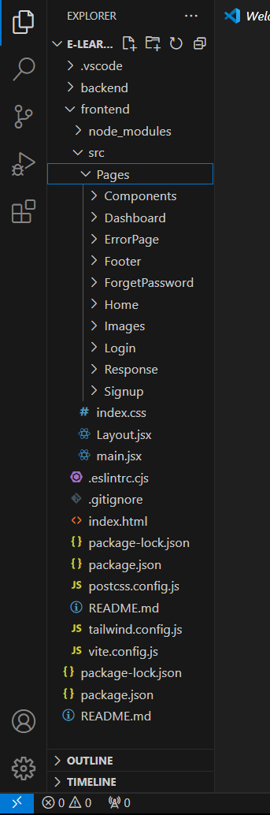

**7.Running the Application**

To run the application locally, start the frontend and backend servers separately. In the client directory, use the command npm start to initiate the frontend, and in the server directory, use the same command to launch the backend. This setup allows for isolated testing and development of each component while maintaining real-time synchronization with each other.

**8.API Documentation**

The backend offers various API endpoints that facilitate core functionalities like user registration, course enrollment, progress tracking, and certificate issuance. Each endpoint is documented with information on request methods, parameters, and example responses, providing clarity on how the frontend communicates with the backend.

# ER Diagram

# 

**9.Authentication**

Authentication is managed through a token-based system, such as JWT, ensuring secure user login and data access. Role-based permissions enable different levels of access, so students, instructors, and administrators each have access to only the features they need, enhancing security across the platform.

**10.User Interface**

The user interface is designed to be intuitive, with visuals of the course catalog, user dashboard, enrollment pages, and discussion forums. This allows users to quickly understand the platform’s functionality and easily access the resources they need. Screenshots or GIFs showcase these elements to guide new users through the available features.

# Architectural Diagram

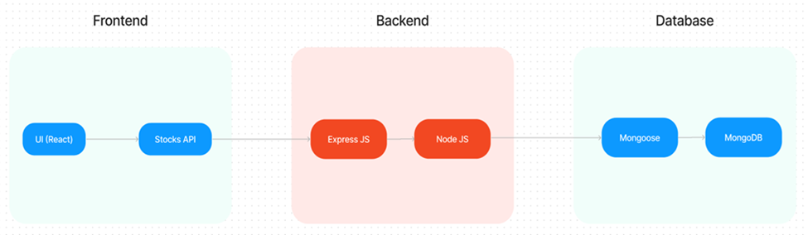

**11.Testing**

The project employs a rigorous testing strategy, using tools like Jest for frontend component testing and Mocha for backend endpoint testing. This ensures that all key features function as expected, and any issues can be identified and resolved before deployment.

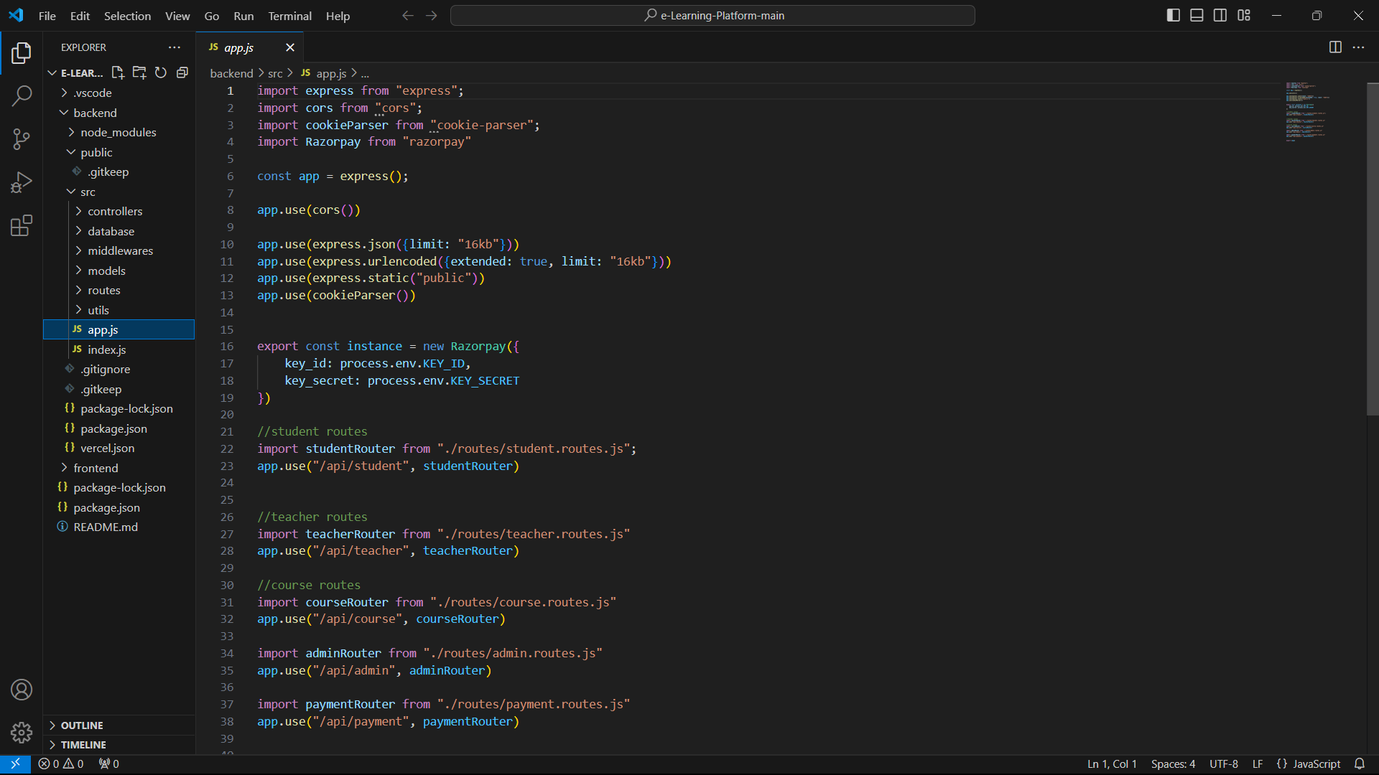

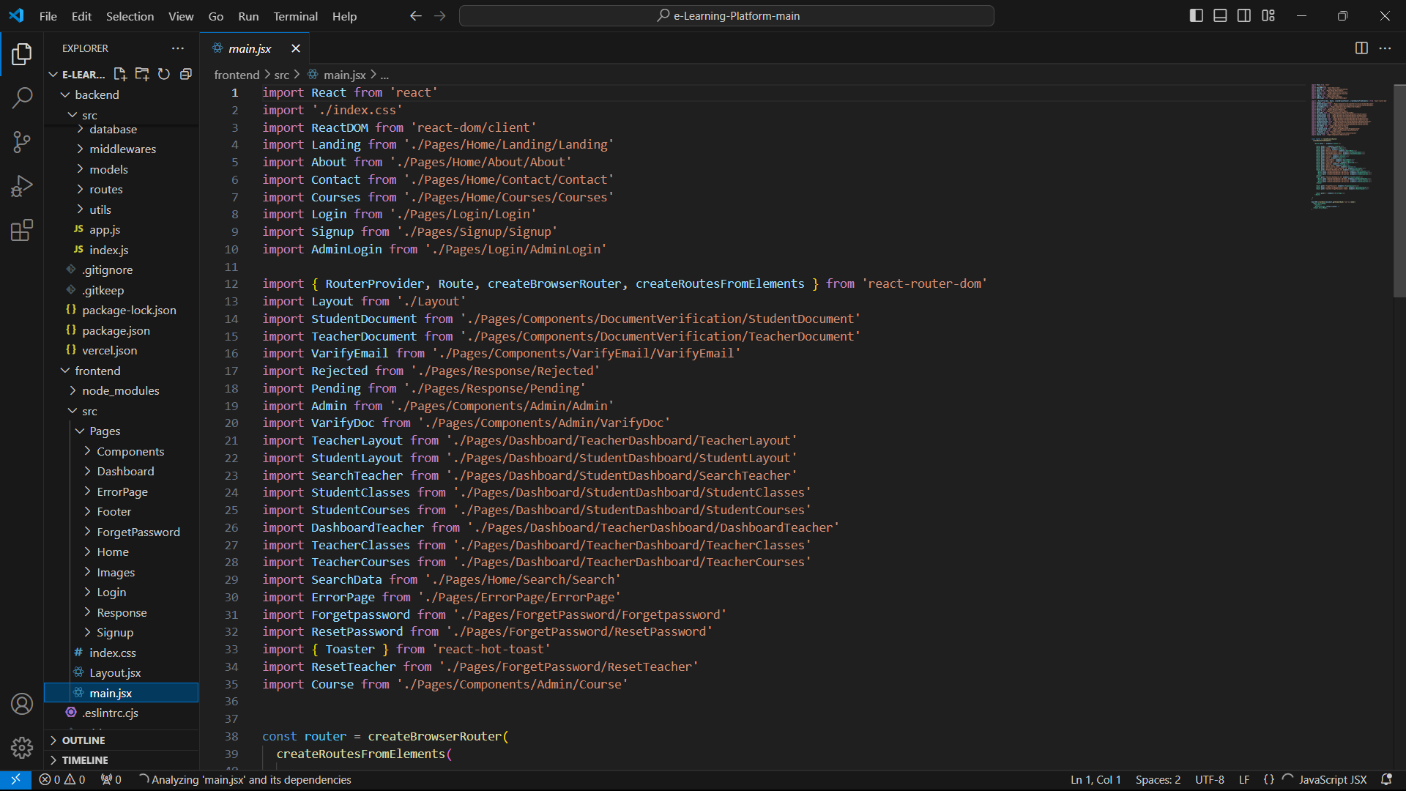

**12.Screenshots or Demo**

Screenshots and a demo link provide a visual representation of the platform’s main functionalities, helping stakeholders and users understand the features available, such as course progress tracking, certification, and paid course options.

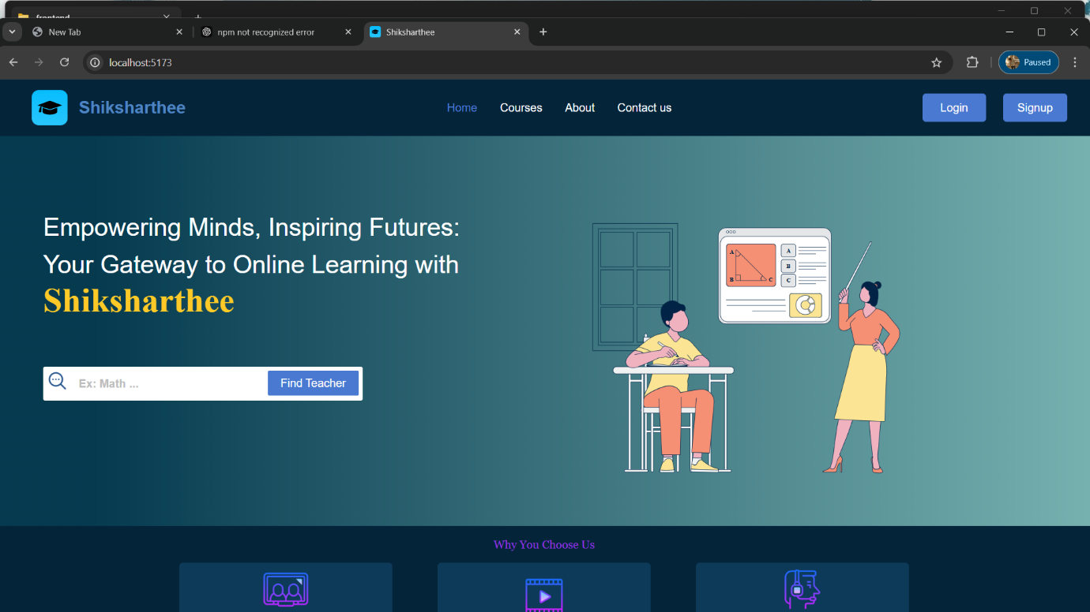

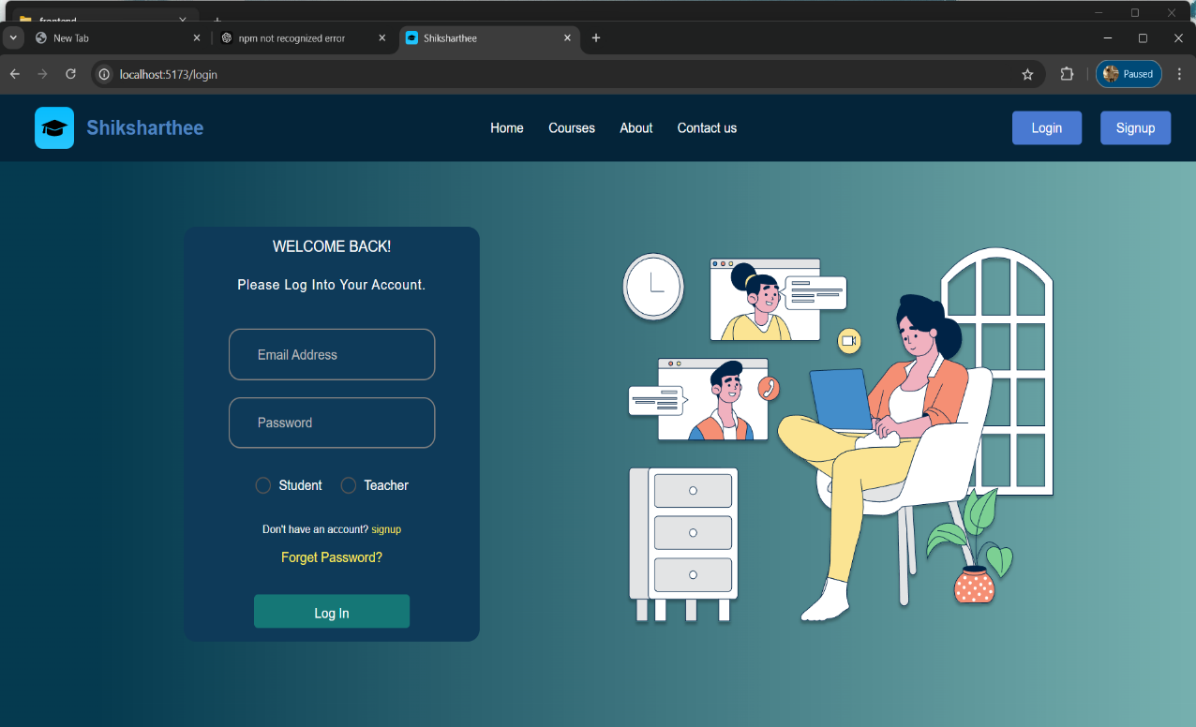

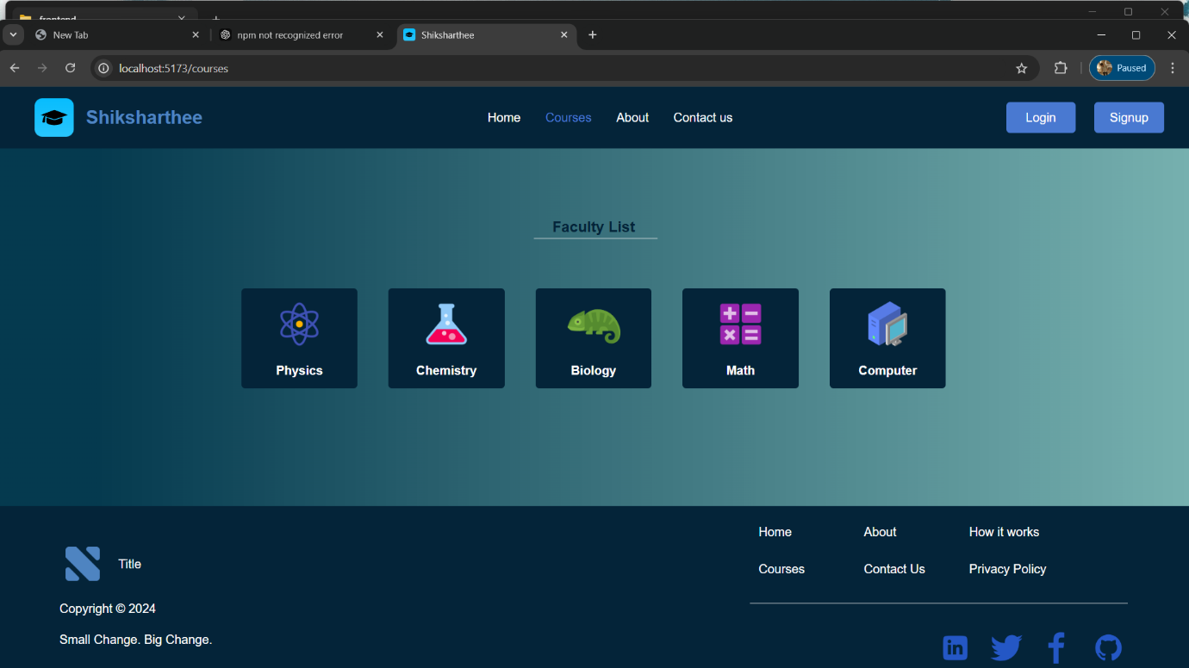

**13.Known Issues**

The project documentation includes a list of known issues or limitations, such as minor UI inconsistencies or potential delays in video content loading, ensuring transparency and aiding in continuous improvement efforts.

**14.Future Enhancements**

Looking ahead, the platform can be further enhanced by developing a mobile app for iOS and Android, introducing real-time chat support for direct communication with instructors, implementing advanced analytics for tracking learning progress, and adding gamification elements to make learning more engaging and interactive.

This expanded version provides more detailed insights into each section, while keeping the focus on the main functionalities and setup requirements of the Online Learning Platform project.

Top of Form

Bottom of Form