MySQL – Assignment:

Questions and Answers:

1. Write a Query to fetch the EmployeeName from the Employee Info table in uppercase and use the ALIAS name as EmpName

Query:

select upper(EmployeeName) as EmpName from EmployeeInfo;

Output:

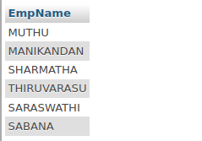

2. Write a query to Count the number of employees working in the department 'HR'

Query:

select count(*)as Num from EmployeeInfo where Department='HR';

Output:



3. Write a query to update the product_name to 'Grapefruit' for all records whose product_name is "Apple".

Query:

select * from Product;

update Product set ProductName='GrapeFruit' where ProductName='Apple';

select * from Product;

Output:

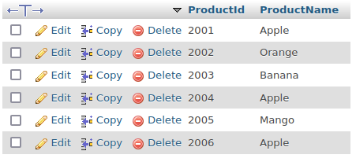

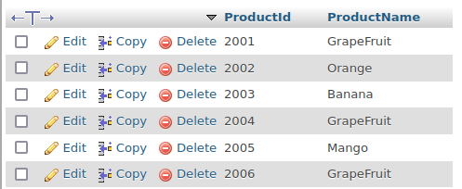

4. Write a query to concatenate two-character strings?

Query:

select * from Employee;

select concat(Fristname,Lastname) as FullName from Employee;

Output:




5. Write a query to fetch all the records from the Employee table ordered by EmpName in descending order and Department in the ascending order

Query:

select * from EmployeeInfo order by EmployeeName Desc;

select * from EmployeeInfo order by Department;

Output:

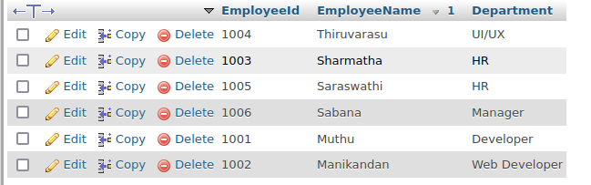

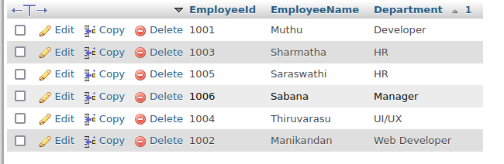

6. From the following tables write a SQL query to find the salesperson and customer who reside in the same city. Return Salesman, customer Name and city

Query:

select * from SalesInfo;

select * from Customer;

select Salesman,Customername,s.city from SalesInfo as s inner join Customer as c on s s.city=c.city;

Output:

