CUSTOMER SEGMENTATION USING DATA SCIENCE

Problem Definition:

- Business Context: Start by understanding the business context and why customer segmentation is necessary. For example, a retail business might want to enhance its marketing strategies.

- Challenges: Identify the current challenges, such as generic marketing efforts, high customer acquisition costs, or low customer retention.

Design Thinking:

- Empathize: Put yourself in the shoes of the customers to understand their needs, preferences, and pain points.

- Define: Clearly articulate the problem based on customer insights. In our retail example, it might be that customers receive irrelevant product recommendations.

- Ideate: Brainstorm potential solutions and data-driven approaches, such as segmentation, to address the problem.

- Prototype: Create a plan for implementing customer segmentation to solve the problem.

Problem Goals:

- Customer Segmentation: The primary goal is to segment the customer base into distinct groups based on their characteristics and behaviors.

- Personalization: Develop strategies for more personalized marketing, product recommendations, and customer experiences.

- Cost Reduction: Optimize marketing spending by targeting the right segments with the right messages, reducing costs.

Project Objectives:

- Data Collection: Gather relevant customer data, including demographics, purchase history, and interaction data.

- Data Preprocessing: Clean and preprocess the data to ensure it's ready for analysis.

- Feature Selection/Engineering: Identify relevant features and possibly create new ones.

- Algorithm Selection: Choose the segmentation method or algorithm (e.g., k-means, RFM analysis, or machine learning).

- Model Training: Train the chosen algorithm on the data.

- Segmentation: Apply the model to segment customers into groups.

- Evaluation: Assess the quality of segments using appropriate metrics.

- Interpretation: Understand the characteristics of each segment and label them based on customer behavior.

- Implementation: Use the segments to tailor marketing strategies and product offerings.

- Monitoring and Iteration: Continuously monitor and update segments as needed.

Flow Chart:

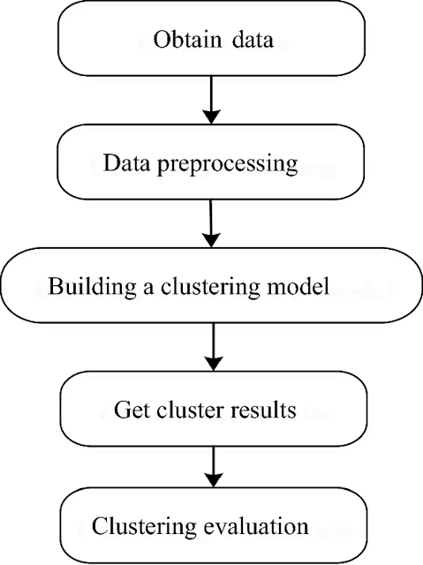

Entity Relationship(ER Diagram):

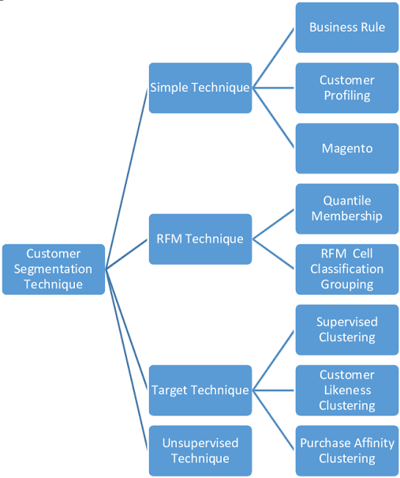

Algorithmic Steps:

- Clustering Algorithms: If using clustering, steps might include initializing centroids, assigning data points to clusters, and updating centroids iteratively.

- RFM Analysis: Calculate Recency, Frequency, and Monetary scores for each customer and group them accordingly.

- Machine Learning: If using machine learning, steps include data splitting, model training, hyperparameter tuning, and prediction.