**Innovation for Customer Segmentation using Data Science**

Innovations in customer segmentation using data science have been transformative for businesses. Some key approaches and techniques include:

**Predictive Analytics:** Using machine learning algorithms to predict customer behavior, preferences, and needs based on historical data, allowing for more targeted marketing and personalized recommendations.

**Cluster Analysis:** Employing unsupervised machine learning techniques to group customers with similar characteristics, enabling businesses to tailor their offerings and marketing strategies to specific segments.

**Natural Language Processing (NLP):** Analyzing customer feedback, reviews, and social media conversations to gain insights into sentiment and opinions, helping businesses understand customer sentiments and concerns.

**Recommendation Systems:** Leveraging collaborative filtering and content-based recommendation algorithms to suggest products or services to customers based on their past interactions and preferences.

**Real-time Data Processing:** Implementing data streaming and real-time analytics to respond to customer behavior in real time, such as adjusting website content or offering immediate customer support.

**Geospatial Data Analysis:** Using location-based data to target customers based on their geographic location and preferences, such as sending location-specific offers or ads.

**Customer Lifetime Value (CLV) Prediction:** Predicting the long-term value of a customer, enabling businesses to allocate resources more effectively to high-value segments.

**A/B Testing and Experimentation:** Conducting controlled experiments to test different marketing strategies and segment-specific campaigns to determine what works best for each customer group.

**Ethical Data Usage:** Innovations also include a growing emphasis on ethical data collection and usage to ensure customer privacy and build trust.

**Personalization Engines:** Developing sophisticated personalization engines that offer tailored product recommendations, content, and experiences to each customer in real time.

These innovations not only enhance customer segmentation but also improve customer experiences, increase customer retention, and boost overall business performance.

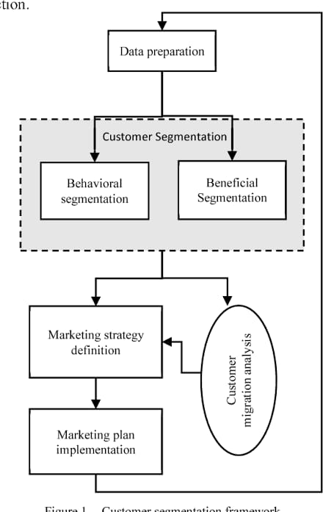

Innovating customer segmentation using data science involves several key steps. Here's a complete guide to implementing this process:

**Step 1: Define Your Objectives:**

Identify your business goals and objectives for customer segmentation. Determine what you want to achieve, such as improving marketing effectiveness, increasing customer retention, or enhancing personalization.

**Step 2: Data Collection:**

Gather relevant data from various sources. This can include customer demographics, transaction history, website behavior, customer feedback, and any other data that can help you understand your customers better.

**Step 3: Data Preprocessing:**

Clean and preprocess the data to ensure it's accurate and consistent. This step involves handling missing values, removing outliers, and transforming data as needed.

**Step 4: Select Data Science Techniques:**

Choose appropriate data science techniques for customer segmentation. Common methods include clustering, classification, and recommendation systems. Select the ones that align with your objectives.

**Step 5: Feature Engineering:**

Identify and create meaningful features from your data that can be used for segmentation. Feature engineering can involve transforming and scaling variables to make them suitable for modeling.

**Step 6: Model Building:**

Train machine learning models for segmentation. Depending on your chosen technique, this can involve using clustering algorithms like K-Means or hierarchical clustering, classification algorithms, or collaborative filtering for recommendation.

**Step 7: Model Evaluation:**

Assess the performance of your segmentation model using metrics such as silhouette score, F1-score, or accuracy, depending on the technique. Ensure that the model aligns with your business objectives.

**Step 8: Customer Segmentation:**

Apply the trained model to segment your customer base. Each customer will be assigned to a specific segment based on their characteristics and behavior.

**Step 9: Interpret Results:**

Analyze the segments and understand their characteristics. Identify the key features that differentiate one segment from another. This interpretation will guide your marketing and personalization strategies.

**Step 10: Implement Personalization:**

Tailor your marketing and communication strategies to each customer segment. This can involve creating targeted marketing campaigns, offering personalized product recommendations, and adjusting content.

**Step 11: A/B Testing:**

Conduct A/B tests to validate the effectiveness of your strategies for each segment. Compare the performance of different approaches and refine them based on the results.

**Step 12: Continuous Improvement:**

Customer segmentation is an ongoing process. Continuously gather data, refine your models, and adapt your strategies to changes in customer behavior and market dynamics.

**Step 13: Ethical Considerations:**

Throughout the process, ensure that you are handling customer data ethically and in compliance with data protection regulations. Respect customer privacy and data security.

**Step 14: Monitor and Iterate:**

Regularly monitor the performance of your segmentation and personalization efforts. Make iterative improvements based on customer feedback and changing business goals.

Remember that innovation in customer segmentation using data science is an evolving field. Stay up-to-date with the latest techniques and technologies to remain competitive and provide the best customer experiences.

