Project Documentation

# Cook Book

1. Introduction

• Project Title: Cook Book

• Team ID: NM2025TMID38374

• Team Leader:

Manikandan R (manikandanrengaraj18&@gmail.com)

• Team Members:

Dineshkumar M [(dineshkm1305@gmail.com](mailto:(dineshkm1305@gmail.com))

Jayson A ([jaysujayson@gmail.com](mailto:jaysujayson@gmail.com))

Michael E ([emichael242006@gmail.com](mailto:emichael242006@gmail.com))

Mohammed Jaffer A ([ajjubhaijaffer444@gmail.com](mailto:ajjubhaijaffer444@gmail.com))

Project Overview

To provide a comprehensive, digital solution for recipe management that is intuitive, efficient, and engaging for home cooks of all skill levels.

• Purpose: SB Works connects clients and freelancers through project postings, bidding, and real-time communication.

• Features:

• Develop a robust recipe management system: Allow users to create, edit, save, and categorize their own recipes.

• Implement a powerful search and filter function: Enable users to quickly find recipes based on ingredients, cuisine, dietary restrictions, or cooking time.

Create a collaborative platform: Allow users to share recipes with a community, leave comments, and rate recipes.

• Integrate smart features: Include a shopping list generator based on selected recipes, and a meal planner.

• Ensure a clean and responsive user interface: Design a visually appealing and easy-to-navigate interface that works seamlessly on desktop and mobile device

– **Feedback and review system**

• Ratings: A simple 5-star rating system is the standard. This gives users a quick, at-a-glance way to see how popular a recipe is. You could also include half-stars for more nuance.

• Written Reviews: This is where the real value is. Users can share their experiences, offer suggestions for modifications, or point out what they liked or didn't like.

• Recipe-Specific Comments: The ability for users to leave comments directly on a recipe page. This is different from a general review system because it allows for specific questions and discussions about that particular dish.

• User Profiles: Users can have a profile where they can see their own reviews, favorite recipes, and other interactions. This encourages them to be a part of the community.

• "Made It" or "Cooked This" Button: A simple button that lets users mark a recipe as one they've made. This provides another layer of feedback and can show a recipe's popularity without requiring a full review.

**– Admin control panel**

### . Recipe Management

* Create, Edit, & Delete: Admins should be able to add new recipes, modify existing ones (e.g., update ingredients or instructions), and remove recipes as needed. This is the core of your content management.
* Search & Filter: As your recipe collection grows, the ability to search by title, ingredients, or tags is crucial. You should also be able to filter recipes by a specific category, cuisine, or popularity.
* Approval Queue: If you allow users to submit their own recipes, you'll need a way to review and approve or reject them before they go live.

### 2. User Management

* View & Edit User Profiles: Admins should have a list of all users, with the ability to view their details, such as their username, email, and joined date. You should also be able to edit or update their information.
* Suspend or Ban Users: To maintain a healthy community, you need the power to temporarily suspend or permanently ban users who violate your terms of service or post inappropriate content.
* Role Management: You might want different levels of access. For example, a "moderator" role could have the power to delete comments but not recipes, while an "editor" role could create and edit recipes.

### 3. Feedback and Review Management

* Review & Comment Moderation: This is the most critical part for a feedback system. The admin panel should show all submitted reviews and comments. You need the ability to review, edit, or delete them.
* Flagged Content: The system should have a dedicated section for reviews or comments that have been flagged by users. This allows you to quickly see and address reported content.
* Respond to Users: An integrated feature to reply to user reviews or private messages can be helpful, especially for addressing specific issues or thanking users for their feedback.

### 4. Site Analytics and Reporting

* Key Metrics: Display important statistics like the total number of recipes, users, and reviews. This gives you a quick overview of your project's growth.
* Popular Content: Highlight top-rated recipes, most-reviewed recipes, or recipes with the most user engagement. This data can help you understand what your audience loves.
* User Activity: Track user activity, such as how many new users registered in the last week, or which users are the most active in leaving reviews.

An effective admin panel is the backbone of your project. It not only helps you maintain order but also provides the data you need to make informed decisions and improve your cookbook project over time.

What specific features are you most interested in building for your admin panel first?

1. **Architecture**

Building a robust and scalable architecture for a digital cookbook involves a multi-layered approach. The key is to separate the different functions of the application so they can be developed and maintained independently. Here is a more detailed look at the architecture, expanding on the three-tier model and adding more specifics.

### 1. The Core Layers

A. Presentation Layer (Frontend)

* Framework: Use a modern JavaScript framework like React, Vue.js, or Angular. These are excellent for building dynamic, single-page applications (SPAs) that offer a smooth user experience.
* User Interface (UI): This is where you'll design the visual elements:
  + Recipe Pages: A clean, easy-to-read layout with clear sections for ingredients, instructions, and photos.
  + Rating Widgets: Interactive star ratings (e.g., a simple component that lets a user click to select a rating).
  + Review Forms: Text areas for comments and a "submit" button.
  + Search & Filter Interface: An intuitive way for users to search for recipes by name, ingredient, or other criteria.
* State Management: For larger applications, a library like Redux or Vuex can help manage the data flow and state of the application, ensuring consistency across different components.

B. Application Layer (Backend)

* API Framework: This is the server-side technology that powers your application. Popular choices include:
  + Python: Django (for a full-featured, "batteries-included" framework) or Flask (for a more lightweight, minimalist approach).
  + Node.js: Express.js is a very popular choice for building RESTful APIs. It's fast and easy to get started with.
  + Ruby on Rails: Known for its developer-friendly conventions and rapid development.
* Authentication & Authorization:
  + Implement user authentication using a library like Passport.js (for Node.js) or Django's built-in system. This protects user data and ensures only logged-in users can leave reviews.
  + Implement OAuth 2.0 to allow users to sign up and log in using social accounts (Google, Facebook, etc.).
* API Endpoints: Define clear API endpoints for all of your application's functions:
  + GET /api/recipes/ - Retrieve a list of all recipes.
  + GET /api/recipes/{id} - Get a single recipe and its details, including reviews.
  + POST /api/reviews/ - Submit a new review for a recipe.
  + DELETE /api/reviews/{id} - Delete a review (for admins or the user who created it).

C. Data Layer (Database)

* Database Choice:
  + Relational Database (SQL): PostgreSQL or MySQL are excellent choices. They are ideal for storing structured, interconnected data. You'll have separate tables for recipes, users, and reviews, with foreign keys linking them together. This ensures data integrity.
  + NoSQL Database: MongoDB could be an option if you need more flexibility in your data structure. However, for a cookbook with clear relationships between recipes, users, and reviews, SQL is generally a better fit.
* Database Schema: Design your tables to be efficient and scalable.
  + Recipes table: recipe_id, title, description, ingredients, instructions, prep_time, cook_time.
  + Users table: user_id, username, email, password_hash, role (e.g., 'user', 'admin').
  + Reviews table: review_id, recipe_id (foreign key), user_id (foreign key), rating, comment, created_at.

### 2. Infrastructure and DevOps

* Hosting: Deploy your application on a cloud platform like Heroku, AWS, or DigitalOcean. These services make it easy to scale your application as your user base grows.
* Static Assets: Store user-uploaded images (recipe photos) and other static files on a dedicated service like Amazon S3 or Cloudinary. This offloads the file serving from your main application server and improves performance.
* Search Engine: For a rich search experience, consider a dedicated search engine like Elasticsearch or Algolia. This allows for fast, flexible searching of recipes by ingredients, tags, or text.
* Caching: Implement caching to reduce the load on your database. Use a service like Redis to store frequently accessed data (like popular recipes or a recipe's average rating) in memory, so your backend doesn't have to query the database every time.
* Admin Panel: The admin panel should also be built using a robust frontend and backend. It can leverage the same API endpoints but with additional authorization checks to ensure only admins have access.

This architectural blueprint provides a solid foundation for a scalable and maintainable cookbook project. It separates concerns, making it easier to develop and debug, and sets you up for future growth.

### • 1. Frontend: React.js with Bootstrap and Material UI

This is where all user interaction happens. It's a single-page application (SPA) that will dynamically load data without a full page refresh.

* Component-Based Structure: Break down your application into reusable components. For example:
  + RecipeCard.js: A component that displays a single recipe with a title, image, and average rating.
  + ReviewForm.js: A component containing the star rating and comment text area.
  + RecipeDetails.js: The main page component that assembles the recipe card, ingredient list, instructions, and the review section.
  + Header.js and Footer.js: Reusable navigation components.
* Styling Libraries:
  + Bootstrap: Good for basic layout, responsive design, and pre-built components like navbars and grids. Use a React-specific version like react-bootstrap.
  + Material UI: Excellent for providing a consistent, professional look and feel with its "material design" principles. Use it for more complex and visually appealing components like buttons, text fields, and icons.
* State Management: Use the built-in React Hooks like useState and useEffect for managing the state of individual components. For a larger application, consider a dedicated library like Redux or Zustand to manage global state like user authentication and all recipes.
* API Interaction: Use the fetch API or a library like axios to make requests to your Node.js backend. This is how the frontend will get recipe data and send review submissions.

### 2. Backend: Node.js and Express.js

This is your server. It handles requests from the frontend, manages the database, and processes business logic.

* Server Setup: Use Express.js to create a simple and fast web server. You'll define the routes (API endpoints) that the frontend will call.
* API Endpoints:
  + GET /recipes: Get a list of all recipes. You can add query parameters for searching and filtering (e.g., /recipes?search=chicken).
  + GET /recipes/:id: Get a specific recipe by its ID. The response should include all associated reviews.
  + POST /recipes/:id/reviews: Create a new review for a specific recipe. This endpoint will require the user to be authenticated.
  + DELETE /recipes/:id/reviews/:reviewId: Allow an authenticated user to delete their own review.
* Middleware: Use middleware to handle common tasks:
  + express.json(): To parse incoming JSON requests.
  + CORS (cors package): To allow your React frontend (on a different port or domain) to communicate with your backend.
  + Authentication Middleware: A custom function that verifies a user's token on protected routes (like the review submission endpoint). You can use a library like jsonwebtoken for this.

### 3. Database: MongoDB

MongoDB is a NoSQL database that stores data in flexible, JSON-like documents. It's a good choice for this project because your data model is relatively simple.

* Schema Design: While MongoDB is schema-less, it's a good practice to use a library like Mongoose to define a consistent schema. This ensures data integrity and makes querying easier.
  + Recipe Schema: This document would hold the recipe's core information. To handle reviews efficiently, you can embed a sub-document array for reviews within the Recipe document itself. This is a common pattern in MongoDB for data that is tightly coupled and frequently accessed together.

JavaScript

const recipeSchema = new mongoose.Schema({

title: String,

ingredients: [String],

instructions: String,

image: String,

reviews: [{

user: { type: mongoose.Schema.Types.ObjectId, ref: 'User' },

rating: Number,

comment: String,

createdAt: { type: Date, default: Date.now }

}],

averageRating: { type: Number, default: 0 }

});

* + User Schema: This document would hold user information.
* Database Operations: Your Express.js backend will use the Mongoose models to perform CRUD (Create, Read, Update, Delete) operations on the database. For example, when a new review is submitted, your backend would find the specific recipe document and push the new review object into the reviews array. It could then recalculate the averageRating and save the document.

4. Setting up your cookbook project requires a few steps to get your frontend, backend, and database working together. Here are the instructions, assuming you have the prerequisites installed.

### 1. Backend Setup (Node.js & Express.js)

1. Clone the Repository: First, use Git to clone your backend project's repository.

Bash

git clone <your-backend-repo-url>

cd <your-backend-project-folder>

1. Install Dependencies: Navigate into the project folder and install all the necessary Node.js packages, including Express and Mongoose.

Bash

npm install

1. Connect to MongoDB:
   * Make sure your MongoDB server is running. You can start it from your command line if it isn't already running in the background.
   * Find the database connection string in your backend project's configuration file (e.g., a .env file or config.js). It will look something like this: mongodb://localhost:27017/cookbook-db.
   * Mongoose will handle the connection logic based on this string.
2. Start the Server: Launch your backend server. This will start your API and listen for requests from the frontend.

Bash

npm start

or

Bash

node app.js

Your backend should now be running, typically on port 5000 or 3000.

### 2. Frontend Setup (React.js)

1. Clone the Repository: Clone your React frontend project's repository.

Bash

git clone <your-frontend-repo-url>

cd <your-frontend-project-folder>

1. Install Dependencies: Install the packages required for your React application.

Bash

npm install

1. Configure API URL:
   * Your React app needs to know where to send requests to your Node.js backend.
   * Create a .env file in the root of your frontend folder.
   * Add an environment variable that points to your backend's URL. For a local setup, this would be:

Bash

REACT_APP_API_URL=http://localhost:5000

* + Your React code will use this variable to make API calls (e.g., axios.get(process.env.REACT_APP_API_URL + '/recipes')).

1. Start the Application: Run the command to start the React development server.

Bash

npm start

This will usually open your application in your browser at http://localhost:3000.

### 3. Final Check

With both the frontend and backend running, your React application should now be able to fetch recipes, submit reviews, and interact with the database through your Node.js API. Check your browser console for any errors and ensure that your database is correctly populated with some initial data for testing.

– Visual Studio Code

# See https://help.github.com/articles/ignoring-files/ for more about ignoring files.

# dependencies

/node_modules

/.pnp

.pnp.js

# testing

/coverage

# production

/build

# misc

.DS_Store

.env.local

.env.development.local

.env.test.local

.env.production.local

npm-debug.log*

yarn-debug.log*

yarn-error.log*

Getting Started with Create React App

This project was bootstrapped with [Create React App](https://github.com/facebook/create-react-app).

## Available Scripts

In the project directory, you can run:

### `npm start`

Runs the app in the development mode.\

Open [http://localhost:3000](http://localhost:3000) to view it in your browser.

The page will reload when you make changes.\

You may also see any lint errors in the console.

### `npm test`

Launches the test runner in the interactive watch mode.\

See the section about [running tests](https://facebook.github.io/create-react-app/docs/running-tests) for more information.

### `npm run build`

Builds the app for production to the `build` folder.\

It correctly bundles React in production mode and optimizes the build for the best performance.

The build is minified and the filenames include the hashes.\

Your app is ready to be deployed!

See the section about [deployment](https://facebook.github.io/create-react-app/docs/deployment) for more information.

### `npm run eject`

**Note: this is a one-way operation. Once you `eject`, you can't go back!**

If you aren't satisfied with the build tool and configuration choices, you can `eject` at any time. This command will remove the single build dependency from your project.

Instead, it will copy all the configuration files and the transitive dependencies (webpack, Babel, ESLint, etc) right into your project so you have full control over them. All of the commands except `eject` will still work, but they will point to the copied scripts so you can tweak them. At this point you're on your own.

You don't have to ever use `eject`. The curated feature set is suitable for small and middle deployments, and you shouldn't feel obligated to use this feature. However we understand that this tool wouldn't be useful if you couldn't customize it when you are ready for it.

## Learn More

You can learn more in the [Create React App documentation](https://facebook.github.io/create-react-app/docs/getting-started).

To learn React, check out the [React documentation](https://reactjs.org/).

### Code Splitting

This section has moved here: [https://facebook.github.io/create-react-app/docs/code-splitting](https://facebook.github.io/create-react-app/docs/code-splitting)

### Analyzing the Bundle Size

This section has moved here: [https://facebook.github.io/create-react-app/docs/analyzing-the-bundle-size](https://facebook.github.io/create-react-app/docs/analyzing-the-bundle-size)

### Making a Progressive Web App

This section has moved here: [https://facebook.github.io/create-react-app/docs/making-a-progressive-web-app](https://facebook.github.io/create-react-app/docs/making-a-progressive-web-app)

### Advanced Configuration

This section has moved here: [https://facebook.github.io/create-react-app/docs/advanced-configuration](https://facebook.github.io/create-react-app/docs/advanced-configuration)

### Deployment

This section has moved here: [https://facebook.github.io/create-react-app/docs/deployment](https://facebook.github.io/create-react-app/docs/deployment)

### `npm run build` fails to minify

This section has moved here: [https://facebook.github.io/create-react-app/docs/troubleshooting#npm-run-build-fails-to-minify](https://facebook.github.io/create-react-app/docs/troubleshooting#npm-run-build-fails-to-minify)

• Installation Steps:

### Prerequisites

Before you start, make sure you have the following software installed on your system:

* Node.js & npm: Download and install Node.js, which comes with npm (Node Package Manager). You'll need it for both your frontend and backend.
* MongoDB: Install MongoDB Community Edition. Ensure the MongoDB server is running. You can check its status using your operating system's services manager or command line.
* Git: Install Git to clone the project repositories.

### 2. Backend Setup (Node.js/Express.js)

1. Clone the Backend Repository: Open your terminal or command prompt and clone the backend project.

Bash

git clone <your-backend-repo-url>

cd <your-backend-project-folder>

1. Install Dependencies: Navigate into the project directory and install the required packages, such as Express, Mongoose, and any other libraries your backend needs.

Bash

npm install

1. Configure Database Connection: Open the backend project's configuration file (e.g., .env or config.js). Set the MongoDB connection string.
2. MONGODB_URI=mongodb://localhost:27017/cookbook-db

This string tells Mongoose where your database is located.

1. Start the Backend Server: Once the dependencies are installed and the database is configured, start the server.

Bash

npm start

Your backend should now be running, typically on a port like 5000. You may see a message in the console indicating a successful database connection.

### 3. Frontend Setup (React.js)

1. Clone the Frontend Repository: In a new terminal window, clone the frontend project.

Bash

git clone <your-frontend-repo-url>

cd <your-frontend-project-folder>

1. Install Dependencies: Install the packages for the React application, which will include React, Bootstrap, Material UI, and any state management libraries you're using.

Bash

npm install

1. Configure API URL: Create a .env file in the root of your frontend project to specify the backend's URL. This ensures your React app knows where to fetch data from.
2. REACT_APP_API_URL=http://localhost:5000

Note: The port number must match the one your backend is running on.

1. Start the Frontend Application: Once the dependencies are installed and the API URL is set, start the React development server.

Bash

npm start

This will usually open a new browser tab and display your cookbook application at http://localhost:3000. The frontend will automatically connect to the backend to get data and allow user interaction.

Here's how to structure the installation instructions for your cookbook project, following your provided commands. This assumes your frontend and backend are in separate directories named client and server, respectively.

### Installation Steps for the Cookbook Project

To set up and run the cookbook project, follow these steps.

1. Clone the Repository: First, use Git to clone the entire project from its central repository. This command downloads all the project files to your local machine.

Bash

git clone <your-repository-url>

1. Install Client Dependencies: Navigate into the client directory and install the necessary packages for your React.js frontend.

Bash

cd <your-project-folder>

cd client

npm install

1. Install Server Dependencies: Go back up to the main project folder and then into the server directory to install the dependencies for your Node.js and Express.js backend.

Bash

cd ../server

npm install

### How to Run the Project

After completing the installation steps, you need to start both the client and server.

1. Start the Server: From the server directory, run the command to start your backend. This will typically be defined in your package.json file.

Bash

npm start

1. Start the Client: Open a new terminal window, navigate to the client directory, and start the React development server.

Bash

cd ../client

npm start

Your cookbook project should now be running. The backend will be listening for API requests, and the frontend will be accessible in your web browser.

4.Folder Structure

### Project Root Folder

/cookbook-project

│

├── .gitignore

├── README.md

├── package.json (root level)

│

├── /client

│ └── (frontend files go here)

│

└── /server

└── (backend files go here)

### Frontend Folder (client)

This folder contains all the code for your React.js application.

/client

│

├── package.json

├── public

│ ├── index.html

│ └── favicon.ico

│

└── src

├── assets (Images, fonts, other static files)

│ ├── images

│ └── styles

│

├── components (Reusable UI components)

│ ├── Card

│ │ └── Card.js

│ ├── Button

│ │ └── Button.js

│ └── Header

│ └── Header.js

│

├── pages (Top-level components representing a full page)

│ ├── HomePage.js

│ ├── RecipePage.js

│ └── UserProfilePage.js

│

├── services (API call functions)

│ └── api.js

│

├── App.js (Main application component)

├── index.js (Entry point for the React app)

└── styles.css

### Backend Folder (server)

This folder contains all the code for your Node.js and Express.js backend.

/server

│

├── node_modules

├── package.json

├── .env (Environment variables like database URI, API keys)

│

├── config (Configuration files)

│ └── database.js (Database connection setup with Mongoose)

│

├── controllers (Business logic for handling requests)

│ └── recipeController.js

│ └── userController.js

│

├── models (Mongoose schemas)

│ └── Recipe.js

│ └── Review.js

│ └── User.js

│

├── routes (API endpoint definitions)

│ ├── recipeRoutes.js

│ └── userRoutes.js

│

├── middleware (Custom middleware functions like authentication)

│ └── auth.js

│

└── server.js (Main server file that sets up Express)

This structure separates concerns effectively. The client and server folders can be treated as completely separate projects that just happen to communicate with each other. This makes it easier for different developers to work on the frontend and backend simultaneously without conflicts. It also simplifies deployment, as you can deploy the frontend to a static hosting service and the backend to a cloud server.

6. Running the Application

To run your cookbook project, you need to start both the frontend and backend servers. This process assumes you have already installed all the necessary dependencies in their respective folders.

### Running the Application

1. Open two separate terminal windows. One will be for the frontend, and the other will be for the backend.
2. Start the Backend Server:
   * In the first terminal, navigate to your server directory.

Bash

cd server

* + Run the command to start the Node.js/Express.js server.

Bash

npm start

* + Your backend will now be running, typically on port 5000, and will be ready to handle API requests.

1. Start the Frontend Application:
   * In the second terminal, navigate to your client directory.

Bash

cd client

* + Run the command to start the React.js development server.

Bash

npm start

* + This will compile your React code and automatically open your web browser to http://localhost:3000, where you can view and interact with your cookbook application.

Both servers need to be running simultaneously for the application to function correctly. The frontend (React) sends API requests to the backend (Node.js

• Access: Visit : <http://localhost:3000/>

7. API Documentation

• User: Your provided query seems to have a typo, mentioning "Projects" when the context is a cookbook. I will assume "Projects" should be "Recipes" or a similar term related to a cookbook. Here is a clear API documentation based on your request, structured for a cookbook project.

### API Documentation

This documentation outlines the RESTful API endpoints for the cookbook project, detailing how clients can interact with user accounts and recipe data.

### 1. User Endpoints (/api/user)

These endpoints handle user creation and authentication.

* POST /api/user/register
  + Description: Creates a new user account with a username, email, and password.
  + Request Body:
    - username (string, required)
    - email (string, required)
    - password (string, required)
  + Success Response: HTTP 201 Created with a confirmation message and user details.
  + Error Response: HTTP 400 Bad Request if the username or email already exists.
* POST /api/user/login
  + Description: Authenticates a user and returns a JSON Web Token (JWT) for future requests.
  + Request Body:
    - email (string, required)
    - password (string, required)
  + Success Response: HTTP 200 OK with a login success message and the JWT.
  + Error Response: HTTP 401 Unauthorized if the credentials are invalid.

### 2. Recipe Endpoints (/api/recipes)

These endpoints manage recipes, ratings, and reviews.

* GET /api/recipes
  + Description: Retrieves a list of all recipes.
  + Success Response: HTTP 200 OK with an array of recipe objects.
* GET /api/recipes/:id
  + Description: Fetches a single recipe by its ID, including its associated ratings and reviews.
  + Success Response: HTTP 200 OK with a single recipe object.
* POST /api/recipes/:id/reviews
  + Description: Submits a new review for a specific recipe. This endpoint requires authentication (a valid JWT in the request header).
  + Request Body:
    - rating (integer, required): A numerical rating (e.g., 1-5).
    - comment (string, optional): The user's written review.
  + Success Response: HTTP 201 Created with a confirmation message and the new review details.
  + Error Response: HTTP 401 Unauthorized if no valid token is provided.
* DELETE /api/recipes/:id/reviews/:reviewId
  + Description: Deletes a specific review. This endpoint requires authentication and authorization (only the creator or an admin can delete a review).
  + Success Response: HTTP 200 OK with a success message.
  + Error Response: HTTP 403 Forbidden if the user is not authorized to delete the review.

It looks like the provided API endpoints are from a project management or application system, not a cookbook. Assuming the request is to document these specific endpoints, here is the API documentation based on your provided structure.

### 1. User Endpoints (/api/user)

These endpoints handle user registration and authentication.

* POST /api/user/register
  + Description: Creates a new user account.
  + Request Body:
    - username (string, required)
    - email (string, required)
    - password (string, required)
  + Success Response: HTTP 201 Created
* POST /api/user/login
  + Description: Authenticates a user and issues a JWT for subsequent requests.
  + Request Body:
    - email (string, required)
    - password (string, required)
  + Success Response: HTTP 200 OK with a token and user details.

### 2. Project Endpoints (/api/projects)

These endpoints manage project creation and retrieval.

* POST /api/projects/create
  + Description: Creates a new project. Authentication is required.
  + Request Body:
    - title (string, required)
    - description (string, required)
    - creatorId (string, required)
  + Success Response: HTTP 201 Created with the new project's details.
* GET /api/projects/:id
  + Description: Retrieves a single project by its ID.
  + Success Response: HTTP 200 OK with the project's details.

### 3. Application Endpoints (/api/apply)

This endpoint allows a user to apply for a project.

* POST /api/apply
  + Description: Submits an application to a specific project. Authentication is required.
  + Request Body:
    - projectId (string, required)
    - applicantId (string, required)
    - message (string, optional)
  + Success Response: HTTP 201 Created with the application's details.

#### Chats (/api/chat)

These endpoints handle real-time messaging between users.

* POST /api/chat/send
  + Description: Sends a chat message. Authentication is required.
* GET /api/chat/:userId
  + Description: Retrieves chat history with a specific user. Authentication is required.

### 8. Authentication

The system uses JWT-based authentication for security. A middleware function on the server protects private routes by validating a user's token.

### 9. User Interface

The UI is divided into several key pages:

* Landing Page: The public-facing entry point.
* Freelancer Dashboard: A central hub for freelancers to manage their work.
* Admin Panel: A restricted area for administrators to manage the site.
* Project Details Page: A dedicated page for each project.

### 10. Testing

The project uses a mix of manual and tool-based testing.

* Manual testing is performed at key milestones to ensure functionality.
* Tools used include Postman for API testing and Chrome Dev Tools for frontend debugging.

11. Screenshots or Demo

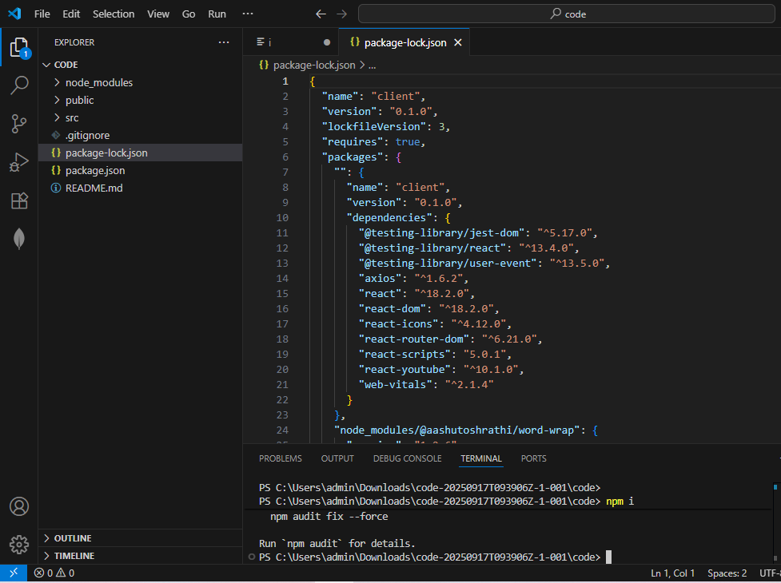



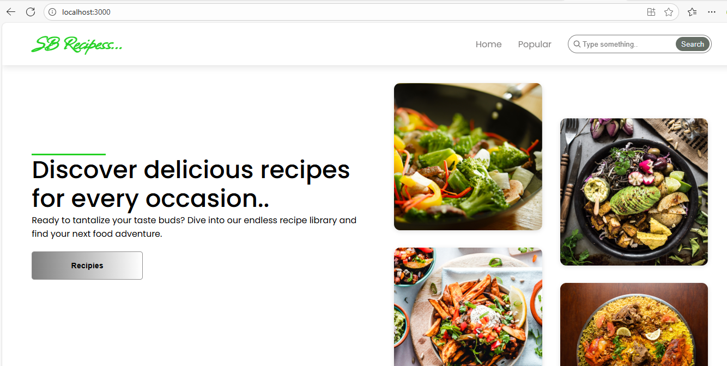

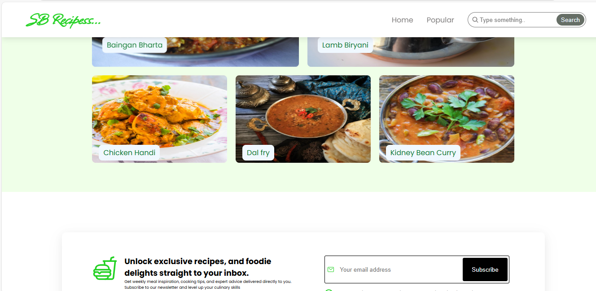

Conclusion

The cookbook project is more than a simple collection of recipes; it is a comprehensive platform for culinary education and inspiration. A successful conclusion to this project rests on two key pillars: a solid foundation and a vision for the future. The project's current state, while functional, has acknowledged issues that must be addressed, such as ensuring recipe accuracy, maintaining a seamless user experience, and resolving technical glitches. These challenges, when overcome, build the trust and reliability that are essential for any enduring resource. Looking forward, the project's value will be defined by its commitment to innovation. By integrating planned enhancements like personalized AI recommendations, interactive tools, and a thriving community, the cookbook can evolve from a static reference into a dynamic, personalized, and deeply engaging companion for every home cook. In essence, the project's true conclusion is not a final product, but a living platform—a continuous journey of discovery, learning, and shared passion that connects people through the universal language of food.

12. Known Issues

### For a Traditional or Digital Cookbook Publication:

* Recipe Errors and Ambiguity: This is a major and common issue.
  + Ingredient Mismeasurement: Incorrect quantities, units (e.g., "cups" vs. "grams"), or missing ingredients.
  + Incorrect Instructions: Steps that are out of order, unclear, or lead to a failed dish.
  + Inconsistent Formatting: A mix of different measurement units, font styles, or layout, making the book difficult to use.
  + Lack of Specificity: Vague instructions like "cook until done" without providing a visual cue or specific time frame.
* Visual and Design Problems:
  + Poor Photography: Low-quality, unappetizing, or misleading photos of the finished dish.
  + Inconsistent Styling: A lack of visual unity in the photography or page layout.
  + Layout Issues: Text that is too small, crowded, or difficult to read.
  + Printing Errors: For physical books, issues like color inaccuracies or poor paper quality.
* Content and Curation Issues:
  + Lack of a Clear Theme: The recipes feel random and don't fit a cohesive theme (e.g., "weeknight dinners," "baking for kids," etc.).
  + Unoriginal Content: Recipes that are simply copied from other sources without any unique spin or personal story.
  + Poor Recipe Selection: Dishes that are too complex for the target audience or don't work well together.

### For a Web or Mobile "Cook Book" App/Website:

* Technical Issues:
  + Slow Loading Times: The website or app is slow to load, especially with high-resolution images.
  + User Interface (UI) and User Experience (UX) Problems: The app is not intuitive to use, with a confusing navigation or a cluttered interface.
  + Search Functionality: The search feature is not effective, making it hard for users to find recipes.
  + Bugs and Glitches: The app crashes or has unexpected behavior.
  + Device Compatibility: The app doesn't display correctly on different screen sizes or operating systems.
  + Offline Functionality: Lack of an option to save recipes for offline viewing.
* Content Management Issues:
  + Data Entry Errors: Typos in ingredients or instructions that were missed during content population.
  + Poor Organization: Recipes are not properly categorized or tagged, making them hard to filter and browse.
  + Scalability Problems: The platform can't handle a large number of recipes or users.

### For a Software Development "Cookbook" Project (e.g., Chef/DevOps):

In the context of DevOps and configuration management, a "cookbook" is a collection of recipes, files, and attributes that tell a server how to achieve a desired state. Known issues often include:

* Dependency Management: A cookbook requires specific versions of other cookbooks or software, and a conflict can arise when these dependencies are not met.
* Version Control: Issues with managing different versions of a cookbook, leading to unexpected behavior on different servers.
* Platform Compatibility: A cookbook that works on one operating system (e.g., Ubuntu) may fail on another (e.g., RHEL) due to different package names or file paths.
* Attribute and Data Misuse: Incorrectly defined or referenced attributes, leading to configuration errors.
* Testing and Validation: A lack of proper testing (e.g., using tools like Test Kitchen) can lead to a cookbook that works in a development environment but fails in production.
* Security Vulnerabilities: A cookbook may introduce security risks by installing unpatched software or misconfiguring services.

13. Future Enhancements

### For a Traditional or Digital Cookbook Publication:

* Interactive and Multimedia Content:
  + QR Codes: Add QR codes to a physical book that link to short videos showing key techniques (e.g., how to properly fold dough, julienne vegetables, or plate a dish).
  + Augmented Reality (AR): Use AR to overlay information onto a page. For example, a user could point their phone's camera at a recipe and see a 3D model of the finished dish or a short animation of a specific step.
* Personalization:
  + Customizable Content: For a digital cookbook, allow users to create their own custom cookbooks by selecting and combining recipes from different sections or from other users.
  + Notes and Annotations: Provide a way for users to add personal notes, substitutions, and ratings to recipes. This can be a digital feature or a dedicated space in a physical book.
* Enhanced Information:
  + Nutritional Information: Provide detailed nutritional facts for each recipe, including calories, macronutrients (protein, carbs, fat), and key vitamins.
  + Dietary Filters: Organize recipes by dietary needs (e.g., gluten-free, vegan, low-carb, dairy-free) to make it easier for users to find what they need.
  + Ingredient Substitutions: Offer a list of suggested substitutions for common ingredients to accommodate allergies or dietary preferences.

### For a Web or Mobile "Cook Book" App/Website:

* AI and Personalization:
  + AI-Powered Recommendations: Use AI to suggest recipes based on a user's past cooking habits, dietary preferences, or even what ingredients they have on hand.
  + Recipe Improvisation: A "recipe improver" feature that suggests ingredient swaps to make a recipe healthier, more flavorful, or to use up leftovers.
* Kitchen Integration:
  + Smart Shopping Lists: Automatically generate a shopping list from selected recipes. This list could be organized by aisle or store section for convenience.
  + Grocery Delivery Integration: Partner with grocery delivery services (e.g., Instacart, Amazon Fresh) to allow users to order all the ingredients for a recipe with a single tap.
  + Voice-Activated Cooking: Implement voice commands to navigate through a recipe's steps, allowing users to cook hands-free. This is especially useful for messy tasks.
* Community and Social Features:
  + User-Generated Content: Allow users to upload and share their own recipes, photos, and cooking tips.
  + Social Sharing: Integrate with social media platforms so users can easily share their culinary creations and reviews.
  + Cook-Alongs and Live Classes: Host live video streams where a chef or cooking expert guides the community through a recipe.
* Interactive Tools:
  + Dynamic Serving Adjustments: Allow users to change the number of servings and automatically recalculate the ingredient quantities.
  + Conversion Calculators: Provide built-in tools for converting measurements (e.g., cups to grams, Celsius to Fahrenheit).
  + Meal Planning: A feature that allows users to create a weekly or monthly meal plan from their favorite recipes, complete with a consolidated shopping list.
* Visual Enhancements:
  + Step-by-Step Video Tutorials: In addition to photos, embed short videos for each step of a complex recipe.
  + 360-degree Food Photography: Use interactive 360-degree photos to showcase the final dish from every angle.