M.Tech · Fundamentals of Artificial Intelligence
Mini Project Report
AI-Based University Enquiry Chatbot
using Knowledge Representation and Natural Language Processing
Project topic No. 29 · Suggested technique: Knowledge Representation + NLP
Submitted by
Team member | Register No.
Manikandan Ayyakkannu | RA2612049015035
Dinakar B | RA2612049015032
Manoj Kumar R | RA2612049015005

Programme: M.Tech - Fundamentals of Artificial Intelligence
Date: October 2026

Live chatbot: https://manikandanayyakkannu.github.io/FAI-Mini-Project/
Submitted along with this report: the solution notebook (University_Enquiry_Chatbot.ipynb), the chatbot website (index.html and web/), the Python engine (chatbot/) and the data files (data/).

Abstract
In this project we built an enquiry chatbot for a whole university, the fictional AI University. Applicants, students and alumni can ask it about admissions and programmes, fees, the academic calendar, exams and results, certificates, university offices, departments, the hostel, placements and events. The university data is stored as frames that inherit from each other (a small semantic network). Personal questions such as "Am I eligible?" or "What will my fee be after the scholarship?" are answered by forward-chaining production rules. In front of this sit an NLP pipeline, a dialogue manager for follow-up questions, and a vector store for FAQ topics that are not in the frames. We tested it on 105 labelled questions. Our chatbot answered 94.3% of them correctly (intent macro-F1 0.96). On the same knowledge, an NLP + vector-retrieval chatbot managed 32.4% and a keyword FAQ-matching chatbot 26.7%. On a separate held-out set, which we ran only once at the end, it scored 80.0%. On university-services questions it scored 90.0% on a held-out set, against 40.0% for the retrieval chatbot. Answers take a few milliseconds (mean 3.2 ms) and every answer can be explained. The finished chatbot is a website that runs completely inside the browser, so anyone can try it from a link.
Keywords: knowledge representation, frames, semantic network, forward chaining, production rules, natural language processing, chatbot, university enquiry, vector store, closed-world assumption

Contents
1. Problem Definition 4
2. AI Problem Formulation 4
2.1 PEAS description 4
2.2 Properties of the task environment 5
2.3 Formal formulation 5
3. Selection and Explanation of the AI Technique 5
3.1 Hybrid intent classifier 6
3.2 Forward chaining with explanations 6
3.3 Saying "not available": the closed-world assumption 6
3.4 From admissions to the whole university 7
3.5 Why not a pure machine-learning or LLM chatbot? 8
4. Python Implementation 8
4.1 The chatbot website 8
5. Dataset and Test-Case Preparation 9
6. Performance Evaluation 10
6.1 Error analysis 12
7. Comparison with Alternative Approaches 12
7.1 Ablation study 13
7.2 Sensitivity to the confidence threshold 13
7.3 Held-out test set 14
7.4 University-services test sets 14
8. Results, Discussion and Conclusion 15
8.1 Results 15
8.2 Discussion and individual observations on the outputs 15
8.3 Limitations 16
8.4 Conclusion 16
9. Demonstration of the Working Prototype 16
9.1 The chat page 16
9.2 A sample conversation 18
Appendix A. How to Use the Solution 19
Appendix B. Software Used 20
References 20

1. Problem Definition
A university answers the same questions again and again, by phone, by e-mail and at many different counters. Applicants ask "What is the fee for B.Tech CSE?" or "Am I eligible for M.Tech AI with 6.8 CGPA?". Current students ask "When do the end-semester exams start?", "How do I get a bonafide certificate?" or "Whom do I contact about my hostel room?". Alumni ask for transcripts. The answers are spread over the admissions office, the exam cell, the registrar, the accounts office and the departments. Nobody answers after office hours, and two staff members do not always give the same answer.
Our aim was to build one enquiry chatbot for the whole university that:
- understands free-form English questions, including paraphrases, abbreviations (B.E, M.Tech, CGPA, plus two) and spelling mistakes;
- answers factual questions about the whole university from a structured knowledge base: admissions and programmes, fees, the academic calendar, exams and results, certificates, offices, departments, hostel, placements and events;
- reasons about personal questions, such as eligibility for a programme or the fee after scholarships, and explains every decision;
- follows the conversation ("How long is it?" after a question about M.Tech AI) and asks for missing details;
- answers free-text FAQs (ragging, Wi-Fi, refunds) through semantic retrieval, and politely refuses out-of-scope questions;
- says clearly when something is not available (a department the university does not have, or a question about another university) instead of giving a wrong answer.
Scope and assumptions: the knowledge base describes a fictional institution, "AI University", with 20 programmes (B.Tech CSE, AI & DS, ECE and Mechanical; B.Sc Computer Science and Mathematics; BCA; B.Com; BBA; B.A. English and Economics; M.Tech AI and Data Science; MBA, MBA Business Analytics and MBA Finance; MCA; M.Com; M.A. English; Ph.D.), 11 departments, 9 university offices, 7 kinds of certificate, 5 facilities, the academic calendar, the examination rules, fee payment, events, research, alumni, the admission process and the scholarship policy. We made up all of this data for the project. The chatbot is text-based, works in English and runs in any web browser without a server.

2. AI Problem Formulation
The chatbot is modelled as a knowledge-based agent. It perceives a sentence, updates its internal state (the dialogue context) and acts by choosing the answer that its knowledge base and inference rules support.

2.1 PEAS description
PEAS element | Description
Performance measure | Answer accuracy, intent precision / recall / F1, correct refusal of out-of-scope questions, response time, explainability
Environment | Applicants, parents, current students and alumni typing questions; the university knowledge (frames, rules, FAQ passages)
Actuators | Text answers, clarification questions, explanation traces
Sensors | The user's typed sentence

2.2 Properties of the task environment
Property | Value | Reason
Observability | Partially observable | The user's intention and personal facts are hidden and must be inferred from text
Determinism | Stochastic | The same need can be phrased in many different ways
Episodes | Sequential | Follow-up questions depend on earlier turns
Dynamics | Static | The knowledge does not change during a conversation
State space | Discrete | Finite sets of intents, entities and facts
Agents | Single agent | One chatbot serves one user per session

2.3 Formal formulation
- Knowledge base (KB): a set of frames F = {University, Program, UGProgram, PGProgram, btech_cse, ..., hostel, ...} linked by is_a edges. Slot lookup uses inheritance: value(f, s) = f.s if the frame stores slot s, otherwise value(parent(f), s).
- Percept to query mapping: the NLP pipeline maps a sentence x to a structured query q = (intent, entities), where intent belongs to 27 intents (program_fee, eligibility, hostel, ...) and the entities are programme, qualification, percentage, CGPA, entrance exam, category, subjects and so on.
- Working memory (WM): for a personal question, WM = facts about the programme (from the frames) plus facts about the applicant (from the sentence).
- Operators (rules): production rules of the form IF c1 AND c2 AND ... THEN add/modify fact (16 eligibility rules and 10 scholarship rules).
- Inference and goal test: forward chaining fires every applicable rule once (refraction) until a goal fact (academic_eligible, net_fee) is derived or no rule can fire.
- Fallback: if no intent is confident, the query is embedded as a vector and the closest FAQ passage is returned when its cosine similarity is above a threshold; otherwise the agent replies "out of scope".
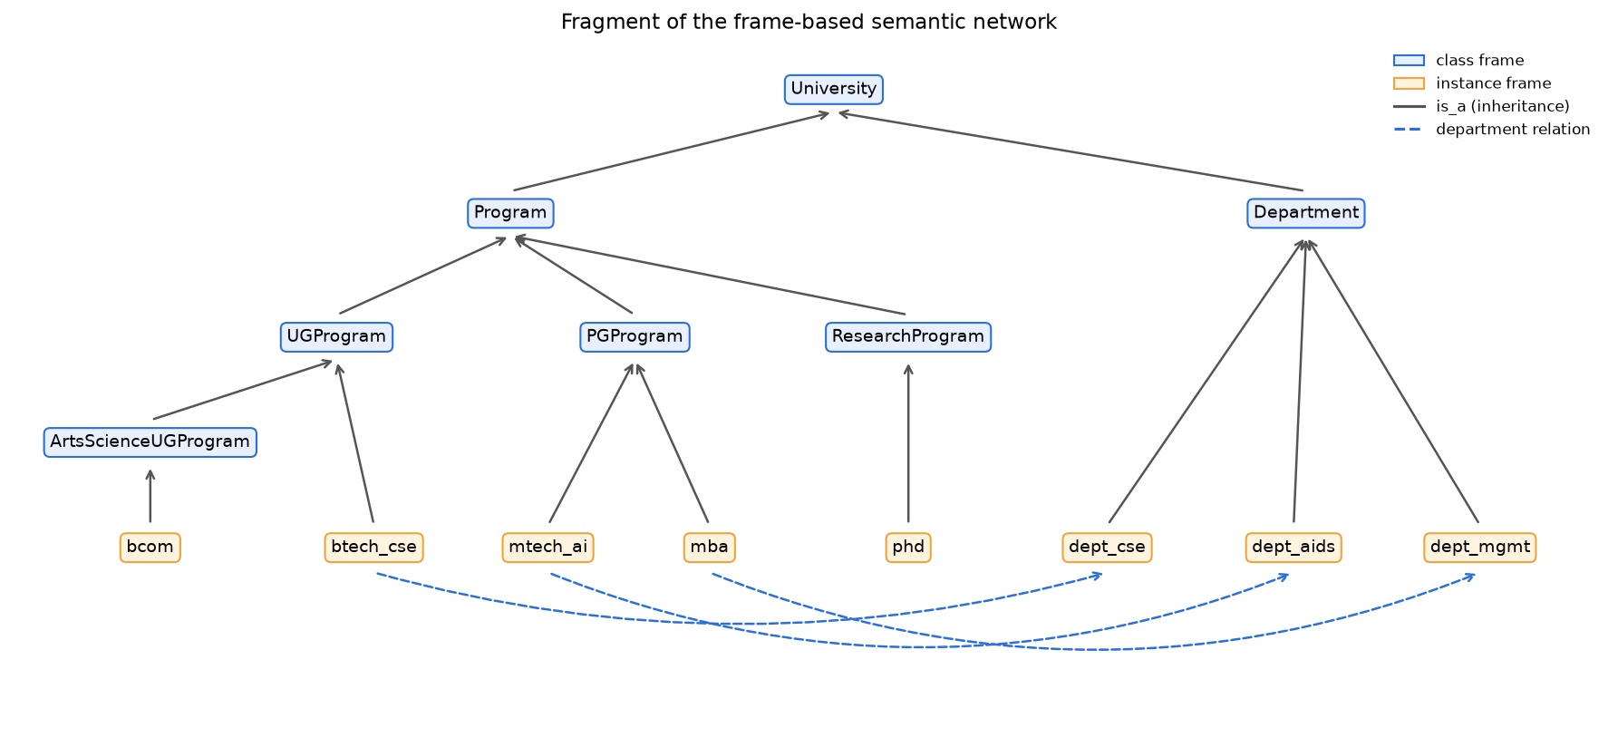
Figure 1. Fragment of the frame-based semantic network (is_a inheritance and department relations).

3. Selection and Explanation of the AI Technique
The suggested technique for this topic was Knowledge Representation + NLP. We ended up with six parts, each from classical AI. The table says what each part does and why we picked it:
Component | Technique used | Why it was chosen
Knowledge representation | Frames with is_a inheritance, which also form a semantic network of (subject, predicate, object) triples | University data is naturally hierarchical (Programme > UG/PG > B.Tech CSE). Inheritance stores duration, documents and deadlines once per class, so the KB is small and consistent.
Reasoning | Production rules + forward chaining with refraction and an explanation trace | Eligibility and scholarship policies are IF-THEN rules. Forward chaining is data-driven: it starts from the applicant's facts and derives the conclusion. Each fired rule becomes a sentence of explanation.
NLP | Normalisation, tokenisation, spelling correction (edit-distance similarity), synonym mapping, stop-word removal, stemming, regex entity extraction, hybrid intent classifier | Easy to follow and explain; needs only 112 example sentences; no GPU or downloaded model; handles Indian academic abbreviations (B.E, M.Tech, CGPA, plus two).
Retrieval fallback | Vector store: TF-IDF word + character n-gram embeddings, cosine similarity, top-k search | Free-text FAQ passages (ragging, Wi-Fi, refunds) are not worth modelling as frames. The embedder is pluggable, so a neural sentence embedding can be used without code changes.
Dialogue management | Context memory + slot filling | Supports follow-up questions and asks for missing facts (marks, qualification) before running the rules.
Closed-world assumption | Whatever is not a frame in the KB is not offered; lists of known missing departments and other institutions help recognise such questions | Without it, "HOD of CSE in SRM?" got our own CSE HOD. Now the bot says what it does not know instead of answering a different question with confidence.

3.1 Hybrid intent classifier
For each intent i the classifier computes score(i) = 0.6 x max cosine similarity between the query and the intent's example sentences (TF-IDF vectors of the pre-processed text) + 0.4 x keyword evidence (1 if a high-precision trigger word of the intent is present). The best intent wins. If even the best score is below 0.30, the query is passed to the vector store or answered as out of scope. A domain-relevance gate rejects questions that contain no word known to the university domain, such as "tell me a joke".

3.2 Forward chaining with explanations
For the question "I did B.E ECE with 6.8 CGPA and qualified GATE - am I eligible for M.Tech AI?" the working memory starts with the programme facts from the frame (minimum 60%, accepted qualifications, entrance exams) and the applicant facts from NLP (qualification = btech_ece, cgpa = 6.8, exam = gate). The engine then fires:
[R1] Converted CGPA 6.8 to 64.6% using the standard formula (CGPA x 9.5).
[R2] The minimum required aggregate for M.Tech Artificial Intelligence is 60%.
[R4] Your qualification (B.Tech ECE) is accepted for M.Tech Artificial Intelligence.
[R6] Your score 64.6% meets the cut-off of 60%.
[R11] There is no specific subject requirement for M.Tech Artificial Intelligence.
[R12] Conclusion: you satisfy the academic eligibility for M.Tech Artificial Intelligence.
[R14] Your GATE score is accepted for admission.
[R16] Because you qualified GATE you are eligible for a stipend: Rs. 12,400 per month.

3.3 Saying "not available": the closed-world assumption
While testing, we noticed two kinds of question that got confident but wrong answers. "Who is the HOD of CSE in SRM University?" was answered with our own CSE HOD, because the bot recognised "HOD" and "CSE" and simply ignored "SRM". And "Who is the HOD of the Civil department?" got a general B.Tech answer, because Civil is not a branch we offer. Both cases are handled with the closed-world assumption: if something is not in the knowledge base, the university does not offer it.
- Other universities: before anything else, the bot looks for the name of another institution (a list of 40 or so, plus any "<name> University"). If it finds one, it says it can only answer about AI University.
- Departments we do not have: the knowledge base also lists subjects that people commonly ask about but AI University does not offer (Civil, EEE, Law, Pharmacy, Hotel Management and so on). If the question names one of these and nothing that we do offer, the bot replies that the department is not available and gives the admissions office's contact details. It reads the question once more without that word, so "I did B.E Civil, can I join MBA?" is still treated as an MBA question.
- Unknown department names: a department name the bot has never heard of ("HOD of the XYZ department") gets the same "not available" reply, instead of a list of every department.
- Greetings and complaints: "hi, do you have seats in medical?" is answered as a question, not just as a greeting, and "the answers are not relevant" gets an apology with an example of how to ask, instead of the out-of-scope message.
We also gave AI & DS its own department, with its own HOD, and added arts, science, commerce and management programmes. The arts and science degrees use a new class frame, ArtsScienceUGProgram. It inherits from UGProgram but overrides the duration (3 years), the cut-off (50%) and the subject requirement, which is another example of inheritance at work.

3.4 From admissions to the whole university
Our first version only answered admission questions. To cover the whole university we added knowledge, not new kinds of reasoning:
- New class frames: Office (9 offices: admissions, registrar, exam cell, accounts, dean of students, hostel, placement cell, international relations, IT helpdesk) and Certificate (7 certificates). Every certificate inherits how to apply and the issuing office from the Certificate class; the provisional certificate overrides the office with the exam cell.
- New instance frames: academic_calendar, examinations, fee_payment, events, research and alumni. The exam dates are not repeated in the examinations frame; the answer reads them from the academic_calendar frame.
- Placement history: every department with placements keeps four seasons (2022-23 to 2025-26). A year in the question selects the season ("placements in 2023" means the batch that graduated in 2023), and a year we have no data for gets "not available" with the latest figures.
- Nine new intents: academic calendar, examination, results, fee payment, certificates, office information, faculty and research, events and alumni, each with example sentences and a few high-precision keywords.
- Links between frames: each topic is linked to the office that handles it (examinations -> exam cell, fee payment -> accounts office, certificates -> registrar), so "Which office handles it?" after an exam question is answered from the dialogue context.
- Entities decide the topic: when a question names an office or a certificate ("exam cell", "TC"), that entity decides the topic, whatever the intent classifier guessed.
The new intents share words with the old ones ("fee", "start", "semester"), so a few rules separate them: "When does the semester start?" is a calendar question, not the admission deadline, and "Can I pay the fees late?" is about paying, not about how much a programme costs.

3.5 Why not a pure machine-learning or LLM chatbot?
We did consider using a large language model, but decided against it. For admissions the numbers (fees, cut-offs) have to be exactly right, the same every time, and explainable. In our system every answer can be traced back to a frame slot or a rule. A language model can make up a fee or a cut-off, it cannot properly justify an eligibility decision, and it needs a paid API or a GPU. Our approach has its own cost: someone has to write the knowledge by hand. We discuss this in Section 8.

4. Python Implementation
We first wrote the chatbot as a small Python 3.12 package. The solution notebook uses it for all the experiments, and it was used to produce every number in this report. It needs numpy, pandas, scikit-learn (TF-IDF and metrics) and matplotlib. The NLP and reasoning parts use only the Python standard library.
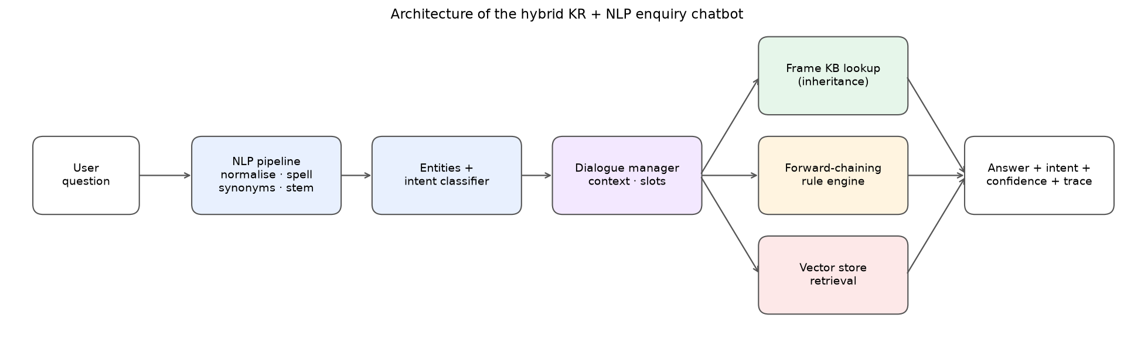
Figure 2. Architecture of the hybrid KR + NLP enquiry chatbot.
Module | Responsibility
knowledge_base.py | Frames, is_a inheritance (get, get_with_source, resolved), semantic-network triples and pattern queries
nlp.py | Normalisation of abbreviations, tokenisation, spelling correction, synonyms, stop words, stemming, entity extraction
intent_classifier.py | Hybrid TF-IDF similarity + keyword intent classifier with a confidence threshold
reasoning.py | Generic forward-chaining production-rule engine (conditions, actions, refraction, explanations)
vector_store.py | In-memory vector store with a pluggable embedder (TF-IDF default; sentence-transformers optional)
answers.py / faq_builder.py | Natural-language answer templates filled from frames; FAQ corpus for retrieval and the baselines
engine.py | UniversityChatbot: dialogue manager (context, slot filling), routing to KB / rules / vector store, trace
baselines.py / evaluation.py | Alternative approaches for comparison; test harness and metrics
data/*.json, data/*.csv | Knowledge base (70 frames), rules (26), intents (27), free-text FAQs (15), four test sets

4.1 The chatbot website
For the demonstration we wanted a link that anyone could open, with nothing to install and no terminal. So we rewrote the same engine in plain JavaScript, one file for each Python module. It runs entirely inside the browser and is hosted for free on GitHub Pages. There is no server and no API key, and both versions read the same data/*.json files. To make sure the website behaves exactly like the Python version, we put 361 test conversations (all four test sets plus 171 extra questions about the newer features) through both. The answers, intents, answer sources and confidence scores came out identical, so the results in Sections 6 and 7 also hold for the website.
File | What it contains
index.html | The chat page: sample questions and guided demos on the left, the conversation on the right
web/css/style.css | Layout and colours (light and dark theme, works on phones)
web/js/knowledge-base.js, nlp.js, intent-classifier.js, reasoning.js, answers.js, similarity.js | The engine, one file per Python module
web/js/chatbot.js | Dialogue manager: decides whether the KB, the rules or the vector store answers
web/js/app.js | Everything on the screen: messages, follow-up suggestions and guided demos
tests/engine-test.html | Runs all four test sets in the browser and shows the accuracy

What happens to every message (respond() in both versions):
- NLP pre-processing, entity extraction and intent classification.
- If a task is pending (e.g. eligibility waiting for marks), the new facts fill the slot and the task continues.
- Personal questions with applicant facts are sent to the forward-chaining engine (eligibility or scholarship rules).
- The dialogue context resolves references ("it") and elliptical follow-ups ("What about MBA?").
- The domain gate and the vector store handle unknown or low-confidence questions.
- Otherwise the answer is filled from the frame KB. The response carries the text, intent, confidence, answer source and a full trace.

5. Dataset and Test-Case Preparation
There is no public dataset for a made-up university, so we wrote the knowledge and the test questions ourselves:
- Knowledge sources: 70 frames, 26 production rules, 27 intents with 178 example sentences, and 175 FAQ passages (160 generated automatically from the frames and 15 free-text passages).
- Main test set: 105 hand-written queries, deliberately different from the intent examples, in 8 categories that test different abilities. Each query is labelled with the expected intent and the expected answer key (e.g. program_fee:btech_ece, eligibility:mtech_ai:yes). An answer counts as correct only when the key matches exactly, so for reasoning questions the eligibility decision itself must be right.
- Held-out test set: 25 further queries written after development finished and evaluated only once, without any change to the system. This gives an unbiased estimate, because the main test set was also used to find bugs.
Category | Main set | Held-out | What it tests
factual | 20 | 2 | Direct factual questions
paraphrase | 20 | 6 | Same needs, different wording and synonyms
typo | 10 | 3 | Spelling mistakes ("hostle feez", "admision procedure")
reasoning | 16 | 5 | Personal eligibility / fee-after-scholarship decisions
multi_turn | 14 | 3 | 5 conversations with follow-ups and slot filling
unstructured_faq | 12 | 3 | Free-text FAQ topics not modelled as frames
out_of_scope | 10 | 3 | Unrelated questions that must be refused
smalltalk | 3 | 0 | Greeting, thanks, goodbye
Total | 105 | 25

For the rest of the university we wrote two more test sets:
- University-services development set: 40 questions on the calendar, exams, results, fee payment, certificates, offices, research, events and alumni, including two short conversations. We wrote them after building these features and then used them to improve the features, so their score is optimistic.
- University-services held-out set: 20 further questions, written before that tuning and scored once.
Category | Development | Held-out
calendar | 6 | 3
exams | 5 | 3
results | 4 | 2
fees_payment | 4 | 2
certificates | 5 | 3
offices | 6 | 3
research | 2 | 1
events | 3 | 2
alumni | 1 | 1
conversation | 4 | 0
Total | 40 | 20

6. Performance Evaluation
Metrics used:
- Answer accuracy: share of queries whose answer key matches the expected key (main metric).
- Intent accuracy and macro precision / recall / F1: how well the question type is understood.
- Out-of-scope precision / recall: whether the chatbot refuses the right questions and only those.
- Recall@k of the vector store: whether the right free-text passage is among the top-k results.
- Latency: mean response time per query.
Metric | Hybrid KR + NLP
Answer accuracy | 0.943
Intent accuracy | 0.943
Intent macro precision | 0.954
Intent macro recall | 0.968
Intent macro F1 | 0.957
Out-of-scope precision | 0.900
Out-of-scope recall | 0.900
Mean latency (ms) | 3.24
Vector store Recall@1 / Recall@3 | 0.92 / 1.00
Latency 95th percentile / max (ms) | 4.28 / 8.10

Observation: 94.3% of the 105 questions got exactly the right answer, and the intent was right just as often (macro-F1 0.96). The chatbot refused 90.0% of the questions it should refuse, and when it did refuse it was right 90.0% of the time. An answer takes 3.2 ms on average, so speed is not an issue.
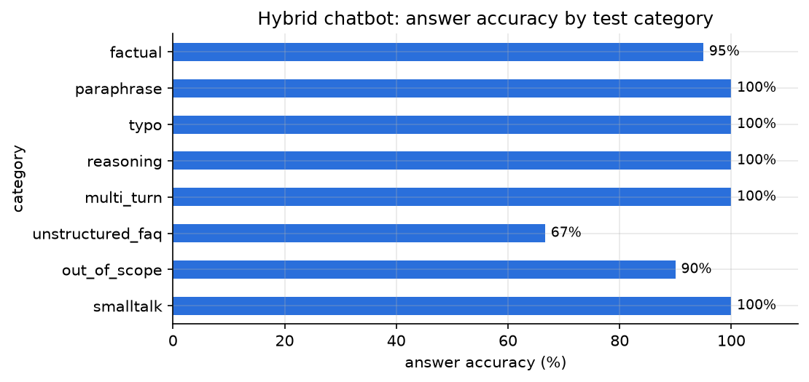
Figure 3. Answer accuracy of the hybrid chatbot by test category.
Observation: 5 of the 8 categories are answered perfectly, including reasoning, multi-turn and spelling mistakes, which are the hard cases for a chatbot. The weakest category is free-text faq topics not modelled as frames (67%): these questions are not in the frames and have to be matched by wording alone.
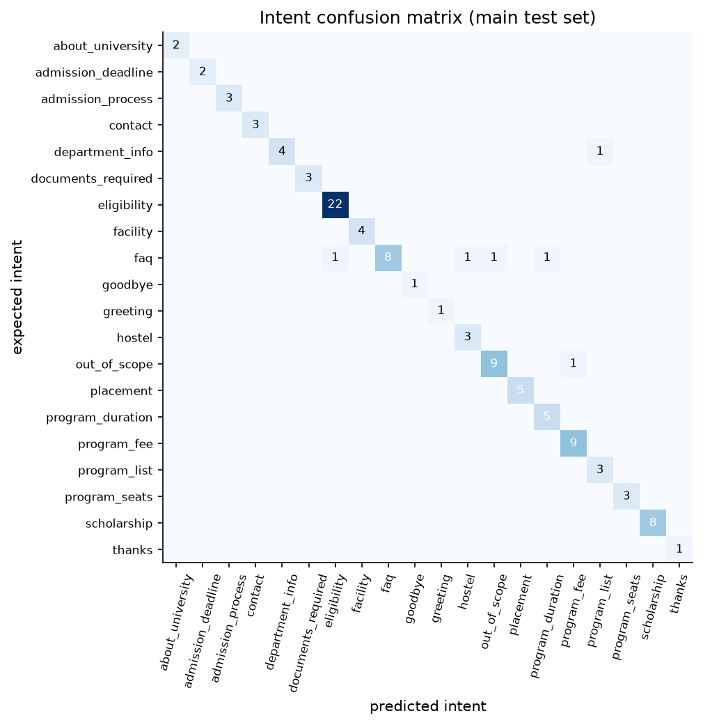
Figure 4. Intent confusion matrix on the main test set.
Observation: Almost everything lies on the diagonal. Only 6 questions got the wrong intent, and no intent is confused systematically with another: each mistake is a single question with an unusual word (listed below).

6.1 Error analysis
ID | Query | Predicted | Cause
F18 | Which department offers MCA? | program_list:all | "offers" sent the query to the programme list instead of the department relation
U02 | Do you have wifi in the hostel? | hostel | "hostel" is a confident KB intent, so the Wi-Fi FAQ was never consulted
U03 | Can diploma holders get lateral entry? | eligibility:ask_program | "diploma" was read as an applicant qualification, so the bot asked which programme
U08 | Do we have to wear a uniform? | fallback | "uniform" has no lexical overlap with "dress code" (a limit of lexical embeddings)
U09 | Can I study abroad for a semester? | program_duration:all | "semester" pulled the query towards the duration intent
O07 | What is the share price of Infosys? | program_fee:all | "price" is a synonym of fee in the domain vocabulary

Observation: Most remaining errors have the same cause: the chatbot compares words, not meanings. "Uniform" and "dress code" share no words, and "price" is a synonym of fee in our domain. A neural sentence embedding in the vector store would fix several of them without changing the knowledge base.

7. Comparison with Alternative Approaches
Two alternative chatbots were built on exactly the same knowledge: the same 175 FAQ question-answer pairs, with identical answer wording. Only the approach differs:
System | Description
Keyword FAQ matching (classic baseline) | Raw lower-cased text, word TF-IDF and cosine similarity to FAQ questions. No NLP, no KR, no reasoning, no memory.
NLP + vector retrieval | The same NLP normalisation and vector store as the proposed system, but every answer is retrieved from the FAQ corpus. No frames, rules or dialogue state.
Hybrid KR + NLP (proposed) | Frames + forward chaining + NLP + dialogue manager + vector-store fallback.

Metric | Keyword FAQ matching | NLP + vector retrieval | Hybrid KR + NLP (proposed)
Answer accuracy | 0.267 | 0.324 | 0.943
Intent accuracy | 0.400 | 0.533 | 0.943
Intent macro precision | 0.457 | 0.502 | 0.954
Intent macro recall | 0.365 | 0.416 | 0.968
Intent macro F1 | 0.335 | 0.414 | 0.957
Out-of-scope precision | 0.077 | 0.185 | 0.900
Out-of-scope recall | 0.100 | 0.500 | 0.900
Mean latency (ms) | 0.46 | 1.13 | 3.24

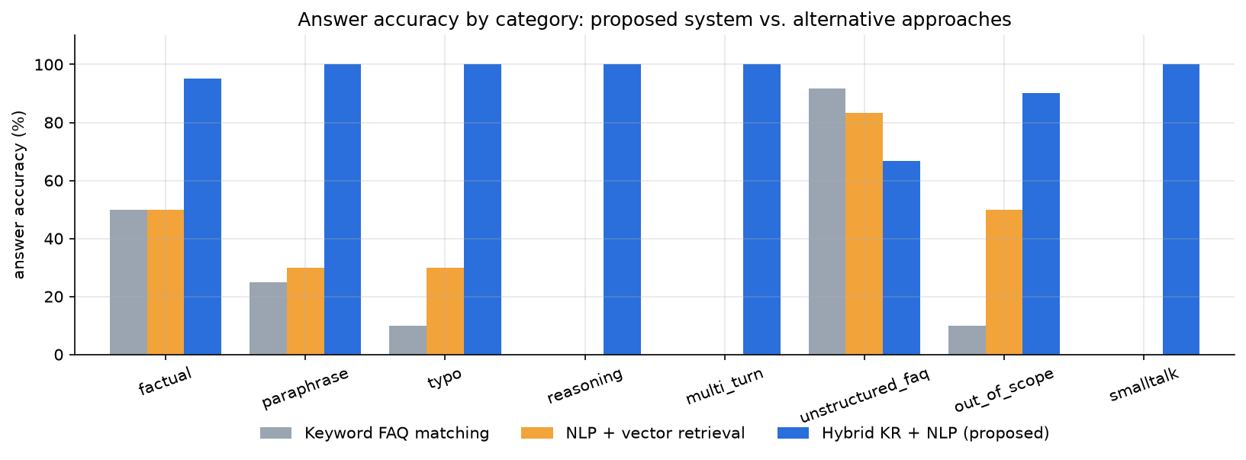
Figure 5. Answer accuracy by category: proposed system vs. alternative approaches.
Observation: Our chatbot is ahead in every category except free-text FAQs, where the retrieval chatbots score 83-92% against our 67%. The biggest gaps are reasoning and multi-turn questions, where both alternatives score 0%: retrieving a stored answer cannot decide whether one particular student is eligible, or remember what "it" refers to.

7.1 Ablation study
To measure what each component contributes, one component was removed at a time:
Configuration | Overall | fact. | para. | typo | reas. | multi | FAQ | OOS
Full hybrid system | 94.3% | 95 | 100 | 100 | 100 | 100 | 67 | 90
without rule-based reasoning | 74.3% | 95 | 100 | 100 | 0 | 57 | 75 | 90
without dialogue context | 85.7% | 95 | 100 | 100 | 100 | 36 | 67 | 90
without spelling correction | 87.6% | 95 | 100 | 30 | 100 | 100 | 67 | 90
without vector-store fallback | 86.7% | 95 | 100 | 100 | 100 | 100 | 0 | 90

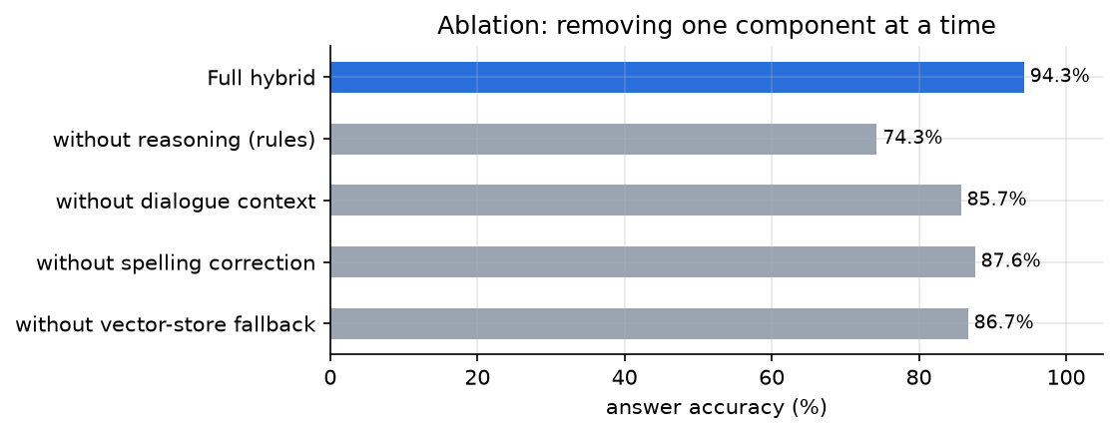
Figure 6. Ablation: answer accuracy when one component is removed.
Observation: Every component earns its place: removing any one of them lowers the accuracy. The largest drop comes without rule-based reasoning (94.3% to 74.3%), which shows that the rules are the core of the system. The other components each fix one kind of question (typos, follow-ups or free-text FAQs).

7.2 Sensitivity to the confidence threshold
The intent-confidence threshold was fixed at 0.30 before testing. The sweep in Figure 7 shows that higher thresholds (0.35-0.55) give slightly higher accuracy and better out-of-scope recall on this test set. This was not adopted, because choosing a parameter on the test set would make the reported result optimistic. It should be validated on new data.
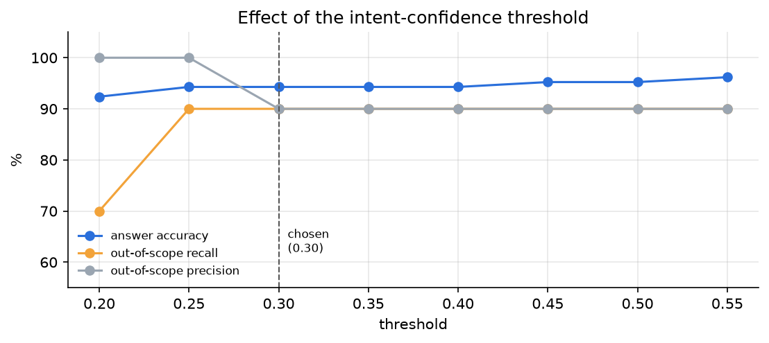
Figure 7. Effect of the intent-confidence threshold.
Observation: The accuracy changes by only a few points between thresholds 0.20 and 0.55, so the system is not sensitive to this setting. Below 0.30 more unrelated questions get an answer; above it, a few more are refused correctly.

7.3 Held-out test set
Metric | Keyword FAQ matching | NLP + vector retrieval | Hybrid KR + NLP (proposed)
Answer accuracy | 0.320 | 0.480 | 0.800
Intent accuracy | 0.360 | 0.560 | 0.800
Intent macro F1 | 0.252 | 0.376 | 0.670
Out-of-scope recall | 0.333 | 0.667 | 0.333

Note: while checking the held-out results, one label (H14, B.Sc Maths for M.Tech Data Science) was found to be wrong. The knowledge base accepts M.Sc Maths, not B.Sc, so the chatbot's "not eligible" answer was correct. The label was corrected; the system itself was not changed.
Observation: On new questions the accuracy falls from 94.3% to 80.0%, which is the honest figure to expect from real users. The ranking of the three chatbots does not change, so the advantage of the knowledge-based design is not a result of tuning on the main test set.

7.4 University-services test sets
The FAQ list that the two alternative chatbots search is generated from the same frames, with one entry for each office, each certificate, the calendar, exams, results, fee payment, events, research and alumni, so all three systems again share the same knowledge.
Test set | Keyword FAQ matching | NLP + vector retrieval | Hybrid KR + NLP (proposed)
Development (40) | 42.5% | 45.0% | 100.0%
Held-out (20) | 40.0% | 40.0% | 90.0%

How to read these numbers honestly: on its first run, before we used it to improve anything, our chatbot scored 72.5% on the development set; the 100% above is after tuning on it. The held-out set scored 80% on its single run. One of its questions, "Can I pay the semester fee using UPI?", revealed a real bug: the spelling corrector turned "using" into "nursing", a word we had added to the vocabulary for the closed-world check. We fixed it by adding everyday words such as "using" to the list of words that are never corrected, and nothing else was changed for the held-out questions. After that fix the held-out score is 90.0%. The remaining misses are "winter break" and "lunch break", phrasings that the calendar intent has not seen.
Observation: Questions from current students are short and use everyday words ("Do we have classes on Saturdays?", "I need my transfer certificate"), so the retrieval chatbots, which match whole FAQ questions, do poorly on them. Our chatbot first finds the office or certificate named in the question, and that entity decides the answer. The held-out set also showed that adding words to the vocabulary has side effects on spelling correction, which is worth testing every time the knowledge base grows.

8. Results, Discussion and Conclusion

8.1 Results
- Main test set: on the 105-query main test set the hybrid chatbot answered 94.3% correctly (intent macro-F1 0.96), against 32.4% for NLP + vector retrieval and 26.7% for keyword FAQ matching.
- Held-out set: 80.0% for the hybrid chatbot, against 48.0% and 32.0%. The drop from the main test set is the expected optimism of a test set that was also used for debugging; the ranking of the three approaches is the same.
- University services: 90.0% on the held-out university-services questions (80% on the first run, before the spelling bug was fixed) and 100.0% on the development set, against 40.0% and 40.0% for the alternatives on the held-out set.
- Speed: mean 3.2 ms per answer on an ordinary laptop, without a GPU. The browser version feels just as instant.

8.2 Discussion and individual observations on the outputs
- The rules make the biggest difference. Both alternatives scored 0% on reasoning questions and about 0% on multi-turn questions. They can show the general eligibility text, but they cannot say whether this particular student ("72% in B.E ECE") is eligible for M.Tech AI. When we switched off only the rule engine, accuracy fell from 94.3% to 74.3%, the biggest drop of any component.
- Inheritance kept the knowledge base small. Duration, documents and deadlines are written once in the UG, PG and Research class frames, and every programme inherits them. When one of these values changes we edit one place. The trace also shows where a value came from, for example that mba.duration comes from the PGProgram frame.
- Explanations needed no extra work. Each rule that fires writes one sentence, e.g. "[R3] A 5% relaxation applies for the OBC category, so the cut-off becomes 55%". The important ones are part of the answer itself ("Converted CGPA 7.2 to 68.4%... Your score meets the cut-off of 50%"), so a student can see exactly why they are or are not eligible, and the notebook prints the full trace. A purely statistical chatbot cannot give this.
- Small NLP steps mattered more than we expected. Spelling correction alone took typo accuracy from 30% to 100%. Without normalising B.E / B.Tech / M.Tech / plus two / CGPA, most entities would not have been found at all.
- People expect the bot to remember the conversation. Without the context memory, multi-turn accuracy falls from 100% to 36%. Students ask "How long is it?" or reply to a question with just "I have 61 percent", and the bot has to understand that.
- Frames and free-text FAQs work well together, with one trade-off. Without the vector store the free-text FAQ questions score 0%; with it, 67% (Recall@3 = 1.00). The plain retrieval chatbots still do better on these (83-92%), because our chatbot sometimes trusts a confident KB intent too much ("Wi-Fi in the hostel" goes to the hostel frame).
- One knowledge base can cover the whole university. Offices, certificates, the calendar and the exam rules are frames just like the programmes, so going from admissions to the whole university needed new frames, intents and answer templates but no new kind of reasoning. Links between frames answer follow-ups such as "Which office handles it?" (examinations -> exam cell). The retrieval chatbots do much worse here because many of these questions are short and use everyday words ("Do we have classes on Saturdays?").
- Spotting out-of-scope questions is the weakest part. The domain gate catches clearly unrelated questions (recall 90.0%), but questions that share words with the domain ("share price of Infosys", "book a movie ticket") still get a university answer.

8.3 Limitations
- Knowledge must be engineered by hand; rules cover only eligibility and scholarship policies.
- The "not available" replies only cover departments and institutions in our lists; an unknown name that is not written as "<name> University" can still slip through.
- TF-IDF embeddings are lexical, so pure synonyms ("in charge of" vs "HOD", "uniform" vs "dress code") are missed.
- The university-services test sets are small (40 and 20 questions) and were written by us after building those features.
- English only; the knowledge base is synthetic; the test sets were written by the developer, not collected from real users.

8.4 Conclusion
We designed, built and tested an enquiry chatbot for the whole university that combines knowledge representation with NLP. Frames with inheritance hold the university's facts: programmes, departments, offices, certificates, the academic calendar and the exam rules. Forward-chaining rules answer personal eligibility and fee questions and explain each step. A simple NLP pipeline turns a free-form question into intent and entities, the dialogue manager handles follow-ups and missing details, and a vector store covers FAQ topics that are not in the frames. Our chatbot clearly beats the retrieval-only chatbots, especially on reasoning and multi-turn questions. It stays fast and explainable, and as a website it can be demonstrated from any phone or laptop.
If we continue the project, we would like to: try a neural sentence embedding in place of TF-IDF (the embedder is already pluggable); learn the intent weights from real chat logs; add backward chaining for questions like "what do I need to become eligible?"; support Tamil and Hindi; and read the knowledge base from the university's real databases (admissions, exam results, fee dues).

9. Demonstration of the Working Prototype
The working chatbot is online at https://manikandanayyakkannu.github.io/FAI-Mini-Project/. It opens straight away in any browser, on a laptop or a phone, with nothing to install.

9.1 The chat page
The page is kept simple, like a normal chat application. On the left are sample questions grouped by topic, plus three guided demos that type out a short conversation on their own (useful during the presentation). On the right is the conversation. The replies contain only the answer, with no technical details. After each answer the bot suggests follow-up questions such as "How long is it?". The (i) button opens a short page about the project, the team and the results. How each answer was produced (intent, entities, rules fired, trace) is shown in the notebook, Section 9.
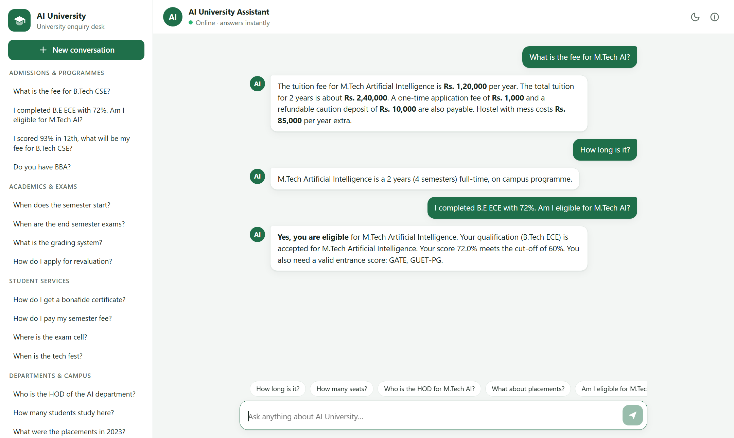
Figure 8. Demo 1: a follow-up question ("How long is it?") answered from context, then an eligibility decision.
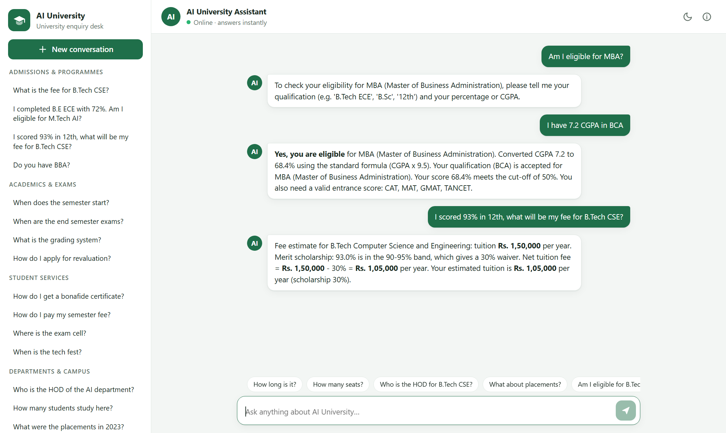
Figure 9. Demo 2: the bot asks for the missing details, converts CGPA to a percentage, and then works out a fee with the merit scholarship.
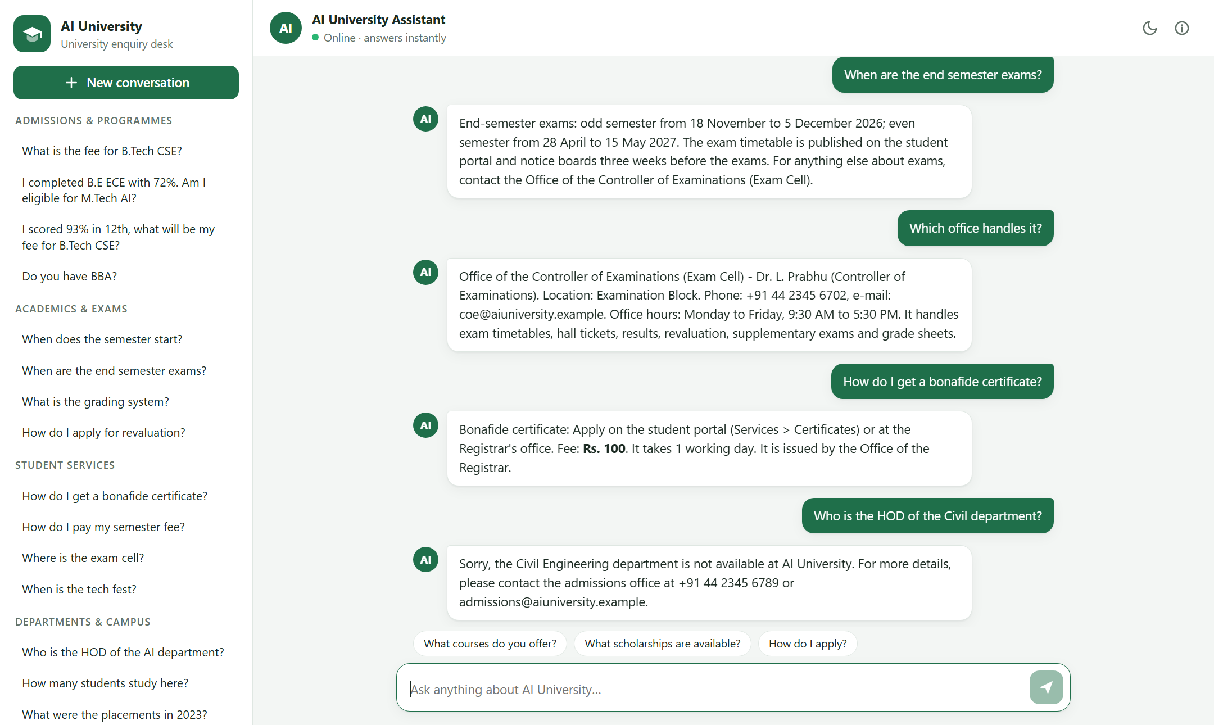
Figure 10. Demo 3: exam dates, "Which office handles it?" answered from context, a certificate, and a department the university does not have.
Observation: In Demo 1, "How long is it?" has no programme in it, yet the answer is about M.Tech AI, taken from the previous question. In Demo 2 the bot asks for the missing marks instead of guessing, then converts the CGPA with rule R1 before checking the cut-off. In Demo 3, "Which office handles it?" is answered with the exam cell because the previous topic was the exams, and the Civil Engineering question gets "not available" rather than a wrong answer. The replies read like a person answering, while the reasoning behind each one stays traceable in the notebook.

9.2 A sample conversation
This is one complete conversation with the chatbot. The line after each answer says which part of the system produced it.
You: What is the fee for M.Tech AI?
Bot: The tuition fee for M.Tech Artificial Intelligence is Rs. 1,20,000 per year. The total tuition for 2 years is about Rs. 2,40,000. A one-time application fee of Rs. 1,000 and a refundable caution deposit of Rs. 10,000 are also payable. Hostel with mess costs Rs. 85,000 per year extra.
(answered by: frame knowledge base)
You: How long is it?
Bot: M.Tech Artificial Intelligence is a 2 years (4 semesters) full-time, on campus programme.
(answered by: frame knowledge base)
You: What about MBA?
Bot: MBA (Master of Business Administration) is a 2 years (4 semesters) full-time, on campus programme.
(answered by: frame knowledge base)
You: Am I eligible for M.Tech AI?
Bot: To check your eligibility for M.Tech Artificial Intelligence, please tell me your qualification (e.g. 'B.Tech ECE', 'B.Sc', '12th') and your percentage or CGPA.
(answered by: dialogue manager)
You: I did B.E ECE with 6.8 CGPA and I qualified GATE
Bot: Yes, you are eligible for M.Tech Artificial Intelligence. Converted CGPA 6.8 to 64.6% using the standard formula (CGPA x 9.5). Your qualification (B.Tech ECE) is accepted for M.Tech Artificial Intelligence. Your score 64.6% meets the cut-off of 60%. Your GATE score is accepted. You will also get a GATE stipend of Rs. 12,400 per month for GATE-qualified students.
(answered by: rule-based reasoning)
You: I scored 96% in 12th and I am a state level athlete. What will my fee be for B.Tech CSE?
Bot: Fee estimate for B.Tech Computer Science and Engineering: tuition Rs. 1,50,000 per year. Merit scholarship: 96.0% >= 95% gives a 50% tuition waiver. Sports quota (state/national level) adds a 25% waiver. The total waiver is capped at 60%. Net tuition fee = Rs. 1,50,000 - 60% = Rs. 60,000 per year. Your estimated tuition is Rs. 60,000 per year (scholarship 60%).
(answered by: rule-based reasoning)
You: hostle fees for girls?
Bot: Separate hostels for boys (1,200 beds) and girls (900 beds) inside the campus. Rooms: single, double and triple sharing. The fee is Rs. 85,000 per year, which includes accommodation and mess (veg and non-veg). AC rooms cost Rs. 20,000 extra per year. In-time 9:00 PM for all students.
(answered by: frame knowledge base)
You: Is the campus ragging free?
Bot: AI University has zero tolerance for ragging. An anti-ragging committee and squad monitor the campus and hostels 24x7, and students can report incidents anonymously on the helpline 1800-180-5522.
(answered by: vector-store search)
You: Who won the cricket match yesterday?
Bot: Sorry, I could not find an answer to that. I can help with admissions, programmes, fees, exams and results, the academic calendar, certificates, university offices, hostel, scholarships, placements, events and campus facilities. For anything else please call the university at +91 44 2345 6789.
(answered by: out of scope)

And a conversation about university services:
You: When are the end semester exams?
Bot: End-semester exams: odd semester from 18 November to 5 December 2026; even semester from 28 April to 15 May 2027. The exam timetable is published on the student portal and notice boards three weeks before the exams. For anything else about exams, contact the Office of the Controller of Examinations (Exam Cell).
(answered by: frame knowledge base)
You: Which office handles it?
Bot: Office of the Controller of Examinations (Exam Cell) - Dr. L. Prabhu (Controller of Examinations). Location: Examination Block. Phone: +91 44 2345 6702, e-mail: coe@aiuniversity.example. Office hours: Monday to Friday, 9:30 AM to 5:30 PM. It handles exam timetables, hall tickets, results, revaluation, supplementary exams and grade sheets.
(answered by: frame knowledge base)
You: How do I get a bonafide certificate?
Bot: Bonafide certificate: Apply on the student portal (Services > Certificates) or at the Registrar's office. Fee: Rs. 100. It takes 1 working day. It is issued by the Office of the Registrar.
(answered by: frame knowledge base)
You: What is the late fee for semester fees?
Bot: Late fee: Rs. 100 per day after the due date, up to Rs. 5,000. Students with unpaid fees do not get a hall ticket. Questions about payments go to the Accounts Office.
(answered by: frame knowledge base)
You: Who is the HOD of the Civil department?
Bot: Sorry, the Civil Engineering department is not available at AI University. For more details, please contact the admissions office at +91 44 2345 6789 or admissions@aiuniversity.example.
(answered by: frame knowledge base)

Observation: Each answer comes from a known place: a frame slot, a rule or an FAQ passage. In the first conversation the misspelt "hostle fees" is corrected, the ragging question is matched in the FAQ passages, and the cricket question is refused instead of being answered with something unrelated. In the second, the exam dates come from the academic-calendar frame, the office from the link between the exams and the exam cell, and the certificate fee and time from the certificate frame. The same questions give the same answers every time.

Appendix A. How to Use the Solution
- The chatbot: open https://manikandanayyakkannu.github.io/FAI-Mini-Project/ in any browser. Click a sample question or type your own. "Demo 1" and "Demo 2" (admissions) and "Demo 3" (exams and services) in the left panel play a short conversation for the presentation.
- Test results in the browser: open tests/engine-test.html on the same site. It runs all four test sets and shows the accuracy and every answer.
- The notebook: open the project folder in VS Code (File > Open Folder), open University_Enquiry_Chatbot.ipynb, select the Python 3.12 kernel (top right) and click Run All. It recomputes every metric and figure in this report.
- Changing the knowledge: the facts, rules, intents and FAQs live in data/*.json. Both the website and the notebook read these files, so an edit there changes both.

Appendix B. Software Used
All the software is free. Nothing needs to be installed to use the chatbot, since it runs in the browser. For the notebook we installed, for the Windows user only:
- Python 3.12.10 (winget install --id Python.Python.3.12 -e --scope user)
- Visual Studio Code with the Python and Jupyter extensions
- Python libraries: numpy, pandas, scikit-learn, matplotlib, jupyter and ipykernel (python -m pip install -r requirements.txt)
- Hosting: GitHub Pages (Settings > Pages > Deploy from branch: main, folder / (root))

References
- S. Russell and P. Norvig, Artificial Intelligence: A Modern Approach, 4th ed., Pearson, 2021 (Ch. 7-10: knowledge-based agents, inference, knowledge representation).
- M. Minsky, "A Framework for Representing Knowledge," MIT AI Laboratory Memo 306, 1974.
- D. Jurafsky and J. H. Martin, Speech and Language Processing, 3rd ed. draft, 2024 (chatbots and dialogue systems; vector semantics).
- C. D. Manning, P. Raghavan and H. Schütze, Introduction to Information Retrieval, Cambridge University Press, 2008 (TF-IDF, cosine similarity).
- F. Pedregosa et al., "Scikit-learn: Machine Learning in Python," Journal of Machine Learning Research, 12, pp. 2825-2830, 2011.

