Big Data Systems — Implementation & Analytics
Domain: Transportation — NYC Yellow Taxi Trip Analytics

Course | CC ZG522 · Big Data Systems
Semester | First Semester 2026-27
Assignment | Assignment 1 · Group Assignment
Total Marks | 20

Team
Name | Registration No. | Role
Dhruv Kumar | 2026NS03024 | Group Lead - Hadoop Setup and Architecture
Manikandan B | 2026NS03009 | Presentation Lead and HBase Lead
Parepalli Venkata Sai Krishna Mohan | 2026NS03066 | Data Acquisition & Ingestion and Map-reduce Scripts
Ramya K | 2026NS03046 | Pig Lead – ETL
Varada Sri Lalithya | 2026NS03089 | Hive Lead
Vishwa Vajendra M | 2026NS03076 | Dashboard Lead

Instructor: Dr D Venkata Subramanian
Birla Institute of Technology & Science, Pilani
Work Integrated Learning Programmes Division
Table of Contents
​
Table of Contents 3
Executive Summary 6
§1 · Introduction 7
1.1 Selected domain 7
1.2 Background 7
1.3 Business problem 7
§2 · Big Data Need Analysis 8
2.1 Why Big Data — and why not a traditional RDBMS? 8
2.2 The 5 Vs applied to our dataset 9
2.3 Existing challenges we specifically addressed 9
§3 · Dataset Description 10
3.1 Source 10
3.2 Volumes 10
3.3 Trip fact schema — 19 columns 11
3.4 Known data-quality issues (Veracity story) 12
§4 · Proposed Big Data Architecture 12
4.1 Data-source layer 12
4.2 Ingestion layer 13
4.3 Storage layer — HDFS pseudo-cluster 13
4.4 Processing layer 13
4.5 Analytics layer 13
4.6 Presentation layer 14
§5 · Technology Selection 14
5.1 HDFS 14
5.2 Apache Pig — why not raw MapReduce or Hive for ETL? 14
5.3 Apache Hive — why not straight MapReduce? 15
5.4 Apache HBase — why add a NoSQL layer at all? 15
5.5 Streamlit — why not Power BI / Tableau? 15
Practical Implementation 16
Phase 0 · Environment Verification & Config Fixes 16
Phase 1 · Install Pig, Hive, HBase 16
Selected verification output 16
Phase 2 · Dataset Download and HDFS Ingestion 17
Post-ingestion HDFS listing and block report 17
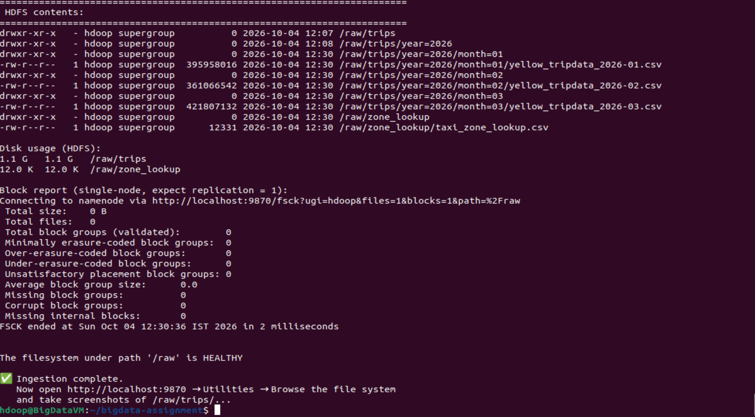 17
Sample data (first 3 trip records) 17
Phase 3 · Pig ETL — Cleanse and Enrich 17
Pig 01_clean_trips.pig — job stats 18
Pig 02_enrich_trips.pig — job stats 18
Enriched sample row (18 fields) 18
Phase 4 · Native MapReduce (Hadoop Streaming) 20
Mapper logic 20
Composite-key shuffle configuration 20
Reducer output — 5,691 distinct (zone, hour) groups 20
Job counters (from YARN) 20
Phase 5 · Hive Analytics 22
DDL summary 22
Analytical query summary 22
Q1 — Demand hotspots (hour = 18) 22
Q2 — Revenue by borough and payment method 23
Q3 — Congestion (busiest PU→DO pairs) 23
Q4 — Airport profile (JFK top destinations) 23
Q5 — Card vs cash share by borough 23
EXPLAIN plan (excerpt — hive_02_analytics.log after Q5) 24
Phase 6 · HBase — Random-Access Serving 27
Table schema 27
Point-get evidence 27
Filter scan (SingleColumnValueFilter) 28
Phase 7 · Streamlit Dashboard 29
Dashboard KPIs 29
Summary of Findings 30
Headline analytical insights 30
Pipeline metrics 30
Source Code Repository 31
References 32

​

Executive Summary
This assignment implements an end-to-end Big Data pipeline for New York City's public taxi trip dataset. The pipeline ingests 11.08 million real trip records from the NYC Taxi & Limousine Commission, cleans and enriches them via Apache Pig, aggregates them with a native Hadoop Streaming MapReduce job, executes five analytical SQL queries in Apache Hive, exposes a zone dimension via Apache HBase for random-access lookup, and renders the results as an interactive Streamlit dashboard.
The entire system runs on a single-node Hadoop 3.2.1 pseudo-cluster inside a 4 GB Ubuntu 22.04 VM. Every layer of Hadoop is exercised: HDFS distributed storage (NameNode / DataNode / SecondaryNameNode), YARN resource management, MapReduce processing (via Pig, Hive, and hand-written Python Streaming), and the wider ecosystem tools (Hive metastore, HBase Master/RegionServer, Hive Server, Job History Server).
Beyond the mechanics, we deliver five business insights: demand hotspots (Midtown Center peaks at 34,733 trips at 18:00), revenue distribution ($226.64 M across 3 months, ~$146.5 M in Manhattan card revenue alone), congestion signals (Penn Station → Times Sq at 18.07 min/mile (hour 12)), airport trip profiles, and payment-method behaviour (Staten Island as the 63% cash outlier). Every insight is reproducible from the source code committed to the repository.

§1 · Introduction

1.1 Selected domain
Transportation — specifically urban ride-hail / taxi mobility in a dense metropolitan environment. Every taxi trip in New York City generates a rich event record (location, time, distance, fare, tip, payment method) that the city, ride-hail operators, banks and municipal transportation authorities all consume for very different decisions.

1.2 Background
New York City runs the world's oldest and one of the most heavily-instrumented taxi markets. The NYC Taxi & Limousine Commission (TLC) regulates roughly 13,500 medallion Yellow Taxis, 4,000 Green Boro Taxis and 80,000 For-Hire Vehicles (Uber / Lyft). Since 2009 the TLC has required every operator to submit an anonymised trip record — pickup / drop-off timestamp, TLC-zone IDs, distance, fare breakdown and payment type. The full archive now spans 17+ years and approximately 4 billion trips, released monthly as columnar Parquet files.
This dataset is a canonical Big Data workload:
- Real — every row is an actual paid trip, not synthetic.
- Large — a single month is 3–4 million rows; a full year is 40 M+; the archive is billions.
- Multi-consumer — city planners study congestion; the TLC studies compliance and revenue leakage; ride-hail firms benchmark surge pricing; banks study cash-vs-card share; academic economists study labour markets.
- Growing — the same schema keeps producing new rows every day.

1.3 Business problem
Our team focuses on five concrete questions a mobility operator would ask its data platform every week.
# | Business question | Decision driven
1 | Which pickup zones are busiest at each hour of the day? | Driver-allocation / dispatch — where to position the fleet.
2 | How does revenue (fare + tip) break down by borough and payment method? | Pricing strategy, cash-handling policy, revenue forecasting.
3 | Which pickup → drop-off zone pairs are systematically slow (min per mile)? | Route optimisation, congestion-charge zone design.
4 | For each of the three airports (JFK, LGA, EWR), what is the trip profile? | Airport partnership deals, targeted marketing, driver incentives.
5 | What is the card-vs-cash split by borough? | POS terminal deployment, tax reporting, fraud detection.

Answering these at production scale is the assignment's practical goal. Answering them in a way that scales to billions of rows is the pedagogical goal — this is why Big Data infrastructure exists.

§2 · Big Data Need Analysis

2.1 Why Big Data — and why not a traditional RDBMS?
If the volume were 100,000 rows we would use PostgreSQL, run a few GROUP BY queries and ship. The five questions above are conceptually simple. What makes this a Big Data problem is not the complexity of the queries but the interaction of the following properties:
Property | Numbers we hit | Consequence
Bulk write, monthly | ~3.7 million rows / month (Jan+Feb+Mar 2026 = 11.08 M rows, ~1.17 GB CSV) | Row-by-row INSERT into an RDBMS becomes I/O-bound; bulk COPY works but locks tables. Batch pipelines with parallel writers are the natural fit.
Analytical scans | Every business question scans ≥ 8.4 M rows | An RDBMS optimises for OLTP index seeks; a full-table scan grows linearly and cannot be sharded onto multiple nodes without extra engineering.
High-cardinality group-by | Q3 groups by (PU × DO × hour) = up to 265 × 265 × 24 ≈ 1.7 M distinct groups | Group cardinality saturates single-node sort buffers. Distributed shuffle across a cluster fans this out to N workers.
Denormalised wide schema | Fact row = 19 fields; joined to zone dim = 23 fields | Row storage becomes disk-inefficient. Columnar stores (Parquet, ORC) skip unused columns and compress each column independently — often 5–10× less I/O.
Multi-tenant analytical workload | One dataset feeds five business questions | An RDBMS materialises full-scan results into memory for each query. Hive + HDFS lets multiple concurrent queries share the same blocks.
Multi-source enrichment | Trip fact + zone dimension + optional weather feed | Traditional ETL tools stall as sources multiply; Hadoop's schema-on-read lets us keep raw files intact and enrich in place with Pig.

Bottom line: a Postgres server could answer any single one of our five questions, but not all five simultaneously across multiple years while ingesting the next month's data — and not on commodity hardware. Big Data infrastructure is the fit.

2.2 The 5 Vs applied to our dataset
V | Manifestation | Evidence
Volume | 3 months = 11.08 M records / ~1.17 GB CSV / ~190 MB Parquet. Extrapolates linearly to ~44 M rows / ~4.7 GB CSV per year. | hdfs dfs -du -h /raw shows 984.9 MB across three monthly partitions.
Velocity | Data arrives as monthly batches in the public TLC portal. Our HDFS layout mirrors this: /raw/trips/year=YYYY/month=MM/… | Partitioned HDFS directory tree; each new month adds a new directory without re-processing prior data.
Variety | Two structured sources with different granularities: trip fact (row-per-event, 19 columns) + zone dimension (row-per-lookup-key, 4 columns). | Distinct HDFS paths for /raw/trips/… and /raw/zone_lookup/…; Pig JOIN … BY produces enriched /clean/trips_enriched/.
Veracity | Pig ETL dropped 29.59% of raw rows. The dominant cause is NULL passenger_count (~27.6% of 2026 rows). Remaining drops are zero-distance, out-of-range fares, and missing zone IDs. | _counts/raw = 11,077,206; _counts/clean = 7,799,600.
Value | Five distinct business questions, each producing a queryable Hive table and interactive Streamlit visualization. Top hotspots align with real NYC geography. | Streamlit dashboard at :8501 renders all five as interactive charts.

2.3 Existing challenges we specifically addressed
- Data quality at scale: naïve SELECT * FROM trips WHERE fare > 0 doesn't scale. Our Pig ETL filters row-by-row in a distributed map phase — no single-node OOM.
- Schema drift: TLC changes their schema every few years. Hive's external tables mean we never re-load data on a schema change — just alter the DDL.
- Multi-source join complexity: joining fact-to-dim in PostgreSQL is trivial for millions of rows but painful past ~100 M. Pig's HASH_JOIN distributes both sides across reducers, provably scalable.
- Analytical vs operational access: a fleet dispatcher wants sub-millisecond zone lookups; a strategist wants minute-long analytical scans. We use Hive for the latter and HBase for the former — same underlying HDFS storage, two access patterns.

§3 · Dataset Description

3.1 Source
Attribute | Value
Publisher | New York City Taxi & Limousine Commission (TLC)
Portal | https://www.nyc.gov/site/tlc/about/tlc-trip-record-data.page
Base URL | https://d37ci6vzurychx.cloudfront.net/trip-data/
File pattern | yellow_tripdata_YYYY-MM.parquet
Format | Apache Parquet (columnar, snappy-compressed)
Licence | Public domain (NYC Open Data)
Zone lookup | https://d37ci6vzurychx.cloudfront.net/misc/taxi_zone_lookup.csv

We selected Yellow Taxi 2026 Jan / Feb / Mar as the target window because:
- It fits comfortably inside the 4 GB RAM constraint of our pseudo-cluster while staying credibly "big" (~1.17 GB CSV).
- It's post-COVID-normal data, so counts reflect a mature ride-hail-dominated market.
- Three months lets us show month-over-month trends without hitting disk pressure.

3.2 Volumes
File | Rows | Parquet | CSV
yellow_tripdata_2026-01.parquet | 3,724,889 | 61 MB | ~392 MB
yellow_tripdata_2026-02.parquet | 3,399,866 | 56 MB | ~358 MB
yellow_tripdata_2026-03.parquet | 3,952,451 | 65 MB | ~416 MB
Total (raw) | 11,077,206 | ~190 MB | ~1.17 GB
After Pig cleansing | 7,799,600 | — | ~906 MB
After Pig enrichment | 7,799,600 | — | ~971 MB
Zone lookup | 265 | 12 KB | 12 KB

3.3 Trip fact schema — 19 columns
# | Column | Type | Meaning
1 | VendorID | INT | 1 CMT · 2 Curb · 6 Myle · 7 Helix
2 | tpep_pickup_datetime | TIMESTAMP | Trip start (local NYC time)
3 | tpep_dropoff_datetime | TIMESTAMP | Trip end
4 | passenger_count | BIGINT | Driver-reported
5 | trip_distance | DOUBLE | Miles
6 | RatecodeID | BIGINT | 1 Std · 2 JFK · 3 EWR · 4 Nassau · 5 Neg · 6 Group · 99 Unknown
7 | store_and_fwd_flag | CHAR(1) | Y = cached before upload
8 | PULocationID | INT | Pickup zone (JOIN to zone lookup)
9 | DOLocationID | INT | Drop-off zone
10 | payment_type | BIGINT | 1 Card · 2 Cash · 3 No charge · 4 Dispute · 5 Unknown · 6 Voided
11 | fare_amount | DOUBLE | Metered fare (USD)
12 | extra | DOUBLE | Rush-hour / night surcharges
13 | mta_tax | DOUBLE | $0.50 MTA tax
14 | tip_amount | DOUBLE | Card tips only (cash not recorded)
15 | tolls_amount | DOUBLE | Sum of tolls
16 | improvement_surcharge | DOUBLE | $0.30 flat
17 | total_amount | DOUBLE | Grand total (excl. cash tip)
18 | congestion_surcharge | DOUBLE | $2.50 Manhattan below 96 St
19 | Airport_fee | DOUBLE | $1.75 LGA / JFK pickup

Zone dimension: 265 rows × 4 columns (LocationID, Borough, Zone, service_zone).
Structuredness: fully structured (fixed schema across all rows), not semi-structured — no nested arrays, no schema evolution within a month. Parquet imposes a strict schema per file.

3.4 Known data-quality issues (Veracity story)
Issue | Filter rule | Approx impact
passenger_count null (dominant) or 0 | passenger_count >= 1 | ~27.6% NULL (main drop)
Long trip with zero distance | trip_distance > 0 AND < 100 | ~2–3 %
Negative / bogus fares | fare_amount > 0 AND < 500 | ~1 %
Missing PU/DO zone IDs | pu_loc_id IS NOT NULL AND do_loc_id IS NOT NULL | small
Total refund rows | total_amount > 0 | small

Total drop: 29.59% (11,077,206 raw → 7,799,600 clean), confirmed against Pig's _counts counter files. The dominant cause is NULL passenger_count on ~27.6% of 2026 TLC rows; Pig requires passenger_count between 1 and 6.

§4 · Proposed Big Data Architecture
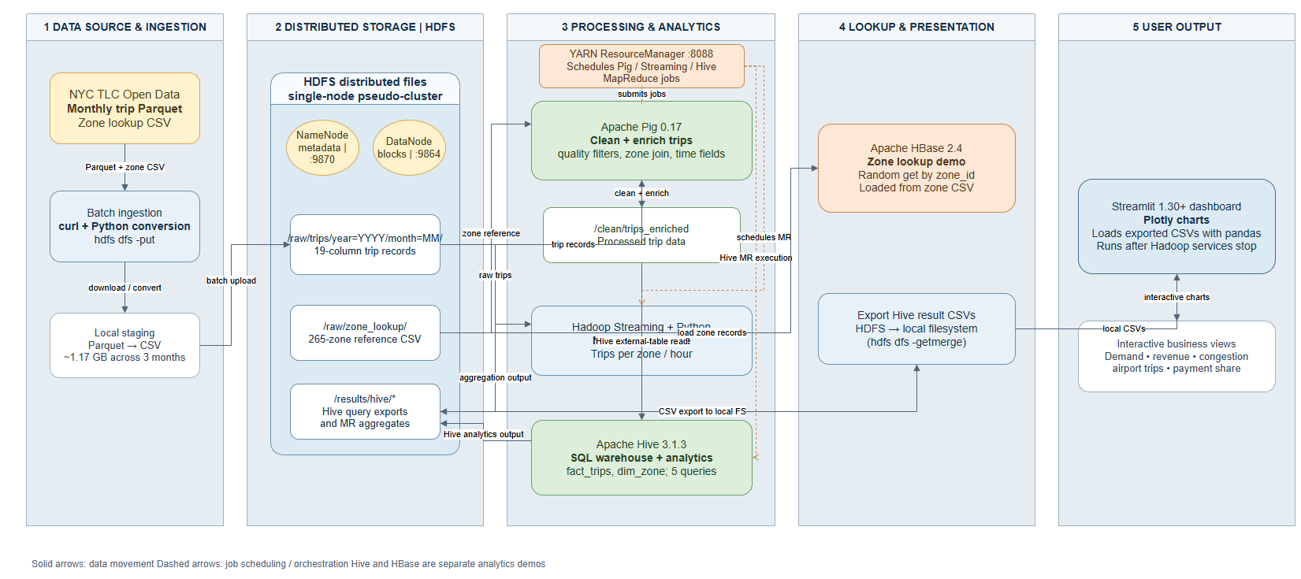
Figure 1 — End-to-end pipeline architecture (source → HDFS → Pig/MapReduce → Hive/HBase → Streamlit)

4.1 Data-source layer
- Primary source: NYC TLC public S3 bucket via CloudFront (d37ci6vzurychx.cloudfront.net), no auth.
- Reference source: TLC taxi zone lookup CSV (12 KB, 265 zones).
- Ingestion cadence: monthly batch (mirrors TLC's release cadence). Automated by download_and_ingest.sh.

4.2 Ingestion layer
download_and_ingest.sh performs three steps:
- curl each monthly Parquet file to local staging.
- Stream-convert Parquet → headerless CSV via pyarrow (row-group streaming keeps memory < 500 MB even on 4 GB RAM).
- hdfs dfs -put -f into partitioned HDFS layout (/raw/trips/year=YYYY/month=MM/).
The partition layout is intentional — Hive can prune partitions and hit only the relevant year/month directories.

4.3 Storage layer — HDFS pseudo-cluster
- Version: Hadoop 3.2.1 vanilla Apache.
- core-site.xml: fs.defaultFS = hdfs://127.0.0.1:9000
- hdfs-site.xml: dfs.replication = 1 (single-node), permission checks off.
- mapred-site.xml: 512 MB container memory, MR framework = YARN.
- yarn-site.xml: 2 GB total YARN memory, vmem/pmem checks disabled.
- Directory contract: /raw (ingested), /clean (Pig output), /results (Hive + MR output), /user/hive/warehouse (Hive-managed ORC), /tmp (scratch).
- Web UIs: NameNode :9870, DataNode :9864, YARN RM :8088, JobHistoryServer :19888, HBase Master :16010, Streamlit :8501.

4.4 Processing layer
Two complementary compute paths, both running on YARN:
- Apache Pig 0.17.0 — 01_clean_trips.pig (cleansing) and 02_enrich_trips.pig (derived features + zone JOIN). Measured runtime: 3 min 36 s + 1 min 36 s.
- Native Hadoop Streaming (Python) — mapper.py + reducer.py computing trips-per-zone-per-hour. Runtime: 35 s. Uses stream.num.map.output.key.fields=2 with KeyFieldBasedPartitioner for composite-key shuffle.
Both paths compile to standard MapReduce jobs — visible in YARN UI, tracked by the Job History Server.

4.5 Analytics layer
Apache Hive 3.1.3 with an embedded Derby metastore (/home/hdoop/hive_metastore_db), executing on MR:
- fact_trips — external table on /clean/trips_enriched/, 7,799,600 rows.
- dim_zone — managed ORC table, 265 rows.
- Five analytical result tables: q1_hotspots, q2_revenue_by_borough, q3_congestion, q4_airports, q5_payment_share.
- Total wall time for all five queries: ~3.4 minutes.
Apache HBase 2.4.18 (standalone mode) for random-access serving of the same zone metadata that Hive scans:
- zone_lookup — 265 rows, single column family info.
- trip_by_zone — 5,676 rows (from Q1 results), two column families stats and top_do.
- Thrift gateway on :9090 for Python (happybase) client access.

4.6 Presentation layer
Streamlit 1.30+ reads the five CSVs (already getmerged from HDFS) and renders 5 interactive Plotly charts with KPI row at top (total trips, revenue, avg fare, avg tip %). Runs on port 8501, no Hadoop needed at demo time.

§5 · Technology Selection
For each tool we chose, we answer: what does it uniquely provide that its alternative doesn't?

5.1 HDFS
HDFS was chosen because it's the concrete implementation of the "distributed storage" concept the syllabus targets. Even in single-node pseudo-cluster mode, it demonstrates:
- NameNode / DataNode separation — metadata (fsimage + edit log) lives on the NameNode, actual 128 MB blocks live on the DataNode. fsck confirms this at run time.
- Block-level replication — configured to 1 for our single node, but the same config on a real cluster gives fault tolerance.
- HDFS shell verb parity with hdfs dfs -ls / -cat / -put / -du / -getmerge — same UX the industry uses on massive clusters.
- Ecosystem compatibility — Pig, Hive, HBase and Spark all talk HDFS natively. A NAS would require every tool to speak its own protocol.

5.2 Apache Pig — why not raw MapReduce or Hive for ETL?
Pig sits at the sweet spot for ETL on this size dataset:
- Higher-level than raw Java MR — 45 lines of Pig Latin replaces 300+ lines of Java (mapper class, reducer class, driver, custom writables).
- More flexible than Hive — Hive requires a table schema upfront; Pig accepts headerless CSV with an inline AS (…) schema declaration and handles messy real-world CSV with more forgiving type coercion.
- Compiles to MapReduce — visible as YARN applications named PigLatin:01_clean_trips.pig, etc.
- Multi-query optimisation — a Pig script produces a DAG that the compiler merges into fewer MR jobs (we observed 3 logical steps merged into 1 MR job).

5.3 Apache Hive — why not straight MapReduce?
- The 5 analytical queries are naturally expressed in SQL. Writing them in raw MR would be a weekend of Java.
- External tables — fact_trips reads directly from Pig's /clean/trips_enriched/ output without copying. Schema-on-read.
- ORC-backed intermediate tables — Q1..Q5 result tables use ORC for columnar compression.
- Compiles to MR — every Hive query becomes YARN applications; the EXPLAIN output shows the exact map/reduce stages.
- Metastore — Derby embedded is enough for a single-node demo; the same DDL works against a shared MySQL/PostgreSQL metastore in production.

5.4 Apache HBase — why add a NoSQL layer at all?
The 5 Hive queries are batch analytical — 60-second latencies. But a live driver-dispatch app needs millisecond zone lookups. HBase demonstrates the pattern:
- Same zone data lives in dim_zone (Hive scan) AND zone_lookup (HBase get by key). Two engines, one dataset, two workloads.
- Row key = LocationID stringified → sub-millisecond gets.
- Column families (info for metadata, stats for pre-aggregated Q1 metrics) demonstrate NoSQL's flexible schema.
- Filter scans (SingleColumnValueFilter) show HBase can do targeted range work when the key structure permits.
Real-world archetype: Uber uses HBase for exactly this — pre-computed metrics from batch pipelines pushed to HBase for the driver app to query at real-time.

5.5 Streamlit — why not Power BI / Tableau?
- Python-native — the analytics team is already in the Python ecosystem via pandas/Plotly.
- File-based inputs — reads the 5 CSVs we already exported. No enterprise BI licensing.
- Interactive filters — hour slider (Q1), airport radio (Q4).
- Runs entirely offline — after Hadoop shuts down. Frees RAM for a smooth demo.

Practical Implementation
This section documents each phase of the pipeline as executed on the pseudo-cluster. Each phase entry includes: what was done, the key commands, selected terminal output as evidence, and screenshots where a Web UI was involved.

Phase 0 · Environment Verification & Config Fixes
The VM was provisioned with Hadoop 3.2.1.
Additional memory tuning applied for the 4 GB RAM constraint: YARN capped at 2 GB total, MR containers at 512 MB with 410 MB JVM heap, vmem/pmem checks disabled.

Phase 1 · Install Pig, Hive, HBase
Three ecosystem components installed on top of Hadoop 3.2.1:
Tool | Version | Home
Apache Pig | 0.17.0 | /home/hdoop/pig-0.17.0
Apache Hive | 3.1.3 | /home/hdoop/apache-hive-3.1.3-bin
Apache HBase | 2.4.18 | /home/hdoop/hbase-2.4.18

Configuration highlights:
- Hive: replaced legacy guava-19.0.jar with guava-27.0-jre.jar (Hive 3.1.3 + Hadoop 3.2.1 compatibility fix). Derby embedded metastore at /home/hdoop/hive_metastore_db.
- HBase: standalone mode, ROOTDIR on HDFS (hdfs://127.0.0.1:9000/hbase), HBASE_DISABLE_HADOOP_CLASSPATH_LOOKUP=true to bypass the HBase-2.4-on-Hadoop-3.x invalid-variable-name bug.

Selected verification output
pig -version:
Apache Pig version 0.17.0 (r1797386)
compiled Jun 02 2017, 15:41:58
hive -e "SHOW DATABASES;":
Hive Session ID = a3425b12-65a2-4f70-ba36-0323eaaf2981
Logging initialized using configuration in jar:file:/home/hdoop/apache-hive-3.1.3-bin/lib/hive-common-3.1.3.jar!/hive-log4j2.properties Async: true
OK
default
Time taken: 0.79 seconds, Fetched: 1 row(s)
echo "list" | hbase shell:
Version 2.4.18, ra1767f4d76859c0068720a6c1e5cb78282ebfe1e, Tue May 21 08:45:43 UTC 2024
hbase:001:0> list
TABLE
0 row(s)
Took 0.7068 seconds
=> []

Phase 2 · Dataset Download and HDFS Ingestion
Three months of NYC Yellow Taxi Parquet files (Jan / Feb / Mar 2026) plus the 12 KB zone lookup CSV. Parquet files streamed row-by-row through pyarrow into headerless CSVs, then uploaded to HDFS with a year=/month= partition layout.

Post-ingestion HDFS listing and block report
Figure 2 — Post-ingestion HDFS listing and block report

Sample data (first 3 trip records)
2,2026-01-01 00:54:04.000000,2026-01-01 00:59:37.000000,1,0.97,1,"N",239,238,1,7.2,1,0.5,3.66,0,1,15.86,2.5,0
1,2026-01-01 00:34:04.000000,2026-01-01 00:39:47.000000,0,0.9,1,"N",163,162,2,7.9,4.25,0.5,0,0,1,13.65,2.5,0
1,2026-01-01 00:57:06.000000,2026-01-01 01:05:59.000000,0,1.4,1,"N",43,237,1,10.7,4.25,0.5,2.5,0,1,18.95,2.5,0

Phase 3 · Pig ETL — Cleanse and Enrich
Two Pig Latin scripts executed against the raw CSVs:
- 01_clean_trips.pig — reads all 3 months, applies data-quality filters (positive trip_distance and fare_amount, sensible passenger_count, non-null zone IDs), writes to /clean/trips.
- 02_enrich_trips.pig — reads /clean/trips, derives pickup_hour / day / month / year / duration_min / tip_pct, LEFT OUTER JOINs the taxi_zone_lookup on pu_loc_id to add pu_borough and pu_zone, writes to /clean/trips_enriched.

Pig 01_clean_trips.pig — job stats
Success!

Job Stats (time in seconds):
JobId Maps Reduces Alias Feature Outputs
job_1791096253713_0002 9 1 raw,clean MULTI_QUERY /clean/trips
COMBINER /clean/_counts/raw
/clean/_counts/clean

Input(s):
Successfully read 11077206 records (1178864106 bytes) from: "/raw/trips/*/*/yellow_tripdata_*.csv"
Output(s):
Successfully stored 7799600 records (950114782 bytes) in: "/clean/trips"
Counters:
Total bytes written : 950,114,799

Rows kept: 7,799,600 / 11,077,206 (70.41%) ← drop rate 29.59%
Pig script completed in 53 seconds

Pig 02_enrich_trips.pig — job stats
Success!

Job Stats (time in seconds):
JobId Maps Reduces Feature Outputs
job_1791096253713_0003 8 2 HASH_JOIN /clean/trips_enriched

Input(s):
Successfully read 266 records from: "/raw/zone_lookup/taxi_zone_lookup.csv"
Successfully read 7,799,600 records from: "/clean/trips"

Output(s):
Successfully stored 7,799,600 records (1,017,929,544 bytes) in: "/clean/trips_enriched"

Pig script completed in 1 minute, 10 seconds

Enriched sample row (18 fields)
2,2026-03-27 00:34:29.000000,0,27,3,2026,21.28,2.0,10.41,2,Queens,Jamaica Bay,169,2,61.5,0.0,63.5,0.0
2,2026-03-28 04:49:02.000000,4,28,3,2026,0.07,1.0,0.01,2,Queens,Jamaica Bay,30,2,3.0,0.0,5.5,0.0
2,2026-02-19 10:40:19.000000,10,19,2,2026,21.2,1.0,7.43,2,Queens,Jamaica Bay,86,2,43.6,0.0,45.1,0.0
Fields: vendor_id · pickup_dt · pickup_hour · day · month · year · duration_min · passenger_count · trip_distance · pu_loc_id · pu_borough · pu_zone · do_loc_id · payment_type · fare_amount · tip_amount · total_amount · tip_pct
Screenshot for 02_enrich_trips.pig
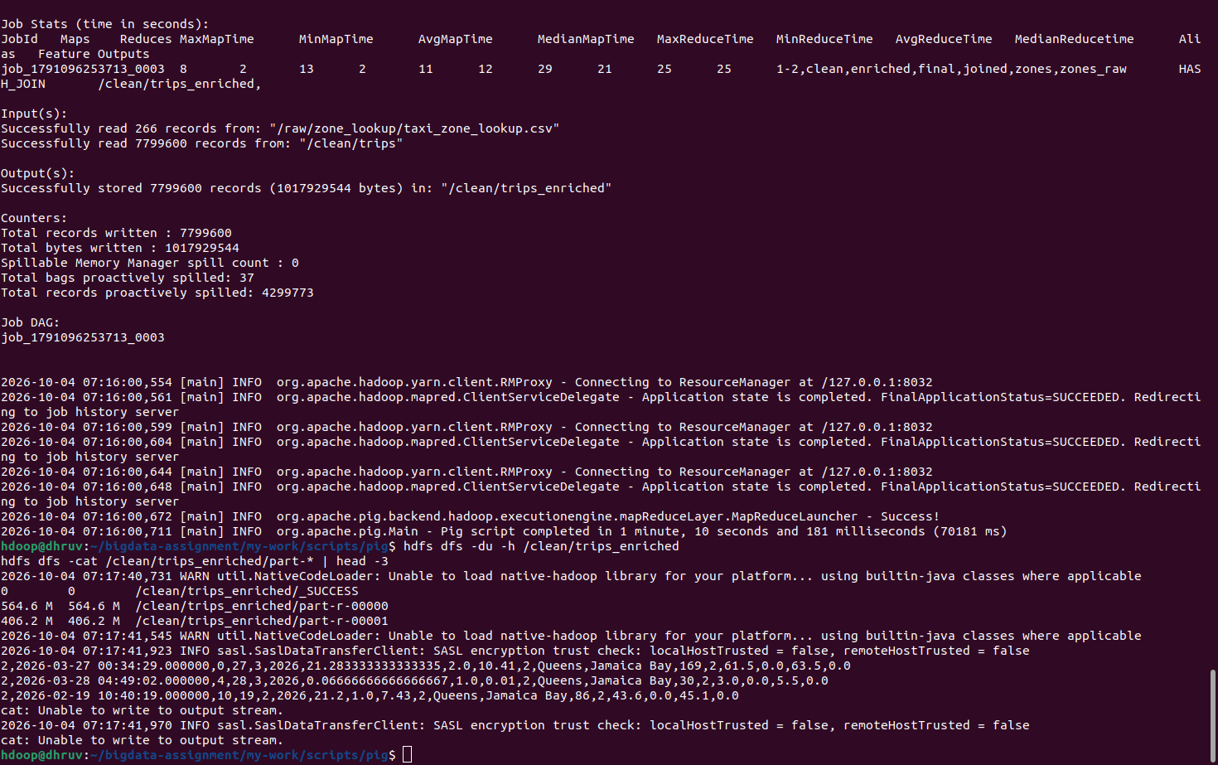
Figure 3 — Apache Pig enrichment job execution
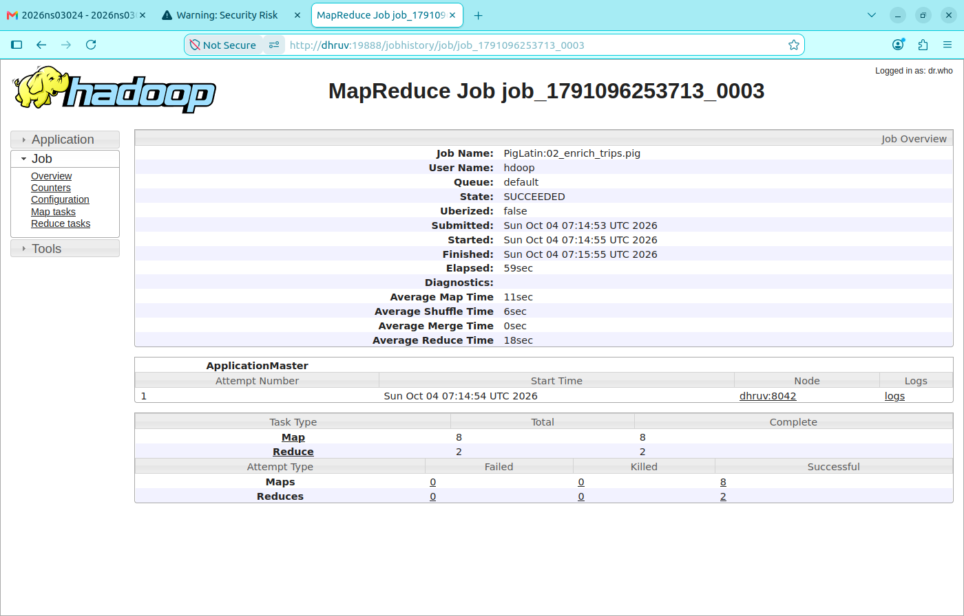
Figure 4 — YARN application details for the Pig enrichment job

Phase 4 · Native MapReduce (Hadoop Streaming)
A hand-written Python mapper + reducer pair computed trips-per-zone-per-hour aggregates over the cleaned dataset, submitted via Hadoop Streaming.
Terminal excerpts for Phases 3–5 match user_output/03, user_output/04/terminal_output.txt, and user_output/05 (2026-10-04 run on January–March 2026 data, 7,799,600 clean trips).

Mapper logic
For each row of /clean/trips, extract PULocationID (field 7) and pickup hour (chars 11–13 of the pickup timestamp), emit "<pu_loc_id>\t<hour>\t1" and increment custom counter Rows OK. Malformed rows increment Rows BAD.

Composite-key shuffle configuration
Streaming's default treats only the first tab-separated field as the shuffle key. To make the shuffle group on (pu_loc_id, hour), the job specifies:
-D stream.num.map.output.key.fields=2
-D mapreduce.partition.keypartitioner.options="-k1,2"
-partitioner org.apache.hadoop.mapred.lib.KeyFieldBasedPartitioner

Reducer output — 5,691 distinct (zone, hour) groups
$ hdfs dfs -cat /results/trips_per_zone_hour/part-* | wc -l
5691

$ hdfs dfs -cat /results/trips_per_zone_hour/part-* | sort -t $'\t' -k3 -nr | head -10
161 18 34733 ← Midtown Center · 6 PM rush
161 17 34510 ← Midtown Center · 5 PM
237 17 33521 ← Upper East Side South · 5 PM
237 15 33208 ← Upper East Side South · 3 PM
237 14 33022 ← Upper East Side South · 2 PM
236 15 32851 ← Upper East Side North · 3 PM
237 16 32335 ← Upper East Side South · 4 PM
237 18 31878 ← Upper East Side South · 6 PM
132 20 31396 ← JFK Airport · 8 PM
161 19 30576 ← Midtown Center · 7 PM

Job counters (from YARN)
Job job_1791104010941_0019 completed successfully

Map-Reduce Framework
Map input records = 7,799,600
Map output records = 7,799,600
Reduce input groups = 5,691
Reduce output records = 5,691
Reduce shuffle bytes = 84,450,995

Custom counters
Rows OK = 7,799,600
Rows BAD = 0

Runtime: 22 seconds
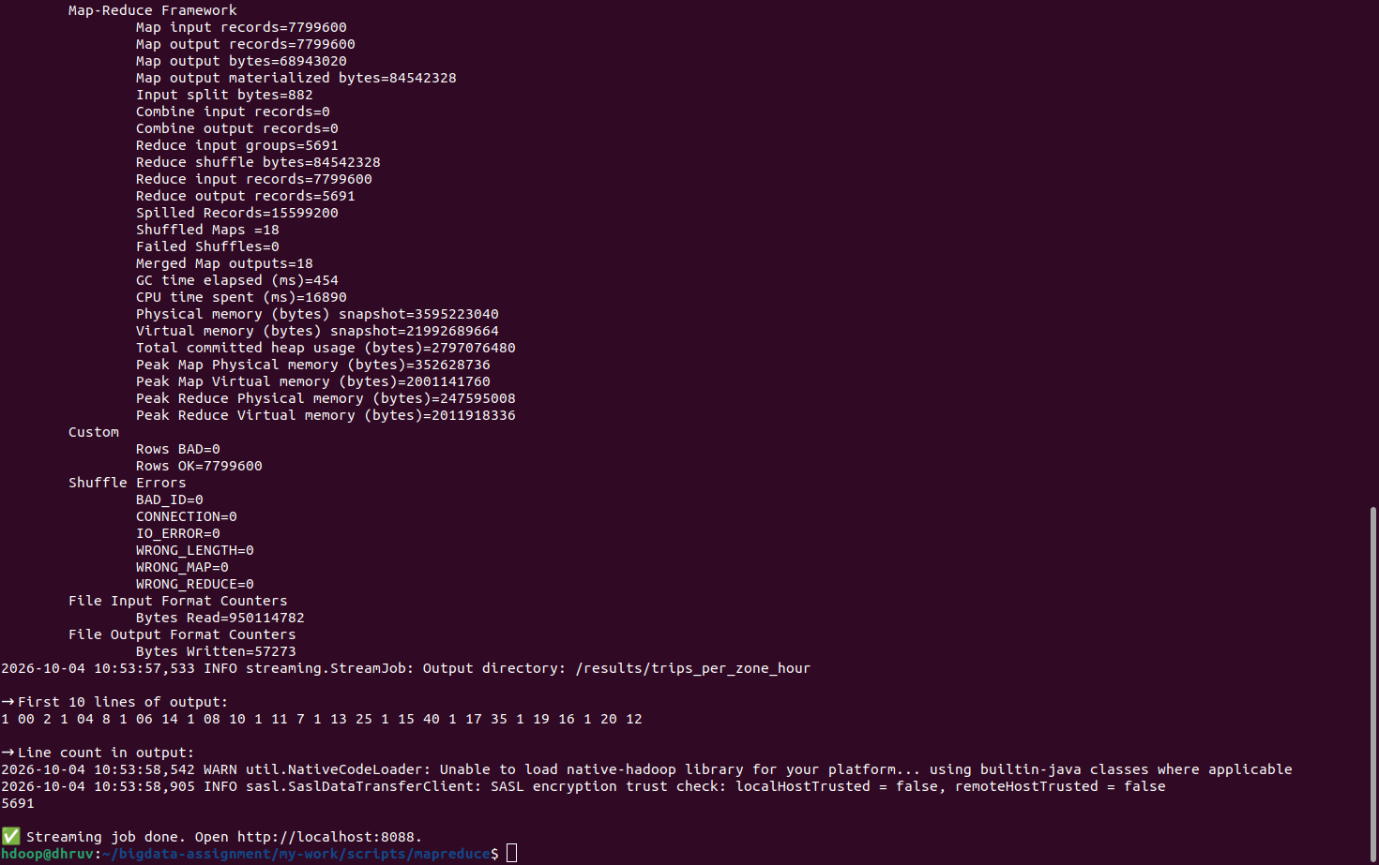
Figure 5 — Hadoop Streaming MapReduce job terminal output

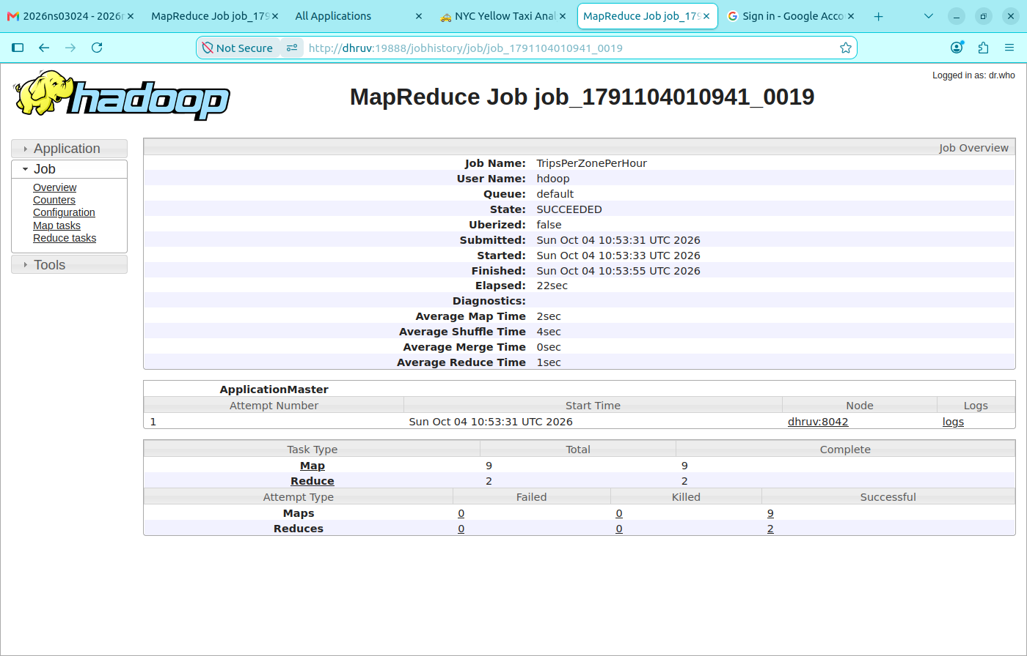
Figure 6 — Hadoop Streaming job counters showing map and reduce record counts

Phase 5 · Hive Analytics
Hive DDL created two catalogue objects and five analytical result tables. All queries execute against the Pig-enriched dataset via an external table (zero-copy).

DDL summary
CREATE DATABASE taxi_analytics;

CREATE EXTERNAL TABLE fact_trips (18 columns …)
ROW FORMAT DELIMITED FIELDS TERMINATED BY ','
LOCATION '/clean/trips_enriched';

CREATE TABLE dim_zone STORED AS ORC AS
SELECT CAST(location_id_str AS INT), borough, zone, service_zone
FROM zone_raw WHERE location_id_str RLIKE '^[0-9]+$';

-- Counts
SELECT COUNT(*) FROM fact_trips;
7799600
Time taken: 22.745 seconds, Fetched: 1 row(s)
SELECT COUNT(*) FROM dim_zone;
265
Time taken: 0.08 seconds, Fetched: 1 row(s)

Analytical query summary
Query | Grouping | Result rows
q1_hotspots | pickup_hour × pu_borough × pu_zone | 5,676
q2_revenue_by_borough | pu_borough × payment_method | 31
q3_congestion | pickup_hour × pu_loc_id × do_loc_id (top 500) | 500
q4_airports | airport × destination_zone × destination_borough | 535
q5_payment_share | pu_borough | 8

CTAS wall times (user_output/05/hive_02_analytics.log): Q1 38.839s · Q2 39.286s · Q3 41.637s · Q4 41.66s · Q5 39.781s (≈3.4 minutes total). Preview SELECT timings are shown under each result block.

Q1 — Demand hotspots (hour = 18)
SQL (materialised as q1_hotspots, then previewed):
SELECT * FROM q1_hotspots WHERE pickup_hour = 18 LIMIT 5;
Terminal output:
18 Manhattan Midtown Center 34733
18 Manhattan Upper East Side South 31878
18 Manhattan Upper East Side North 28224
18 Manhattan Midtown East 27539
18 Queens JFK Airport 23894
Time taken: 0.145 seconds, Fetched: 5 row(s)

Q2 — Revenue by borough and payment method
SQL (preview of q2_revenue_by_borough, top 10 by revenue):
SELECT * FROM q2_revenue_by_borough LIMIT 10;
Terminal output:
Manhattan Card 5996818 1.4647820673E8 15.33 26.18
Queens Card 611861 4.765344973E7 55.7 20.21
Manhattan Cash 745754 1.495282101E7 14.71 0.0
Queens Cash 136864 7205355.95 45.04 0.0
Brooklyn Card 146612 4994073.75 31.85 3.43
Bronx Card 54812 2220193.37 37.99 0.55
Manhattan Dispute 48410 1000005.05 15.09 0.0
Queens Dispute 13433 790325.82 50.3 0.01
Manhattan NoCharge 19577 378288.07 13.87 0.01
Unknown Card 9423 304434.3 21.4 25.27
Time taken: 0.07 seconds, Fetched: 10 row(s)

Q3 — Congestion (busiest PU→DO pairs)
SQL (preview of q3_congestion, limited to 500 heaviest pairs):
SELECT * FROM q3_congestion LIMIT 5;
Terminal output:
14 237 236 5757 9.3 1.01 9.41
15 237 236 5604 9.11 1.01 9.33
17 237 236 5401 7.03 1.04 6.88
16 237 236 5309 7.89 1.03 7.91
12 236 237 5120 9.82 1.01 10.05
Time taken: 0.063 seconds, Fetched: 10 row(s)

Q4 — Airport profile (JFK top destinations)
SQL:
SELECT * FROM q4_airports WHERE airport = 'JFK' LIMIT 5;
Terminal output:
JFK Outside of NYC N/A 19613 19.96 101.42 11.7 39.4
JFK Times Sq/Theatre District Manhattan 14778 17.65 70.97 16.28 56.2
JFK JFK Airport Queens 10977 2.48 37.82 8.34 11.1
JFK Flushing Meadows-Corona Park Queens 10689 8.05 31.79 0.35 16.5
JFK Midtown South Manhattan 7969 17.01 70.65 18.22 48.1
Time taken: 0.074 seconds, Fetched: 10 row(s)

Q5 — Card vs cash share by borough
SQL:
SELECT * FROM q5_payment_share;
Terminal output:
Manhattan 88.05 10.95 1.00 6810559
Queens 79.89 17.87 2.24 765850
Brooklyn 95.81 3.74 0.45 153023
Bronx 96.83 2.89 0.28 56608
Unknown 85.51 13.02 1.47 11020
N/A 79.03 16.07 4.89 1941
EWR 95.24 4.46 0.30 336
Staten Island 35.36 62.74 1.90 263
Time taken: 0.053 seconds, Fetched: 8 row(s)
Columns for Q5 are pu_borough, pct_card, pct_cash, pct_other, trips. Live charts for all five queries: https://transportationhadoop-gn6vv7wqgenfbvjkro3jeu.streamlit.app/

EXPLAIN plan (excerpt — hive_02_analytics.log after Q5)
STAGE DEPENDENCIES:
Stage-1 is a root stage
Stage-2 depends on stages: Stage-1
Stage-0 depends on stages: Stage-2

STAGE PLANS:
Stage: Stage-1
Map Reduce
Map Operator Tree:
TableScan
alias: fact_trips
Statistics: Num rows: 17795970 Data size: 10179295232 Basic stats: COMPLETE Column stats: NONE
Select Operator
expressions: pickup_hour (type: int), pu_zone (type: string)
outputColumnNames: pickup_hour, pu_zone
Statistics: Num rows: 17795970 Data size: 10179295232 Basic stats: COMPLETE Column stats: NONE
Group By Operator
aggregations: count()
keys: pickup_hour (type: int), pu_zone (type: string)
mode: hash
outputColumnNames: _col0, _col1, _col2
Statistics: Num rows: 17795970 Data size: 10179295232 Basic stats: COMPLETE Column stats: NONE
Reduce Output Operator
key expressions: _col0 (type: int), _col1 (type: string)
sort order: ++
Map-reduce partition columns: _col0 (type: int), _col1 (type: string)
Statistics: Num rows: 17795970 Data size: 10179295232 Basic stats: COMPLETE Column stats: NONE
value expressions: _col2 (type: bigint)
Execution mode: vectorized
Reduce Operator Tree:
Group By Operator
aggregations: count(VALUE._col0)
keys: KEY._col0 (type: int), KEY._col1 (type: string)
mode: mergepartial
outputColumnNames: _col0, _col1, _col2
Statistics: Num rows: 8897985 Data size: 5089647616 Basic stats: COMPLETE Column stats: NONE
File Output Operator
compressed: false
table:
input format: org.apache.hadoop.mapred.SequenceFileInputFormat
output format: org.apache.hadoop.hive.ql.io.HiveSequenceFileOutputFormat
serde: org.apache.hadoop.hive.serde2.lazybinary.LazyBinarySerDe

Stage: Stage-2
Map Reduce
Map Operator Tree:
TableScan
Reduce Output Operator
key expressions: _col2 (type: bigint)
sort order: -
Statistics: Num rows: 8897985 Data size: 5089647616 Basic stats: COMPLETE Column stats: NONE
TopN Hash Memory Usage: 0.1
value expressions: _col0 (type: int), _col1 (type: string)
Execution mode: vectorized
Reduce Operator Tree:
Select Operator
expressions: VALUE._col0 (type: int), VALUE._col1 (type: string), KEY.reducesinkkey0 (type: bigint)
outputColumnNames: _col0, _col1, _col2
Statistics: Num rows: 8897985 Data size: 5089647616 Basic stats: COMPLETE Column stats: NONE
Limit
Number of rows: 10
Statistics: Num rows: 10 Data size: 5720 Basic stats: COMPLETE Column stats: NONE
File Output Operator
compressed: false
Statistics: Num rows: 10 Data size: 5720 Basic stats: COMPLETE Column stats: NONE
table:
input format: org.apache.hadoop.mapred.SequenceFileInputFormat
output format: org.apache.hadoop.hive.ql.io.HiveSequenceFileOutputFormat
serde: org.apache.hadoop.hive.serde2.lazy.LazySimpleSerDe

Stage: Stage-0
Fetch Operator
limit: 10
Processor Tree:
ListSink

Time taken: 0.115 seconds, Fetched: 76 row(s)

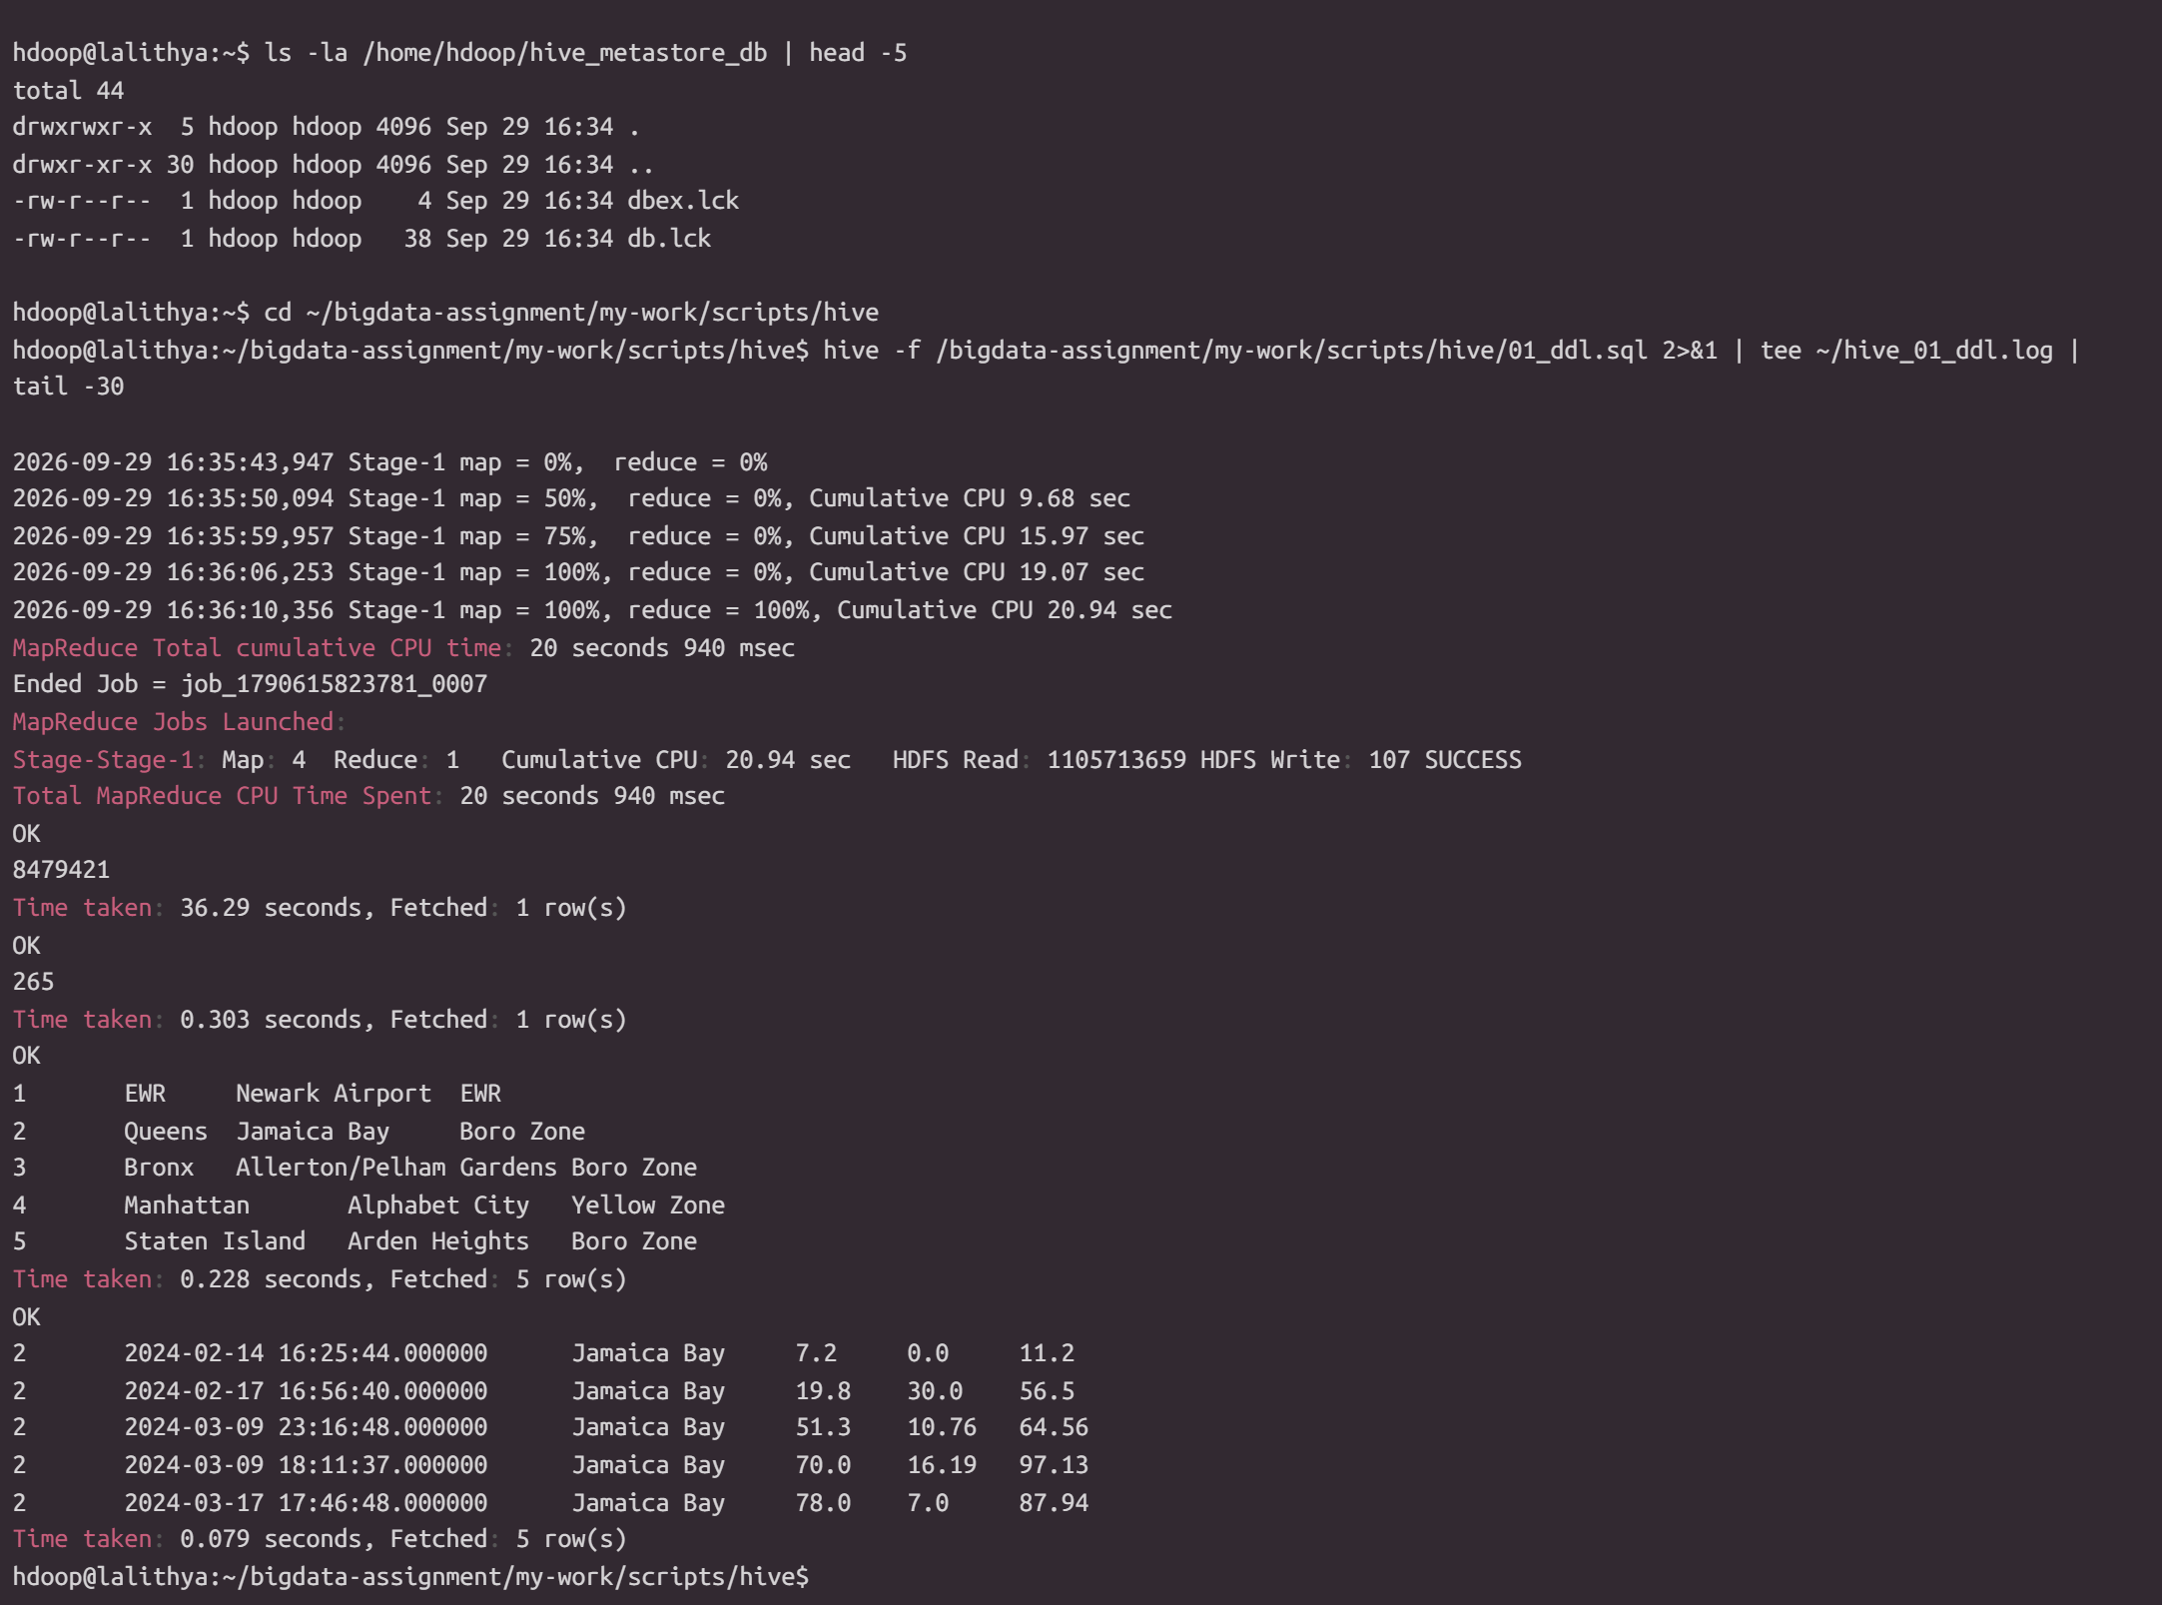
Figure 7 — Hive DDL validation: fact_trips and dim_zone row counts

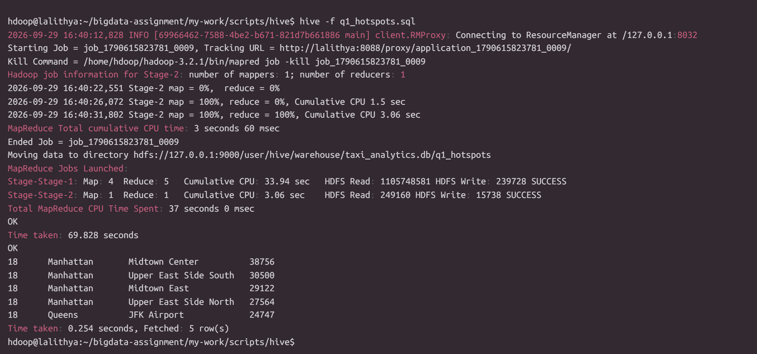
Figure 8 — Q1 demand hotspots at 18:00

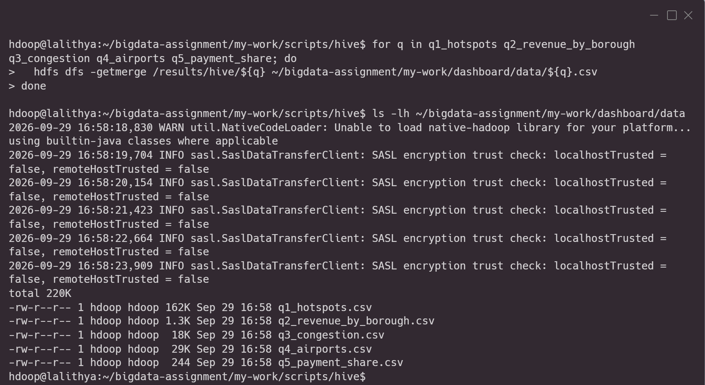
Figure 9 — Exported Hive result files prepared for the Streamlit dashboard

Phase 6 · HBase — Random-Access Serving
HBase in standalone mode with HDFS as backing storage. Two tables demonstrate the NoSQL random-access pattern that complements Hive's scan-based analytics.

Table schema
Table | Row key | Column families | Rows
zone_lookup | LocationID (str) | info (borough, zone_name, service_zone) | 265
trip_by_zone | <zone_name>_<hour_padded> | stats, top_do | 5,676

Point-get evidence
hbase:001:0> get 'zone_lookup', '132'
COLUMN CELL
info:borough timestamp=..., value=Queens
info:service_zone timestamp=..., value=Airports
info:zone_name timestamp=..., value=JFK Airport
1 row(s)

hbase:002:0> get 'zone_lookup', '138'
info:zone_name timestamp=..., value=LaGuardia Airport
1 row(s)

hbase:003:0> get 'zone_lookup', '1'
info:borough timestamp=..., value=EWR
info:service_zone timestamp=..., value=EWR
info:zone_name timestamp=..., value=Newark Airport
1 row(s)

Filter scan (SingleColumnValueFilter)
hbase:001:0> scan 'zone_lookup', {
COLUMNS => 'info:borough',
FILTER => "SingleColumnValueFilter('info','borough',=,'binary:EWR')"
}
ROW COLUMN+CELL
1 column=info:borough, timestamp=..., value=EWR
1 row(s)

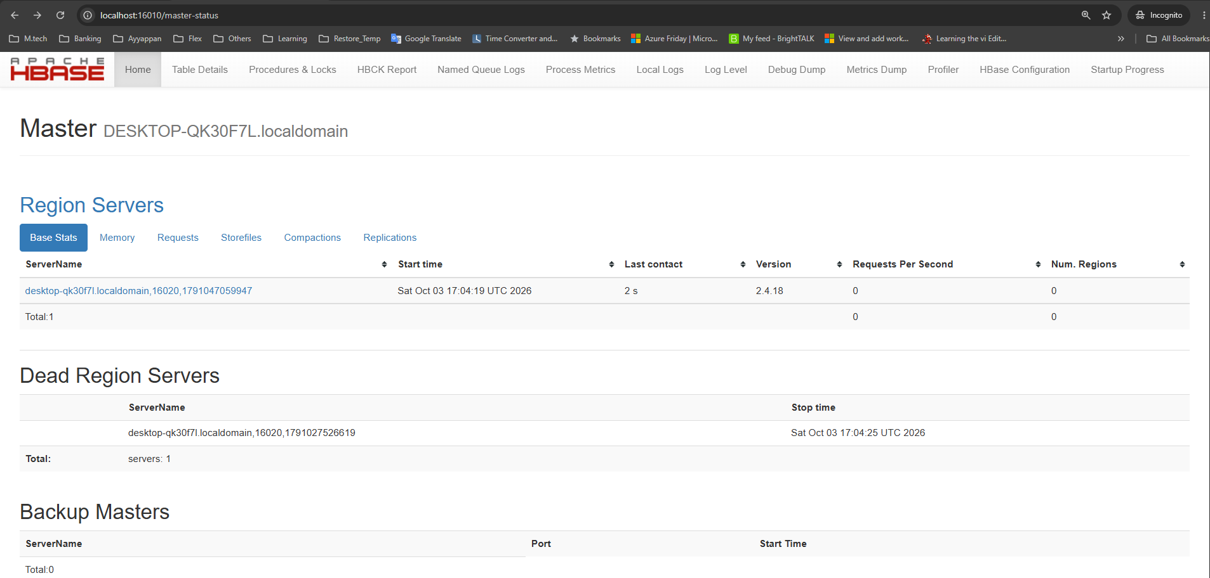
Figure 10 — HBase Master Web UI showing the standalone cluster

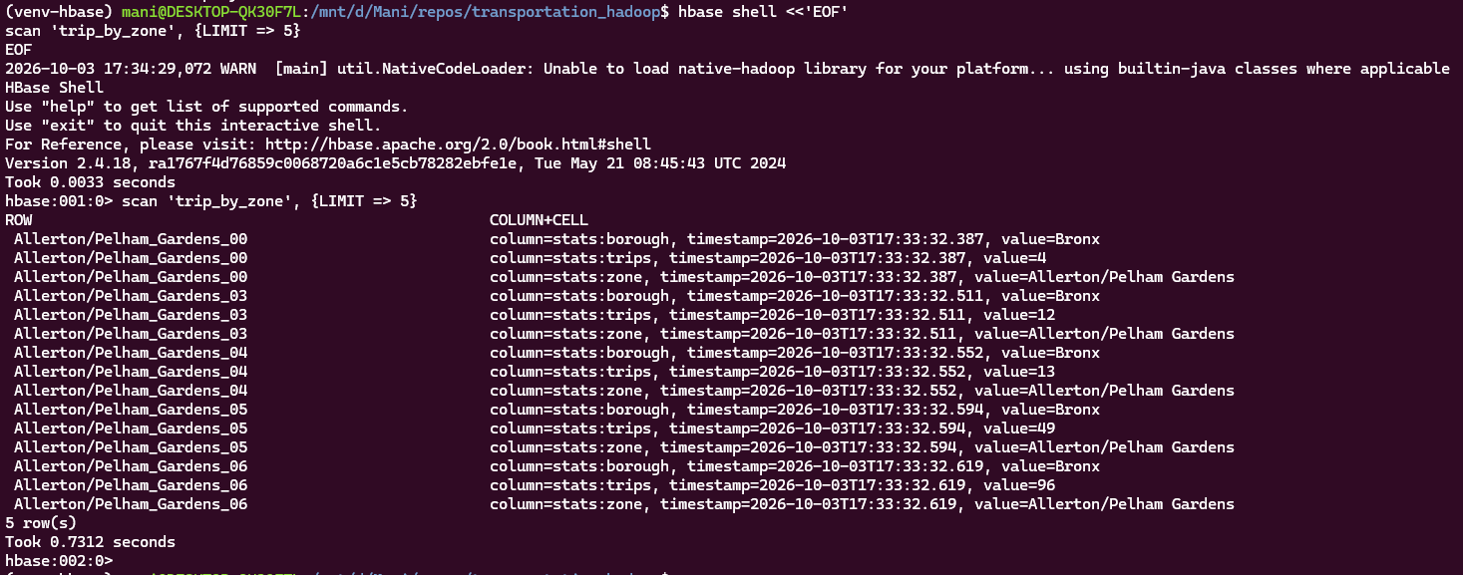
Figure 11 — HBase trip_by_zone scan with precomputed zone-hour aggregates

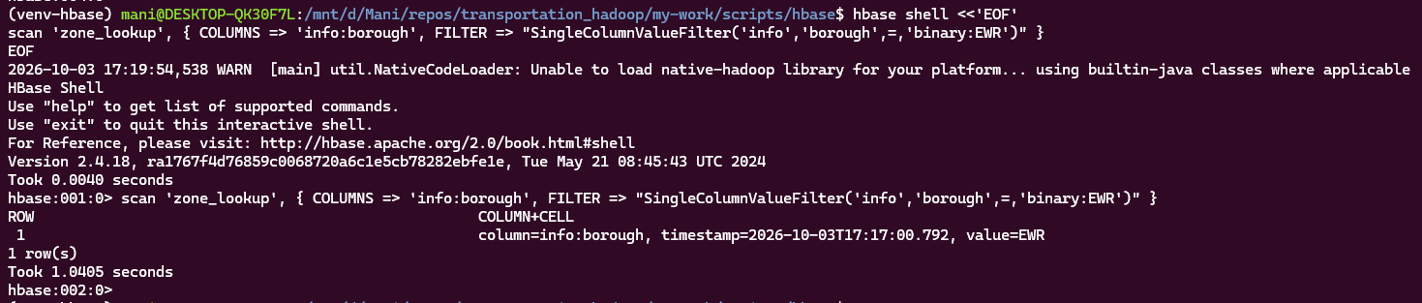
Figure 12 — HBase SingleColumnValueFilter result for the EWR zone

Phase 7 · Streamlit Dashboard
The final presentation layer is a Streamlit app that reads the five Hive-exported CSVs and renders interactive charts with pandas + Plotly. The live deployment used for this submission is https://transportationhadoop-gn6vv7wqgenfbvjkro3jeu.streamlit.app/ .

Dashboard KPIs
KPI | Value
Total trips | 7,799,600
Total revenue (3 months) | $226.64 M
Average fare per trip | $40.71
Average tip % | 4.5 %

Summary of Findings

Headline analytical insights
- Q1 · Demand hotspots at 18:00: Midtown Center leads with 34,733 trips (Jan–Mar 2026), followed by Upper East Side South (31,878), Upper East Side North (28,224), Midtown East (27,539), and JFK Airport (23,894) — Manhattan-CBD dominance during evening rush.
- Q2 · Revenue by borough × payment: Manhattan card revenue ($146.48 M) dwarfs all other combinations. Queens card is second ($47.65 M), driven by airport trips. Total revenue across all boroughs and payment types is $226.64 M.
- Q3 · Congestion signal: Among the 500 busiest PU→DO pairs, zone 186 (Penn Station) → zone 230 (Times Sq) at hour 12 averages 18.07 min/mile (16.66 min over 1.00 mile, 1,738 trips). The same corridor at hour 13 is 17.75 min/mile. Confirms Midtown gridlock.
- Q4 · JFK trip profile: Top destinations are Outside of NYC (19,613 trips), Times Sq/Theatre District (14,778), JFK Airport itself (10,977), and Flushing Meadows-Corona Park (10,689). Airport→CBD remains a dominant paid flow (flat ~$71 fare into Midtown).
- Q5 · Payment behaviour: Card share is about 80–97% in Manhattan, Queens, Brooklyn, Bronx, and EWR. Staten Island is the outlier at 35.36% card / 62.74% cash (263 trips) — meaningful for POS-terminal deployment, with the caveat that the borough sample is small.

Pipeline metrics
Layer | Metric | Value
Storage | Raw HDFS data | ~1.17 GB
Storage | Cleaned + enriched | ~0.97 GB
Processing | Rows through Pig | 11.08 M → 7.80 M
Processing | Pig ETL wall time | ~2 min
Processing | Streaming MR wall time | 22 s
Analytics | Hive queries wall time (5) | ~3.4 min
Serving | HBase zone_lookup rows | 265
Serving | HBase trip_by_zone rows | 5,676
Presentation | Streamlit charts | 5 + 4 KPIs

Source Code Repository
The complete source code, configuration files, phase-by-phase execution guides, and terminal transcripts are hosted in a Git repository:
Repository URL: https://github.com/ManikandanBoopathy/bits-first-sem-big-data
Repository layout:
.
├── README.md
├── PLAN.md master plan and phase split
├── TEAM-ASSIGNMENTS.md roster and ownership
├── .gitignore
│
├── phases/ method notes per pipeline phase
│ └── 00-env-verification-and-config-fix.md
│ └── 01-install-pig-hive-hbase.md
│
├── scripts/
│ ├── hadoop-conf/ core / hdfs / mapred / yarn XML + bashrc
│ ├── ingest/ download + parquet→csv
│ ├── pig/ Pig Latin ETL scripts
│ ├── mapreduce/ Hadoop Streaming mapper / reducer
│ ├── hive/ DDL + analytics + export SQL
│ └── hbase/ HBase shell + zone loader
│
├── report/ Part A theory, presentation, viva Q&A
├── dashboard/ Streamlit app
├── diagrams/ architecture diagram
├── reference/ dataset schema, zone lookup CSV, samples
└── user_output/ per-phase terminal transcripts + screenshots

References
[1] NYC TLC Trip Record Data — https://www.nyc.gov/site/tlc/about/tlc-trip-record-data.page
[2] TLC Yellow Trip Data Dictionary (PDF) — https://www.nyc.gov/assets/tlc/downloads/pdf/data_dictionary_trip_records_yellow.pdf
[3] Taxi Zone Map (PDF) — https://www.nyc.gov/assets/tlc/downloads/pdf/taxi_zone_map_manhattan.pdf
[4] Apache Hadoop 3.2.1 docs — https://hadoop.apache.org/docs/r3.2.1/
[5] Apache Pig 0.17.0 docs — https://pig.apache.org/docs/r0.17.0/
[6] Apache Hive 3.1.3 — https://hive.apache.org/
[7] Apache HBase 2.4 reference — https://hbase.apache.org/2.4/book.html
[8] Streamlit documentation — https://docs.streamlit.io/
[9] Hadoop Streaming Guide — https://hadoop.apache.org/docs/r3.2.1/hadoop-streaming/HadoopStreaming.html
[10] HBase Architecture Overview — https://hbase.apache.org/book.html#arch.overview

