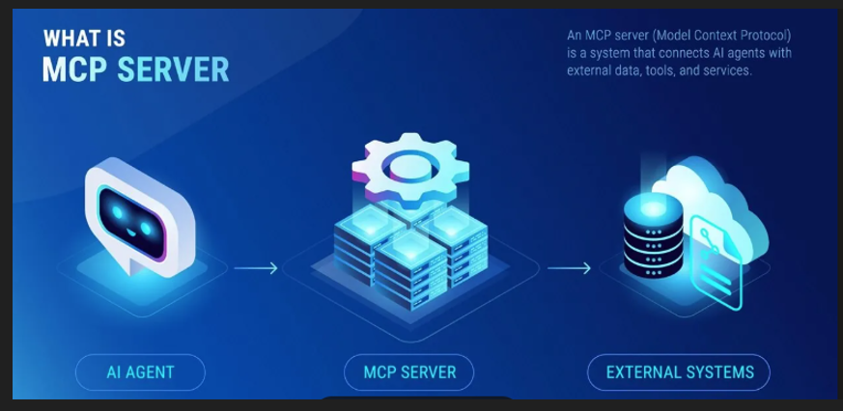

Microsoft.McpServer.ProjectTemplates –Nuget

npx @modelcontextprotocol/inspector

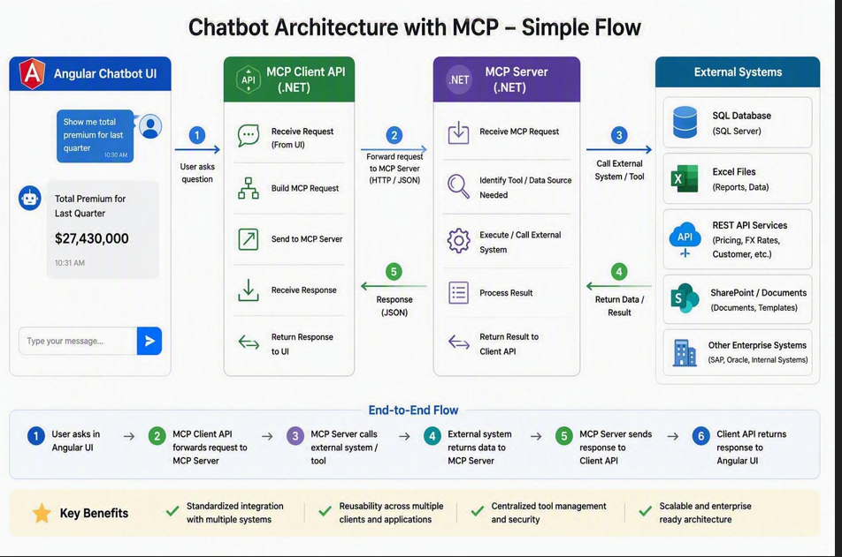

With RAG
