1. Protect your mysql password by saving in a file :

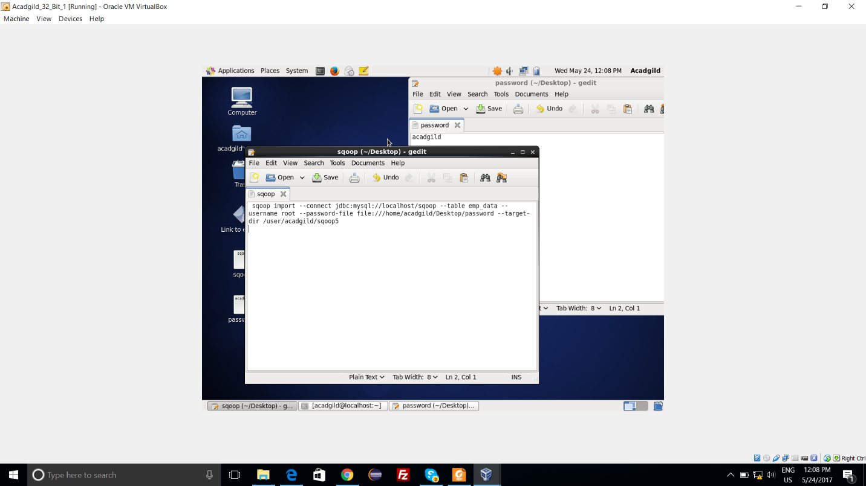

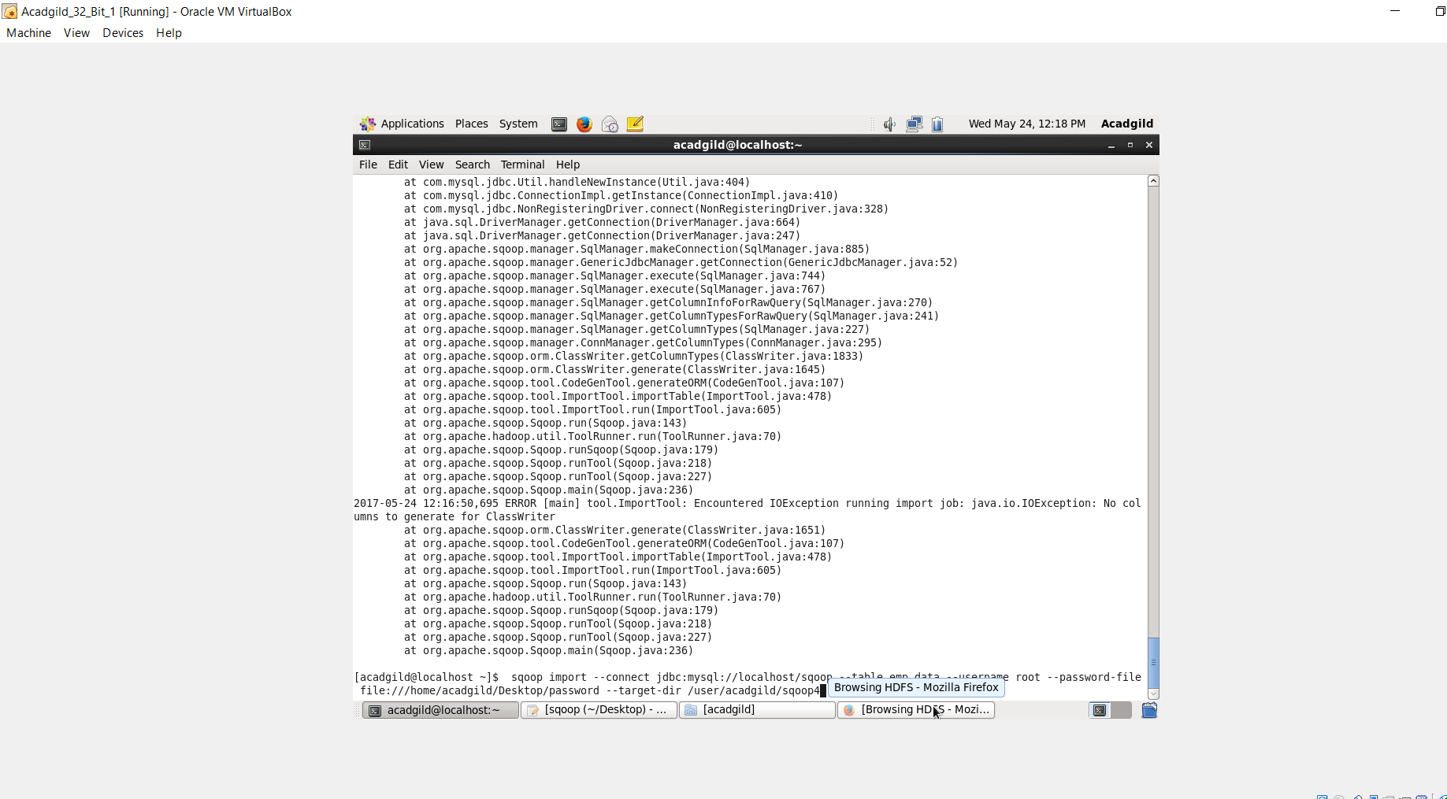

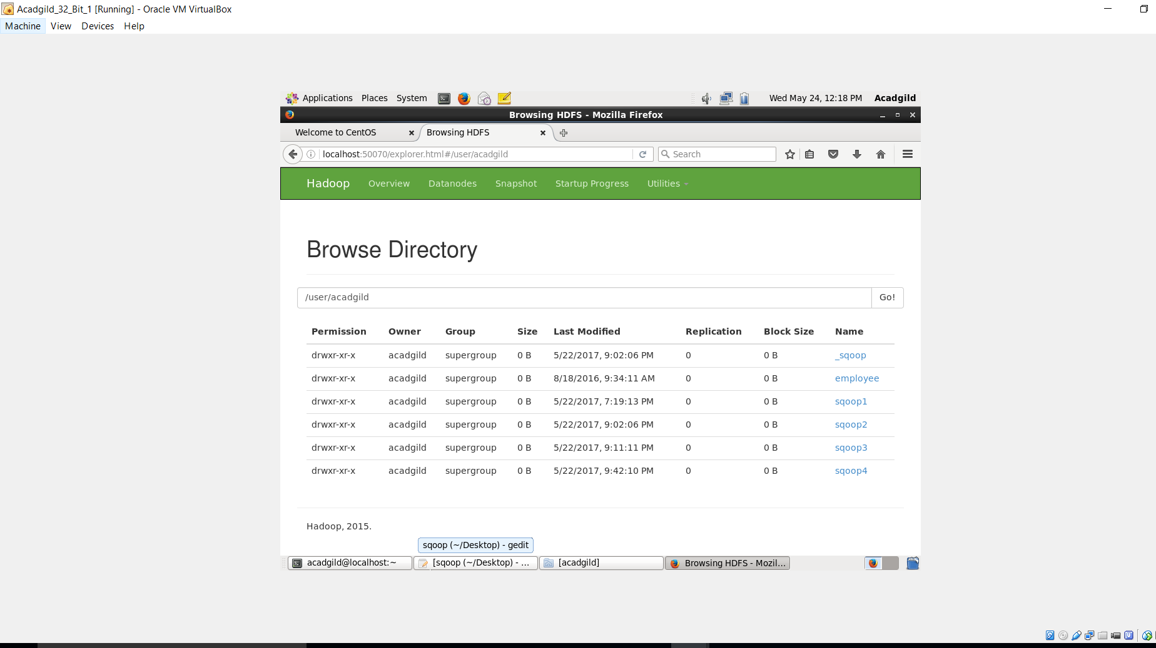

Protect your mysql password by reding it from a standard input :

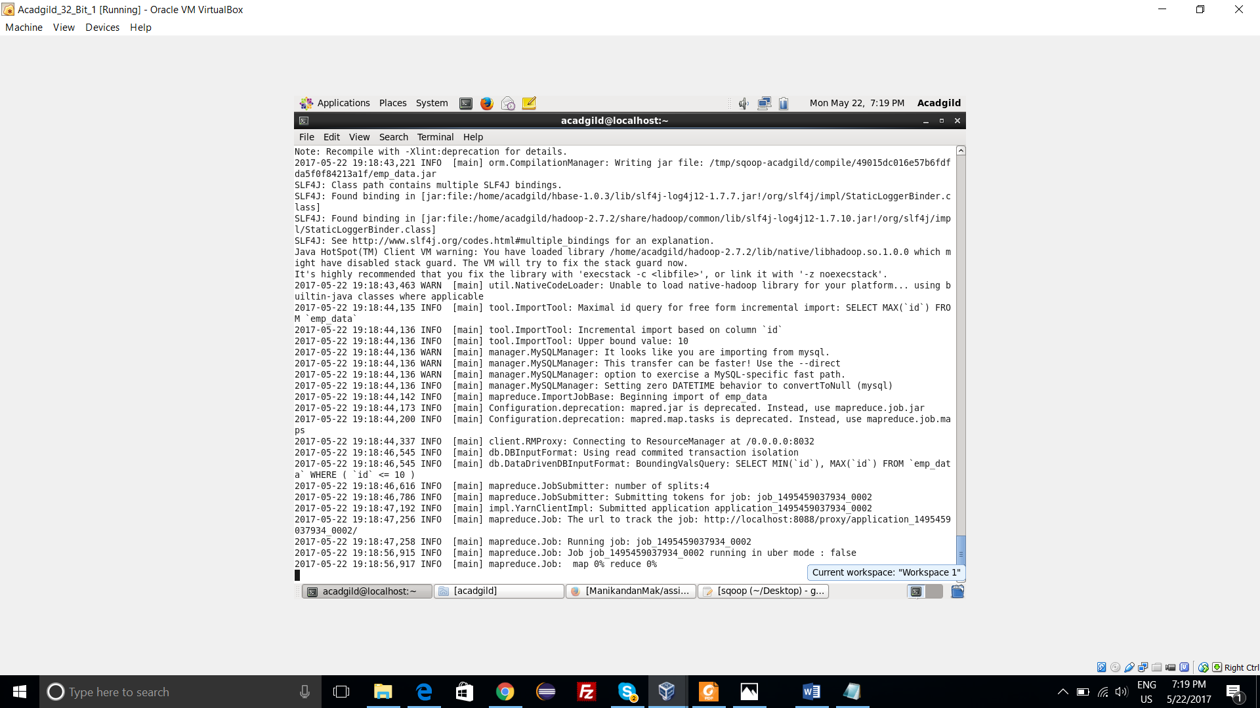

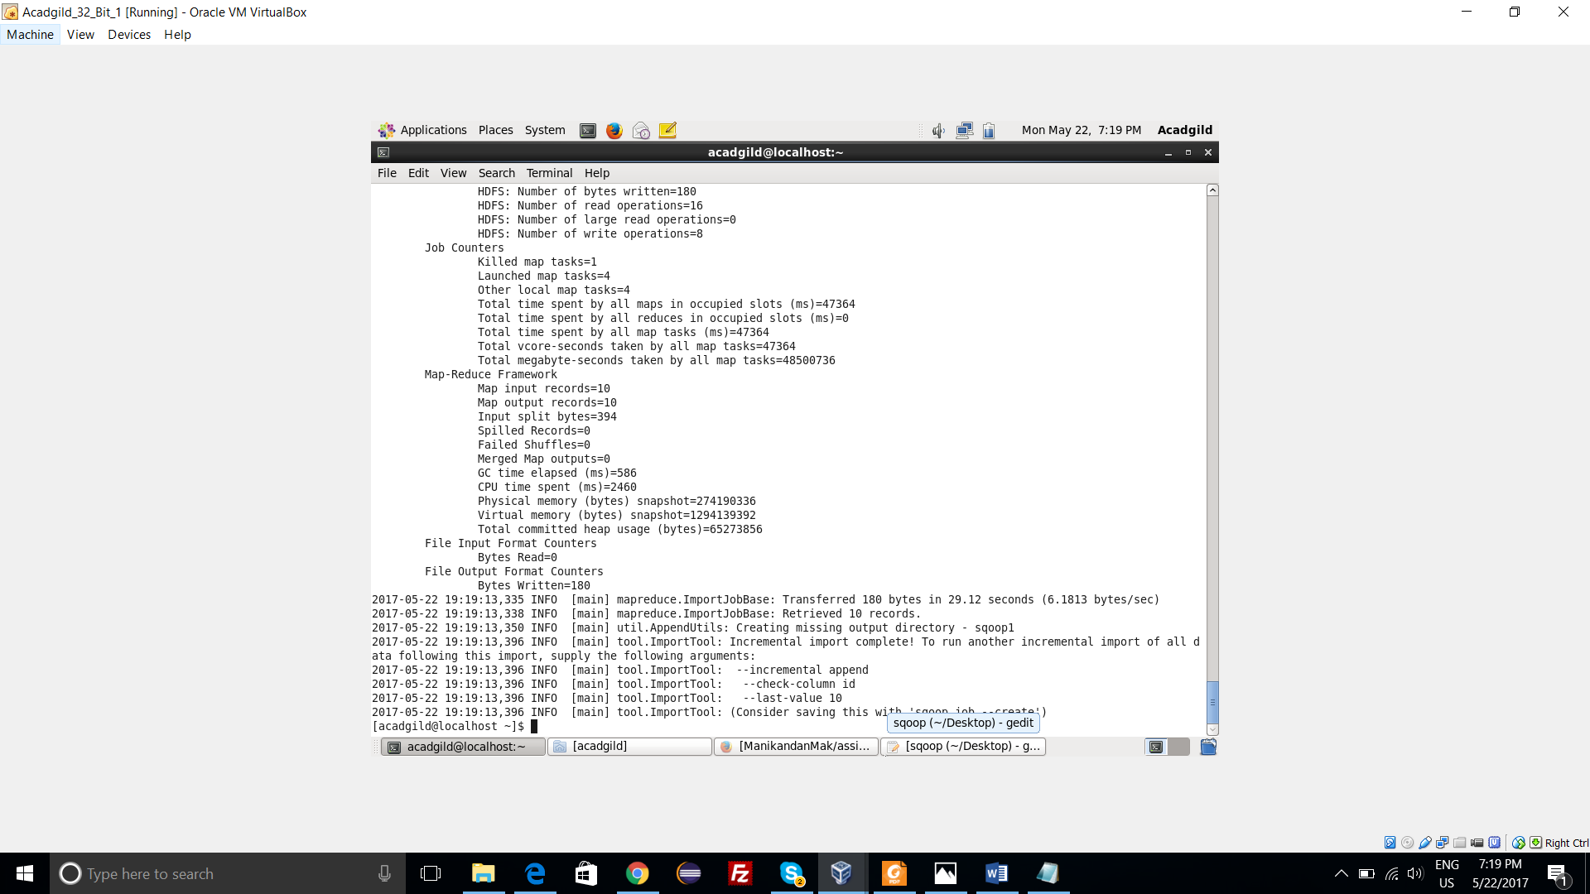

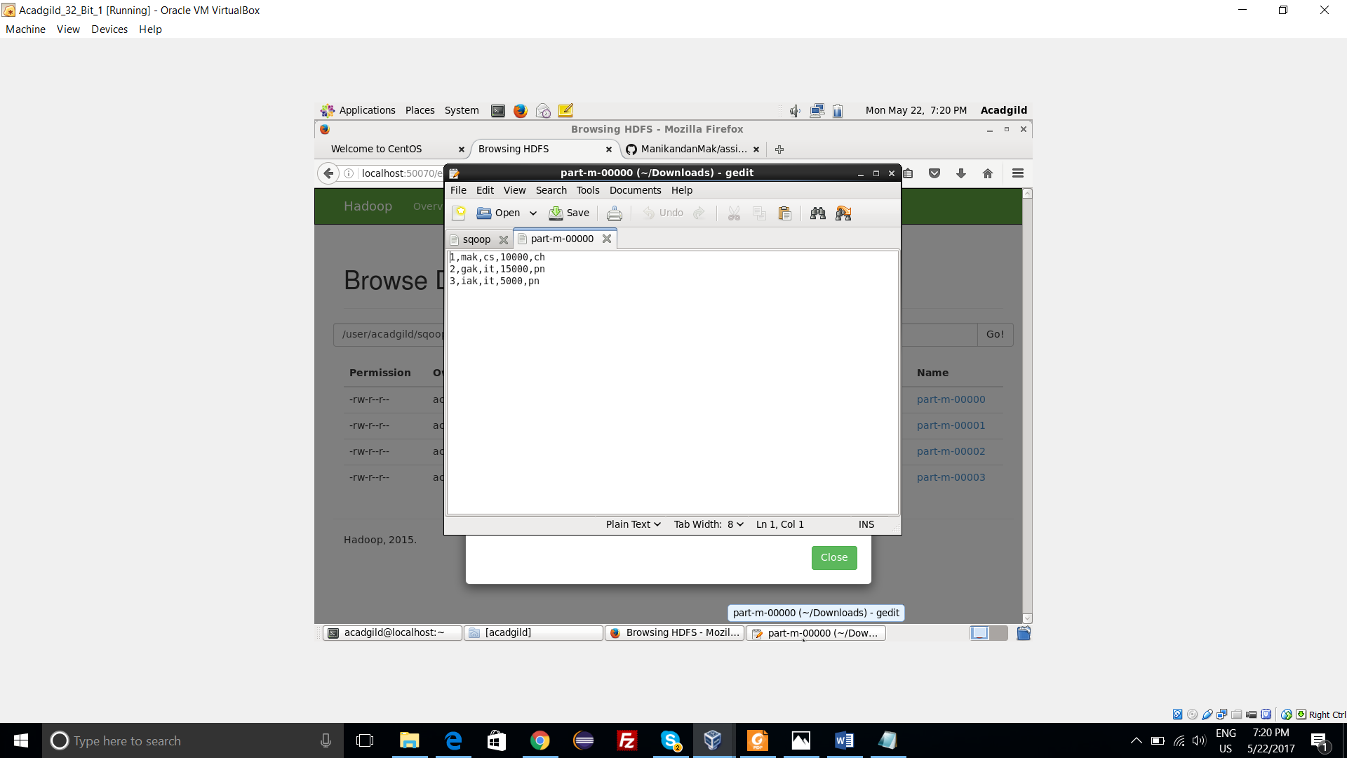

1. **Speed Transfer :**

* Sqoop can handle bulk transfers very well.
* You can speed up the transfers by using the –**direct**parameter.
* Normally Sqoop uses JDBC as an interface for transferring data.
* Alternatively, direct mode transfers the data using the native utilities of the database provider.
* In MySQL, mysqldump and mysqlimport are used for data transfers between MySQL.
* Sqoop will use pg_dump utility to import the data.

