Overview

The purpose of Pole Data Cleansing (PDC) process is to identify poles that are solely owned by Telstra and require asset transfer to NBN. This is accomplished by consolidating pole data obtained from three different data sources such as Utility, TPNI and PDB within the NBN GIS and inventory systems.

Technical Terms

1. **Electrical Utility Data:**

Each utility provider’s database has its own unique standards and specifications, with pole data recorded at varying levels of complexity. Utility data generally have the most accurate pole location data and pole identification tag data. It may or may not record Telstra and Private Poles. Utility poles data needs to be imported from SpatialNET into GDSS using the Utility Pole Import functionality in GDSS in order to be used for pole data cleansing.

1. **Telstra Planning Network Inventory (TPNI):**

TPNI is Telstra design database. It may have a variable and random shift of 1m to about 20m from the exact pole latitude and longitude to avoid overlapping with pits, duct, trenches, strands, etc. The TPNI data can be generated from GDSS portal using the Pole Data Export functionality.

1. **Telstra Pole Database (PDB):**

PDB is used to record licenses and capture field inspection results. PDB generally have the most accurate pole ownership data. PDB can be generated from GDSS portal using the Pole Data Export functionality.

1. **PSTN-IBC**

PSTN wires can be of 2 types:

* Thick black wire which comes from a PSTN box (Black cylindrical or white rectangular).
* Thin black wire which comes from a riser (white pipe attached to the pole) and hangs directly from a hook.

1. **BB- AC or BB-CONST**

Telstra HFC wires can be of 2 types:

* BB-AC, which means Aerial Telstra HFC. This is a thick silver wire with a loop and a small knot inside the loop.
* BB-CONST, which means Under Telstra HFC. This is a thin black wire which comes from a riser and hangs from a hook with a small clamp in the beginning.

Work Flow

Extract SAM Boundary from Spatialnet

Data Check

Generate TPNI, PDB and Utility Data from GDSS

If utility not

available in Proper Data

GDSS Data not proper

Generate PUR

Self QA

QA

Pole Data Cleansing

Remediation request

Datacheck

Process of Data check is to ensure that 3 data sets such as utility, TPNI and PDB provided are proper to proceed for data cleansing

Checks involved for data check are the following

* If the Utility count is zero or less than tpni and pdb, check for utility poles in Gmaps. If found, raise Utility data remediation request in IT Central.
* Check if NBN_ID and tag_id are present for all the Utility data. If not, raise Utility data remediation request.
* Check for the Job history of Utility Data in SpatialNET. If the data is uploaded prior to 10 months, raise Utility data remediation request.
* If the SAM has Utility owner as 'AUSGRID' and tag_id doesn't start with 2 alphabets for too many entries then utility data needs remediation.
* For SAMs having ‘SA Power Networks’ and ‘United Energy’ ownership, the tag_id will be blank. Remediation request is not required for such SAMs.
* Before raising remediation request, to check if the utility data is available in NBN SharePoint, go to this link: ‘***http://portal.nbnco.net.au/coo/networkplanning/Utility***’. Select the Utility provider for your SAM, if it is Ausgrid or SA Power Networks check if the particular FSA is available with NBN (For other utility providers, it will be ‘Entire Franchise Area’).

Steps for Datacheck

1. Login to SpatialNET and select the job for boundary extraction.
2. Select Find -> Landbase -> Boundaries. Give the SAM_name and select the entry with type= SAM. Click Select.
3. Go to NBN_NDD -> Design Exchange -> Export Design. Give the Output location (PUR folder in Telstra HFC), uncheck Select All and check only L331_SAM. Click Extract
4. Zip all the extracted boundary files into one zipped file and store it in ‘***Telstra HFC\PUR\Data_Check****’*.
5. Login to GDSS. Select MTM -> Utility Pole Import -> Enter the SAM_name and click Select and Next.
6. If the utility data is not available in GDSS, generate the PUR (Pole Utilization Report) from SpatialNET. Filter it into UTILITY.xlsx using ‘***TelstraHFC_Pole_Cleansing_Script_v0.1.xlsm***’. Load it in MapInfo. Create points and save it as MapInfo file (.TAB).
7. In GDSS, Select MTM -> Pole Data Export -> Enter the SAMname and click Select.
8. Select Utility, TPNI and Telstra Pole Data. Uncheck Boundary Export and upload the zipped boundary file, export and download the GDSS package which contains the MapInfo files for utility, pdb and tpni. Store it in Data_Check folder.
9. Unzip the package. Load the L331_SAM boundary and the 3 data in MapInfo. Check if the data is present within the boundary

Pole data cleansing

Once the data check is proper, we will proceed with cleansing.

Pole data cleansing involves identifying the poles owned by Telstra, Utility owners and poles do not have Telstra presence by analyzing the pole data obtained from three different data sources such as Utility, TPNI and PDB within the NBN GIS and inventory systems.

Steps for pole data cleansing

Generate the SAM boundary from PNI and the 3 sets of data (TPNI, PDB and Utility) from GDSS.

1. Rename and load the data files tpni_poles, pdb_poles and utility_poles along with the buffer template TLS10.1.3_POLE_XXXX-YY_N50_1_Wash into MapInfo to the same layer.
2. Run the latest version of ‘Format_TPNI_GDSS’ and ‘Format_utility_poles’ scripts.
3. Turn on Editable on the buffer template and Bing Hybrid for map view.
4. Create buffers and perform data cleansing.
5. Using Google Street View examine the poles and determine pole ownership and joint use. Look for PSTN and Telstra HFC wires on the pole in Google map and update the following fields:

* Joint_use in utility_poles. If no utility data is available, pole_use in pdb_poles.
* Comment and target_asset_flag field in buffer template accordingly.

target_asset_flag= Y: Asset is transferable from Telstra to NBN.

1. When buffering is complete, perform the below steps:

* Pack the buffers in tabular format.
* Merge the pole layers. The data for different fields of buffer will be extracted firstly from the Utility dataset, then Pole DB, and lastly TPNI.
* Export the buffer template and save it in the working folder as .csv file.

1. Using Pole data CleansingScripts.xlsm, convert the exported TLS10_1_3_POLE_XXXX-YY_N50_1_wash.csv file into .xlsx. Execute the remaining steps in the script to get the final Asset Transfer Sheet (ATS).
2. A Quality Assurance (QA) is performed again on the ATS to double-check and confirm that the values of all the fields are correct in Asset Transfer Sheet.
3. The ATS for cleansed pole data will be uploaded on the Connect MTM portal where the file will be available to Telstra.

**Different wire combinations observed.**

1. Utility poles with only electric wires: joint_use = N and comment = Desktop inspected - No Telstra, No license required.

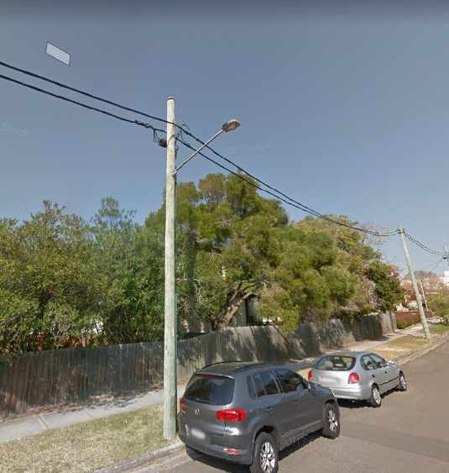

1. Utility poles with PSTN/Telstra HFC and electric wires: joint_use = Y and comment = Desktop inspected.

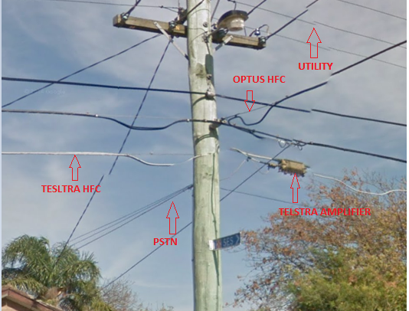

1. Utility poles with only PSTN/Telstra HFC: Field inspection required - Confirm ownership and joint use.

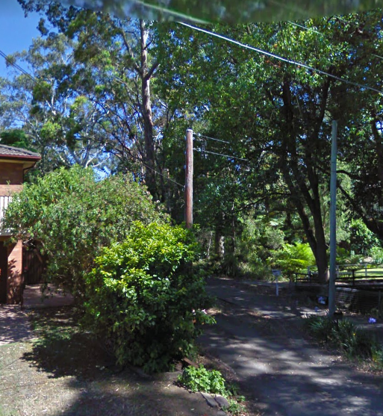

1. Telstra poles with only PSTN/Telstra HFC: joint_use = N, comment = Desktop inspected and target_asset_flag = Y.

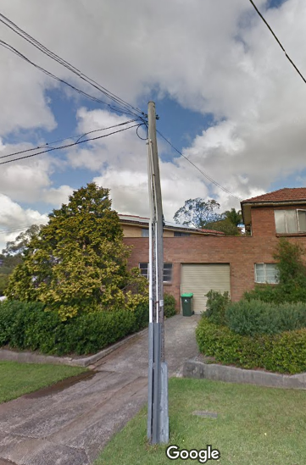

1. Telstra poles with PSTN/Telstra HFC and electric wires: joint_use = Y, comment = Desktop inspected and target_asset_flag = N.

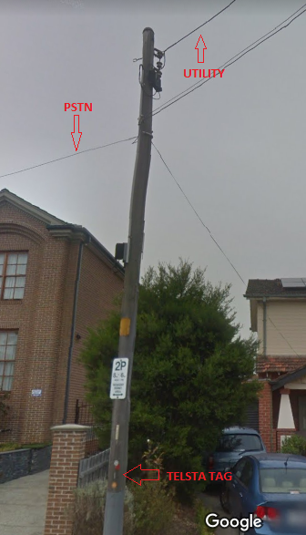

**Scripts used for PDC**

Format_TPNI_GDSS’

Loaded TPNI and PDB may contain previously updated data, while running the script it will refresh the PDB and TPNI and remove added comments or updated joint use.

Format_utility_poles’

Refreshing of utility data will be done by this script and it will generate the URL for each utility entries according to the latitude and longitude provided to make the buffering easier.

Merge_Pole_Layers_TelstraHFC

Merging of data from different data layers into the buffer template and make the buffer template in a readable format is done by this script. We will get all the updated data in a single csv file. This is further formatted to make the ATS.

Format Utility_PUR

This script is used for changing the format of pole utilization report taken from spatialnet and make it in the form of utility data from GDSS and readable with Map Info tool.

TelstraHFC_Pole_Cleansing_Script

Asset transfer sheet which is the final output from PDC is created by making changes and updates to the csv file created from MapInfo tool. This can be done by various macros included in the script.